COMP201- Object Oriented Programming

Spring 2017

HOMEWORK7

In this homework, you are asked to write an application for listing the movies directed by the selected director.

**Program Execution:**

The application reads the list of the directors and the movie names from movies.txt. The example file is as following:

4 Peter Jackson

Lord of the Rings

King Kong

The Hobbit

The Lovely Bones

5 Christopher Nolan

Interstellar

Insomnia

Inception

Memento

Dunkirk

1 Ang Lee

Life of Pi

3 David Fincher

Alien

Seven

The Girl with the Dragon Tattoo

The first line presents the number of movies directed by the given director. Then, name-surname of the director is given. In the next lines, movies directed by the given director are listed. For instance, the director Peter Jackson directed 4 movies. The names of those movies are: Lord of the Rings, King Kong, The Hobbit and The Lovely Bones.

After reading directors and movies from the input file, your application presents them in a user-friendly interface as shown below:

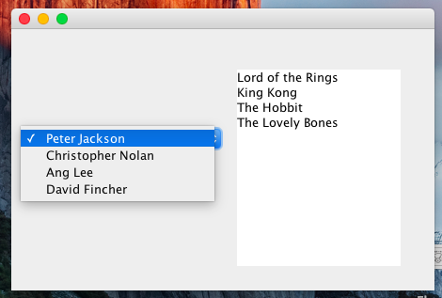

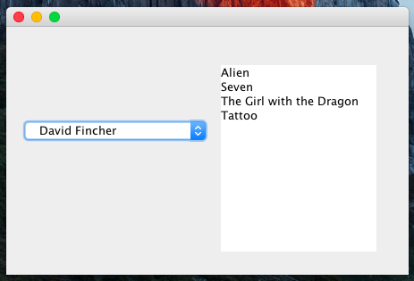

Your application lists the names of directors in a combobox. When the user selects a director from the combobox, the movies directed by the selected director are listed in the TextPane.

**Programming Tips:**

- You are allowed to use any interface designing tool (i.e. WindowBuilder)

- **jComboBox** and **JTextPane** are the classes that you need to use for designing GUI.

- You need to implement **ItemListener** interface for the combobox to understand when the user selected a director.

- For writing the movies to the textPane, you can use setText() method.

- For adding a new director to the combobox, you can use addItem() method.

- You may need to use two additional classes: Director and Movie. Obviously, in the Director class, you need to include an array of Movie. You should also handle adding a movie to this array.

- In your frame, you may need to keep an array of directors and you need to handle adding a new director to this array.