**COMP112 – Object Oriented Programming**

**Spring 2017**

**Makeup Assignment**

**Foreword**: This is **NOT** a mandatory assignment. This assignment is given for students who want to change grades of 1 or 2 of his/her previous assignments with the lowest grades. When submitting, you have to write instead of which previous assignment(s) you are submitting and willing to change the grade in the comments section.

**Assignment Description:**

In this assignment, you are asked to write a Tetris Game application. Most of you know the rules of the Tetris game; you simply put falling pieces of different kind next to or on top of each other in a box, in order to build full lines. For each line, you need to increase the player’s score, and after some level, you need to increase the speed of the falling pieces. You should show the type of next piece to the user. The game is over when any of the pieces reach the top line of the box.

**Required Classes:**

The class diagram is given below:

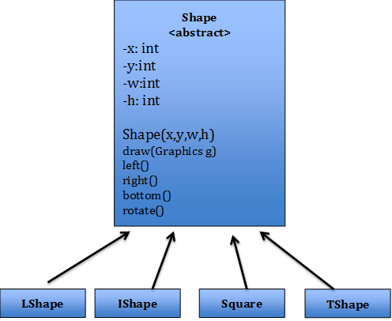

* Shape is an abstract class.
* void draw(Graphics g), left(), right(), bottom() and rotate() are abstract methods in the Shape class. Left and right methods move the block to left or right. Rotate block rotates the block 90 degrees clockwise (preferably, the position of the top left corner should stay the same). Bottom button should quickly push the block to the bottom. You should monitor the keyboard arrow buttons to call these methods (up arrow button can be used for rotate method).
* The attributes of Shape class is described below:
  + x: the X coordinate of the top left corner of the shape
  + y: the Y coordinate of the top left corner of the shape
  + w: width of each square in the shape (note that each shape consists of 4 squares)
  + h: height of each square in the shape.

In the Shape class, there is only one constructor with four integer parameters to set x, y, w, h values.

**Sample Output:**

