

KlikkFix

Whitepaper V1
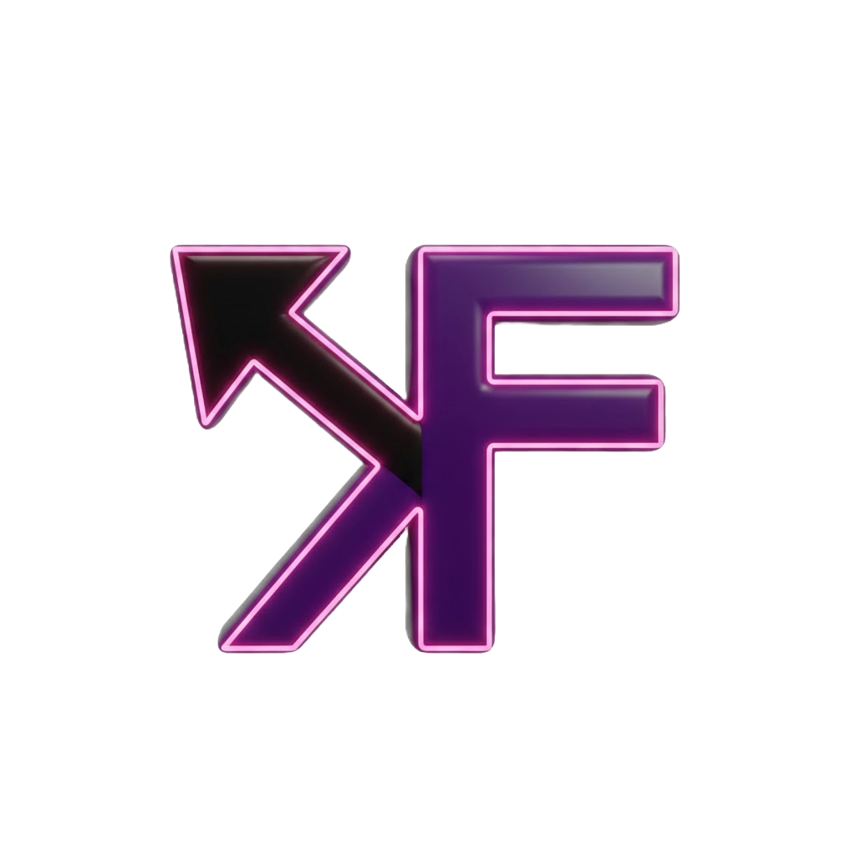

Authors: Ahmet Tugsuz & Temoor Kiani
Date: 25.01.2026

Revision D – KlikkFix whitepaper documentation

Table of Contents
- Executive Summary
- The Problem: Too Much Interface, Too Little Outcome
- The Solution: Improving Text Without Breaking Flow
- A Custom AI That Learns How You Write
© KlikkFix. All rights reserved.

Table of Contents
- Executive Summary
- The Problem: Too Much Interface, Too Little Outcome
  - Interface Overload
  - Fragmented workflows
  - Chat-based AI Friction
- The Solution: Improving Text Without Breaking Flow
  - Traditional flow
  - KlikkFix flow
- Target Audience – Designed for
  - Go-to-market strategy
- A Custom AI That Learns How You Write
5.1 Learning through use
5.2 Optional, user-controlled personalization
5.3 Linguistic DNA
5.4 Adaptation without friction
- Why KlikkFix

- Executive Summary
Modern AI tools promise efficiency, yet many introduce additional complexity into everyday workflows. Over time, interfaces grow heavier, workflows become fragmented, and simple actions require disproportionate effort. As a result, AI assistance often takes longer to use than the task it is meant to improve.
KlikkFix is built to reverse this trend.
KlikkFix is a one-click, action-focused digital utility designed to help users complete essential tasks faster by removing unnecessary interface elements, popup windows, chat explanations, navigation layers, and decision points. Rather than introducing a new environment to work inside, KlikkFix operates directly within the user’s existing context. It prioritizes clarity, speed, and completion over interaction, engagement, or feature volume.
This whitepaper explains the problem KlikkFix addresses, how the product works in practice, and why its design approach represents a new category of lightweight execution tools focused on outcomes rather than interfaces.

- The Problem: Too Much Interface, Too Little Outcome

2.1 Interface Overload
Most workflow and AI apps evolve by continuously adding features. While well-intentioned, this often results in:
- Overcrowded dashboards
- Sidebars and nested menus
- Multiple views for related actions
- Increased learning curves

2.2 Fragmented Workflows
Users are often forced to move between different screens, tabs, or applications to complete a single objective. This constant context switching interrupts focus, increases cognitive load, and breaks momentum, even for simple tasks.
A common example is improving a short piece of text, such as a work email.
While the task itself is trivial, the process required by most AI tools introduces friction that discourages frequent use. Over time, users either tolerate inefficient workflows or stop using the tools altogether.
2.3 Chat-based AI Friction
Many AI tools rely on chat-based interfaces where users must explain context and intent repeatedly, even for small changes. Simple tasks such as rephrasing a sentence or adjusting tone often require multiple prompts, responses, and clarifications. Chat bubbles, explanations, and long replies add unnecessary friction and take attention away from the actual task. As a result, actions that should take seconds become time-consuming, and AI assistance introduces complexity instead of reducing it.
Each small interruption feels trivial, but cumulatively, they erode focus and drain productivity.
- The Solution: Improving Text Without Breaking Flow
Let’s compare workflows to further visualize the impact KlikkFix could have.
3.1 Traditional flow (today):
- User is writing an email or document
- Opens a new browser tab
- Navigates to an AI tool
- Copies the text
- Pastes it into a prompt
- Explains what they want
- User waits for response, often accompanied by explanatory output.
- Copies the result
- Returns to the original tab
- Pastes the text back
This time-consuming process, interrupts concentration, introduces unnecessary decision points, and turns a simple improvement into a multi-step interaction. The user is required to explain intent, manage context, and manually transfer content, even though the desired outcome is clear.
  - KlikkFix flow:
- The user highlights text directly where they are working
- Triggers the “Improve Text” action using a custom keybind (e.g. Alt + I)
- The result appears instantly
The user highlights text directly where they are already working and triggers a predefined action using a custom keybind. The result is generated instantly and returned in place, without opening a new tab, launching a chat interface, or requiring additional explanation.
KlikkFix performs these actions using GPT-4o in the background, while keeping the user fully embedded in their existing workflow. The user does not interact with a chatbot or conversational interface. They perform an action and receive a result.
- Target Audience – Designed for

Who KlikkFix Is For
KlikkFix is designed for users who work primarily with text and value speed, consistency, and minimal disruption in their daily workflows. It is intended for moments where the desired outcome is clear and execution should be immediate.

Who KlikkFix Is Not For
KlikkFix is not designed to replace conversational AI tools, creative exploration platforms, or long-form ideation environments. It does not aim to support open-ended dialogue, brainstorming, or exploratory interaction.
KlikkFix Go-To-Market strategy
KlikkFix is designed with a clearly defined target audience and usage context. A separate
go-to-market document outlines positioning, messaging, channels, and key metrics, and is kept flexible to adapt as the product grows.
This whitepaper defines the core principles and boundaries that will guide all marketing and distribution efforts.

- A Custom AI That Learns How You Write
KlikkFix is not a generic AI assistant by default, unless the user chooses it to be.
In its current form, KlikkFix allows users to explicitly customize their Personal AI Assistant by defining tone preferences, writing habits, and language patterns. This gives users direct control over how AI output is shaped, ensuring predictable and consistent results across use cases.
At the same time, KlikkFix is designed with a clear forward direction. Future versions will introduce changes to the Personal Assistant, so that its primary source of learning user behavior, is through user input and usage patterns over time, reducing the need for manual configuration. Rather than asking users to define their writing style upfront, the system will infer preferences organically based on how the product is used.

5.1 Learning Through Use
In its evolved form, KlikkFix will learn passively through interaction patterns, combined with explicit user input when provided. This learning is focused on improving output relevance, not profiling users or altering behavior.
Examples of signals include:
- The tone and structure the user consistently applies
- Words, phrases, or styles the user avoids or corrects
- The level of directness or elaboration preferred
As these patterns become clearer, KlikkFix adjusts how results are delivered while preserving the same interaction model.
“The action remains the same.
The output becomes more familiar.”

5.2 Optional, User-Controlled Personalization
Personalization in KlikkFix is explicitly opt-in.
Users can:
- Enable or disable Personal AI at any time
- Choose a general writing tone (e.g. casual, friendly, formal, direct)
- Define writing habits and tones to avoid
- Make quick adjustments without entering complex settings
When turned off, KlikkFix reverts to neutral, default behavior.

5.3 Linguistic DNA
Over time, KlikkFix builds an understanding of each user’s linguistic DNA.
By this, we’re talking about the recurring patterns that define how a person writes. This includes sentence structure, word choice, tone preferences, phrasing habits, and elements the user consistently avoids or corrects.
Rather than relying on static profiles or predefined personas, KlikkFix adapts to these patterns through continued use. The system learns how the user communicates by observing real input and real adjustments, allowing AI output to increasingly align with the user’s natural writing style.

5.4 Adaptation Without Friction
The goal of Personal AI is not to feel “intelligent,” but to feel familiar and grounded.
The AI adapts to you, the user, while the interaction model stays the same:
highlight → shortcut → action.

Your data is safe with us - KlikkFix never exports or stores private text externally. Learning happens locally or through anonymized session data, ensuring complete privacy.
- Why KlikkFix
KlikkFix is built on the belief that AI should reduce effort, not introduce new systems to manage. Its goal is not to replace existing tools, workflows, or writing styles, but to quietly enhance them at the point of use.
By focusing on single-click actions, predictable outcomes, and optional personalization, KlikkFix treats AI as infrastructure rather than an interface. It is designed to disappear into the workflow, supporting users without demanding attention.
The long-term goal of KlikkFix is to make AI assistance feel less like a product users visit, and more like a capability that is simply available when needed, fast, controlled, and aligned with how people already work.

KlikkFix is designed to disappear into your workflow, not disrupt it.
Take control of your digital productivity today.
[See KlikkFix in Action / Download Extension] Visit www.klikkfix.no to get started.

