|  |  |
| --- | --- |
| **Topic** | Oracle SQL Language Fundamentals I |
| **Document Name** | SQL02-EX-01-05 |
|  |  |

## Exercise SQL02-EX-01:

**Definiton :** Write an SQL query that selects employee’s id, employee’s first name, employee’s last name and employee’s **number of months** from hire_date to today for all employees. (Hint:MONTHS_BETWEEN)

**SQL:**

SELECT

employee_id, first_name, last_name,

FLOOR(MONTHS_BETWEEN(TO_DATE('22-08-2015'), hire_date)) AS "Number of Months"

FROM

HR.employees;

**Screenshot:**

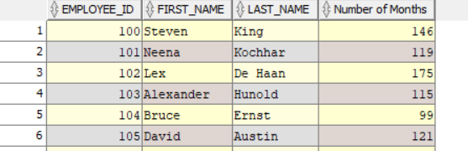

## Exercise SQL02-EX-02:

**Definiton :** Write a query that displays the grade of all employees based on the value of the column JOB_ID, using the following data: (Use DECODE)

|  |  |
| --- | --- |
| **Job** | **Grade** |
| AD_PRES | A |
| ST_MAN | B |
| IT_PROG | C |
| SA_REP | D |
| ST_CLERK | E |
| None of the above | 0 |

**SQL:**

SELECT DISTINCT job_id as Job,

DECODE(job_id, 'AD_PRES','A',

'ST_MAN','B',

'IT_PROG','C',

'SA_REP','D',

'ST_CLERK','E',

'0') Grade

FROM HR.employees

ORDER BY Grade ASC;

**Screenshot:**

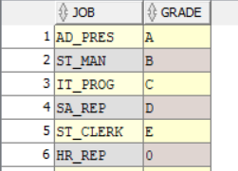

## Exercise SQL02-EX-03:

**Definiton :** Write a query for SQL02-EX-02(previous question) with using **CASE WHEN.**

**SQL:**

SELECT DISTINCT

job_id AS Job,

CASE job_id

WHEN 'AD_PRES' THEN 'A'

WHEN 'ST_MAN' THEN 'B'

WHEN 'IT_PROG' THEN 'C'

WHEN 'SA_REP' THEN 'D'

WHEN 'ST_CLERK' THEN 'E'

ELSE '0'

END AS Grade

FROM HR.employees

ORDER BY Grade ASC;

**Screenshot:**

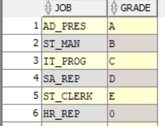

## Exercise SQL02-EX-04:

**Definiton :** Write a query that displays the employee number and last name of all employees who work in a department with any employee whose last name contains a “i”.

**SQL:**

select e.employee_id, e.last_name

from hr.employees e

where e.last_name LIKE '%i%' and e.department_id is not null;

**Screenshot:**

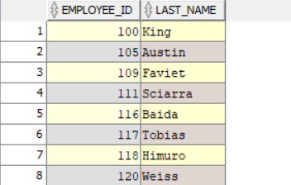

## Exercise SQL02-EX-05:

**Definiton :**

* Create a table for MY_EMP_TABLE with following columns
* Insert following rows,
* Update salary with 1.10 times of salary value
* Delete rows which first_name is David
* Truncate table.

|  |  |  |  |
| --- | --- | --- | --- |
| **ID** | **LAST_NAME** | **FIRST_NAME** | **SALARY** |
| 1 | Black | John | 1100 |
| 2 | White | Kent | 1300 |
| 3 | Orange | David | 1700 |
| 4 | Pink | Alissa | 1900 |

**SQL:**

CREATE TABLE MY_EMP_TABLE(

ID Number(1),

LAST_NAME VARCHAR2(20),

FIRST_NAME VARCHAR2(20),

SALARY number(10)

);

INSERT ALL

INTO MY_EMP_TABLE(ID,LAST_NAME,FIRST_NAME,) VALUES (1,'Black', 'John', 1100)

INTO MY_EMP_TABLE(ID,LAST_NAME,FIRST_NAME,) VALUES (2,'White', 'Kent', 1300)

INTO MY_EMP_TABLE(ID,LAST_NAME,FIRST_NAME,) VALUES (3,'Orange', 'David', 1700)

INTO MY_EMP_TABLE(ID,LAST_NAME,FIRST_NAME,) VALUES (4,'Pink', 'Alissa', 1900)

SELECT * FROM MY_EMP_TABLE ;

**Screenshot:**

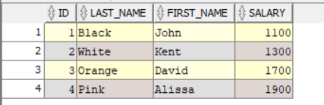

**SQL:**

UPDATE MY_EMP_TABLE

SET SALARY = SALARY*1.1;

SELECT * FROM MY_EMP_TABLE ;

**Screenshot:**

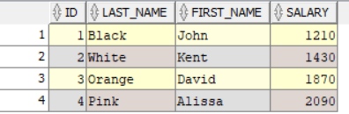

**SQL:**

DELETE FROM MY_EMP_TABLE

WHERE FIRST_NAME = 'David';

SELECT * FROM MY_EMP_TABLE ;

**Screenshot:**

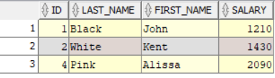

**SQL:**

TRUNCATE TABLE MY_EMP_TABLE ;

SELECT * FROM MY_EMP_TABLE ;

**Screenshot:**

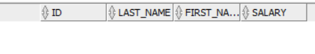

**-AHMET USTA**