|  |  |
| --- | --- |
| **Topic** | Oracle SQL Language Fundamentals I |
| **Document Name** | SQL03-EX-01-05 |
|  |  |

## Exercise SQL03-EX-01:

**Definiton :** Write followig SQL queries:

* Add a colum to employees table named MAX_SALARY.
* Update MAX_SALARY with maximum salary amount with subquery.
* Delete employee who have minimum salary using subquery.

**SQL:**

ALTER TABLE HR.employees ADD (Max_Salary NUMBER (8));

UPDATE HR.EMPLOYEES

SET Max_Salary = (SELECT MAX(salary) FROM HR.employees

);

DELETE FROM HR.employees

WHERE salary = (SELECT MIN(salary) FROM HR.employees);

**Screenshot:**

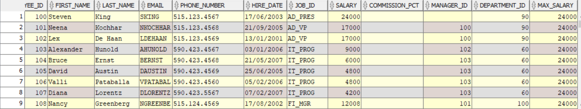

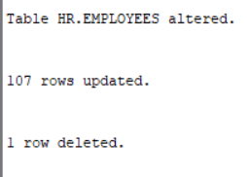

## Exercise SQL03-EX-02:

**Definiton :** Write followig SQL queries:

* Define index (named DPR_NAME_IDX) on DEPARTMENT_NAME column of DEPARTMENTS table.
* Define constraint (named CNSTR_SALARY) on employee salary. (Salary must be between 1000$ and 100.000$)
* Drop defined index.
* Enable, disable, drop defined constraint.

**SQL:**

CREATE INDEX DPR_NAME_IDX ON HR.departments (department_name);

ALTER TABLE HR.employees ADD CONSTRAINT CNSTR_SALARY

CHECK (salary>1000 AND salary<100000);

DROP INDEX DPR_NAME_IDX;

ALTER TABLE HR.employees ENABLE CONSTRAINT CNSTR_SALARY;

ALTER TABLE HR.employees DISABLE CONSTRAINT CNSTR_SALARY;

ALTER TABLE HR.employees DROP CONSTRAINT CNSTR_SALARY;

**Screenshot:**

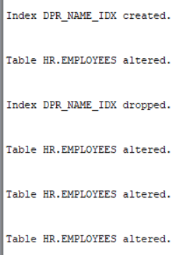

## Exercise SQL03-EX-03:

**Definiton :** Create a table from EMPLOYEES with distinct department_id column. Add department_name to that table. With DEPARTMENTS table, update department_name for included department_ids and insert department_id and department_name values for not included rows. Use MERGE keyword.

**SQL:**

CREATE TABLE NEW_TABLE AS (SELECT department_id FROM HR.departments);

ALTER TABLE NEW_TABLE ADD (department_name VARCHAR2(30));

MERGE INTO NEW_TABLE t USING (SELECT * FROM HR.departments) d ON

(t.department_id = d.department_id) WHEN MATCHED THEN

UPDATE SET t.department_name = d.department_name;

**Screenshot:**

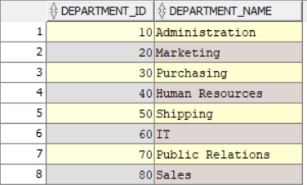

## Exercise SQL03-EX-04:

**Definiton :** Using **WITH** keyword, do following jobs:

* Firstly select first_name, last_name, job_id, department_id from employees table whoes job_id starts with ‘S’.
* Additionally select job_title and min-max salary amount.
* Add department_name to that query.
* Lastly concat first_name and last_name with space as full_name alias and list with other selected columns.

**SQL:**

WITH MY_EMPLOYEES AS (SELECT FIRST_NAME,LAST_NAME,JOB_ID,DEPARTMENT_ID

FROM HR.EMPLOYEES WHERE FIRST_NAME LIKE 'S%'),

JOB_MAX_MIN AS (SELECT JOB_ID,JOB_TITLE,MIN_SALARY,MAX_SALARY FROM HR.JOBS),

DEP_DETAIL AS (SELECT DEPARTMENT_ID,DEPARTMENT_NAME FROM HR.DEPARTMENTS)

SELECT

e.first_name,

e.last_name,

e.job_id,

e.department_id,

j.job_title,

j.min_salary,

j.max_salary,

d.department_name,

e.first_name || ' ' || e.last_name AS full_name

FROM MY_EMPLOYEES e

JOIN JOB_MAX_MIN j ON e.job_id = j.job_id

JOIN DEP_DETAIL d ON e.department_id = d.department_id;

**Screenshot:**

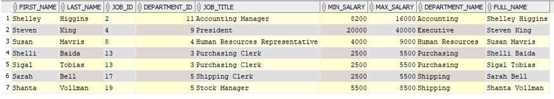

## Exercise SQL03-EX-05:

**Definiton :** Search for COMMIT and ROLLBACK keywords and explain them.

The “COMMIT” statement is used to permanently save the changes made in a transaction to the database permanently.

The “ROLLBACK” statement is used to undo the changes made in a transaction and return the database to previous state before the transaction began.

**SQL:**

COMMIT

ROLLBACK

**Screenshot:**

