**ANSWER 1:**

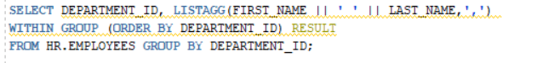

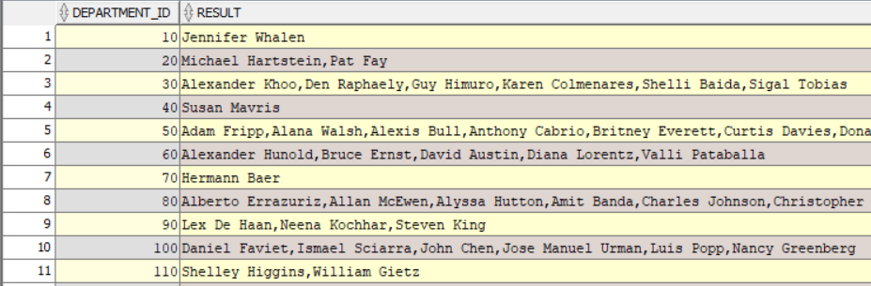

**ANSWER 2:**

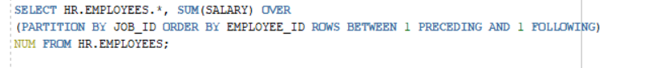

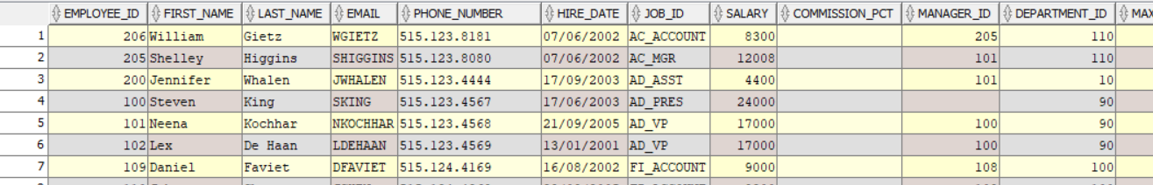

**ANSWER 3:**



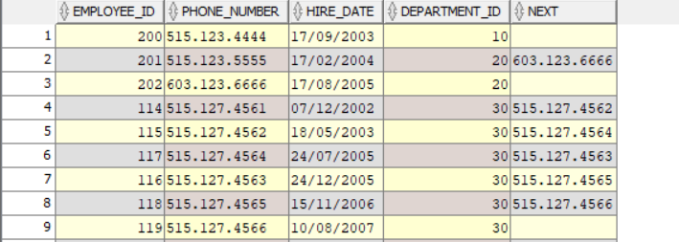

**ANSWER 4:**



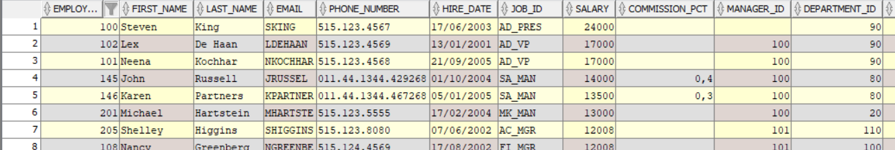

**ANSWER 5:**



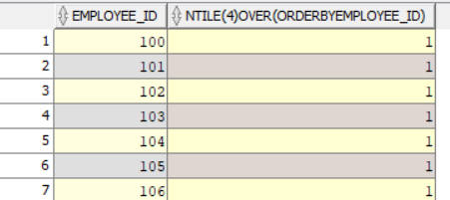

**ANSWER 6:**

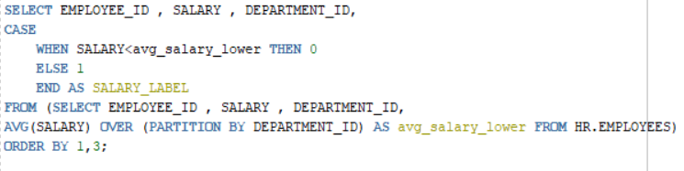

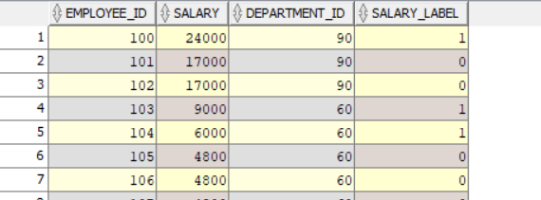

**ANSWER 7:**

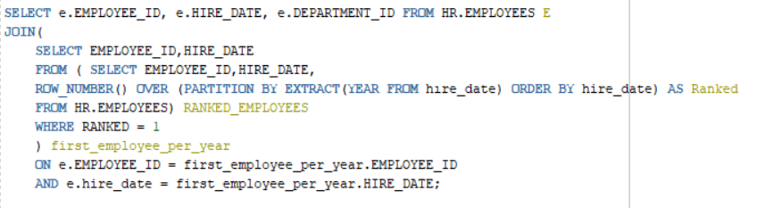

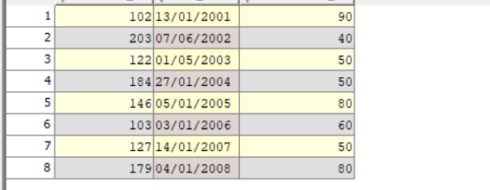

**ANSWER 8:**

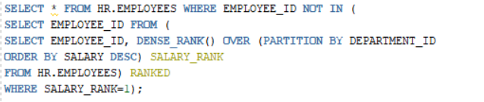

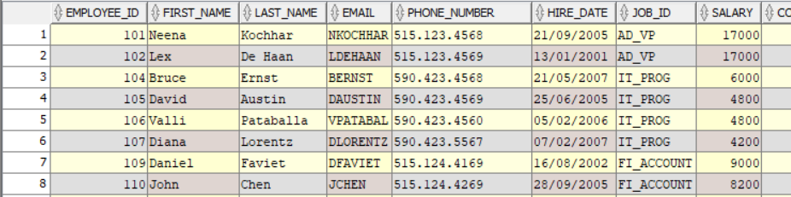

**ANSWER 9:**

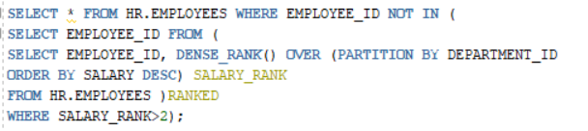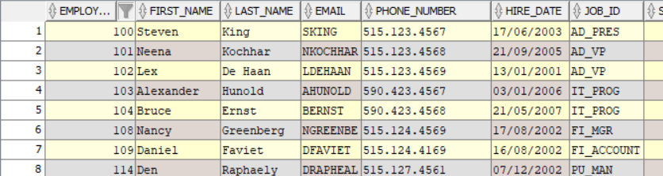

**ANSWER 10:**

