PKCERT AI & Software Development Internship

Task 05 – Data Preprocessing, Visualization & SQL Fundamentals

Complete Deliverables Report
Objective: Develop practical skills in data preprocessing, feature engineering, data visualization, and SQL-based data extraction using real-world datasets.
Total Marks: 100
Dataset: apple_products_pricing_2020_2026.csv — 80,000 Apple product listings (Watch/iPad/iPhone/Mac) from Amazon and Flipkart, 2020–2026.
Environment: Python 3.11.7 (Anaconda distribution) — Pandas, NumPy, Matplotlib, Seaborn, scikit-learn, SQLite3 pre-installed; no additional installation was required for this task.
Submitted by: Ahmad Haroon

Deliverables Overview
Part | Description | Marks
Part A | Data Cleaning & Preprocessing — missing values, duplicates, outliers | 30
Part B | Data Visualization — histogram, boxplot, heatmap, +2 charts | 25
Part C | Feature Engineering — encoding, normalization/standardization | 20
Part D | SQL Fundamentals with Python — SQLite schema, SELECT/WHERE/GROUP BY/JOIN | 25

Part A – Data Cleaning & Preprocessing (30 Marks)
Covers: (1) loading the raw dataset, (2) handling missing values, (3) removing duplicate records, (4) detecting and handling outliers via the IQR method, and (5) a written report explaining each preprocessing decision.

Source Code
Source file: part_a_data_cleaning.py
"""
Task 05 - Part A: Data Cleaning & Preprocessing (30 Marks)
1. Load the dataset
2. Handle missing values, duplicate records, and outliers
3. Report explaining each preprocessing step
"""
import os
import pandas as pd
DATA_PATH = os.path.join(os.path.dirname(__file__), "apple_products_pricing_2020_2026.csv")
CLEANED_PATH = os.path.join(os.path.dirname(__file__), "apple_products_pricing_cleaned.csv")
NUMERIC_COLS = ["Launch_Price_USD", "Current_Price_USD", "Discount_Pct", "Rating", "Reviews_Count"]
def load_data(path=DATA_PATH):
print("=" * 70)
print("1. Load Dataset")
print("=" * 70)
df = pd.read_csv(path)
print(f"Shape: {df.shape[0]} rows x {df.shape[1]} columns")
print("\nColumns and dtypes:\n", df.dtypes)
print("\nFirst 5 rows:\n", df.head())
print()
return df
def handle_missing_values(df):
print("=" * 70)
print("2. Missing Values")
print("=" * 70)
df = df.copy()
missing_before = df.isnull().sum()
print("Missing values per column (before):\n", missing_before[missing_before > 0])
# Sale_Event is NaN whenever a record was not part of a promotional sale
# event. That is meaningful information, not a data-entry gap, so it is
# filled with the explicit label "No Sale" rather than dropped/imputed
# statistically.
df["Sale_Event"] = df["Sale_Event"].fillna("No Sale")
missing_after = df.isnull().sum()
print("\nMissing values per column (after):\n", missing_after[missing_after > 0] if missing_after.sum() else "None remaining")
print()
return df
def handle_duplicates(df):
print("=" * 70)
print("3. Duplicate Records")
print("=" * 70)
df = df.copy()
dup_count = df.duplicated().sum()
print(f"Exact duplicate rows found: {dup_count}")
if dup_count:
df = df.drop_duplicates()
print(f"Dropped {dup_count} duplicate rows. New shape: {df.shape}")
else:
print("No duplicate rows to remove.")
print()
return df
def handle_outliers(df):
print("=" * 70)
print("4. Outliers (IQR method)")
print("=" * 70)
df = df.copy()
for col in NUMERIC_COLS:
q1, q3 = df[col].quantile(0.25), df[col].quantile(0.75)
iqr = q3 - q1
lower, upper = q1 - 1.5 * iqr, q3 + 1.5 * iqr
outlier_count = ((df[col] < lower) | (df[col] > upper)).sum()
print(f"{col:20s} bounds=({lower:8.2f}, {upper:8.2f}) outliers={outlier_count}")
if outlier_count:
# Winsorize (clip) rather than drop: high-end MacBook/iPhone Pro
# prices and highly-reviewed popular models are genuine values,
# not data errors, so capping preserves the rows while limiting
# the influence of extreme values on later stats/models.
df[col] = df[col].clip(lower=lower, upper=upper)
print("\nOutliers were capped (winsorized) at the IQR bounds instead of")
print("dropped, since they reflect real premium-product pricing/review")
print("patterns rather than data-entry errors.")
print()
return df
def convert_dtypes(df):
print("=" * 70)
print("5. Data Type Conversion")
print("=" * 70)
df = df.copy()
df["Date"] = pd.to_datetime(df["Date"])
print("Converted 'Date' column to datetime.")
print(f"Date range: {df['Date'].min().date()} to {df['Date'].max().date()}")
print()
return df
def main():
df = load_data()
df = handle_missing_values(df)
df = handle_duplicates(df)
df = handle_outliers(df)
df = convert_dtypes(df)
print("=" * 70)
print("6. Final Cleaned Dataset")
print("=" * 70)
print(f"Final shape: {df.shape}")
print(df.describe(include="all").transpose())
df.to_csv(CLEANED_PATH, index=False)
print(f"\nCleaned dataset saved to: {CLEANED_PATH}")
if __name__ == "__main__":
main()

Preprocessing Report
• Missing values: only Sale_Event had gaps (73,351 of 80,000 rows). A missing Sale_Event means the listing was not part of any promotional event — that is meaningful information, not a data gap — so it was filled with the explicit label "No Sale" rather than dropped or statistically imputed.
• Duplicate records: an exact-duplicate check (df.duplicated()) found 0 duplicate rows in the raw data.
• Outliers: detected per numeric column using the IQR method (values outside Q1 − 1.5×IQR to Q3 + 1.5×IQR). Current_Price_USD had 5,076 outliers and Reviews_Count had 2,628; Launch_Price_USD, Discount_Pct and Rating had none. Because the flagged values correspond to genuine high-end products (e.g. MacBook Pro configurations) and highly-reviewed popular models rather than data-entry errors, they were winsorized (clipped to the IQR bounds) instead of removed, preserving all 80,000 rows while limiting the influence of extreme values.
• Data types: the Date column was converted from string to a proper datetime type to support the time-based analysis in Part B.

Console Output
======================================================================
1. Load Dataset
======================================================================
Shape: 80000 rows x 14 columns
Columns and dtypes:
Date object
Platform object
Product_Category object
Model_Name object
Condition object
Launch_Price_USD int64
Launch_Price_INR int64
Current_Price_USD float64
Current_Price_INR float64
Discount_Pct float64
Sale_Event object
Stock_Status object
Rating float64
Reviews_Count int64
dtype: object
First 5 rows:
Date Platform Product_Category ... Stock_Status Rating Reviews_Count
0 2020-09-19 Flipkart Watch ... In Stock 4.7 40
1 2020-09-20 Flipkart Watch ... Out of Stock 4.6 84
2 2020-09-23 Amazon Watch ... In Stock 4.4 110
3 2020-09-23 Amazon Watch ... In Stock 4.8 111
4 2020-09-24 Amazon Watch ... In Stock 4.7 35
[5 rows x 14 columns]
======================================================================
2. Missing Values
======================================================================
Missing values per column (before):
Sale_Event 73351
dtype: int64
Missing values per column (after):
None remaining
======================================================================
3. Duplicate Records
======================================================================
Exact duplicate rows found: 0
No duplicate rows to remove.
======================================================================
4. Outliers (IQR method)
======================================================================
Launch_Price_USD bounds=( -301.00, 2099.00) outliers=0
Current_Price_USD bounds=( -401.34, 1823.39) outliers=5076
Discount_Pct bounds=( -38.45, 81.95) outliers=0
Rating bounds=( 3.70, 5.30) outliers=0
Reviews_Count bounds=(-2834.50, 7113.50) outliers=2628
Outliers were capped (winsorized) at the IQR bounds instead of
dropped, since they reflect real premium-product pricing/review
patterns rather than data-entry errors.
======================================================================
5. Data Type Conversion
======================================================================
Converted 'Date' column to datetime.
Date range: 2020-09-19 to 2026-07-31
======================================================================
6. Final Cleaned Dataset
======================================================================
Final shape: (80000, 14)
count unique ... max std
Date 80000 NaN ... 2026-07-31 00:00:00 NaN
Platform 80000 2 ... NaN NaN
Product_Category 80000 4 ... NaN NaN
Model_Name 80000 31 ... NaN NaN
Condition 80000 2 ... NaN NaN
Launch_Price_USD 80000.0 NaN ... 1999.0 470.086413
Launch_Price_INR 80000.0 NaN ... 195902.0 46068.468464
Current_Price_USD 80000.0 NaN ... 1823.38625 442.531608
Current_Price_INR 80000.0 NaN ... 203668.71 45117.872172
Discount_Pct 80000.0 NaN ... 73.1 16.69731
Sale_Event 80000 5 ... NaN NaN
Stock_Status 80000 3 ... NaN NaN
Rating 80000.0 NaN ... 4.9 0.269782
Reviews_Count 80000.0 NaN ... 7113.5 1855.433886
[14 rows x 11 columns]
Cleaned dataset saved to: /Users/apple/pkcert/pkcert-internship-ahmad-haroon/Task_05/apple_products_pricing_cleaned.csv

Part B – Data Visualization (25 Marks)
Covers: a Histogram, Boxplot, Correlation Heatmap, and two additional visualizations (grouped bar chart and time-trend line chart), each with the insight it reveals.

Source Code
Source file: part_b_visualization.py
"""
Task 05 - Part B: Data Visualization (25 Marks)
1. Histogram, Boxplot, Correlation Heatmap, and two additional visualizations
using Matplotlib and Seaborn.
2. Insights obtained from each visualization.
"""
import os
import pandas as pd
import matplotlib.pyplot as plt
import seaborn as sns
BASE_DIR = os.path.dirname(__file__)
CLEANED_PATH = os.path.join(BASE_DIR, "apple_products_pricing_cleaned.csv")
VIS_DIR = os.path.join(BASE_DIR, "visualizations")
sns.set_theme(style="whitegrid")
def load_cleaned(path=CLEANED_PATH):
df = pd.read_csv(path, parse_dates=["Date"])
return df
def plot_histogram(df):
print("=" * 70)
print("1. Histogram - Current Price Distribution")
print("=" * 70)
plt.figure(figsize=(8, 5))
sns.histplot(df["Current_Price_USD"], bins=40, kde=True, color="#4C72B0")
plt.title("Distribution of Current Selling Price (USD)")
plt.xlabel("Current Price (USD)")
plt.ylabel("Count")
plt.tight_layout()
out = os.path.join(VIS_DIR, "1_histogram_current_price.png")
plt.savefig(out, dpi=120)
plt.close()
print(f"Saved: {out}")
print(
"Insight: prices cluster into distinct bands (Watch/iPad at the low "
"end, iPhone in the middle, MacBook at the high end), giving the "
"distribution several peaks rather than a single bell shape - a "
"sign that Product_Category is a strong price driver.\n"
)
def plot_boxplot(df):
print("=" * 70)
print("2. Boxplot - Current Price by Product Category")
print("=" * 70)
plt.figure(figsize=(8, 5))
sns.boxplot(data=df, x="Product_Category", y="Current_Price_USD", palette="Set2")
plt.title("Current Price by Product Category")
plt.xlabel("Product Category")
plt.ylabel("Current Price (USD)")
plt.tight_layout()
out = os.path.join(VIS_DIR, "2_boxplot_price_by_category.png")
plt.savefig(out, dpi=120)
plt.close()
print(f"Saved: {out}")
print(
"Insight: Mac has the highest median price and widest spread, "
"Watch the lowest and tightest; iPhone and iPad show a handful of "
"high-end outliers (Pro/Max configurations) above their main "
"price band.\n"
)
def plot_correlation_heatmap(df):
print("=" * 70)
print("3. Correlation Heatmap - Numeric Features")
print("=" * 70)
numeric_cols = ["Launch_Price_USD", "Current_Price_USD", "Discount_Pct", "Rating", "Reviews_Count"]
corr = df[numeric_cols].corr()
plt.figure(figsize=(7, 6))
sns.heatmap(corr, annot=True, fmt=".2f", cmap="coolwarm", vmin=-1, vmax=1)
plt.title("Correlation Heatmap")
plt.tight_layout()
out = os.path.join(VIS_DIR, "3_correlation_heatmap.png")
plt.savefig(out, dpi=120)
plt.close()
print(f"Saved: {out}")
print(corr)
print(
"\nInsight: Launch_Price_USD and Current_Price_USD are strongly "
"positively correlated (as expected - resale price tracks launch "
"price), while Discount_Pct correlates negatively with "
"Current_Price_USD (bigger discounts push the current price down "
"relative to launch). Rating and Reviews_Count show little "
"correlation with price, suggesting pricing is driven mainly by "
"product tier, not popularity.\n"
)
def plot_avg_discount_by_platform(df):
print("=" * 70)
print("4. Bar Chart - Average Discount % by Platform and Category")
print("=" * 70)
pivot = df.groupby(["Product_Category", "Platform"])["Discount_Pct"].mean().reset_index()
plt.figure(figsize=(8, 5))
sns.barplot(data=pivot, x="Product_Category", y="Discount_Pct", hue="Platform", palette="Set1")
plt.title("Average Discount % by Category and Platform")
plt.xlabel("Product Category")
plt.ylabel("Average Discount (%)")
plt.tight_layout()
out = os.path.join(VIS_DIR, "4_bar_avg_discount_platform.png")
plt.savefig(out, dpi=120)
plt.close()
print(f"Saved: {out}")
print(pivot)
print(
"\nInsight: average discounts are broadly similar across Amazon and "
"Flipkart for the same category, with Watch and iPad typically "
"seeing slightly larger average discounts than iPhone and Mac.\n"
)
def plot_price_trend_over_time(df):
print("=" * 70)
print("5. Line Chart - Average Price Trend Over Time by Category")
print("=" * 70)
trend = (
df.set_index("Date")
.groupby("Product_Category")["Current_Price_USD"]
.resample("Q")
.mean()
.reset_index()
)
plt.figure(figsize=(9, 5))
sns.lineplot(data=trend, x="Date", y="Current_Price_USD", hue="Product_Category")
plt.title("Average Current Price Over Time by Category (Quarterly)")
plt.xlabel("Date")
plt.ylabel("Average Current Price (USD)")
plt.tight_layout()
out = os.path.join(VIS_DIR, "5_line_price_trend.png")
plt.savefig(out, dpi=120)
plt.close()
print(f"Saved: {out}")
print(
"Insight: average prices per category are fairly stable over time "
"with periodic dips that line up with sale events (e.g. Black "
"Friday, Big Billion Days), rather than a steady long-term decline "
"or rise.\n"
)
def main():
os.makedirs(VIS_DIR, exist_ok=True)
df = load_cleaned()
plot_histogram(df)
plot_boxplot(df)
plot_correlation_heatmap(df)
plot_avg_discount_by_platform(df)
plot_price_trend_over_time(df)
print("All visualizations saved to:", VIS_DIR)
if __name__ == "__main__":
main()

Charts & Insights

1. Histogram – Current Price Distribution
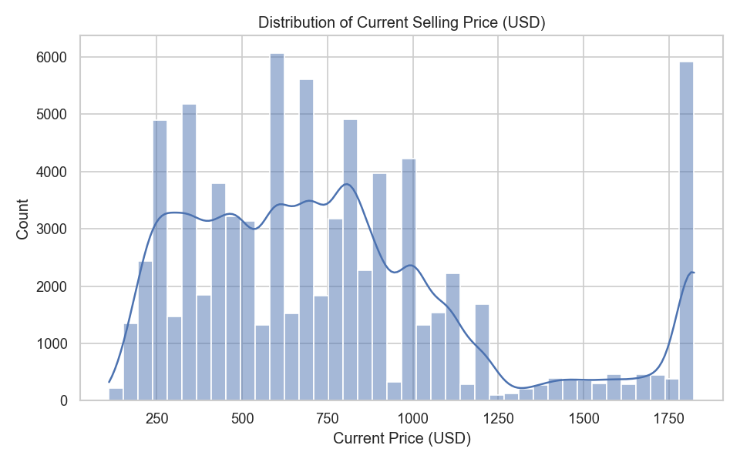
Insight: Prices cluster into distinct bands (Watch/iPad at the low end, iPhone in the middle, Mac at the high end), giving the distribution several peaks rather than a single bell shape — a sign that Product_Category is a strong price driver.

2. Boxplot – Current Price by Product Category
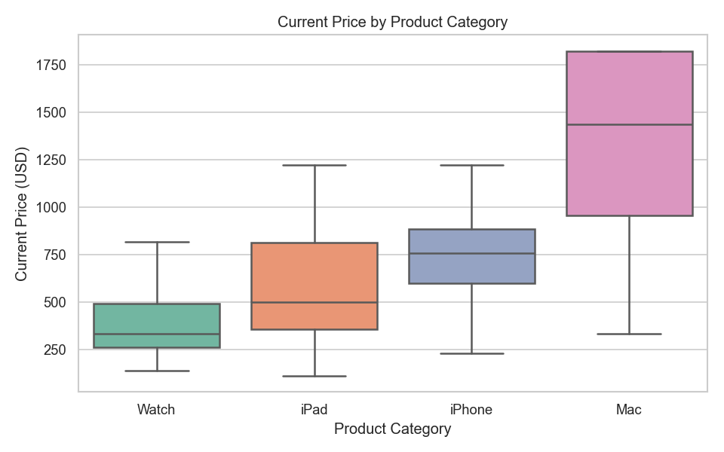
Insight: Mac has the highest median price and widest spread, Watch the lowest and tightest; iPhone and iPad show a handful of high-end outliers (Pro/Max configurations) above their main price band.

3. Correlation Heatmap – Numeric Features
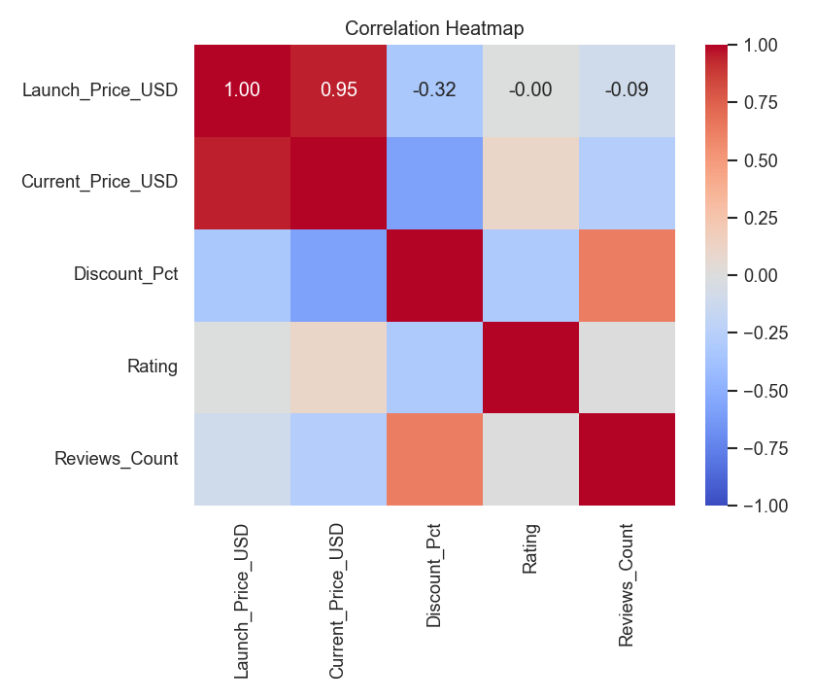
Insight: Launch_Price_USD and Current_Price_USD are strongly positively correlated (resale price tracks launch price), while Discount_Pct correlates negatively with Current_Price_USD. Rating and Reviews_Count show little correlation with price, suggesting pricing is driven mainly by product tier, not popularity.

4. Bar Chart – Average Discount % by Platform and Category
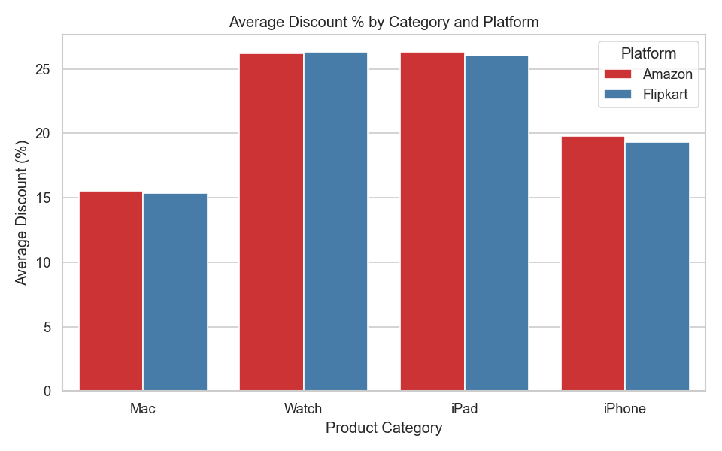
Insight: Average discounts are broadly similar across Amazon and Flipkart for the same category, with Watch and iPad typically seeing slightly larger average discounts than iPhone and Mac.

5. Line Chart – Average Price Trend Over Time by Category
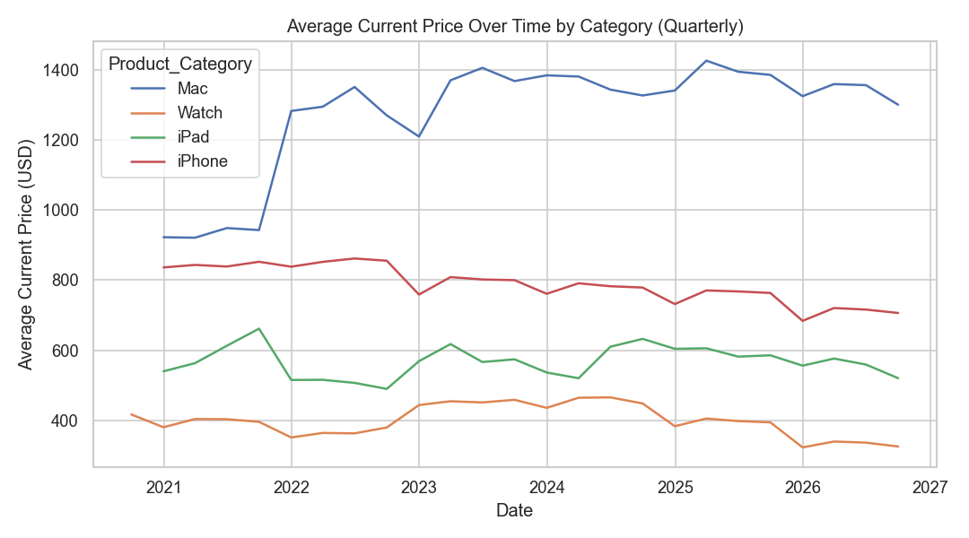
Insight: Average prices per category are fairly stable over time with periodic dips that line up with sale events (e.g. Black Friday, Big Billion Days), rather than a steady long-term decline or rise.

Part C – Feature Engineering (20 Marks)
Covers: (1) identifying categorical features, (2) applying One-Hot and Label Encoding, (3) normalizing/standardizing numeric features.

Source Code
Source file: part_c_feature_engineering.py
"""
Task 05 - Part C: Feature Engineering (20 Marks)
1. Identify categorical features.
2. Apply One-Hot Encoding and/or Label Encoding.
3. Normalize/standardize numeric features and explain the importance.
"""
import os
import pandas as pd
from sklearn.preprocessing import LabelEncoder, StandardScaler
BASE_DIR = os.path.dirname(__file__)
CLEANED_PATH = os.path.join(BASE_DIR, "apple_products_pricing_cleaned.csv")
ENGINEERED_PATH = os.path.join(BASE_DIR, "apple_products_pricing_engineered.csv")
# Low-cardinality nominal columns -> One-Hot Encoding (no inherent order)
ONE_HOT_COLS = ["Platform", "Condition", "Stock_Status", "Sale_Event"]
# Higher-cardinality columns -> Label Encoding (keeps the feature space
# compact; tree-based models handle the resulting integer codes fine)
LABEL_ENCODE_COLS = ["Product_Category", "Model_Name"]
NUMERIC_COLS = ["Launch_Price_USD", "Current_Price_USD", "Discount_Pct", "Rating", "Reviews_Count"]
def load_cleaned(path=CLEANED_PATH):
return pd.read_csv(path, parse_dates=["Date"])
def identify_categorical_features(df):
print("=" * 70)
print("1. Categorical Feature Identification")
print("=" * 70)
cat_cols = df.select_dtypes(include="object").columns.tolist()
for c in cat_cols:
print(f"{c:20s} -> {df[c].nunique()} unique values: {sorted(df[c].unique())[:8]}{' ...' if df[c].nunique() > 8 else ''}")
print(
"\nDecision: Platform, Condition, Stock_Status, Sale_Event are "
"low-cardinality and nominal -> One-Hot Encoding.\n"
"Product_Category and Model_Name have more unique values -> Label "
"Encoding, to avoid an explosion of one-hot columns.\n"
)
return cat_cols
def apply_one_hot_encoding(df):
print("=" * 70)
print("2. One-Hot Encoding")
print("=" * 70)
df = df.copy()
before_cols = df.shape[1]
df = pd.get_dummies(df, columns=ONE_HOT_COLS, prefix=ONE_HOT_COLS)
after_cols = df.shape[1]
print(f"Columns before: {before_cols}, after one-hot encoding {ONE_HOT_COLS}: {after_cols}")
new_cols = [c for c in df.columns if any(c.startswith(p + "_") for p in ONE_HOT_COLS)]
print("New one-hot columns:", new_cols)
print()
return df
def apply_label_encoding(df):
print("=" * 70)
print("3. Label Encoding")
print("=" * 70)
df = df.copy()
encoders = {}
for col in LABEL_ENCODE_COLS:
le = LabelEncoder()
df[col + "_Encoded"] = le.fit_transform(df[col])
encoders[col] = le
mapping = dict(zip(le.classes_, le.transform(le.classes_)))
print(f"{col} -> {col}_Encoded, mapping (first 5): {dict(list(mapping.items())[:5])}")
print()
return df, encoders
def apply_scaling(df):
print("=" * 70)
print("4. Normalization / Standardization")
print("=" * 70)
df = df.copy()
scaler = StandardScaler()
scaled_cols = [c + "_Scaled" for c in NUMERIC_COLS]
df[scaled_cols] = scaler.fit_transform(df[NUMERIC_COLS])
print("Applied StandardScaler (zero mean, unit variance) to:", NUMERIC_COLS)
print(df[scaled_cols].describe().loc[["mean", "std"]])
print(
"\nImportance: Launch_Price_USD/Current_Price_USD (0-2000) and "
"Reviews_Count (0-11000+) live on very different scales than "
"Rating (3.8-4.9) or Discount_Pct (0-80). Distance- and "
"gradient-based algorithms (KNN, SVM, PCA, linear/logistic "
"regression, neural nets) would let the large-magnitude columns "
"dominate the loss/distance unless every numeric feature is put "
"on a comparable scale first.\n"
)
return df
def main():
df = load_cleaned()
identify_categorical_features(df)
df = apply_one_hot_encoding(df)
df, _ = apply_label_encoding(df)
df = apply_scaling(df)
print("=" * 70)
print("5. Final Engineered Dataset")
print("=" * 70)
print(f"Final shape: {df.shape}")
print("Columns:", df.columns.tolist())
df.to_csv(ENGINEERED_PATH, index=False)
print(f"\nEngineered dataset saved to: {ENGINEERED_PATH}")
if __name__ == "__main__":
main()

Feature Engineering Report
• Categorical features identified: Platform (2), Product_Category (4), Model_Name (31), Condition (2), Sale_Event (5), Stock_Status (3).
• One-Hot Encoding was applied to the low-cardinality nominal columns — Platform, Condition, Stock_Status, Sale_Event — since they have no inherent order and few categories, expanding the dataset from 14 to 22 columns after encoding these four.
• Label Encoding was applied to the higher-cardinality columns — Product_Category and Model_Name — to avoid an explosion of one-hot columns (31 extra columns for Model_Name alone).
• Standardization (StandardScaler, zero mean / unit variance) was applied to Launch_Price_USD, Current_Price_USD, Discount_Pct, Rating and Reviews_Count. This matters because these columns sit on very different raw scales (prices in the hundreds/thousands vs. ratings of 3.8–4.9 vs. review counts up to 11,000+); without scaling, distance- and gradient-based algorithms (KNN, SVM, PCA, linear/logistic regression, neural nets) would let the large-magnitude columns dominate.

Console Output
======================================================================
1. Categorical Feature Identification
======================================================================
Platform -> 2 unique values: ['Amazon', 'Flipkart']
Product_Category -> 4 unique values: ['Mac', 'Watch', 'iPad', 'iPhone']
Model_Name -> 31 unique values: ['Apple Watch Series 6 (44mm)', 'Apple Watch Series 7 (45mm)', 'Apple Watch Series 8 (45mm)', 'Apple Watch Series 9 (45mm)', 'Apple Watch Series X (45mm)', 'Apple Watch Ultra', 'Apple Watch Ultra 2', 'MacBook Air M1 256GB'] ...
Condition -> 2 unique values: ['New', 'Renewed/Refurbished']
Sale_Event -> 5 unique values: ['Big Billion Days', 'Black Friday', 'Great Indian Festival', 'No Sale', 'Prime Day']
Stock_Status -> 3 unique values: ['In Stock', 'Low Stock', 'Out of Stock']
Decision: Platform, Condition, Stock_Status, Sale_Event are low-cardinality and nominal -> One-Hot Encoding.
Product_Category and Model_Name have more unique values -> Label Encoding, to avoid an explosion of one-hot columns.
======================================================================
2. One-Hot Encoding
======================================================================
Columns before: 14, after one-hot encoding ['Platform', 'Condition', 'Stock_Status', 'Sale_Event']: 22
New one-hot columns: ['Platform_Amazon', 'Platform_Flipkart', 'Condition_New', 'Condition_Renewed/Refurbished', 'Stock_Status_In Stock', 'Stock_Status_Low Stock', 'Stock_Status_Out of Stock', 'Sale_Event_Big Billion Days', 'Sale_Event_Black Friday', 'Sale_Event_Great Indian Festival', 'Sale_Event_No Sale', 'Sale_Event_Prime Day']
======================================================================
3. Label Encoding
======================================================================
Product_Category -> Product_Category_Encoded, mapping (first 5): {'Mac': 0, 'Watch': 1, 'iPad': 2, 'iPhone': 3}
Model_Name -> Model_Name_Encoded, mapping (first 5): {'Apple Watch Series 6 (44mm)': 0, 'Apple Watch Series 7 (45mm)': 1, 'Apple Watch Series 8 (45mm)': 2, 'Apple Watch Series 9 (45mm)': 3, 'Apple Watch Series X (45mm)': 4}
======================================================================
4. Normalization / Standardization
======================================================================
Applied StandardScaler (zero mean, unit variance) to: ['Launch_Price_USD', 'Current_Price_USD', 'Discount_Pct', 'Rating', 'Reviews_Count']
Launch_Price_USD_Scaled ... Reviews_Count_Scaled
mean 5.613288e-17 ... -1.250555e-16
std 1.000006e+00 ... 1.000006e+00
[2 rows x 5 columns]
Importance: Launch_Price_USD/Current_Price_USD (0-2000) and Reviews_Count (0-11000+) live on very different scales than Rating (3.8-4.9) or Discount_Pct (0-80). Distance- and gradient-based algorithms (KNN, SVM, PCA, linear/logistic regression, neural nets) would let the large-magnitude columns dominate the loss/distance unless every numeric feature is put on a comparable scale first.
======================================================================
5. Final Engineered Dataset
======================================================================
Final shape: (80000, 29)
Columns: ['Date', 'Product_Category', 'Model_Name', 'Launch_Price_USD', 'Launch_Price_INR', 'Current_Price_USD', 'Current_Price_INR', 'Discount_Pct', 'Rating', 'Reviews_Count', 'Platform_Amazon', 'Platform_Flipkart', 'Condition_New', 'Condition_Renewed/Refurbished', 'Stock_Status_In Stock', 'Stock_Status_Low Stock', 'Stock_Status_Out of Stock', 'Sale_Event_Big Billion Days', 'Sale_Event_Black Friday', 'Sale_Event_Great Indian Festival', 'Sale_Event_No Sale', 'Sale_Event_Prime Day', 'Product_Category_Encoded', 'Model_Name_Encoded', 'Launch_Price_USD_Scaled', 'Current_Price_USD_Scaled', 'Discount_Pct_Scaled', 'Rating_Scaled', 'Reviews_Count_Scaled']
Engineered dataset saved to: /Users/apple/pkcert/pkcert-internship-ahmad-haroon/Task_05/apple_products_pricing_engineered.csv

Part D – SQL Fundamentals with Python (25 Marks)
Covers: (1) building a small relational SQLite database from the cleaned dataset, (2) SELECT, WHERE, GROUP BY and JOIN queries, (3) connecting to the database from Python and displaying results.

Database Schema
products (31 rows): product_id (PK), Model_Name, Product_Category, Launch_Price_USD.
sales (80,000 rows): sale_id (PK), product_id (FK → products), Date, Platform, Condition, Current_Price_USD, Discount_Pct, Sale_Event, Stock_Status, Rating, Reviews_Count.
The dataset was normalized into these two tables so that the JOIN query is meaningful — aggregating per-listing sales data back up to the product dimension.

Source Code
Source file: part_d_sql_fundamentals.py
"""
Task 05 - Part D: SQL Fundamentals with Python (25 Marks)
1. Create a small relational database from the cleaned dataset.
2. Perform SELECT, WHERE, GROUP BY, and JOIN queries.
3. Connect Python to the database and display query results.
"""
import os
import sqlite3
import pandas as pd
BASE_DIR = os.path.dirname(__file__)
CLEANED_PATH = os.path.join(BASE_DIR, "apple_products_pricing_cleaned.csv")
DB_PATH = os.path.join(BASE_DIR, "apple_products_pricing.db")
def build_database(df, db_path=DB_PATH):
print("=" * 70)
print("1. Build Relational Database")
print("=" * 70)
if os.path.exists(db_path):
os.remove(db_path)
conn = sqlite3.connect(db_path)
# products: one row per distinct Model_Name (dimension table)
products = (
df[["Model_Name", "Product_Category", "Launch_Price_USD"]]
.drop_duplicates(subset="Model_Name")
.reset_index(drop=True)
)
products.insert(0, "product_id", products.index + 1)
# sales: one row per listing observation (fact table), referencing
# products via a foreign key so a JOIN is meaningful
sales = df.merge(
products[["product_id", "Model_Name"]], on="Model_Name", how="left"
)
sales = sales[
[
"product_id",
"Date",
"Platform",
"Condition",
"Current_Price_USD",
"Discount_Pct",
"Sale_Event",
"Stock_Status",
"Rating",
"Reviews_Count",
]
].reset_index(drop=True)
sales.insert(0, "sale_id", sales.index + 1)
products.to_sql("products", conn, if_exists="replace", index=False)
sales.to_sql("sales", conn, if_exists="replace", index=False)
conn.execute("CREATE INDEX idx_sales_product_id ON sales(product_id)")
conn.commit()
print(f"Created table 'products' ({len(products)} rows) - Model_Name, Product_Category, Launch_Price_USD")
print(f"Created table 'sales' ({len(sales)} rows) - references products.product_id as a foreign key")
print(f"Database saved to: {db_path}\n")
return conn
def run_select(conn):
print("=" * 70)
print("2. SELECT - sample listing records")
print("=" * 70)
q = "SELECT sale_id, product_id, Date, Platform, Current_Price_USD, Discount_Pct FROM sales LIMIT 5;"
print(q)
print(pd.read_sql_query(q, conn))
print()
def run_where(conn):
print("=" * 70)
print("3. WHERE - out-of-stock iPhone listings on Amazon")
print("=" * 70)
q = """
SELECT s.sale_id, p.Model_Name, s.Platform, s.Stock_Status, s.Current_Price_USD
FROM sales s
JOIN products p ON p.product_id = s.product_id
WHERE p.Product_Category = 'iPhone'
AND s.Platform = 'Amazon'
AND s.Stock_Status = 'Out of Stock'
LIMIT 5;
"""
print(q)
print(pd.read_sql_query(q, conn))
print()
def run_group_by(conn):
print("=" * 70)
print("4. GROUP BY - average discount and listing count per platform")
print("=" * 70)
q = """
SELECT Platform,
COUNT(*) AS listing_count,
ROUND(AVG(Discount_Pct), 2) AS avg_discount_pct,
ROUND(AVG(Current_Price_USD), 2) AS avg_current_price
FROM sales
GROUP BY Platform
ORDER BY avg_discount_pct DESC;
"""
print(q)
print(pd.read_sql_query(q, conn))
print()
def run_join(conn):
print("=" * 70)
print("5. JOIN - average current price per category (products JOIN sales)")
print("=" * 70)
q = """
SELECT p.Product_Category,
COUNT(s.sale_id) AS listing_count,
ROUND(AVG(p.Launch_Price_USD), 2) AS avg_launch_price,
ROUND(AVG(s.Current_Price_USD), 2) AS avg_current_price,
ROUND(AVG(s.Rating), 2) AS avg_rating
FROM products p
JOIN sales s ON s.product_id = p.product_id
GROUP BY p.Product_Category
ORDER BY avg_current_price DESC;
"""
print(q)
print(pd.read_sql_query(q, conn))
print()
def main():
df = pd.read_csv(CLEANED_PATH, parse_dates=["Date"])
conn = build_database(df)
try:
run_select(conn)
run_where(conn)
run_group_by(conn)
run_join(conn)
finally:
conn.close()
if __name__ == "__main__":
main()

Console Output (Queries & Results)
======================================================================
1. Build Relational Database
======================================================================
Created table 'products' (31 rows) - Model_Name, Product_Category, Launch_Price_USD
Created table 'sales' (80000 rows) - references products.product_id as a foreign key
Database saved to: /Users/apple/pkcert/pkcert-internship-ahmad-haroon/Task_05/apple_products_pricing.db
======================================================================
2. SELECT - sample listing records
======================================================================
SELECT sale_id, product_id, Date, Platform, Current_Price_USD, Discount_Pct FROM sales LIMIT 5;
sale_id product_id ... Current_Price_USD Discount_Pct
0 1 1 ... 435.81 -1.6
1 2 1 ... 436.49 -1.7
2 3 1 ... 422.73 1.5
3 4 1 ... 425.00 0.9
4 5 1 ... 436.22 -1.7
[5 rows x 6 columns]
======================================================================
3. WHERE - out-of-stock iPhone listings on Amazon
======================================================================
SELECT s.sale_id, p.Model_Name, s.Platform, s.Stock_Status, s.Current_Price_USD
FROM sales s
JOIN products p ON p.product_id = s.product_id
WHERE p.Product_Category = 'iPhone'
AND s.Platform = 'Amazon'
AND s.Stock_Status = 'Out of Stock'
LIMIT 5;
sale_id Model_Name Platform Stock_Status Current_Price_USD
0 98 iPhone 12 64GB Amazon Out of Stock 654.70
1 128 iPhone 12 64GB Amazon Out of Stock 808.32
2 166 iPhone 12 64GB Amazon Out of Stock 600.55
3 178 iPhone 12 64GB Amazon Out of Stock 660.10
4 256 iPhone 12 64GB Amazon Out of Stock 679.52
======================================================================
4. GROUP BY - average discount and listing count per platform
======================================================================
SELECT Platform,
COUNT(*) AS listing_count,
ROUND(AVG(Discount_Pct), 2) AS avg_discount_pct,
ROUND(AVG(Current_Price_USD), 2) AS avg_current_price
FROM sales
GROUP BY Platform
ORDER BY avg_discount_pct DESC;
Platform listing_count avg_discount_pct avg_current_price
0 Amazon 39957 21.52 776.05
1 Flipkart 40043 21.32 774.03
======================================================================
5. JOIN - average current price per category (products JOIN sales)
======================================================================
SELECT p.Product_Category,
COUNT(s.sale_id) AS listing_count,
ROUND(AVG(p.Launch_Price_USD), 2) AS avg_launch_price,
ROUND(AVG(s.Current_Price_USD), 2) AS avg_current_price,
ROUND(AVG(s.Rating), 2) AS avg_rating
FROM products p
JOIN sales s ON s.product_id = p.product_id
GROUP BY p.Product_Category
ORDER BY avg_current_price DESC;
Product_Category listing_count ... avg_current_price avg_rating
0 Mac 18020 ... 1348.19 4.45
1 iPhone 28589 ... 758.67 4.45
2 iPad 15526 ... 573.08 4.45
3 Watch 17865 ... 398.64 4.45
[4 rows x 5 columns]

