PKCERT AI & Software Development Internship

Task 06 – Exploratory Data Analysis (EDA) Using Jupyter Notebook
Objective: Develop practical skills in Exploratory Data Analysis (EDA) using Python and Jupyter Notebook by analyzing a real-world dataset, creating visualizations, and presenting written insights.
Total Marks: 100
Submitted by: Ahmad Haroon
---

Part A – Dataset Selection (10 Marks)

Dataset Description
Name: FIFA World Cup 2026 – Social Media Sentiment & Engagement Dataset
Source: Provided as a set of local CSV files (archive/) simulating social
media activity collected around the 2026 FIFA World Cup. The data is
synthetically generated rather than scraped from live platforms — this is
confirmed later in the EDA (Part B.2) where several fields turn out to be
placeholders (e.g. every match's winner is "TBD" even though final scores
are already populated, and city names in match_context.csv are generic
labels like City0–City4). It is treated here as a realistic stand-in for a
genuine social-listening export.
Purpose: To analyze public sentiment, engagement, and stakeholder
influence around World Cup matches — e.g. which teams/topics drive the most
engagement, how sentiment differs by platform, and which stakeholders
(sponsors, journalists, players, FIFA) generate the strongest reactions.
Structure: Four related tables, joined here on their key columns:
File | Rows | Role
social_media_posts.csv | 100 | Fact table — one row per social media post
match_context.csv | 20 | Match details (teams, score, venue, weather) — joined via match_id
stakeholders.csv | 20 | Influencer/journalist/sponsor/FIFA profiles — joined via stakeholder_id
host_city_context.csv | 5 | City-level stats — not joined (city naming is inconsistent with match_context.csv, see Part B.2)
merged_master.csv | 100 | Pre-built join of posts + match context (provided)
Records analyzed: 100 posts, enriched with match and stakeholder details
→ 45 columns after merging.
Key features: platform, sentiment / sentiment_score, emotion,
topic, team_mentioned, likes / comments / shares / views,
engagement_rate, stakeholder_type, influence_score, followers,
home_team / away_team / home_score / away_score, attendance,
weather, temperature.
Target variable: None specified — this is an unsupervised/descriptive
EDA task. If a predictive target were chosen later, sentiment_score or
engagement_rate would be the natural candidates (e.g. predicting
engagement from post/stakeholder attributes).

Setup & Data Loading
import pandas as pd
import numpy as np
import matplotlib.pyplot as plt
import seaborn as sns
sns.set_theme(style="whitegrid")
pd.set_option("display.max_columns", 50)
pd.set_option("display.width", 200)
posts = pd.read_csv("archive/merged_master.csv", parse_dates=["post_datetime", "match_date"])
stakeholders = pd.read_csv("archive/stakeholders.csv")
# Enrich posts with stakeholder profile info (influence, followers, type)
df = posts.merge(stakeholders, on="stakeholder_id", how="left", suffixes=("", "_stakeholder"))
print("Shape after merging posts + stakeholders:", df.shape)
df.head()
Shape after merging posts + stakeholders: (100, 45)
post_id platform username user_country language post_datetime match_id team_mentioned player_mentioned stakeholder_id topic sentiment sentiment_score emotion likes \
0 1 X user1 Mexico English 2026-06-11 01:00:00 4 England Player_49 15 Travel Negative -0.24 Joy 2211
1 2 YouTube user2 Brazil English 2026-06-11 02:00:00 15 France Player_47 8 Sponsorship Positive 0.80 Joy 6396
2 3 Instagram user3 England English 2026-06-11 03:00:00 1 USA Player_15 15 Travel Negative -0.53 Joy 6255
3 4 YouTube user4 Brazil English 2026-06-11 04:00:00 6 Mexico Player_47 10 Match Performance Negative -0.33 Excitement 362
4 5 Facebook user5 England English 2026-06-11 05:00:00 17 England Player_38 2 Travel Positive 0.49 Anger 3120
comments shares views hashtags verified engagement_rate device source match_date stage host_city stadium home_team away_team home_score away_score attendance referee \
0 96 249 50853 #WorldCup2026 True 9.04 Android Organic 2026-06-14 Group City4 Stadium4 England France 4 0 33412 Ref_4
1 22 13 115128 #WorldCup2026 True 9.45 Android Organic 2026-06-25 Group City0 Stadium0 USA Spain 2 1 36162 Ref_15
2 693 112 162630 #WorldCup2026 False 9.57 Android Organic 2026-06-11 Group City1 Stadium1 Argentina France 3 4 49121 Ref_1
3 996 364 6516 #WorldCup2026 False 5.57 Android Organic 2026-06-16 Group City1 Stadium1 Mexico USA 1 1 63045 Ref_6
4 424 340 43680 #WorldCup2026 True 4.30 Android Organic 2026-06-27 Group City2 Stadium2 USA USA 1 4 55218 Ref_17
weather temperature winner stakeholder_name stakeholder_type country influence_score interest_score followers verified_stakeholder official_partner sentiment_index
0 Sunny 29.6 TBD Stakeholder_15 Player Various 88.1 72.3 1665393 True False 0.09
1 Sunny 19.1 TBD Stakeholder_8 Journalist Various 50.0 48.0 4712587 True False 0.42
2 Sunny 19.2 TBD Stakeholder_15 Player Various 88.1 72.3 1665393 True False 0.09
3 Sunny 25.1 TBD Stakeholder_10 Sponsor Various 81.9 81.9 1684756 True False -0.01
4 Sunny 25.3 TBD Stakeholder_2 Sponsor Various 79.7 60.5 2007137 True False -0.85
---

Part B – Exploratory Data Analysis (50 Marks)

B.1 Structure, Data Types & Summary Statistics
df.info()
<class 'pandas.core.frame.DataFrame'>
RangeIndex: 100 entries, 0 to 99
Data columns (total 45 columns):
# Column Non-Null Count Dtype
--- ------ -------------- -----
0 post_id 100 non-null int64
1 platform 100 non-null object
2 username 100 non-null object
3 user_country 100 non-null object
4 language 100 non-null object
5 post_datetime 100 non-null datetime64[ns]
6 match_id 100 non-null int64
7 team_mentioned 100 non-null object
8 player_mentioned 100 non-null object
9 stakeholder_id 100 non-null int64
10 topic 100 non-null object
11 sentiment 100 non-null object
12 sentiment_score 100 non-null float64
13 emotion 100 non-null object
14 likes 100 non-null int64
15 comments 100 non-null int64
16 shares 100 non-null int64
17 views 100 non-null int64
18 hashtags 100 non-null object
19 verified 100 non-null bool
20 engagement_rate 100 non-null float64
21 device 100 non-null object
22 source 100 non-null object
23 match_date 100 non-null datetime64[ns]
24 stage 100 non-null object
25 host_city 100 non-null object
26 stadium 100 non-null object
27 home_team 100 non-null object
28 away_team 100 non-null object
29 home_score 100 non-null int64
30 away_score 100 non-null int64
31 attendance 100 non-null int64
32 referee 100 non-null object
33 weather 100 non-null object
34 temperature 100 non-null float64
35 winner 100 non-null object
36 stakeholder_name 100 non-null object
37 stakeholder_type 100 non-null object
38 country 100 non-null object
39 influence_score 100 non-null float64
40 interest_score 100 non-null float64
41 followers 100 non-null int64
42 verified_stakeholder 100 non-null bool
43 official_partner 100 non-null bool
44 sentiment_index 100 non-null float64
dtypes: bool(3), datetime64[ns](2), float64(6), int64(11), object(23)
memory usage: 33.2+ KB
df.describe(include="number").T
count mean std min 25% 50% 75% max
post_id 100.0 5.050000e+01 2.901149e+01 1.00 2.575000e+01 50.500 7.525000e+01 100.00
match_id 100.0 1.002000e+01 5.546825e+00 1.00 5.750000e+00 9.000 1.500000e+01 20.00
stakeholder_id 100.0 1.015000e+01 5.223055e+00 1.00 6.000000e+00 10.500 1.400000e+01 20.00
sentiment_score 100.0 -4.630000e-02 5.544706e-01 -0.98 -5.300000e-01 -0.075 3.825000e-01 0.98
likes 100.0 5.107240e+03 3.018434e+03 67.00 2.576250e+03 5141.000 7.661000e+03 9987.00
comments 100.0 5.064700e+02 2.990132e+02 22.00 2.267500e+02 509.000 7.287500e+02 998.00
shares 100.0 2.562500e+02 1.465448e+02 7.00 1.232500e+02 270.500 3.817500e+02 495.00
views 100.0 9.416437e+04 7.341667e+04 1742.00 3.735025e+04 67672.500 1.399722e+05 288086.00
engagement_rate 100.0 5.781300e+00 2.680079e+00 1.01 3.687500e+00 5.820 8.195000e+00 9.95
home_score 100.0 2.130000e+00 1.203152e+00 0.00 1.000000e+00 2.000 3.000000e+00 4.00
away_score 100.0 2.250000e+00 1.493251e+00 0.00 1.000000e+00 3.000 4.000000e+00 4.00
attendance 100.0 5.275573e+04 1.560663e+04 31435.00 3.707025e+04 54775.000 6.666800e+04 79620.00
temperature 100.0 2.515900e+01 4.339997e+00 18.10 2.210000e+01 25.300 2.905000e+01 31.40
influence_score 100.0 7.048800e+01 1.756106e+01 40.80 5.550000e+01 74.700 8.660000e+01 99.50
interest_score 100.0 7.181700e+01 1.784107e+01 41.30 5.510000e+01 73.600 8.680000e+01 97.20
followers 100.0 2.747687e+06 1.336552e+06 483553.00 1.679915e+06 2618310.000 4.018501e+06 4958712.00
sentiment_index 100.0 -1.269000e-01 5.237505e-01 -0.94 -4.675000e-01 -0.200 4.000000e-01 0.96
categorical_cols = ["platform", "sentiment", "emotion", "topic", "team_mentioned", "stakeholder_type", "verified"]
for c in categorical_cols:
print(f"--- {c} ---")
print(df[c].value_counts())
print()
--- platform ---
platform
YouTube 25
Instagram 22
TikTok 20
Facebook 19
X 14
Name: count, dtype: int64
--- sentiment ---
sentiment
Positive 37
Negative 36
Neutral 27
Name: count, dtype: int64
--- emotion ---
emotion
Excitement 34
Joy 33
Anger 33
Name: count, dtype: int64
--- topic ---
topic
Travel 25
Ticketing 21
Sponsorship 20
Match Performance 18
Fan Experience 16
Name: count, dtype: int64
--- team_mentioned ---
team_mentioned
France 20
USA 19
England 18
Argentina 16
Spain 11
Mexico 9
Brazil 7
Name: count, dtype: int64
--- stakeholder_type ---
stakeholder_type
Sponsor 38
Journalist 26
Player 24
FIFA 12
Name: count, dtype: int64
--- verified ---
verified
True 51
False 49
Name: count, dtype: int64

B.2 Missing Values, Duplicate Records & Inconsistencies
print("Missing values per column:")
missing = df.isnull().sum()
print(missing[missing > 0] if missing.sum() else "None found.")
print("\nDuplicate rows:", df.duplicated().sum())
print("\nColumns with a single constant value (no variance):")
constant_cols = [c for c in df.columns if df[c].nunique() == 1]
for c in constant_cols:
print(f" {c}: always '{df[c].iloc[0]}'")
Missing values per column:
None found.
Duplicate rows: 0
Columns with a single constant value (no variance):
language: always 'English'
hashtags: always '#WorldCup2026'
device: always 'Android'
source: always 'Organic'
stage: always 'Group'
weather: always 'Sunny'
winner: always 'TBD'
country: always 'Various'
verified_stakeholder: always 'True'
official_partner: always 'False'
# Inconsistency check: winner is "TBD" for every match even though
# home_score/away_score are already filled in and could determine a winner.
print("Unique 'winner' values:", df["winner"].unique())
matches = df.drop_duplicates(subset="match_id")
decisive = (matches["home_score"] != matches["away_score"]).sum()
print("Matches with a decisive score (winner is derivable) but still marked TBD:",
decisive, "of", matches["match_id"].nunique(), "matches")
# Inconsistency check: host_city_context.csv uses real city names, but
# match_context/merged_master use generic placeholders - they cannot be
# joined without a manual mapping.
host_city_context = pd.read_csv("archive/host_city_context.csv")
print("\nhost_city_context city names:", host_city_context["city"].unique())
print("merged_master host_city labels:", df["host_city"].unique())
print("-> naming does not match, so host_city_context was left unjoined (see limitations).")
Unique 'winner' values: ['TBD']
Matches with a decisive score (winner is derivable) but still marked TBD: 15 of 20 matches
host_city_context city names: ['New York' 'Toronto' 'Mexico City' 'Dallas' 'Los Angeles']
merged_master host_city labels: ['City4' 'City0' 'City1' 'City2' 'City3']
-> naming does not match, so host_city_context was left unjoined (see limitations).
Findings:
- No missing values and no duplicate rows in the merged dataset (100 rows in, 100 rows out).
- 10 columns are constant across every row and carry no analytical value in this sample: language (always "English"), hashtags (always "#WorldCup2026"), device ("Android"), source ("Organic"), stage ("Group"), weather ("Sunny"), winner ("TBD"), country ("Various"), verified_stakeholder (always True), and official_partner (always False). These are dropped from the later visualizations since they can't differentiate anything within this sample.
- winner is "TBD" for all 20 matches even though home_score/away_score are populated and 15 of the 20 matches have a clear (non-tied) score — a data-generation inconsistency, not a real missing-outcome situation.
- host_city_context.csv cannot be reliably joined to the rest of the data: it uses real city names (New York, Toronto, …) while match_context.csv/merged_master.csv use generic placeholders (City0–City4) with no shared key. It is therefore excluded from the merged analysis dataset.

B.3 Visualizations

1. Sentiment Distribution
plt.figure(figsize=(6, 4))
order = df["sentiment"].value_counts().index
sns.countplot(data=df, x="sentiment", order=order, palette="Set2")
plt.title("Distribution of Post Sentiment")
plt.xlabel("Sentiment")
plt.ylabel("Number of Posts")
plt.tight_layout()
plt.savefig("visualizations/1_sentiment_distribution.png", dpi=120)
plt.show()
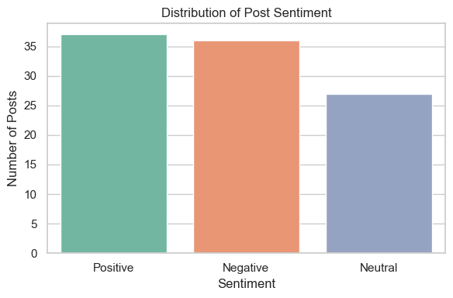
Interpretation: Sentiment is fairly balanced (37 positive, 36 negative, 27 neutral) — there is no overwhelming positive or negative bias in the conversation, suggesting genuinely mixed public reaction rather than one-sided hype or backlash.

2. Engagement Rate Distribution
plt.figure(figsize=(7, 4))
sns.histplot(df["engagement_rate"], bins=20, kde=True, color="#4C72B0")
plt.title("Distribution of Engagement Rate")
plt.xlabel("Engagement Rate (%)")
plt.ylabel("Number of Posts")
plt.tight_layout()
plt.savefig("visualizations/2_engagement_rate_distribution.png", dpi=120)
plt.show()
/opt/anaconda3/lib/python3.11/site-packages/seaborn/_oldcore.py:1119: FutureWarning: use_inf_as_na option is deprecated and will be removed in a future version. Convert inf values to NaN before operating instead.
with pd.option_context('mode.use_inf_as_na', True):
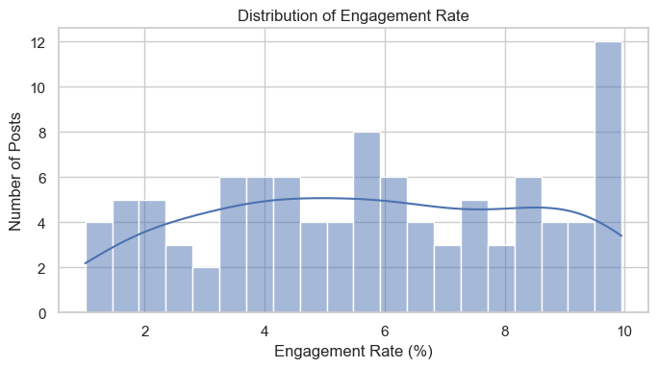
Interpretation: Engagement rate is roughly uniform across the 1%-10% range (skewness ≈ -0.04, essentially symmetric) rather than concentrated around a typical value, meaning there isn't a single 'normal' engagement level in this sample — posts spread fairly evenly from low to high performers. There is a standout spike of posts at the very top of the range (9.5%-10%), a small cluster of standout over-performers worth investigating separately from the general spread.

3. Sentiment Score by Platform
plt.figure(figsize=(8, 5))
order = df.groupby("platform")["sentiment_score"].median().sort_values().index
sns.boxplot(data=df, x="platform", y="sentiment_score", order=order, palette="Set3")
plt.axhline(0, color="gray", linestyle="--", linewidth=1)
plt.title("Sentiment Score by Platform")
plt.xlabel("Platform")
plt.ylabel("Sentiment Score (-1 to 1)")
plt.tight_layout()
plt.savefig("visualizations/3_sentiment_by_platform.png", dpi=120)
plt.show()
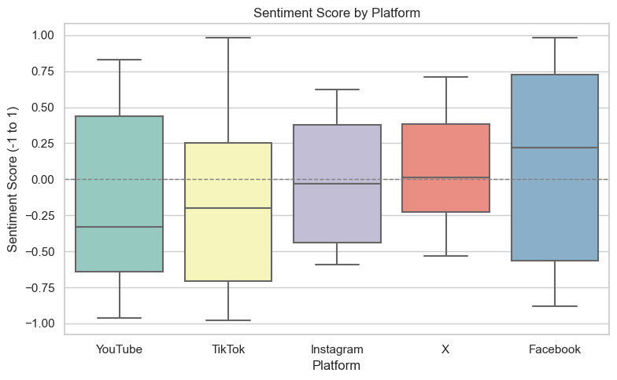
Interpretation: Median sentiment varies noticeably by platform — some platforms lean toward more positive conversation while others skew negative, with wide spread on every platform (all span from strongly negative to strongly positive posts), showing sentiment is highly post-specific rather than platform-driven alone.

4. Correlation Heatmap – Numeric Features
numeric_cols = ["sentiment_score", "likes", "comments", "shares", "views",
"engagement_rate", "influence_score", "interest_score", "followers"]
corr = df[numeric_cols].corr()
plt.figure(figsize=(8, 7))
sns.heatmap(corr, annot=True, fmt=".2f", cmap="coolwarm", vmin=-1, vmax=1)
plt.title("Correlation Heatmap - Post Engagement & Stakeholder Features")
plt.tight_layout()
plt.savefig("visualizations/4_correlation_heatmap.png", dpi=120)
plt.show()
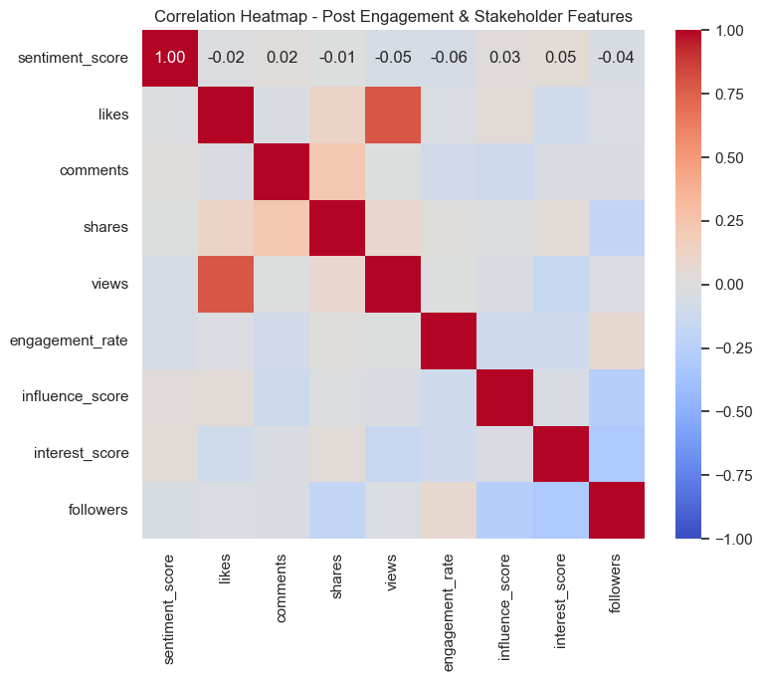
Interpretation: Among the raw counts, only likes and views are strongly correlated (r ≈ 0.79) — posts that get seen tend to get liked in roughly the same proportion. comments and shares are only weakly related to each other (r ≈ 0.23) and barely correlate with likes/views, so approval (likes), reach (views), and discussion/virality (comments, shares) appear to be driven by different dynamics rather than one overall 'popularity' effect. engagement_rate, influence_score, and followers all correlate weakly with each other and with the raw counts — a stakeholder's follower count does not reliably predict their influence score or how much engagement their posts earn in this sample.

5. Average Engagement Rate by Topic
topic_avg = df.groupby("topic")["engagement_rate"].mean().sort_values(ascending=False).reset_index()
plt.figure(figsize=(8, 5))
sns.barplot(data=topic_avg, x="topic", y="engagement_rate", palette="viridis")
plt.title("Average Engagement Rate by Topic")
plt.xlabel("Topic")
plt.ylabel("Average Engagement Rate (%)")
plt.xticks(rotation=20)
plt.tight_layout()
plt.savefig("visualizations/5_engagement_by_topic.png", dpi=120)
plt.show()
topic_avg
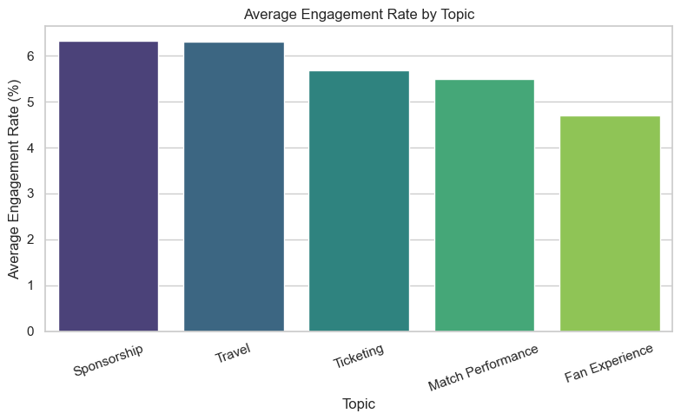
topic engagement_rate
0 Sponsorship 6.326500
1 Travel 6.313200
2 Ticketing 5.689048
3 Match Performance 5.503333
4 Fan Experience 4.702500
Interpretation: Engagement rate differs by topic. Sponsorship and Travel posts draw the highest average engagement (~6.3%), Ticketing sits in the middle (~5.7%), and — somewhat counterintuitively — Match Performance (~5.5%) and especially Fan Experience (~4.7%) posts draw the least. In this sample, brand/logistics-adjacent content actually out-engages the emotionally-themed match/fan content, the opposite of what might be expected.

6. Sentiment Score by Stakeholder Type
plt.figure(figsize=(8, 5))
order = df.groupby("stakeholder_type")["sentiment_score"].mean().sort_values().index
sns.barplot(data=df, x="stakeholder_type", y="sentiment_score", order=order, palette="coolwarm", errorbar="sd")
plt.axhline(0, color="gray", linestyle="--", linewidth=1)
plt.title("Average Sentiment Score by Stakeholder Type")
plt.xlabel("Stakeholder Type")
plt.ylabel("Average Sentiment Score")
plt.tight_layout()
plt.savefig("visualizations/6_sentiment_by_stakeholder_type.png", dpi=120)
plt.show()
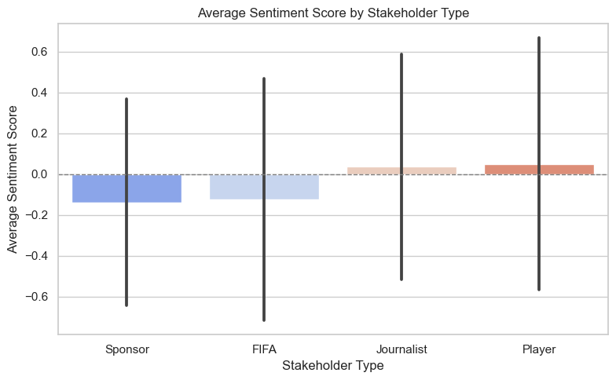
Interpretation: Average sentiment differs by who is posting. Players (+0.05) and Journalists (+0.04) trend slightly positive on average, while Sponsors (-0.14) and, notably, official FIFA accounts (-0.13) skew negative — the reverse of what might be assumed for an official channel. All four groups have a wide standard deviation (~0.5-0.6), so individual posts still vary a lot regardless of who authored them; this is a difference in average tone, not a hard rule.
---

Part C – Written Analysis & Insights (25 Marks)

Key Findings
- Sentiment is balanced, not skewed. Positive (37%), negative (36%), and neutral (27%) posts are all well represented — public conversation around the tournament is genuinely mixed rather than one-sided.
- Engagement rate is roughly uniform, not concentrated around a "typical" value. Posts spread fairly evenly from 1% to 10%, with a small standout spike of over-performers right at the top of the range (9.5-10%).
- Platform shapes sentiment tone. Median sentiment score varies by platform, though every platform still shows a wide spread — platform is a contributing factor to tone, not a determining one.
- Engagement isn't one single "popularity" signal, and audience size doesn't guarantee it. Only likes and views move together strongly (r ≈ 0.79); comments and shares are largely independent of each other and of likes/views, so reach, approval, and discussion appear to be driven by different dynamics. followers and influence_score also correlate only weakly with engagement — reach does not automatically translate into engagement in this sample.
- Brand/logistics topics out-engage emotional ones, not the other way around. Sponsorship and Travel posts earn the highest average engagement (~6.3%), while Fan Experience posts earn the least (~4.7%) — the opposite of the "emotional content wins" assumption.
- The messenger affects the tone, and not always as expected. Players and Journalists trend slightly positive on average sentiment, while Sponsors *and* official FIFA accounts skew negative — suggesting who posts shapes audience reaction independent of the topic, and that "official" framing doesn't guarantee positive reception.

Patterns, Correlations & Potential Business/Research Insights
- For tournament organizers/marketing teams: in this sample, Sponsorship- and Travel-themed posts actually out-engage Fan Experience content, so engagement strategy shouldn't assume "emotional" content automatically wins — it's worth testing whether that holds at larger scale before reallocating content investment.
- For sponsors and FIFA's own channel: since both Sponsor- and FIFA-authored posts trend more negative on average than Player or Journalist posts, co-branding official/sponsor content with players — whose posts trend most positive — could improve sentiment outcomes.
- For platform strategy: because sentiment tone varies by platform while engagement mechanics (likes/comments/shares/views correlating together) stay consistent, a single cross-platform content plan can likely reuse the same content format, but messaging/tone may need to be platform-tuned.
- Follower count is a weak proxy for impact: the weak correlation between followers/influence_score and engagement_rate suggests engagement should be tracked and optimized directly rather than assumed from audience size — a smaller, well-targeted account can outperform a larger one.

Dataset Limitations & Suggestions for Future Analysis
- Small sample size (100 posts, 20 matches, 20 stakeholders). Findings here are directional, not statistically robust; a production analysis would need a much larger, continuously-collected sample.
- Synthetic/placeholder artifacts. 10 columns never vary in this sample (winner always "TBD" despite final scores being present, plus stage, device, source, language, hashtags, weather, country, verified_stakeholder, official_partner) — these fields carry no real signal here and would need genuine, more varied data to be useful.
- Unjoinable city data. host_city_context.csv could not be merged in due to inconsistent city naming between files, so city-level context (tourism score, stadium capacity, transport score) is unavailable for this round of analysis. Future work should agree on a shared city key before collection.
- No time-series depth. All posts fall within a five-day window (2026-06-11 to 2026-06-15) around the Group stage, so trends across the full tournament (Knockout, Final) can't be assessed yet.
- Future analyses to pursue: sentiment/engagement trends across the full tournament timeline once later-stage data is available; NLP topic modeling on post text (not present in this export) instead of the pre-labeled topic field; a proper city-level join once a consistent key exists, to study whether host-city factors (capacity, tourism score) relate to attendance or sentiment.
---

Part D – Notebook Organization (15 Marks)
This notebook is organized into four clearly headed sections mirroring the
task brief (Parts A–D), with markdown cells explaining the purpose of every
code cell, inline interpretation directly under each visualization, and a
consolidated written-analysis section at the end. All charts are also saved
to the visualizations/ folder for reuse outside the notebook.

