

FUNCTIONAL PROTOTYPE REPORT

HYPEFIT AI - Smart Fitness Hub with Gemini AI Assistant

Project Name | HYPEFIT AI
Student Name | Ahmad Daffa
Course | Capstone Project
Institution | Universitas Amikom Yogyakarta
Email | ahmmdaffa280904@gmail.com
Date | 3 June 2026

This document explains the functional prototype of HYPEFIT AI. The focus is on how the application works from the user's perspective, starting from the landing page, login flow, dashboard, AI chatbot, nutrition features, and enrollment flow. The screenshots in this document were captured from the local web prototype running on localhost.

1. Project Overview
HYPEFIT AI is a web-based fitness application prototype designed as a smart fitness hub. The application combines a premium futuristic fitness interface with AI-assisted features powered by Gemini API. The prototype is built to demonstrate how a user can explore fitness programs, log in to a member dashboard, calculate BMI, generate diet plans, and interact with FitBot as a personal fitness assistant.
The prototype is not intended as a medical application. Its recommendations are general fitness guidance, and users with serious health conditions should consult a doctor or certified nutrition professional.

2. Prototype Objectives
• Provide a working fitness web interface that can be demonstrated locally.
• Show the main user journey from landing page to dashboard.
• Implement FitBot as a Gemini-powered AI assistant.
• Add BMI calculation and diet plan generation features inside the dashboard.
• Provide membership selection and athlete enrollment flow.
• Keep the UI consistent with the HYPEFIT dark futuristic visual identity.

3. Target Users
The prototype targets fitness users who want a simple digital hub for training, nutrition, and AI-based guidance. The main user can be a beginner, student, or gym member who needs structured workout and nutrition suggestions but does not yet use a full professional coaching platform.

4. Main User Flow
Step | User Action | System Response
1 | Open the web application | Landing page appears with HYPEFIT branding and navigation
2 | Click Log In | Login page is displayed
3 | Enter demo credentials | User is redirected to the dashboard
4 | Open dashboard sections | Training, Nutrition, and Settings pages can be accessed from sidebar
5 | Ask FitBot | AI chatbot opens and processes user questions
6 | Use nutrition tools | User can view macros and generate a daily meal plan
7 | Select membership plan | User is redirected to athlete enrollment
8 | Submit enrollment form | Enrollment success page is displayed

5. Functional Prototype Screens

Figure 1. Landing page HYPEFIT AI
The first screen introduces the HYPEFIT AI brand, hero message, navigation menu, login button, and call-to-action to open FitBot.
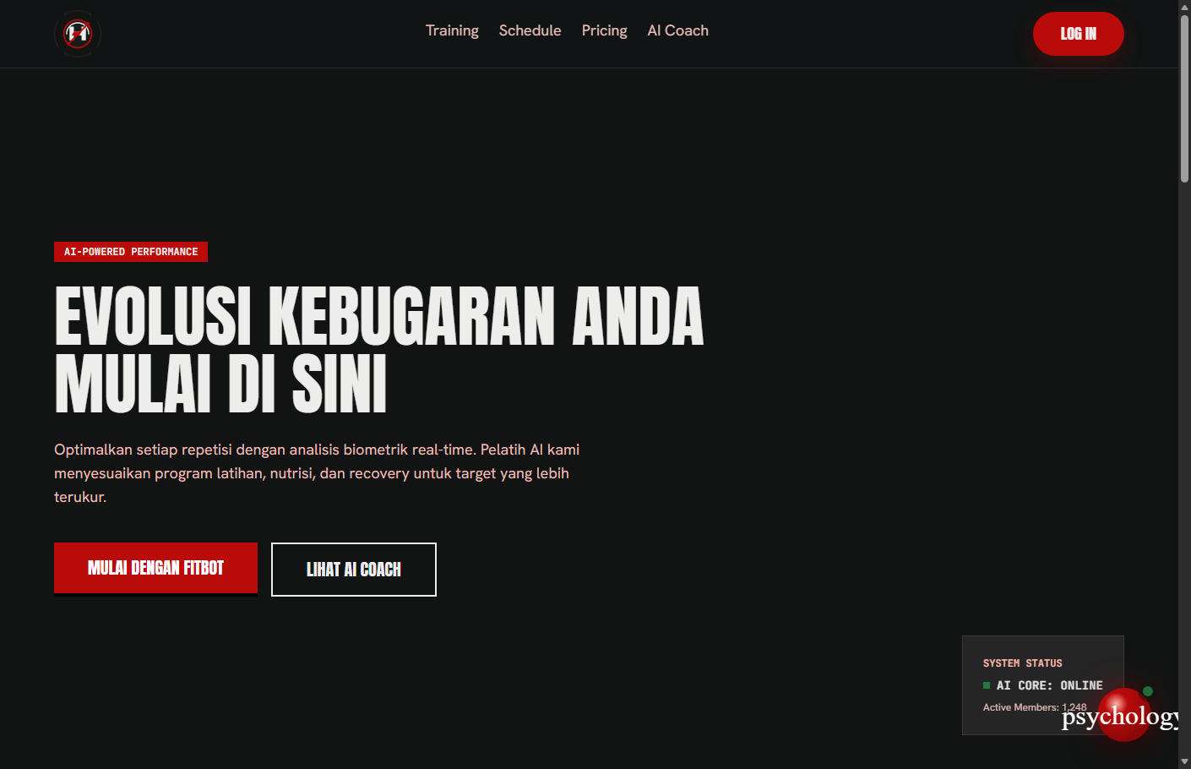
Figure 1. Landing page HYPEFIT AI

Figure 2. AI Coach section
This section explains the AI assistant experience and shows how FitBot is presented as a fitness coach inside the application.
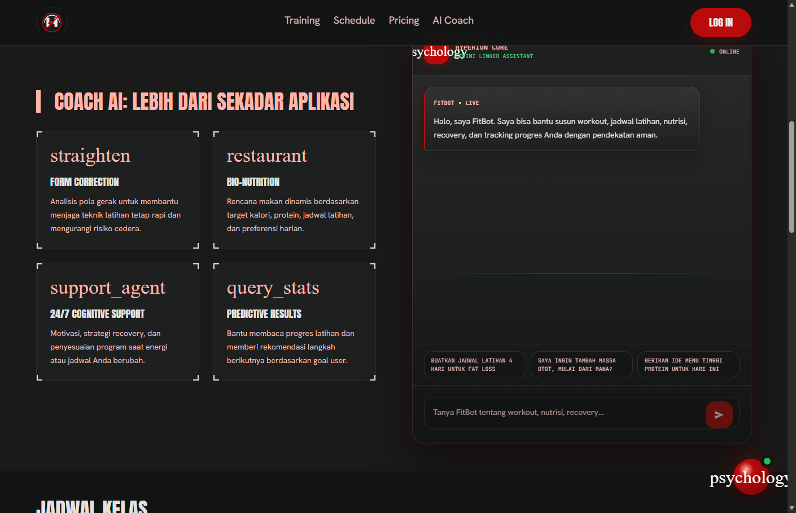
Figure 2. AI Coach section

Figure 3. Pricing plan section
The Lite, Pro, and Elite cards show the available membership options and become the entry point to the enrollment flow.
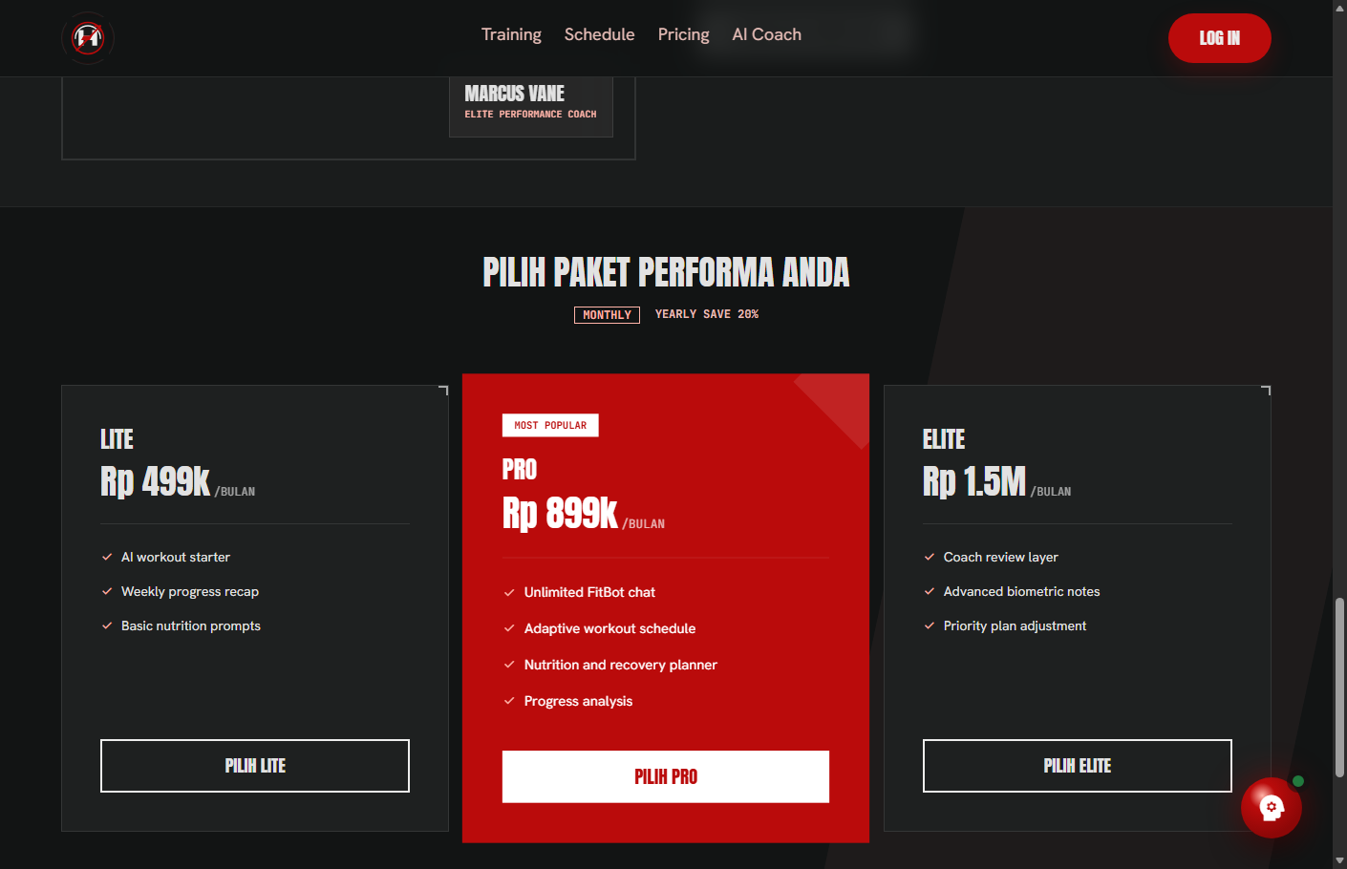
Figure 3. Pricing plan section

Figure 4. Login page
The login screen is used to access the local dashboard demo. It uses demo credentials for prototype purposes.
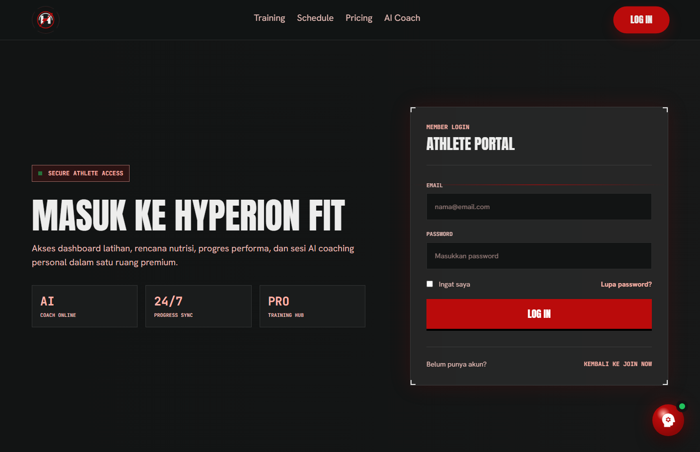
Figure 4. Login page

Figure 5. Member dashboard overview
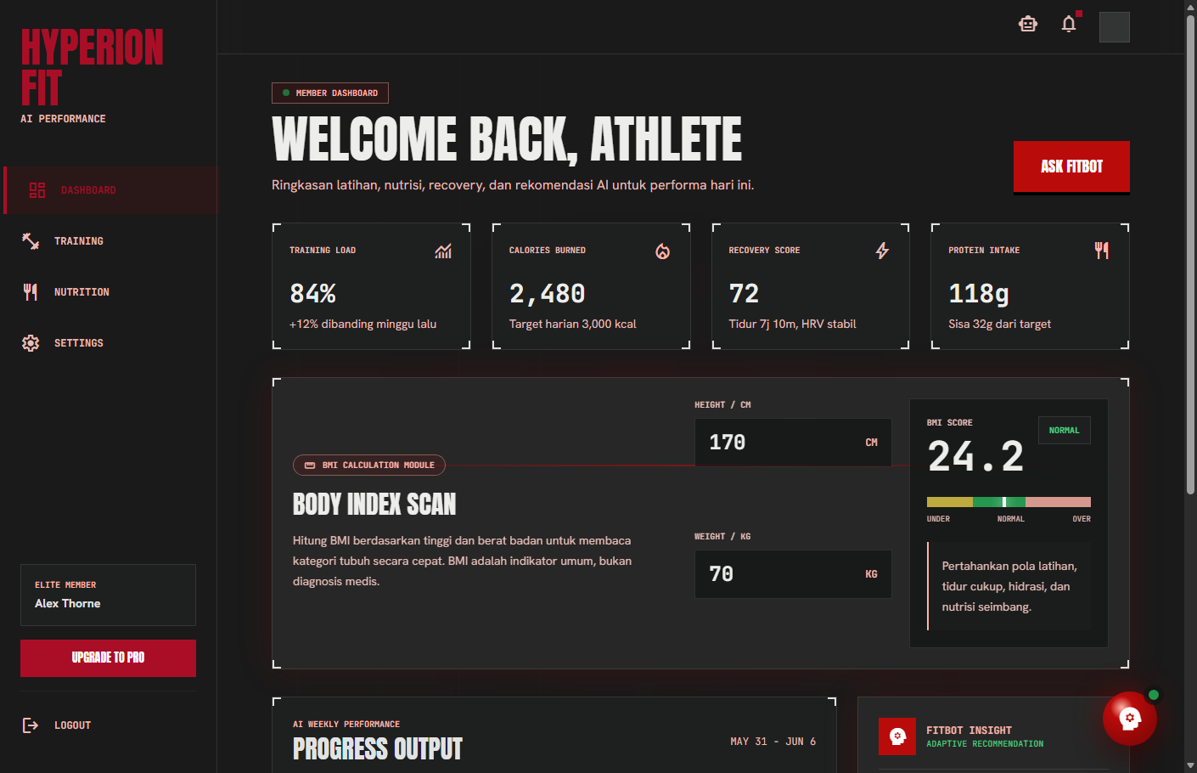
The dashboard summarizes training load, calories burned, recovery score, protein intake, and the BMI module.

Figure 5. Member dashboard overview

Figure 6. BMI Calculation Module
The BMI module calculates the user's BMI from height and weight, then displays the score, category, and short guidance.
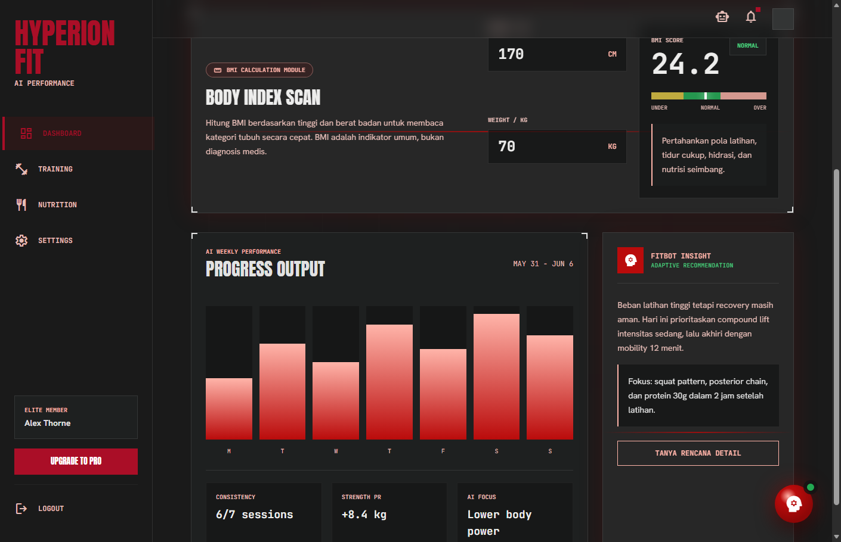
Figure 6. BMI Calculation Module

Figure 7. Training page
The training page shows current set information, rest timer, performance metrics, workout history, and exercise library.
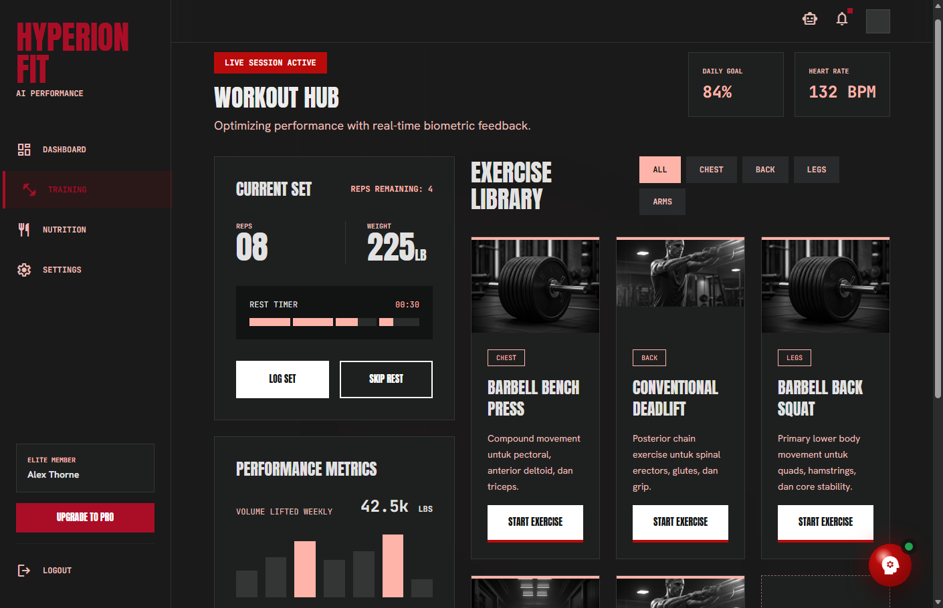
Figure 7. Training page

Figure 8. Nutrition page
The nutrition page shows macro distribution, meal entries, hydration information, and coach suggestion.
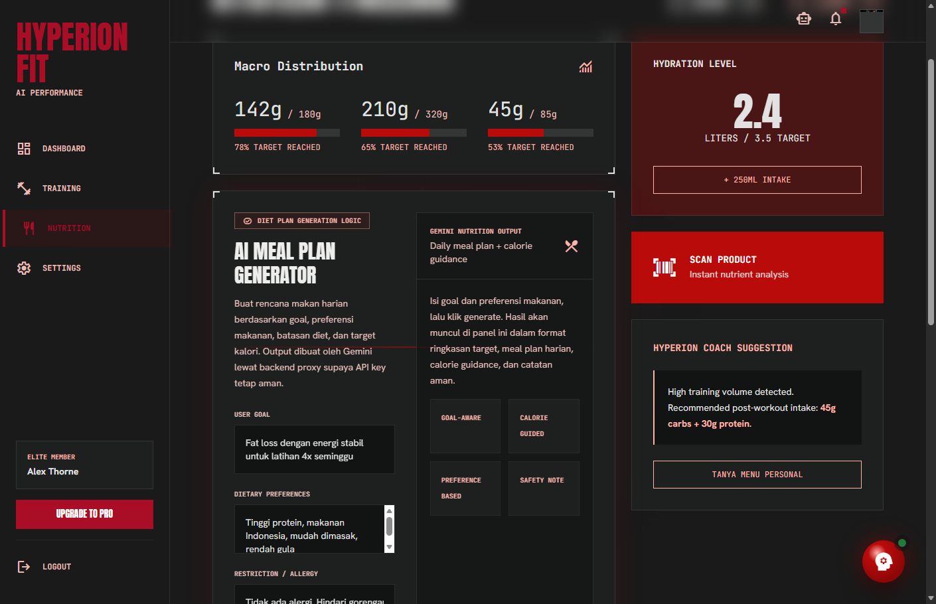
Figure 8. Nutrition page

Figure 9. AI Meal Plan Generator
The new diet plan generator takes user goal, dietary preferences, restrictions, target calories, and meal count to request a meal plan from Gemini through the backend.
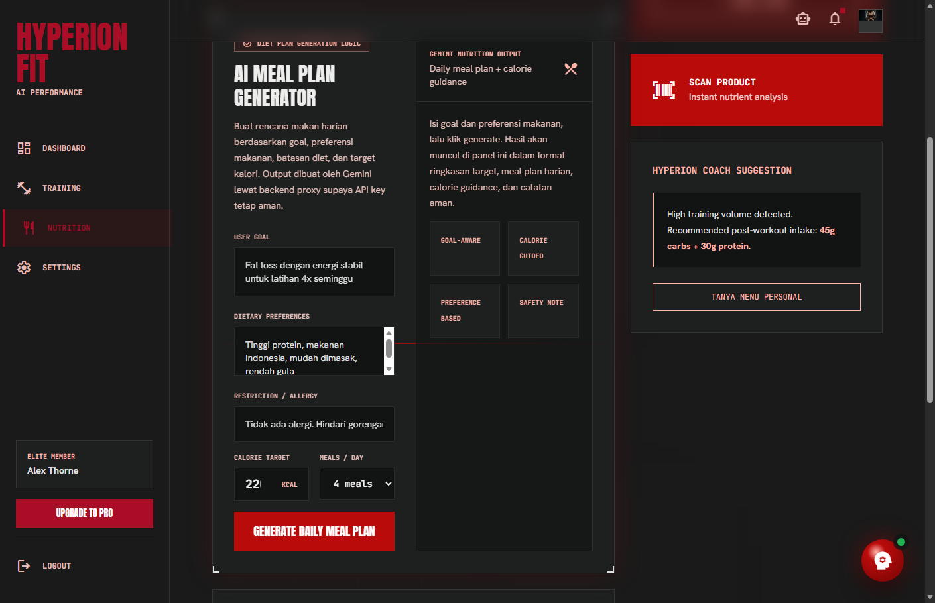
Figure 9. AI Meal Plan Generator

Figure 10. Settings page
The settings page represents athlete profile configuration, membership status, security controls, and notification options.
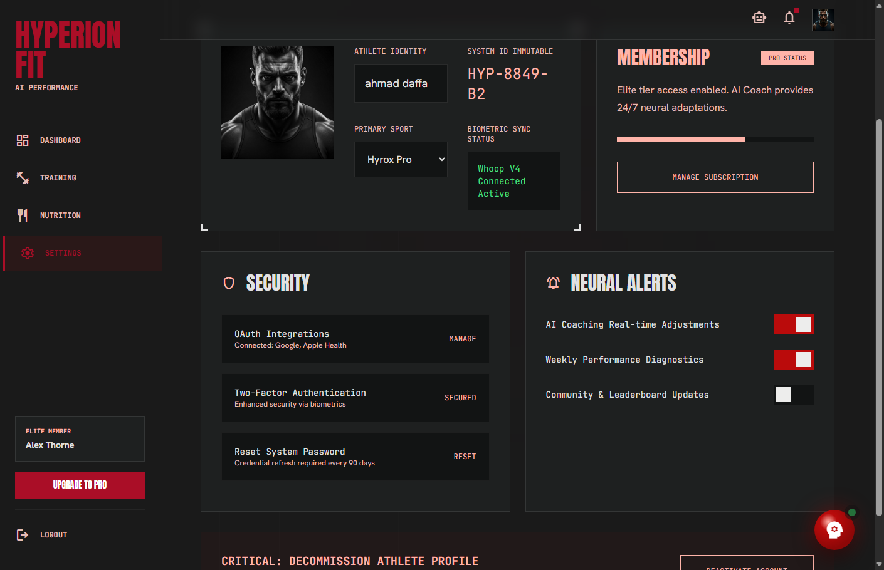
Figure 10. Settings page

Figure 11. FitBot chatbot
FitBot is the Gen AI feature that receives user questions and returns fitness-related responses in Indonesian through Gemini API.
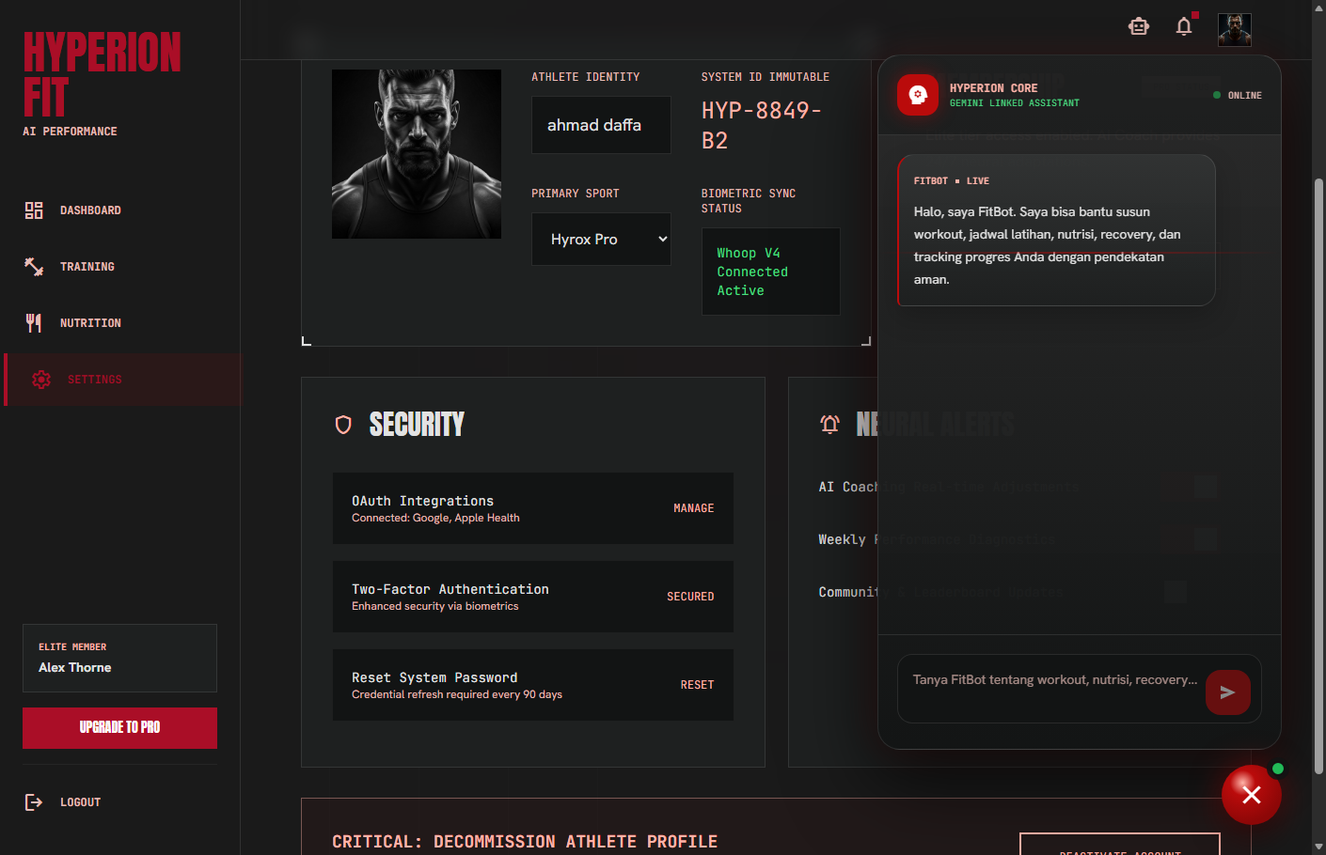
Figure 11. FitBot chatbot

Figure 12. Athlete enrollment page
The enrollment form collects athlete identity, email, WhatsApp contact, age, weight, height, and consent.
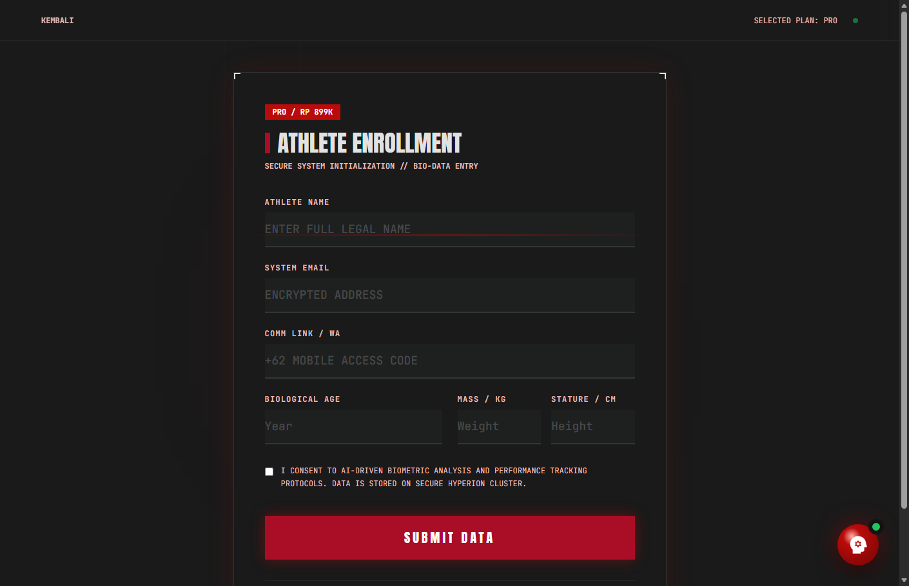
Figure 12. Athlete enrollment page

Figure 13. Enrollment success page
After submitting the enrollment form, the user receives a confirmation screen showing the selected package and success message.
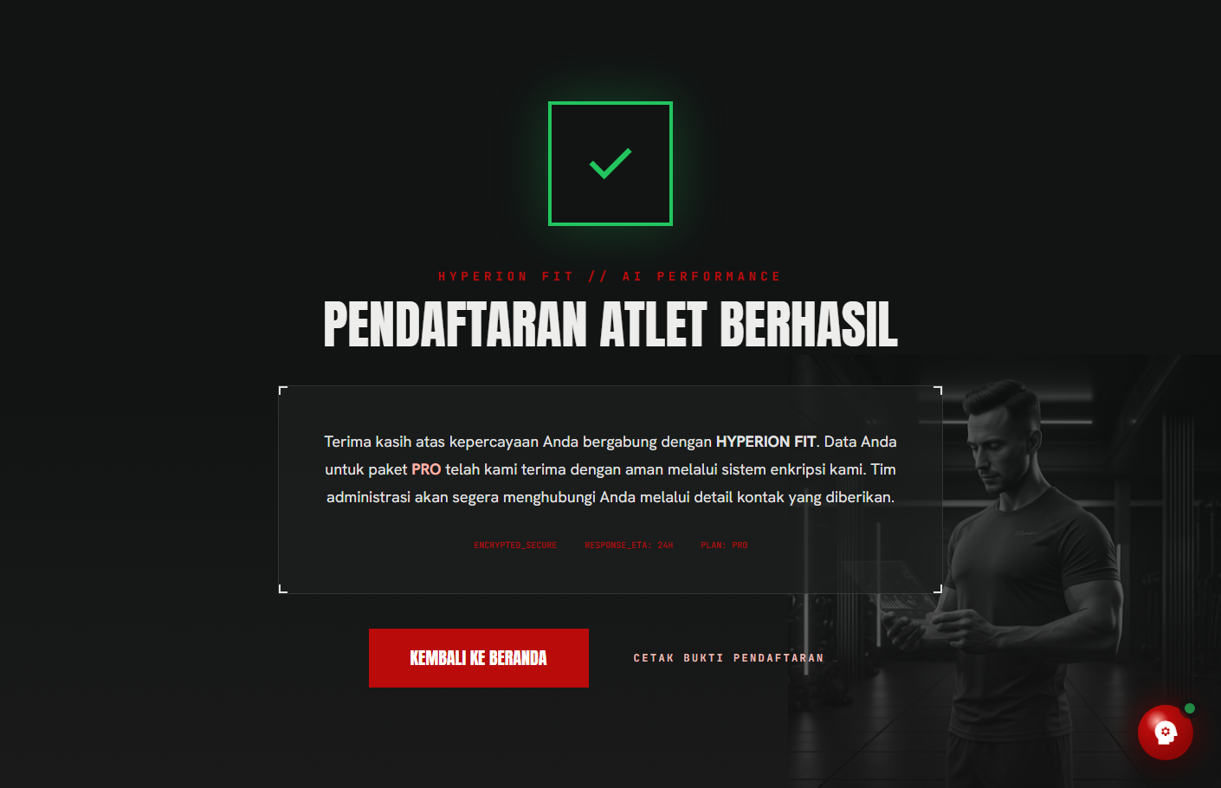
Figure 13. Enrollment success page

6. Feature Details
Feature | Description | Prototype Status
Landing Page | Displays branding, navigation, hero message, and FitBot entry point. | Implemented
Login Demo | Allows access to dashboard using demo credentials. | Implemented
Dashboard Overview | Shows training load, calories, recovery score, protein intake, and BMI module. | Implemented
BMI Calculation | Calculates BMI based on height and weight and shows category guidance. | Implemented
Training Page | Shows current set, rest timer, performance metrics, history, and exercise library. | Implemented
Nutrition Page | Shows macro distribution, meals, hydration, and nutrition suggestion. | Implemented
Diet Plan Generator | Uses goal, preferences, restrictions, calorie target, and meal count as input for Gemini meal planning. | Implemented
Settings Page | Displays profile, membership, security, and notification settings. | Implemented
FitBot Chatbot | Uses Gemini API through backend proxy to answer fitness questions. | Implemented
Enrollment Flow | Lets user choose a plan, submit athlete data, and view success page. | Implemented

7. Demo Credentials
Email | Password
ahmmdaffa280904@gmail.com | 12345678
The login is still a local prototype login. It is not connected to a production authentication system or database.

8. Gen AI Functionality
The main Gen AI feature is FitBot. Users can ask about workout recommendations, training schedules, nutrition tips, recovery, and progress tracking. The message is sent from the frontend to the Express backend, then the backend forwards the prompt to Gemini API. The Gemini response is returned to the frontend and displayed as a chat bubble.
The Nutrition page also includes an AI Meal Plan Generator. This feature collects user goal, dietary preferences, restrictions, target calories, and number of meals per day. The backend then builds a structured nutrition prompt and sends it to Gemini to generate a daily meal plan with calorie guidance.

9. Prototype Limitations
• The login system is still a local demo and does not use a database.
• Dashboard metrics are static sample data.
• The chatbot history is not stored permanently.
• Diet plan output depends on Gemini API availability and API key configuration.
• The prototype has not been deployed to a public hosting platform.
• The application does not provide medical diagnosis.

10. Functional Testing Summary
Test Area | Expected Result | Result
Landing page | Page loads with hero UI | Passed
Login | Valid demo credential opens dashboard | Passed
Sidebar navigation | Dashboard pages change based on selected menu | Passed
BMI module | BMI score and category update from input | Passed
FitBot | Chatbot opens and accepts prompt | Passed
Diet plan generator | Form accepts nutrition input and sends request to backend | Passed
Enrollment | Submit form opens success page | Passed
Refresh behavior | Refresh returns to landing hero area | Passed

11. Conclusion
The HYPEFIT AI functional prototype successfully demonstrates the intended user journey and main application features. Users can start from the landing page, log in to the dashboard, explore training and nutrition pages, calculate BMI, generate AI-based meal plan guidance, chat with FitBot, and complete the membership enrollment flow.
Although the prototype still uses static data and demo authentication, the core functionality is already visible and usable for presentation. The project can be extended further with real database integration, production authentication, deployment, and persistent user history.

