Freight Rate Prediction Challenge
Report: data understanding, validation approach, model and December forecast

1. Summary
The task is to predict the price (posted_rate) of freight loads: 12,000 loads in validation.csv (Nov–Dec 2025), plus one fixed lane (Lexington to Fort Wayne, 360 miles, Dry Van, 32,000 lb) for every day of December 2025.
- Data: 48,000 labelled loads (Jan–Oct 2025). Distance explains most of the price (correlation 0.91); equipment type adds a clear premium. Fewer than 1% of values are missing, and 292 weights are negative sign errors.
- Validation: because the test period is in the future, I validated by time with three expanding-window folds, not with a random split. The last fold (train Jan–Aug, test Sep–Oct) is closest to the real setting.
- Model: 80% gradient boosting (robust absolute-error loss) plus 20% ridge regression, both predicting log(rate).
- Result (my own estimate): average over the three folds MAPE 5.15%, MAE $121, against 6.69% / $158 for a linear baseline and 10.53% / $219 for a naive rate-per-mile baseline. The official score is computed by Spotter after submission, so I cannot confirm it.

2. Data understanding
File | Rows | Purpose
train_test.csv | 48,000 (Jan 1 – Oct 31) | Labelled loads: used to train and validate
validation.csv | 12,000 (Nov 1 – Dec 31) | Same inputs, no rate: to predict
validation_predictions_template.csv | 12,000 | load_id + empty predicted_rate to fill
december_chart_inputs.csv | 31 | Fixed lane, only the date changes

Each load has pickup and delivery city with coordinates, distance, equipment (Dry Van, Reefer, Flatbed), weight, date, market_index, quote_signal and the target posted_rate. Rates range from $57 to $25,533 (median $2,031).
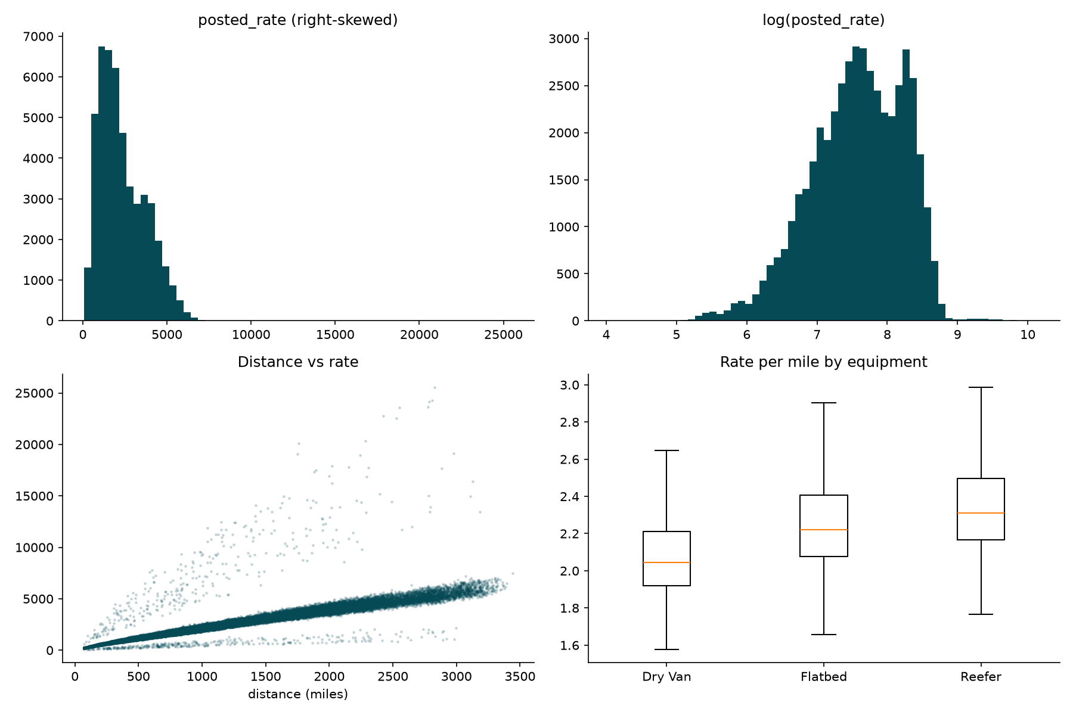
Figure 1. Target distribution, distance vs rate, and rate per mile by equipment.
Main findings:
- Distance dominates. The points form a tight band that rises with distance, with a few loads far above and below it.
- Equipment matters. Median rate per mile is $2.05 for Dry Van, $2.22 for Flatbed and $2.31 for Reefer.
- Weak single signals. weight, market_index and quote_signal each have a correlation of about 0.03–0.04 (in absolute value) with the rate on their own.
- Seasonality. market_index follows a yearly pattern (low in winter, peak in May, low again in autumn), which matters for how it is filled when missing.
- Skew. rates are right-skewed, so I model log(rate) and convert back.
- Extreme loads. About 1.5% of loads are far from the main band (for example more than 25% error even for the final model). I treat them as unpredictable noise.
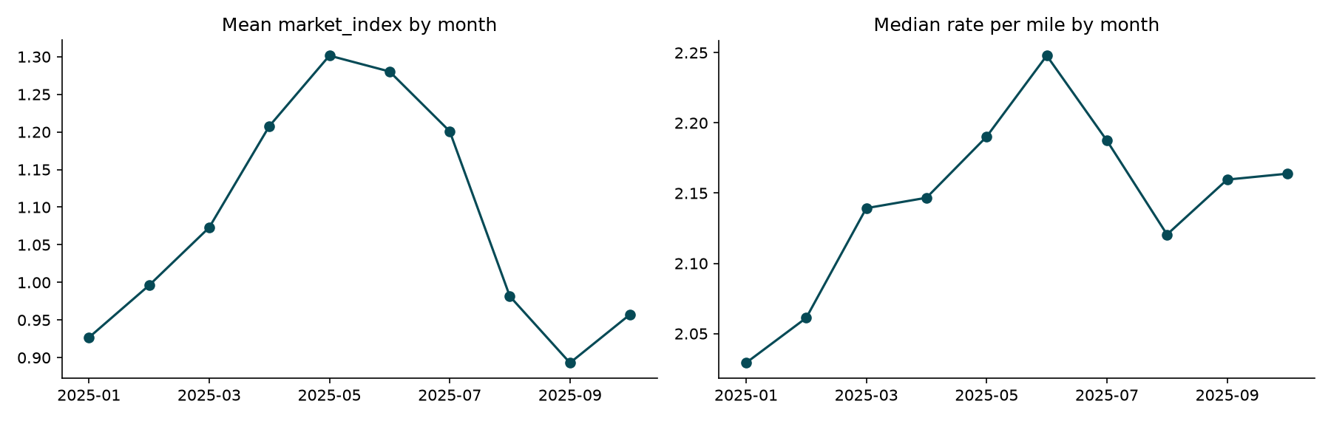
Figure 2. market_index and median rate per mile by month.

3. Missing and bad data
Problem | Train (48,000) | Validation (12,000) | Treatment
weight missing | 300 (0.63%) | 165 | Median weight of the same equipment type
market_index missing | 374 (0.78%) | 249 | Median market_index of the same calendar month
weight negative | 292 (0.61%) | 145 | abs() and a weight_bad flag
All other columns | complete | complete | none needed

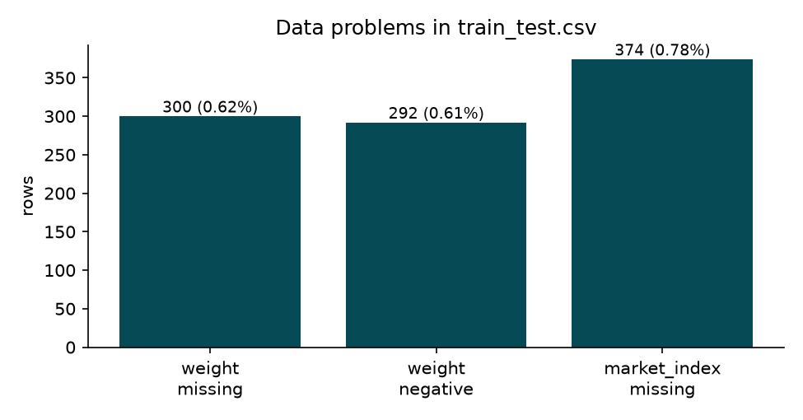
Figure 3. Data problems in the training file.
Delete or fill? Rows can be deleted from training, but not from validation: every load_id needs a prediction, so a fill method is required anyway. I compared three options on the three time folds using the boosting model:
Strategy | MAE ($) | RMSE ($) | MAPE (%)
Delete rows with missing values (training only) | 121.34 | 634.10 | 5.21
Fill with global median | 121.29 | 634.17 | 5.21
Fill with grouped median (chosen) | 121.27 | 633.84 | 5.21

The three strategies give the same average error (5.21% MAPE, MAE within $0.10), which is expected because only about 1% of rows are affected. I chose the grouped median because it keeps every row and respects the seasonal pattern of market_index, not because it is measurably better. Medians are always learned from the training part of each fold, so no future information leaks into the fill values. I also added missing-value flags so the model can tell filled values from real ones.

4. Data split and validation approach
The validation file starts on Nov 1, the day after the last training date. A random split would mix months and make the estimate too optimistic, because rates and market_index change over the year. I therefore used an expanding window: train on everything before the test period, then test on the following two months.
Fold | Training period | Test period | Training rows
1 | Jan – Apr | May – Jun | 19,110
2 | Jan – Jun | Jul – Aug | 28,806
3 | Jan – Aug | Sep – Oct | 38,477

I report MAE, RMSE and MAPE on the original dollar rate, because the official metric is not disclosed. The final model is then trained on all 48,000 labelled loads.

5. Model
- Features (15): distance, weight, market_index, quote_signal, equipment, pickup and delivery city codes, coordinates, day of week, and three flags (weight missing, market_index missing, weight was negative).
- Target: log(posted_rate). Errors then behave like percentages and the long right tail has less influence.
- Gradient boosting (histogram-based, leaf-wise trees: 400 iterations, learning rate 0.06, 31 leaves, 255 bins) captures non-linear effects and interactions such as equipment x distance x season. I used an absolute-error loss (trees follow the sign of the residual, leaf values are median residuals) because a small group of extreme rates distorts squared-error training: squared-error boosting scored 6.17% average MAPE against 5.21% with the absolute-error loss.
- Ridge regression on distance and equipment (with interactions) is very stable. The final prediction is 0.8 x boosting + 0.2 x ridge in log space. Only numpy, pandas and matplotlib may be used here, so both models are implemented from scratch in src/freight.py instead of using scikit-learn.
I chose the blend weight by testing 100%, 90%, 80%, 70%, 60% and 50% boosting on the three folds. Average MAPE was 5.21%, 5.15%, 5.15%, 5.20%, 5.30% and 5.44% respectively; 90% and 80% are tied at two decimals and 80% is slightly lower unrounded. Boosting alone is best on fold 1, where there is little training data, but only ties the linear model on fold 3, where more ridge helps. The weight was chosen on the same three folds it is reported on, and the gain over boosting alone is only 0.06 percentage points of MAPE, so it should not be over-interpreted.

6. Validation results
Model | Fold 1 MAPE | Fold 2 MAPE | Fold 3 MAPE | Avg MAE ($)
Naive: median rate per mile x distance | 11.01% | 10.11% | 10.49% | 219.3
Linear: ridge on distance + equipment | 8.21% | 5.86% | 5.99% | 157.7
Gradient boosting, squared-error loss | 6.17% | 5.75% | 6.60% | 141.4
Gradient boosting only (absolute-error loss) | 4.47% | 5.22% | 5.94% | 121.3
Final: 80% boosting + 20% ridge | 4.91% | 5.02% | 5.52% | 120.9

Final model, average over folds: MAE $120.9, RMSE $634.2, MAPE 5.15%. RMSE is almost the same for the stronger models (about $634–$646) because it is dominated by a small number of extreme loads that no model predicts.
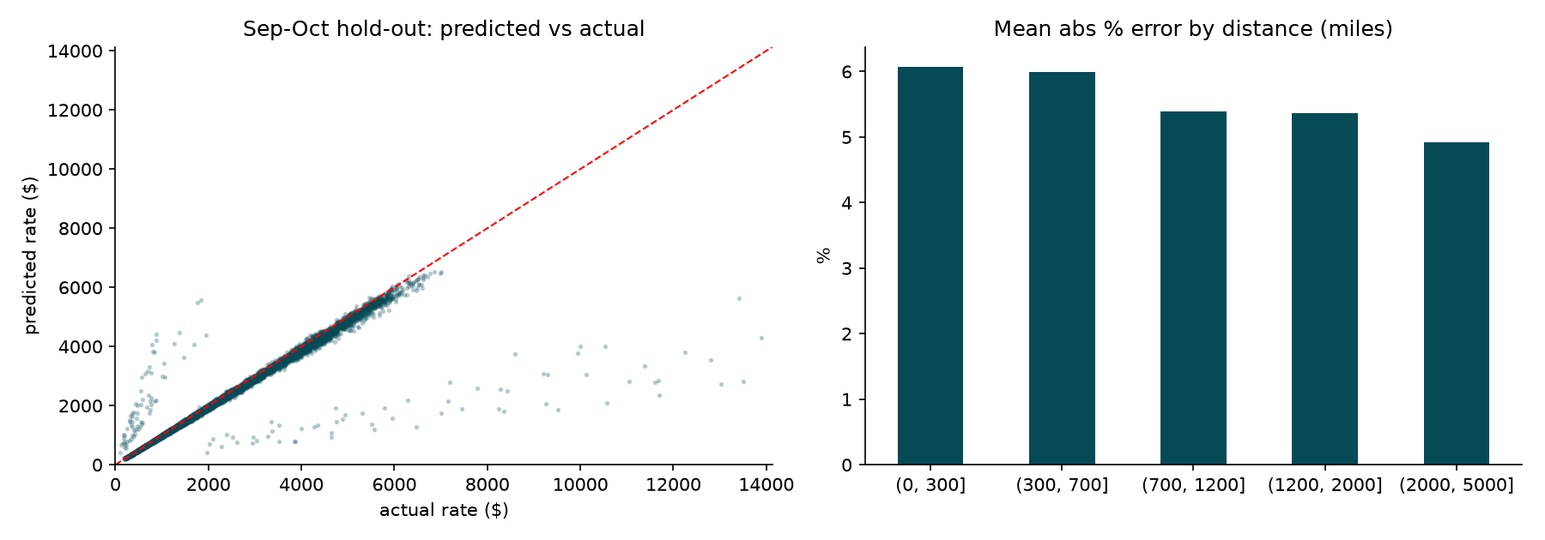
Figure 4. Sep–Oct hold-out (fold 3): predicted vs actual, and error by distance.
- Typical vs average error. On fold 3 the median absolute error is 2.9% while the mean is 5.5%. 1.5% of loads have errors above 25% and pull the mean up.
- By equipment: Dry Van 5.2%, Reefer 5.7%, Flatbed 6.2% mean absolute % error.
- By distance: highest for short trips (under 700 miles, about 6.0–6.1%) and lowest above 2,000 miles (4.9%), likely because the same dollar noise is a larger share of a short-haul rate.
- What drives predictions: permutation importance on fold 3 ranks distance far above everything else, then equipment, quote_signal and weight. market_index and the coordinates add almost nothing once distance is known.

7. Final predictions
The final model was trained on all 48,000 labelled loads, with fill medians learned from them, and applied to validation.csv. The predictions were written into the template in the same row order (checked in code), giving validation_predictions.csv with 12,000 rows. Predicted rates run from $212 to $6,630 (median $1,992). The official scorer accepted both files.

December 2025 chart
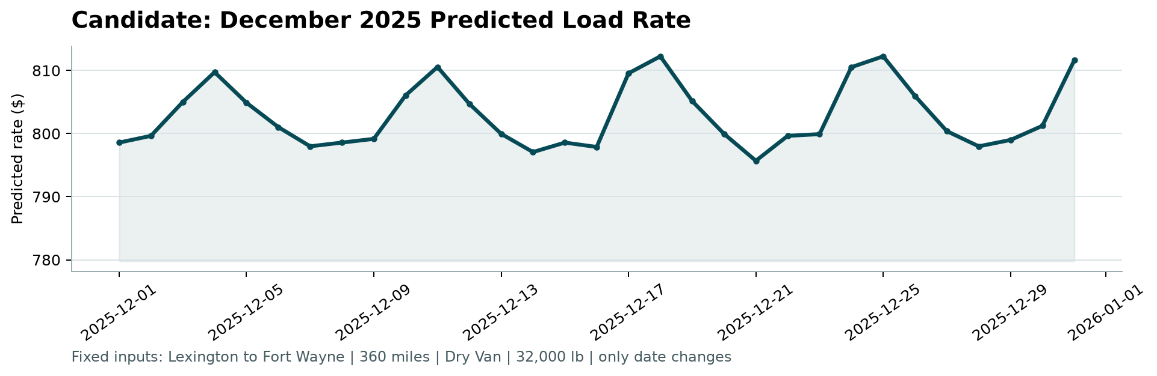
Figure 5. candidate_december.png: predicted rate, Lexington to Fort Wayne, 360 miles, Dry Van, 32,000 lb.
The predictions stay between about $796 and $812 (mean $803). The line is nearly flat because only the date changes and the y-axis of the scorer chart is zoomed to a few dollars; the whole month varies by only about 2%.
Assumption to note: december_chart_inputs.csv holds only the date, but the model also needs coordinates, market_index and quote_signal. I copied the coordinates from other Lexington and Fort Wayne rows, and used the daily average of market_index and quote_signal from the December rows of validation.csv. A different choice for these two inputs would shift the curve slightly.

8. Limitations and next steps
- The estimated error comes from three folds on historical months. Nov–Dec could behave differently (holiday effects, market shifts), and I cannot test December directly because no December rates exist.
- About 1.5% of loads have extreme rates. If the validation set has them too, they will dominate any squared-error metric regardless of the model. I did not delete them from training; the absolute-error loss limits their influence.
- The model choice is based on a small number of experiments. More folds would give a more reliable comparison.
- Ideas to try: lane-level features (historical rate per mile on each lane), hyperparameter tuning, LightGBM or XGBoost, and an explicit classifier for the extreme loads.

9. Reproducibility
Code, dependencies and run instructions are in the repository README. The only dependencies are matplotlib, numpy and pandas (versions in requirements.txt). In short: pip install -r requirements.txt, python run_pipeline.py --data-dir data, then python score.py with the two prediction files. The pipeline is deterministic (no randomness) and writes every number in this report to reports/results.json. The notebook notebooks/freight_rate_analysis.ipynb walks through the same steps with explanations.

