Browser Evaluation “IDN” project

Ahmed Khatab, Loay Askalany, Mumin Elsayed

Nile University

Computer Engineering – ECEN – 401

# Abstract

The Browser Evaluation “IDN” project uses NODE.JS and Python to take URL’s as input, load them, screenshots the URL address, and adds it into an excel file for future use.

# Introduction:

Internationalizing Domain Names in Applications (IDNA) is a mechanism defined in 2003 for handling internationalized domain names containing non-ASCII characters. These names either are Latin letters with diacritics (ñ, é) or are written in languages or scripts which do not use the Latin alphabet: Arabic, Hangul, Hiragana and Kanji for instance. Although the Domain Name System supports non-ASCII characters, applications such as e-mail and web browsers restrict the characters which can be used as domain names for purposes such as a hostname. That’s why we need to evaluate the ability of these browser to test their ability to handle such cases –domains-. And this is what this project about.

# Implementation:

We used the argument handler to call a child process to run the python code depending on the NODE.JS variables. We used read files synchronies instead of asynchronies to block the following functions. We used the web driver module to open the browser, we also used pillow image library to save the screenshots and insert them into the excel file. Our code takes the desktop’s resolution and the browser’s size/dimensions and takes the screenshot exactly on the URL address location.

# Results:

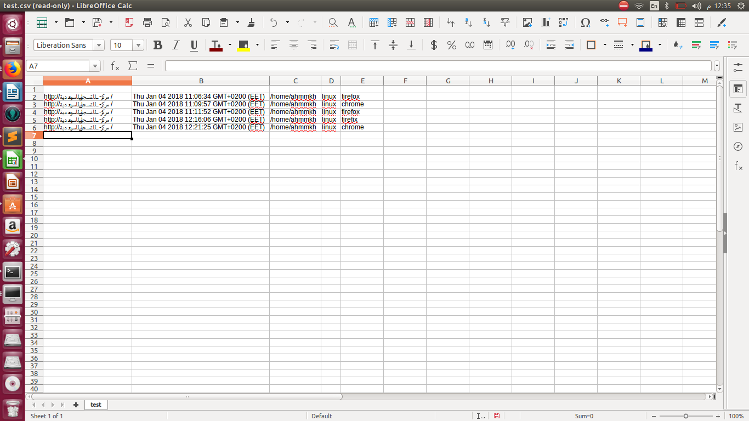In figure (1), the code inserts general information about the screenshot separated in different columns, with the URL’s, date & time of screenshot, path of the screenshot file, operating system, and the browser used, respectively.

# Appendix:

**Figure 1: Output Excel Sheet**

**Figure 2: NODE.js Code**

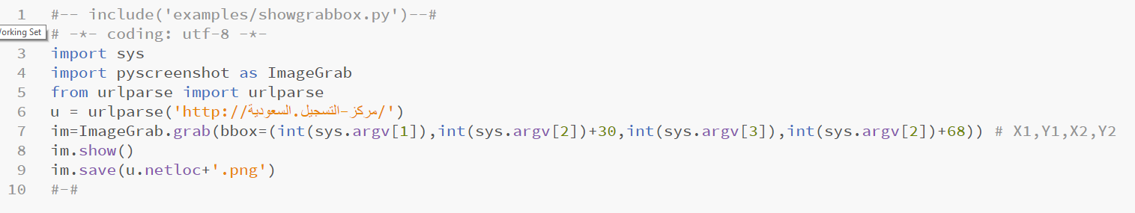

**Figure 3: Python Code**