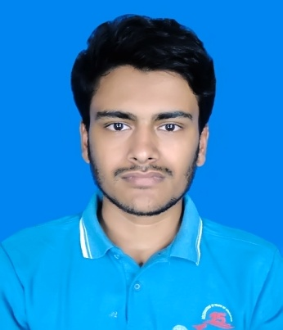Curriculum Vitae of

Saiful Islam Sajon

Asulia Model Town

Khagan, Aulia, Savar, Dhaka

Contact No: +8801622567102

Email: saifulislamsajon@gmail.com

# Career Objective

To grab an opportunity and set myself a goal where I can be innovative and attain a challenging position by exercising my interpersonal and professional skills to the fullest for the growth of the organization and mine as well innovative and competitive world.

# Education

**Bachelor of Computer Science & Engineering**

|  |  |
| --- | --- |
| Institution | : City University of Bangladesh |
| Result | : 3.84 (Out of 4) |
| Passing Year | : Still Studing |
| Major | : Software Engineering |

**Higher Secondary Certificate Examination**

|  |  |
| --- | --- |
| Institution | : Narsingdi Technical School and College |
| Result | : 4.42 (Out of 5) |
| Passing Year | : 2012 |
| Group | : Science |
| Board | : Technical Education Board |

**Secondary School Certificate Examination**

|  |  |
| --- | --- |
| Institution | : Narsingdi Technical School and College |
| Result | : 4.61 (Out of 5) |
| Passing Year | : 2014 |
| Group | : Science |
| Board | : Technical Education Board |

# Professional Experience

|  |  |
| --- | --- |
| 01/2017-03/2017 | **Team Leader**  Albert Heijn, Utrecht  Responsible for the entire product-handling process   * Managed a team of 10 stockers * Spoke to customers when handling errors occurred |
|  |  |
|  |  |

**Extra Curriculum Activities**

* Executive member BASIS student forum city university chapter
* Founder Narsingdi Creative Student Forum
* Volunteer Bangladesh Innovation Forum

**Participations**

* Participant of City University Intra University Programming Contest 2017
* Participated on Engineering Summit 2017 City University

**Skills**

* Language: Bangla (mother tongue) English (good spoken and written command)
* Software: Microsoft word, Microsoft Excel
* Programming language: C, JAVA(OOP), PHP
* Others computer language: HTML, CSS, JAVA SCRIPT, BOOTSTRAP

# Biography

|  |  |
| --- | --- |
| Name | : Saiful Islam Sajon |
| Father’s Name | : Abdul Baten Miah |
| Mother’s Name | : Jonaki Begum |
| Date of Birth | : 15/06/1994 |
| Sex | : Male |
| Religion | : Islam |
| Nationality | : Bangladeshi (by birth) |
| Marital Status | : Single |
| Sex | : Male |
| Permanent Address | : C/O: Abdul Baten, Vill: Charmarjal, P.O: Marjal Bazar,  P.S: Raipura, District: Narsingdi |

**Reference**

I declare that the information provided in this cv are correct, true and complete to the best of my knowledge and belief.