**Classroom Assistant**

**By**

**Md. Shafiqul Islam**

**Id: 142362316**

**&**

**Md. Tariqul Islam**

**Id: 142362321**

Supervised By

**Saon Karmoker**

Lecturer

Department of CSE

City University



**CITY UNIVERSITY**

**DHAKA, BANGLADESH**

**12th January 2019**

**Introduction:**

A classroom assistant is an instrument for conducting live classroom like sessions over the internet. In this, students and tutors can communicate using voice, video, chat and whiteboard tools. They also have facilities like application sharing, polling, breakout sessions and quizzes. It allows the tutor and students to participate in real time lessons and discussions. Students can ask questions, drawn on the whiteboard, and participate in breakout sessions. Almost everything that can be done in a real classroom, can also be done in a classroom assistant. Moreover, the whole classroom session can be recorded and made available for review afterwards.

**Background Study:**

Nowadays , there are a lot of students who wants to learn anything in a comfort way. But the real classroom can’t give them a sufficient time . Moreover, sometimes they missed some important topic given by the teachers that can not be recovered. And also they thought the classroom an efficient alternative for the f2f-meetings, as they did not have to travel to the study-centers and as the sessions were more frequent. Contact with tutors are limited and in most cases it takes place through e-mail or in discussion groups .But students and tutors all still felt that the classroom assistant should be as upplement to f2f meetings and not a total replacement. They missed the direct communication, the meeting over coffee and the general chitchat which makes learning fun. In the beginning tutors felt very insecure when using the classroom assistant and they certainly felt exhausted afterwards. But after some sessions they got used to the specific requirements on communicating and keeping track of interactions in the classroom.

**Aims:**

Aims of the proposed system are given below –

* to create an environment that will help stimulate purposeful communication
* togive students the ability to use their new language spontaneously to express their thoughts, needs and desires.
* new skills are allowed to develop though use and experimentation.
* the same course materials provide them with some common ground regardless of their geographic distance from each other.
* The classroom material is supplemented by extra activities available from our web site via the internet.

**Objective:**

The general objective of this project is to learn in online.In order to attain the general objective, the following list of specific objectives is given below-

* In this website, students can browse and learn their needed topic.
* developed a list of specifications based on the needs of tutors,students and educational experts.
* Our website provides theavailability of training materials for students and teachers.
* Also provides the availability of voice over Internet(VoIP), presentation tools, whiteboard tools,application sharing, public and privatechat, feedback tools, document sharing, polling and quizzes.
* To build-up more secure & efficient system.
* To overcome the limitations of current system.
* To provide easy & user friendly interface.
* To implement system with less requirements.

**Scope of the project:**

The system is highly flexible one and is well efficient to make easy interactions between students and teachers. The key focus is given on data security as the project is online and will be transferred in network. The speed and accuracy will be maintained in a proper way. This will be a user- friendly one and can successfully overcome strict and severe validation checks. The system will be a flexible one and changes whenever can be mad easy. Using the facility and flexibility in PHP and SQL, The software can be developed in a neat and simple manner there by reducing the operator’s work. Since the project is developed in Larval (PHP framework) as a font-end HTML5 &CSS3 and back-end SQL it can be modified easily and used for a long period.Through this project,I have tried to automate the task of:

* Checking username available or not during the registration process.
* Available information of lectures.
* Give a modification power to admin. So administrator of site can make any changes such like add a new course,post and so on.

**Proposed system:**

In our proposed system we have lots of lectures from where student can gather their knowledge about their expected topic. The advantage of the system it is very easy to use .In this application .A user must be registered to log in.For seeing the available post there is no need to log in . After creating a post they can edit, update and delete the post. Admin of the system will control of the whole system. Admin must approve the post to view on homepage. Admin can also able delete the post. The system is designed to easily allow a user to search if they required of the property. Users search any key to show details like etc. The proposed system has several advantages:

* User friendly interface.
* Fast access to centralized database with more storage capacity.
* The register users can post involve existing courses.
* Proposed system will produce updates information for students
* The system is designed and developed in such a way that is tries to overcome all the pre describe problems.
* The proposed systems which will allow the user to quickly search their desired cources.
* Users should be able to get Course information such as course name, course lectures, and they can submit assignment.
* Administrator can only able to make changes on the site.
* Administrator should be allowingposts approve or delete requested post.

**Diagram are given below:**

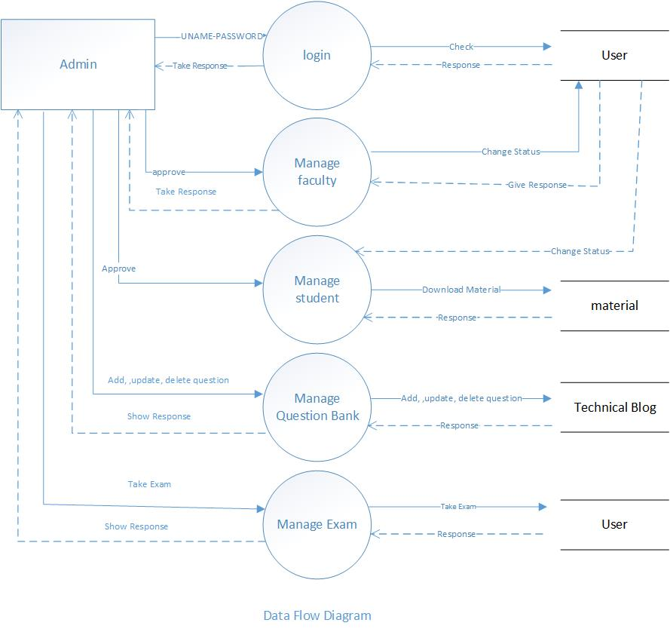

Fig: Data Flow Diagram

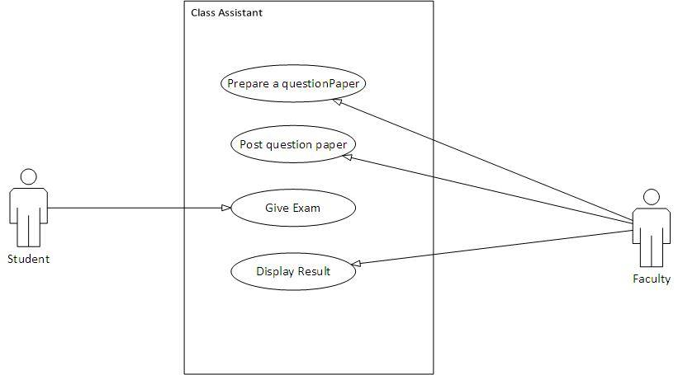

Fig: Use Case Diagram

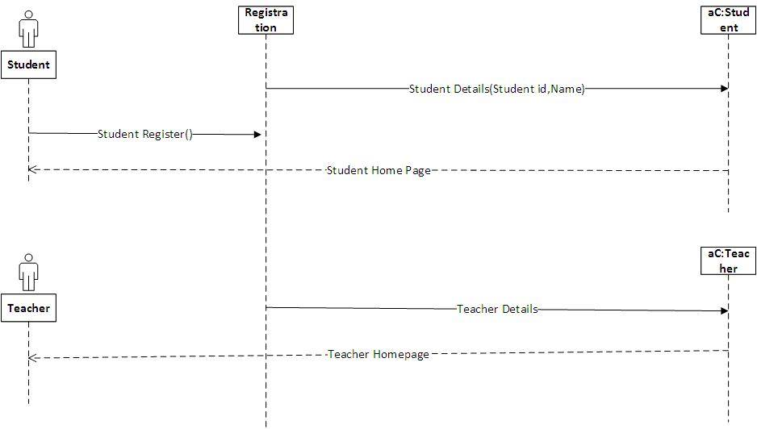

Fig: Sequence Diagram

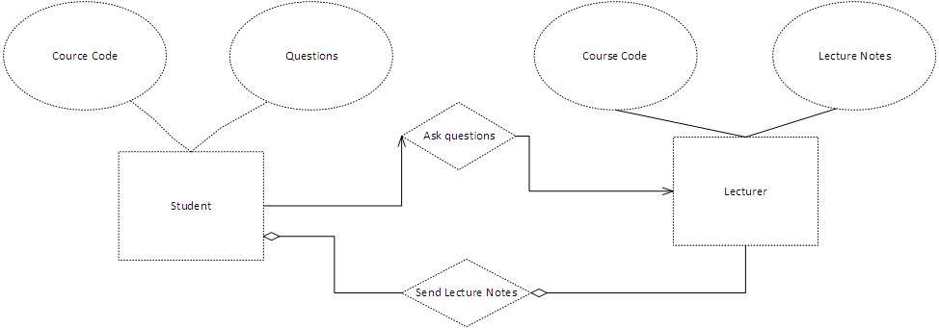

**Fig: ER- Diagram**

**Audience:**

Three types of audience of this system like students, teachers, admin etc. The role of the audience is described here.

**Teachers**:

Teachers can create posts ,add courses, check assignment ,upload lectures.

**Students:**

Students will be able to view all post. After registration a student can participate in different courses , submit assignment and also can participate in exams . All registered students post their personal details to admin. When users post admin received approve notification by his/her email. When admin approved users post it will visible for show all students. Users can manage their personal details and also he/she able to updates and delete his/her post.

**Admin:**

Admin control & access the whole system. Admin can approve or cancel property post, add new property, manage all property records.

**Special features:**

Our project has some special features which distinguish this project from the existing system. The special features of this project are states below-

* Mail verification
* Notification
* Subscriber

**Tools & Technology:**

Tools and technology that will be used to create the system in this project are given below –

**Technology Used:**

* HTML5 and CSS3 for creating the user interface of the system.
* PHP (Larvalframework) will be used for creating business logic and process inside the system.
* MySQL will be used to create the centralized database storage of the system.

**Software requirements:**

* PHP 7.1.3
* XAMPP Server
* Text Editor ( Sublime Text)

**Hardware requirements:**

* Intel Dual core or higher processor.
* 2GB Ram or higher.
* 312GB HDD or higher.
* Network Connectivity.

**System Design**

**ER Diagram:**

An entity relationship diagram (ERD) shows the relationships of entity sets stored in a database. An entity in this context is a component of data. In other words, ER diagrams illustrate the logical structure of databases.

**Functional Requirement:**

Functional Requirements are the statement of services the system should provide how the system should react to the user in a particular situation. It includes system analysis.

* Register user.
* Login user.
* Add Course
* Delete Courses
* Upload lectures
* Get lectures

**Non-functional Requirement:**

A non-functional requirement is a requirement that specifies criteria that can be used to judge the operation of a system, rather than specific behaviors.

* User authentication

**Classroom Assistant strategy:**

Classroom Assistantis a web-based application. The best features of this application is to provide online education without any hazard. This application is for communication between teacher and student. In this system will be able to keep all data and safe and secure. Today’s onlinebased learning need to keep more information. Without a solid system for students , teachers and administrator to share lecturesand student’s information can be lost. To remain competitive, system needs a simple solution that can run individual function, connect entire operation, use the wed as a key communication tool and simplify day to day operational responsibilities giving staff more than time with user.

**Class Assistance for Students:**

* Register as a user for login.
* View new post
* View details about Courses
* Search Course categorized by name, course id.
* Submit assignment
* Can participate exam
* Students can contact contact with teacher through email.
* Students will be notified latest post.

**Class Assistance forTeacher:**

* Add courses
* Upload lectures
* Check assignments
* Arrange exam
* Provide result
* Create post under courses

**Class Assistance for Admin:**

* Manages all administrative records with safe and secure.
* Property approving system.
* Property post system.
* Manage
* View notification & subscribers.

**Conclusion:**

The classroom assistant transcends the boundaries of location, time and space providing a flexible learning environment for all. Schools, universities and corporate organizations benefit form classrooms because it provides an excellent way for experts to teach a geographically dispersed group of students without hassle.

**References:**

1) Giesbertz, Wil, Rusman, Ellen,Spoelstra, Howard en Wigman, Marcel(2008).

*Verder met de virtueleklas*Heerlen: Open Universiteit Nederland ± IPO.

2) Rusman, Ellen en Giesbertz, Wil(2008).*Gebruikerservaringen met eenvirtueleklas.*Heerlen: Open Universiteit Nederland ± IPO.

--------------------That’s end of pre defense documentation -----------------------------