PROGRAMMING PRACTICE

1.OBJECTIVE (TASK)
The goal of this project is to design and implement a robust, scalable Movie Database Management System using C++, demonstrating mastery in Object-Oriented Programming (OOP) principles and advanced software engineering techniques. This system will serve as both a high-performance application and an educational tool, providing insight into the application of industry-standard software design practices.

Core Objectives:
- Design a Scalable and Efficient Movie Database:
  - Develop a system that can store and manage up to 100,000 movie records, ensuring both performance and memory efficiency.
  - Implement full CRUD (Create, Read, Update, Delete) functionality, enabling seamless addition, modification, and removal of movie records.
- Apply Advanced OOP Principles:
  - Use encapsulation to safeguard data and abstraction to simplify complex operations, ensuring code maintainability.
  - Leverage inheritance and polymorphism to build an extensible system, ready for future feature enhancements.
- Integrate Advanced Functionalities:
  - Implement dynamic memory management techniques to efficiently handle large datasets, ensuring no memory leaks.
  - Ensure data persistence using binary file serialization, allowing for the automatic saving and loading of the movie database upon program exit and startup.
  - Provide powerful search and filter capabilities (e.g., by title, language, rating, and release year), enhancing user experience.
- Enhance User Experience with an Interactive Interface:
  - Design an intuitive menu-driven user interface to interact with the database.
  - Offer customizable movie rating visualizations, allowing users to choose from five distinct display styles.
- Optimize Performance and Memory Usage:
  - Focus on fast search performance and minimal memory usage, ensuring the system remains efficient even with large datasets.
  - Implement RAII (Resource Acquisition Is Initialization) for automatic and safe memory management, ensuring proper resource cleanup.

Expected Outcome:
This project will result in a fully functional and high-performance Movie Database Management System, capable of handling large datasets efficiently while demonstrating proficiency in C++ programming, memory management, and object-oriented design principles. The system will serve as both a practical tool for managing movie data and an educational resource to master advanced software development techniques. Overall, this project demonstrates the practical application of advanced C++ and OOP concepts in building a real-world, scalable software system.
2.DESIGN (METHOD&STRUCTURE)
This section outlines the design decisions and architecture for the Movie Database System. It provides an in-depth look into the system's structure, including the core components and their interactions, as well as the algorithms and memory management techniques used to ensure scalability and performance. The design focuses on Object-Oriented Programming (OOP) principles, employing best practices to create a maintainable, efficient, and extensible solution for managing movie data.
System Architecture Overview
ARCHITECTURE TYPE:

The system follows a Two-Tier Object-Oriented Architecture, where the presentation layer (console interface) directly interacts with the business logic layer, ensuring simplicity and efficient communication. This architecture is well-suited for console-based applications, offering clear structure, easy maintenance, and straightforward implementation without unnecessary complexity.

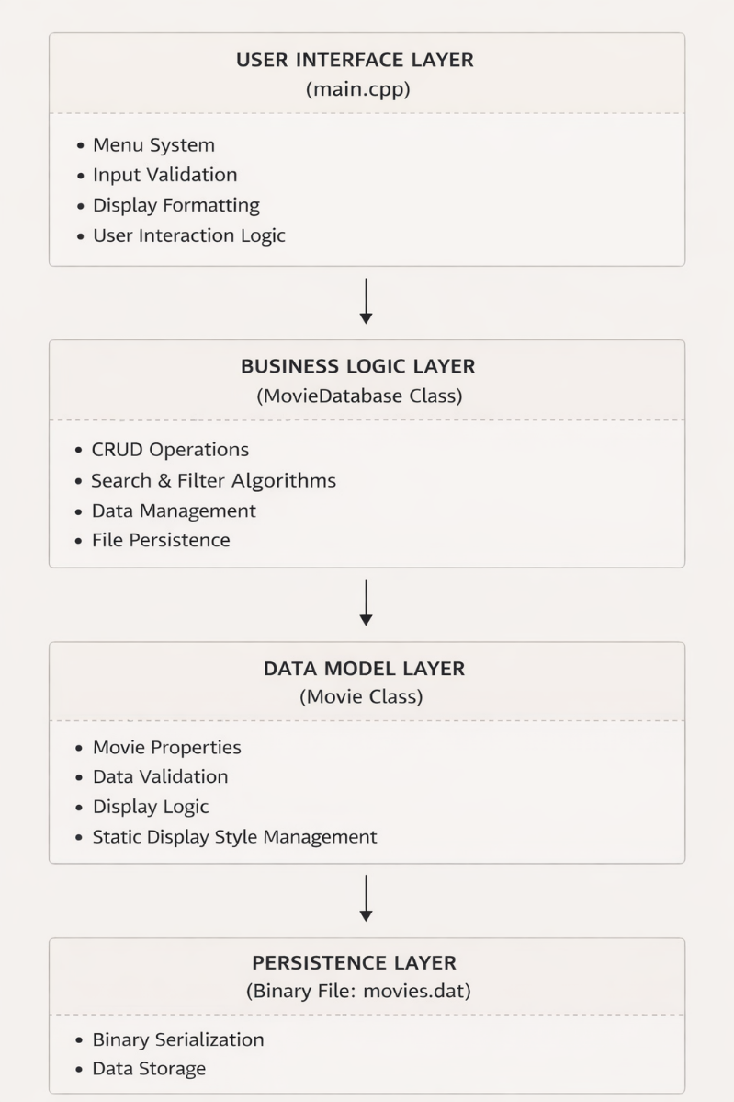
LAYERS:

Figure 1: Design Layers
Design Philosophy
- Separation of Concerns: Each layer has distinct responsibilities.
- Encapsulation: Data is protected and accessed through methods.
- Single Responsibility: Each class has one primary purpose.
- Open/Closed Principle: The system is easy to extend without modifying existing code.

CLASS DESIGN & RELATIONSHIPS
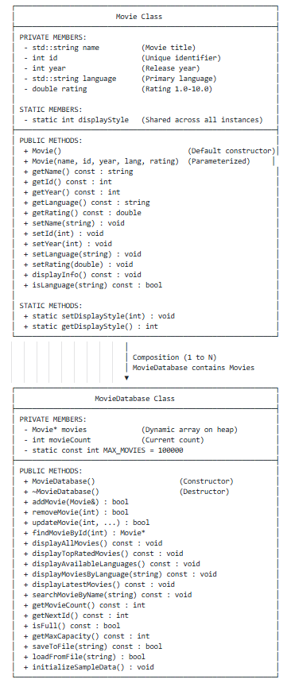

Figure 2: Class Design and Relationships

RELATIONSHIP TYPE: COMPOSITION
MovieDatabase HAS-A collection of Movie objects.
- Strong ownership: MovieDatabase manages the lifetime of Movie objects
- Movies cannot exist independently of the database in this design
- Deep coupling for efficient data management
CLASS RESPONSIBILITIES
Movie Class
- Data Container: Holds individual movie information
- Data Validation: Ensures valid rating (1.0–10.0), year (1888–2030), and ID
- Display Logic: Formats movie information for output
- Style Management: Static display style shared across all instances
MovieDatabase Class
- Collection Management: Stores and organizes movies
- CRUD Operations: Create, Read, Update, Delete functionality
- Search Algorithms: Finds movies using multiple criteria
- File Operations: Handles data saving and loading
- Memory Management: Allocates and frees dynamic memory

DATA STRUCTURES & MEMORY MANAGEMENT
Primary Data Structure
Dynamic Array (Heap-Allocated)
Declaration
Movie* movies; // Pointer to dynamic array
Allocation (Constructor)
movies = new Movie[MAX_MOVIES]; // Allocate 100,000 Movie objects on heap
Deallocation (Destructor)
delete[] movies; // Free memory when database is destroyed
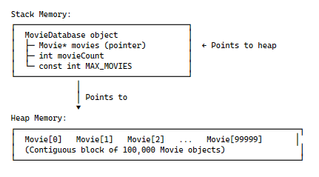
MEMORY LAYOUT:

Figure 3: Memory Layout
The Movie Database System is designed to efficiently manage a large collection of movie records using dynamic memory allocation on the heap. Each movie occupies approximately 88 bytes, resulting in a minimum memory usage of 8.4 MB for 100,000 movies, with additional memory consumed by dynamic string content. Heap allocation ensures safe memory usage, long program lifetime, scalability, and cache-friendly access.
Memory management strictly follows the RAII (Resource Acquisition Is Initialization) pattern, where resources are acquired during object construction and released during destruction. This approach guarantees automatic cleanup, except safety, and eliminates memory leaks. A static class variable is used to manage shared display styles, reducing memory overhead and maintaining consistency across all movie objects.
The system supports complete CRUD operations using simple and reliable linear algorithms. Movie insertion operates in constant time, while search, update, and deletion operations execute in linear time due to the array-based structure. Additional features such as rating-based filtering, latest-release detection, name searching, and language filtering are implemented using efficient linear and two-pass algorithms.
Persistent storage is handled through binary file serialization and deserialization, allowing fast and reliable saving and loading of large datasets. Output presentation is optimized through a switch-based display mechanism, providing multiple visual styles with constant-time execution per movie.
Overall, the system emphasizes performance, safety, clarity, and scalability, making it well-suited for large-scale data handling and as a demonstration of strong Object-Oriented Programming and software engineering practices.
PROJECT FILE HIERARCHY:
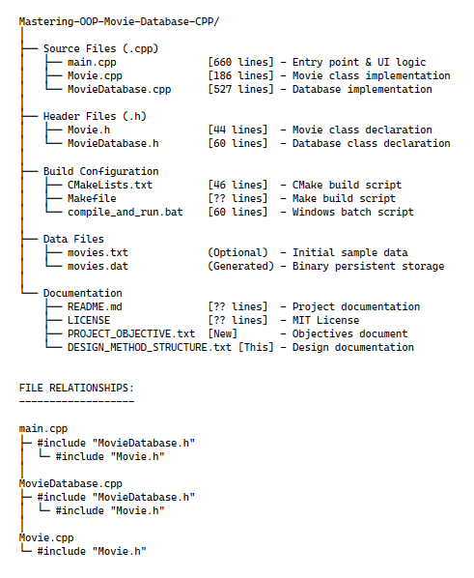

Figure 4: Project File Hierarchy& Relationships

Architecture Characteristics
Aspect | Design Choice | Rationale
Pattern | Layered Architecture | Promotes clean separation of concerns for ease of maintenance and extensibility
Data Storage | In-Memory Array | Fast access, optimal for datasets up to 100,000 records
Persistence | Binary Files | Ensures efficient data storage and retrieval with minimal I/O overhead
User Interface | Console/CLI | Simple, cross-platform, and lightweight for educational purposes
Memory Model | Heap Allocation | Efficient handling of large datasets while preventing stack overflow

Design Decisions
- Encapsulation:
  - All data members are kept private to ensure data integrity, with controlled access through getters and setters.
  - Validation logic ensures that the movie data (rating, year, language) remains consistent and within valid bounds.
- Static Member Design:
  - The displayStyle static variable is used to maintain a uniform display style across all instances of the Movie class, making it easy to change the display format at runtime.
- Validation Logic:
  - Ensures that movie ratings are between 1.0 and 10.0, and the year is within the valid movie release range (1888–2030).
Movie Entity Structure
Movie {
name: string(variable length, max ~200 chars)
id: int(4 bytes, range: 0 to MAX_INT)
year: int(4 bytes, range: 1888-2030)
language: string(variable length, max ~50 chars)
rating: double(8 bytes, range: 1.0-10.0)
}
Estimated size per movie: approximately 88–100 bytes (depending on string capacity and memory alignment).

Validation Rules
- Name: Ensured non-empty, checked for invalid input.
- ID: Always non-negative and unique.
- Year: Validated within the range of 1888–2030.
- Language: Non-empty string for language identification.
- Rating: Clamped between 1.0 and 10.0.
Note: This data model represents the logical structure of a Movie object. The actual implementation is realized using a C++ class with appropriate data types and validation logic.

Algorithm Design
CRUD Operations
- Create (Add Movie):
  - Appends a new movie to the database if space is available, with a constant time complexity of O(1).
- Read (Find Movie):
  - Performs a linear search with a time complexity of O(n) to find a movie by its ID.
- Update Movie:
  - Uses the findMovieById method to locate and update a movie’s attributes. It operates with O(n) time complexity.
- Delete (Remove Movie):
  - Removes a movie by shifting the elements, resulting in a time complexity of O(n).
Search Algorithms
- Search by Name (Substring):
  - Searches the name attribute of each movie using a linear search approach, with a time complexity of O(n).
- Filter by Language:
  - Filters movies by their language attribute using a linear search approach, with a time complexity of O(n).
- Find Top Rated:
  - Finds the highest-rated movie by iterating through all movies and comparing ratings. This algorithm performs in O(n) time.
Design Principles Applied
- SOLID Principles:
  - Single Responsibility Principle (SRP): Each class is responsible for a single task (e.g., Movie for movie details, MovieDatabase for data management).
  - Open/Closed Principle (OCP): The system is designed to be easily extensible (e.g., adding new display styles in the Movie class).
  - Liskov Substitution Principle (LSP): Not directly applied, as the current design does not use inheritance.
  - Interface Segregation Principle (ISP): Methods exposed are tailored to each class's responsibilities, with no unnecessary or excessive dependencies.
  - Dependency Inversion Principle (DIP): Higher-level modules depend on abstractions, not concrete implementations, making future modifications easy.
- DRY:
  - Code is reused effectively for validation, display, and persistence operations, reducing redundancy and enhancing maintainability.
- KISS:
  - The system uses simple, clear structures (e.g., array-based storage, linear searches), focusing on ease of understanding and effectiveness.
- YAGNI:
  - Features such as multi-threading, GUI, and network functionalities have been deliberately excluded, keeping the focus on core functionality and educational values.
Error Handling Design
- Input Validation:
  - Ensures all data entered by the user is validated before being used. Invalid input is rejected with clear error messages.
- File I/O:
  - Error handling for file operations ensures that the system can recover gracefully if the database file is missing or corrupted, and default data is loaded if needed.
- Memory Safety:
  - RAII ensures that memory is cleaned up properly, preventing leaks and ensuring resource safety.

Algorithm Documentation
1. System Overview
The Movie Database System is an Object-Oriented application developed using C++, designed to efficiently manage a large-scale movie collection of up to 100,000 records. The system supports full CRUD operations (Create, Read, Update, Delete), multiple rating display styles, and binary file persistence to ensure data durability across program executions.
2. Main Program Flow
Algorithm: Main Execution Flow
BEGIN
1. Create MovieDatabase object
2. Load data from file or initialize sample data
3. Display program header and welcome message
4. WHILE program is running:
a. Display menu (10 options + Exit)
b. Read user input
c. Execute selected operation using SWITCH statement
d. Pause for user input (except Exit)
5. Display exit message
END
3. Core Operations
3.1 Add Movie
1. Check if database has reached maximum capacity
2. Generate a unique movie ID
3. Clear input buffer
4. Prompt user for movie details:
- Name
- Release Year
- Language
- Rating
5. Create Movie object
6. Insert movie into database
7. Save updated database to file
3.2 Remove Movie
1. Prompt user to enter movie ID
2. Locate movie by ID
3. Remove movie from database
4. Shift remaining elements to maintain continuity
5. Save updated database to file
3.3 Update Movie
1. Prompt user for movie ID
2. Locate movie in database
3. Display existing movie information
4. Prompt for new values (empty input retains old value)
5. Update movie attributes
6. Save changes to file
3.4 Search Movie by Name
1. Accept search keyword from user
2. Convert keyword to lowercase
3. Traverse database:
- Compare movie names (case-insensitive)
4. Display all matching results
3.5 Filter Movies by Language
1. Display available languages
2. Accept language input from user
3. Traverse database:
- Match language (case-insensitive)
4. Display filtered results

4. MovieDatabase Class Methods
4.1 addMovie(movie)
IF movieCount < MAX_MOVIES:
movies[movieCount] = movie
movieCount++
RETURN true
RETURN false
4.2 removeMovie(id)
FOR i = 0 to movieCount - 1:
IF movies[i].getId() == id:
Shift all elements after index i left by one
movieCount--
RETURN true
RETURN false

4.3 findMovieById(id)
FOR i = 0 to movieCount - 1:
IF movies[i].getId() == id:
RETURN reference to movies[i]
RETURN null
4.4 searchMovieByName(term)
Convert search term to lowercase
FOR each movie in database:
IF movie name contains search term:
Display movie

4.5 Display Top-Rated Movies
FOR each movie in database:
IF rating >= 9.0:
Display movie

4.6 Display Latest Movies
Determine most recent release year
FOR each movie:
IF year >= (maxYear - 2):
Display movie

5. File Operations
5.1 saveToFile(filename)
1. Open binary file in write mode
2. Write total movie count
3. FOR each movie:
- Write name length and name
- Write ID, release year
- Write language length and language
- Write rating
4. Close file

5.2 loadFromFile(filename)
1. Open binary file in read mode
2. Read movie count
3. FOR each movie:
- Read name length and name
- Read ID, release year
- Read language length and language
- Read rating
4. Close file

6. Movie Class
6.1 displayInfo()
1. Display movie ID, name, year, and language
2. SWITCH displayStyle:
Case 0: [*****-----] rating / 10
Case 1: [#####.....] rating / 10
Case 2: [ooooo.....] rating / 10
Case 3: [+++++ ] rating / 10
Case 4: Numeric rating (rating / 10.0)

7. Complexity Analysis
Operation | Time Complexity | Space Complexity
Add Movie | O(1) | O(1)
Remove Movie | O(n) | O(1)
Search / Find | O(n) | O(1)
Display | O(n) | O(1)
Save / Load | O(n) | O(n)
Total Space Complexity:
O(100,000) — fixed upper bound for maximum movie storage.
8. Key Object-Oriented Concepts Used
- Encapsulation: Private data members accessed via getters and setters
- Abstraction: Simplified interfaces for complex database operations
- Composition: MovieDatabase class contains Movie objects
- Static Members: Shared display style across all movie objects
- Resource Management: Dynamic memory allocation with proper destructor cleanup

9. Data Structures Used
- Dynamic Array: Heap-allocated array of Movie objects
- Static Variable: Shared display style configuration

End of Condensed Algorithm Documentation
Flowchart Documentation

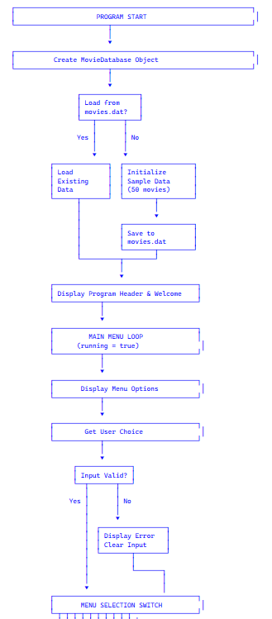

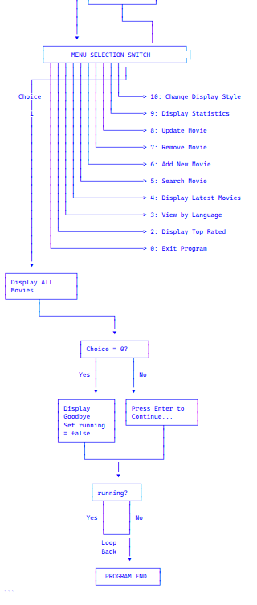

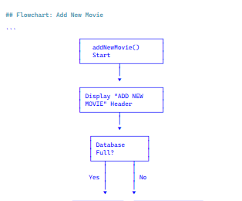

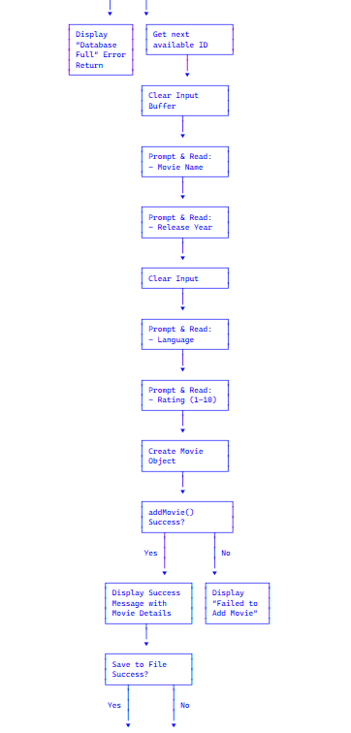
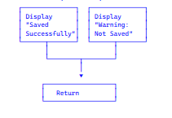

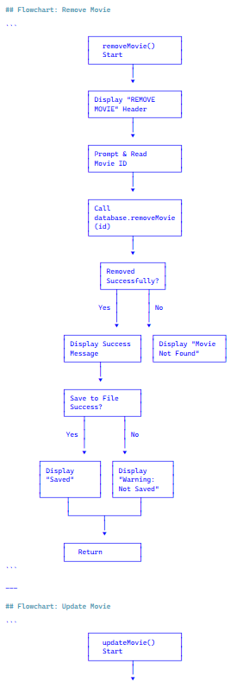
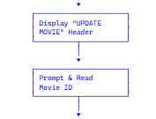

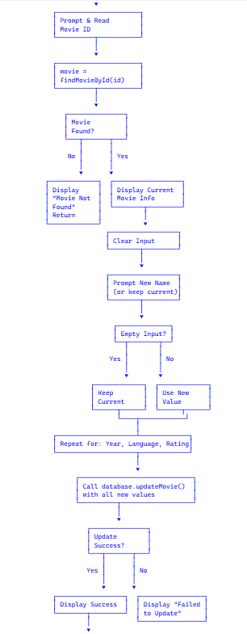

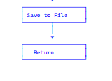

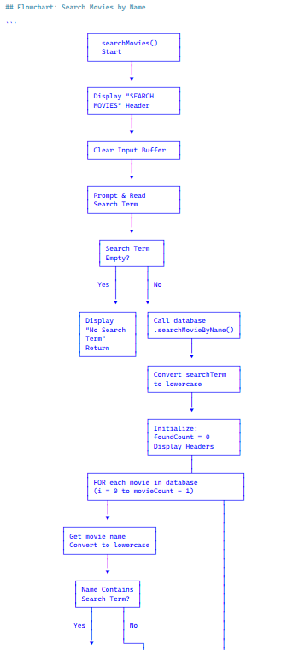
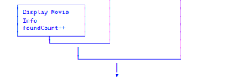

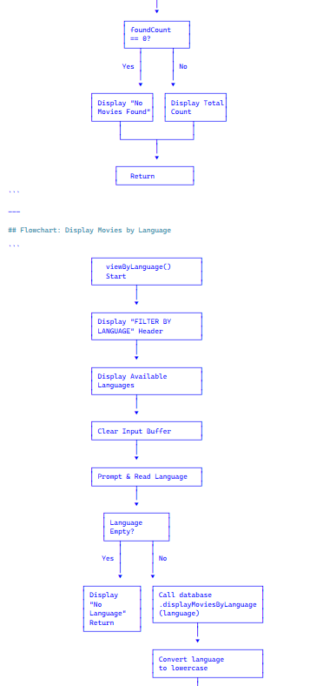
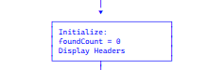

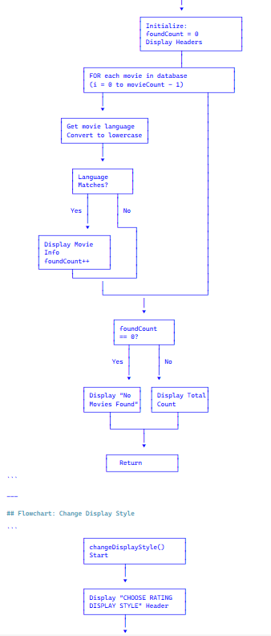
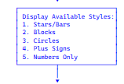

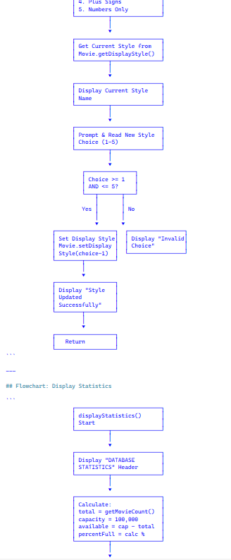
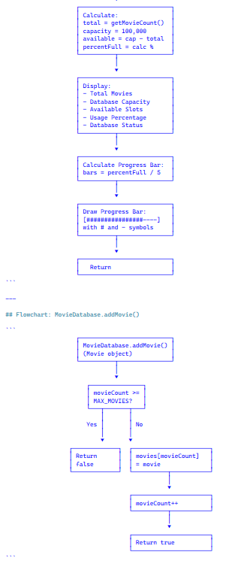

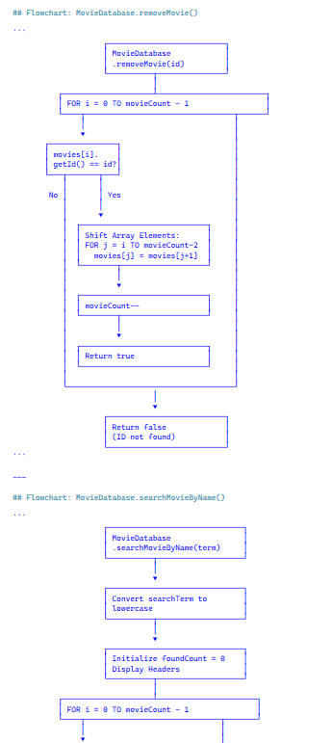
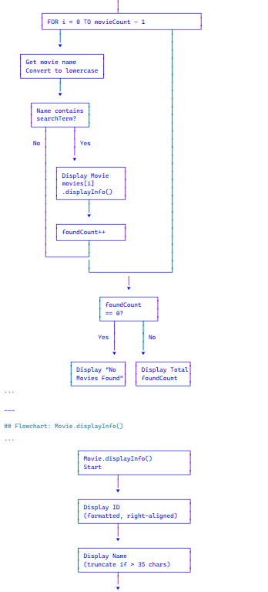
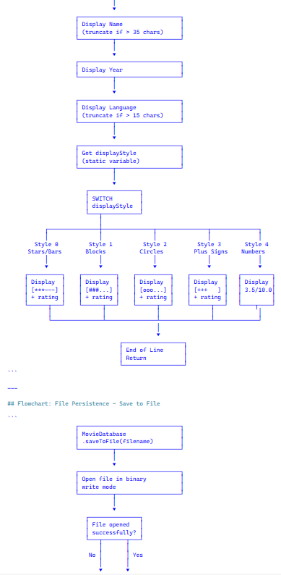
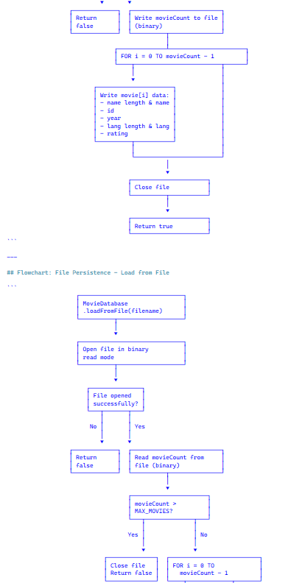
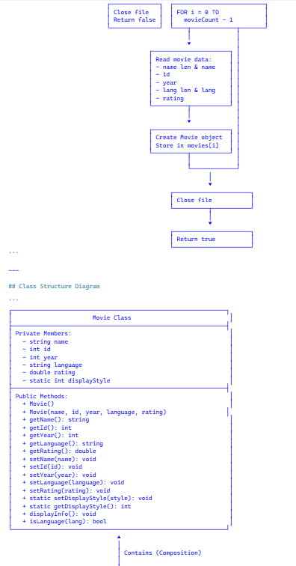

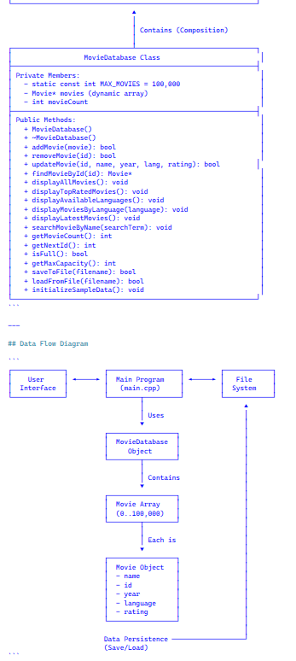
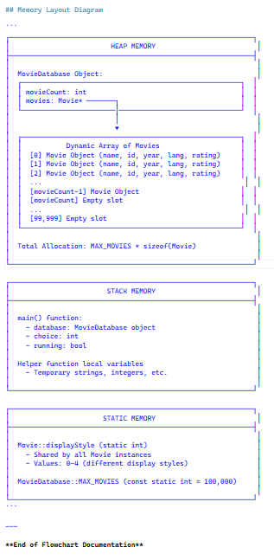

End of Flow Chart Diagram

3. IMPLEMENTATION (CODE)

movie.h
#ifndef MOVIE_H
#define MOVIE_H
#include <string>
// Movie class represents a single movie with its properties
class Movie {
private:
// Movie attributes
std::string name;
int id;
int year;
std::string language;
double rating; // Rating from 1.0 to 10.0
// Static variable to hold the current display style
static int displayStyle; // 0=stars, 1=blocks, 2=circles, 3=plus, 4=numbers
public:
// Constructors
Movie();
Movie(const std::string& name, int id, int year, const std::string& language, double rating);
// Getters to access private data
std::string getName() const;
int getId() const;
int getYear() const;
std::string getLanguage() const;
double getRating() const;
// Setters to modify private data
void setName(const std::string& name);
void setId(int id);
void setYear(int year);
void setLanguage(const std::string& language);
void setRating(double rating);
// Static method to set display style for all movies
static void setDisplayStyle(int style);
static int getDisplayStyle();
// Display movie information
void displayInfo() const;
// Check if movie is in a specific language
bool isLanguage(const std::string& lang) const;
};
#endif // MOVIE_H

MovieDatabase.h

#ifndef MOVIEDATABASE_H
#define MOVIEDATABASE_H
#include "Movie.h"
#include <vector>
// This class manages a collection of movies
class MovieDatabase
{
private:
static const int MAX_MOVIES = 100000; // Maximum capacity: 100,000 movies!
Movie *movies; // Dynamic array to store all movies (heap allocation)
int movieCount; // Keep track of how many movies we have
public:
// Constructor
MovieDatabase();
// Destructor to free memory
~MovieDatabase();
// Add a movie to the database
bool addMovie(const Movie &movie);
// Remove a movie by ID
bool removeMovie(int id);
// Update movie information
bool updateMovie(int id, const std::string &name, int year, const std::string &language, double rating);
// Find a movie by ID
Movie *findMovieById(int id);
// Show all movies in the database
void displayAllMovies() const;
// Find and show the highest rated movies
void displayTopRatedMovies() const;
// Add a method to get all unique languages
void displayAvailableLanguages() const;
// Show movies in a specific language
void displayMoviesByLanguage(const std::string &language) const;
// Show the most recent movies
void displayLatestMovies() const;
// Search movie by name
void searchMovieByName(const std::string &searchTerm) const;
// Get total number of movies
int getMovieCount() const;
// Get next available ID
int getNextId() const;
// Check if database is full
bool isFull() const;
// Get maximum capacity
int getMaxCapacity() const;
// File persistence methods
bool saveToFile(const std::string &filename = "movies.dat") const;
bool loadFromFile(const std::string &filename = "movies.dat");
// Load movies from movies.txt file into database
void initializeSampleData();
};
#endif // MOVIEDATABASE_H
MovieDisplays.h
#ifndef MOVIE_DISPLAY_H
#define MOVIE_DISPLAY_H
#include <string>
#include <iostream>
// Helper class for beautiful console output
class MovieDisplay
{
public:
// Different rating display styles
enum RatingStyle
{
STYLE_BARS, // [*****] or [***--]
STYLE_BLOCKS, // [?????] or [?????]
STYLE_NUMBERS, // 5.0/5.0
STYLE_DOTS, // [�����] or [�����]
STYLE_PLUS // [+++++] or [+++ ]
};
// Display rating with selected style
static std::string getRatingDisplay(int rating, RatingStyle style = STYLE_BARS)
{
std::string result = "[";
switch (style)
{
case STYLE_BARS:
for (int i = 0; i < rating; i++)
result += "*";
for (int i = rating; i < 5; i++)
result += "-";
break;
case STYLE_BLOCKS:
for (int i = 0; i < rating; i++)
result += "#";
for (int i = rating; i < 5; i++)
result += ".";
break;
case STYLE_NUMBERS:
result = "";
return std::to_string(rating) + ".0/5.0";
case STYLE_DOTS:
for (int i = 0; i < rating; i++)
result += "o";
for (int i = rating; i < 5; i++)
result += ".";
break;
case STYLE_PLUS:
for (int i = 0; i < rating; i++)
result += "+";
for (int i = rating; i < 5; i++)
result += " ";
break;
}
result += "] " + std::to_string(rating) + "/5";
return result;
}
// Draw a fancy box around text
static void drawBox(const std::string &title, int width = 100)
{
std::cout << std::string(width, '=') << std::endl;
int padding = (width - title.length()) / 2;
std::cout << std::string(padding, ' ') << title << std::endl;
std::cout << std::string(width, '=') << std::endl;
}
// Draw separator line
static void drawLine(char character = '-', int width = 100)
{
std::cout << std::string(width, character) << std::endl;
}
};
#endif // MOVIE_DISPLAY_H

main.cpp
#include <iostream>
#include <iomanip>
#include <limits>
#include "MovieDatabase.h"
using namespace std;
// Function to clear input buffer
void clearInput() {
cin.clear();
cin.ignore(numeric_limits<streamsize>::max(), '\n');
}
// Function to display the main menu
void displayMenu() {
cout << "\n" << string(100, '=') << endl;
cout << " MOVIE DATABASE MENU" << endl;
cout << string(100, '=') << endl;
cout << " 1. View All Movies" << endl;
cout << " 2. View Top-Rated Movies" << endl;
cout << " 3. View Movies by Language" << endl;
cout << " 4. View Latest Movies" << endl;
cout << " 5. Search Movie by Name" << endl;
cout << " 6. Add New Movie" << endl;
cout << " 7. Remove Movie" << endl;
cout << " 8. Update Movie Information" << endl;
cout << " 9. View Database Statistics" << endl;
cout << " 10. Change Display Style" << endl;
cout << " 0. Exit Program" << endl;
cout << string(100, '=') << endl;
cout << "Enter your choice (0-10): ";
}
// Function to change rating display style
void changeDisplayStyle() {
cout << "\n" << string(100, '=') << endl;
cout << " CHOOSE RATING DISPLAY STYLE" << endl;
cout << string(100, '=') << endl;
cout << "\nAvailable styles:" << endl;
cout << " 1. Stars/Bars [**********] [*******---]" << endl;
cout << " 2. Blocks [##########] [#######...]" << endl;
cout << " 3. Circles [oooooooooo] [ooooooo...]" << endl;
cout << " 4. Plus Signs [++++++++++] [+++++++ ]" << endl;
cout << " 5. Numbers Only 9.5/10.0" << endl;
cout << "\nCurrent style: ";
int currentStyle = Movie::getDisplayStyle();
switch(currentStyle) {
case 0: cout << "Stars/Bars"; break;
case 1: cout << "Blocks"; break;
case 2: cout << "Circles"; break;
case 3: cout << "Plus Signs"; break;
case 4: cout << "Numbers Only"; break;
}
cout << "\n\nEnter new style (1-5): ";
int choice;
cin >> choice;
if (choice >= 1 && choice <= 5) {
Movie::setDisplayStyle(choice - 1);
cout << "\n? Display style updated successfully!" << endl;
cout << "All movie ratings will now display in the new style." << endl;
} else {
cout << "\n? Invalid choice!" << endl;
}
}
// Function to add a new movie
void addNewMovie(MovieDatabase& database) {
cout << "\n" << string(100, '=') << endl;
cout << " ADD NEW MOVIE" << endl;
cout << string(100, '=') << endl;
if (database.isFull()) {
cout << "\nError: Database is full! Cannot add more movies." << endl;
return;
}
string name, language;
int year;
double rating;
int id = database.getNextId();
clearInput();
cout << "\nEnter movie name: ";
getline(cin, name);
cout << "Enter release year: ";
cin >> year;
clearInput();
cout << "Enter language: ";
getline(cin, language);
cout << "Enter rating (1.0-10.0): ";
cin >> rating;
Movie newMovie(name, id, year, language, rating);
if (database.addMovie(newMovie)) {
cout << "\n" << string(60, '=') << endl;
cout << " SUCCESS! Movie added to database" << endl;
cout << string(60, '=') << endl;
cout << " Movie ID: " << id << endl;
cout << " Name: " << name << endl;
cout << " Rating: ";
// Show rating in current style
cout << "[";
int stars = (int)rating;
int currentStyle = Movie::getDisplayStyle();
switch(currentStyle) {
case 0: for (int i = 0; i < stars; i++) cout << "*"; for (int i = stars; i < 10; i++) cout << "-"; break;
case 1: for (int i = 0; i < stars; i++) cout << "#"; for (int i = stars; i < 10; i++) cout << "."; break;
case 2: for (int i = 0; i < stars; i++) cout << "o"; for (int i = stars; i < 10; i++) cout << "."; break;
case 3: for (int i = 0; i < stars; i++) cout << "+"; for (int i = stars; i < 10; i++) cout << " "; break;
case 4: cout << fixed << setprecision(1) << rating << "/10.0"; break;
}
if (currentStyle != 4) {
cout << "] " << fixed << setprecision(1) << rating << "/10";
}
cout << endl;
cout << string(60, '=') << endl;
// Save changes to file
if (database.saveToFile("movies.dat")) {
cout << "\n? Changes saved successfully!" << endl;
} else {
cout << "\n? Warning: Could not save changes to file!" << endl;
}
} else {
cout << "\n? Failed to add movie." << endl;
}
}
// Function to remove a movie
void removeMovie(MovieDatabase& database) {
cout << "\n" << string(100, '=') << endl;
cout << " REMOVE MOVIE" << endl;
cout << string(100, '=') << endl;
int id;
cout << "\nEnter the ID of the movie to remove: ";
cin >> id;
if (database.removeMovie(id)) {
cout << "\n" << string(60, '=') << endl;
cout << " SUCCESS! Movie removed from database" << endl;
cout << " Movie ID: " << id << endl;
cout << string(60, '=') << endl;

// Save changes to file
if (database.saveToFile("movies.dat")) {
cout << "\n? Changes saved successfully!" << endl;
} else {
cout << "\n? Warning: Could not save changes to file!" << endl;
}
} else {
cout << "\n? Movie not found with ID: " << id << endl;
}
}
// Function to update a movie
void updateMovie(MovieDatabase& database) {
cout << "\n" << string(100, '=') << endl;
cout << " UPDATE MOVIE" << endl;
cout << string(100, '=') << endl;

int id;
cout << "\nEnter the ID of the movie to update: ";
cin >> id;

Movie* movie = database.findMovieById(id);
if (movie == nullptr) {
cout << "\n? Movie not found with ID: " << id << endl;
return;
}
// Display current information
cout << "\n" << string(60, '-') << endl;
cout << "Current movie information:" << endl;
cout << string(60, '-') << endl;
cout << "Name: " << movie->getName() << endl;
cout << "Year: " << movie->getYear() << endl;
cout << "Language: " << movie->getLanguage() << endl;
cout << fixed << setprecision(1);
cout << "Rating: " << movie->getRating() << "/10" << endl;
cout << string(60, '-') << endl;
// Get new information
string name, language;
int year;
double rating;
clearInput();
cout << "\nEnter new movie name (or press Enter to keep current): ";
getline(cin, name);
if (name.empty()) name = movie->getName();
cout << "Enter new release year (or 0 to keep current): ";
cin >> year;
if (year == 0) year = movie->getYear();
clearInput();
cout << "Enter new language (or press Enter to keep current): ";
getline(cin, language);
if (language.empty()) language = movie->getLanguage();
cout << "Enter new rating 1.0-10.0 (or 0 to keep current): ";
cin >> rating;
if (rating == 0.0) rating = movie->getRating();
if (database.updateMovie(id, name, year, language, rating)) {
cout << "\n" << string(60, '=') << endl;
cout << " SUCCESS! Movie updated" << endl;
cout << string(60, '=') << endl;

// Save changes to file
if (database.saveToFile("movies.dat")) {
cout << "\n? Changes saved successfully!" << endl;
} else {
cout << "\n? Warning: Could not save changes to file!" << endl;
}
} else {
cout << "\n? Failed to update movie." << endl;
}
}
// Function to search movies by name
void searchMovies(MovieDatabase& database) {
cout << "\n" << string(100, '=') << endl;
cout << " SEARCH MOVIES" << endl;
cout << string(100, '=') << endl;
string searchTerm;
clearInput();
cout << "\nEnter movie name to search (case-insensitive): ";
getline(cin, searchTerm);
// Handle empty input
if (searchTerm.empty()) {
cout << "\n? No search term entered!" << endl;
return;
}
database.searchMovieByName(searchTerm);
}
// Function to view movies by language
void viewByLanguage(MovieDatabase& database) {
cout << "\n" << string(100, '=') << endl;
cout << " FILTER BY LANGUAGE" << endl;
cout << string(100, '=') << endl;
// Show available languages
database.displayAvailableLanguages();
string language;
clearInput();
cout << "\nEnter language name (case-insensitive): ";
getline(cin, language);
// Handle empty input
if (language.empty()) {
cout << "\n? No language entered!" << endl;
return;
}
database.displayMoviesByLanguage(language);
}
// Function to display database statistics
void displayStatistics(MovieDatabase& database) {
cout << "\n" << string(100, '=') << endl;
cout << " DATABASE STATISTICS" << endl;
cout << string(100, '=') << endl;
int total = database.getMovieCount();
int capacity = database.getMaxCapacity(); // Get actual capacity (100,000)
int available = capacity - total;
float percentFull = (total * 100.0) / capacity;
cout << "\n Total Movies........: " << total << endl;
cout << " Database Capacity...: " << capacity << " movies" << endl;
cout << " Available Slots.....: " << available << " movies" << endl;
cout << " Usage Percentage....: " << fixed << setprecision(2) << percentFull << "%" << endl;
cout << " Database Status.....: " << (database.isFull() ? "FULL" : "Available") << endl;
// Draw progress bar
cout << "\n Capacity Usage: [";
int bars = (int)(percentFull / 5);
for (int i = 0; i < bars; i++) cout << "#";
for (int i = bars; i < 20; i++) cout << "-";
cout << "] " << fixed << setprecision(2) << percentFull << "%" << endl;
cout << "\n" << string(100, '=') << endl;
}
// Main program entry point
int main() {
// Create a database to store movies
MovieDatabase database;
// Try to load existing data from file
if (!database.loadFromFile("movies.dat")) {
// If file doesn't exist, load the 50 sample movies
database.initializeSampleData();
// Save initial data
database.saveToFile("movies.dat");
std::cout << "\nInitialized database with 50 sample movies." << std::endl;
} else {
std::cout << "\nLoaded existing database from file." << std::endl;
}
// Program header
cout << "\n";
cout << string(100, '=') << endl;
cout << string(100, '=') << endl;
cout << " MOVIE DATABASE MANAGEMENT SYSTEM" << endl;
cout << " Mastering Object-Oriented Programming in C++" << endl;
cout << string(100, '=') << endl;
cout << string(100, '=') << endl;
cout << "\nWelcome! The database has been initialized with " << database.getMovieCount() << " movies." << endl;
cout << "Database Capacity: " << database.getMaxCapacity() << " movies (Plenty of room to grow!)" << endl;
cout << "Tip: Try option 10 to change the rating display style!" << endl;
// Main program loop
int choice;
bool running = true;
while (running) {
displayMenu();
cin >> choice;
// Check for input errors
if (cin.fail()) {
cout << "\n? Invalid input! Please enter a number between 0 and 10." << endl;
clearInput();
continue;
}
switch (choice) {
case 1:
database.displayAllMovies();
break;
case 2:
database.displayTopRatedMovies();
break;
case 3:
viewByLanguage(database);
break;
case 4:
database.displayLatestMovies();
break;
case 5:
searchMovies(database);
break;
case 6:
addNewMovie(database);
break;
case 7:
removeMovie(database);
break;
case 8:
updateMovie(database);
break;
case 9:
displayStatistics(database);
break;
case 10:
changeDisplayStyle();
break;
case 0:
cout << "\n" << string(100, '=') << endl;
cout << " THANK YOU FOR USING THE SYSTEM!" << endl;
cout << string(100, '=') << endl;
cout << "\nOOP Concepts Demonstrated:" << endl;
cout << " � Encapsulation: Private data with public methods" << endl;
cout << " � Abstraction: Complex operations hidden behind simple interfaces" << endl;
cout << " � Composition: MovieDatabase contains Movie objects" << endl;
cout << " � Data Validation: Input checking and error handling" << endl;
cout << " � User Interaction: Menu-driven interface with multiple display styles" << endl;
cout << "\nTotal Movies in Database: " << database.getMovieCount() << endl;
cout << "\nProgram terminated successfully." << endl;
cout << string(100, '=') << endl;
running = false;
break;
default:
cout << "\n? Invalid choice! Please enter a number between 0 and 10." << endl;
break;
}
// Pause before showing menu again (except on exit)
if (running) {
cout << "\nPress Enter to continue...";
clearInput();
cin.get();
}
}
return 0;
}

movie.cpp
#include "Movie.h"
#include <iostream>
#include <iomanip>
// Initialize static member
int Movie::displayStyle = 0; // Default to stars/bars
// Default constructor initializes everything to default values
Movie::Movie() : name(""), id(0), year(0), language(""), rating(0.0) {}
// Constructor that takes all movie details as parameters
Movie::Movie(const std::string& name, int id, int year, const std::string& language, double rating)
: name(name), id(id), year(year), language(language), rating(rating) {
// Make sure rating stays between 1.0 and 10.0
if (this->rating < 1.0) this->rating = 1.0;
if (this->rating > 10.0) this->rating = 10.0;
// Validate year to be reasonable (first film was 1888, future limit 2030)
if (this->year < 1888) this->year = 1888;
if (this->year > 2030) this->year = 2030;
// ID should not be negative
if (this->id < 0) this->id = 0;
}
// Return the movie name
std::string Movie::getName() const {
return name;
}
// Return the movie ID
int Movie::getId() const {
return id;
}
// Return the release year
int Movie::getYear() const {
return year;
}
// Return the movie language
std::string Movie::getLanguage() const {
return language;
}
// Return the rating
double Movie::getRating() const {
return rating;
}
// Update the movie name
void Movie::setName(const std::string& name) {
this->name = name;
}
// Update the movie ID
void Movie::setId(int id) {
this->id = id;
}
// Update the release year
void Movie::setYear(int year) {
this->year = year;
}
// Update the language
void Movie::setLanguage(const std::string& language) {
this->language = language;
}
// Update the rating (only accepts 1.0-10.0)
void Movie::setRating(double rating) {
if (rating >= 1.0 && rating <= 10.0) {
this->rating = rating;
}
}
// Static method to set display style
void Movie::setDisplayStyle(int style) {
if (style >= 0 && style <= 4) {
displayStyle = style;
}
}
// Static method to get display style
int Movie::getDisplayStyle() {
return displayStyle;
}
// Print movie information in a nice format
void Movie::displayInfo() const {
std::cout << std::left << std::setw(5) << id
<< std::setw(50) << name
<< std::setw(6) << year
<< std::setw(15) << language;
// Show rating based on current display style
std::cout << "[";
int stars = (int)(rating); // Full stars
switch(displayStyle) {
case 0: // Stars/Bars [**********] [*******---]
for (int i = 0; i < stars; i++) std::cout << "*";
for (int i = stars; i < 10; i++) std::cout << "-";
std::cout << "] " << std::fixed << std::setprecision(1) << rating << "/10";
break;
case 1: // Blocks [##########] [#######...]
for (int i = 0; i < stars; i++) std::cout << "#";
for (int i = stars; i < 10; i++) std::cout << ".";
std::cout << "] " << std::fixed << std::setprecision(1) << rating << "/10";
break;
case 2: // Circles [oooooooooo] [ooooooo...]
for (int i = 0; i < stars; i++) std::cout << "o";
for (int i = stars; i < 10; i++) std::cout << ".";
std::cout << "] " << std::fixed << std::setprecision(1) << rating << "/10";
break;
case 3: // Plus Signs [++++++++++] [+++++++ ]
for (int i = 0; i < stars; i++) std::cout << "+";
for (int i = stars; i < 10; i++) std::cout << " ";
std::cout << "] " << std::fixed << std::setprecision(1) << rating << "/10";
break;
case 4: // Numbers Only
std::cout << std::fixed << std::setprecision(1) << rating << "/10.0]";
break;
default: // Fallback to stars
for (int i = 0; i < stars; i++) std::cout << "*";
for (int i = stars; i < 10; i++) std::cout << "-";
std::cout << "] " << std::fixed << std::setprecision(1) << rating << "/10";
break;
}
std::cout << std::endl;
}
// Helper function to check if this movie is in a particular language (case-insensitive)
bool Movie::isLanguage(const std::string& lang) const {
std::string lowerLang1 = language;
std::string lowerLang2 = lang;

// Convert both to lowercase for case-insensitive comparison
for (size_t i = 0; i < lowerLang1.length(); i++) {
lowerLang1[i] = tolower(lowerLang1[i]);
}
for (size_t i = 0; i < lowerLang2.length(); i++) {
lowerLang2[i] = tolower(lowerLang2[i]);
}
return lowerLang1 == lowerLang2;
}

MovieDatabase.cpp
#include "MovieDatabase.h"
#include <iostream>
#include <iomanip>
#include <string>
#include <algorithm>
#include <fstream>

// Initialize empty database with dynamic memory allocation
MovieDatabase::MovieDatabase() : movieCount(0) {
movies = new Movie[MAX_MOVIES]; // Allocate memory on heap for 100,000 movies
}

// Destructor to free allocated memory
MovieDatabase::~MovieDatabase() {
delete[] movies; // Free the dynamically allocated memory
}

// Try to add a movie if there's space
bool MovieDatabase::addMovie(const Movie& movie) {
if (movieCount < MAX_MOVIES) {
movies[movieCount] = movie;
movieCount++;
return true;
}
return false;
}

// Remove a movie by its ID
bool MovieDatabase::removeMovie(int id) {
// Find the movie with the given ID
for (int i = 0; i < movieCount; i++) {
if (movies[i].getId() == id) {
// Shift all movies after this one to the left
for (int j = i; j < movieCount - 1; j++) {
movies[j] = movies[j + 1];
}
movieCount--;
return true;
}
}
return false; // Movie not found
}
// Update movie information
bool MovieDatabase::updateMovie(int id, const std::string& name, int year, const std::string& language, double rating) {
Movie* movie = findMovieById(id);
if (movie != nullptr) {
movie->setName(name);
movie->setYear(year);
movie->setLanguage(language);
movie->setRating(rating);
return true;
}
return false;
}
// Find a movie by ID and return pointer to it
Movie* MovieDatabase::findMovieById(int id) {
for (int i = 0; i < movieCount; i++) {
if (movies[i].getId() == id) {
return &movies[i];
}
}
return nullptr; // Not found
}
// Display all movies with a nice table format
void MovieDatabase::displayAllMovies() const {
if (movieCount == 0) {
std::cout << "\nThe database is empty!" << std::endl;
return;
}

std::cout << "\n" << std::string(100, '=') << std::endl;
std::cout << " COMPLETE MOVIE DATABASE" << std::endl;
std::cout << std::string(100, '=') << std::endl;
std::cout << std::left << std::setw(5) << "ID"
<< std::setw(50) << "Movie Name"
<< std::setw(6) << "Year"
<< std::setw(15) << "Language"
<< "Rating" << std::endl;
std::cout << std::string(100, '-') << std::endl;

for (int i = 0; i < movieCount; i++) {
movies[i].displayInfo();
}
std::cout << std::string(100, '-') << std::endl;
std::cout << "Total movies: " << movieCount << " | Capacity: " << MAX_MOVIES << " | Available: " << (MAX_MOVIES - movieCount) << std::endl;
std::cout << std::string(100, '=') << std::endl;
}

// Find the highest rating and display all movies with that rating
void MovieDatabase::displayTopRatedMovies() const {
if (movieCount == 0) {
std::cout << "\nThe database is empty!" << std::endl;
return;
}

// First loop: find the maximum rating
int maxRating = 0;
for (int i = 0; i < movieCount; i++) {
if (movies[i].getRating() > maxRating) {
maxRating = movies[i].getRating();
}
}

std::cout << "\n" << std::string(100, '=') << std::endl;
std::cout << " TOP-RATED MOVIE(S) [Rating: " << maxRating << "/5]" << std::endl;
std::cout << std::string(100, '=') << std::endl;
std::cout << std::left << std::setw(5) << "ID"
<< std::setw(50) << "Movie Name"
<< std::setw(6) << "Year"
<< std::setw(15) << "Language"
<< "Rating" << std::endl;
std::cout << std::string(100, '-') << std::endl;

// Second loop: display all movies that have the max rating
int count = 0;
for (int i = 0; i < movieCount; i++) {
if (movies[i].getRating() == maxRating) {
movies[i].displayInfo();
count++;
}
}

std::cout << std::string(100, '-') << std::endl;
std::cout << "Total top-rated movies: " << count << std::endl;
std::cout << std::string(100, '=') << std::endl;
}

// Add a method to get all unique languages
void MovieDatabase::displayAvailableLanguages() const {
std::cout << "\nAvailable languages in database:" << std::endl;

// Count movies by language
int englishCount = 0, frenchCount = 0, koreanCount = 0, japaneseCount = 0;
int italianCount = 0, spanishCount = 0, portugueseCount = 0;

for (int i = 0; i < movieCount; i++) {
std::string lang = movies[i].getLanguage();
std::transform(lang.begin(), lang.end(), lang.begin(), ::tolower);

if (lang == "english") englishCount++;
else if (lang == "french") frenchCount++;
else if (lang == "korean") koreanCount++;
else if (lang == "japanese") japaneseCount++;
else if (lang == "italian") italianCount++;
else if (lang == "spanish") spanishCount++;
else if (lang == "portuguese") portugueseCount++;
}

std::cout << " 1. English - " << std::setw(2) << englishCount << " movies" << std::endl;
std::cout << " 2. French - " << std::setw(2) << frenchCount << " movies" << std::endl;
std::cout << " 3. Korean - " << std::setw(2) << koreanCount << " movies" << std::endl;
std::cout << " 4. Japanese - " << std::setw(2) << japaneseCount << " movies" << std::endl;
std::cout << " 5. Italian - " << std::setw(2) << italianCount << " movies" << std::endl;
std::cout << " 6. Spanish - " << std::setw(2) << spanishCount << " movies" << std::endl;
std::cout << " 7. Portuguese - " << std::setw(2) << portugueseCount << " movies" << std::endl;

std::cout << "\n Total: " << movieCount << " movies across 7 languages" << std::endl;
}

// Filter and display movies by language (case-insensitive)
void MovieDatabase::displayMoviesByLanguage(const std::string& language) const {
std::cout << "\n" << std::string(100, '=') << std::endl;
std::cout << " MOVIES IN " << language << std::endl;
std::cout << std::string(100, '=') << std::endl;
std::cout << std::left << std::setw(5) << "ID"
<< std::setw(50) << "Movie Name"
<< std::setw(6) << "Year"
<< std::setw(15) << "Language"
<< "Rating" << std::endl;
std::cout << std::string(100, '-') << std::endl;

int count = 0;
for (int i = 0; i < movieCount; i++) {
if (movies[i].isLanguage(language)) {
movies[i].displayInfo();
count++;
}
}

if (count == 0) {
std::cout << "No movies found in " << language << std::endl;
std::cout << "\nTip: Language names are case-insensitive (e.g., 'english', 'ENGLISH', 'English' all work)" << std::endl;
displayAvailableLanguages();
}

std::cout << std::string(100, '-') << std::endl;
std::cout << "Total movies in " << language << ": " << count << std::endl;
std::cout << std::string(100, '=') << std::endl;
}

// Find and display the latest movies by year
void MovieDatabase::displayLatestMovies() const {
if (movieCount == 0) {
std::cout << "\nThe database is empty!" << std::endl;
return;
}

// Find the most recent year
int latestYear = 0;
for (int i = 0; i < movieCount; i++) {
if (movies[i].getYear() > latestYear) {
latestYear = movies[i].getYear();
}
}

std::cout << "\n" << std::string(100, '=') << std::endl;
std::cout << " LATEST MOVIE(S) [Year: " << latestYear << "]" << std::endl;
std::cout << std::string(100, '=') << std::endl;
std::cout << std::left << std::setw(5) << "ID"
<< std::setw(50) << "Movie Name"
<< std::setw(6) << "Year"
<< std::setw(15) << "Language"
<< "Rating" << std::endl;
std::cout << std::string(100, '-') << std::endl;

// Display all movies from that year
int count = 0;
for (int i = 0; i < movieCount; i++) {
if (movies[i].getYear() == latestYear) {
movies[i].displayInfo();
count++;
}
}

std::cout << std::string(100, '-') << std::endl;
std::cout << "Total latest movies: " << count << std::endl;
std::cout << std::string(100, '=') << std::endl;
}

// Search for movies by name (partial match, case-insensitive)
void MovieDatabase::searchMovieByName(const std::string& searchTerm) const {
std::cout << "\n" << std::string(100, '=') << std::endl;
std::cout << " SEARCH RESULTS FOR: \"" << searchTerm << "\"" << std::endl;
std::cout << std::string(100, '=') << std::endl;
std::cout << std::left << std::setw(5) << "ID"
<< std::setw(50) << "Movie Name"
<< std::setw(6) << "Year"
<< std::setw(15) << "Language"
<< "Rating" << std::endl;
std::cout << std::string(100, '-') << std::endl;

int count = 0;
std::string lowerSearchTerm = searchTerm;
std::transform(lowerSearchTerm.begin(), lowerSearchTerm.end(), lowerSearchTerm.begin(), ::tolower);

for (int i = 0; i < movieCount; i++) {
std::string movieName = movies[i].getName();
std::transform(movieName.begin(), movieName.end(), movieName.begin(), ::tolower);

// Check if movie name contains the search term
if (movieName.find(lowerSearchTerm) != std::string::npos) {
movies[i].displayInfo();
count++;
}
}

if (count == 0) {
std::cout << "No movies found matching \"" << searchTerm << "\"" << std::endl;
std::cout << "\nSearch Tips:" << std::endl;
std::cout << " � Search is case-insensitive ('inception', 'INCEPTION', 'Inception' all work)" << std::endl;
std::cout << " � Partial names work (search 'lord' finds 'Lord of the Rings')" << std::endl;
std::cout << " � Try different keywords or spellings" << std::endl;
std::cout << "\nExamples: 'godfather', 'dark knight', 'spirited', 'parasite'" << std::endl;
}

std::cout << std::string(100, '-') << std::endl;
std::cout << "Total matches: " << count << std::endl;
std::cout << std::string(100, '=') << std::endl;
}

// Return how many movies are in the database
int MovieDatabase::getMovieCount() const {
return movieCount;
}

// Get the next available ID
int MovieDatabase::getNextId() const {
int maxId = 0;
for (int i = 0; i < movieCount; i++) {
if (movies[i].getId() > maxId) {
maxId = movies[i].getId();
}
}
return maxId + 1;
}

// Check if database is full
bool MovieDatabase::isFull() const {
return movieCount >= MAX_MOVIES;
}

// Get maximum capacity
int MovieDatabase::getMaxCapacity() const {
return MAX_MOVIES;
}

// Load movies from text file into the database
void MovieDatabase::initializeSampleData() {
std::ifstream file("movies.txt");

if (!file.is_open()) {
std::cerr << "Error: Could not open movies.txt file!" << std::endl;
std::cerr << "Please ensure movies.txt exists in the program directory." << std::endl;
return;
}

std::string line;
int loadedCount = 0;

while (std::getline(file, line)) {
// Skip empty lines
if (line.empty()) {
continue;
}

// Parse the line: Name|ID|Year|Language|Rating
std::string name, language;
int id, year;
double rating;

// Find delimiter positions
size_t pos1 = line.find('|');
size_t pos2 = line.find('|', pos1 + 1);
size_t pos3 = line.find('|', pos2 + 1);
size_t pos4 = line.find('|', pos3 + 1);

if (pos1 == std::string::npos || pos2 == std::string::npos ||
pos3 == std::string::npos || pos4 == std::string::npos) {
std::cerr << "Warning: Skipping malformed line: " << line << std::endl;
continue;
}

try {
// Extract fields
name = line.substr(0, pos1);
id = std::stoi(line.substr(pos1 + 1, pos2 - pos1 - 1));
year = std::stoi(line.substr(pos2 + 1, pos3 - pos2 - 1));
language = line.substr(pos3 + 1, pos4 - pos3 - 1);
rating = std::stod(line.substr(pos4 + 1));

// Add movie to database
if (addMovie(Movie(name, id, year, language, rating))) {
loadedCount++;
} else {
std::cerr << "Warning: Could not add movie (database full): " << name << std::endl;
}
} catch (const std::exception& e) {
std::cerr << "Warning: Error parsing line: " << line << std::endl;
std::cerr << " Exception: " << e.what() << std::endl;
}
}

file.close();

std::cout << "Successfully loaded " << loadedCount << " movies from movies.txt" << std::endl;
}

// Save database to file
bool MovieDatabase::saveToFile(const std::string& filename) const {
std::ofstream file(filename, std::ios::binary);
if (!file.is_open()) {
std::cerr << "Error: Could not open file for writing: " << filename << std::endl;
return false;
}

// Write movie count
file.write(reinterpret_cast<const char*>(&movieCount), sizeof(movieCount));

// Write each movie
for (int i = 0; i < movieCount; i++) {
// Write movie ID
int id = movies[i].getId();
file.write(reinterpret_cast<const char*>(&id), sizeof(id));

// Write movie name (length + string)
std::string name = movies[i].getName();
size_t nameLen = name.length();
file.write(reinterpret_cast<const char*>(&nameLen), sizeof(nameLen));
file.write(name.c_str(), nameLen);

// Write year
int year = movies[i].getYear();
file.write(reinterpret_cast<const char*>(&year), sizeof(year));

// Write language (length + string)
std::string language = movies[i].getLanguage();
size_t langLen = language.length();
file.write(reinterpret_cast<const char*>(&langLen), sizeof(langLen));
file.write(language.c_str(), langLen);

// Write rating
double rating = movies[i].getRating();
file.write(reinterpret_cast<const char*>(&rating), sizeof(rating));
}

file.close();
return true;
}

// Load database from file
bool MovieDatabase::loadFromFile(const std::string& filename) {
std::ifstream file(filename, std::ios::binary);
if (!file.is_open()) {
// File doesn't exist yet - not an error, just use default data
return false;
}

// Read movie count
int count;
file.read(reinterpret_cast<char*>(&count), sizeof(count));

if (count < 0 || count > MAX_MOVIES) {
std::cerr << "Error: Invalid movie count in file" << std::endl;
file.close();
return false;
}

// Clear current database
movieCount = 0;

// Read each movie
for (int i = 0; i < count; i++) {
int id, year;
double rating;
std::string name, language;
size_t nameLen, langLen;

// Read movie ID
file.read(reinterpret_cast<char*>(&id), sizeof(id));

// Read movie name
file.read(reinterpret_cast<char*>(&nameLen), sizeof(nameLen));
name.resize(nameLen);
file.read(&name[0], nameLen);

// Read year
file.read(reinterpret_cast<char*>(&year), sizeof(year));

// Read language
file.read(reinterpret_cast<char*>(&langLen), sizeof(langLen));
language.resize(langLen);
file.read(&language[0], langLen);

// Read rating
file.read(reinterpret_cast<char*>(&rating), sizeof(rating));

// Add movie to database
addMovie(Movie(name, id, year, language, rating));
}

file.close();
return true;
}

MovieDatabase.cpp
#include "MovieDatabase.h"
#include <iostream>
#include <iomanip>
#include <string>
#include <algorithm>
#include <fstream>
// Initialize empty database with dynamic memory allocation
MovieDatabase::MovieDatabase() : movieCount(0)
{
movies = new Movie[MAX_MOVIES]; // Allocate memory on heap for 100,000 movies
}

// Destructor to free allocated memory
MovieDatabase::~MovieDatabase()
{
delete[] movies; // Free the dynamically allocated memory
}

// Try to add a movie if there's space
bool MovieDatabase::addMovie(const Movie &movie)
{
if (movieCount < MAX_MOVIES)
{
movies[movieCount] = movie;
movieCount++;
return true;
}
return false;
}

// Remove a movie by its ID
bool MovieDatabase::removeMovie(int id)
{
// Find the movie with the given ID
for (int i = 0; i < movieCount; i++)
{
if (movies[i].getId() == id)
{
// Shift all movies after this one to the left
for (int j = i; j < movieCount - 1; j++)
{
movies[j] = movies[j + 1];
}
movieCount--;
return true;
}
}
return false; // Movie not found
}

// Update movie information
bool MovieDatabase::updateMovie(int id, const std::string &name, int year, const std::string &language, double rating)
{
Movie *movie = findMovieById(id);
if (movie != nullptr)
{
movie->setName(name);
movie->setYear(year);
movie->setLanguage(language);
movie->setRating(rating);
return true;
}
return false;
}

// Find a movie by ID and return pointer to it
Movie *MovieDatabase::findMovieById(int id)
{
for (int i = 0; i < movieCount; i++)
{
if (movies[i].getId() == id)
{
return &movies[i];
}
}
return nullptr; // Not found
}

// Display all movies with a nice table format
void MovieDatabase::displayAllMovies() const
{
if (movieCount == 0)
{
std::cout << "\nThe database is empty!" << std::endl;
return;
}

std::cout << "\n"
<< std::string(100, '=') << std::endl;
std::cout << " COMPLETE MOVIE DATABASE" << std::endl;
std::cout << std::string(100, '=') << std::endl;
std::cout << std::left << std::setw(5) << "ID"
<< std::setw(50) << "Movie Name"
<< std::setw(6) << "Year"
<< std::setw(15) << "Language"
<< "Rating" << std::endl;
std::cout << std::string(100, '-') << std::endl;

for (int i = 0; i < movieCount; i++)
{
movies[i].displayInfo();
}
std::cout << std::string(100, '-') << std::endl;
std::cout << "Total movies: " << movieCount << " | Capacity: " << MAX_MOVIES << " | Available: " << (MAX_MOVIES - movieCount) << std::endl;
std::cout << std::string(100, '=') << std::endl;
}

// Find the highest rating and display all movies with that rating
void MovieDatabase::displayTopRatedMovies() const
{
if (movieCount == 0)
{
std::cout << "\nThe database is empty!" << std::endl;
return;
}

// First loop: find the maximum rating
int maxRating = 0;
for (int i = 0; i < movieCount; i++)
{
if (movies[i].getRating() > maxRating)
{
maxRating = movies[i].getRating();
}
}

std::cout << "\n"
<< std::string(100, '=') << std::endl;
std::cout << " TOP-RATED MOVIE(S) [Rating: " << maxRating << "/5]" << std::endl;
std::cout << std::string(100, '=') << std::endl;
std::cout << std::left << std::setw(5) << "ID"
<< std::setw(50) << "Movie Name"
<< std::setw(6) << "Year"
<< std::setw(15) << "Language"
<< "Rating" << std::endl;
std::cout << std::string(100, '-') << std::endl;

// Second loop: display all movies that have the max rating
int count = 0;
for (int i = 0; i < movieCount; i++)
{
if (movies[i].getRating() == maxRating)
{
movies[i].displayInfo();
count++;
}
}

std::cout << std::string(100, '-') << std::endl;
std::cout << "Total top-rated movies: " << count << std::endl;
std::cout << std::string(100, '=') << std::endl;
}

// Add a method to get all unique languages
void MovieDatabase::displayAvailableLanguages() const
{
std::cout << "\nAvailable languages in database:" << std::endl;

// Count movies by language
int englishCount = 0, frenchCount = 0, koreanCount = 0, japaneseCount = 0;
int italianCount = 0, spanishCount = 0, portugueseCount = 0;

for (int i = 0; i < movieCount; i++)
{
std::string lang = movies[i].getLanguage();
std::transform(lang.begin(), lang.end(), lang.begin(), ::tolower);

if (lang == "english")
englishCount++;
else if (lang == "french")
frenchCount++;
else if (lang == "korean")
koreanCount++;
else if (lang == "japanese")
japaneseCount++;
else if (lang == "italian")
italianCount++;
else if (lang == "spanish")
spanishCount++;
else if (lang == "portuguese")
portugueseCount++;
}

std::cout << " 1. English - " << std::setw(2) << englishCount << " movies" << std::endl;
std::cout << " 2. French - " << std::setw(2) << frenchCount << " movies" << std::endl;
std::cout << " 3. Korean - " << std::setw(2) << koreanCount << " movies" << std::endl;
std::cout << " 4. Japanese - " << std::setw(2) << japaneseCount << " movies" << std::endl;
std::cout << " 5. Italian - " << std::setw(2) << italianCount << " movies" << std::endl;
std::cout << " 6. Spanish - " << std::setw(2) << spanishCount << " movies" << std::endl;
std::cout << " 7. Portuguese - " << std::setw(2) << portugueseCount << " movies" << std::endl;

std::cout << "\n Total: " << movieCount << " movies across 7 languages" << std::endl;
}

// Filter and display movies by language (case-insensitive)
void MovieDatabase::displayMoviesByLanguage(const std::string &language) const
{
std::cout << "\n"
<< std::string(100, '=') << std::endl;
std::cout << " MOVIES IN " << language << std::endl;
std::cout << std::string(100, '=') << std::endl;
std::cout << std::left << std::setw(5) << "ID"
<< std::setw(50) << "Movie Name"
<< std::setw(6) << "Year"
<< std::setw(15) << "Language"
<< "Rating" << std::endl;
std::cout << std::string(100, '-') << std::endl;

int count = 0;
for (int i = 0; i < movieCount; i++)
{
if (movies[i].isLanguage(language))
{
movies[i].displayInfo();
count++;
}
}

if (count == 0)
{
std::cout << "No movies found in " << language << std::endl;
std::cout << "\nTip: Language names are case-insensitive (e.g., 'english', 'ENGLISH', 'English' all work)" << std::endl;
displayAvailableLanguages();
}

std::cout << std::string(100, '-') << std::endl;
std::cout << "Total movies in " << language << ": " << count << std::endl;
std::cout << std::string(100, '=') << std::endl;
}

// Find and display the latest movies by year
void MovieDatabase::displayLatestMovies() const
{
if (movieCount == 0)
{
std::cout << "\nThe database is empty!" << std::endl;
return;
}

// Find the most recent year
int latestYear = 0;
for (int i = 0; i < movieCount; i++)
{
if (movies[i].getYear() > latestYear)
{
latestYear = movies[i].getYear();
}
}

std::cout << "\n"
<< std::string(100, '=') << std::endl;
std::cout << " LATEST MOVIE(S) [Year: " << latestYear << "]" << std::endl;
std::cout << std::string(100, '=') << std::endl;
std::cout << std::left << std::setw(5) << "ID"
<< std::setw(50) << "Movie Name"
<< std::setw(6) << "Year"
<< std::setw(15) << "Language"
<< "Rating" << std::endl;
std::cout << std::string(100, '-') << std::endl;

// Display all movies from that year
int count = 0;
for (int i = 0; i < movieCount; i++)
{
if (movies[i].getYear() == latestYear)
{
movies[i].displayInfo();
count++;
}
}

std::cout << std::string(100, '-') << std::endl;
std::cout << "Total latest movies: " << count << std::endl;
std::cout << std::string(100, '=') << std::endl;
}

// Search for movies by name (partial match, case-insensitive)
void MovieDatabase::searchMovieByName(const std::string &searchTerm) const
{
std::cout << "\n"
<< std::string(100, '=') << std::endl;
std::cout << " SEARCH RESULTS FOR: \"" << searchTerm << "\"" << std::endl;
std::cout << std::string(100, '=') << std::endl;
std::cout << std::left << std::setw(5) << "ID"
<< std::setw(50) << "Movie Name"
<< std::setw(6) << "Year"
<< std::setw(15) << "Language"
<< "Rating" << std::endl;
std::cout << std::string(100, '-') << std::endl;

int count = 0;
std::string lowerSearchTerm = searchTerm;
std::transform(lowerSearchTerm.begin(), lowerSearchTerm.end(), lowerSearchTerm.begin(), ::tolower);

for (int i = 0; i < movieCount; i++)
{
std::string movieName = movies[i].getName();
std::transform(movieName.begin(), movieName.end(), movieName.begin(), ::tolower);

// Check if movie name contains the search term
if (movieName.find(lowerSearchTerm) != std::string::npos)
{
movies[i].displayInfo();
count++;
}
}

if (count == 0)
{
std::cout << "No movies found matching \"" << searchTerm << "\"" << std::endl;
std::cout << "\nSearch Tips:" << std::endl;
std::cout << " � Search is case-insensitive ('inception', 'INCEPTION', 'Inception' all work)" << std::endl;
std::cout << " � Partial names work (search 'lord' finds 'Lord of the Rings')" << std::endl;
std::cout << " � Try different keywords or spellings" << std::endl;
std::cout << "\nExamples: 'godfather', 'dark knight', 'spirited', 'parasite'" << std::endl;
}

std::cout << std::string(100, '-') << std::endl;
std::cout << "Total matches: " << count << std::endl;
std::cout << std::string(100, '=') << std::endl;
}

// Return how many movies are in the database
int MovieDatabase::getMovieCount() const
{
return movieCount;
}

// Get the next available ID
int MovieDatabase::getNextId() const
{
int maxId = 0;
for (int i = 0; i < movieCount; i++)
{
if (movies[i].getId() > maxId)
{
maxId = movies[i].getId();
}
}
return maxId + 1;
}

// Check if database is full
bool MovieDatabase::isFull() const
{
return movieCount >= MAX_MOVIES;
}

// Get maximum capacity
int MovieDatabase::getMaxCapacity() const
{
return MAX_MOVIES;
}

// Load movies from text file into the database
void MovieDatabase::initializeSampleData()
{
std::ifstream file("movies.txt");

if (!file.is_open())
{
std::cerr << "Error: Could not open movies.txt file!" << std::endl;
std::cerr << "Please ensure movies.txt exists in the program directory." << std::endl;
return;
}

std::string line;
int loadedCount = 0;

while (std::getline(file, line))
{
// Skip empty lines
if (line.empty())
{
continue;
}

// Parse the line: Name|ID|Year|Language|Rating
std::string name, language;
int id, year;
double rating;

// Find delimiter positions
size_t pos1 = line.find('|');
size_t pos2 = line.find('|', pos1 + 1);
size_t pos3 = line.find('|', pos2 + 1);
size_t pos4 = line.find('|', pos3 + 1);

if (pos1 == std::string::npos || pos2 == std::string::npos ||
pos3 == std::string::npos || pos4 == std::string::npos)
{
std::cerr << "Warning: Skipping malformed line: " << line << std::endl;
continue;
}

try
{
// Extract fields
name = line.substr(0, pos1);
id = std::stoi(line.substr(pos1 + 1, pos2 - pos1 - 1));
year = std::stoi(line.substr(pos2 + 1, pos3 - pos2 - 1));
language = line.substr(pos3 + 1, pos4 - pos3 - 1);
rating = std::stod(line.substr(pos4 + 1));

// Add movie to database
if (addMovie(Movie(name, id, year, language, rating)))
{
loadedCount++;
}
else
{
std::cerr << "Warning: Could not add movie (database full): " << name << std::endl;
}
}
catch (const std::exception &e)
{
std::cerr << "Warning: Error parsing line: " << line << std::endl;
std::cerr << " Exception: " << e.what() << std::endl;
}
}

file.close();

std::cout << "Successfully loaded " << loadedCount << " movies from movies.txt" << std::endl;
}

// Save database to file
bool MovieDatabase::saveToFile(const std::string &filename) const
{
std::ofstream file(filename, std::ios::binary);
if (!file.is_open())
{
std::cerr << "Error: Could not open file for writing: " << filename << std::endl;
return false;
}

// Write movie count
file.write(reinterpret_cast<const char *>(&movieCount), sizeof(movieCount));

// Write each movie
for (int i = 0; i < movieCount; i++)
{
// Write movie ID
int id = movies[i].getId();
file.write(reinterpret_cast<const char *>(&id), sizeof(id));

// Write movie name (length + string)
std::string name = movies[i].getName();
size_t nameLen = name.length();
file.write(reinterpret_cast<const char *>(&nameLen), sizeof(nameLen));
file.write(name.c_str(), nameLen);

// Write year
int year = movies[i].getYear();
file.write(reinterpret_cast<const char *>(&year), sizeof(year));

// Write language (length + string)
std::string language = movies[i].getLanguage();
size_t langLen = language.length();
file.write(reinterpret_cast<const char *>(&langLen), sizeof(langLen));
file.write(language.c_str(), langLen);

// Write rating
double rating = movies[i].getRating();
file.write(reinterpret_cast<const char *>(&rating), sizeof(rating));
}

file.close();
return true;
}

// Load database from file
bool MovieDatabase::loadFromFile(const std::string &filename)
{
std::ifstream file(filename, std::ios::binary);
if (!file.is_open())
{
// File doesn't exist yet - not an error, just use default data
return false;
}

// Read movie count
int count;
file.read(reinterpret_cast<char *>(&count), sizeof(count));

if (count < 0 || count > MAX_MOVIES)
{
std::cerr << "Error: Invalid movie count in file" << std::endl;
file.close();
return false;
}

// Clear current database
movieCount = 0;

// Read each movie
for (int i = 0; i < count; i++)
{
int id, year;
double rating;
std::string name, language;
size_t nameLen, langLen;

// Read movie ID
file.read(reinterpret_cast<char *>(&id), sizeof(id));

// Read movie name
file.read(reinterpret_cast<char *>(&nameLen), sizeof(nameLen));
name.resize(nameLen);
file.read(&name[0], nameLen);

// Read year
file.read(reinterpret_cast<char *>(&year), sizeof(year));

// Read language
file.read(reinterpret_cast<char *>(&langLen), sizeof(langLen));
language.resize(langLen);
file.read(&language[0], langLen);

// Read rating
file.read(reinterpret_cast<char *>(&rating), sizeof(rating));

// Add movie to database
addMovie(Movie(name, id, year, language, rating));
}

file.close();
return true;
}

OUTPUT

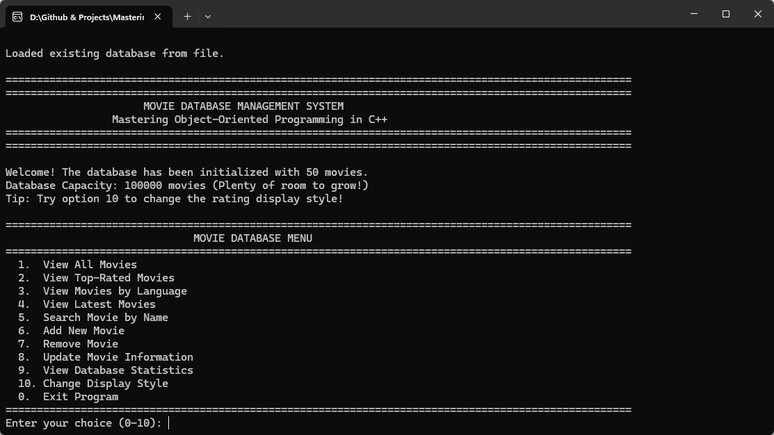Figure 5: General Output

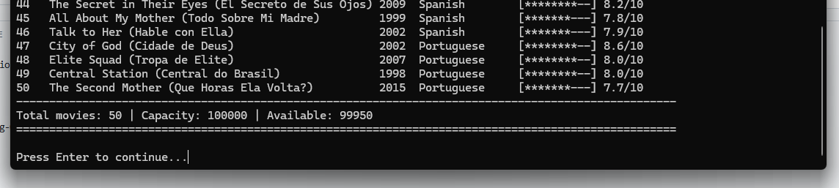
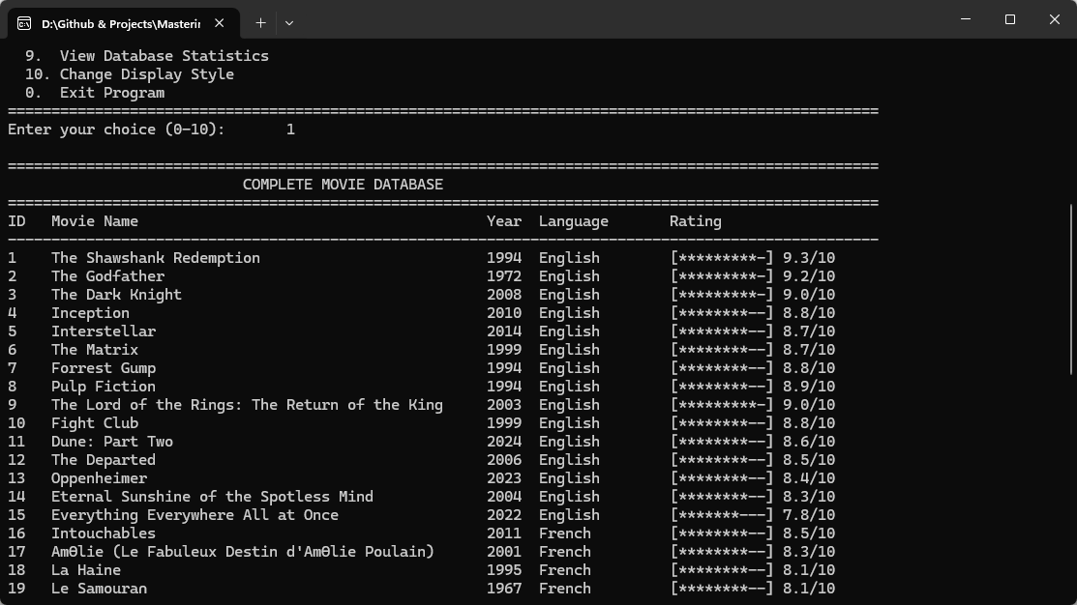

Figure 5: Viewing all Movies

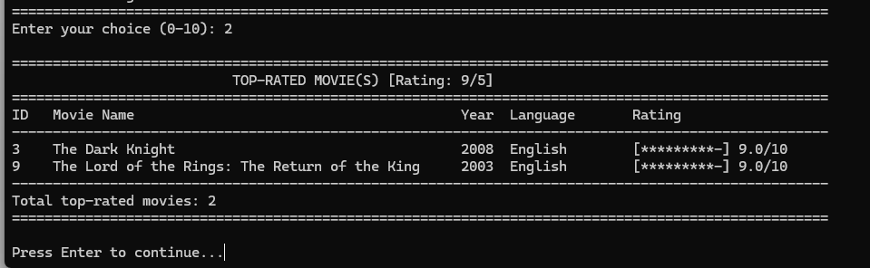

Figure 6: Viewing Top Rated Movies

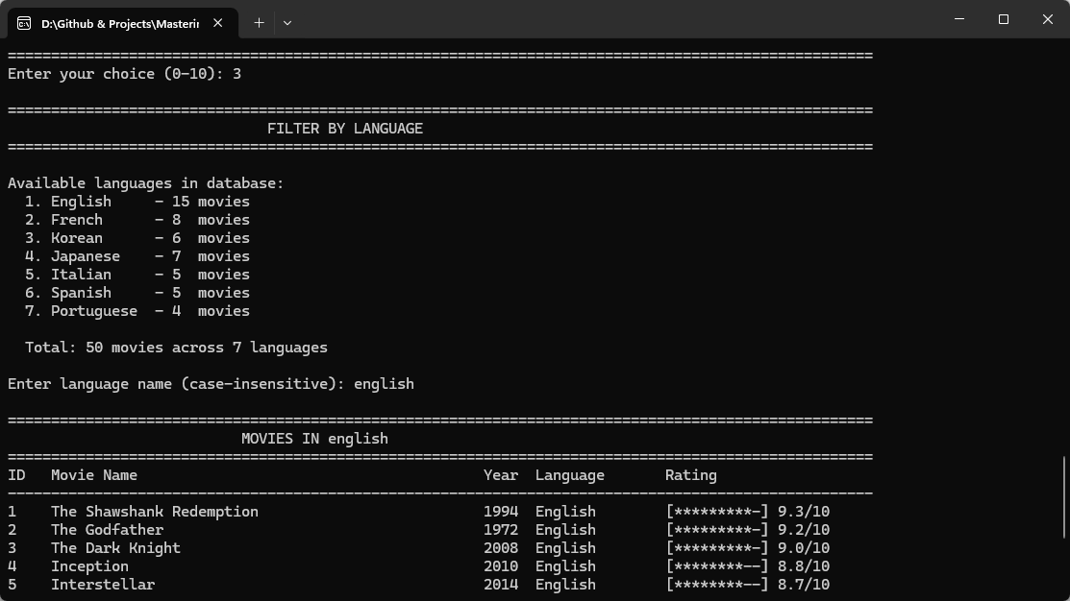

Figure 7: View Movies by language

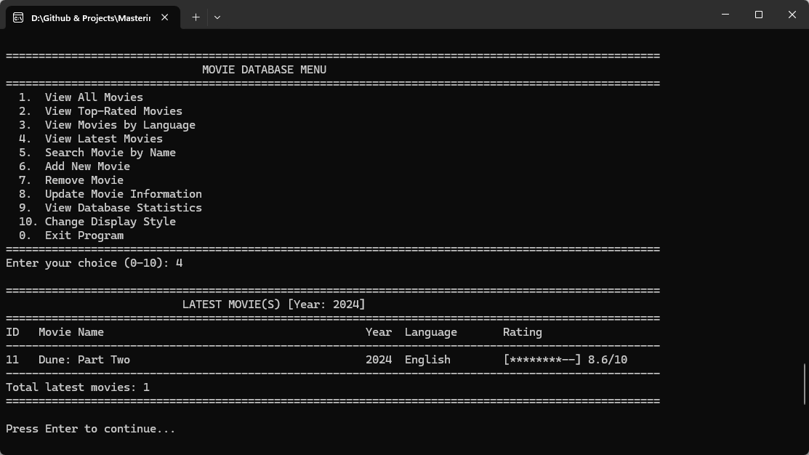

Figure 8: Viewing Latest Movies

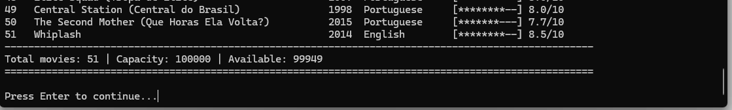
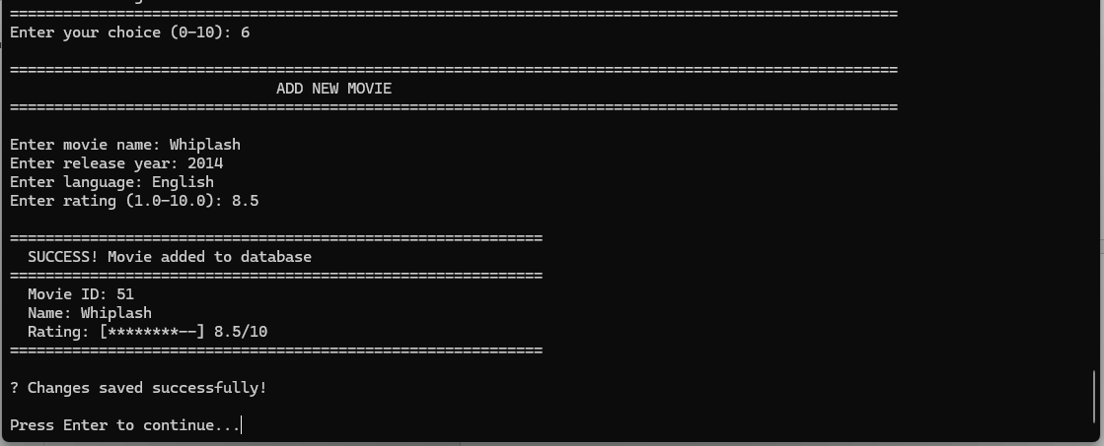

Figure 8: Adding Movies

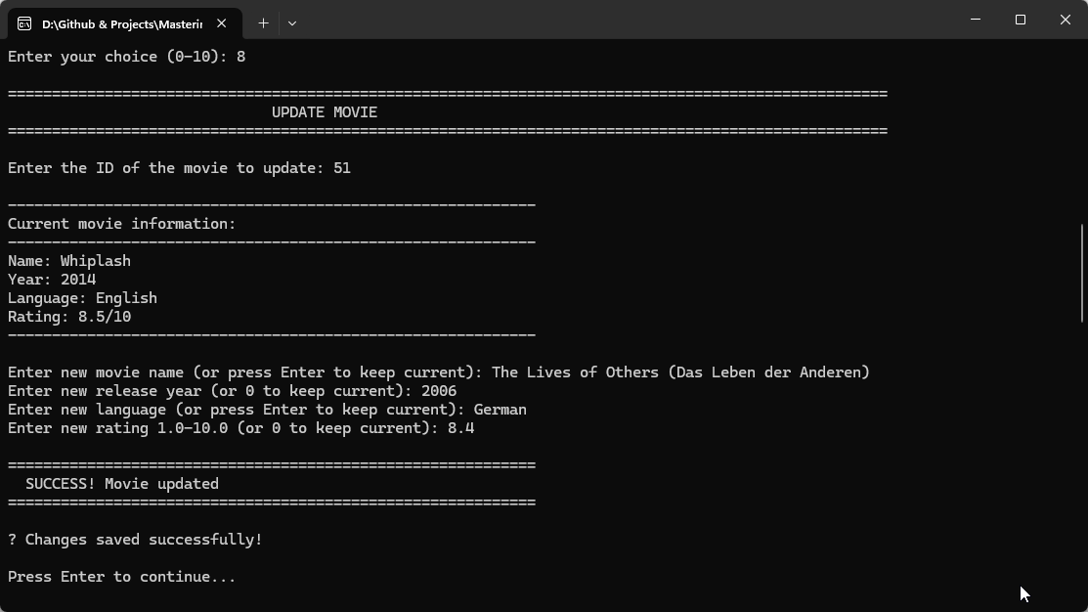

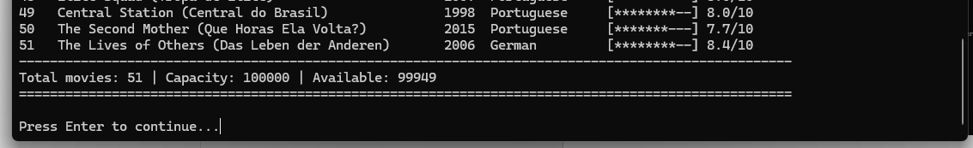

Figure 9: Updating Movies Information

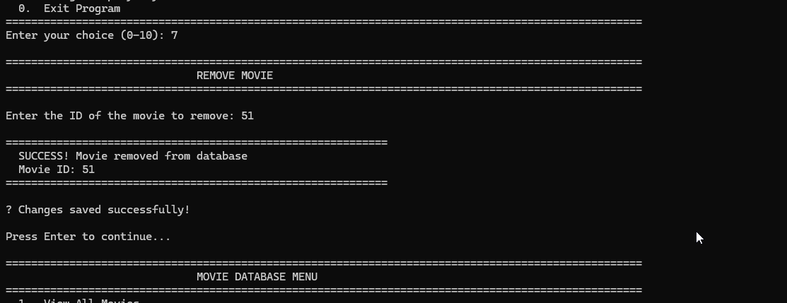

Figure 9: Removing Movies

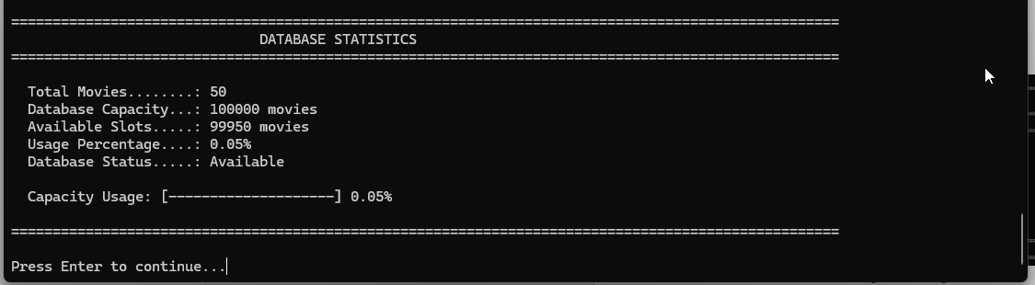

Figure 10: Database Information

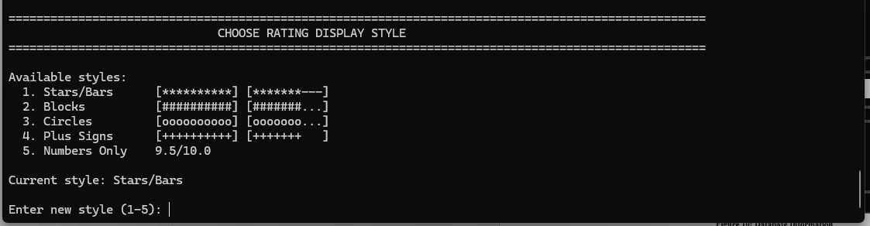

Figure 10: Changing Style

