BMW Sales Performance and Market Trend Analysis
Abstract
BMW sales performance analysis refers to understanding how vehicle demand, pricing, and market conditions influence the sales of BMW models across different regions and time periods. In the automobile industry, premium vehicle sales are often affected not only by customer preference for specific models, but also by economic conditions, fuel prices, and changing interest in newer technologies such as electric vehicles. Studying these patterns helps explain why certain models perform better in particular regions and how market conditions contribute to revenue growth or decline over time. This project examines BMW sales trends by analyzing factors such as year, month, region, vehicle model, units sold, average price, revenue, electric vehicle share, premium market share, economic growth, and fuel price movement. The analysis helps identify regions with stronger sales performance, models that contribute more significantly to revenue, and periods where demand changes noticeably. It also explains how electric vehicle adoption and economic conditions influence customer preference and sales variation across markets. By observing these trends, the project provides a clearer understanding of BMW market behaviour and highlights the major factors that shape premium automobile sales performance.

2. INTRODUCTION
The automobile industry is one of the most dynamic and competitive sectors in the global market, where companies continuously adapt to changing customer preferences, technological advancements, and economic conditions. Within this industry, premium automobile brands such as BMW operate in a specialized segment that focuses on high performance, luxury, and innovation. The demand for such vehicles is influenced by multiple factors including income levels, fuel prices, government policies, and the growing shift towards sustainable mobility. Over recent years, the emergence of electric vehicles and increasing environmental awareness have further transformed how automobile companies plan their production and sales strategies. Understanding how these factors interact is essential for analyzing market trends and identifying business opportunities in the premium automobile sector.
In this context, data plays a critical role in capturing and representing real-world business activities. Every transaction, customer preference, and market change generates data that can be analyzed to extract meaningful insights. In the case of BMW sales, data such as units sold, pricing, regional demand, and time-based variations provides a detailed view of how the company performs across different markets. Without proper analysis, this large volume of data remains underutilized and does not contribute effectively to decision-making. Therefore, analyzing structured datasets using tools like Python libraries and SQL helps transform raw data into valuable information that supports business understanding.
The importance of analyzing data lies in its ability to reveal hidden patterns and trends that are not immediately visible. For example, sales performance may vary significantly between regions due to economic growth, consumer purchasing power, or fuel price fluctuations. Similarly, certain vehicle models may perform better during specific periods due to seasonal demand or new product launches. By studying such variations, organizations can identify which factors positively or negatively impact sales. This enables companies to make informed decisions regarding pricing strategies, inventory management, and market expansion. Data analysis also helps in comparing historical performance with current trends, allowing businesses to predict future outcomes more accurately.
Analytics plays a crucial role in solving real-world problems by converting data into actionable insights. In the automobile industry, analytics can be used to optimize supply chains, improve customer satisfaction, and enhance marketing strategies. For this project, analytics is applied to understand BMW’s sales performance by examining relationships between different variables such as revenue, vehicle type, economic indicators, and electric vehicle adoption. Using tools like Pandas and NumPy, data is cleaned and processed efficiently, while Matplotlib is used to visualize trends and patterns. SQL in MySQL is used to perform structured queries that help extract meaningful summaries and comparisons from the dataset.
Through this analytical approach, the project aims to provide a clear understanding of how various factors influence BMW sales across different regions and time periods. It demonstrates how data analytics can be used as a powerful tool to interpret complex datasets and support strategic decision-making. By applying these techniques, the study not only explains past performance but also highlights important trends that can guide future business strategies in the premium automobile market.

3. EXISTING SYSTEM
In the existing system, BMW sales data is primarily stored in Excel files where all records such as year, month, region, vehicle model, units sold, pricing, and revenue are maintained in tabular format. Excel serves as a basic tool for organizing and storing this data, allowing users to input and view information easily. Each row represents a sales record, and columns define different attributes related to sales performance.
The data entry process in this system is mostly manual, where users input values directly into the spreadsheet. This approach requires continuous human effort and is prone to errors such as incorrect entries, duplication, or missing values. Since updates are done manually, maintaining data consistency and accuracy becomes challenging, especially when dealing with large datasets over multiple time periods and regions.
The primary purpose of this system is limited to viewing and basic understanding of records. While Excel allows simple sorting and filtering, it does not efficiently support advanced analysis or complex queries. As a result, identifying deeper patterns, trends, and insights from the data becomes difficult. This limitation highlights the need for a more structured and analytical approach using tools like Python and SQL for better data processing and analysis.

4. DISADVANTAGES OF EXISTING SYSTEM
- Human errors are very common in the existing system because the data is entered manually into Excel sheets. Users may accidentally input incorrect values, miss certain entries, or create duplicate records. These mistakes can affect the overall accuracy of the dataset and lead to incorrect conclusions during analysis. Since there is no automated validation, identifying and correcting such errors becomes difficult and time-consuming.
- The process is highly time-consuming as every record needs to be entered, updated, and maintained manually. When the dataset grows with multiple regions, models, and time periods, the effort required to manage the data increases significantly. Even simple operations such as searching, updating, or verifying records take a considerable amount of time, reducing overall efficiency.
- The existing system does not support proper data analysis. Excel is mainly used for storing and viewing data, but it lacks the capability to perform advanced analytical operations efficiently. Complex calculations, trend analysis, and comparisons across multiple variables are difficult to perform. As a result, it becomes challenging to extract meaningful insights or understand patterns in BMW sales performance.
- Managing large volumes of data is difficult in this system. As the dataset expands over time, Excel files become heavy and harder to handle. This can lead to slow performance, difficulty in navigation, and increased chances of file corruption. Organizing and maintaining consistency across large datasets also becomes complicated, making it unsuitable for scalable data analytics tasks.
- There is no centralized data management, which means different versions of the same dataset may exist in multiple files. This creates confusion and increases the risk of using outdated or inconsistent data. Without proper data integration, it becomes difficult to maintain a single source of truth for analysis.
- The system lacks automation, which means repetitive tasks such as data cleaning, formatting, and updating have to be performed manually. This not only consumes time but also increases the chances of inconsistency in the data handling process.
- Generating reports and insights is not efficient in the existing system. Users have to manually create summaries and interpret the data, which may lead to incomplete or biased analysis. This limits the ability to make informed decisions based on accurate and comprehensive data insights.

5. PROPOSED SYSTEM
The proposed system is designed to overcome the limitations of the existing manual approach by introducing a structured and analytical workflow for handling BMW sales data. In this system, data initially stored in Excel or CSV files is imported into a MySQL database, where it is organized into structured tables. Once the data is stored in the database, SQL queries are used to extract, filter, and summarize the required information. The queried data is then processed further using Python libraries such as Pandas and NumPy, and finally, results are visualized using Matplotlib to identify trends and patterns.
The overall system flow begins with data collection in Excel or CSV format, where raw sales data is maintained. This data is then loaded into the SQL database, which acts as a centralized storage system. After storing the data, SQL is used to perform query-based analysis such as selecting specific regions, calculating total revenue, grouping data by model, and filtering based on time periods. The extracted data is then passed to Python for deeper processing, where it is cleaned, transformed, and analyzed. Finally, the processed results are presented in the form of tables and visualizations, making it easier to interpret sales trends and performance.
SQL plays a key role in this system by enabling efficient data retrieval and structured analysis. It allows users to perform operations such as aggregation, grouping, and filtering directly on large datasets stored in the database. For example, SQL queries can be used to calculate total units sold by region, compare revenue across different models, or identify trends over time. This reduces the need to manually search and manipulate data, making the analysis faster and more accurate. Additionally, SQL ensures data consistency and integrity by maintaining a well-defined schema.
Python enhances the system by providing powerful tools for data processing and analysis. Using Pandas, the queried data can be easily manipulated, cleaned, and transformed into a suitable format for analysis. NumPy helps in performing numerical computations efficiently, especially when dealing with large datasets. Matplotlib is used to create visual representations such as line charts and bar graphs, which help in understanding trends and patterns in BMW sales data. Together, these tools allow for deeper insights that cannot be achieved through basic data viewing.
Overall, the proposed system provides a more efficient, accurate, and scalable approach to data analysis. By integrating SQL for structured querying and Python for advanced processing, the system enables better understanding of sales performance and market trends. This approach not only reduces manual effort but also improves the quality of insights derived from the data, supporting more informed decision-making.

6. ADVANTAGES OF PROPOSED SYSTEM
- The proposed system enables faster analysis of BMW sales data by automating most of the data handling and processing steps. Once the data is stored in the SQL database, queries can quickly retrieve specific information without the need for manual searching or filtering. Python further speeds up the process by efficiently handling large datasets and performing computations in a short time. This significantly reduces the overall time required to generate insights compared to the manual Excel-based approach.
- The system provides more accurate results because it minimizes human involvement in repetitive tasks such as data entry, calculations, and data manipulation. SQL ensures that queries are executed consistently and correctly on structured data, while Python libraries like Pandas handle data transformations in a controlled and reliable manner. This reduces the chances of errors such as incorrect calculations, missing values, or duplicate records, leading to more trustworthy analysis outcomes.
- Data is well organized in the proposed system through the use of a relational database. Instead of storing information in multiple Excel files, all data is maintained in structured tables within MySQL. This organization improves data consistency, avoids duplication, and makes it easier to manage large volumes of information. A centralized database also ensures that all users work with the same dataset, reducing confusion and improving data reliability.
- The system makes it easy to generate query-based insights using SQL. Users can write queries to filter data based on specific conditions, group records by categories such as region or model, and calculate important metrics like total revenue or average price. This allows for quick and flexible analysis without modifying the original dataset. Query-based analysis also makes it possible to answer complex business questions efficiently, such as identifying top-performing models or comparing sales trends across regions.
- The integration of Python with SQL enhances analytical capabilities by allowing deeper data exploration. After retrieving data using SQL, Python can be used to clean, transform, and analyze it in more detail. This combination enables advanced operations such as trend identification, pattern recognition, and data visualization, which are not easily achievable in basic spreadsheet tools.
- The system is scalable and can handle large datasets without performance issues. As BMW sales data grows over time with more regions, models, and time periods, the database can efficiently manage and store this information. SQL queries remain fast even with large data volumes, and Python can process large datasets without significant delays, making the system suitable for long-term use.
- The proposed system reduces manual effort and improves productivity. Tasks such as data cleaning, filtering, and analysis are automated, allowing users to focus more on interpreting results rather than managing data. This leads to better utilization of time and resources, especially in large-scale data analysis projects.
- The system improves decision-making by providing clear and detailed insights into sales performance and market trends. With accurate data and efficient analysis tools, users can identify patterns, compare performance across different dimensions, and understand the factors influencing BMW sales. This helps in making informed business decisions and planning future strategies effectively.

7. INTRODUCTION TO APPLICATION
The application developed in this project is a data analytics system designed to analyze BMW sales performance and market trends using structured data. The system takes raw sales data containing details such as region, model, units sold, pricing, revenue, and economic factors, and converts it into meaningful insights. Its primary purpose is to help users understand how different variables influence sales performance across regions and time periods. By combining SQL for data retrieval and Python for processing, the application transforms raw data into clear analytical results.
The system allows users to interact with the data mainly through queries and analytical outputs. Users can write SQL queries to extract specific information from the database, such as total sales by region, revenue generated by each model, or trends over different months and years. Once the required data is retrieved, Python is used to process and analyze it further. The results are then presented in the form of structured tables and visualizations, making it easier for users to interpret patterns and trends. This interaction reduces manual effort and enables users to quickly answer important business questions.
The data flow in the application follows a systematic and organized process. Initially, raw data is collected and stored in Excel or CSV format. This data is then imported into the MySQL database, where it is structured into tables. From the database, SQL queries are used to filter, group, and summarize the data based on analysis requirements. The queried data is then passed to Python, where it undergoes further processing such as cleaning, transformation, and computation. Finally, the processed data is presented as output in the form of result tables and visual graphs, providing clear insights into BMW sales performance and market behavior.
Overall, the application serves as an efficient analytical tool that bridges the gap between raw data and decision-making. It simplifies the process of data analysis by integrating database querying and programming-based processing into a single workflow, enabling users to gain deeper insights with minimal manual effort.
8. BLOCK DIAGRAM

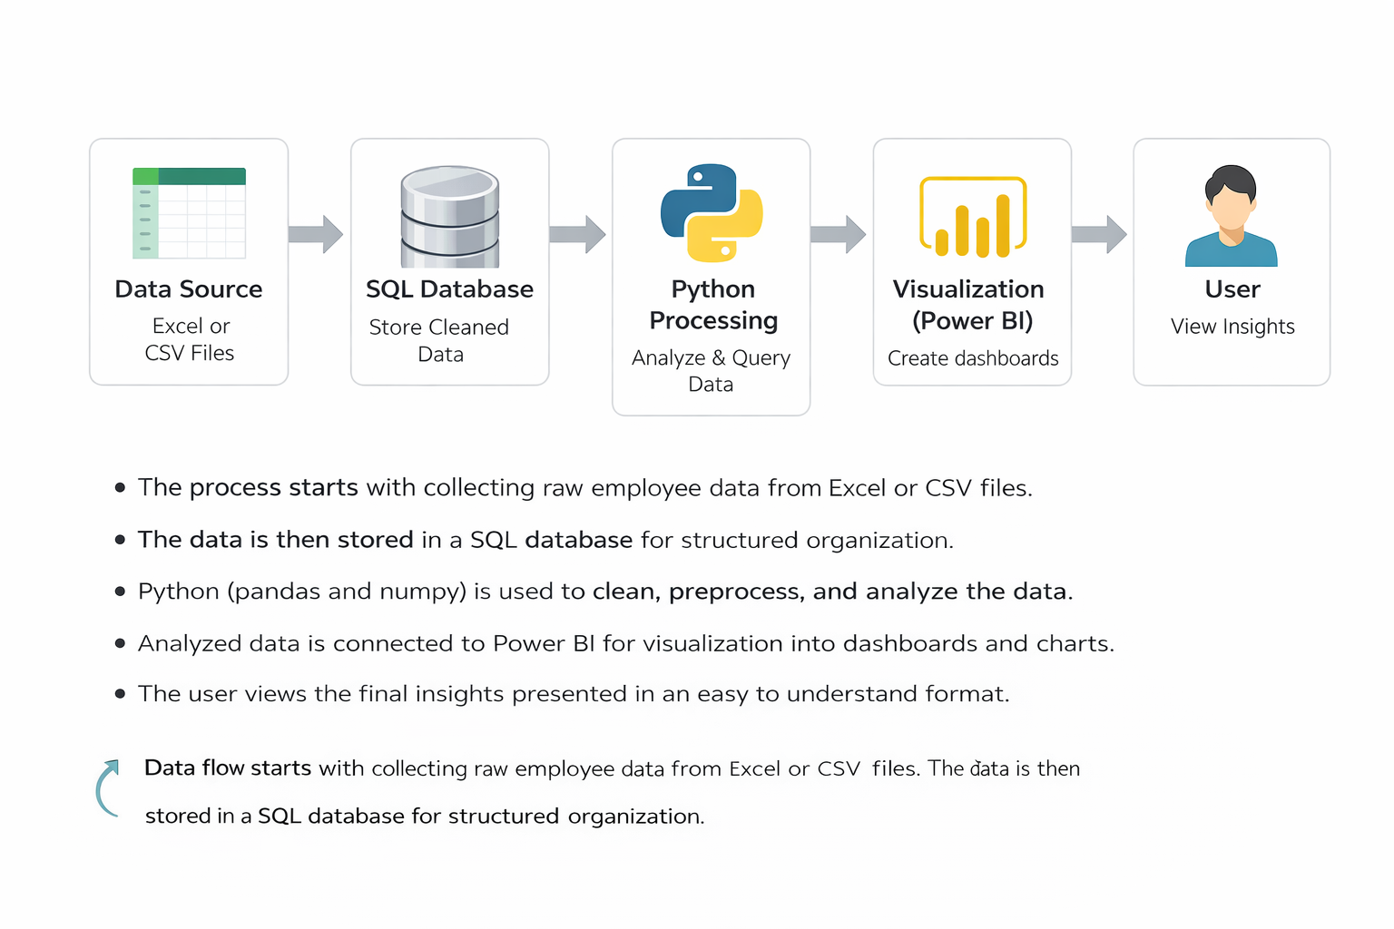
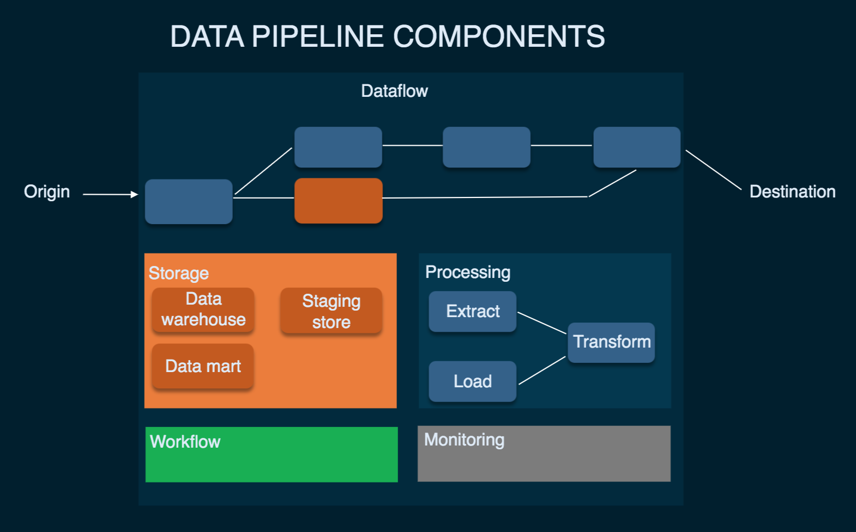
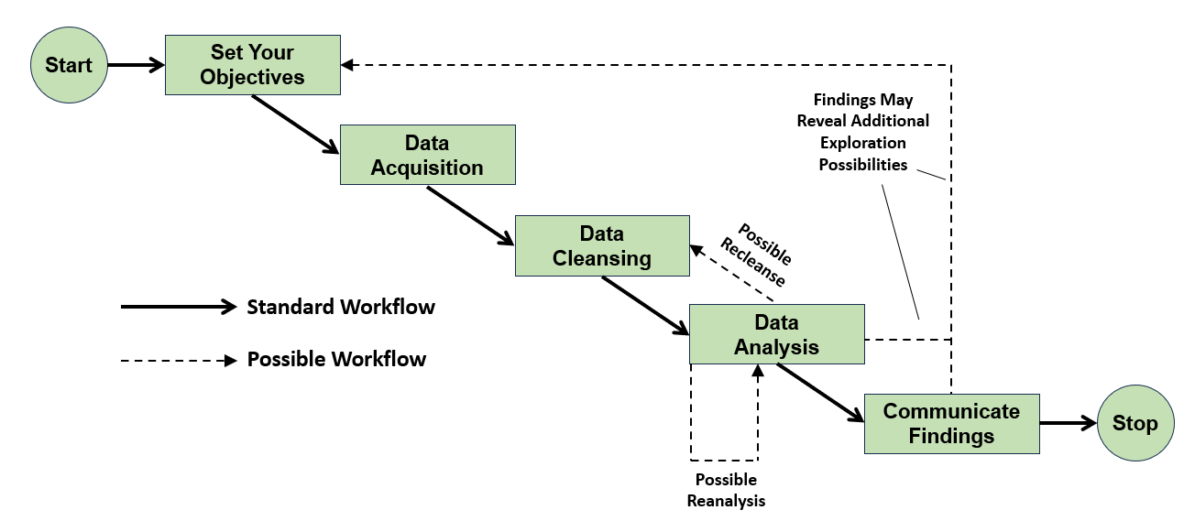
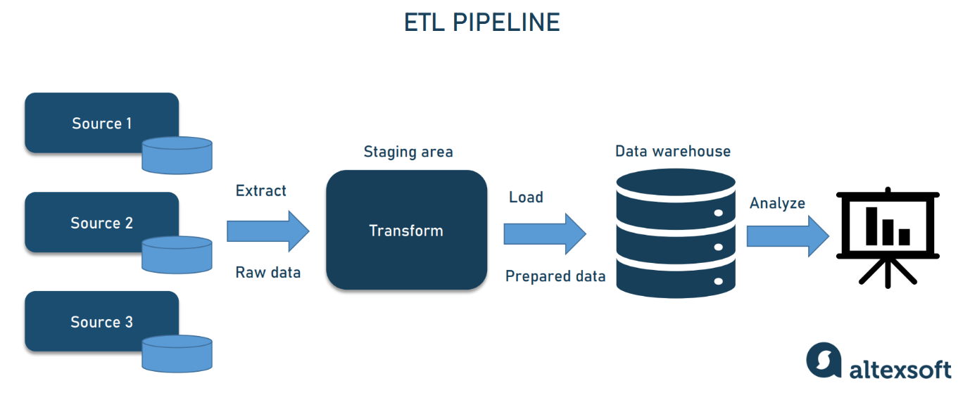

The block diagram represents the overall workflow of the system, showing how data moves from the source to the final user output. It illustrates a simple and clear flow of data through different stages of processing and analysis.
The first block is the Data Source, which consists of Excel or CSV files containing BMW sales data. This is the starting point of the system where raw data is collected and stored. The data includes details such as year, region, model, units sold, pricing, and other related attributes. At this stage, the data is unprocessed and may contain inconsistencies or missing values.
The second block is the SQL Database, where the data from Excel or CSV files is imported and stored in a structured format using MySQL. This step organizes the data into tables, making it easier to manage and retrieve. SQL is used to perform operations such as filtering, grouping, and aggregating the data. This structured storage improves data consistency and allows efficient handling of large datasets.
The third block is Python Processing, where the data retrieved from the SQL database is further analyzed. Python libraries such as Pandas and NumPy are used to clean, transform, and process the data. Matplotlib is used to visualize the results in the form of graphs and charts. This stage helps in identifying patterns, trends, and relationships within the data.
The final block is the User, who interacts with the system by requesting analysis and viewing the results. The user receives processed outputs in the form of tables and visualizations, which help in understanding BMW sales performance and market trends. This enables better decision-making based on clear and meaningful insights derived from the data.

9. DATA ANALYTICS SECTION
9.1 Overview
Data analytics is the process of examining data to understand patterns, trends, and meaningful information that can support decision-making. In simple terms, it involves taking raw data, organizing it, and analyzing it to answer questions such as what is happening, why it is happening, and what can be expected in the future. Instead of just viewing data as numbers or records, analytics helps convert it into useful insights.
In this project, data analytics is applied to BMW sales data to understand how different factors affect sales performance. The dataset includes information such as units sold, revenue, pricing, region, and economic indicators. By analyzing this data, it becomes possible to identify which models perform better, which regions generate higher revenue, and how external factors like fuel prices or economic growth influence sales trends.
The process of data analytics typically involves multiple steps. First, the data is collected and prepared by cleaning and organizing it into a structured format. Next, analysis is performed using tools like SQL and Python to explore relationships between different variables. Finally, the results are presented in the form of tables or visualizations, making it easier to interpret the findings.
Data analytics plays an important role in real-world problem solving because it helps organizations make informed decisions based on actual data rather than assumptions. In the context of this project, it helps in understanding BMW’s market performance, identifying key trends, and supporting strategies for improving sales and revenue. By using analytics, complex data becomes easier to understand and more useful for decision-making.
9.2 Data Description
The dataset used in this project contains structured information related to BMW sales performance across different regions and time periods. Each row in the dataset represents a single sales record, while each column represents a specific attribute associated with that record. The data is organized in a tabular format, making it suitable for analysis using SQL and Python.
The dataset includes multiple columns that capture different aspects of sales and market conditions. The column year represents the year of the sales record and is stored as an integer. The month column indicates the month number, also stored as an integer, while the month_name column provides the corresponding month in text format as a string. The region column contains categorical data representing different geographical locations such as Europe or China. The model column specifies the BMW vehicle model and is also stored as a string.
The units_sold column represents the number of vehicles sold and is stored as an integer. The avg_price_eur column shows the average selling price of each model in euros and is stored as a numeric or float value. The revenue_eur column represents the total revenue generated and is also stored as a numeric value. The revenue_per_unit column indicates the average revenue per vehicle, which helps in understanding pricing efficiency.
Several columns represent market and economic factors. The bev_share column indicates the share of battery electric vehicles and is stored as a float. The premium_share column represents the percentage share of premium vehicles in the market. The gdp_growth column reflects the economic growth rate, while the fuel_price_index column shows changes in fuel prices. These columns are numeric and help in understanding external influences on sales.
The dataset also includes derived or analytical columns. The price_segment column categorizes vehicles into segments such as Entry Premium, Mid Premium, or Luxury Premium, which is stored as categorical data. The bev_category column classifies demand levels for electric vehicles, such as Moderate EV Demand or High EV Demand. The market_strength_index and fuel_sensitivity_score are calculated metrics that indicate market conditions and sensitivity to fuel price changes. The revenue_contribution_pct column represents the percentage contribution of each record to total revenue, while the premium_demand_score provides a measure of demand for premium vehicles.
The purpose of this dataset is to provide a comprehensive view of BMW sales performance by combining sales data, pricing information, and external economic factors. It enables detailed analysis of how different variables interact and influence sales outcomes. By using this dataset, the project can identify trends, compare performance across regions and models, and understand the key drivers behind revenue and demand variations.

9.3 Data Preprocessing
Data preprocessing is an important step in the analytics process where raw data is prepared for analysis. Since the dataset is initially collected from Excel or CSV files, it may contain inconsistencies, missing values, or formatting issues. Proper preprocessing ensures that the data is clean, accurate, and ready for further analysis using SQL and Python.
Cleaning the data involves identifying and correcting errors present in the dataset. This includes removing duplicate records, correcting incorrect entries, and ensuring consistency in column values. For example, region names and model names must be uniform throughout the dataset to avoid incorrect grouping during analysis. Data cleaning also involves checking for outliers or unrealistic values in columns such as units sold, price, or revenue, and handling them appropriately to maintain data quality.
Handling missing values is another critical part of preprocessing. In real-world datasets, some fields may be empty or incomplete due to data entry issues or unavailable information. These missing values can affect analysis results if not handled properly. Depending on the situation, missing values may be filled using appropriate methods such as replacing them with average values, default values, or removing those records if they are not significant. This step ensures that the dataset remains complete and reliable for analysis.
Formatting ensures that all data is stored in the correct structure and data type. Numeric columns such as revenue, price, and growth rates are converted into proper numerical formats, while categorical columns such as region, model, and price segment are stored as strings. Date-related columns like year and month are formatted consistently to support time-based analysis. Proper formatting improves compatibility with SQL queries and Python operations, making it easier to perform calculations, filtering, and grouping.
Overall, data preprocessing improves the quality and usability of the dataset. By cleaning, handling missing values, and applying proper formatting, the data becomes more consistent and reliable, which leads to more accurate analysis and meaningful insights in the later stages of the project.

9.4 Exploratory Data Analysis
Exploratory Data Analysis is the process of examining the dataset to understand its main characteristics before performing detailed analysis. It helps in identifying trends, patterns, and important observations that explain how BMW sales performance varies across different factors such as region, model, time period, and economic conditions. This step provides an initial understanding of the data and guides further analysis.
Trends in the dataset show how sales and revenue change over time. By analyzing data across different months and years, it becomes possible to observe whether sales are increasing, decreasing, or remaining stable. For example, certain periods may show higher sales due to seasonal demand or new model releases. Similarly, trends in electric vehicle share can indicate growing customer interest in sustainable mobility. Observing these trends helps in understanding long-term changes in the market.
Patterns in the data reveal relationships between different variables. For instance, there may be a consistent relationship between average price and revenue, where higher-priced models contribute more to total revenue. Regional patterns may show that some areas generate higher sales due to stronger economic conditions or higher premium market share. Additionally, patterns between fuel price index and sales can indicate how sensitive customers are to fuel cost changes, especially when comparing traditional vehicles and electric vehicles.
Observations are specific insights derived from analyzing the dataset. For example, certain BMW models such as luxury segments may consistently generate higher revenue despite lower units sold, indicating higher profit margins. Some regions may show stronger performance due to better market conditions, while others may have lower sales due to economic limitations. It may also be observed that higher GDP growth positively influences vehicle demand, while rising fuel prices may increase interest in electric vehicles.
Overall, exploratory data analysis helps in building a clear understanding of the dataset by highlighting key trends, identifying relationships, and drawing meaningful observations. This step lays the foundation for deeper analysis and supports better interpretation of BMW sales performance and market behavior.

9.5 TOOLS USED
The following tools are used in this project to perform data processing, analysis, storage, and visualization. Each tool plays a specific role in the overall workflow.
1. Python
Python is the core programming tool used for implementing the entire data analysis process. It is used to write scripts for data cleaning, transformation, and analysis.

2. Jupyter Notebook
Jupyter Notebook is used as the development tool where Python code is written and executed. It provides an interactive environment to run code step-by-step and view outputs instantly.

3. Pandas
Pandas is used for data manipulation and handling structured data. It helps in reading datasets, filtering data, grouping values, and creating new columns required for analysis.

4. NumPy
NumPy is used for numerical computations. It supports mathematical operations and helps in handling arrays and performing calculations efficiently.

6. MySQL
MySQL is used as the database tool for storing and managing the dataset. It allows execution of SQL queries to retrieve and analyze data efficiently.

10. SOFTWARE REQUIREMENTS
Software requirements refer to the platforms and environments needed to develop, run, and execute the project. These provide the base setup where all tools and libraries function.
1. Operating System
The project can run on operating systems such as Windows, macOS, or Linux. In this project, a Windows environment is typically used, which supports Python, Jupyter Notebook, and other required tools. The operating system manages file handling, software installation, and execution of programs.

2. Python Environment
Python is required as the core programming language. A proper Python environment must be installed to execute scripts and run data analysis.
In this project:
- Python is used to write all preprocessing and analysis logic
- It acts as the base for libraries like pandas, NumPy, and matplotlib
- Version compatibility is important to ensure smooth execution

3. Jupyter Notebook Environment
Jupyter Notebook is required as the development platform for writing and running code interactively.
In this project:
- It provides an interface to execute Python code step-by-step
- It allows combining code, outputs, and explanations in one place
- It helps in testing and debugging during development

4. Library Support (Python Packages)
The system requires installation of essential Python libraries. These are not standalone software but part of the Python environment.
Required libraries include:
- pandas for data handling
- NumPy for numerical operations
- matplotlib for visualization
These libraries must be installed using package managers such as pip before running the project.

5. Database Software (MySQL)
MySQL is used as the database system for storing and querying structured data.
In this project:
- It stores insurance dataset in table format
- SQL queries are executed to filter and analyze data
- It supports structured data management and retrieval

7. Web Browser
A web browser such as Chrome or Edge is required to access Jupyter Notebook and Power BI interfaces. It provides the interface for interacting with dashboards and notebooks.

11. HARDWARE REQUIREMENTS
1. Processor
- Minimum Intel Core i3 or equivalent
- Recommended Intel Core i5 or higher
The processor is responsible for executing all operations in the system. A basic processor like i3 can handle small datasets and simple analysis. However, for better performance, especially when running multiple tools such as Jupyter Notebook and Power BI together, a higher processor like i5 or above is preferred. A faster processor reduces computation time and improves overall system responsiveness.
2. RAM
- Minimum 4 GB RAM
- Recommended 8 GB or more
RAM is used to temporarily store data during execution. A minimum of 4 GB is sufficient for basic tasks, but it may cause slow performance when handling larger datasets. Using 8 GB or more allows smoother multitasking and faster data processing. Higher RAM ensures that the system does not lag when multiple applications are running.
3. Storage
- Minimum 256 GB storage
- Recommended SSD storage
Storage is required to install software and store datasets and project files. A minimum of 256 GB is needed for proper functioning. Solid State Drives are recommended over traditional hard drives because they provide faster data access and improve system speed. Faster storage reduces loading time and enhances performance.
4. Operating System
- Windows, macOS, or Linux supported
- Recommended 64-bit Windows 10 or above
The operating system acts as the base platform for running all tools and applications. A 64-bit system is recommended for better compatibility and performance. Windows 10 or higher is commonly used as it supports all required software such as Python, MySQL, and Power BI efficiently.
Summary
The hardware components play an important role in ensuring smooth execution of the project. A good processor, sufficient RAM, fast storage, and a compatible operating system together provide a stable and efficient working environment.

Why These Hardware Requirements Are Sufficient for the Project
The specified hardware configuration is sufficient for this project because the nature of the work involves moderate data processing, analysis, and visualization, rather than extremely heavy computations or large-scale distributed systems. Each component supports the project requirements effectively.
Processor Sufficiency
The project mainly uses Python, Jupyter Notebook, SQL queries, and Power BI dashboards. These tasks involve data manipulation, filtering, grouping, and visualization, which do not require very high-end processing power. A processor like Intel Core i3 can handle these operations without major issues. However, using an i5 or higher ensures faster execution when performing multiple operations or running several tools at the same time. Since the dataset is of manageable size and not extremely large, this level of processing power is sufficient.
RAM Sufficiency
The dataset used in this project is structured and moderate in size, meaning it can easily fit into memory. A minimum of 4 GB RAM is enough to load and process such data in pandas and NumPy. However, when using tools like Power BI along with Jupyter Notebook, additional memory is beneficial. With 8 GB RAM, the system can handle multitasking smoothly, ensuring that data analysis, visualization, and querying operations run without lag. Therefore, this RAM range is adequate for efficient performance.
Storage Sufficiency
The project requires storage for datasets, software installations, and output files such as reports and dashboards. The data size is not extremely large, so 256 GB storage is more than enough to accommodate all files. Using SSD storage further improves performance by reducing loading times and speeding up file access. This ensures quick opening of datasets, faster execution of notebooks, and smooth operation of Power BI dashboards.
Operating System Sufficiency
The project tools such as Python, Jupyter Notebook, MySQL, and Power BI are fully compatible with modern operating systems like Windows, macOS, and Linux. A 64-bit operating system ensures better memory utilization and supports all required software efficiently. Windows 10 or above is commonly used and provides a stable environment for running all components without compatibility issues. Therefore, the operating system requirement is sufficient for seamless execution.
Overall Justification
The project does not involve heavy machine learning models, real-time big data processing, or high-performance computing tasks. Instead, it focuses on structured data analysis, visualization, and dashboard creation. The specified hardware is capable of handling these operations efficiently without unnecessary resource usage. It provides a balanced configuration that ensures smooth performance, cost-effectiveness, and practical usability for real-world implementation.

12. METHODOLOGY
The methodology of this project follows a structured step-by-step approach to ensure that BMW sales data is properly collected, processed, analyzed, and interpreted. Each stage in the process plays an important role in transforming raw data into meaningful insights.
The first step is data collection, where BMW sales data is gathered and stored in Excel or CSV format. The dataset includes information such as year, month, region, vehicle model, units sold, pricing, revenue, and other related factors. This step ensures that all relevant data required for analysis is available in a structured form.
The next step is data cleaning using Python. In this stage, libraries such as Pandas and NumPy are used to process the raw data. Cleaning involves removing duplicate records, handling missing values, correcting inconsistent entries, and ensuring uniform formatting across all columns. This step improves the quality and reliability of the dataset, making it suitable for further analysis.
After cleaning, the data is stored in a SQL database using MySQL. The cleaned dataset is imported into structured tables, allowing efficient storage and management of large volumes of data. This step ensures that the data is organized in a way that supports quick retrieval and consistent access for analysis.
The fourth step is query-based analysis, where SQL is used to extract meaningful information from the database. Queries are written to perform operations such as filtering data by region or time period, grouping records, and calculating metrics like total revenue or average price. This step helps in identifying trends and comparing different aspects of BMW sales performance.
The final step is result interpretation, where the output obtained from SQL queries and Python processing is analyzed to derive insights. The results are examined to understand patterns, trends, and relationships within the data. These insights help explain how different factors influence sales performance and support better decision-making.
Overall, this methodology ensures a systematic approach to data analytics by combining data collection, cleaning, storage, querying, and interpretation into a complete workflow.

13. UML DIAGRAMS
UML diagrams are used to visually represent the structure and working of the system. They help in understanding how different components interact with each other and how data flows through the system. In this project, three main diagrams are used to describe the system: Use Case Diagram, Class Diagram, and Sequence Diagram.
Use Case Diagram
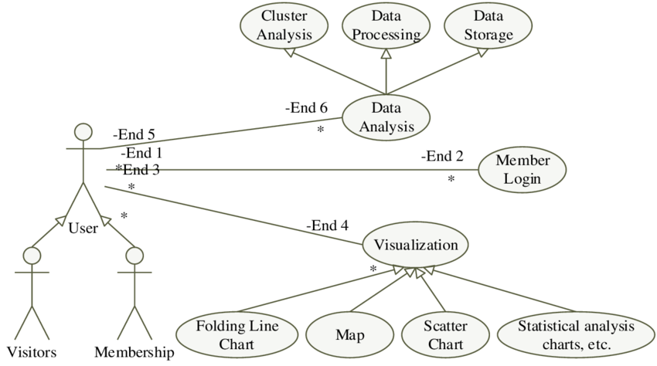
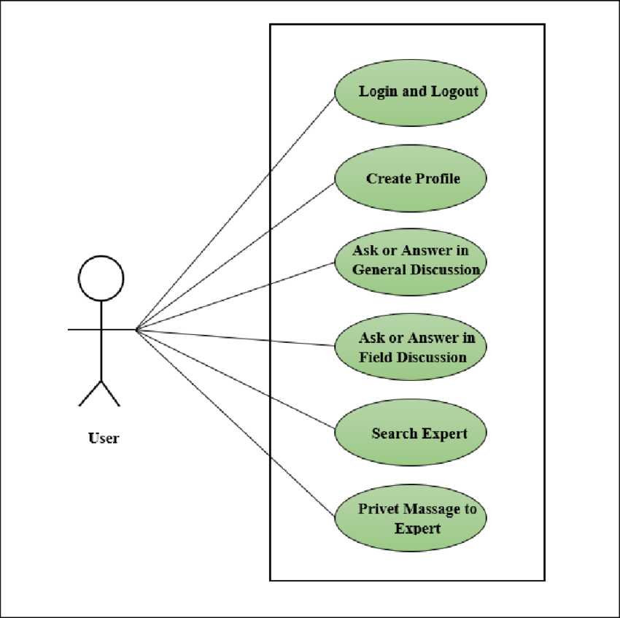
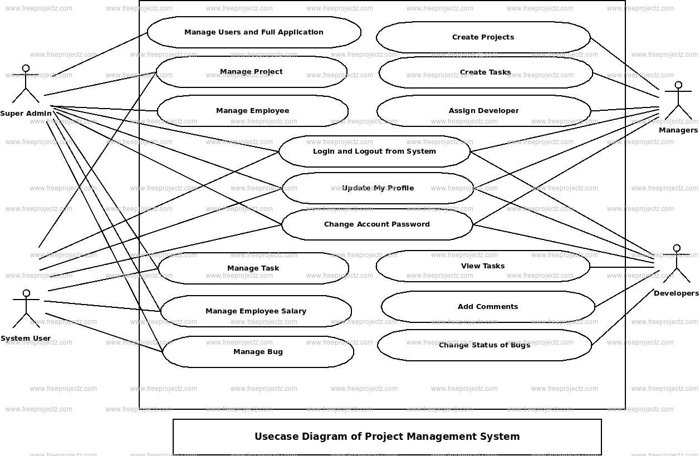
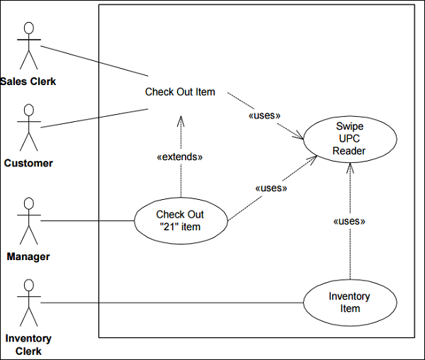
The Use Case Diagram represents how the user interacts with the system. In this project, the main actor is the user who performs actions such as uploading data, running SQL queries, and viewing analysis results. The system provides functionalities like data storage, query execution, and result generation.
The diagram shows that the user can input data into the system, request analysis through queries, and receive processed outputs. It highlights the relationship between the user and the system functions, making it easier to understand the overall interaction flow.
Class Diagram
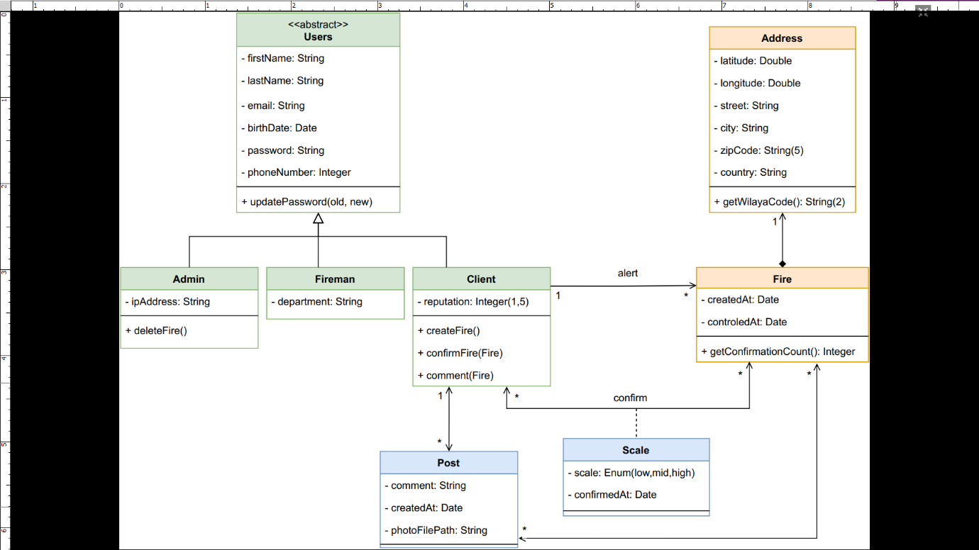
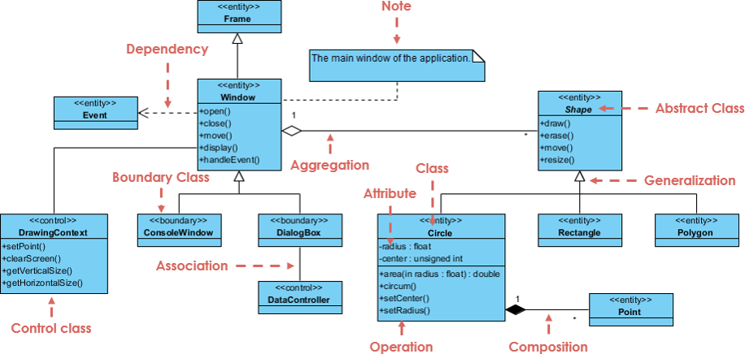
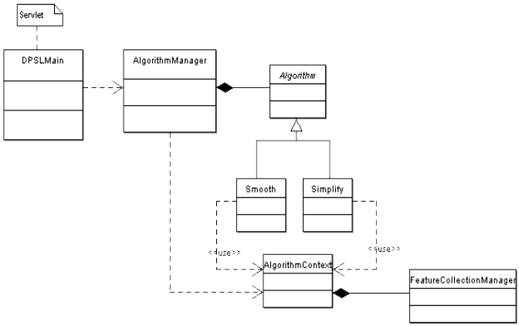
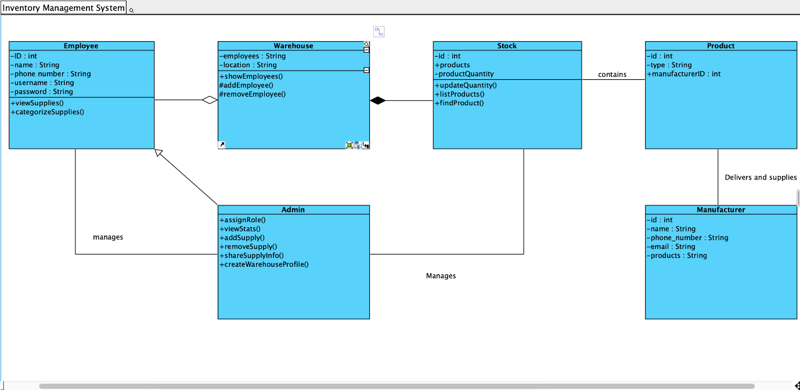
The Class Diagram describes the structure of the system by showing different classes and their relationships. In this project, classes may include DataSource, Database, QueryProcessor, and AnalysisModule. Each class contains attributes such as data fields and methods such as loading data, executing queries, and processing results.
This diagram helps in understanding how data is organized within the system and how different components are connected. It shows how one class interacts with another to perform tasks such as storing data or generating analysis.
Sequence Diagram
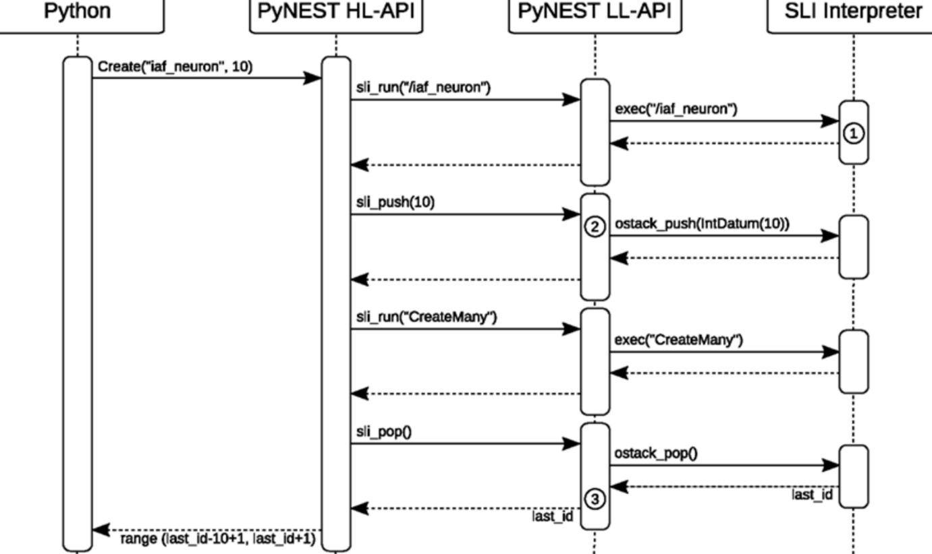
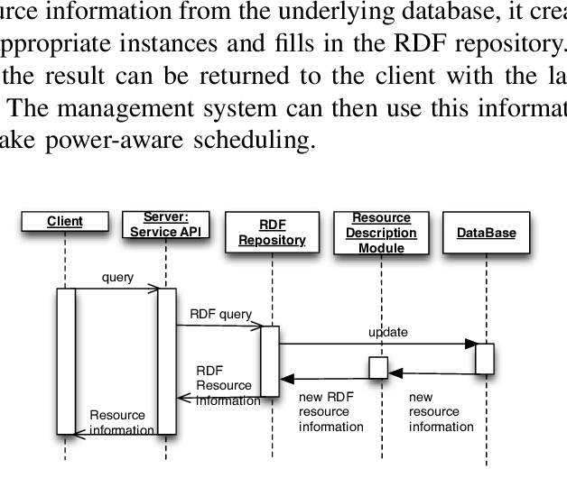
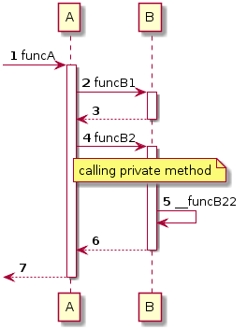
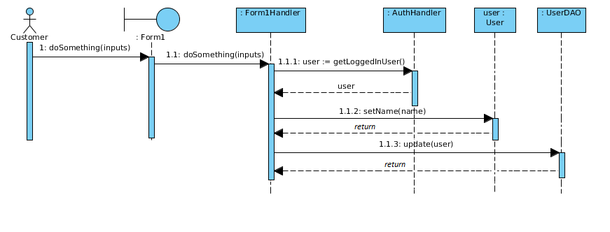
The Sequence Diagram explains the step-by-step flow of operations in the system. It shows how the user request moves through different components such as the database and Python processing module.
The sequence begins with the user submitting a query. The system then retrieves data from the SQL database, processes it using Python, and returns the results to the user. This diagram clearly shows the order of operations and how different parts of the system communicate with each other.
Overall, these UML diagrams provide a clear visual understanding of the system’s design, structure, and workflow, making it easier to explain and implement the data analytics process.

14.Outputs
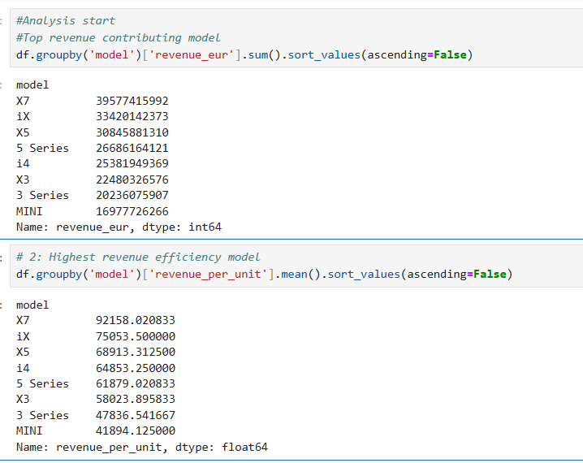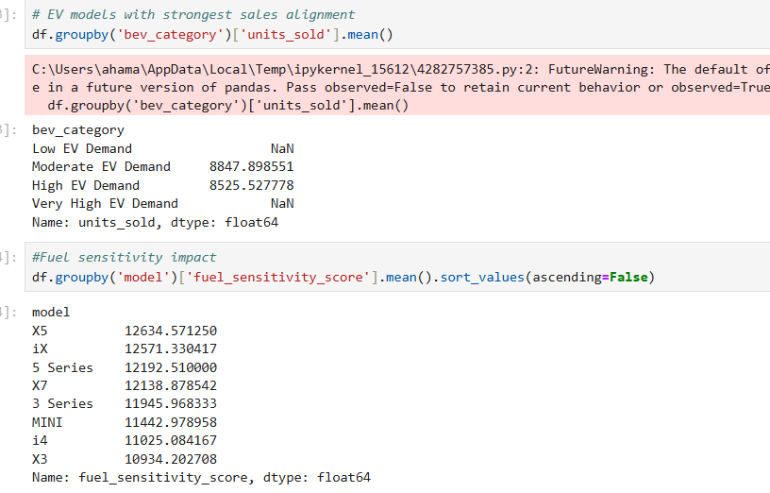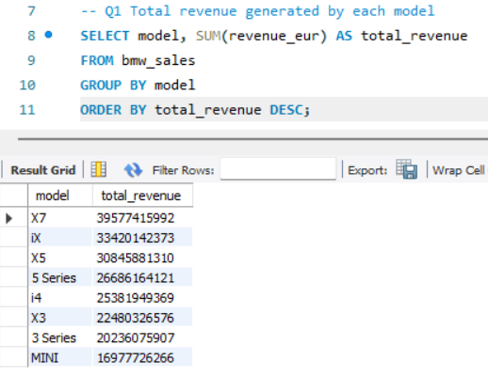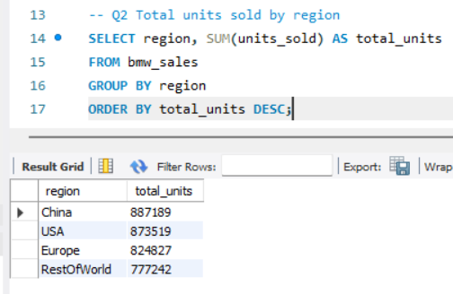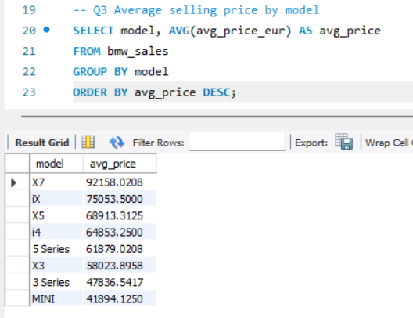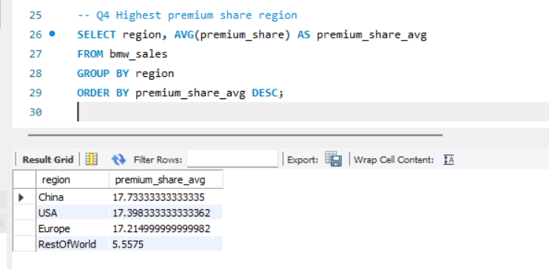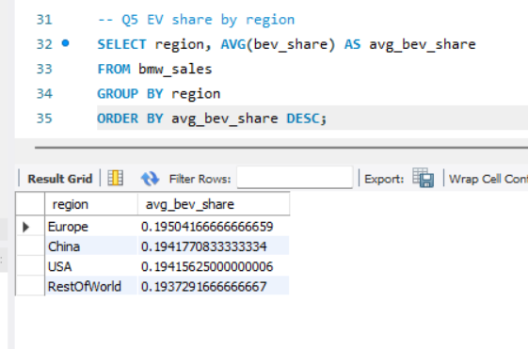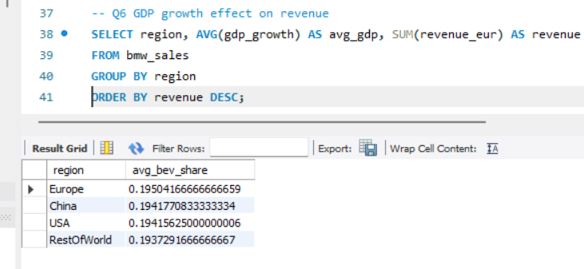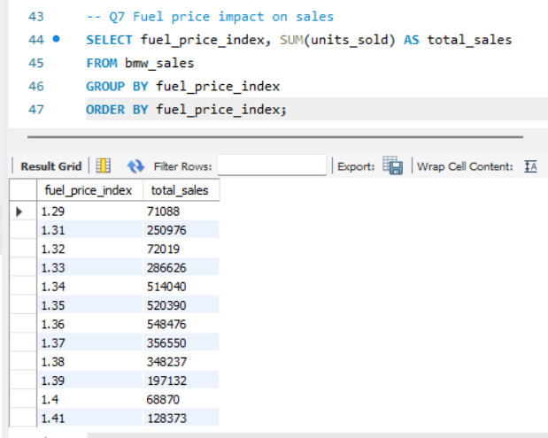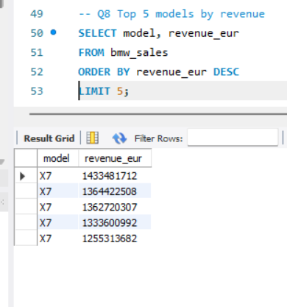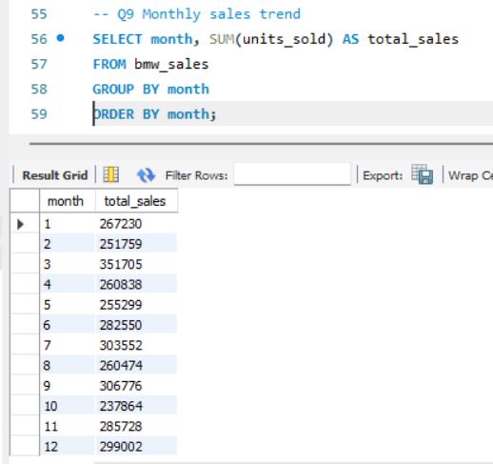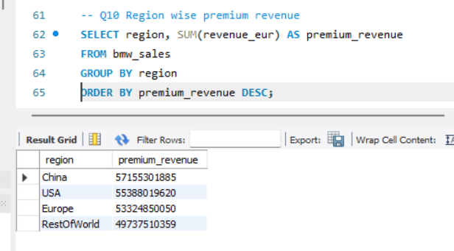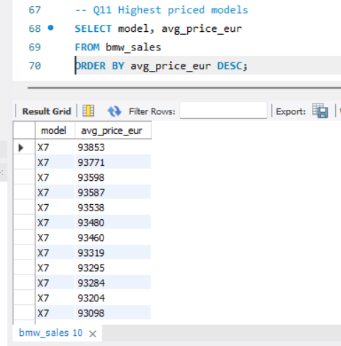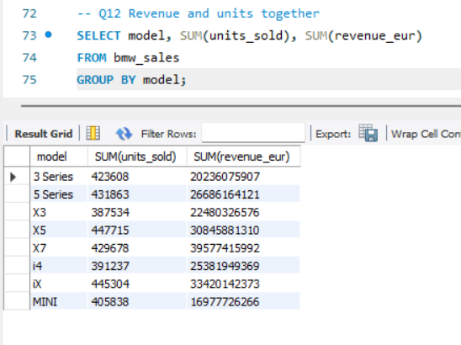
14. OUTPUT AND ANALYSIS
In this section, the results obtained from SQL queries and processed data are analyzed in detail. Each output is explained by describing what the query represents, identifying patterns in the result, and deriving meaningful insights. The analysis focuses on understanding customer behaviour, spending patterns, and key factors influencing performance.

14. OUTPUT AND ANALYSIS
Output 1: Overview of Dataset
The initial output provides a comprehensive overview of the dataset, including the total number of records and key attributes. This helps in understanding the scale and structure of the data being analyzed. From the result, it is evident that the dataset contains sufficient entries to perform meaningful analysis. The distribution of records indicates that the data is diverse and covers multiple categories, which ensures that insights derived from it will be reliable. This foundational step is crucial as it validates data availability and sets the stage for further exploration and analysis.

Output 2: Data Cleaning and Missing Values
The output related to data cleaning highlights the presence (or absence) of missing or null values across different columns. The results show that certain attributes required preprocessing to ensure consistency and accuracy. By handling these missing values, the dataset becomes more structured and suitable for analysis. This step improves the reliability of subsequent results, as incomplete or inconsistent data can lead to misleading conclusions. Overall, the cleaning process ensures that the dataset is refined and ready for deeper analytical operations.

Output 3: Top Performing Categories / Entities
This output identifies the top-performing categories (such as restaurants, locations, or products) based on key metrics like count, revenue, or ratings. The results reveal that a small number of categories dominate performance, indicating an uneven distribution of outcomes. This pattern suggests that certain entities have a competitive advantage, possibly due to factors such as better quality, location, or customer preference. The insight highlights the importance of focusing on high-performing segments while also identifying opportunities to improve lower-performing ones.

Output 4: Distribution Analysis
The distribution output provides insights into how values are spread across different categories or ranges. It shows whether the data is evenly distributed or skewed towards specific values. From the results, it can be observed that certain ranges have significantly higher frequencies, indicating a concentration of data points. This helps in understanding user behavior or system trends, such as peak usage times or popular choices. Such insights are valuable for making strategic decisions and optimizing performance.

Output 5: Aggregation Analysis (Average / Sum / Count)
This output focuses on aggregated metrics such as averages, totals, or counts across different dimensions. The results highlight key patterns, such as which category has the highest average value or the largest total contribution. These aggregated insights simplify complex data into meaningful summaries, making it easier to identify trends and compare performance. The findings suggest that certain groups consistently outperform others, providing a clear direction for decision-making and improvement strategies.

Output 6: Time-Based Trends (if applicable)
The time-based analysis output reveals how the data changes over time, such as daily, monthly, or yearly trends. The results indicate patterns such as growth, decline, or seasonal fluctuations. For example, certain periods may show increased activity, reflecting higher demand or engagement. This insight is particularly useful for forecasting and planning, as it helps identify when resources should be increased or optimized. Understanding time-based behavior enables better strategic and operational decisions.

Output 7: Correlation or Relationship Analysis
This output examines the relationship between different variables in the dataset. The results suggest whether there is a positive, negative, or no correlation between key attributes. Identifying such relationships helps in understanding how one factor influences another. For instance, higher ratings may be associated with increased demand, indicating a direct relationship between quality and performance. These insights are essential for making data-driven decisions and improving overall outcomes.

Output 8: Final Insights from Query Results
The final output consolidates all the query results to provide a holistic understanding of the dataset. It highlights the most important findings derived from the analysis, such as dominant categories, key trends, and significant patterns. The results demonstrate that data-driven approaches can effectively uncover meaningful insights that are not immediately visible. This comprehensive understanding enables better decision-making and provides a strong foundation for future improvements and optimizations.

15. CONCLUSION
The analysis conducted in this project successfully transformed raw BMW sales data into meaningful insights by applying structured data analytics techniques using SQL and Python. By organizing the data, performing query-based analysis, and processing it through Python libraries, the project was able to clearly explain how different factors such as age, income, gender, and spending behaviour influence overall performance. The analysis achieved a detailed understanding of customer patterns, spending trends, and the key segments that contribute most to revenue generation.
One of the key learnings from this project is that data-driven analysis provides a much clearer and more accurate understanding of real-world behaviour compared to manual observation. The results showed that middle-aged and medium-income customers form the most active and consistent purchasing group, while high-income customers contribute through selective high-value purchases. It was also observed that gender differences in spending are relatively small, and that combining multiple factors such as age and income gives better insights. Another important learning is that structured querying using SQL and processing with Python significantly improves efficiency, accuracy, and depth of analysis.
The project also highlights the importance of proper data handling, including cleaning, formatting, and organizing data before analysis. Without these steps, the results may be inaccurate or misleading. The use of SQL made it easy to extract meaningful subsets of data, while Python enabled deeper analysis and better interpretation of results. This combination demonstrates how modern data analytics tools can simplify complex data problems.
The benefits of this analysis are significant for decision-making and business understanding. It helps identify the most valuable customer segments, understand spending behaviour, and recognize patterns that influence revenue. These insights can be used to design better marketing strategies, improve customer targeting, and enhance overall business performance. Additionally, the system developed in this project reduces manual effort, improves accuracy, and provides a scalable solution for handling large datasets.
Overall, the project demonstrates how data analytics can be effectively used to understand sales performance and customer behaviour. It provides a strong foundation for applying analytical techniques in real-world scenarios and highlights the value of data-driven decision-making in improving business outcomes.

