CS-2005 Database Systems - Assignment 02
Case Study 1: Art Gallery Network "Picasso"
Name: ______________ Roll No: __________ Section: ____
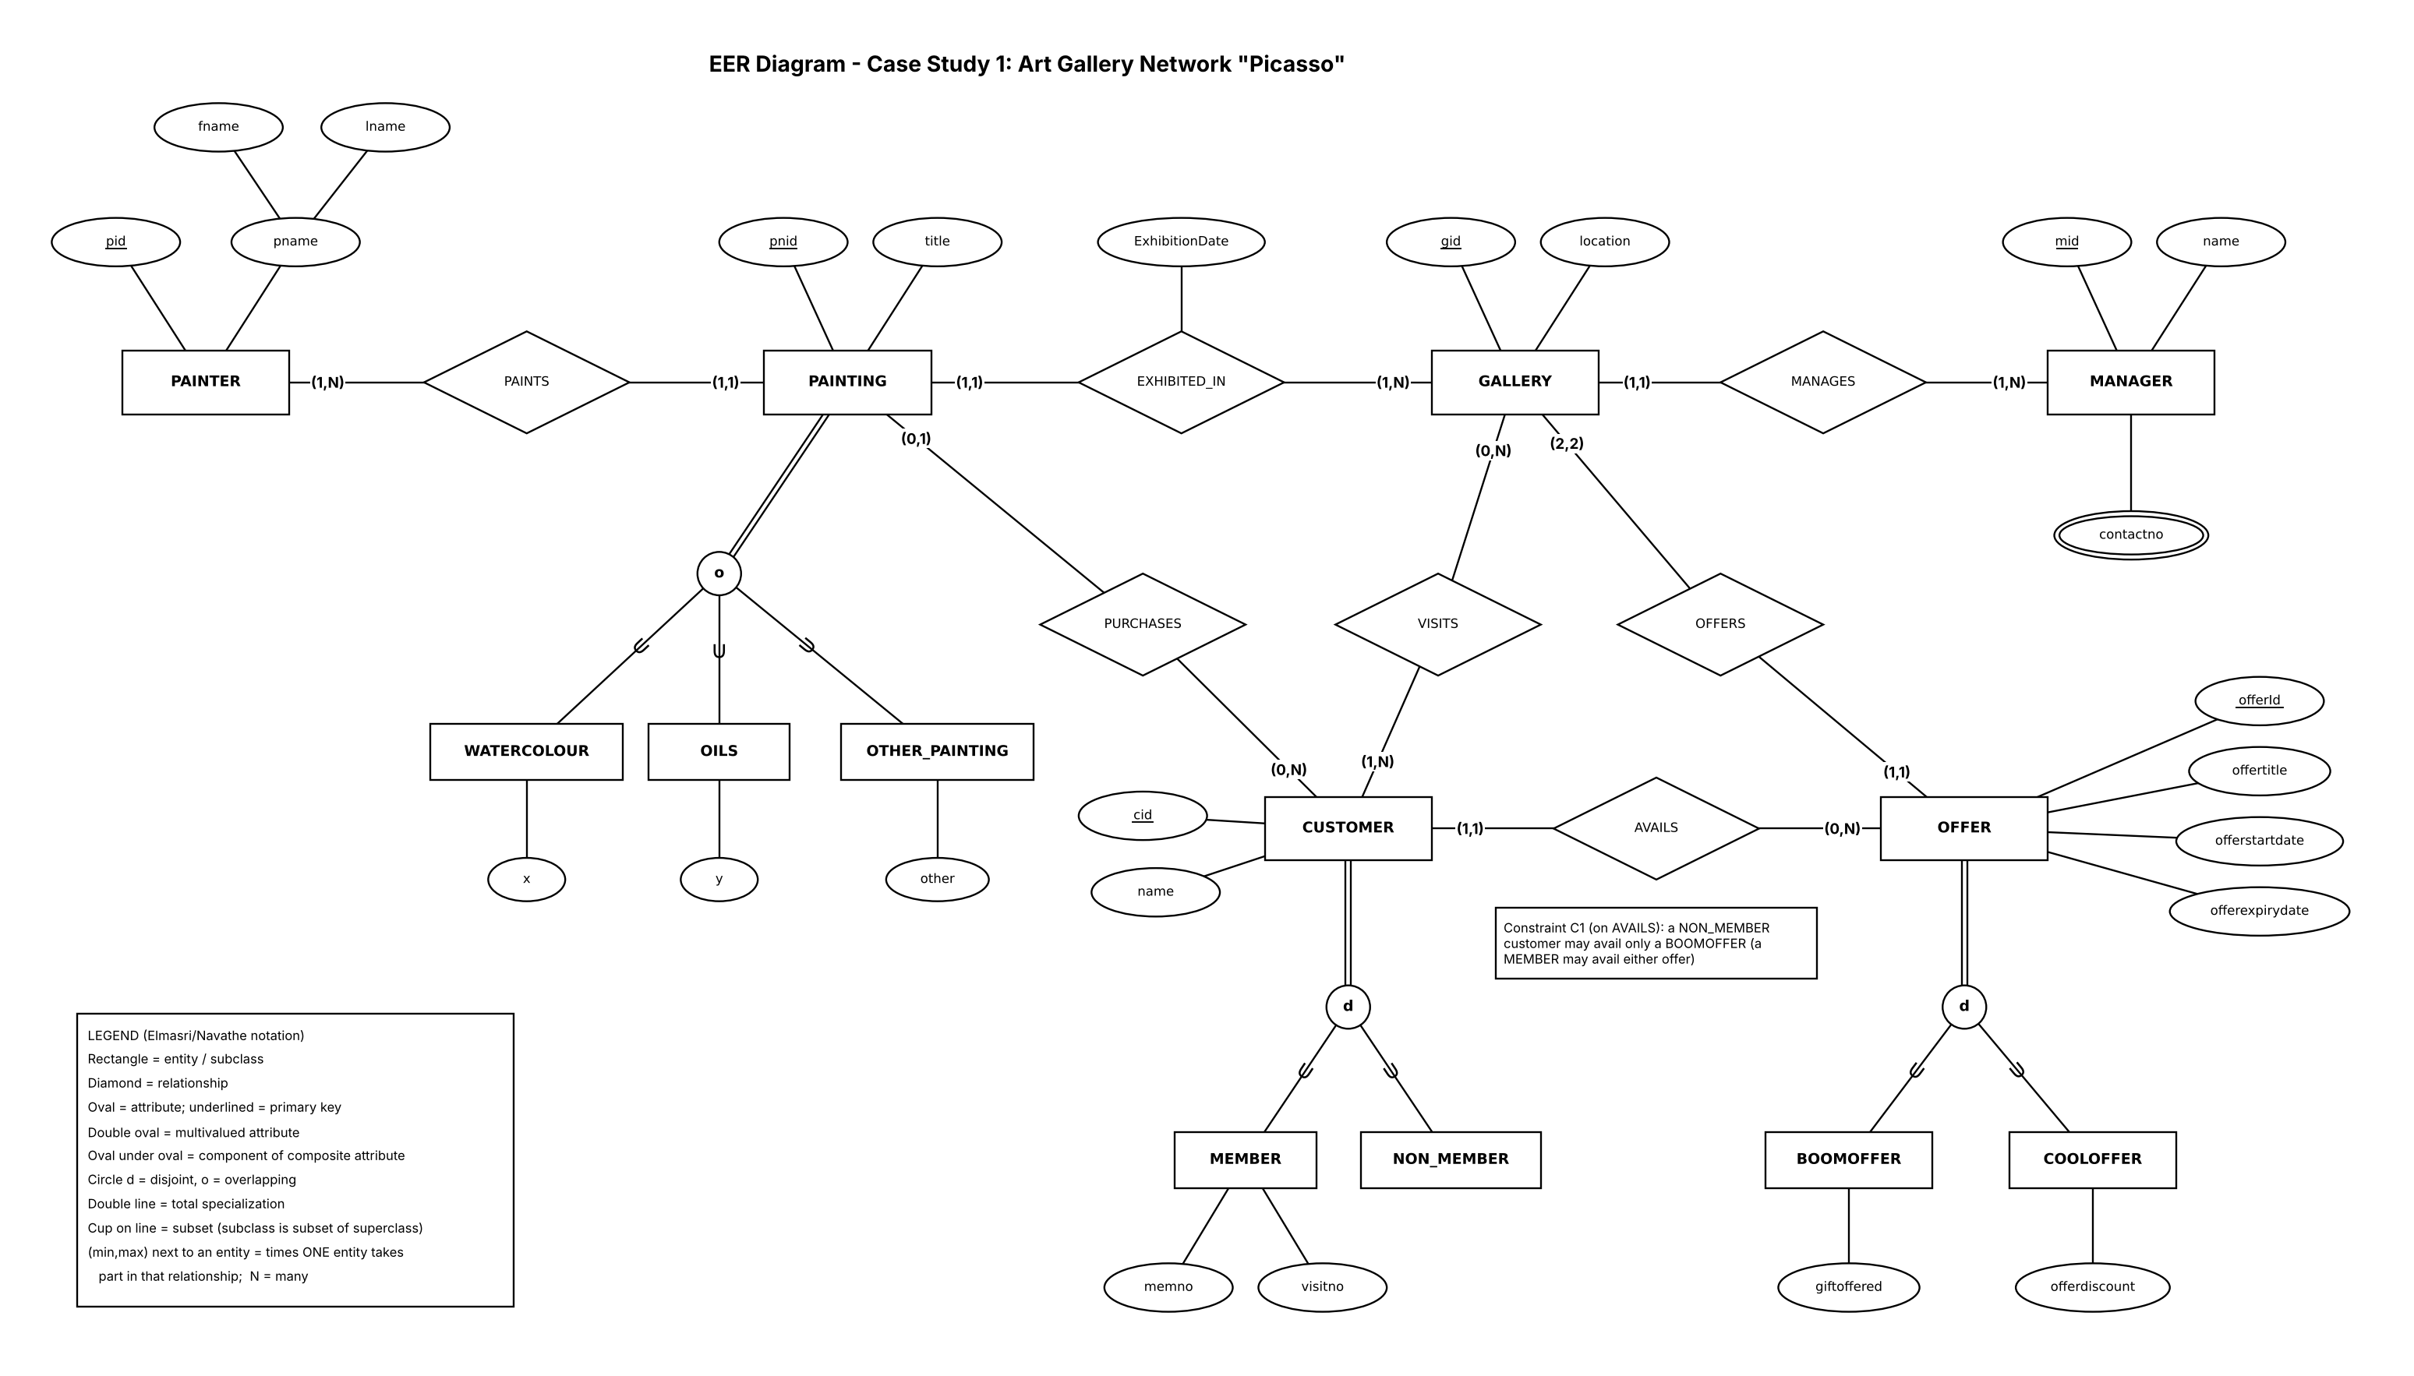

Part A - EER Diagram
Notation: Elmasri/Navathe (see legend inside the figure). Every relationship line carries a (min,max) pair: min 0 = partial participation, min 1 or more = total participation.

A.1 Entities, attributes and primary keys
Entity | Kind | Primary key | Other attributes
PAINTER | Strong | pid | pname (composite: fname, lname)
PAINTING | Strong, superclass | pnid | title
GALLERY | Strong | gid | location
CUSTOMER | Strong, superclass | cid | name
MANAGER | Strong | mid | name; contactno (multivalued)
OFFER | Superclass (generalization) | offerId | offertitle, offerstartdate, offerexpirydate
WATERCOLOUR, OILS, OTHER_PAINTING | Subclasses of PAINTING | pnid (inherited) | x, y, other (one each)
MEMBER, NON_MEMBER | Subclasses of CUSTOMER | cid (inherited) | memno, visitno (MEMBER only)
BOOMOFFER, COOLOFFER | Subclasses of OFFER | offerId (inherited) | giftoffered / offerdiscount

A.2 Relationships, cardinality and participation
Relationship | Left end (min,max) | Right end (min,max) | Type | Attributes / note
PAINTS | PAINTER (1,N) total | PAINTING (1,1) total | 1:N | -
EXHIBITED_IN | PAINTING (1,1) total | GALLERY (1,N) total | N:1 | attribute ExhibitionDate
PURCHASES | CUSTOMER (0,N) partial | PAINTING (0,1) partial | 1:N | unsold paintings allowed
VISITS | GALLERY (0,N) partial | CUSTOMER (1,N) total | M:N | -
MANAGES | MANAGER (1,N) total | GALLERY (1,1) total | 1:N | -
OFFERS | GALLERY (2,2) total | OFFER (1,1) total | 1:N | one BoomOffer + one CoolOffer (A3)
AVAILS | CUSTOMER (1,1) total | OFFER (0,N) partial | N:1 | constraint C1 on the diagram

A.3 Specialization / generalization
Superclass | Subclasses | Constraint | Reason
PAINTING | WATERCOLOUR, OILS, OTHER_PAINTING | Overlapping (o), total | "A single painting can belong to multiple categories"; OTHER_PAINTING is the catch-all, so every painting is in at least one
CUSTOMER | MEMBER, NON_MEMBER | Disjoint (d), total | "Exactly two types"; "can never be a non-member and vice versa"
OFFER | BOOMOFFER, COOLOFFER | Disjoint (d), total | Generalization: both offers share offerId, offertitle, start and expiry dates; "exactly two types"

Part B - Relational Schema
Mapping follows Chapter 9: Step 1 (entities), Step 4 (1:N: foreign key on the N side, relationship attribute moves with it), Step 5 (M:N: relationship table), Step 6 (multivalued attribute: new table), and option 8A for every specialization (superclass table plus one table per subclass, subclass key = superclass key). So every rectangle in the diagram is one table. Composite pname becomes fname and lname.
Table | Columns and data types | Primary key | Foreign keys (parent)
PAINTER | pid INT NOT NULL  fname VARCHAR(30) NOT NULL  lname VARCHAR(30) NOT NULL | pid | -
MANAGER | mid INT NOT NULL  name VARCHAR(60) NOT NULL | mid | -
MANAGER_CONTACT | mid INT NOT NULL  contactno VARCHAR(15) NOT NULL | mid, contactno | mid -> MANAGER(mid) ON DELETE CASCADE
GALLERY | gid INT NOT NULL  location VARCHAR(100) NOT NULL  mid INT NOT NULL | gid | mid -> MANAGER(mid)
OFFER | offerid INT NOT NULL  offertitle VARCHAR(60) NOT NULL  offerstartdate DATE NOT NULL  offerexpirydate DATE NOT NULL  gid INT NOT NULL | offerid | gid -> GALLERY(gid)
BOOMOFFER | offerid INT NOT NULL  giftoffered VARCHAR(60) NOT NULL | offerid | offerid -> OFFER(offerid) ON DELETE CASCADE
COOLOFFER | offerid INT NOT NULL  offerdiscount DECIMAL(5,2) NOT NULL | offerid | offerid -> OFFER(offerid) ON DELETE CASCADE
CUSTOMER | cid INT NOT NULL  name VARCHAR(60) NOT NULL  offerid INT NOT NULL | cid | offerid -> OFFER(offerid)
MEMBER | cid INT NOT NULL  memno INT NOT NULL  visitno INT NOT NULL | cid | cid -> CUSTOMER(cid) ON DELETE CASCADE
NON_MEMBER | cid INT NOT NULL | cid | cid -> CUSTOMER(cid) ON DELETE CASCADE
PAINTING | pnid INT NOT NULL  title VARCHAR(100) NOT NULL  exhibition_date DATE NOT NULL  pid INT NOT NULL  gid INT NOT NULL  cid INT | pnid | pid -> PAINTER(pid)  gid -> GALLERY(gid)  cid -> CUSTOMER(cid)
WATERCOLOUR | pnid INT NOT NULL  x VARCHAR(50) NOT NULL | pnid | pnid -> PAINTING(pnid) ON DELETE CASCADE
OILS | pnid INT NOT NULL  y VARCHAR(50) NOT NULL | pnid | pnid -> PAINTING(pnid) ON DELETE CASCADE
OTHER_PAINTING | pnid INT NOT NULL  other VARCHAR(50) NOT NULL | pnid | pnid -> PAINTING(pnid) ON DELETE CASCADE
VISITS | gid INT NOT NULL  cid INT NOT NULL | gid, cid | gid -> GALLERY(gid)  cid -> CUSTOMER(cid)

Part C - Constraint Descriptions
Constraint | Where | Why it is needed
PRIMARY KEY | Every table | Identifies each row. In subclass tables the PK is also an FK, because a subclass entity is the same entity as its superclass entity
FOREIGN KEY, NOT NULL | GALLERY.mid, OFFER.gid, CUSTOMER.offerid, PAINTING.pid, PAINTING.gid | Maximum 1 and minimum 1 (1,1): "exactly one". No UNIQUE, because the other side may repeat (max N)
FOREIGN KEY, nullable | PAINTING.cid | PURCHASES is (0,1): NULL means the painting is not sold
Composite PRIMARY KEY | VISITS(gid,cid); MANAGER_CONTACT(mid,contactno) | The same pair or number is stored only once
UNIQUE | MEMBER.memno | A member number identifies one member
NOT NULL | Names, titles, location, dates, subclass attributes | These values "have to be stored" in the case study
CHECK | offerexpirydate >= offerstartdate; offerdiscount 0 to 100; visitno >= 0 | Rejects impossible values
ON DELETE CASCADE | MANAGER_CONTACT and all subclass tables | These rows have no meaning without their parent row

Rules plain SQL cannot declare (enforced by trigger or transaction logic):
Rule | How it is enforced
C1: a NON_MEMBER may avail only a BOOMOFFER | Trigger on CUSTOMER / NON_MEMBER (needs three tables)
CUSTOMER and OFFER are disjoint and total (never in both subclass tables, always in one) | Trigger, or insert superclass and subclass row in one transaction
Every PAINTING is in at least one category table (total) | Transaction logic or deferred trigger
Gallery has exactly one BoomOffer and one CoolOffer (2,2) | Trigger or application check
Minimum 1 on the "one" side: painter has a painting, gallery has a painting, manager has a gallery, customer visited a gallery | A parent row exists before its first child, so SQL cannot demand it; insert both in one transaction

Part D - Design Justification

D.1 Entities and relationships
- PAINTER, PAINTING, GALLERY, CUSTOMER, MANAGER are real things with their own identifiers, so each is a strong entity and a table. No weak entity is needed.
- OFFER is a generalization: Boomoffer and Cooloffer share four attributes and differ in one each, so the shared part is moved up into OFFER.
- Subclasses exist only where the case study gives them their own attributes or rules (categories of painting, member or non-member, type of offer).
- 1:N relationships (PAINTS, EXHIBITED_IN, PURCHASES, MANAGES, OFFERS, AVAILS): the entity whose maximum is 1 holds the foreign key (Step 4). VISITS is the only M:N relationship, so it becomes a table (Step 5).
- ExhibitionDate is on the relationship EXHIBITED_IN because it belongs to neither painting nor gallery; being 1:N it is stored in PAINTING.
- The (min,max) values come from phrases such as "no painter who has not painted", "no gallery without painting" and "zero, one or many".

D.2 Constraints
- NOT NULL on a foreign key gives minimum 1 on that side; a nullable foreign key gives minimum 0. A key is never UNIQUE when the other side may repeat.
- Option 8A for all specializations: it works for disjoint and overlapping, total and partial (PAINTING is overlapping, which one type column cannot store) and keeps the schema identical to the diagram. The cost is that disjoint and total need triggers (Part C).
- Data types: INT for identifiers and counts; VARCHAR(n) for text; VARCHAR(15) for contactno (phone numbers have "+" and leading zeros); DATE for dates; DECIMAL(5,2) for the exact discount percentage.

D.3 Assumptions
# | Assumption | Justification
A1 | pid, pnid, cid, mid, offerId are primary keys like gid | The case study calls them "identifier"
A2 | "Iname" = lname; CoolOffer's "offered" = offerId | Typing errors; both offers need the same key
A3 | Each gallery has exactly one BoomOffer and one CoolOffer; each offer belongs to one gallery | "Exactly two types" read literally gives (2,2). If "many per type" is meant, change to (2,N)
A4 | PAINTING specialization is overlapping and total, with OTHER_PAINTING as catch-all | "Multiple categories" gives overlapping; if partial is meant, use a single line
A5 | x, y, other are placeholder attributes (VARCHAR(50)); offerdiscount is a percentage | No types are given in the case study
A6 | Every customer avails exactly one offer, not necessarily from a gallery visited | "Exactly one offer"; no link to VISITS is stated
A7 | memno is a unique member number; visitno is the member's visit count | "visitno" is not defined
A8 | Only pname is composite; a manager has at least one contact number | Only pname is divided; "contactno has to be stored"
A9 | SQL is DBMS-neutral and CHECK constraints are enforced | Needed for the CHECK constraints in Part C

