CS-2005 Database Systems - Assignment 02
Case Study 2: Islamabad Digital Media Center (IDMC)
Name: ______________ Roll No: __________ Section: ____
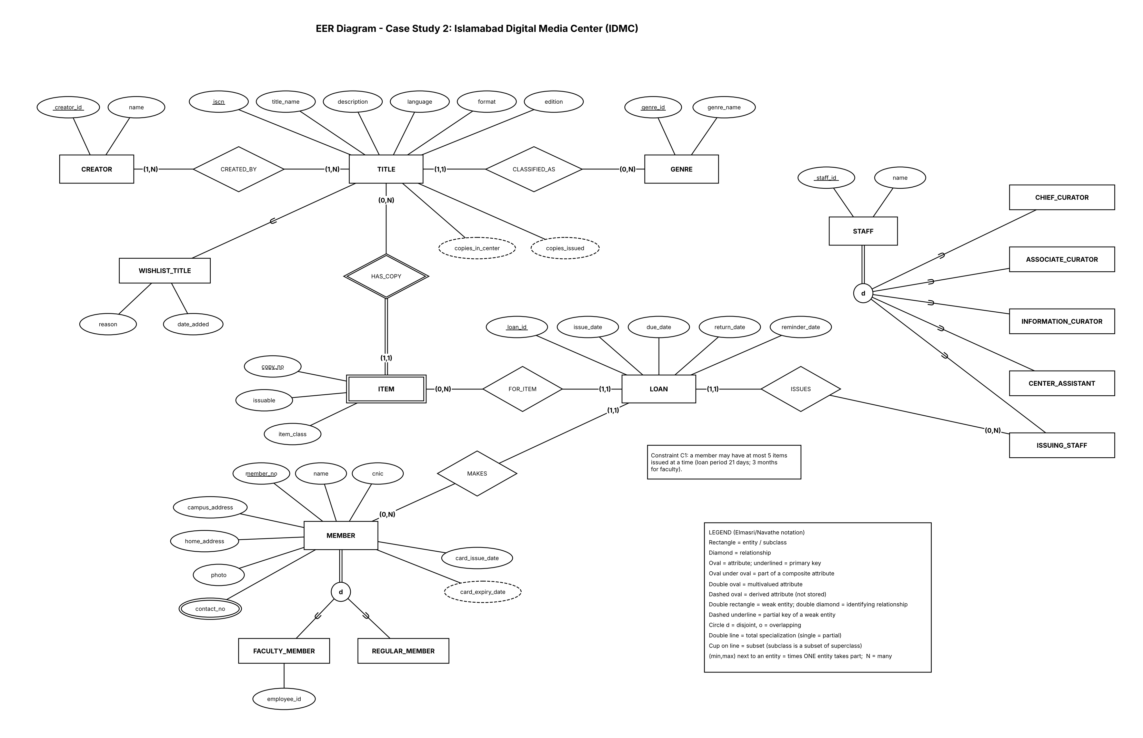

Part A - EER Diagram
Notation: Elmasri/Navathe (see legend inside the figure). Every relationship line carries a (min,max) pair: min 0 = partial participation, min 1 or more = total participation.

A.1 Entities, attributes and primary keys
Entity | Kind | Primary key | Other attributes
TITLE | Strong, superclass | iscn | title_name, description, language, format, edition; copies_in_center, copies_issued (derived)
WISHLIST_TITLE | Subclass of TITLE | iscn (inherited) | reason, date_added
CREATOR | Strong | creator_id | name
GENRE | Strong | genre_id | genre_name
ITEM | Weak (owner TITLE) | iscn + copy_no (partial key copy_no) | issuable, item_class
MEMBER | Strong, superclass | member_no (card number) | name, cnic, campus_address, home_address, photo, card_issue_date; card_expiry_date (derived); contact_no (multivalued)
FACULTY_MEMBER, REGULAR_MEMBER | Subclasses of MEMBER | member_no (inherited) | employee_id (faculty only)
STAFF | Strong, superclass | staff_id | name
CHIEF_CURATOR, ASSOCIATE_CURATOR, INFORMATION_CURATOR, CENTER_ASSISTANT, ISSUING_STAFF | Subclasses of STAFF | staff_id (inherited) | none
LOAN | Strong | loan_id | issue_date, due_date, return_date, reminder_date

A.2 Relationships, cardinality and participation
Relationship | Left end (min,max) | Right end (min,max) | Type | Attributes / note
CREATED_BY | CREATOR (1,N) total | TITLE (1,N) total | M:N | -
CLASSIFIED_AS | TITLE (1,1) total | GENRE (0,N) partial | N:1 | -
HAS_COPY (identifying) | TITLE (0,N) partial | ITEM (1,1) total | 1:N | wishlist titles have no copies
FOR_ITEM | ITEM (0,N) partial | LOAN (1,1) total | 1:N | an item may never be borrowed
MAKES | MEMBER (0,N) partial | LOAN (1,1) total | 1:N | 20% of members never borrow
ISSUES | ISSUING_STAFF (0,N) partial | LOAN (1,1) total | 1:N | relationship of a subclass

A.3 Specialization / generalization
Superclass | Subclasses | Constraint | Reason
MEMBER | FACULTY_MEMBER, REGULAR_MEMBER | Disjoint (d), total | Faculty are automatic members (employee_id, three-month loans); everyone else registers by form; a member is one or the other
STAFF | Five staff types | Disjoint (d), total | The five types named in the case study; one person has one role; only ISSUING_STAFF issues items
TITLE | WISHLIST_TITLE | Partial (one subclass, no circle) | Only titles the curators want to acquire but cannot obtain are on the wishlist

Part B - Relational Schema
Mapping follows Chapter 9: Step 1 (entities), Step 2 (weak entity ITEM: primary key = owner key + partial key), Step 4 (1:N: foreign key on the N side), Step 5 (M:N: relationship table), Step 6 (multivalued contact_no: new table) and option 8A for every specialization. Derived attributes (copies_in_center, copies_issued, card_expiry_date) are computed by queries and not stored.
Table | Columns and data types | Primary key | Foreign keys (parent)
GENRE | genre_id INT NOT NULL  genre_name VARCHAR(50) NOT NULL | genre_id | -
CREATOR | creator_id INT NOT NULL  name VARCHAR(100) NOT NULL | creator_id | -
TITLE | iscn VARCHAR(20) NOT NULL  title_name VARCHAR(150) NOT NULL  description CLOB  language VARCHAR(30) NOT NULL  format VARCHAR(10) NOT NULL  edition VARCHAR(20)  genre_id INT NOT NULL | iscn | genre_id -> GENRE(genre_id)
TITLE_CREATOR | iscn VARCHAR(20) NOT NULL  creator_id INT NOT NULL | iscn, creator_id | iscn -> TITLE(iscn) ON DELETE CASCADE  creator_id -> CREATOR(creator_id)
WISHLIST_TITLE | iscn VARCHAR(20) NOT NULL  reason VARCHAR(100) NOT NULL  date_added DATE NOT NULL | iscn | iscn -> TITLE(iscn) ON DELETE CASCADE
ITEM | iscn VARCHAR(20) NOT NULL  copy_no INT NOT NULL  issuable CHAR(1) NOT NULL  item_class VARCHAR(30) | iscn, copy_no | iscn -> TITLE(iscn) ON DELETE CASCADE
MEMBER | member_no INT NOT NULL  name VARCHAR(100) NOT NULL  cnic CHAR(13) NOT NULL  campus_address VARCHAR(200) NOT NULL  home_address VARCHAR(200)  photo VARCHAR(255)  card_issue_date DATE NOT NULL | member_no | -
MEMBER_CONTACT | member_no INT NOT NULL  contact_no VARCHAR(15) NOT NULL | member_no, contact_no | member_no -> MEMBER(member_no) ON DELETE CASCADE
FACULTY_MEMBER | member_no INT NOT NULL  employee_id INT NOT NULL | member_no | member_no -> MEMBER(member_no) ON DELETE CASCADE
REGULAR_MEMBER | member_no INT NOT NULL | member_no | member_no -> MEMBER(member_no) ON DELETE CASCADE
STAFF | staff_id INT NOT NULL  name VARCHAR(100) NOT NULL | staff_id | -
CHIEF_CURATOR | staff_id INT NOT NULL | staff_id | staff_id -> STAFF(staff_id) ON DELETE CASCADE
ASSOCIATE_CURATOR | staff_id INT NOT NULL | staff_id | staff_id -> STAFF(staff_id) ON DELETE CASCADE
INFORMATION_CURATOR | staff_id INT NOT NULL | staff_id | staff_id -> STAFF(staff_id) ON DELETE CASCADE
CENTER_ASSISTANT | staff_id INT NOT NULL | staff_id | staff_id -> STAFF(staff_id) ON DELETE CASCADE
ISSUING_STAFF | staff_id INT NOT NULL | staff_id | staff_id -> STAFF(staff_id) ON DELETE CASCADE
LOAN | loan_id INT NOT NULL  issue_date DATE NOT NULL  due_date DATE NOT NULL  return_date DATE  reminder_date DATE  member_no INT NOT NULL  iscn VARCHAR(20) NOT NULL  copy_no INT NOT NULL  staff_id INT NOT NULL | loan_id | member_no -> MEMBER(member_no)  iscn, copy_no -> ITEM(iscn, copy_no)  staff_id -> ISSUING_STAFF(staff_id)

Part C - Constraint Descriptions
Constraint | Where | Why it is needed
PRIMARY KEY (composite) | ITEM(iscn, copy_no); TITLE_CREATOR; MEMBER_CONTACT | A weak entity is identified by owner key + partial key; pairs are stored once
FOREIGN KEY, NOT NULL | TITLE.genre_id; LOAN.member_no, (iscn, copy_no), staff_id | (1,1): every title has one genre; every loan has one member, one item, one issuing staff member
Composite FOREIGN KEY | LOAN(iscn, copy_no) -> ITEM | A loan points to exactly one copy of one title
UNIQUE | MEMBER.cnic; FACULTY_MEMBER.employee_id; GENRE.genre_name | Each person, employee and genre appears once
CHECK | TITLE.format IN (PHYSICAL, DIGITAL); ITEM.issuable IN (Y, N); due_date >= issue_date; return_date >= issue_date | Rejects impossible values; the case study separates physical and digital titles and issuable and non-issuable items
NOT NULL | Names, dates, language, campus_address, issuable | Required data ("have to be known" in the case study)
ON DELETE CASCADE | ITEM, WISHLIST_TITLE, subclass tables, MEMBER_CONTACT, TITLE_CREATOR (title side) | These rows have no meaning without their parent row

Rules plain SQL cannot declare (enforced by trigger or transaction logic):
Rule | How it is enforced
A member may have at most 5 items issued at a time | Trigger on LOAN: count of loans of the member with return_date NULL must be below 5
A loan is allowed only for an item with issuable = Y | Trigger on LOAN (needs ITEM)
due_date = issue_date + 21 days (faculty: 3 months); reminder after the grace period (1 week; faculty 2 weeks) | Application logic, stored in due_date and reminder_date
MEMBER and STAFF are disjoint and total; a title has at least one creator | Trigger or one transaction; SQL cannot demand a minimum of 1 child

Part D - Design Justification

D.1 Entities and relationships
- TITLE and ITEM are separate: a title is the catalog record (one ISCN), an item is a physical or digital copy (250,000 items for 100,000 titles). ITEM is weak because a copy has no identity without its title (iscn + copy_no).
- LOAN is an entity so every issue, return and reminder is kept as history; a plain M:N relationship could not record the same member borrowing the same item twice.
- Specializations: MEMBER (faculty differ: automatic, employee_id, longer loans), STAFF (five named roles; only issuing staff issue items), TITLE (wishlist titles).
- CREATED_BY is M:N (several creators per title, many titles per creator), so it becomes a table. Every other relationship is 1:N, so the foreign key sits on the N side.
- TITLE (0,N) in HAS_COPY: wishlist titles have no copies. MEMBER (0,N) in MAKES: about 20% of members never borrow.
- ISSUES is attached to ISSUING_STAFF, not STAFF, because only that subclass issues items (a subclass taking part in its own relationship).

D.2 Constraints
- Composite foreign key (iscn, copy_no) in LOAN is needed because the weak entity ITEM has a composite key. NOT NULL on foreign keys gives minimum 1.
- CHECK and UNIQUE keep the data valid: allowed formats, issuable flag, date order, one CNIC per member.
- Rules that need a trigger (5-item limit, issuable items only) are listed in Part C because they involve counts or other tables.
- Data types: ISCN is VARCHAR(20) (a code, not a number); description is CLOB (one sentence to several pages); CNIC is CHAR(13); phone numbers are VARCHAR(15); dates are DATE.

D.3 Assumptions
# | Assumption | Justification
A1 | ITEM is a weak entity identified by iscn + copy_no | Copies of a title are numbered; a copy cannot exist without its title
A2 | LOAN is one item issued to one member by one issuing staff member | The case study tracks "borrowing activity"; history is kept
A3 | member_no is the number on the card; renewal keeps it and changes card_issue_date | card_expiry_date = issue + 4 years is derived
A4 | A title has one genre and at least one creator | The catalog lists titles by creator, title and genre
A5 | Wishlist titles are TITLE rows with a WISHLIST_TITLE row and no items | Wishlist titles are not currently obtainable
A6 | Non-issuable items (archival, rare, maps) are flagged issuable = N | The curators must tell issuable from non-issuable items
A7 | Loan period, grace period and the 5-item limit are business rules in the application | They are policy values, not stored data; due_date is stored
A8 | Faculty data comes from employee records (employee_id); home_address is optional | "Faculty information is retrieved from employee records"
A9 | Catalog description is stored in TITLE; there is no separate CATALOG entity | The catalog is the TITLE data itself

