CS-2005 Database Systems - Assignment 02
Case Study 3: Aircraft Manufacturing Company "AeroNova"
Name: ______________ Roll No: __________ Section: ____
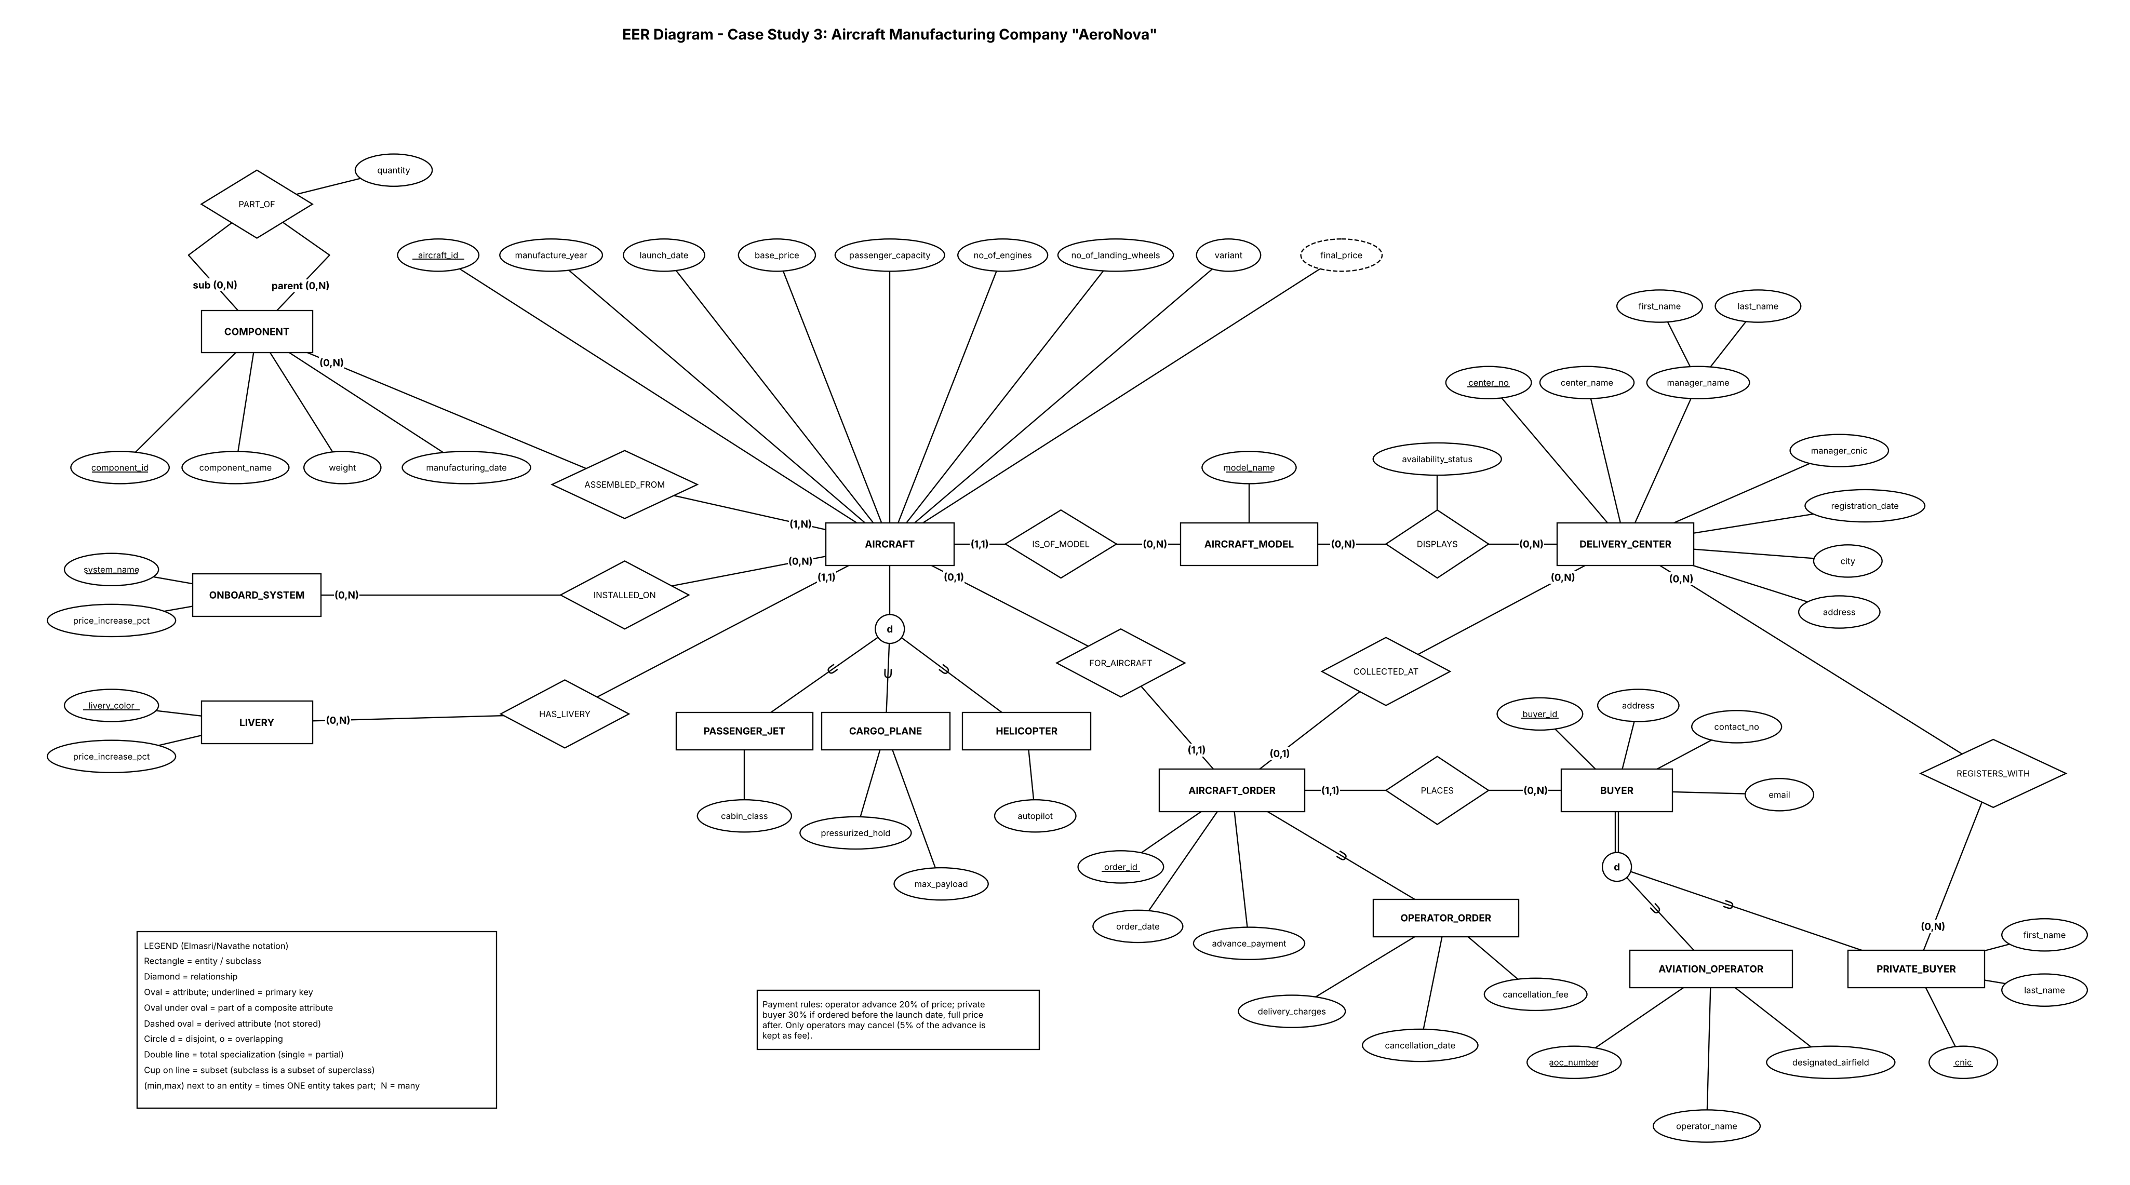

Part A - EER Diagram
Notation: Elmasri/Navathe (see legend inside the figure). Every relationship line carries a (min,max) pair: min 0 = partial participation, min 1 or more = total participation.

A.1 Entities, attributes and primary keys
Entity | Kind | Primary key | Other attributes
AIRCRAFT | Strong, superclass | aircraft_id | manufacture_year, launch_date, base_price, passenger_capacity, no_of_engines, no_of_landing_wheels, variant; final_price (derived)
PASSENGER_JET, CARGO_PLANE, HELICOPTER | Subclasses of AIRCRAFT | aircraft_id (inherited) | cabin_class / pressurized_hold, max_payload / autopilot
AIRCRAFT_MODEL | Strong | model_name | -
COMPONENT | Strong | component_id | component_name, weight, manufacturing_date
LIVERY | Strong | livery_color | price_increase_pct
ONBOARD_SYSTEM | Strong | system_name | price_increase_pct
DELIVERY_CENTER | Strong | center_no | center_name, manager_name (composite: first_name, last_name), manager_cnic, registration_date, city, address
BUYER | Strong, superclass | buyer_id | address, contact_no, email
AVIATION_OPERATOR, PRIVATE_BUYER | Subclasses of BUYER | buyer_id (inherited) | aoc_number, operator_name, designated_airfield / cnic, first_name, last_name
AIRCRAFT_ORDER | Strong, superclass | order_id | order_date, advance_payment
OPERATOR_ORDER | Subclass of AIRCRAFT_ORDER | order_id (inherited) | delivery_charges, cancellation_date, cancellation_fee

A.2 Relationships, cardinality and participation
Relationship | Left end (min,max) | Right end (min,max) | Type | Attributes / note
IS_OF_MODEL | AIRCRAFT (1,1) total | AIRCRAFT_MODEL (0,N) partial | N:1 | -
ASSEMBLED_FROM | AIRCRAFT (1,N) total | COMPONENT (0,N) partial | M:N | every aircraft has at least one component
PART_OF (recursive) | COMPONENT as sub (0,N) | COMPONENT as parent (0,N) | M:N | attribute quantity
HAS_LIVERY | AIRCRAFT (1,1) total | LIVERY (0,N) partial | N:1 | price +4% to +6%
INSTALLED_ON | AIRCRAFT (0,N) partial | ONBOARD_SYSTEM (0,N) partial | M:N | each system +2%
DISPLAYS | DELIVERY_CENTER (0,N) partial | AIRCRAFT_MODEL (0,N) partial | M:N | attribute availability_status
REGISTERS_WITH | PRIVATE_BUYER (0,N) partial | DELIVERY_CENTER (0,N) partial | M:N | private buyers only
PLACES | BUYER (0,N) partial | AIRCRAFT_ORDER (1,1) total | 1:N | -
FOR_AIRCRAFT | AIRCRAFT_ORDER (1,1) total | AIRCRAFT (0,1) partial | 1:1 | one order per aircraft (A6)
COLLECTED_AT | AIRCRAFT_ORDER (0,1) partial | DELIVERY_CENTER (0,N) partial | N:1 | private orders only

A.3 Specialization / generalization
Superclass | Subclasses | Constraint | Reason
AIRCRAFT | PASSENGER_JET, CARGO_PLANE, HELICOPTER | Disjoint (d), partial | Each aircraft is one type; the case study says "several types including" these three, so other types may exist (single line)
BUYER | AVIATION_OPERATOR, PRIVATE_BUYER | Disjoint (d), total | Every buyer is an operator or a private buyer; they have different keys (AOC number, CNIC) but share address, contact and email
AIRCRAFT_ORDER | OPERATOR_ORDER | Partial (one subclass, no circle) | Only operators pay delivery charges and may cancel

Part B - Relational Schema
Mapping follows Chapter 9: Step 1 (entities), Step 4 (1:N and N:1: foreign key on the side with maximum 1, including the 1:1 FOR_AIRCRAFT as a UNIQUE foreign key), Step 5 (M:N: relationship tables, including the recursive PART_OF with its quantity), Step 8A for every specialization. The composite manager_name becomes two columns. final_price is derived and not stored.
Table | Columns and data types | Primary key | Foreign keys (parent)
AIRCRAFT_MODEL | model_name VARCHAR(50) NOT NULL | model_name | -
LIVERY | livery_color VARCHAR(30) NOT NULL  price_increase_pct DECIMAL(5,2) NOT NULL | livery_color | -
ONBOARD_SYSTEM | system_name VARCHAR(50) NOT NULL  price_increase_pct DECIMAL(5,2) NOT NULL | system_name | -
AIRCRAFT | aircraft_id INT NOT NULL  manufacture_year INT NOT NULL  launch_date DATE NOT NULL  base_price DECIMAL(14,2) NOT NULL  passenger_capacity INT NOT NULL  no_of_engines INT NOT NULL  no_of_landing_wheels INT NOT NULL  variant VARCHAR(10) NOT NULL  model_name VARCHAR(50) NOT NULL  livery_color VARCHAR(30) NOT NULL | aircraft_id | model_name -> AIRCRAFT_MODEL(model_name)  livery_color -> LIVERY(livery_color)
PASSENGER_JET | aircraft_id INT NOT NULL  cabin_class VARCHAR(11) NOT NULL | aircraft_id | aircraft_id -> AIRCRAFT(aircraft_id) ON DELETE CASCADE
CARGO_PLANE | aircraft_id INT NOT NULL  pressurized_hold CHAR(1) NOT NULL  max_payload DECIMAL(10,2) NOT NULL | aircraft_id | aircraft_id -> AIRCRAFT(aircraft_id) ON DELETE CASCADE
HELICOPTER | aircraft_id INT NOT NULL  autopilot CHAR(1) NOT NULL | aircraft_id | aircraft_id -> AIRCRAFT(aircraft_id) ON DELETE CASCADE
INSTALLED_ON | aircraft_id INT NOT NULL  system_name VARCHAR(50) NOT NULL | aircraft_id, system_name | aircraft_id -> AIRCRAFT(aircraft_id) ON DELETE CASCADE  system_name -> ONBOARD_SYSTEM(system_name)
COMPONENT | component_id INT NOT NULL  component_name VARCHAR(80) NOT NULL  weight DECIMAL(10,2) NOT NULL  manufacturing_date DATE NOT NULL | component_id | -
ASSEMBLED_FROM | aircraft_id INT NOT NULL  component_id INT NOT NULL | aircraft_id, component_id | aircraft_id -> AIRCRAFT(aircraft_id) ON DELETE CASCADE  component_id -> COMPONENT(component_id)
PART_OF | parent_id INT NOT NULL  sub_id INT NOT NULL  quantity INT NOT NULL | parent_id, sub_id | parent_id -> COMPONENT(component_id)  sub_id -> COMPONENT(component_id)
DELIVERY_CENTER | center_no INT NOT NULL  center_name VARCHAR(80) NOT NULL  manager_first_name VARCHAR(40) NOT NULL  manager_last_name VARCHAR(40) NOT NULL  manager_cnic CHAR(13) NOT NULL  registration_date DATE NOT NULL  city VARCHAR(50) NOT NULL  address VARCHAR(200) NOT NULL | center_no | -
DISPLAYS | center_no INT NOT NULL  model_name VARCHAR(50) NOT NULL  availability_status VARCHAR(12) NOT NULL | center_no, model_name | center_no -> DELIVERY_CENTER(center_no) ON DELETE CASCADE  model_name -> AIRCRAFT_MODEL(model_name)
BUYER | buyer_id INT NOT NULL  address VARCHAR(200) NOT NULL  contact_no VARCHAR(15) NOT NULL  email VARCHAR(100) | buyer_id | -
AVIATION_OPERATOR | buyer_id INT NOT NULL  aoc_number VARCHAR(20) NOT NULL  operator_name VARCHAR(100) NOT NULL  designated_airfield VARCHAR(100) NOT NULL | buyer_id | buyer_id -> BUYER(buyer_id) ON DELETE CASCADE
PRIVATE_BUYER | buyer_id INT NOT NULL  cnic CHAR(13) NOT NULL  first_name VARCHAR(40) NOT NULL  last_name VARCHAR(40) NOT NULL | buyer_id | buyer_id -> BUYER(buyer_id) ON DELETE CASCADE
REGISTERS_WITH | buyer_id INT NOT NULL  center_no INT NOT NULL | buyer_id, center_no | buyer_id -> PRIVATE_BUYER(buyer_id) ON DELETE CASCADE  center_no -> DELIVERY_CENTER(center_no) ON DELETE CASCADE
AIRCRAFT_ORDER | order_id INT NOT NULL  order_date DATE NOT NULL  advance_payment DECIMAL(14,2) NOT NULL  buyer_id INT NOT NULL  aircraft_id INT NOT NULL  center_no INT | order_id | buyer_id -> BUYER(buyer_id)  aircraft_id -> AIRCRAFT(aircraft_id)  center_no -> DELIVERY_CENTER(center_no)
OPERATOR_ORDER | order_id INT NOT NULL  delivery_charges DECIMAL(12,2)  cancellation_date DATE  cancellation_fee DECIMAL(14,2) | order_id | order_id -> AIRCRAFT_ORDER(order_id) ON DELETE CASCADE

Part C - Constraint Descriptions
Constraint | Where | Why it is needed
PRIMARY KEY (composite) | INSTALLED_ON, ASSEMBLED_FROM, PART_OF, DISPLAYS, REGISTERS_WITH | Each M:N pair is stored once
FOREIGN KEY, NOT NULL | AIRCRAFT.model_name, AIRCRAFT.livery_color, AIRCRAFT_ORDER.buyer_id, AIRCRAFT_ORDER.aircraft_id | (1,1): every aircraft has one model and one livery; every order has one buyer and one aircraft
FOREIGN KEY, nullable | AIRCRAFT_ORDER.center_no | COLLECTED_AT is (0,1): only private orders have a collection center
UNIQUE | AIRCRAFT_ORDER.aircraft_id; AVIATION_OPERATOR.aoc_number; PRIVATE_BUYER.cnic | One order per aircraft (max 1); AOC number and CNIC identify one buyer
CHECK | variant IN (TURBOFAN, TURBOPROP); cabin_class IN (NARROW_BODY, WIDE_BODY); Y/N flags; percentages 0 to 100; quantity > 0; parent_id <> sub_id; cancellation date and fee together | The case study names the allowed values; a component cannot contain itself
NOT NULL | Dates, prices, names, addresses, subclass attributes | Required data
ON DELETE CASCADE | Subclass tables; INSTALLED_ON, ASSEMBLED_FROM, DISPLAYS, REGISTERS_WITH | These rows have no meaning without their parent row

Rules plain SQL cannot declare (enforced by trigger or transaction logic):
Rule | How it is enforced
Payment: operator advance 20% of price; private buyer 30% before the launch date, full price after; cancellation fee 5% of the advance | Application logic (price needs livery and system percentages); stored as amounts
Only operator orders may be cancelled; private orders must have center_no, operator orders must not | Trigger on AIRCRAFT_ORDER and OPERATOR_ORDER
final_price = base_price x (1 + livery % + 2% per onboard system) | Derived: computed by a query or view, not stored
BUYER is disjoint and total; every aircraft has at least one component | Trigger or one transaction; SQL cannot demand a minimum of 1 child

Part D - Design Justification

D.1 Entities and relationships
- AIRCRAFT is the central entity with subclasses for the three types, because each type has its own attributes. AIRCRAFT_MODEL, LIVERY, ONBOARD_SYSTEM and COMPONENT are separate entities because each is shared by many aircraft and carries its own data (price percentage, weight).
- BUYER is a generalization: operators and private buyers have different keys but the same contact data, and both place orders. A surrogate buyer_id lets AIRCRAFT_ORDER point to one table.
- DELIVERY_CENTER keeps the manager as attributes (a composite name), because the manager is described by only three values.
- Recursive PART_OF is M:N between COMPONENT and itself with attribute quantity, so it becomes a table with two foreign keys to COMPONENT (parent_id, sub_id).
- M:N relationships (ASSEMBLED_FROM, INSTALLED_ON, DISPLAYS, REGISTERS_WITH) become tables; DISPLAYS stores availability_status because it belongs to the pair (center, model).
- (min,max): an aircraft always has a model and a livery (1,1) but may have no onboard system (0,N); an order always has one buyer (1,1); only private orders have a collection center (0,1).

D.2 Constraints
- UNIQUE on AIRCRAFT_ORDER.aircraft_id gives the maximum 1 of FOR_AIRCRAFT. CHECK constraints keep only the allowed values from the case study.
- Option 8A for all specializations keeps one table per rectangle; rules about which subclass applies need triggers (Part C).
- Data types: DECIMAL for prices and weights (exact money values); INT for years and counts; CHAR(13) for CNIC; VARCHAR for names; DATE for dates.

D.3 Assumptions
# | Assumption | Justification
A1 | aircraft_id and model_name are keys; variant (turbofan or turboprop) is an attribute of AIRCRAFT | "Each model can be produced in two variants"; each aircraft is one of them
A2 | The three aircraft types are disjoint and partial | The case study says "including"
A3 | An aircraft has exactly one livery and any number of onboard systems; final_price is derived | Price rules: livery 4% to 6%, 2% per system
A4 | A component is a part type; PART_OF is M:N with quantity | "May have zero, one or many sub-components"
A5 | A delivery center manager is stored as attributes, not as an entity | Only name, CNIC are given
A6 | Each order is for one aircraft and one aircraft has at most one order | Simplification: a cancelled aircraft is not re-ordered
A7 | Private orders store the chosen collection center; operator orders use the operator's designated airfield | "Private buyers must collect from a delivery center"
A8 | availability_status values are AVAILABLE, LIMITED, UNAVAILABLE | The case study does not list values
A9 | Registering a private buyer with the company means a PRIVATE_BUYER row; REGISTERS_WITH links to centers | "Register with the company" and "with multiple delivery centers"

