CS-2005 Database Systems - Assignment 02
Case Study 4: Journal of E-Commerce Research Knowledge
Name: ______________ Roll No: __________ Section: ____
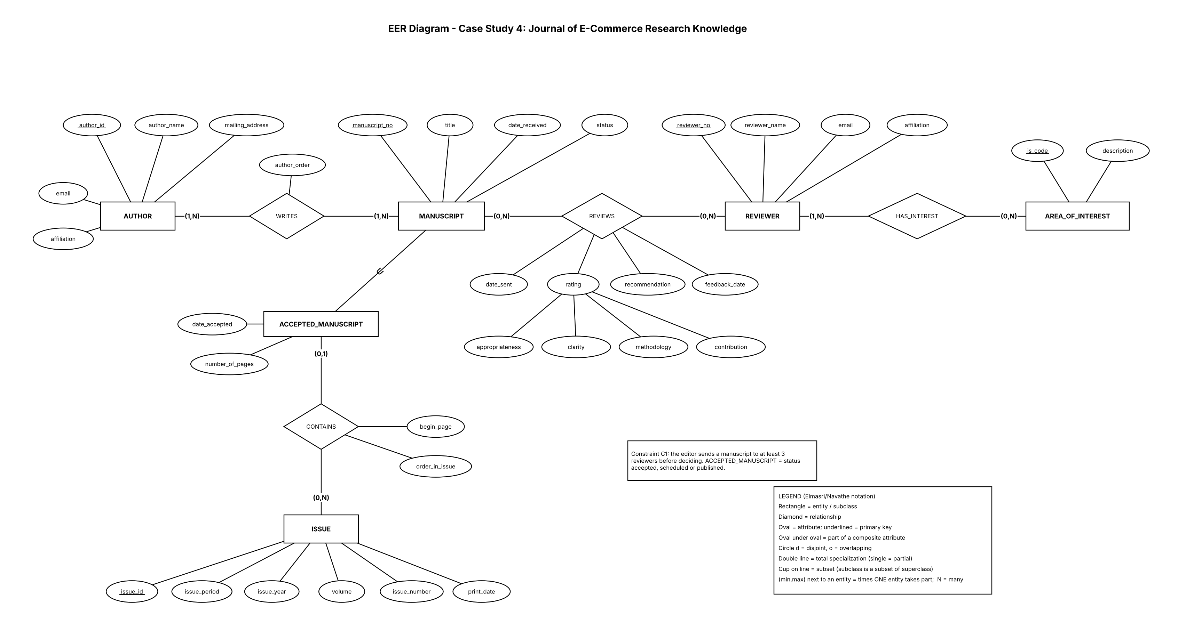

Part A - EER Diagram
Notation: Elmasri/Navathe (see legend inside the figure). Every relationship line carries a (min,max) pair: min 0 = partial participation, min 1 or more = total participation.

A.1 Entities, attributes and primary keys
Entity | Kind | Primary key | Other attributes
MANUSCRIPT | Strong, superclass | manuscript_no | title, date_received, status
ACCEPTED_MANUSCRIPT | Subclass of MANUSCRIPT | manuscript_no (inherited) | date_accepted, number_of_pages
AUTHOR | Strong | author_id | author_name, mailing_address, email, affiliation
REVIEWER | Strong | reviewer_no | reviewer_name, email, affiliation
AREA_OF_INTEREST | Strong | is_code | description
ISSUE | Strong | issue_id | issue_period, issue_year, volume, issue_number, print_date

A.2 Relationships, cardinality and participation
Relationship | Left end (min,max) | Right end (min,max) | Type | Attributes / note
WRITES | AUTHOR (1,N) total | MANUSCRIPT (1,N) total | M:N | attribute author_order (position in the credits)
REVIEWS | MANUSCRIPT (0,N) partial | REVIEWER (0,N) partial | M:N | date_sent, rating (composite: appropriateness, clarity, methodology, contribution), recommendation, feedback_date
HAS_INTEREST | REVIEWER (1,N) total | AREA_OF_INTEREST (0,N) partial | M:N | -
CONTAINS | ACCEPTED_MANUSCRIPT (0,1) partial | ISSUE (0,N) partial | N:1 | attributes begin_page, order_in_issue

A.3 Specialization / generalization
Superclass | Subclasses | Constraint | Reason
MANUSCRIPT | ACCEPTED_MANUSCRIPT | Partial (one subclass, no circle) | Only about 10% of manuscripts are accepted; only accepted manuscripts are typeset, scheduled in an issue and published. Membership is defined by status = accepted, scheduled or published

Part B - Relational Schema
Mapping follows Chapter 9: Step 1 (entities), Step 4 (CONTAINS is N:1, so its foreign key and attributes go into ACCEPTED_MANUSCRIPT), Step 5 (M:N: relationship tables WRITES, REVIEWS, HAS_INTEREST with their attributes), and option 8A for the specialization. The composite rating becomes four columns.
Table | Columns and data types | Primary key | Foreign keys (parent)
AUTHOR | author_id INT NOT NULL  author_name VARCHAR(100) NOT NULL  mailing_address VARCHAR(200) NOT NULL  email VARCHAR(100) NOT NULL  affiliation VARCHAR(150) | author_id | -
MANUSCRIPT | manuscript_no INT NOT NULL  title VARCHAR(200) NOT NULL  date_received DATE NOT NULL  status VARCHAR(12) NOT NULL | manuscript_no | -
WRITES | manuscript_no INT NOT NULL  author_id INT NOT NULL  author_order INT NOT NULL | manuscript_no, author_id | manuscript_no -> MANUSCRIPT(manuscript_no) ON DELETE CASCADE  author_id -> AUTHOR(author_id)
REVIEWER | reviewer_no INT NOT NULL  reviewer_name VARCHAR(100) NOT NULL  email VARCHAR(100) NOT NULL  affiliation VARCHAR(150) | reviewer_no | -
AREA_OF_INTEREST | is_code VARCHAR(10) NOT NULL  description VARCHAR(100) NOT NULL | is_code | -
HAS_INTEREST | reviewer_no INT NOT NULL  is_code VARCHAR(10) NOT NULL | reviewer_no, is_code | reviewer_no -> REVIEWER(reviewer_no) ON DELETE CASCADE  is_code -> AREA_OF_INTEREST(is_code)
REVIEWS | manuscript_no INT NOT NULL  reviewer_no INT NOT NULL  date_sent DATE NOT NULL  appropriateness_rating INT  clarity_rating INT  methodology_rating INT  contribution_rating INT  recommendation VARCHAR(6)  feedback_date DATE | manuscript_no, reviewer_no | manuscript_no -> MANUSCRIPT(manuscript_no) ON DELETE CASCADE  reviewer_no -> REVIEWER(reviewer_no)
ISSUE | issue_id INT NOT NULL  issue_period VARCHAR(6) NOT NULL  issue_year INT NOT NULL  volume INT NOT NULL  issue_number INT NOT NULL  print_date DATE | issue_id | -
ACCEPTED_MANUSCRIPT | manuscript_no INT NOT NULL  date_accepted DATE NOT NULL  number_of_pages INT  issue_id INT  begin_page INT  order_in_issue INT | manuscript_no | manuscript_no -> MANUSCRIPT(manuscript_no) ON DELETE CASCADE  issue_id -> ISSUE(issue_id)

Part C - Constraint Descriptions
Constraint | Where | Why it is needed
PRIMARY KEY (composite) | WRITES(manuscript_no, author_id); REVIEWS(manuscript_no, reviewer_no); HAS_INTEREST(reviewer_no, is_code) | Each pair is stored once: an author writes a manuscript once, a reviewer reviews it once
FOREIGN KEY | All relationship tables; ACCEPTED_MANUSCRIPT.issue_id (nullable) | (0,1) CONTAINS: an accepted manuscript may not yet be scheduled, so NULL is allowed
UNIQUE | WRITES(manuscript_no, author_order); ACCEPTED_MANUSCRIPT(issue_id, order_in_issue); ISSUE(volume, issue_number) | Two authors cannot share a position; two manuscripts cannot share a place in one issue; an issue is identified by volume and number
CHECK | status values; issue_period values; ratings 1 to 10; recommendation accept or reject; number_of_pages > 0; feedback_date >= date_sent | The case study fixes these values and the 10-point scale
CHECK (all or none) | ACCEPTED_MANUSCRIPT: issue_id, begin_page, order_in_issue | A manuscript is either not scheduled (all NULL) or fully scheduled
NOT NULL | title, date_received, status, names, emails, date_sent, date_accepted | Required when the record is created ("every manuscript must have an author")
ON DELETE CASCADE | Subclass table; WRITES, REVIEWS, HAS_INTEREST (manuscript or reviewer side) | These rows have no meaning without their parent row

Rules plain SQL cannot declare (enforced by trigger or transaction logic):
Rule | How it is enforced
A manuscript is sent to at least 3 reviewers before the decision | Trigger or application check on REVIEWS (a count)
Every manuscript has at least one author; every reviewer has at least one area of interest | Insert parent and first child in one transaction
The editor decides only after all reviewers returned feedback (feedback_date not NULL) | Application logic
status changes in order: received, under review, accepted or rejected, scheduled, published; a published issue sets its manuscripts to published | Application logic or trigger on ISSUE.print_date

Part D - Design Justification

D.1 Entities and relationships
- MANUSCRIPT, AUTHOR, REVIEWER, AREA_OF_INTEREST and ISSUE are the five things the journal tracks, each with its own identifier. No weak entity is needed.
- ACCEPTED_MANUSCRIPT is a subclass because only accepted manuscripts have an acceptance date, a page count and a place in an issue (about 10% of all manuscripts); this avoids many empty columns in MANUSCRIPT.
- Authors and reviewers are separate entities, because the case study gives them different data and rules (only authors with submissions are kept; reviewers have areas of interest).
- All three M:N relationships become tables. WRITES carries author_order, because the order of authors belongs to the pair (manuscript, author). REVIEWS carries the review data, because a rating belongs to one reviewer reading one manuscript.
- CONTAINS is attached to the subclass, because only accepted manuscripts appear in an issue; an issue may exist with no manuscripts yet (0,N).
- (min,max): every manuscript has an author (1,N); a reviewer has at least one area, but an area may have no reviewer (0,N); a manuscript rejected on scope has no reviewers (0,N).

D.2 Constraints
- Composite keys and UNIQUE constraints enforce "one review per reviewer per manuscript" and "one position per author or per place in an issue".
- CHECK constraints hold the fixed values of the case study (status list, seasons, 1-10 ratings, accept or reject).
- Data types: INT for numbers and ratings; VARCHAR for names, titles and codes (is_code like IS2003); DATE for all dates; issue_period, issue_year and issue_number avoid reserved words.

D.3 Assumptions
# | Assumption | Justification
A1 | One editor; the editor is not stored as an entity | The case study never describes editor data
A2 | issue_id is a surrogate key; (volume, issue_number) is unique | The case study gives period, year, volume and number but no key
A3 | Authors and reviewers are different people | No reviewer is described as an author
A4 | Only the current status of a manuscript is stored, not its history | Status is "changed" to the new value
A5 | Review feedback columns are NULL until the reviewer answers | date_sent is recorded first, feedback later
A6 | number_of_pages is NULL until typesetting is done | "Once typeset, the number of pages is recorded"
A7 | Contact and name data are single-valued (one email per author) | Not stated otherwise

