Machine Learning Midterm Report

Classification and Clustering on the Breast Cancer Wisconsin and Wine Datasets



Student Full Name: Ahmet Demir
Student ID: 23040102028
Signature:
Github Repo Link: https://github.com/ahmttdmr/ML_midterm/tree/main
Youtube Video Link: https://youtu.be/RwI3BbFLbow
This report summarises the experiments in breast_cancer.ipynb and wine.ipynb. Both notebooks follow the same numerik sections and share the functions in helpers.py, but the data, fitted models and results of the two datasets are kept separate.

1. Loading the Datasets
Both datasets were loaded from scikit-learn. The features were converted into a pandas DataFrame with the original feature names, and the target was kept in a separate Series, so the target is never part of X. The original class labels were kept unchanged.

2. Dataset Quality Checks

2.1 Missing values & duplicates
Neither dataset contains missing values: the missing-value count is zero for every column of both datasets. There are also no duplicate rows in either dataset. Therefore no imputation was needed and no artificial missing values were created.

2.2 Potential outliners & Data types
Potential outliers were counted per feature with the IQR rule. In Breast Cancer, 29 of the 30 features have at least one IQR outlier. The highest counts belong to the error features: area error has 65 flagged values, followed by radius error and perimeter error with 38 each.
In Wine the data are much cleaner: only 7 of the 13 features have any IQR outlier and no feature has more than 4 flagged values.
All 30 Breast Cancer features and all 13 Wine features are numerical (float64); there are no categorical features. No data-quality problem was found that would require changing the datasets.

3. Exploratory Data Analysis

3.1 Class distribution and correlations

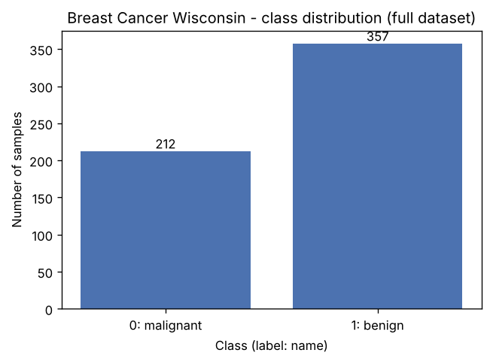
Figure 1. Breast Cancer Wisconsin – class distribution
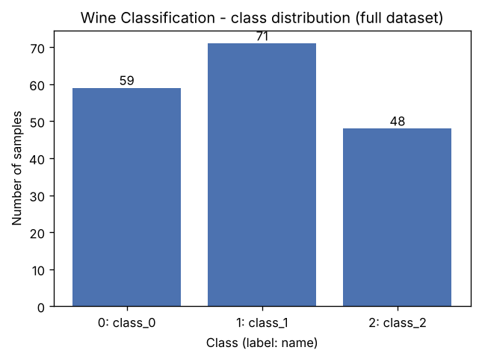
Figure 2. Wine – class distribution
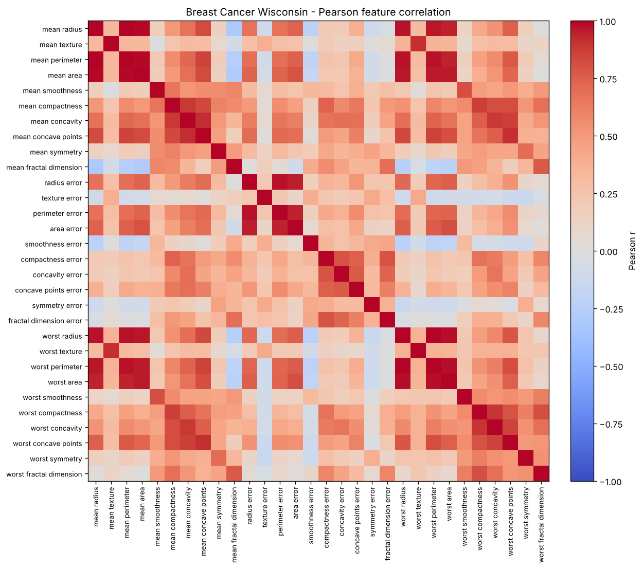
Figure 3. Breast Cancer Wisconsin – Pearson feature-correlation heatmap
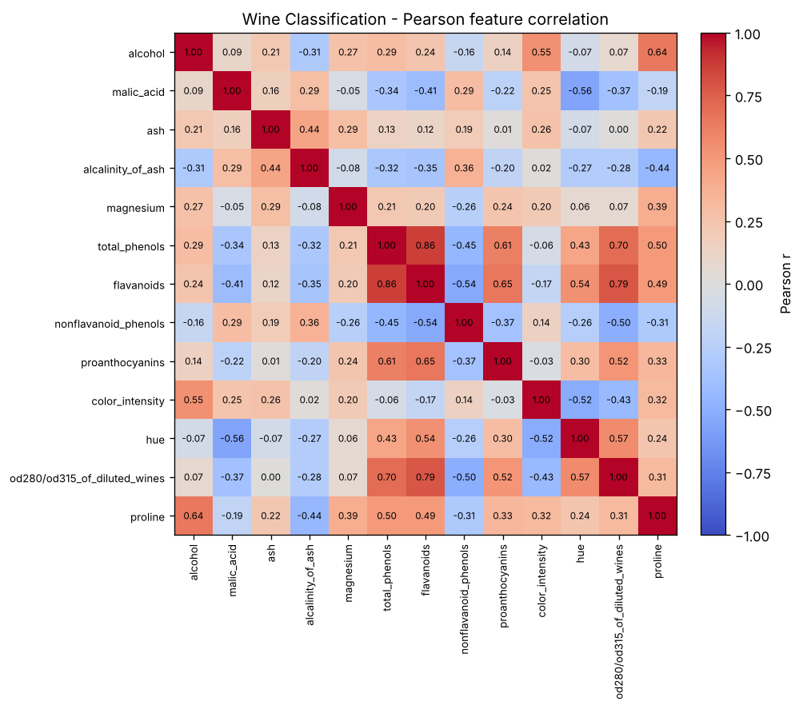
Figure 4. Wine – Pearson feature-correlation heatmap

3.2 Boxplots

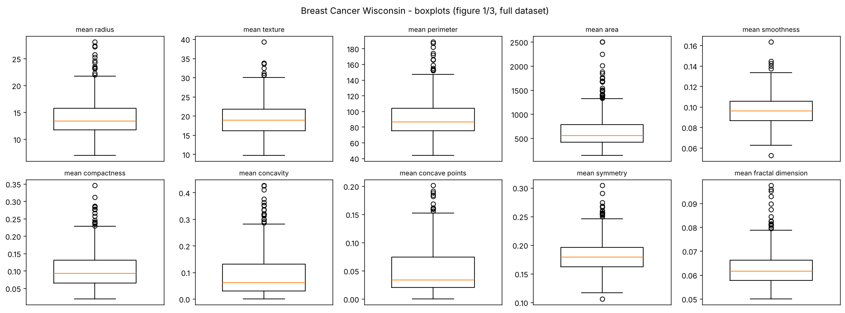
Figure 5. Breast Cancer Wisconsin – boxplots of the ten mean features
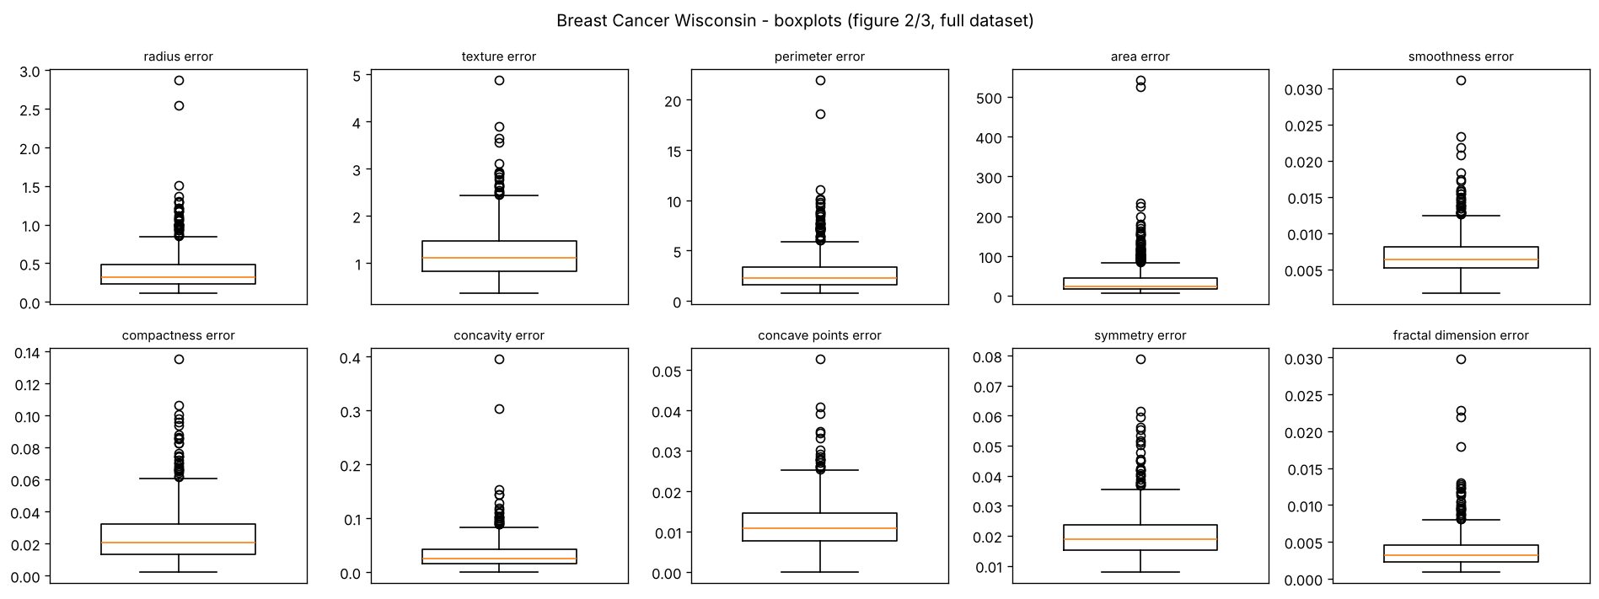
Figure 6. Breast Cancer Wisconsin – boxplots of the ten error features
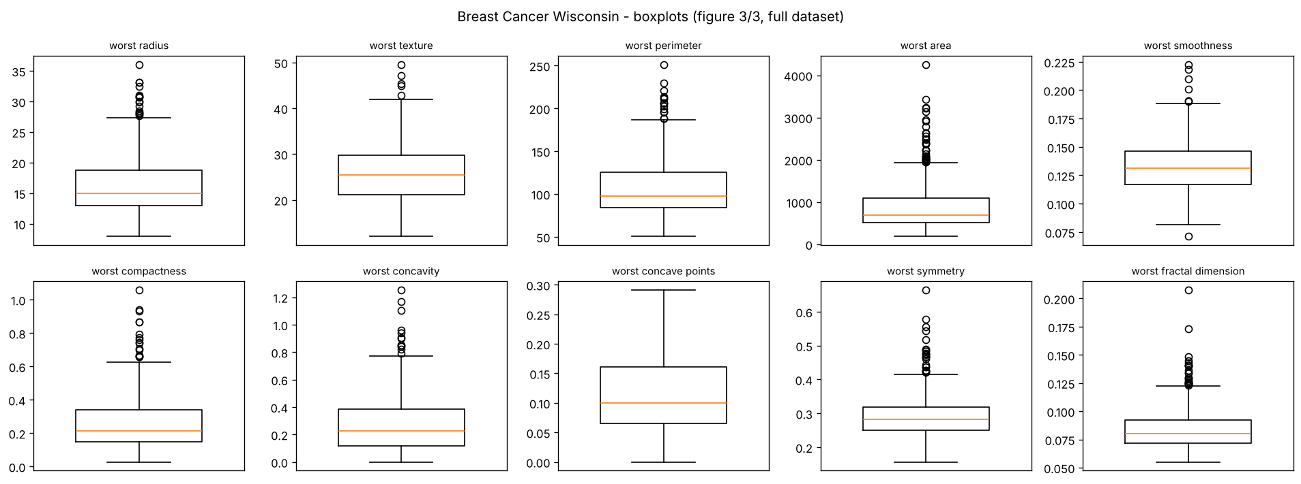
Figure 7. Breast Cancer Wisconsin – boxplots of the ten worst features
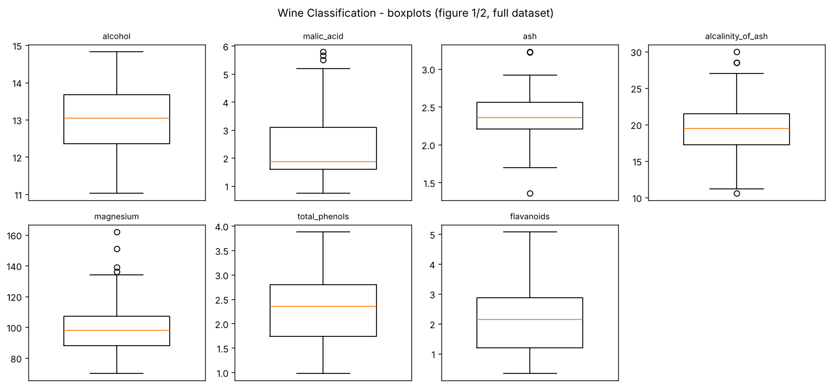
Figure 8. Wine – boxplots, features 1–7

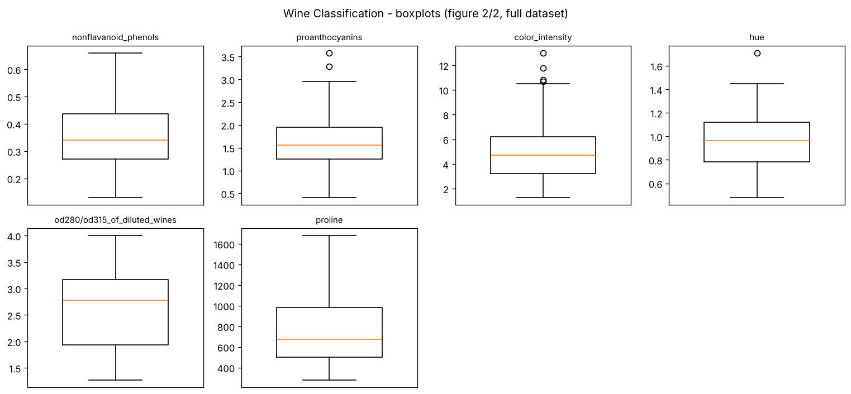
Figure 9. Wine – boxplots, features 8–13

4. Splitting the Datasets
For each dataset, 20% of the samples were reserved once as the test set. Remaining part were seperated training and validation subsets three times. Once for each seed in [42, 52, 62]. This gives approximately 70% training, 10% validation subsets.

Dataset | Training | Validation | Test | Total
Breast Cancer | 398 (69.95%) | 57 (10.02%) | 114 (20.04%) | 569
Wine | 124 (69.66%) | 18 (10.11%) | 36 (20.22%) | 178

5. Data Preprocessing and Scaling
No missing values exist in either dataset, so no imputation step was added. StandartScaler was chosen before runnig the experiments and use for both datasets and all three seeds. It transforms every feature to z = (x − mean) / standard deviation. it puts all features on a comparable scale for the distance-based methods.

6. Preparing the Two Data Representations
Two representations were prepared for each dataset and each seed. The unscaled representation contains all original features without any change. The scaled representation contains the same features and the same sample indices after the StandardScaler procedure of Section 5.

7. Training the Classification Models

Algorithm | Settings | Fits per dataset
Decision Tree | max_depth = 2, 3, 5, 10, None; random_state = seed | 5 × 2 × 3 = 30
KNN | n_neighbors = 1, 3, 5, 7, 11; uniform weights; Euclidean distance | 5 × 2 × 3 = 30
Gaussian Naive Bayes | default settings | 1 × 2 × 3 = 6

I trained three types of models: Decision Tree, KNN and Gaussian Naive Bayes. There were 11 settings in total. Each setting was trained on unscaled and scaled data, with three seeds. This gives 66 runs per dataset and 132 runs in total. A loop in helpers.py produces all runs. Every model was trained on the training data only. Each run has its own ID. For every run I saved the training and validation scores. The seed-42 models were kept for the final test. All other settings are the scikit-learn defaults. Package versions are listed in requirements.txt.

8. Measuring Validation Performance
For every classifier run, accuracy, macro-precision, macro-recall, macro-F1 and ROC-AUC were calculated on its own validation subset. Then I calculated the mean and standart deviation to make a 22 row summary table for each dataset.

8.1 Summary tables and model selection

Table. Breast Cancer Wisconsin – 22-row classifier summary
Algorithm | Repr. | Parameter | Train accuracy | Train macro-F1 | Val accuracy | Val macro-precision | Val macro-recall | Val macro-F1 | Val ROC-AUC
Decision Tree | unscaled | depth=2 | 0.956 ± 0.004 | 0.953 ± 0.004 | 0.918 ± 0.020 | 0.913 ± 0.016 | 0.912 ± 0.031 | 0.912 ± 0.024 | 0.922 ± 0.040
Decision Tree | unscaled | depth=3 | 0.976 ± 0.004 | 0.974 ± 0.004 | 0.924 ± 0.027 | 0.920 ± 0.023 | 0.917 ± 0.036 | 0.918 ± 0.030 | 0.941 ± 0.021
Decision Tree | unscaled | depth=5 | 0.995 ± 0.004 | 0.995 ± 0.005 | 0.924 ± 0.020 | 0.917 ± 0.018 | 0.923 ± 0.031 | 0.919 ± 0.023 | 0.930 ± 0.025
Decision Tree | unscaled | depth=10 | 1.000 ± 0.000 | 1.000 ± 0.000 | 0.924 ± 0.010 | 0.916 ± 0.011 | 0.927 ± 0.017 | 0.919 ± 0.011 | 0.927 ± 0.017
Decision Tree | unscaled | depth=None | 1.000 ± 0.000 | 1.000 ± 0.000 | 0.924 ± 0.010 | 0.916 ± 0.011 | 0.927 ± 0.017 | 0.919 ± 0.011 | 0.927 ± 0.017
KNN | unscaled | k=1 | 1.000 ± 0.000 | 1.000 ± 0.000 | 0.889 ± 0.051 | 0.884 ± 0.049 | 0.876 ± 0.063 | 0.879 ± 0.057 | 0.876 ± 0.063
KNN | unscaled | k=3 | 0.959 ± 0.004 | 0.956 ± 0.004 | 0.901 ± 0.041 | 0.900 ± 0.042 | 0.885 ± 0.047 | 0.891 ± 0.045 | 0.930 ± 0.023
KNN | unscaled | k=5 | 0.951 ± 0.003 | 0.947 ± 0.003 | 0.918 ± 0.027 | 0.917 ± 0.027 | 0.905 ± 0.031 | 0.911 ± 0.030 | 0.948 ± 0.035
KNN | unscaled | k=7 | 0.948 ± 0.003 | 0.944 ± 0.003 | 0.912 ± 0.000 | 0.913 ± 0.007 | 0.897 ± 0.006 | 0.904 ± 0.001 | 0.958 ± 0.029
KNN | unscaled | k=11 | 0.945 ± 0.003 | 0.940 ± 0.003 | 0.924 ± 0.010 | 0.935 ± 0.015 | 0.903 ± 0.012 | 0.916 ± 0.011 | 0.961 ± 0.031
Gaussian NB | unscaled | default | 0.937 ± 0.004 | 0.932 ± 0.005 | 0.942 ± 0.020 | 0.938 ± 0.016 | 0.937 ± 0.031 | 0.937 ± 0.023 | 0.980 ± 0.013
Decision Tree | scaled | depth=2 | 0.956 ± 0.004 | 0.953 ± 0.004 | 0.918 ± 0.020 | 0.913 ± 0.016 | 0.912 ± 0.031 | 0.912 ± 0.024 | 0.922 ± 0.040
Decision Tree | scaled | depth=3 | 0.976 ± 0.004 | 0.974 ± 0.004 | 0.924 ± 0.027 | 0.920 ± 0.023 | 0.917 ± 0.036 | 0.918 ± 0.030 | 0.941 ± 0.021
Decision Tree | scaled | depth=5 | 0.995 ± 0.004 | 0.995 ± 0.005 | 0.924 ± 0.020 | 0.917 ± 0.018 | 0.923 ± 0.031 | 0.919 ± 0.023 | 0.930 ± 0.025
Decision Tree | scaled | depth=10 | 1.000 ± 0.000 | 1.000 ± 0.000 | 0.924 ± 0.010 | 0.916 ± 0.011 | 0.927 ± 0.017 | 0.919 ± 0.011 | 0.927 ± 0.017
Decision Tree | scaled | depth=None | 1.000 ± 0.000 | 1.000 ± 0.000 | 0.924 ± 0.010 | 0.916 ± 0.011 | 0.927 ± 0.017 | 0.919 ± 0.011 | 0.927 ± 0.017
KNN | scaled | k=1 | 1.000 ± 0.000 | 1.000 ± 0.000 | 0.942 ± 0.020 | 0.941 ± 0.028 | 0.934 ± 0.016 | 0.937 ± 0.021 | 0.934 ± 0.016
KNN | scaled | k=3 | 0.981 ± 0.004 | 0.979 ± 0.004 | 0.959 ± 0.020 | 0.970 ± 0.014 | 0.944 ± 0.027 | 0.955 ± 0.023 | 0.979 ± 0.016
KNN | scaled | k=5 | 0.974 ± 0.003 | 0.972 ± 0.003 | 0.959 ± 0.020 | 0.970 ± 0.014 | 0.944 ± 0.027 | 0.955 ± 0.023 | 0.979 ± 0.017
KNN | scaled | k=7 | 0.972 ± 0.003 | 0.970 ± 0.003 | 0.971 ± 0.027 | 0.978 ± 0.020 | 0.960 ± 0.036 | 0.968 ± 0.030 | 0.978 ± 0.019
KNN | scaled | k=11 | 0.972 ± 0.001 | 0.969 ± 0.002 | 0.965 ± 0.035 | 0.975 ± 0.025 | 0.952 ± 0.048 | 0.961 ± 0.039 | 0.994 ± 0.005
Gaussian NB | scaled | default | 0.936 ± 0.005 | 0.931 ± 0.006 | 0.930 ± 0.018 | 0.924 ± 0.014 | 0.928 ± 0.029 | 0.925 ± 0.020 | 0.976 ± 0.015

Table. Wine – 22-row classifier summary
Algorithm | Repr. | Parameter | Train accuracy | Train macro-F1 | Val accuracy | Val macro-precision | Val macro-recall | Val macro-F1 | Val ROC-AUC
Decision Tree | unscaled | depth=2 | 0.935 ± 0.008 | 0.936 ± 0.011 | 0.852 ± 0.032 | 0.872 ± 0.021 | 0.849 ± 0.049 | 0.848 ± 0.036 | 0.905 ± 0.022
Decision Tree | unscaled | depth=3 | 0.992 ± 0.000 | 0.993 ± 0.000 | 0.944 ± 0.056 | 0.961 ± 0.037 | 0.941 ± 0.061 | 0.946 ± 0.055 | 0.961 ± 0.043
Decision Tree | unscaled | depth=5 | 1.000 ± 0.000 | 1.000 ± 0.000 | 0.944 ± 0.056 | 0.961 ± 0.037 | 0.941 ± 0.061 | 0.946 ± 0.055 | 0.955 ± 0.046
Decision Tree | unscaled | depth=10 | 1.000 ± 0.000 | 1.000 ± 0.000 | 0.944 ± 0.056 | 0.961 ± 0.037 | 0.941 ± 0.061 | 0.946 ± 0.055 | 0.955 ± 0.046
Decision Tree | unscaled | depth=None | 1.000 ± 0.000 | 1.000 ± 0.000 | 0.944 ± 0.056 | 0.961 ± 0.037 | 0.941 ± 0.061 | 0.946 ± 0.055 | 0.955 ± 0.046
KNN | unscaled | k=1 | 1.000 ± 0.000 | 1.000 ± 0.000 | 0.704 ± 0.032 | 0.689 ± 0.024 | 0.684 ± 0.022 | 0.671 ± 0.023 | 0.765 ± 0.018
KNN | unscaled | k=3 | 0.836 ± 0.012 | 0.829 ± 0.013 | 0.667 ± 0.056 | 0.661 ± 0.050 | 0.652 ± 0.048 | 0.646 ± 0.043 | 0.833 ± 0.031
KNN | unscaled | k=5 | 0.788 ± 0.009 | 0.774 ± 0.009 | 0.704 ± 0.032 | 0.728 ± 0.072 | 0.686 ± 0.029 | 0.667 ± 0.040 | 0.864 ± 0.012
KNN | unscaled | k=7 | 0.790 ± 0.021 | 0.780 ± 0.023 | 0.667 ± 0.000 | 0.647 ± 0.023 | 0.654 ± 0.015 | 0.636 ± 0.032 | 0.846 ± 0.008
KNN | unscaled | k=11 | 0.739 ± 0.009 | 0.731 ± 0.008 | 0.630 ± 0.032 | 0.615 ± 0.013 | 0.614 ± 0.021 | 0.600 ± 0.001 | 0.822 ± 0.025
Gaussian NB | unscaled | default | 0.984 ± 0.000 | 0.984 ± 0.000 | 0.963 ± 0.032 | 0.968 ± 0.029 | 0.966 ± 0.030 | 0.964 ± 0.031 | 1.000 ± 0.000
Decision Tree | scaled | depth=2 | 0.935 ± 0.008 | 0.936 ± 0.011 | 0.852 ± 0.032 | 0.872 ± 0.021 | 0.849 ± 0.049 | 0.848 ± 0.036 | 0.905 ± 0.022
Decision Tree | scaled | depth=3 | 0.992 ± 0.000 | 0.993 ± 0.000 | 0.944 ± 0.056 | 0.961 ± 0.037 | 0.941 ± 0.061 | 0.946 ± 0.055 | 0.961 ± 0.043
Decision Tree | scaled | depth=5 | 1.000 ± 0.000 | 1.000 ± 0.000 | 0.944 ± 0.056 | 0.961 ± 0.037 | 0.941 ± 0.061 | 0.946 ± 0.055 | 0.955 ± 0.046
Decision Tree | scaled | depth=10 | 1.000 ± 0.000 | 1.000 ± 0.000 | 0.944 ± 0.056 | 0.961 ± 0.037 | 0.941 ± 0.061 | 0.946 ± 0.055 | 0.955 ± 0.046
Decision Tree | scaled | depth=None | 1.000 ± 0.000 | 1.000 ± 0.000 | 0.944 ± 0.056 | 0.961 ± 0.037 | 0.941 ± 0.061 | 0.946 ± 0.055 | 0.955 ± 0.046
KNN | scaled | k=1 | 1.000 ± 0.000 | 1.000 ± 0.000 | 0.963 ± 0.032 | 0.968 ± 0.027 | 0.968 ± 0.027 | 0.966 ± 0.030 | 0.975 ± 0.022
KNN | scaled | k=3 | 0.968 ± 0.008 | 0.969 ± 0.008 | 0.944 ± 0.056 | 0.950 ± 0.052 | 0.952 ± 0.048 | 0.946 ± 0.056 | 1.000 ± 0.000
KNN | scaled | k=5 | 0.976 ± 0.000 | 0.976 ± 0.001 | 0.981 ± 0.032 | 0.981 ± 0.032 | 0.984 ± 0.027 | 0.981 ± 0.032 | 1.000 ± 0.000
KNN | scaled | k=7 | 0.960 ± 0.008 | 0.960 ± 0.008 | 0.981 ± 0.032 | 0.981 ± 0.032 | 0.984 ± 0.027 | 0.981 ± 0.032 | 1.000 ± 0.000
KNN | scaled | k=11 | 0.965 ± 0.005 | 0.966 ± 0.005 | 0.981 ± 0.032 | 0.981 ± 0.032 | 0.984 ± 0.027 | 0.981 ± 0.032 | 1.000 ± 0.000
Gaussian NB | scaled | default | 0.984 ± 0.000 | 0.984 ± 0.000 | 0.963 ± 0.032 | 0.968 ± 0.029 | 0.966 ± 0.030 | 0.964 ± 0.031 | 1.000 ± 0.000

9. Evaluating the Selected Models on the Test Sets

After choosing the best model for each dataset, I tested only the seed-42 version of that model on the test set, using the seed-42 scaler. I did not retrain the models, test any other model, or pick a seed by its score. These two tests do not add new model fits.

9.1 Final performance metrics

Table. Final test evaluation of the selected classifiers
 | Breast Cancer | Wine
Selected configuration | breast_cancer_knn_scaled_k7 | wine_knn_scaled_k11
Evaluation seed | 42 | 42
Mean validation macro-F1 | 0.9677 | 0.9814
Std of validation macro-F1 | 0.0297 | 0.0323
Test accuracy | 0.9737 | 1.0000
Test macro-precision | 0.9800 | 1.0000
Test macro-recall | 0.9643 | 1.0000
Test macro-F1 | 0.9713 | 1.0000
Test ROC-AUC | 0.9888 | 1.0000

Table. Per-class classification reports on the test sets.
Dataset | Class | Precision | Recall | F1-score | Support
Breast Cancer | 0: malignant | 1.0000 | 0.9286 | 0.9630 | 42
Breast Cancer | 1: benign | 0.9600 | 1.0000 | 0.9796 | 72
Wine | 0: class_0 | 1.0000 | 1.0000 | 1.0000 | 12
Wine | 1: class_1 | 1.0000 | 1.0000 | 1.0000 | 14
Wine | 2: class_2 | 1.0000 | 1.0000 | 1.0000 | 10

9.2 ROC curves

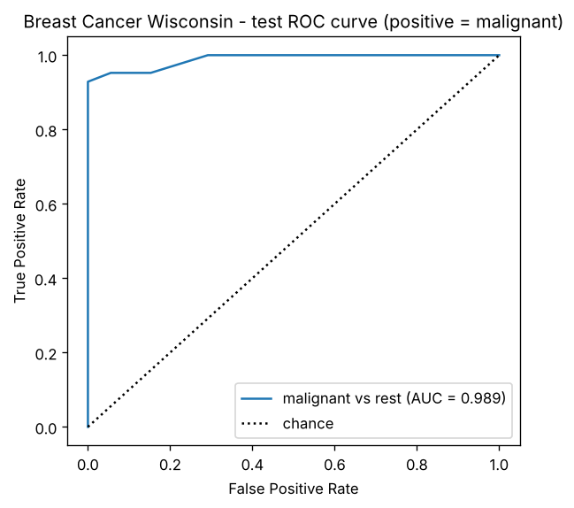
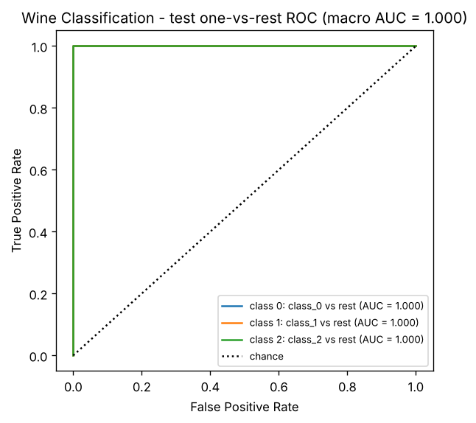

9.3 Error interpretation

Breast Cancer: The model made three errors on the test set. All three are malignant tumours predicted as benign. One example is row 41. Three of its seven nearest neighbours were malignant and four were benign, so it lost by one vote. In real life this error means a missed cancer. This is why recall for the malignant class (0.929) is more important than accuracy here.
Wine: The model made no errors on the test set. This does not prove that the model is perfect. The test set has only 36 samples. The validation score of the same model was also not perfect (0.981). Some errors should be expected on new wines.
Limitations: The validation sets are small, with 57 and 18 samples. The three splits overlap, so they are not independent. Only seed 42 was tested, so each test result is a single measurement.

10. K-Means Clustering

10.1 Fitting the clustering models
K-Means was trained on the unscaled and scaled training data for each seed. This gives 6 fits per dataset and 12 in total. The labels were not used during training. The number of clusters was fixed to 2 for Breast Cancer and 3 for Wine, the same as the number of classes. Each fit used random_state=seed and n_init=10. Cluster IDs are only group numbers, not class labels.

