What is the TurtleBot?
TurtleBot is a mobile robot that can be purchased as a kit or fully assembled. It's a low-cost, personal robot kit with open-source software. With TurtleBot, you’ll be able to build a robot that can drive around your house, see in 3D, and have enough horsepower to create exciting applications.
The TurtleBot 2 model, which we will use in the simulation, is shown in the following image:
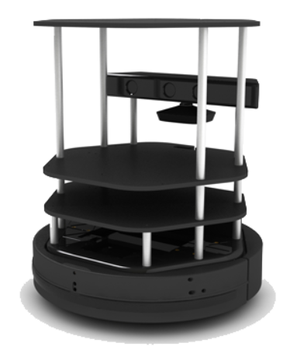
The main items that comprise the TurtleBot 2 model from bottom to top in the preceding image are as follows:
- A mobile base (Kobuki Base) that also serves as support for the upper stages of the robot
- A netbook (ROS Compatible) resting on a module plate
- A vision sensor with a color camera and 3D depth sensor
- Other module plates used to hold items
Overall, the TurtleBot model stands about 420 mm (16.5 inches) high and the base is approximately 355 mm (14 inches) in diameter.
TurtleBot rests on the floor on two wheels and a caster. The base is configured as a differential drive base, which means that when the TurtleBot is moving, the rotational velocity of the wheels can be controlled independently. So, for example, TurtleBot can move back and forth in a straight line when the wheels are driven in the same direction, clockwise (CW) or counterclockwise (CCW), with the same rotational velocity. If the wheels turn at different rotational velocities, TurtleBot can make turns as the velocity of the wheels is controlled.
The vision sensor, as shown in the preceding image of TurtleBot2, is an Xbox 360 Kinect sensor manufactured by Microsoft. Originally designed for video games, the Kinect sensor is a popular vision and depth sensor for robotics.
We will first source the workspace setup files in the Course Command Shell (CCS) and then start the simulation environment as follows:
$ source $HOME/hrwros_ws/devel/setup.bash

$ roslaunch turtlebot_gazebo turtlebot_world.launch

In Week1 we covered ROS nodes, topics and services. Now, we will apply what we have learned on the TurtleBot. Before running the commands below, remember to start a new CCS and source the workspace setup files. Let's start by looking at the complete list of ROS services:
$ rosservice list
Observe how a lot of ROS Services shown do not concern the TurtleBot. Try the following command for a more concentrated result:
$ rosservice list | grep mobile_base

The information about the nodes or topic is interesting, but at the moment we don't really know how to make the robot move.
However, after a quick search on the web, we found the turtlebot_teleop package, let's try it!
Start a new CCS, source the workspace setup files, and run the following command:
$ roslaunch turtlebot_teleop keyboard_teleop.launch
You will see some information about how to Control Your Turtlebot on the CCS.
Press the 'i' button on your keyboard, remember you need to have the CCS you just started active, The teleoperation will not work if the active window is the Gazebo simulation or any other program.
Odometry is the usage of data from motion sensors to estimate the change in position over time. In a new CCS run the following command:
$ rostopic echo /odom
Let's move around with the TurtleBot using the keyboard teleoperation and see where we are in the environment. Notice that you can now actively view the positons and velocities of the TurtleBot in all directions.
Now we will focus only on the velocity of the Turtlebot, did you know that you can echo only one section of the topic, let's try it. Stop, the previous command, and run this one instead.
$ rostopic echo /odom/twist
Now you will see only the twist part of the odometry, it has two components, linear and angular, keep moving the turtlebot to see how they change.

Now let's move the TurtleBot in a simple straight line. Try the following command by replacing '<ANS_Q1>' the correct name of the topic you found in the previous question.
Notice that this will only work if you have first killed the node /turtlebot_teleop_keyboard.
$ rostopic pub <ANS_Q1> \geometry_msgs/Twist '{linear: {x: 0.5, y: 0, z: 0}, angular: {x: 0, y: 0, z: 0}}'
Notice how the TurtleBot moves for a while in a straight line then comes to a stop. To make the TurtleBot move again you can ctrl+c try the same command again.
Another option publish the topic with a specific rate. The following command will publish the command with a rate of 10 Hz and will make the TurtleBot move in circles.
$ rostopic pub -r 10 <ANS_Q1> \geometry_msgs/Twist '{linear: {x: 0.1, y: 0, z: 0}, angular: {x: 0, y: 0, z: -0.6}}'
To notice -r 10 in this command. Now let's open up rqt_graph You can do this using the following command:
$ rosrun rqt_graph rqt_graph
Make sure you select "Nodes/Topics (active)" from the select drop bar on the top left of the window.
You should see the node publishing to /cmd_vel_mux/input/teleop They are highlighted on red and green in the following figure.
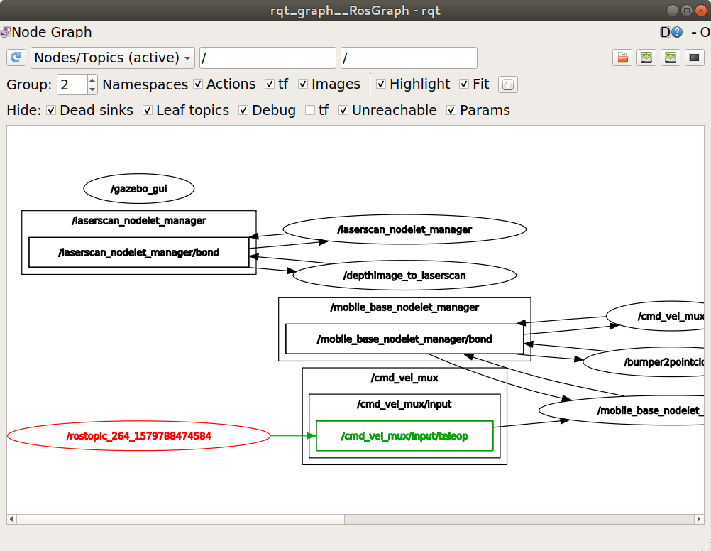
Note: The node it's /rostopic_XXX_XXXXXXX however, this is not topic. It's a ROS node. That's is why it's an ellipse. The name is generated automatically since we are publishing via our CCS.

In this section, we will use RViz to visualize what the robot is doing. RViz is a great tool for debugging and we will use it for the rest of the course.
First, launch the TurtleBot world.
$ roslaunch turtlebot_gazebo turtlebot_world.launch
Now, we will open up a pre-configured RViz file in a second CCS.
$ roslaunch turtlebot_rviz_launchers view_robot.launch
So what are we going to visualize in Let's do Odometry! Remember that, Odometry is the use of data from motion sensors to estimate in position over time.
In a new CCS let's echo the odometry topic.
$ rostopic echo /odom
This will keep the data updated; however, the robot is not moving there is not much change. You will just see fluctuations around the values.
So let's move the robot to see in those values!!
We have learned 3 ways to move the turtlebot, so let's use them - (Remember to use only one at the time)
- The first one is publishing directly on the CCS.
$ rostopic pub -r 10 /cmd_vel_mux/input/teleop geometry_msgs/Twist '{linear: {x: 0.1, y: 0, z: 0}, angular: {x: 0, y: 0, z: -1}}'
- The second one is using the keyboard_teleop functionality
$ roslaunch turtlebot_teleop keyboard_teleop.launch
- The third one is using our python script to control the turtlebot
$ rosrun hrwros_week3 drive_turtlebot_circle.py
Now you should see the values change in the /odom topic
Let's move over now to RViz in order to visualize the odometry
Go to the RVIZ window and change the following settings:
- Global options on the left side panel for frame, change base_link or base_footprint to .
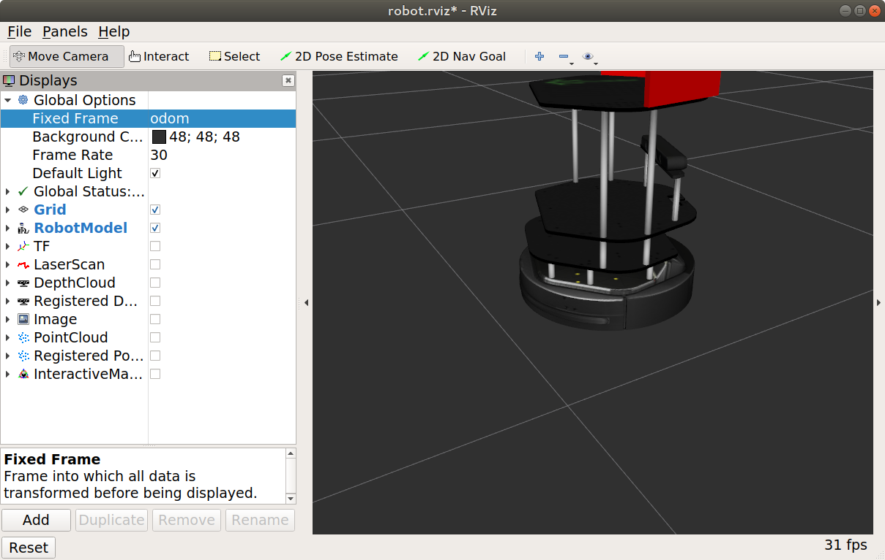
- Click on Add, and select the By topic tab.
- Choose /odom -> odometry and click on OK.
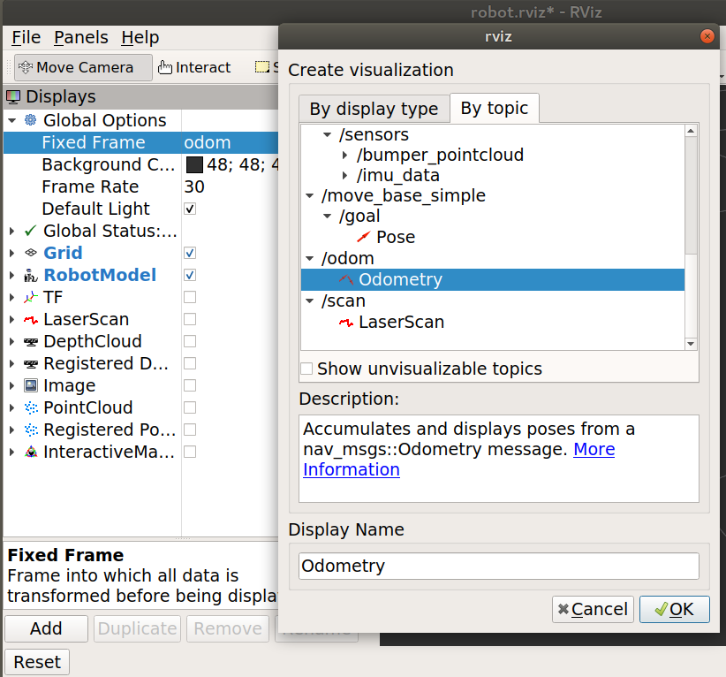
- Make sure the topic name is /odom, uncheck the covariance checkbox and set the Keep value to 10.
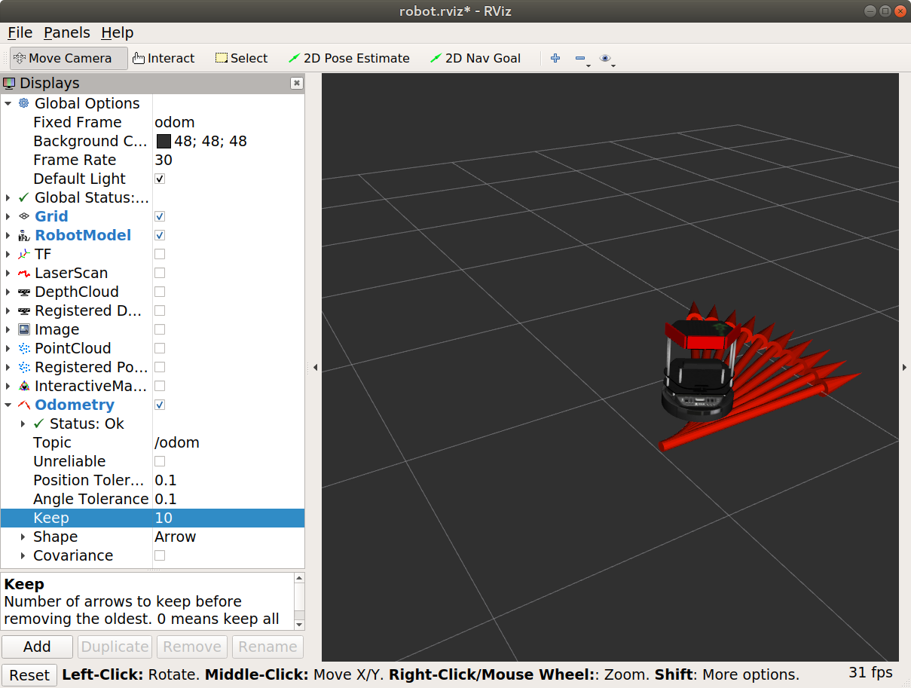

Ready for intelligence?
You can move the Turtlebot using the following methods:
  - Teleoperation
  - Using the command line (CCS)
  - Using scripts

What is necessary for navigation?
In order to navigate in any environment, we need a few key elements. For a robot this is no different. What we need is:
- A map of the environment
- The current location on the map (localization)
- A route to take (path planning)
- Obstacle avoidance

Mapping theory

A map is mandatory for navigation. There are two ways to get a map:
- Use a pre-existing map
- Build by the robot itself (mapping process)
The mapping process is called SLAM: Simultaneous Localization And Mapping.
There are two main types of maps that are relevant in our case. Those are the topological maps and the metric maps.

Mapping with Turtlebot
The Turtlebot uses a SLAM implementation called “gmapping”, and a laser scanner to gather information about the environment and build a map
Localization theory
Localization methods are grouped into two categories: Global and Local.
Global:
- Give a location with respect to the world
- Often inaccurate compared to local methods
- For example: GPS or Wi-Fi hotspots
Local:
- Give a location with respect to local sensor feedback
- Can be highly accurate compared to global methods
- For example laser scanner and cameras

Map registration
Sometimes global localization methods can not give accurate enough results to localize a robot in a map.
- Local sensor readings can give accurate positioning with respect to obstacles in the map, but there may be multiple places on the map that look the same.
- Location can be narrowed down by estimating a range of positions a robot is likely to be by tracking how much the robot moves and by taking many measurements.
Mapping and Localization Tutorial
Mapping Tutorial
In this tutorial you will be guided to map the TurtleBot_world using gmapping. First of all, we have to start our Gazebo simulation.
$ roslaunch turtlebot_gazebo turtlebot_world.launch
Next, open up a second CCS. It may require a bit of patience for Gazebo to start. In the second CCS we will view the active ROS nodes.
$ rosnode list
Look if there is a node with slam or gmapping in its name. You should not see those in the list of nodes. Next, we will open up the gmapping_demo launch file. Remember that gmapping is a specific SLAM implementation.
$ roslaunch turtlebot_gazebo gmapping_demo.launch
After that, open up a third CCS and check the active ROS nodes again. You should see the /slam_gmapping node is now active. Let's look at the topics this node is publishing and subscribing to.
$ rosnode info /slam_gmapping
Under subscription we can see /scan, through which the this nodes receive the information gathered by the laser scanner. We also see this node is publishing to the map topic of the environment as expected.
To visualize the mapping process, let's open up RViz. We can open up a 'blank' RViz window and add our robot model and further settings. However, it's easier to load up a configuration. Run the following command in a third CCS.
$ roslaunch turtlebot_rviz_launchers view_navigation.launch
To make everything clearer, you will need to change some settings.
- Set LaserScan/size(m) to 0.06
- Set LaserScan/style to 'flat squares'
- Set Localmap/Costmap/Topic to /map
- Set Globalmap/Costmap/Topic to /map
Right now, we are ready to go. If we now move the robot around the environment, the mapping process should start. To do so, we can use teleoperation. Run this in a fourth CCS.
$ roslaunch turtlebot_teleop keyboard_teleop.launch
Press the z key few times to slow the robot down. Because we are creating a map with a metric representation, it will be sensitive to noise. To ensure the quality of the map, move around slowly and try to keep an object in sight at all time.
After moving around for a while you will have created a great map. This map will be very useful when we want to navigate the world. However, we need to save it somewhere. In a fifth CCS run the following command.
$ rosrun map_server map_saver -f $HOME/<choose a directory>/test_map
Notice the we named our map test_map. If you browse to the directory specified in the previous command we will find 2 files:
- test_map.pgm
- test_map.yaml
Open the First file. You can see that this file contains a picture of the environment similar to this one.
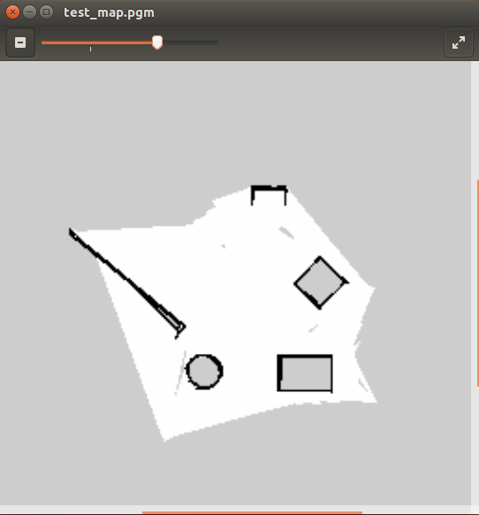
Next, open the first file. You will see that it points to the .pgm file, and contains further information about the resolution, origin, etc. It should look similar to the following figure.
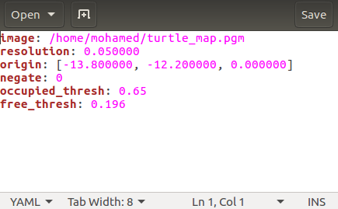
Localization Tutorial
So, we have seen how to create a map of the environment. Now we will load our map and try to get the TurtleBot to localize itself properly.
First of all, let's open the TurtleBot in Gazebo. In the first CCS enter:
$ roslaunch turtlebot_gazebo turtlebot_world.launch
Right now, we will need to open up the nodes responsible for localization. In the second CCS execute:
$ roslaunch turtlebot_gazebo amcl_demo.launch map_file:=$HOME/<directory of map>/test_map.yaml
Note that the map file used should the yaml file. So the previous command should end with something like map_file:=$HOME/test_map.yaml, if you saved the map file in your home folder.
The amcl stands for Adaptive Monte Carlo Localization. This is a probabilistic localization system for a robot moving in 2D which uses a particle filter to track the pose of a robot against a known map. The known map in this case is the one we just created.
Finally in a third CCS we will open up RViz to visualize the navigation.
$ roslaunch turtlebot_rviz_launchers view_navigation.launch
Right now we are ready to go. Remember from the lecture, we can have an absolute position on the map if we use a global method of localization. However, with local method localization can be obtained only by moving the robot around first and taking more measurements. The robot will start of somewhere random on the map view in RViz with something similar to the following.
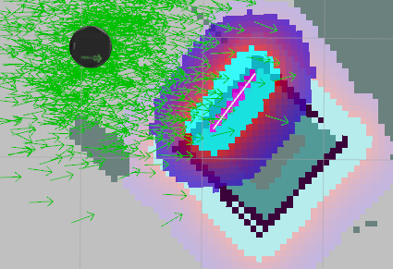
Let's break this picture down. The round black circle is the TurtleBot. It's surrounded by green arrows which are probabilistic estimates of its actual position. Pretty much like the blue squares you saw in the lecture slides.
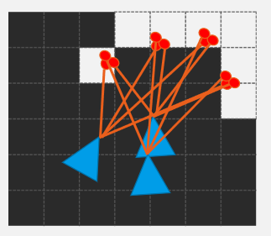
Then you see the edges from the square as in our original map. One of its edges is purple with (and a thin white line form the laser scan is on it). This is one of 'measurements' the robot has take to localize itself. So now we have to move the robot and let it take more measurements to improve localization.
Run this in a fourth CCS to teleoperate the robot.
$ roslaunch turtlebot_teleop keyboard_teleop.launch
Now move the robot around and observe the green arrows around it. Since we get more certainty about where the robot is, the arrows should come close and closer indicating more a more accurate probabilistic model. It should be similar to the following:
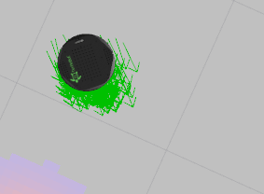
The position of the robot should also be positioned correctly on the map. Take a look at Gazebo to see whether that's true.
This can be done easier if you could just give the TurtleBot a hint of where it's. RViz provides us with a tool to do so. The 2D Pose estimate.
ROS navigation stack
The ROS Navigation Stack is meant for 2D maps, square or circular robots with a holonomic drive, and a planar laser scanner, all of which a Turtlebot has. It uses odometry, sensor data, and a goal pose to give safe velocity commands.
- The node “move_base” is where all the magic happens in the ROS Navigation Stack.
- Uses a global and local planner to accomplish the navigation goal.
- Manages communication within the navigation stack.
- Sensor information is gathered (sensor sources node), then put into perspective (sensor transformations node), then combined with an estimate of the robots position based off of its starting position (odometry source node). This information is published so that “move_base” can calculate the trajectory and pass on velocity commands (through the base controller node).

Path planning tutorial
In previous tutorials, we have seen how to create a map and localize the robot properly in the environment. In this we will take it a step further, and make the robot navigates to a goal position autonomously.
First of all, let's open the TurtleBot in Gazebo. In the first CCS enter:
$ roslaunch turtlebot_gazebo turtlebot_world.launch
Right now, we will need to open up the nodes responsible for localization and navigation, on a second CCS execute:
$ roslaunch turtlebot_gazebo amcl_demo.launch
amcl for Adaptive Monte Carlo Localization. This is a probabilistic localization system for a robot moving in 2D which uses a particle filter to track the pose of a robot against a known map (the default one is none is specified). This launcher also starts the move_base node, which is responsible for planning and controlling the movements of the robot.
in a third we will open up RViz to visualize the navigation.
$ roslaunch turtlebot_rviz_launchers view_navigation.launch
Right now we are ready to go.
Use the 2D post estimate button on the top of your screen if you want to change the initial localization of the robot on the map.
, use the 2D Nav goal to give the robot a target position to move to. Then, watch the TurtleBot as it generates a path and tries to follow it.
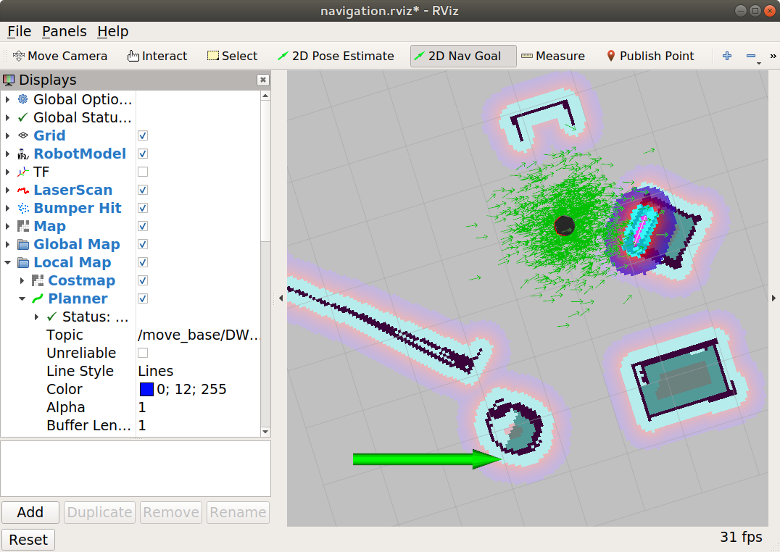
Now, to test the unknown obstacle avoidance functionality. Give the robot a target position far away. When you see the generated map, add an extra obstacle in Gazebo. This can be easily done using the top menu.
Watch how the TurtleBot maneuvers around the obstacle then back to the original path. This is done using the local planner.
