Ahmed Iqbal

CS 4395.001

4/15/2023

**KebabBot Report and Evaluation**

System Description:

The KebabBot is a chatbot built using Dialogflow. It has three primary abilities: to take an order for a doner kebab meal, to answer questions about the doner kebab meal, and to answer questions about Ottoman history (I chose Ottoman history because doner kebab originated from there). Dialogflow provides many different tools with which to build a chatbot. I used four ones which I will describe here. The first is an intent tool. An intent is essentially the chatbot recognizing what the user is trying to do and responding according to the way it was trained. I have created and trained several different intents to deal with the various situations that would arise when taking an order. There are also intents to recognize when an order is finished, in which case the response is to confirm the order. The next tool I used is the entity tool. An entity is a type of information that you want to extract from the user’s input. DIalog flow provides many types of entities, such as number and name, but it also allows you to create your own custom entities. I utilized these to create entities of the meat choices and the type of meal that the user would want. The next tool is a knowledge base tool. A knowledge base is a predefined set of information that you provide from which the chatbot can answer questions. I utilized this beta feature via documents containing FAQs and their answers that I then uploaded. The final tool is the small talk tool. I used this tool to enable the user to have small talk with the chatbot. I customized and configured some of the responses to be specific to KebabBot.

Various NLP Techniques:

Parsing user responses: Parsing the user response is a very common NLP technique used to extract the meaning in the user’s text. The method of doing this entails decomposing the user’s input into smaller chunks. We can then analyze these pieces to determine the true meaning of a response. The first step is to preprocess the input to remove unnecessary input like stopwords or punctuation. Then, we put the input into a parser which identifies how each word relates to the other words. FOr example, it can determine what the verb is, which noun is doing the verb, and which noun the verb is being done to. This is very useful in Kebab bot, as if we can recognize a certain verb like “order”, then we can extract the user’s order as being the object of the verb. In KebabBot, the user’s input is parsed to recognize entities such as the meat choice and type of meal. It is also used to recognize whether a question is coming in about the food, and what the question is asking, and then the appropriate response is given from the knowledge base. A similar thing happens when you ask a question on Ottoman history to the bot.

Information retrieval: Information retrieval is an important NLP technique that entails searching a knowledge base with the goal of providing a response with the most relevant information. This is essential to answer questions without recognizing the exact question and having a predefined answer. There are many ways to do this, one of which is a keyword based search. This is when keywords from the question or prompt are extracted and matched against the knowledge base to see and return an answer that contains the keywords. ANother way is called natural language query processing which is when you try to understand the structure of the query to determine its intent and to then search for an answer based upon that. In KebabBot, we use this d=feature extensively in our FAQ capabilities. FIrstly, we provide good knowledge bases from which the information can be extracted. As to the particular method of information retrieval, I cannot be sure, but I can say based on my training and testing that it is keywords based retrieval. This is based on me asking the question, “who is the goat of basketball?”, and the chatbot took that as me selecting my meat choice as lamb, since I listed the word “goat” as a synonym of lamb.

DIagram of dialog tree:

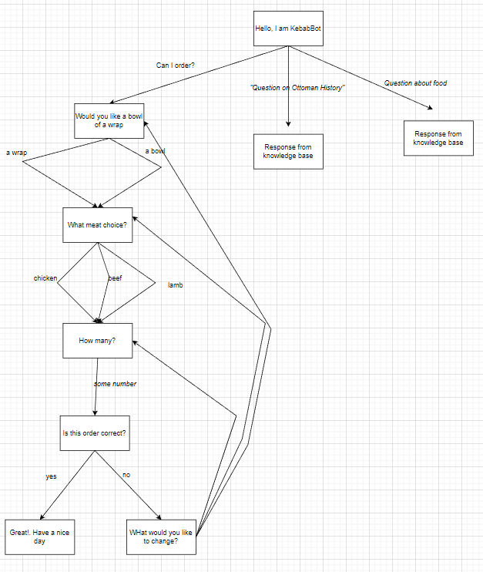

Sample interactions:

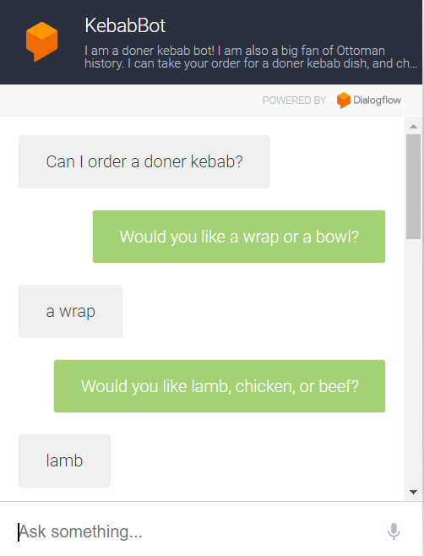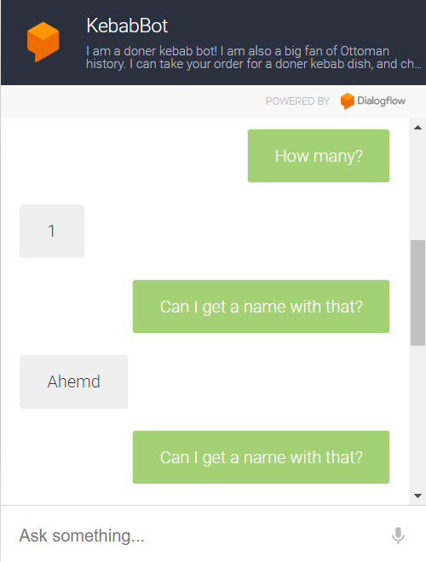

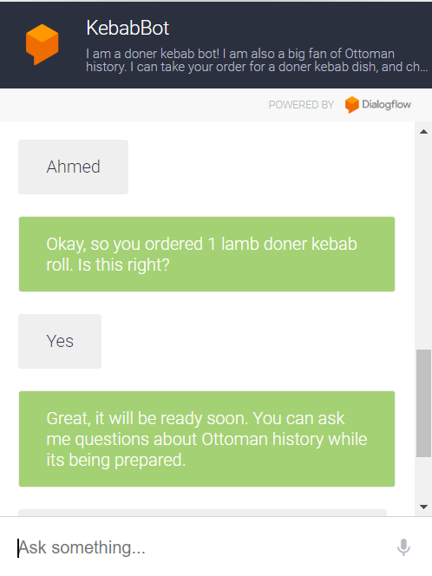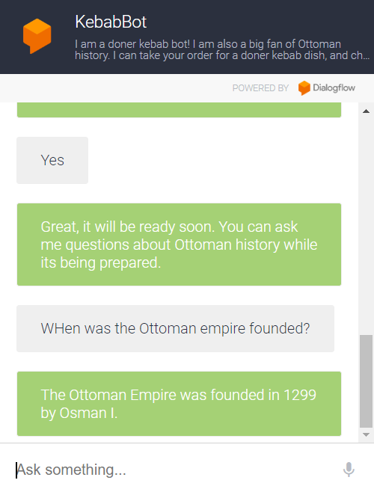

Appendix:

For the Ottoman FAQs: <https://docs.google.com/spreadsheets/d/1nUIN60iJsxdsUmwQSh2wfeTmxeG2OTh-x3wXIXd27AA/edit?usp=sharing>

EXample:

What was the Ottoman Empire?

The Ottoman Empire was a state that was founded in 1299 by Osman Bey, a Turkish tribal leader. It was a Sunni Muslim state that lasted until 1922 and was centered in what is now Turkey.

For the food FAQs:

<https://docs.google.com/spreadsheets/d/1Uz0JS3sVB2h6xyispO_cH3Gq7zs-2PQeeg1YEg9tiMg/edit?usp=sharing>

Example:

Is the food fresh?

Yes!

Evaluations:

This chatbot is very good at what it is designed to do, which is to take orders. Its weaknesses lie in its not being able to answer complex questions about the food or ottoman history, or questions that It doesn't have access to in the knowledge base.