MYTHICHEATS
Sprint 1 Deliverable
Group Members:
- Ahmed Nazim (24L-2611) – Developer/Architect
- Ahmad Khan (24L-2541) – Project Lead/Requirement Engineer
Project Title: MythiCheats
1.Introduction: MythiCheats is a dedicated academic productivity and community platform designed specifically for students at FAST-NUCES. The platform addresses the fragmentation of student resources by providing a centralized, secure hub where students can manage their courses, engage in real-time campus-wide discussions, and customize their digital workspace. By utilizing university-restricted Google OAuth, MythicHeats ensures a verified and safe environment for peer-to-peer interaction and resource sharing.
2. Sprint 1 Backlog
Module Selected for Sprint 1: Core Foundation & Connectivity Module
Features Included:
- University-Restricted Google Authentication
- Dynamic Course/Page Management System
- Real-time Global Community Chat
- System Theme Engine (Light/Dark/System)
- PWA Integration (Desktop/Mobile App Download)
3. User Stories
User Story 1: Secure University Login
- Description: As a FAST student, I want to log in using my university Google account so that I can access campus-exclusive features without creating a new set of credentials.
- Sub-User Stories:
  - 1.1 As a user, I want the system to reject non-university emails so that the community remains private.
  - 1.2 As a new user, I want my username to be automatically generated from my email and roll number to maintain a professional identity.
- Acceptance Criteria:
  - Login only accepts @lhr.nu.edu.pk domains.
  - Successful login redirects to the main Dashboard.
  - Invalid domains return an AUTH_ERROR.
User Story 2: Dashboard Organization
  - Description: As a student, I want to create custom pages for my courses so that I can organize my academic links and notes in one place.
  - Sub-User Stories:
  - 2.1 – As a user, I want to add a new course page with a specific title.
  - 2.2 – As a user, I want my added pages to be saved permanently to my profile.
  - Acceptance Criteria:
  - Clicking "Add Page" creates a new entry in the sidebar.
  - Data persists after page refresh.
  - User Story 3: Real-time Communication
  - Description: As a student, I want to participate in a global chat so that I can ask academic questions to the entire student body in real-time.
  - Sub-User Stories:
  - 3.1 – As a user, I want my messages to be sent instantly using the "Enter" key.
  - 3.2 – As a user, I want to see the sender's verified name next to their message.
  - Acceptance Criteria:
  - Messages appear for all users within 200ms.
  - Chat history loads upon joining.

  - 4. Structured Specifications
  - Specification 1: Google OAuth Domain Validation (Sign-in)
  - Input: Google User Metadata (Email, Name).
  - Process: Extract domain from email; Check if domain equals @lhr.nu.edu.pk; Generate JWT session via Supabase.
  - Output: HTTP 200 (Success) with redirect to /dashboard.
  - Precondition: User clicks "Sign in with Google."
  - Postcondition: Session established; User record created in profiles table.
  - Error Codes: 403 FORBIDDEN (Invalid Domain).
  - Specification 2: Real-time Message Broadcast
  - Input: message_text (String), user_id (UUID).
  - Process: Insert record into chat_messages table; Supabase Realtime broadcasts payload to all active subscribers.
  - Output: UI update on all connected clients.
  - Precondition: User is authenticated.
  - Postcondition: Message stored in PostgreSQL database.
  - Error Codes: 401 UNAUTHORIZED.
  - Specification 3: Theme Toggle Engine
  - Input: Selection ("light" | "dark" | "system").
  - Process: Apply CSS class to document root; Save selection to LocalStorage.
  - Output: UI colors change instantly.
  - Precondition: App is loaded.
  - Error Codes: N/A (Defaults to "system").
  - Specification 4: Dynamic Page Creation
  - Input: Page Title (String).
  - Process: Validate title length; Insert into user_pages table linked to current user_id.
  - Output: 201 Created; New Sidebar item rendered.
  - Precondition: User is logged in.
  - Postcondition: Page count for user increments by 1.

  - 5. Scrum Board (Trello) & Burn-down
  - Trello Snapshots:
  - Snapshot 1 (Start): 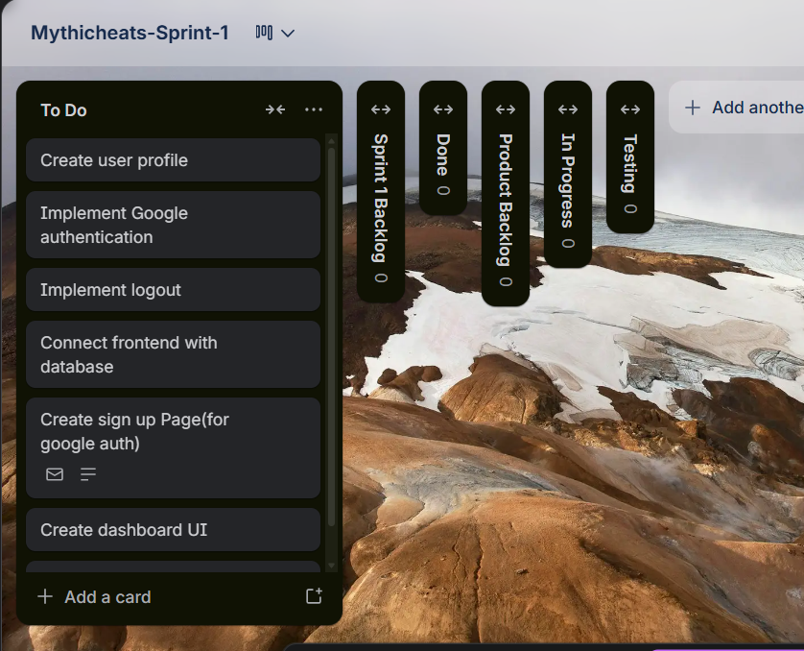.
  - Snapshot 2 (Mid): 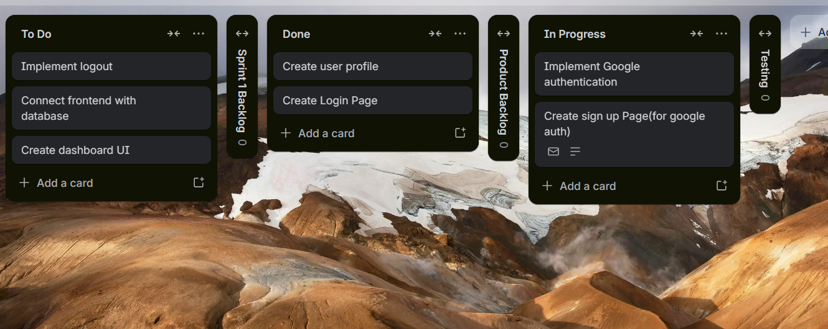
  - Snapshot 3 (End):
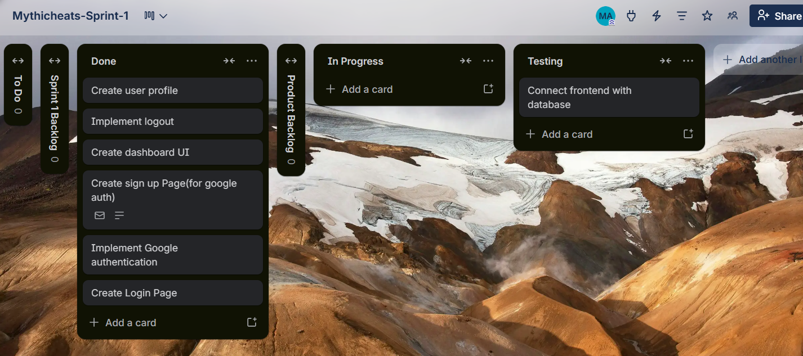

  - Burn-down Chart:
- Day of Sprint | - Planned Tasks Remaining (Ideal) | - Actual Tasks Remaining
- Day 1 (Start) | - 7 | - 7
- Day 4 | - 5 | - 5
- Day 8 | - 3 | - 2
- Day 12 | - 1 | - 1
- Day 14 (End) | - 0 | - 0

  - 6. Non-Functional Requirements (NFR)
To ensure a professional and reliable experience for the FAST-NUCES student body, the following non-functional requirements have been established:
- MythiCheats Security & Authentication: MythiCheats shall strictly enforce university-domain validation by automatically rejecting any login attempt that does not originate from an @lhr.nu.edu.pk Google account. All user sessions must be managed via encrypted JWT tokens with a 24-hour expiration period to ensure security on shared campus computers.
- Mythicheats Data Privacy: Mythicheats shall utilize Row-Level Security (RLS) at the database level to protect student data. This ensures that while the "Global Chat" is accessible to all verified students, personal "Course Pages" and private user metadata are strictly accessible only by the owner of that specific account.
- Mythicheats Performance: Mythicheats must provide a highly responsive real-time experience. Global Chat messages should be synchronized across all active clients with a latency of less than 200ms, and the initial dashboard load time should not exceed 2 seconds on a standard campus Wi-Fi connection.
- Mythicheats Availability: Mythicheats shall function as a Progressive Web App (PWA). The platform must provide an "Install" prompt on Chromium-based browsers, allowing students to save the application to their desktop or mobile home screen for quick, native-like access.
- Mythicheats Scalability: Mythicheats shall be architected to handle a peak load of at least 100 concurrent students during high-traffic periods (such as mid-term or final exam weeks) without any degradation in chat performance or database query speed.
- Mythicheats Usability: Mythicheats must provide a customizable user interface that supports a "Theme Toggle" (Light, Dark, and System modes). The application should automatically detect the user's OS preference while allowing for manual overriding to ensure visual comfort during late-night study sessions.

  - 7. Implementation Screenshots
  - 
   