Name: Student 1: AHmad Khan Student 2: Student 3:

Roll #: Student 1: 24L2541 Student 2: Student 3:

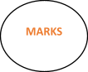
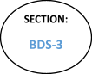
ASSIGNMENT
Classifying Email as Spam or Non-Spam DATA FILE ATTACHED

Dataset Characteristics  Multivariate | Subject Area  Computer Science | Associated Tasks  Classification
Feature Type  Integer, Real | # Instances  4601 | # Features  57

What do the instances in this dataset represent?
Emails

Additional Information
The "spam" concept is diverse: advertisements for products/web sites, make money fast schemes, chain letters, pornography...
The classification task for this dataset is to determine whether a given email is spam or not. Our collection of spam e-mails came from our postmaster and individuals who had filed spam.
Our collection of non-spam e-mails came from filed work and personal e-mails, and hence the word 'george' and the area code '650' are indicators of non-spam. These are useful when constructing a personalized spam filter. One would either have to blind such non-spam indicators or get a very wide collection of non-spam to generate a general purpose spam filter.
The last column of 'spambase.data' denotes whether the e-mail was considered spam (1) or not (0), i.e. unsolicited commercial e-mail. Most of the attributes indicate whether a particular word or character was frequently occuring in the e-mail. The run-length attributes (55-57) measure the length of sequences of consecutive capital letters. For the statistical measures of each attribute, see the end of this file. Here are the definitions of the attributes:
48 continuous real [0,100] attributes of type word_freq_WORD = percentage of words in the e-mail that match WORD, i.e. 100 * (number of times the WORD appears in the e-mail) / total number of words in e-mail. A "word" in this case is any string of alphanumeric characters bounded by non-alphanumeric characters or end-of-string.
6 continuous real [0,100] attributes of type char_freq_CHAR] = percentage of characters in the e-mail that match CHAR, i.e. 100 * (number of CHAR occurences) / total characters in e-mail
1 continuous real [1,...] attribute of type capital_run_length_average = average length of uninterrupted sequences of capital letters
1 continuous integer [1,...] attribute of type capital_run_length_longest = length of longest uninterrupted sequence of capital letters
1 continuous integer [1,...] attribute of type capital_run_length_total = sum of length of uninterrupted sequences of capital letters = total number of capital letters in the e-mail
1 nominal {0,1} class attribute of type spam = denotes whether the e-mail was considered spam
(1) or not (0), i.e. unsolicited commercial e-mail.

Name: Student 1: AHmad Khan Student 2: Student 3:

Roll #: Student 1: 24L2541 Student 2: Student 3:

Assignment: Spam Data Classification Using Naive Bayes and Performance Evaluation Instructions:
- In this assignment, you are required to use the Naive Bayes classifier for classifying emails as either spam or not spam. You will implement the Naive Bayes algorithm, evaluate its performance using various metrics, and report your results in the provided performance sheet format. Use only the space provided. Do not exceed the allocated page or cell limits.

Data:
You will use the Spam dataset (attached). Make sure to clean and preprocess the data as necessary (e.g., handling missing values, scaling features).

Steps to Complete the Assignment:
-Display whole data summary of all variables including inputs and response.

Data Splitting:
  - Split the data into training and testing sets with a 80:20 and 60:40 ratio.
  - Ensure that the data is appropriately transformed for use with Naive Bayes

Model Training Using Naive Bayes:
  - Implement the Naive Bayes classifier.
  - Train the model on the training dataset.

Prediction and Performance Evaluation:
  - Use the trained Naive Bayes model to make predictions on the test dataset.
  - Calculate the following performance metrics:
    - Confusion Matrix (Heat map)
    - Accuracy
    - Precision
    - Recall (Sensitivity)
    - Specificity
    - F1-score

Submit:
  - Your code.
    - A performance sheet (provided below) with the results of your Naive Bayes classification model.

Submission Deadline:
Submit your code and performance sheet in the GCR.
- The code file (e.g., G1-(BDS-3A)_Code)
- The performance sheet in PDF format (e.g., G1-(BDS-3A)_Sheet).

Important Notice:
Late submissions or handwritten performance sheets will result in zero marks. Please type the results, paste high-resolution heat maps, and submit a soft copy (pdf format).

Name: Student 1: AHmad Khan Student 2: Student 3:
TP | FN
FP | TN

TP | FN
FP | TN

Roll #: Student 1: 24L2541 Student 2: Student 3:

METRIC | PERFORMANCE REPORT
Model Used | Naïve Bayes
Data Split Ratio | 80:20 | 60:40
Confusion Matrix
Accuracy
Precision
Recall (Sensitivity)
Specificity
Also, calculate specificity manually by applying the formula and substituting values from the cross-tabulation (confusion matrix) and show in a cell.
Specificity Manual  = 𝑓𝑜𝑟𝑚𝑢𝑙𝑎 ℎ𝑒𝑟𝑒  𝑡𝑦𝑝𝑒 ℎ𝑒𝑟𝑒 | = 𝑣𝑎𝑙𝑢𝑒𝑠 𝑡𝑦𝑝𝑒 ℎ𝑒𝑟𝑒  𝑡𝑦𝑝𝑒 ℎ𝑒𝑟𝑒 | = 𝑣𝑎𝑙𝑢𝑒𝑠 𝑡𝑦𝑝𝑒 ℎ𝑒𝑟𝑒  𝑡𝑦𝑝𝑒 ℎ𝑒𝑟𝑒
F1-Score

Name: Student 1: AHmad Khan Student 2: Student 3:

Roll #: Student 1: 24L2541 Student 2: Student 3:

How did you scaled features: All features/Training/test features etc. combine or separate?

ans==To preserve data integrity and prevent data leaking, a rigorously separated scaling strategy was used. Only the training set was used to learn the scaling parameters (mean and standard deviation), which were subsequently applied to the test and training sets.
They are scaled using the exact same parameters taken from training, never from test statistics, and were transformed using transform() without refitting.
converted using fit_transform(), which uses only the training data to calculate and apply scaling statistics. This division simulates real-world scenarios where knowledge acquired just during training must be used to process subsequent data.

StandardScaler from sklearn.preprocessing was the scaler used.

Also, write python command of feature scaling with method/scaler you used:
from sklearn.preprocessing import StandardScaler scaler = StandardScaler()
X_train_scaled = scaler.fit_transform(X_train) X_test_scaled = scaler.transform(X_test)
Compare and Provide any comments regarding the model performance with the change in split ratio and why?
Ans :The model typically shows more devastating performance (lowered accuracy, recall, and F1 score) when the train test split shifts from 80:20 to 60:40. This occurs because the Naive Bayes classifier has fewer examples to accurately estimate the probability distributions of features for spam and non-spam emails due to less training data (60%). The model learns these patterns more precisely with 80% more training data, which improves generalization. However, the performance reduction is typically slight but obvious because Naive Bayes is straightforward and performs well even with moderate data.

DATA SUMMARY AND HEAT MAP OF CONFUSION MATRIX
DATA SUMMARY

Name: Student 1: AHmad Khan Student 2: Student 3:

Roll #: Student 1: 24L2541 Student 2: Student 3:

Distribution of Classes:
1,813 emails (39.4%) were spam.
2,788 emails (60.6%) were not spam.
Types of Features:
Features for 48-word frequency, such as word_freq_free, which is the percentage of words in the email that match a certain phrase (scaled 0–100).
Six character frequency attributes, such as char_freq_$, which is the percentage of characters that match a given symbol on a range of 0 to 100.
3 features of capital run-length:
Average length of sequences of capital letters The longest string of successive capital letters The total quantity of capital letters
Type of Data: The objective is binary (0/1) and all features are continuous real or integer values
Preprocessing: The original dataset had no missing values.
In order to prevent data leakage, features were scaled using StandardScaler and applied independently, fitting only to training data before being transformed into test and training sets.
The dataset's goal is to detect spam by identifying real-world patterns such as promotional and place specific phrases like George or 650 (non spam indicators).
Total Instances (Rows): 4,601
Total Columns: 58
Most word/char features are zero inflated (median = 0, mean > 0)
Capital features show high variance
Min = 0 for most features; Max = 100 for % based features

*HEAT MAP (80:20) | *HEAT MAP (60:40)
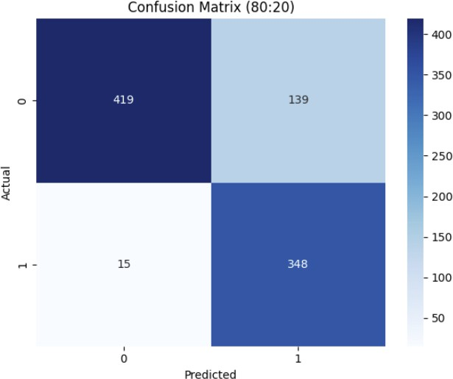 | 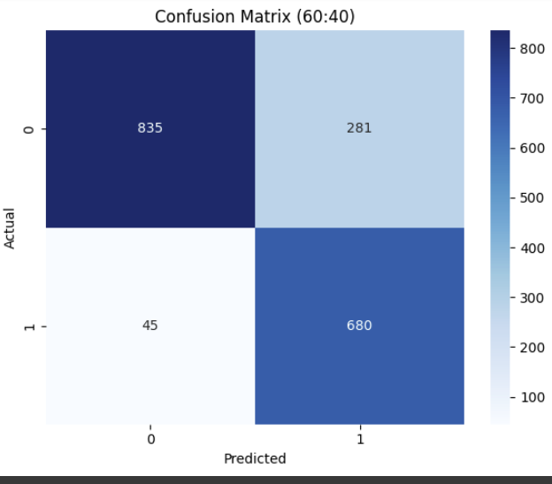
*Actual rows vs. Predicted columns

