Contexts/Advocacy Project Sources Compilation
Potential Sources for WR60 Culmination Research Projects
Compilation of Articles, Journals, Books, Etc.
Research Focus Bullet Points (Contexts Project):
- Guiding Question: Why has filming declined in California suburbia in recent years (2020-2025)?
- Contextualize Starting from the COVID-19 Era
- Hollywood as an institution in Los Angeles
- Political economy of filmmaking in California
- Labor inequality of the film industry (i.e. unions, bargain agreements, subsidizations/permits)
- Case studies in other states with a focus on Hollywood as the central “hub”
- Effect on suburbia, politically/economically
- Contextualize public image of suburbia if seemingly supportable by concrete evidence
- Timeline: Cause (COVID-19, Digitalization, Politics of Hollywood) → Effect (Labor Inequality, Loss of Jobs, Economic Downturn in California) [2020-2025, General Time Period]
- COVID-> Labor (Suburbia), Strikes, Laws -> Digitalization Shift in Industry w/ Tech Improvements Loops Back to Labor
Research Focus Bullet Points (Advocacy Project):
- Guiding Question: How do we bring a production boom back to Hollywood’s production to California?
- Look into what makes Hollywood so important for suburbia or socioeconomic development globally/locally (transition from context project there may be to talk about globally speaking)
- Specific laws (potentially best “evidence” to support claims)
- Don’t be afraid to talk about own thoughts, especially when advocating
- Structure paragraphs as more of a “debate” between opponents and proponents
- Still not sure what I should focus on advocating exactly so maybe get that clarified (ideally address ALL issues in Contexts Project)
- Developing strong points about how suburban life revolves around Hollywood may provide a solid foundation for advocacy (feel like I failed to touch upon this idea in the Contexts Project)
- On addressing strikes – With further research it seems that the strikes themselves aren’t the problem but what happens internally? Why do these strikes happen? Seems like a job security issue but do studios even care at all (they can just move out of California even without strikes going on)

Author(s) | Title, Publication Year, Type | Notes
Allen J. Scott | On Hollywood: The Place, the Industry (2005)  Type: Book | Valuable information on Hollywood in the 21st century.  Useful for advocacy as Allen J. Scott expresses their own opinions about Hollywood from this time including but not limited to:  - Geopolitical importance of Hollywood (could be tied into argument for suburban necessity)  - Fragmentation of Hollywood’s industries  - Increasing globalization of Hollywood (the good and bad)
Thorsten Hennig-Thurau, S. Abraham Ravid, Olav Sorenson | The Economics of Filmed Entertainment in the Digital Era (2021)  Type: From Journal of Cultural Economics | Relevant and current, contextualizing the film industry from the perspective of the COVID-19 era and convenience of digital streaming services.
Katie Kilkenny | Who’s Going to Halt Hollywood’s Production Exodus — and How? (2025)  Type: News Article, The Hollywood Reporter | Highly relevant and current, covering the political economy, labor issues, and policy battles pushing film production out of California.  It links local economic impacts, including in LA’s suburbs, to global trade debates. Different levels of the film industry can be contextualized (state, national, global).  Illustrates the complex institutional forces (political, economic) behind the decline in California filming.
Megan Jamerson | Hollywood’s filming decline hits local small businesses in L.A. (2025)  Type: Radio Podcast, Transcript | Contextualizes current immediate effects on local suburban businesses (i.e. Burbank) and how business owners have seen less customers.  Support needed with concrete evidence to avoid correlation not causation issues when integrating this source. References several other sources that are of relevance.  Mentions film incentive programs.  Provides lens of the situation through the eyes of regular citizens not employed by the film industry.
FilmLA | L.A. On-Location Filming Falls in First Quarter (2025)  Type: Article/Report | Provides concrete data for the decline in on-location filming in Los Angeles.  On-location production figures are based on days of permitted production within the jurisdictions served by FilmLA. One “Shoot Day” (or “SD”) is defined as one crew’s permission to film at one or more defined locations during any 24-hour period.  FilmLA’s reported five-year average excludes 2020, which due to the significant impact of COVID-19 on production that year, distorts all historical comparisons.
Matt Stevens, Nicole Sperling | There’s a Feeling We’re Not in Hollywood Anymore (2025)  Type: News Article, The New York Times | Provides the “mood” towards the film industry from the perspective of a reporter from Los Angeles.  Links relevant sources with concrete data.
Brooks Barnes | With the Strikes Over, the Mood in Hollywood Is Decidedly Mixed (2023)  Type: News Article, The New York Times | Details the aftermath of the Los Angeles Hollywood Writer’s Guild strikes.
Olsberg•Spi | Global Film and Television Production Incentives (2024)  Type: White Paper (Research-based Report) | Provides film incentives data from abroad.
Michael Johnson Jr | Hollywood survival strategies in the post-COVID 19 era  Type: From Humanities and Social Sciences Communications | Careful if using this source, the author is unknown but credible points are made about how industries continue to reconstruct from the COVID-19 era.  Has Hollywood really fully recovered from the COVID-19 era?
Paris Marx | How Hollywood used the digital transition against workers  Type: Blog Post, Disconnect
Christi Carras | L.A. prop houses prepare for the return of production after dual Hollywood strikes  Type: News Article, The Los Angeles Times
Lance Ignon, Michael Thom | Expert testimony: Film industry incentives don’t justify the cost (2025)  Type: Testimony from USC Professor  Michael Thom’s Publications | May be a decent starting point as to why a researcher in the field of Hollywood economics thinks the tax incentives are not sufficient to bring back Hollywood to California. No specific evidence is given by this source directly, but they cite 4 studies they have done to prove why as well as others done by his peers.  Below is one such example of his publications which can serve as a foundation for the “opponent side” of advocacy.
Michael Thom | Lights, Camera, but No Action? Tax and Economic Development Lessons From State Motion Picture Incentive Programs (2016)  Type: Article from The American Review of Public Administration | Argues tax credits have no significant benefit to Hollywood’s development (on employment, wages, etc.). Makes claims for proper policy design in the future.
California Film Commission | California Film Commission announces 48 new projects to film in California thanks to the state’s Film & Television Tax Credit Program (2025)  Type: Press Release | Directly shows how the California government pushes laws as beneficial to the film and television industry, citing quotes from leaders such as Governor Gavin Newsom.
Ariel Zilber | Warner Bros. Discovery to split cable TV networks from streaming, Hollywood studios (2025)  Type: News Article from New York Post | Provides an example (with Warner Bros. Discovery) shifting production away from cable TV.  Is the lack of funds really the reason Hollywood is leaving California?
China Widener, Jana Arbanas, Doug Van Dyke, Chris Arkenberg, Bree Matheson, Brooke Auxier | 2025 Digital Media Trends: Social platforms are becoming a dominant force in media and entertainment  Type: Pop Culture Article from Deloitte | Provides useful infographics for showing how social media is dominating the content industry. It gives an interesting take on the matter demonstrating that other factors are affecting Hollywood other than just costs. There is a general shift away from “how it was back then.”
Michael D. Smith | Lessons from Hollywood’s Digital Transformation (2021)  Type: Opinion Paper from Harvard Business Review | Gives good points about the digital shift in a timely manner (talking from 2021 where Hollywood started to digitalize).  First-person perspective makes it easy to link it in conversation with some other advocate/scholar.
16 million workers were unionized in 2024
Type:

Potential Multimodal Integrations
Input
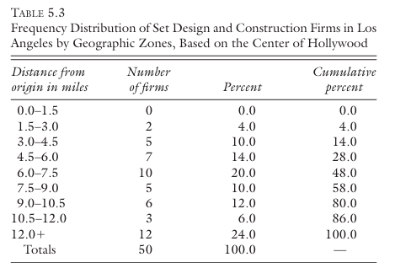
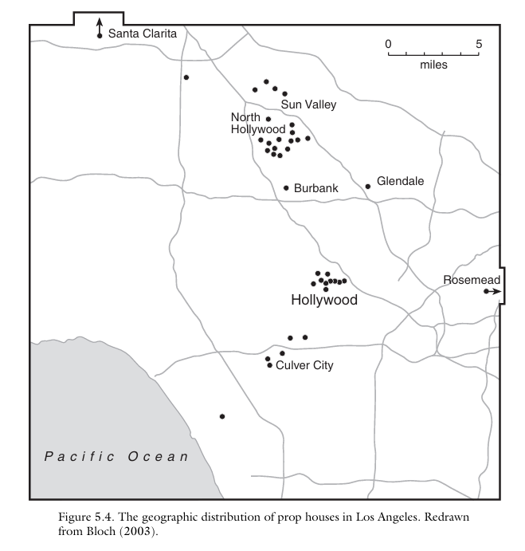
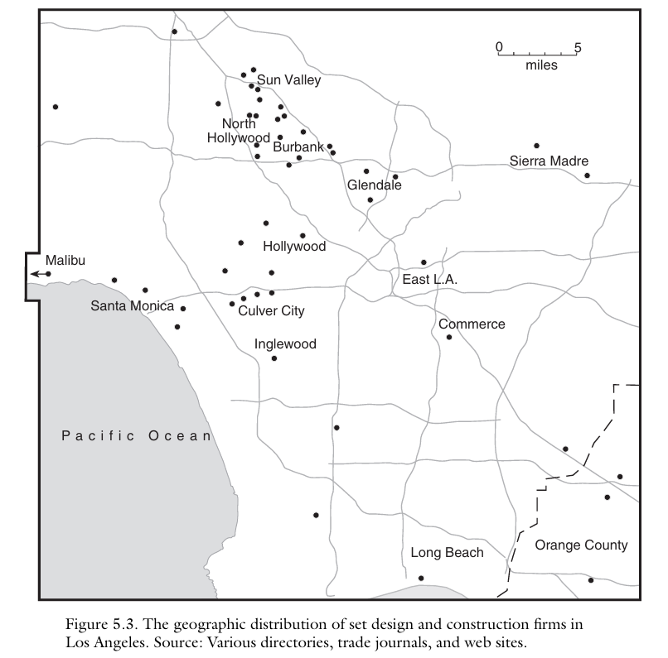

Promising Sources
Title | “Eye-Catching” Passages
On Hollywood: The Place, the Industry (2005) | Useful for Advocacy Project AND Contexts Project.
The Economics of Filmed Entertainment in the Digital Era (2021) | Although the film industry has witnessed many technological changes—the introduction of sound, of color, the invention of television—digitalization, more than any of these others, has unleashed a radical transformation of the industry. It has changed not just the nature of production, but also the businesses of distribution and of exhibition. It has challenged decades-long industry rules and routines.  COVID-19, if anything, has accelerated this transformation. When the pandemic kept people home, streaming services came to the rescue, providing audiences with filmed entertainment on their televisions, computers, tablets, and other digital devices. Since the advent of digitalization in the late 1990s, some of the more radical reconfigurations of the industry had been delayed by those with entrenched interests in the old system. But the pandemic has swept their objections aside.  Theaters, as exhibitors of movies, have traditionally been the main setting in which people have consumed films (Vogel 2020). But that has been changing. People increasingly watch filmed entertainment not just on their televisions but on a variety of mobile digital devices. COVID-19 has, at least temporarily, accelerated this trend. Movie theaters, in response, have been adapting, adopting their operations to differentiate further the experience of the big screen from that offered by streaming to digital devices.
L.A. On-Location Filming Falls in First Quarter (2025) | 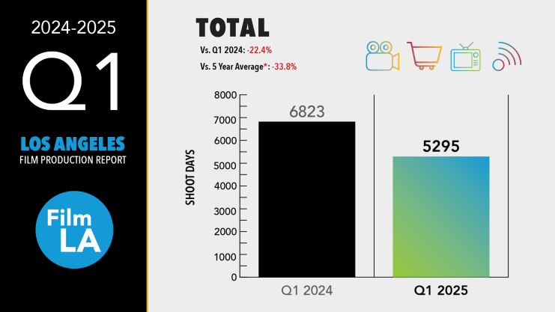  The wildfires that devastated the Pacific Palisades and Altadena communities had only a small effect on L.A. area filming. A recent FilmLA analysis determined that combined, these areas had hosted 1,405 Shoot Days over the past four years – or roughly 1.3 percent of all regional filming. Approximately 545 unique filming locations fell within the fires’ burn zones. At the order of the City and County, burn areas remain off-limits.  “Loss of filming opportunity in no way compares to the cost of the Eaton and Palisades Fires in terms of loss of life, resident displacement and property damage,” noted FilmLA VP of Integrated Communications Philip Sokoloski. “The fires sent many productions scrambling to reschedule shoots and displaced hundreds of industry workers from their homes. But their impact on local filming levels appears to have been temporary.”
Global Film and Television Production Incentives (2024) | Incentives are investments in the long-term growth of a film and television production sector. At a basic level they are designed to attract, stimulate, or retain production expenditure, which, in the absence of the incentive, would not have occurred or would have been undertaken elsewhere. The incentive is issued to the production only after the expenditure has been undertaken in the jurisdiction, after individuals hired by the production (often hundreds of individuals, or more) have been paid, and after robust verification that the spend is eligible given the rules of the system. As with any other economic development investment, the impact of production incentives should be measured with economic metrics including gross value added (GVA) and job creation as well as other markers such as impacts on infrastructure growth, and broader sectoral development. Given the high cultural value of film and television production, broader impacts should also be considered – including on strategic outcomes such as tourism and national branding. These impacts are covered in detail in Section 3 of this White Paper. Production incentives stimulate both local and international projects – both key components of a healthy film and television production sector. Across emerging and established markets, large-scale international productions can bring high levels of investment, transferable skills, and infrastructure development. Meanwhile, a strong local industry also delivers these impacts, and can also deliver cultural value and produces talent that also play a critical role – both creatively and technically – in contributing to the successful production of international projects. The most successful incentive programs are conceived as long-term, continued investments that sustain activity over many years. An ongoing incentive offer is critical in economic development terms, since each screen production will be budgeted, financed and sited by its investors as a standalone project – much like an investment in a new infrastructure development.  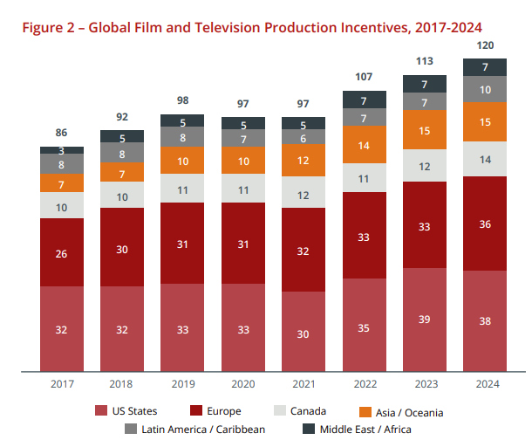
Lessons from Hollywood’s Digital Transformation (2021) | The first is that digital transformations tend to create abundance where there was once scarcity. After all, what could be more abundant than digitally encoded information that can be reproduced an infinite number of times, at no additional cost, and without loss of quality? Because most business models are based on the idea of controlling scarce resources, this aspect of digital transformations can be very disruptive and even hard to conceptualize.  The second is that digital transformations often affect many areas of a firm’s competitive environment at the same time. This expanded scope can cause experienced managers who are used to evaluating threats from individual market transformations to miss the combined threat caused by multiple digital changes that are occurring simultaneously.
2025 Digital Media Trends: Social platforms are becoming a dominant force in media and entertainment | Streaming video services: balancing value and frustrations  A similar tension seems to exist with streaming video services, which have subscription costs that may outweigh their perceived value. Fifty-three percent of consumers surveyed say their SVOD subscriptions are the paid media and entertainment services they use most frequently. However, 41% percent of consumers overall say the content available on SVOD isn’t worth the price, up five percentage points from our 2024 report.14 At the same time, roughly half (47%) of consumers say they pay too much for the streaming services they use, suggesting there is an imbalance between cost and perceived value. Indeed, while the average number of paid SVOD services has remained the same, at four per subscribing household, the overall cost subscribers surveyed say they pay has gone up 13% in the past year, from an average of $61 per month to $69. Gen Z and millennials, with an average of 5 paid SVOD services, have seen a 20% increase (figure 3).  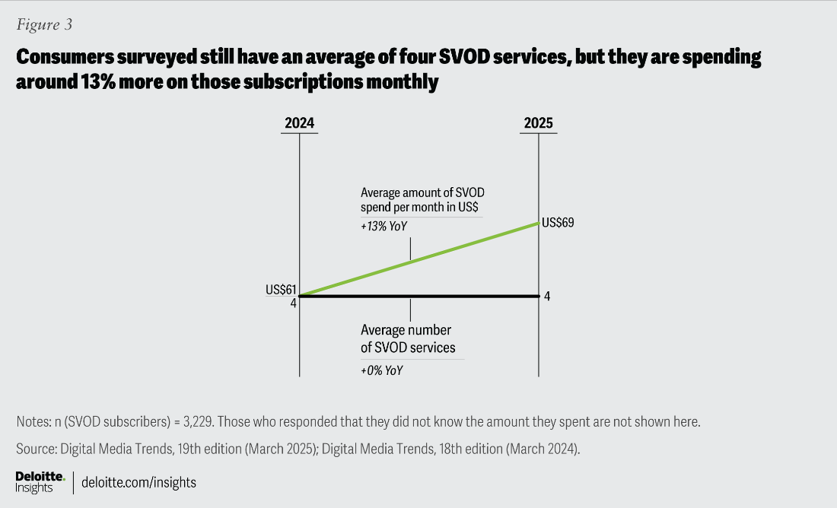
Lights, Camera, but No Action? Tax and Economic Development Lessons From State Motion Picture Incentive Programs (2016) | Abstract  Despite mixed results, state government use of targeted economic development programs has escalated. This study evaluates the impact of motion picture incentive programs, an array of tax incentives employed by over 40 states to entice film and television productions out of California and New York, on labor and economic conditions from 1998 through 2013. Results suggest that sales and lodging tax waivers had no effect on any of four different economic indicators. Transferable tax credits had a small, sustained effect on motion picture employment levels but no effect on wages. Refundable tax credits had no employment effect and only a temporary wage effect. Neither credit affected gross state product or motion picture industry concentration. Incentive spending also had no influence. These findings demonstrate the heterogeneous impacts of different incentives offered under a single program and should inform future economic development policy design.

Further Plans AP
I plan to look closely at sources (more so than I did in the Contexts Project) and continue to implement multimodal elements effectively.
Many of these sources link other useful sources so theoretically a whole roster of credible sources for my Advocacy Project is obtainable.

AP Abstract
The decline of film production in California has prompted state policymakers to focus heavily on tax incentive programs as the primary solution, but this approach overlooks the deeper structural transformation that Hollywood is experiencing in the digital era. This paper evaluates current efforts to bring production back to California, particularly through enhanced tax credits and film subsidies, while examining why these measures have shown limited success despite significant state investment/reliance. Through analysis of production data, academic research on incentive effectiveness, and industry reports on digital transformation, this research demonstrates that California's production exodus stems from more than just basic cost considerations. It reflects a fundamental shift in how entertainment content is created, distributed, and consumed. The COVID-19 pandemic accelerated existing trends toward streaming platforms, social media content creation, and decentralized production models that challenge traditional Hollywood's geographic concentration. While tax incentives remain necessary to maintain competitive parity with other states, they cannot address the core issue: the entertainment industry is undergoing a radical digitalization that has changed the economics of content production. This paper argues that California needs a comprehensive approach that combines competitive tax policy with strategic investments in digital infrastructure, workforce development for emerging media formats, and regulatory frameworks that position the state as a leader in next-generation content creation rather than trying to restore the old studio system. By addressing both immediate competitive pressures and long-term structural changes, California can maintain its entertainment industry leadership while adapting to the realities of the digital media landscape.
Comments:
- Is it okay to focus on “one thing” if it can address all issues from my Context Project? It feels like there is a deeper issue that needs to be addressed rather than unionized strikes directly.

