Anthony Ahn
Professor Hiscock
Writing 60
8 August 2025
Bringing Prime Hollywood Back to the SoCal Stage
As Hollywood’s exodus away from California to other parts of the world devalues production in SoCal, tax changes alone will not suffice in effectively anchoring the industry to the area. At a surface level, Hollywood studios are moving production out of the state due to rising costs associated with the rising power of California’s labor unions. Yet, the issue may be rooted in the infrastructural shift the film and TV entertainment industry is undergoing within the 21st century. There is simply more demand for online streaming services than ever before. Therefore, for California to once again become the central hub for Hollywood, a combination of higher motion picture incentives (MPIs) in California, the potential organization of campaigns to win labor unions in other states and countries, and the reorganization of the internal decisions that compose Hollywood. While attempts to anchor Hollywood to California are not limited to these incentives, they represent the major direction government officials should take in revitalizing film and TV entertainment in SoCal.
Motion picture incentives are a category of public funding aimed at alleviating the surface level pressures Hollywood continues to face with rising production costs stemming from the COVID-19 era. According to Michael Thom, a researcher on taxation and public finance, motion picture incentives (MPIs) “comprise a portfolio of incentives funded with state tax dollars aimed at enticing motion picture-related activity by reducing production costs. Incentives fit within states’ prototypical economic development approach to reduce barriers to market entry, attract new industries, and reap the benefits of subsequent tax revenue growth” (Thom, 3). One can classify MPI programs as a surface level attempt to motivate the film and TV entertainment industry. Incentives such as these, however, have become a norm rather than an innovative policy that will keep Hollywood production in California. A recent example of an MPI would be Governor Gavin Newsom’s $750 million Film and Television Tax Credit Program funding. The California Film Commission justifies this agenda stating, “This diverse slate of feature films – ranging from major studio productions to independent film – is expected to generate $664 million in total spending throughout the state, including $485 in qualified expenditures and more than $302 million in wages for California workers” (California Film Commission). While California may have one of the most beneficial MPI programs, it is evident that other states have similar if not better incentives to pull Hollywood production outside of California.
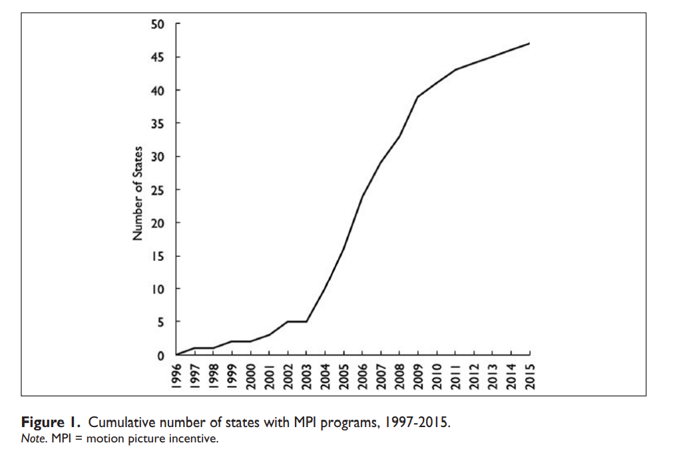
Fig. 1. Cumulative Number of U.S. States with MPI Programs, 1997-2015 (Thom, 5)

From the graph above, even by 2015 nearly all 50 states implemented MPI programs to drive film and TV entertainment industry outside of California. It is therefore reasonable to argue that MPI programs alone will not entice Hollywood studios to rely on California for production. Other aspects that make states outside California enticing for prospective studios must also be addressed to resolve the Hollywood exodus.
California is home to strong unions such as the Writer’s Guild of America and SAG-AFTRA. Many states outside of California lack significant union power which fights for the quality of life of workers in Hollywood’s industry including higher wages. Advocates from the Economic Policy Institutes, a pro-union organization, states “60 million workers would join a union if they could,” proposing solutions to unionize workers at federal and state levels (Poydock et al.). Evidently, it is more profitable to relocate most of Hollywood production outside of California with a history of successful unionization.
With technological developments and the advent of COVID-19, online services have become increasingly profitable. […]
[Conclusion/Tie All Points to Call to Action]

Works Cited
California Film Commission. “California Film Commission Announces 48 New Projects to Film in California Thanks to the State’s Film & Television Tax Credit Program.” California Film Commission, 23 June 2025, https://film.ca.gov/california-film-commission-announces-48-new-projects-to-film-in-california-thanks-to-the-states-film-television-tax-credit-program.
Hennig-Thurau, Thorsten, et al. “The Economics of Filmed Entertainment in the Digital Era.” Journal of Cultural Economics, vol. 45, no. 2, June 2021, pp. 157–170. Springer, doi:10.1007/s10824-021-09407-6. Accessed 12 July 2025.
Kilkenny, Katie. “Who’s Going to Halt Hollywood’s Production Exodus — and How?” The Hollywood Reporter, 7 May 2025, www.hollywoodreporter.com/business/business-news/hollywood-production-trump-movie-tariffs-1236209847/.
Olsberg•SPI. “Global Film and Television Production Incentives: A White Paper.” Motion Picture Association, Nov. 2024, www.motionpictures.org/wp-content/uploads/2024/11/GLOBAL_OlsbergSPI-Incentives-White-Paper_November-2024.pdf.
Poydock, Margaret, et al. Millions of Workers Want to Join Unions but Couldn’t. Economic Policy Institute, 28 Jan. 2025, https://www.epi.org/publication/millions-of-workers-millions-of-workers-want-to-join-unions-but-couldnt.
Scott, Allen J. On Hollywood: The Place, The Industry. Princeton University Press, 2005.
Thom, Michael. "Lights, Camera, but No Action? Tax and Economic Development Lessons from State Motion Picture Incentive Programs." The American Review of Public Administration, vol. 47, no. 2, 2017, pp. 147–166, doi:10.1177/0275074016651958.

