Anthony Ahn
Professor Hiscock
Writing 60
15 August 2025
Keeping Prime Hollywood on the SoCal Stage
As Hollywood’s exodus away from California to other parts of the world devalues production in SoCal, tax changes alone cannot suffice in effectively anchoring the industry to the area. At a surface level, Hollywood studios are moving production out of the state due to rising costs associated with the rising power of California’s labor unions. Yet, the issue may be rooted deeper in the infrastructural shift the film and TV entertainment industry continues to undergo in the 21st century. There is simply more demand for online streaming services than ever before. Therefore, what California needs to keep Hollywood production high within the state itself is a combination of higher in-state motion picture incentives (MPIs), the organization of campaigns to win labor unions in other states and countries, and the reconstruction of the internal decisions within Hollywood corporations. While attempts to anchor Hollywood to California are not limited to these incentives, they represent the major direction government officials should take in revitalizing film and TV entertainment production within SoCal.
Motion picture incentives are a category of public funding aimed at alleviating the surface level pressures Hollywood continues to face with rising production costs stemming from the COVID-19 era. According to Michael Thom, a researcher focused on taxation and public finance, motion picture incentives (MPIs) “comprise a portfolio of incentives funded with state tax dollars aimed at enticing motion picture-related activity by reducing production costs. Incentives fit within states’ prototypical economic development approach to reduce barriers to market entry, attract new industries, and reap the benefits of subsequent tax revenue growth” (Thom, 3). One can classify MPI programs as a surface level attempt to motivate the film and TV entertainment industry. Incentives such as these, however, have become a norm rather than an innovative policy that will keep Hollywood production in California, hence why they can be considered surface level. A recent example of an MPI would be Governor Gavin Newsom’s $750 million Film and Television Tax Credit Program funding. The California Film Commission justifies this agenda stating, “This diverse slate of feature films – ranging from major studio productions to independent film – is expected to generate $664 million in total spending throughout the state, including $485 in qualified expenditures and more than $302 million in wages for California workers” (California Film Commission). Politicians and policymakers largely support an increase in funding to keep California’s film and TV production at an all-time high, but skeptics argue it will not be enough to prevent Hollywood’s exodus. Katie Kilkenny, a labor and media reporter from The Hollywood Reporter, cites Teamsters motion picture division director Lindsay Dougherty who says, “We have been in this race with film and television tax credits for many decades at this point, and it just doesn’t seem to be enough” (Kilkenny). Kilkenny reports from a context where President Donald Trump has recently proposed tariffs on film and TV produced outside of California that seemingly fell through. While these economic incentives and deterrents are a direct way to control Hollywood’s growth within California, these economic policies are not capable of taming the complex sociopolitical conflict within this industry. In other words, while California may have one of the most beneficial MPI programs and continues to implement policies to incentivize in-state production, it is evident that other states have similar if not better incentives to pull Hollywood production outside of California.
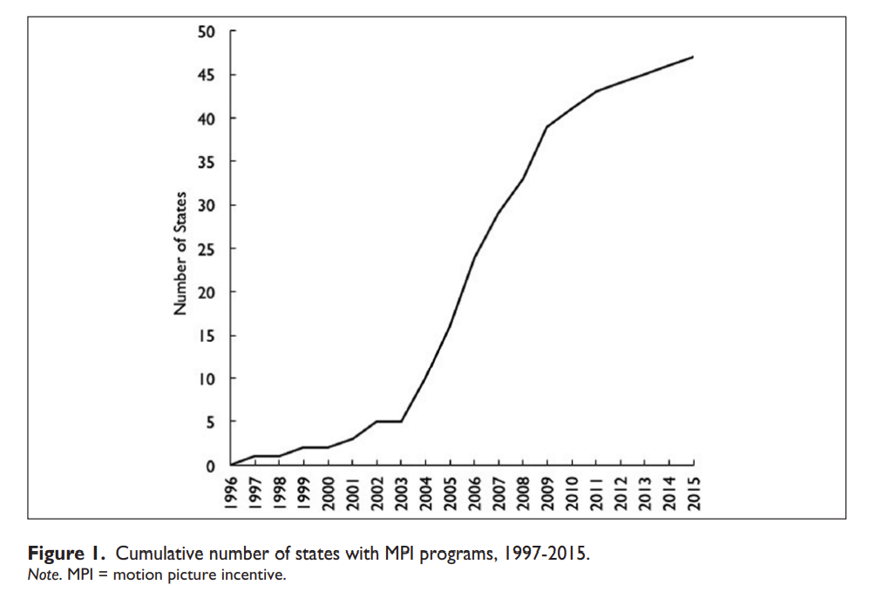
Fig. 1. Cumulative Number of U.S. States with MPI Programs, 1997-2015 (Thom, 5)
From the graph above, even by 2015 nearly all 50 states implemented MPI programs to drive film and TV entertainment industry outside of California whether intentionally or not. An example of a state that has increased MPIs in recent years is New Jersey.
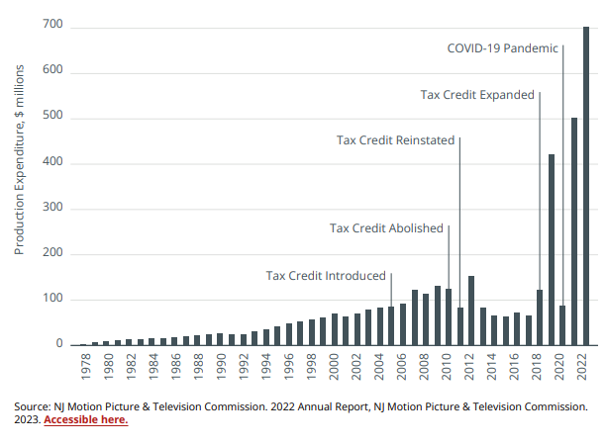
Fig. 2 New Jersey Production Expenditure, 1978-2022 (Olsberg•SPI)
As seen from the figure above, MPIs in the form of tax credits appear to have a positive correlation with increased motion picture production within New Jersey. New Jersey is just one example of the 50 states within America that have implemented competitive MPIs that attract Hollywood studios over. It is therefore reasonable to argue that MPI programs alone will not entice Hollywood studios to rely on California for production. Studios may tend to prefer other states unless a production is location-dependent on California. Other aspects that make states outside California enticing for prospective studios must also be addressed to prevent Hollywood’s complete exodus out of California.
California is home to strong unions such as the Writer’s Guild of America and SAG-AFTRA. Many states outside of California lack significant union power which fights for the quality of life of workers in Hollywood’s industry including higher wages. Advocates from the Economic Policy Institutes, a pro-union organization, states “60 million workers would join a union if they could,” and they propose solutions to unionize workers at federal and state levels in America (Poydock et al.). It is inherently more profitable to relocate most of Hollywood production outside of California given this history of unionization. Production studios do not have to deal with as many strict labor laws in certain states outside of California.
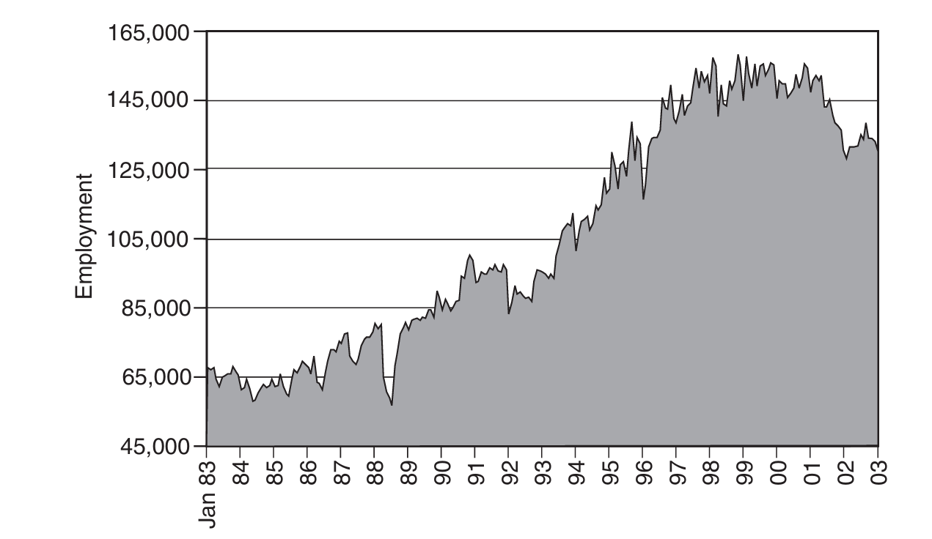
Fig. 3 Employment in SIC 78, LA County, January 1983 to December 2002 (Scott, 123)
In Professor Allen J. Scott’s book, On Hollywood: The Place, The Industry, they provide a historical example of how strong unions in California impacted employment within SIC 78, a major group of establishments involved in motion picture production. In the chart above, a significant drop in employment between 1988 and 1989 “is a consequence of the strike by members of the Writers Guild between March and August of that year” (Scott, 122). Yet, the upwards trend indicates that Hollywood employment remained on a rise through 2002. Unions in California have the power to direct strike if they feel industries continue to treat them unfairly particularly due to the lack of union prevent laws. Studios are forced to recover from these potential gaps in employment which can disrupt production and profitability. It is also important to note that many unions, especially those associated with the Hollywood industry, have a national presence but lack influence in some states due to specific legislation. According to Alex Ates in a Backstage article breaking down “right-to-work” laws, Ates proposes “right-to-work” laws act almost as “union prevention” laws means that states “do not mandate employees to pay a fee to a union. This intentional loophole means that even if a union negotiates for worker benefits, the workers don’t need to join the union” (Ates). Essentially, this means that a worker is not required to be an official member to gain worker benefits in “right-to-work” states. This results in a weaker negotiation power within these states. A lack of funding from union members can contribute to less contracting power with studios as opposed to states like California where unions may require members to pay dues to their union. For example, Georgia is a “right-to-work” state that has seen a significant increase in film and TV production presence due to generous MPIs.

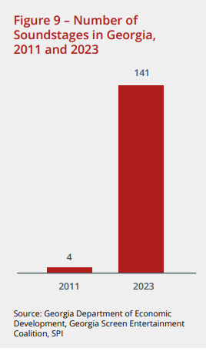
Fig. 4. Number of Soundstages in Georgia 2011 and 2023 (Olsberg•SPI)
As seen in the infographic above, studio infrastructure has developed in Georgia in recent years attributed to a “competitive incentive […] [that] has indirectly stimulated large amounts of private investment in studio infrastructure” (Olsberg•SPI). Again, MPIs are often only a part of what attracts the film and TV industry to a state. Competitive incentives within Georgia “indirectly” stimulated studio growth as it can also be attributed to favorable conditions for studios operate with “right-to-work” laws to their advantage. This growth also aligns with the recent Writer’s Guild of America and SAG-AFTRA strikes in 2023 which may have pushed some production away from California towards states with increasing MPIs. Therefore, for California to increase in-state Hollywood production a nationwide intervention is necessary to abolish “right-to-work” laws in Southern states and ultimately give unions more membership and negotiating power with contractors. If studios are forced to provide workers with the same benefits expected within California across the nation, Hollywood production may choose to remain in California or invest in production outside of the United States itself. Yet, there is a deeper systematic change that also needs to be reevaluated to resolve internal conflict within the Hollywood industry.
With technological developments and the advent of COVID-19, online services have become increasingly profitable. Researchers at Deloitte argue that the “streaming on-demand video (SVOD) revolution has fragmented pay TV audiences, imposed higher costs on studios now operating direct-to-consumer services, and delivered thinner margins for their efforts” (Deloitte Center for Technology, Media & Telecommunications). Studios are undergoing an important infrastructural shift towards providing SVOD service with dramatic effects to the established motion picture industry. As digitalization grows in demand, revenue from sources such as cable television, movie theaters, and physical productions drop. In this regard, researchers at Deloitte agree with economists in “The Economics of Filmed Entertainment in the Digital Era” from the Journal of Cultural Economics who argue “Digitalization also promises to raise interesting questions about contract design and industry structure. For instance, contracts with exhibitors will have to adjust as studios no longer have an interest in guaranteeing exhibition windows. These changes will affect the incentives and the entire business model of movie exhibition” (Hennig-Thurau, Thorsten, et al.). Here, movie exhibition refers to the public showing of a film in a movie theater which, according to researchers, may be threatened as studios redirect their attention to on-demand streaming services. With this potential decline in the established infrastructure for film and TV production, studios are less inclined to remain in California as streaming services are not physically bound like theaters are.
While interventions to prevent Hollywood production from leaving California may prove beneficial to maintain California’s status as the film and TV production hub of America, it is also important to recognize that Hollywood itself will continue to evolve throughout the 21st century. Many incentives are only a temporary fix to Hollywood’s growth outside of California. However, stronger nationwide union protections paired with a positive mindset towards digitalization appear necessary if California aims to remain the center of global film and TV production. Ultimately, leaders of the industry must respond effectively to this infrastructural shift of Hollywood and cannot remain caught up in what used to make the industry run.

Works Cited
Ates, Alex. “Understanding Union Rules for Actors in ‘Right-to-Work’ States.” Backstage, last updated 27 Jan. 2021, www.backstage.com/magazine/article/actors-union-rules-in-right-to-work-states-70120.
California Film Commission. “California Film Commission Announces 48 New Projects to Film in California Thanks to the State’s Film & Television Tax Credit Program.” California Film Commission, 23 June 2025, https://film.ca.gov/california-film-commission-announces-48-new-projects-to-film-in-california-thanks-to-the-states-film-television-tax-credit-program.
Deloitte Center for Technology, Media & Telecommunications. “2025 Digital Media Trends: Social Platforms Are Becoming a Dominant Force in Media and Entertainment.” Deloitte Insights, 25 Mar. 2025, www.deloitte.com/us/en/insights/industry/technology/digital-media-trends-consumption-habits-survey/2025.html.
Hennig-Thurau, Thorsten, et al. “The Economics of Filmed Entertainment in the Digital Era.” Journal of Cultural Economics, vol. 45, no. 2, June 2021, pp. 157–170. Springer, doi:10.1007/s10824-021-09407-6. Accessed 12 July 2025.
Kilkenny, Katie. “Who’s Going to Halt Hollywood’s Production Exodus — and How?” The Hollywood Reporter, 7 May 2025, www.hollywoodreporter.com/business/business-news/hollywood-production-trump-movie-tariffs-1236209847/.
Olsberg•SPI. “Global Film and Television Production Incentives: A White Paper.” Motion Picture Association, Nov. 2024, www.motionpictures.org/wp-content/uploads/2024/11/GLOBAL_OlsbergSPI-Incentives-White-Paper_November-2024.pdf.
Poydock, Margaret, et al. Millions of Workers Want to Join Unions but Couldn’t. Economic Policy Institute, 28 Jan. 2025, https://www.epi.org/publication/millions-of-workers-millions-of-workers-want-to-join-unions-but-couldnt.
Scott, Allen J. On Hollywood: The Place, The Industry. Princeton University Press, 2005.
Thom, Michael. "Lights, Camera, but No Action? Tax and Economic Development Lessons from State Motion Picture Incentive Programs." The American Review of Public Administration, vol. 47, no. 2, 2017, pp. 147–166, doi:10.1177/0275074016651958.

