Anthony Ahn
Professor Hiscock
Writing 60
18 July 2025
Hollywood’s Exodus Away from the SoCal Stage
Southern California suburbs thrive off the film industry with Hollywood at the core of the Los Angeles County since the early 20th century. Residents of the county, however, cite a noticeable vacancy of the entertainment industry in SoCal with major studios seeking locations outside California. In a morning Marketplace radio program, Megan Jamerson reports that a small local restaurant Chili John’s in Burbank has seen less customers. The owner, Steve Hager, comments in an interview “Burbank runs off the entertainment industry – So as long as the entertainment industry is slow, all the services are going to be slow” (Jamerson). Hager is aware that Burbank, among many suburban cities centralized around Hollywood, feeds off the entertainment industry to maintain a customer base. Suburban residents’ way of life may even revolve around the industry itself. Yet Hollywood, in its timeless sovereignty throughout the century, has seen a significant decline in recent years since the COVID-19 era. In recent times, Hollywood continues to undergo an unstable socioeconomic shift wrought by unionized strikes, higher incentives to outsource production to foreign countries, and the digitalization of Hollywood productions through popular streaming services in the U.S.
Hollywood attributes a significant portion of its global competitiveness to its decentralization despite its position as a central institution of SoCal. Professor Allen J. Scott, in his book On Hollywood: The Place, The Industry, proposes that the globalization of Hollywood has roots in the late 20th century as “the production system was significantly reconstituted as a congeries of many small and medium-sized firms linked together in shifting coalitions by flexible production networks.” Professor Scott’s insight into the network of industries comprising Hollywood demonstrates the industry has self-righting dynamic between itself and the workers it employs in various sectors of this continuously evolving complex network. Proof lies in how workers maintain power against corporations in the entertainment industry as Professor Scott notes “Hollywood has never had much of a tendency to generate low wage, low-skill jobs, in large measure because the long-standing guilds and unions have been notably successful in erecting institutional barriers to wage-cutting by employers” (Scott, 5). By this account, it is clear Hollywood is dependent on a sustainable relationship between the labor force and the sub-industries the vast network employs. In other words, the labor force itself is an example of the further decentralization of Hollywood as the guilds and unions aim to maintain socioeconomics balance in Hollywood in terms of rights, wages, and political power. Another prime example of this decentralization of Hollywood and the persistence of labor protection rights is with the prop houses industry that supply essential items to facilitate the construction of sets locally.
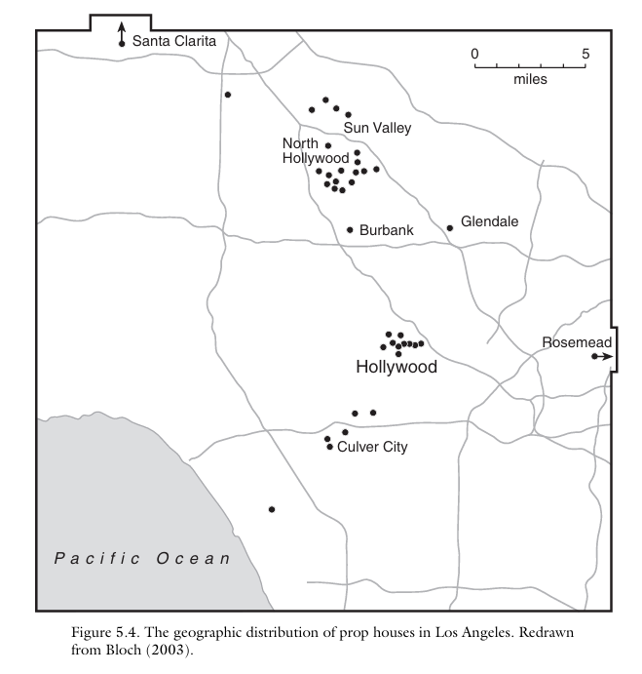
Fig. 1. The geographic distribution of prop houses in Los Angeles as of 2003 (Scott, 92)

As observed above, even in 2003, a surprisingly large number of prop houses are in suburban areas outside of Hollywood such as Burbank, Culver City, and Rosemead largely to pull a labor force from its surrounding residents as Professor Scott observes “there is a rather strongly developed agglomeration of set design and construction firms in the vicinity of Burbank and North Hollywood, coinciding with a distinctive cluster of studios. This area also lies close to residential neighborhoods with high densities of immigrant Latino workers, who appear, on the basis of fieldwork observations, to be the preferred labor force in at least some segments of the set construction sector” (Scott, 89). Professor Scott’s data shows that suburban development has also been essential for supplying the labor force of the Hollywood industry. A detriment to workers will therefore result in economic losses on both sides for the duration of a strike as seen The Los Angeles Times, Christi Carras where interviews prominent prop houses Omega and ISS and notes “local vendors that supply productions with the furniture, equipment, decorations and other items they need to dress a film or TV set were among the hardest hit during the work stoppages, just as they were bouncing back from shutdowns caused by the COVID-19 pandemic.” The work stoppages refer to the actors’ SAG-AFTRA strike and demands from the Writers’ Guild of America (WGA) which Carras reports halted filming for “a combined six months” (Carras). Both teams of Hollywood stand tall with local businesses continuing through COVID-19 coupled with strikes from an unsatisfied labor force who continue to fight for more financial equality. Strikes and end agreements, however, result in rising costs for Hollywood if demands increase from the labor force who feel mistreated. Brooks Barnes, a journalist focused on all aspects of the entertainment industry, reports from The New York Times “Everywhere you look in Hollywood, or so it seems, businesses are trying to cut costs. […] Anonymous Content, a production and management company, laid off 8 percent of its staff last month. United Talent Agency also trimmed its head count, as did several competing agencies. […] DreamWorks Animation recently eliminated 4 percent of its work force, while Starz, the premium cable network and streaming service, is reducing head count by 10 percent. Netflix is restructuring its animation division, which is expected to result in layoffs and fewer self-made films” (Barnes). From an economic standpoint, labor is essential for an industry like Hollywood to continue to thrive. Consequently, strikes contribute to the decline of the once thriving entertainment industry of Hollywood by leading to higher unemployment and a potential delocalization of production away from the suburbs of SoCal.
Coupled with the rising number of strikes in Hollywood, there is no longer an incentive for the once localized Hollywood to direct production solely in California and many businesses are outsourcing labor to other parts of the world.
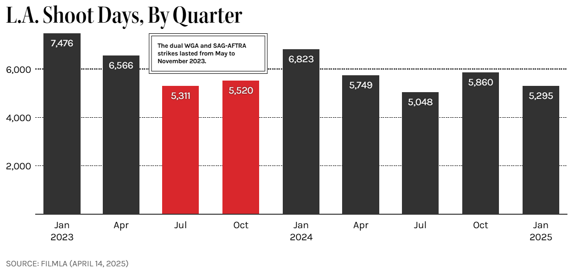
Fig. 2. Number of Shoot of Days in L.A. from 2023-2025 (FilmLA)
According to FilmLA, a film office for the County of Los Angeles and other local jurisdictions, “In the midst of a global decline in production and intensifying competition for film projects and jobs, on-location production in Greater Los Angeles declined by -22.4 percent from January through March 2025 to 5,295 Shoot Days (SD)” (FilmLA). In the above infographic, Q1 refers to the first three months of the calendar year. Based on numerical trends, it appears that businesses are beginning to shift film production away from Los Angeles, an indication that parts of Hollywood are attempting to cut costs in reaction to losses associated with the recent actors’ and writers’ strikes. Matt Stevens and Nicole Sperling cite a general sense that Hollywood is leaving California from The New York Times, report “Michael F. Miller Jr., a vice president at the International Alliance of Theatrical Stage Employees, who oversees film and television production for the union, said that roughly 18,000 full-time jobs have evaporated in the past three years, primarily in California.” Businesses have been increasing layoffs to reduce costs to reclaim profitability. Generally, international sites are cheaper for film production as “More countries offer generous tax incentives than ever before, and many of the programs — including Germany’s and the Czech Republic’s — have recently sweetened their deals to give out rebates that are comparable to or larger than California’s, with looser rules that allow more kinds of projects to qualify” (Stevens and Sperling).
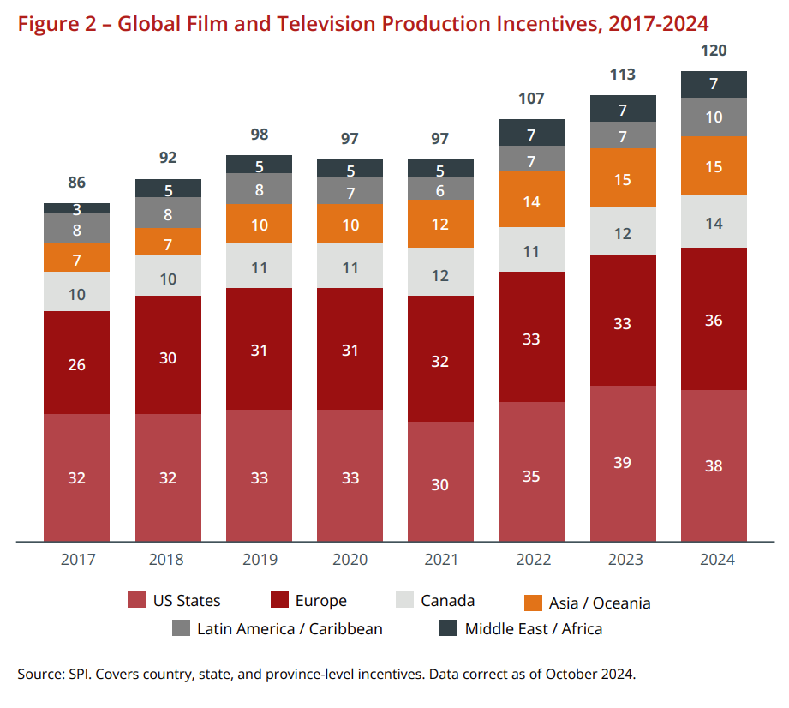
Fig. 3. Number of Film and Television Incentives by Continent, 2017-2024 (Olsberg•Spi)
A graph from a white paper report by Olsberg•Spi on global film and television incentives outlines a steady increase in lucrative policy changes outside of the United States, especially in Europe where it has become competitive with America as of 2024. California Governor Gavin Newsom has responded with a $750 million tax incentive plan to revive Hollywood’s presence in SoCal. From The Hollywood Reporter, labor and media reporter Katie Kilkenny notes there is skepticism about these policy changes citing Teamsters motion picture division director Lindsay Doughtery who argues “We have been in this race with film and television tax credits for many decades at this point, and it just doesn’t seem to be enough.” Businesses are fighting for reduced production costs and “In March [of 2025], the California Film Commission revealed a record 51 films will receive tax credits to shoot in the state, estimating that the projects will pay about $347 million in wages and generate $578 million in economic activity,” a small portion of the industry as a whole (Kilkenny). For the film industry, the cost of high wages has become unsustainable, and Hollywood is beginning to harness technological innovations to further mitigate these barriers to profitability. Digitalization through online streaming services is one way Hollywood is maintaining its global prowess.
While unionized strikes and foreign policy incentives capture the politics behind the threat to Hollywood, the COVID-19 pandemic marked a dramatic turning point in Hollywood’s economic and technological landscape that increased the demand for many popular streaming services. Economic researchers Thorsten Hennig-Thurau, S. Abraham Ravid, and Olav Sorenson, writing in the Journal of Cultural Economics, explain that “COVID-19, if anything, has accelerated this transformation. When the pandemic kept people home, streaming services came to the rescue, providing audiences with filmed entertainment on their televisions, computers, tablets, and other digital devices.” From their perspective as economists studying the film industry, digitalization is portrayed as a monumental shift, comparable in scale to past technological leaps such as sound and color, but ultimately part of the film industry’s long history of adapting to innovation. They suggest that although traditional business models are destabilized, these changes present new strategic opportunities, urging readers to “embrace these opportunities, find ways to overcome the research challenges of the ‘new’ digitalized industry, and continue the quest to shed light on and guide the industry’s future paths” (Hennig-Thurau et al.). They frame the disruption of long-established practices in the film industry in a positive light for businesses and shareholders implying that the industry is resilient and capable of evolving when coupled with technological advancements. In contrast, Paris Marx, a tech-industry researcher, adopts a far more critical stance toward these developments through the lens of a consumer and writer. Writing in his newsletter Disconnect, Marx argues that the digital shift has resulted in the merging of widespread industry corporations while undermining the quality of life of writers. He observes that “what’s happened here is twofold: Companies are merging, which gives them even greater leverage against workers, but also any smaller companies that depend on them for business, like cinemas. Plus, they’re developing and rolling out new technologies that restructure the conditions of the industry to further enhance their power.” Unlike the economists’ somewhat optimistic view of digitalization as a field of new business possibilities, Marx emphasizes how streaming platforms and major conglomerates have weaponized technological change to reduce costs, minimize residual payments, and potentially replace human workers altogether with artificial intelligence. “After this decades-long process of digitization, consolidation, and centralizing power on the part of major entertainment conglomerates, they’re wielding it to further transform the face of the industry and what it means to work in it,” Marx warns, specifically citing the recent WGA strikes as a response to these threats (Paris). While Hennig-Thurau et al. acknowledge that digitalization disrupts old patterns, Marx underscores how this disruption translates into job losses, precarious working conditions, and declining power for creative laborers.
Hollywood originates from a 20th century movement for suburban expansion and has built itself as the primary industry that continues to attract business ventures to Los Angeles County. Rising costs for the industry come from a combination of unionized strikes, lower production costs in foreign countries, and an overall preference for the industry to gravitate to the digital market to compensate for losses contextualize the reason as to why many parts of the once tight Hollywood experience an exodus out of California.

Works Cited
Barnes, Brooks. “With the Strikes Over, the Mood in Hollywood Is Decidedly Mixed.” The New York Times, 8 Nov. 2023, www.nytimes.com/2023/11/08/business/media/hollywood-strike-actors-writers.html.
Carras, Christi. “L.A. Prop Houses Prepare for the Return of Production after Dual Hollywood Strikes.” Los Angeles Times, 27 Nov. 2023, www.latimes.com/entertainment-arts/business/story/2023-11-27/la-prop-houses-actors-writers-strikes-sag-aftra.
Hennig-Thurau, Thorsten, et al. “The Economics of Filmed Entertainment in the Digital Era.” Journal of Cultural Economics, vol. 45, no. 2, June 2021, pp. 157–170. Springer, doi:10.1007/s10824-021-09407-6. Accessed 12 July 2025.
FilmLA. “L.A. On‑Location Filming Falls in First Quarter.” FilmLA, 14 Apr. 2025, filmla.com/la-on-location-filming-falls-in-first-quarter/.
Jamerson, Megan. “Hollywood’s Filming Decline Hits Local Small Businesses in L.A.” Marketplace, 19 June 2025, www.marketplace.org/story/2025/06/19/las-small-businesses-hit-by-hollywood-filming-decline.
Kilkenny, Katie. “Who’s Going to Halt Hollywood’s Production Exodus — and How?” The Hollywood Reporter, 7 May 2025, www.hollywoodreporter.com/business/business-news/hollywood-production-trump-movie-tariffs-1236209847/.
Marx, Paris. “How Hollywood Used the Digital Transition against Workers.” Disconnect, 19 May 2023, www.disconnect.blog/p/how-hollywood-studios-used-the-digital.
Olsberg•SPI. “Global Film and Television Production Incentives: A White Paper.” Motion Picture Association, Nov. 2024, www.motionpictures.org/wp-content/uploads/2024/11/GLOBAL_OlsbergSPI-Incentives-White-Paper_November-2024.pdf.
Scott, Allen J. On Hollywood: The Place, The Industry. Princeton University Press, 2005.
Stevens, Matt, and Nicole Sperling. “There’s a Feeling We’re Not in Hollywood Anymore.” The New York Times, 19 Apr. 2025, www.nytimes.com/2025/04/19/movies/hollywood-filming-overseas.html.

