Anthony Ahn
Professor Hiscock
Writing 60
26 July 2025
Hollywood’s Exodus Away from the SoCal Stage
Southern California suburbs thrive off the film industry with Hollywood at the core of the Los Angeles County since the early 20th century. Residents of the county, however, cite a noticeable vacancy of Hollywood-related entertainment industries in SoCal with major studios seeking locations outside California. In a morning Marketplace radio program, Megan Jamerson reports that a small local restaurant Chili John’s in Burbank has seen less customers. The owner, Steve Hager, comments in an interview “Burbank runs off the entertainment industry – So as long as the entertainment industry is slow, all the services are going to be slow” (Jamerson). Hager is aware that Burbank, among many suburban cities centralized around Hollywood, feeds off the film and TV entertainment industries to maintain a growing customer base. Suburban residents’ way of life may even revolve around the industry itself. Yet Hollywood, in its timeless sovereignty throughout the century, has seen a significant decline in recent years since the COVID-19 era. Following chronologically, Hollywood has seen an infrastructural shift to streaming services during and after peak COVID-19 times with these technological shifts contributing to an influx of unionized strikes. In turn, increasing labor costs from organized strikes have led to many parts of Hollywood’s industry leaving California to seek lower production costs.
The COVID-19 pandemic marked a dramatic turning point in Hollywood’s economic and technological landscape that increased the demand for many popular streaming services. Industries may continue to see streaming services as a worthwhile investment in recovering from the pandemic. Economic researchers Thorsten Hennig-Thurau, S. Abraham Ravid, and Olav Sorenson, writing in the Journal of Cultural Economics, explain that “COVID-19, if anything, has accelerated this transformation. When the pandemic kept people home, streaming services came to the rescue, providing audiences with filmed entertainment on their televisions, computers, tablets, and other digital devices” (Hennig Thurau et al., 157). From their perspective as economists studying the film industry, digitalization is portrayed as a monumental shift, comparable in scale to past technological leaps such as sound and color, but ultimately part of the film industry’s long history of adapting to innovation. They suggest that although traditional business models are destabilized, these changes present new strategic opportunities, urging readers to “embrace these opportunities, find ways to overcome the research challenges of the ‘new’ digitalized industry, and continue the quest to shed light on and guide the industry’s future paths” (Hennig Thurau et al., 160). Economics researchers continue to observe the developing digitalized industry as they mention. They frame the disruption of long-established practices in the film industry in a positive light for businesses and shareholders implying that the industry is resilient and capable of evolving when coupled with technological advancements. With growing popularity in streaming especially due to its convenience, these claims seem to justify an inevitable shift of the film and TV industry in providing these services. In contrast, Paris Marx, a tech-industry researcher, adopts a far more critical stance toward these developments through the lens of a consumer and writer. Writing in his newsletter Disconnect, Marx argues that the digital shift has resulted in the merging of widespread industry corporations while undermining the quality of life of writers. He observes that “what’s happened here is twofold: Companies are merging, which gives them even greater leverage against workers, but also any smaller companies that depend on them for business, like cinemas. Plus, they’re developing and rolling out new technologies that restructure the conditions of the industry to further enhance their power.” Unlike the economists’ somewhat optimistic view of digitalization as a field of new business possibilities, Marx emphasizes how streaming platforms and major conglomerates have weaponized technological change to reduce costs, minimize residual payments, and potentially replace human workers altogether with artificial intelligence. “After this decades-long process of digitization, consolidation, and centralizing power on the part of major entertainment conglomerates, they’re wielding it to further transform the face of the industry and what it means to work in it,” Marx warns, specifically citing the recent WGA strikes as a response to these threats (Paris). While Marx’s blog post may portray the situation as in favor of the industries, unions possess considerable power against them in the 21st century. This power in the hands of the labor force is another cause as to why industries are currently struggling to reduce production costs overall. In 2023, an editor for The Guardian Betsy Reed reports that the WGA successfully obtained a contract that “guarantees that AI is not considered a ‘writer’, that companies cannot force writers to use AI, and that companies must disclose if writers are given any AI-generated material to work with” (Reed). Workers’ leverage against companies adapting technological developments continues to grow with this victory paving a way for the labor force to gain more power over the industry itself. Growing opposing forces from workers may cause industries to face rising costs which only provides further incentives to reduce overall production costs by any means. Adapting new technological developments is one method that can be used to remedy rising labor costs. Yet, workers may see these advancements as a threat to their livelihood in fear of industries relying more on growing technologies over traditional manpower.
As seen above with Hollywood’s bias towards integrating new technological developments into reducing production costs, decentralization of the industries comprising Hollywood are what allows it to adapt accordingly. Hollywood attributes a significant portion of its global competitiveness to its decentralization despite its position as a central institution of SoCal. Professor Allen J. Scott, in his book On Hollywood: The Place, The Industry, proposes that the globalization of Hollywood has roots in the late 20th century as “the production system was significantly reconstituted as a congeries of many small and medium-sized firms linked together in shifting coalitions by flexible production networks” (Scott, 5). Professor Scott’s insight into this network of industries comprising Hollywood demonstrates that it has always been able to change its infrastructure every year. In other words, some industries contributing to Hollywood’s success may adapt to the changing economy or be pushed out of the network entirely. Proof lies in how workers maintain power against corporations in the entertainment industry acting as a union or essential part of this complex network. This leverage, in recent years, has proven troublesome for the profitability of Hollywood’s internal industries. As Professor Scott notes “Hollywood has never had much of a tendency to generate low wage, low-skill jobs, in large measure because the long-standing guilds and unions have been notably successful in erecting institutional barriers to wage-cutting by employers” (Scott, 5). By this account, it is clear Hollywood is dependent on a sustainable relationship between the labor force and the sub-industries the vast network employs. In other words, the labor force itself is an example of the further decentralization of Hollywood as the guilds and unions aim to maintain socioeconomics balance in Hollywood in terms of rights, wages, and political power. In other words, workers now share a considerable portion of socioeconomic power over Hollywood’s industries. Another prime example of this decentralization of Hollywood and the persistence of labor protection rights is with the prop houses industry that supply essential items to facilitate the construction of sets locally.
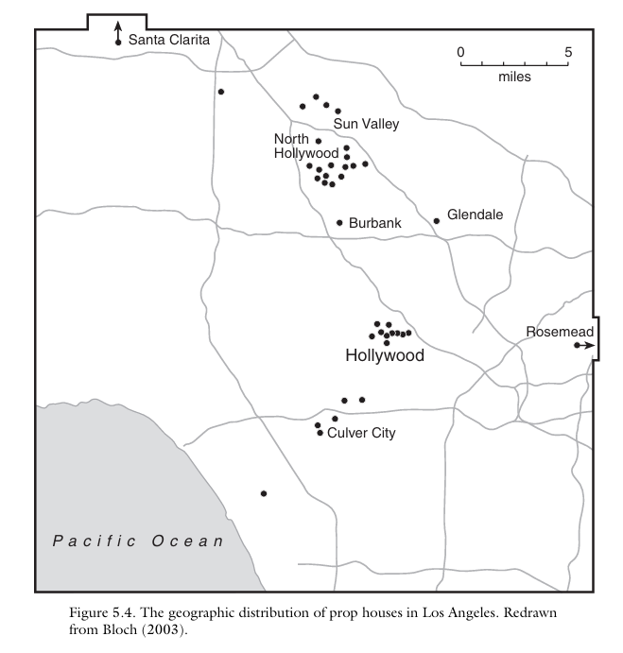
Fig. 1. The geographic distribution of prop houses in Los Angeles as of 2003 (Scott, 92)

As observed above, even in 2003, a surprisingly large number of prop houses are in suburban areas outside of Hollywood such as Burbank, Culver City, and Rosemead largely to pull a labor force from its surrounding residents as Professor Scott observes “there is a rather strongly developed agglomeration of set design and construction firms in the vicinity of Burbank and North Hollywood, coinciding with a distinctive cluster of studios. This area also lies close to residential neighborhoods with high densities of immigrant Latino workers, who appear, on the basis of fieldwork observations, to be the preferred labor force in at least some segments of the set construction sector” (Scott, 89). Professor Scott’s data shows that suburban development has also been essential for supplying the labor force of the Hollywood industry. While the exact composition of the labor force may have changed, we can expect that manual labor is still sought after by surrounding industries. For one, technological advancements in the 21st century may require industries to employ more technology-biased jobs rather than labor-intensive ones. During a worker’s strike, however, industries must fight to stay productive as seen from The Los Angeles Times, Christi Carras where interviews prominent prop houses Omega and ISS and notes “local vendors that supply productions with the furniture, equipment, decorations and other items they need to dress a film or TV set were among the hardest hit during the work stoppages, just as they were bouncing back from shutdowns caused by the COVID-19 pandemic.” The work stoppages refer to the actors’ SAG-AFTRA strike and demands from the Writers’ Guild of America (WGA) which Carras reports halted filming for “a combined six months” (Carras).
Both employers and workers of Hollywood stand tall with local businesses continuing through COVID-19 coupled with strikes from an unsatisfied labor force who continue to fight for more financial equality. Strikes and end agreements, however, result in rising costs for Hollywood if demands increase from the labor force who feel mistreated. While strikes may be a short-term detriment, they can prove to grow into a larger economic issue for Hollywood if workers leverage too many demands from industries. Hollywood’s desperation is captured by Brooks Barnes, a journalist focused on all aspects of the entertainment industry, reports from The New York Times “Everywhere you look in Hollywood, or so it seems, businesses are trying to cut costs. […] Anonymous Content, a production and management company, laid off 8 percent of its staff last month. United Talent Agency also trimmed its head count, as did several competing agencies. […] DreamWorks Animation recently eliminated 4 percent of its work force, while Starz, the premium cable network and streaming service, is reducing head count by 10 percent. Netflix is restructuring its animation division, which is expected to result in layoffs and fewer self-made films” (Barnes). Like Marx’s blog post, Barnes appears to portray industries in a negative light with layoffs. Layoffs, however, may not be directly a result of strikes but rather a combination of rising wages from unions’ demands and a newfound shift in industries incorporating technological advancements to increase the efficiency and profitability of their infrastructures.
With rising costs for Hollywood in the post-COVID-19 era, there is no longer an incentive for the once localized Hollywood to direct production solely in California and many businesses are outsourcing labor to other parts of the world. As opposed to in the 20th century, outsourcing proves more accessible in the 21st century with technological advancements in communication and transportation.
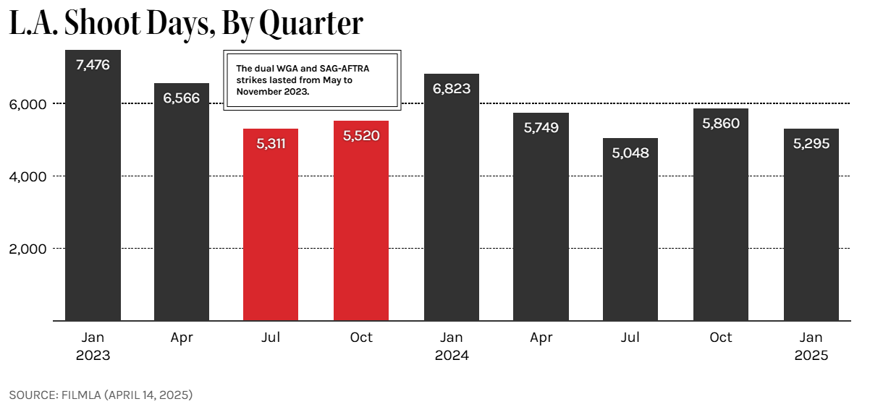
Fig. 2. Number of Shoot of Days in L.A. from 2023-2025 (FilmLA)
According to FilmLA, a film office for the County of Los Angeles and other local jurisdictions, “In the midst of a global decline in production and intensifying competition for film projects and jobs, on-location production in Greater Los Angeles declined by -22.4 percent from January through March 2025 to 5,295 Shoot Days (SD)” (FilmLA). In the above infographic, Q1 refers to the first three months of the calendar year. Based on numerical trends, it appears that businesses are beginning to shift film production away from Los Angeles, an indication that parts of Hollywood are attempting to cut costs in reaction to losses associated with the recent actors’ and writers’ strikes. Matt Stevens and Nicole Sperling cite a general sense that Hollywood is leaving California from The New York Times, report “Michael F. Miller Jr., a vice president at the International Alliance of Theatrical Stage Employees, who oversees film and television production for the union, said that roughly 18,000 full-time jobs have evaporated in the past three years, primarily in California.” Businesses have been increasing layoffs to reduce costs to reclaim profitability. Generally, international sites are cheaper for film production as “More countries offer generous tax incentives than ever before, and many of the programs — including Germany’s and the Czech Republic’s — have recently sweetened their deals to give out rebates that are comparable to or larger than California’s, with looser rules that allow more kinds of projects to qualify” (Stevens and Sperling).
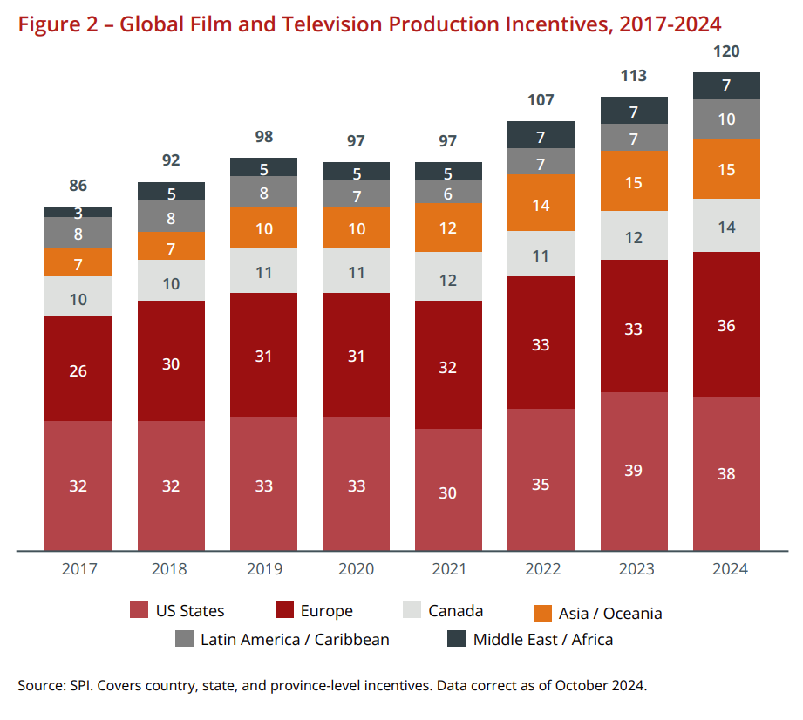
Fig. 3. Number of Film and Television Incentives by Continent, 2017-2024 (Olsberg•Spi)
A graph from a white paper report by Olsberg•Spi on global film and television incentives outlines a steady increase in lucrative policy changes outside of the United States, especially in Europe where it has become competitive with America as of 2024. California Governor Gavin Newsom has responded with a $750 million tax incentive plan to revive Hollywood’s presence in SoCal. From The Hollywood Reporter, labor and media reporter Katie Kilkenny notes there is skepticism about these policy changes citing Teamsters motion picture division director Lindsay Doughtery who argues “We have been in this race with film and television tax credits for many decades at this point, and it just doesn’t seem to be enough.” Businesses are fighting for reduced production costs and “In March [of 2025], the California Film Commission revealed a record 51 films will receive tax credits to shoot in the state, estimating that the projects will pay about $347 million in wages and generate $578 million in economic activity,” a small portion of the industry as a whole (Kilkenny). For the film and TV industry, the cost of high wages only further motivates Hollywood to investigate mitigating production costs through new technologies and moving production elsewhere. Digitalization through online streaming services is one way Hollywood continues to maintain its global prowess. Hollywood will only continue to see an infrastructural shift with these rising costs in mind.
Hollywood originates from a 20th century movement for suburban expansion and has built itself as the primary industry that continues to attract business ventures to Los Angeles County. Rising costs for the industry come from a combination of unionized strikes, lower production costs in foreign countries, and an overall preference for the industry to gravitate to the digital market to compensate for losses contextualize the reason as to why many parts of the once tight Hollywood experience an exodus out of California. Through some speculation, we can observe that the suburban life of the Los Angeles County depends on Hollywood to bring in business from all parts of California. Chili John’s is only one account as to how suburban residents see the business Hollywood brings as their way of life. If Hollywood’s exodus away from California continues, this may prove detract from livelihood of SoCal itself.

Works Cited
Barnes, Brooks. “With the Strikes Over, the Mood in Hollywood Is Decidedly Mixed.” The New York Times, 8 Nov. 2023, www.nytimes.com/2023/11/08/business/media/hollywood-strike-actors-writers.html.
Carras, Christi. “L.A. Prop Houses Prepare for the Return of Production after Dual Hollywood Strikes.” Los Angeles Times, 27 Nov. 2023, www.latimes.com/entertainment-arts/business/story/2023-11-27/la-prop-houses-actors-writers-strikes-sag-aftra.
Hennig-Thurau, Thorsten, et al. “The Economics of Filmed Entertainment in the Digital Era.” Journal of Cultural Economics, vol. 45, no. 2, June 2021, pp. 157–170. Springer, doi:10.1007/s10824-021-09407-6.
FilmLA. “L.A. On‑Location Filming Falls in First Quarter.” FilmLA, 14 Apr. 2025, filmla.com/la-on-location-filming-falls-in-first-quarter/.
Jamerson, Megan. “Hollywood’s Filming Decline Hits Local Small Businesses in L.A.” Marketplace, 19 June 2025, www.marketplace.org/story/2025/06/19/las-small-businesses-hit-by-hollywood-filming-decline.
Kilkenny, Katie. “Who’s Going to Halt Hollywood’s Production Exodus — and How?” The Hollywood Reporter, 7 May 2025, www.hollywoodreporter.com/business/business-news/hollywood-production-trump-movie-tariffs-1236209847/.
Marx, Paris. “How Hollywood Used the Digital Transition against Workers.” Disconnect, 19 May 2023, www.disconnect.blog/p/how-hollywood-studios-used-the-digital.
Olsberg•SPI. “Global Film and Television Production Incentives: A White Paper.” Motion Picture Association, Nov. 2024, www.motionpictures.org/wp-content/uploads/2024/11/GLOBAL_OlsbergSPI-Incentives-White-Paper_November-2024.pdf.
Reed, Betsy. “Screenwriters Won a Historic Victory against AI – the Rest of Us Should Follow.” The Guardian, 7 Oct. 2023, www.theguardian.com/commentisfree/2023/oct/07/screenwriters-won-a-historic-victory-against-ai-the-rest-of-us-should-follow.
Scott, Allen J. On Hollywood: The Place, The Industry. Princeton University Press, 2005.
Stevens, Matt, and Nicole Sperling. “There’s a Feeling We’re Not in Hollywood Anymore.” The New York Times, 19 Apr. 2025, www.nytimes.com/2025/04/19/movies/hollywood-filming-overseas.html.

