Research and Planning
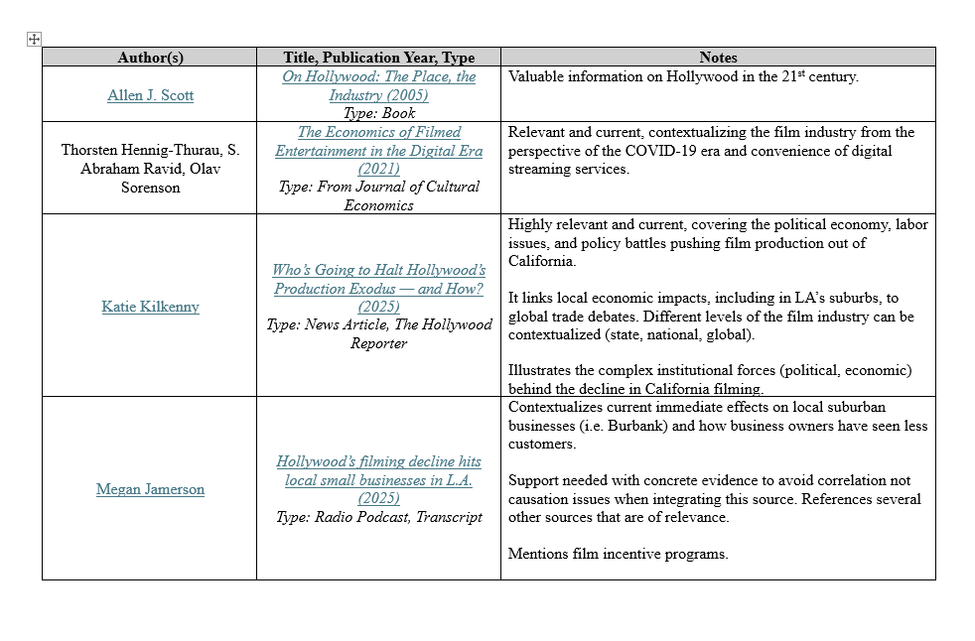
Organizing sources in a tabular manner helped me worry less about if I would use the source and focus more on the ideas in a source that caught my attention. Many sources I never ended up incorporating into my drafts of the Contexts Project. Yet this process allowed me to look over the content of many sources leading me into other potential sources and so on. Rather than having a bunch of browser tabs open, this method was certainly more organized and allowed me to focus on what I wanted to discuss in my paper.
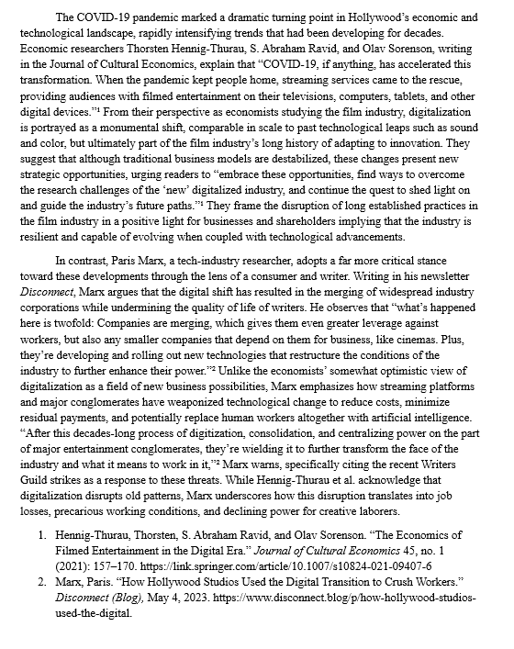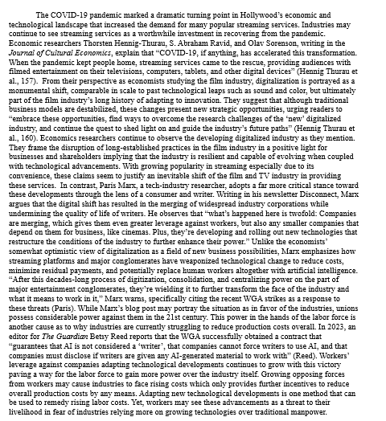

From the Integrating Sources assignment, I adapted the paragraphs I wrote into the Contexts Project. I felt more comfortable with using the quote-sandwich method coming from this assignment. In the adaptation in my final draft of the Contexts Project (right), I use more quotes and explanations aimed at contextualizing the socioeconomic situation between strikes and technological developments in conversation.

Revising and Collaborating
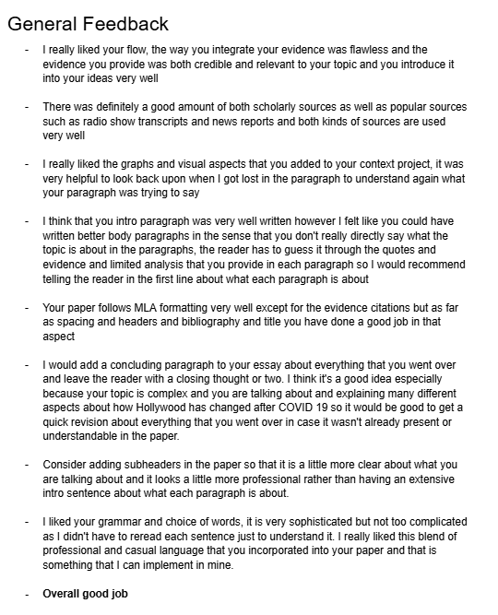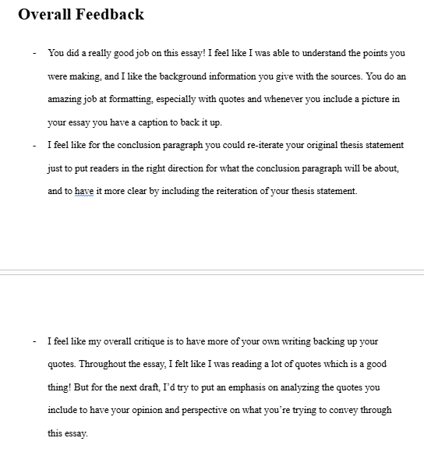
My peers had similar ideas to share about my draft with a holistic approach to critique on how I could read more into my sources and provide my own insight more clearly. They also criticized the lack of a clearly defined thesis which I agreed with and improved in my following drafts. Generally, feedback didn’t conflict in the process.

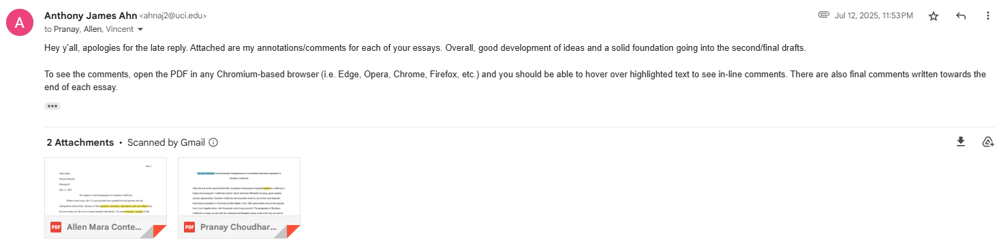

As a peer editor, I aimed to write comments as short as possible while providing meaningful critique. I did this by adding inline comments in a PDF editor to allow my peers to see exactly which line I was commenting about with each note. I feel my feedback between both peers is similar as I feel I let my biases from my own writing latch on which I tried my best to prevent. Each peer had a very structured approach to their writing while I emphasized content in my earlier draft.

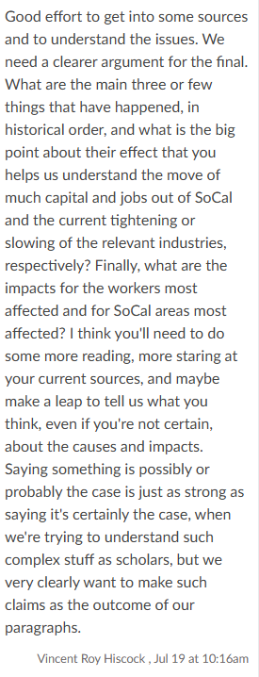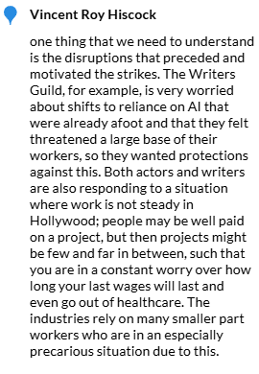
I was afraid to take a “leap” into what I thought about some of the information I extracted from my sources which the instructor comments helped my overcome. The comment on the “why” of my context helped me look deeper in my sources and provide my own insight into why Hollywood has become the way it is in present.

Moving Ahead
A fault I had with my Contexts Project is not spending more time with my sources, especially ones with potentially enough information for the entire project itself. I should take into account the strength of my sources in analyzing the different conversations of my context as is necessary for the Advocacy Project. I feel the Advocacy Project will rely more heavily on my own insight for me to deliver a convincing narrative/solution.
A more structured approach to my composition will help me organize my claims better with the Advocacy Project. I feel the quote-sandwich method of composition is still applicable, however. Yet, I feel it will be more productive if I connect the “conversations” between multiple sources with more diligence.

