

UNIVERSITY COLLEGE OF TECHNOLOGY SARAWAK (UCTS)

SCHOOL OF COMPUTING

YEAR 1, SEMESTER 2, SESSION 2018

**CSS 3133 Object Oriented Programming**

**Object-Oriented Programming Assignment**

PREPARED FOR:

S.M. Anli Sherine

Group Name : Group zero

Group Leader : Then Vui Lin

PREPARED BY:

|  |  |
| --- | --- |
| Then Vui Lin | BCS 1704 0003 |
| Chen Zhi Hao | BCS 1704 0004 |
| Sia Yuk Heng | BCS 1704 0001 |
| Daniel Wong Tze Yiu | BCS 1707 0005 |

**Training Modules**

Achieved Test Cases for Stock Exchange Losses:

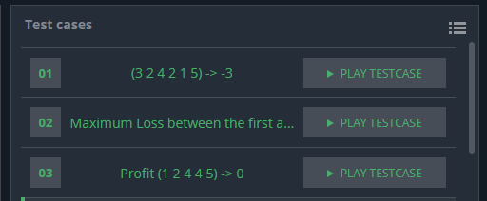

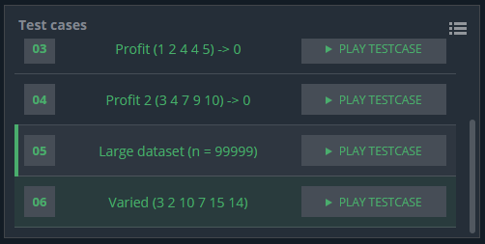

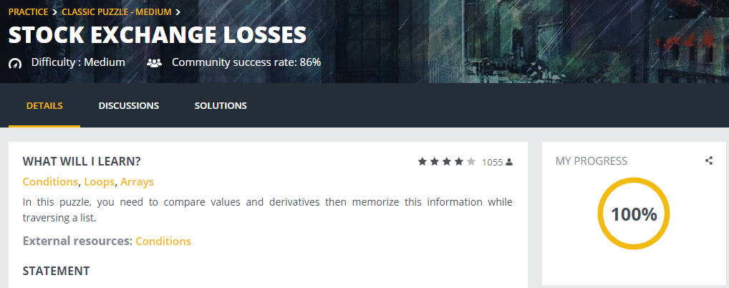

Program flowchart for Stock Exchange Losses:

True

i+1

Read v[i]

i < n?

i = 0

Declare integer array v[n]

Read n

Declare integer variables n, i, loss, maxindex, minindex

Start

False

Declare integer variables max and min   
max = v[0]  
min = v[0]

End

True

Write  
-loss

Declare integer variable temp  
temp = max  
max = min  
min = temp  
Declare integer variable loss2  
loss2 =0

False

minindex < maxindex?  
 and  
maxindex != n-1?

True

False

False

True

v[i] = min

minindex = i

loss = max - min

False

v [i] < min?

i+1

True

max = v[i]

maxindex = i

v[i] > max?

i < n?

i =1

False

False

True

loss = loss2

loss = loss

loss>=loss2?

False

i+1

max = v[i]

maxindex = i

False

True

True

True

v[i] = min

minindex = i

loss2 = max - min

v [i] < min?

v[i] > max?

i < n?

i = minindex+1

Program Codes for Stock Exchange Losses(including inline comments) :

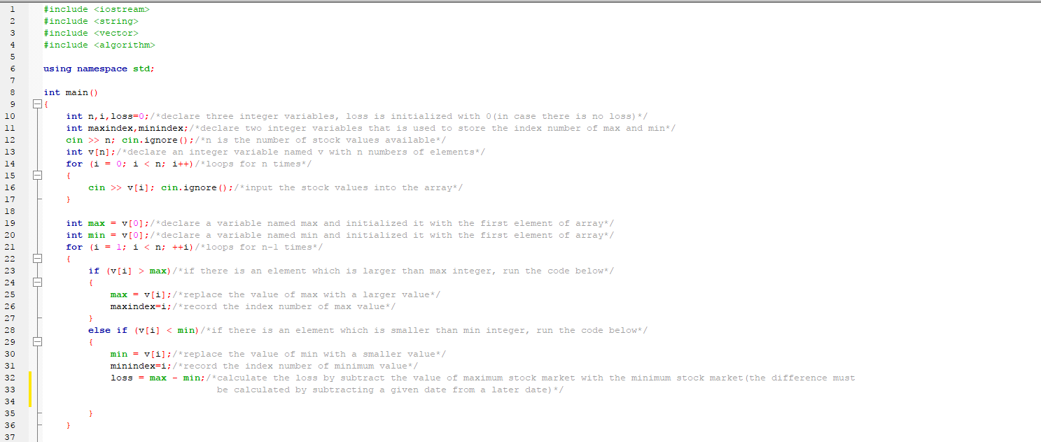

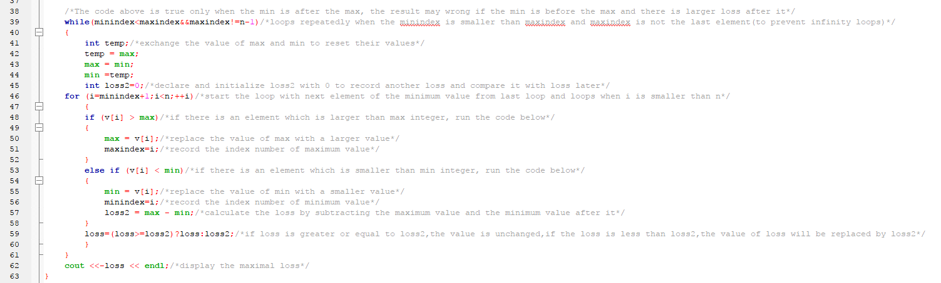

**Student Course Timetable Arrangement System**

Program Code:

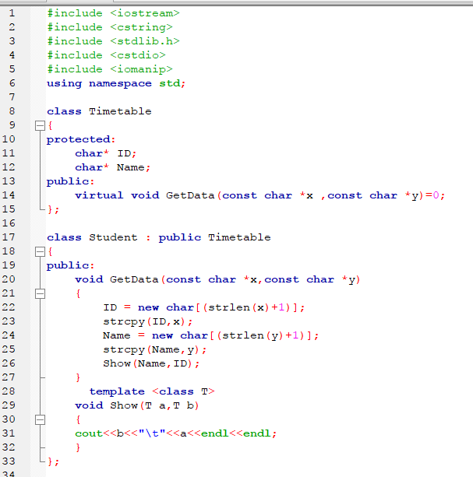

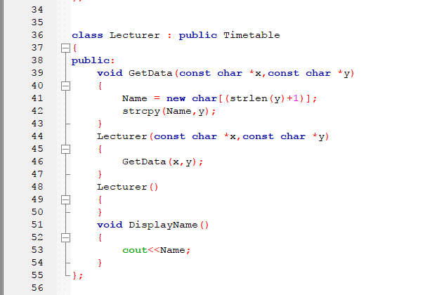

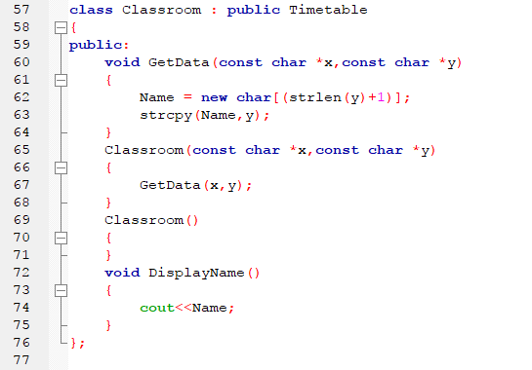

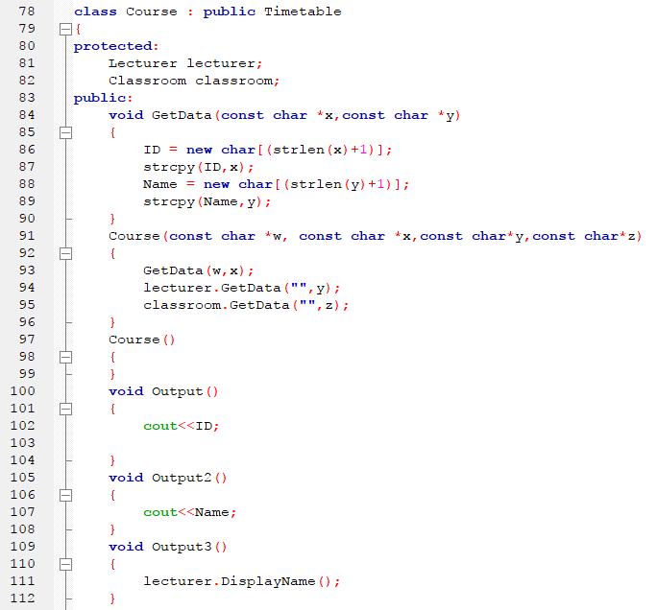

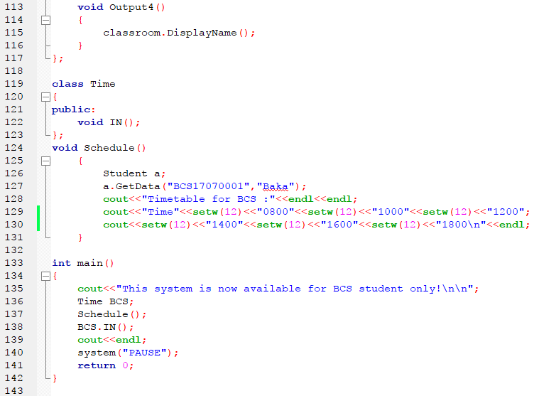

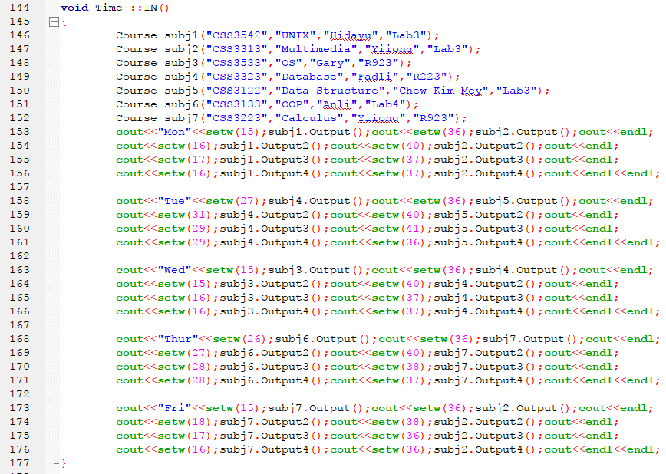

Output:

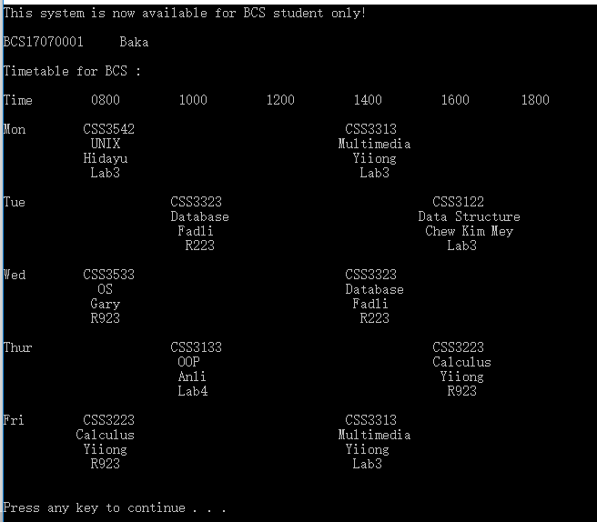

Github:

<https://github.com/re0saya/test>