**EE110 Design Project**

**JAEKWAN AHN**

**UID: 604057669**

**DUE: MARCH 09, 2016**

**Expressions for my design formulae**

**Transfer function: $H\left(s\right)=(-R_{F})\left(\frac{1+sCR_{L}+s^{2}LC}{1+sC(R+R_{L})+s^{2}LC}\right)=(-{10}^{4})(\frac{1+2.53×{10}^{-8}s+2.53×{10}^{-10}s^{2}}{1+2.20×{10}^{-8}s+2.53×{10}^{-10}s^{2}})$**

**Notch frequency: $f_{o}=10 \left[kHz\right] or ω_{o}=2π×{10}^{4} [\frac{rad}{s}]$**

**Notch bandwidth: $2℥f_{o}=1.385 [kHz]$ or $2℥ω_{o}=$ 8707 $[\frac{rad}{s}]$**

**Pass-band gain: $\left|H(jω)\right|=\left|H(j∞)\right|=R_{F}={10}^{4}$**

**In Bode Plot: $20\log{{10}^{4}}=80 dB$**

**Stop-band gain: $\left|H(jω)\right|=\left|H(jω_{o})\right|=R_{F}\frac{R_{L}}{{R+R}_{L}}=115$**

**In Bode Plot: $20\log{115}=41.2 dB$**

**A schematic of my design**

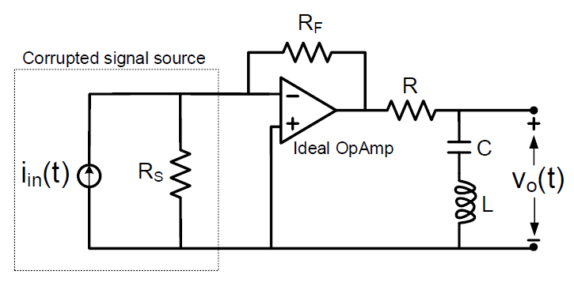

**Component values: $R_{s}=10kΩ; R_{F}=10 kΩ; R=860Ω; C=2.53nF; L=100mH; R_{L}=10Ω$**

**Bode plots of the magnitude and phase response of the filter circuit**

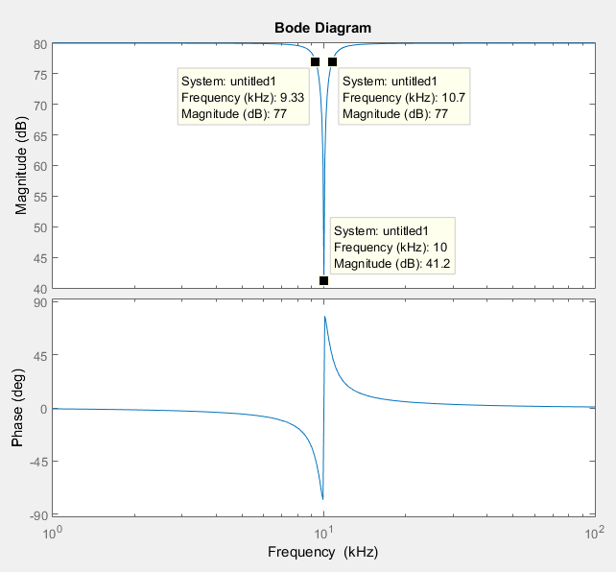

**Notch frequency: $f_{o}=10 \left[kHz\right]$**

**Notch bandwidth: $ω_{C2}-ω_{C1}=10.7-9.33 \left[kHz\right]=1.37 [kHz]$**

**Pass-band gain: $80 dB$**

**Stop-band gain: $41.2 dB$**

**Expected steady state output voltage for $i_{in}=10\cos\left(2π×9×{10}^{3}t\right)µA$**

$$V_{out\left(steady state\right)}=0.08379\cos\left(2π×9×{10}^{3}t+147.3475°\right) V$$

**or**

$$V_{out\left(steady state\right)}=83.79\cos\left(2π×9×{10}^{3}t+147.3475°\right) mV$$

**Extra Credit**

**Expressions for my design formulae**

**Transfer function: $H\left(s\right)=(-R_{F}){\left(\frac{1+sCR_{L}+s^{2}LC}{1+sC(R+R_{L})+s^{2}LC}\right)}^{2}=(-{10}^{4}){(\frac{1+2.53×{10}^{-8}s+2.53×{10}^{-10}s^{2}}{1+1.92×{10}^{-8}s+2.53×{10}^{-10}s^{2}})}^{2}$**

**Notch frequency: $f_{o}=10 \left[kHz\right] or ω_{o}=2π×{10}^{4} [\frac{rad}{s}]$**

**Notch bandwidth: $ω_{C2}-ω_{C1}=11-9.09 \left[kHz\right]=1.91 [kHz]$**

**Pass-band gain: $\left|H(jω)\right|=\left|H(j∞)\right|=R_{F}={10}^{4}$**

**In Bode Plot: $20\log{{10}^{4}}=80 dB$**

**Stop-band gain: $\left|H(jω)\right|=\left|H(jω_{o})\right|=R_{F}{(\frac{R_{L}}{{R+R}_{L}})}^{2}=1.73$**

**In Bode Plot: $20\log{1.73}=4.77 dB$**

**A schematic of my design**

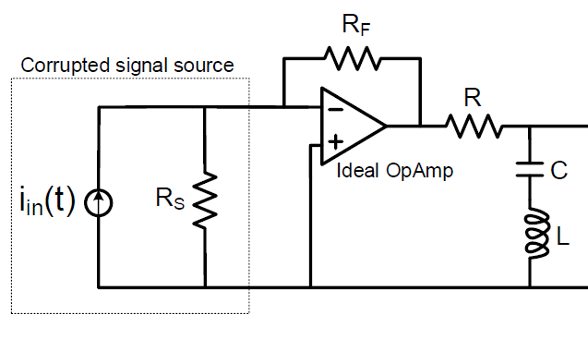

**Component values: $R_{s}=10kΩ; R_{F}=10 kΩ; R=750Ω; C=2.53nF; L=100mH; R_{L}=10Ω$**

**Bode plots of the magnitude and phase response of the filter circuit**

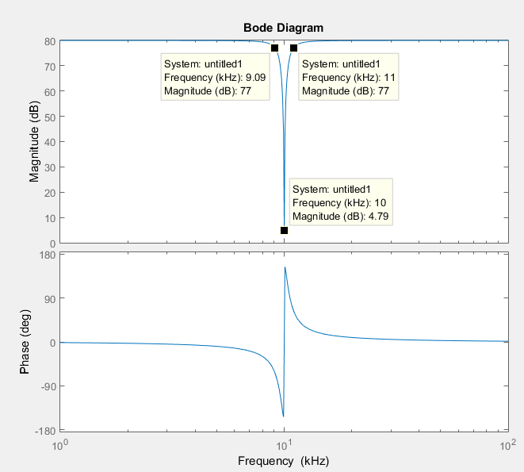

**Notch frequency:**

**Notch bandwidth:**

**Pass-band gain:**

**Stop-band gain:**

**Expected steady state output voltage for**

**or**