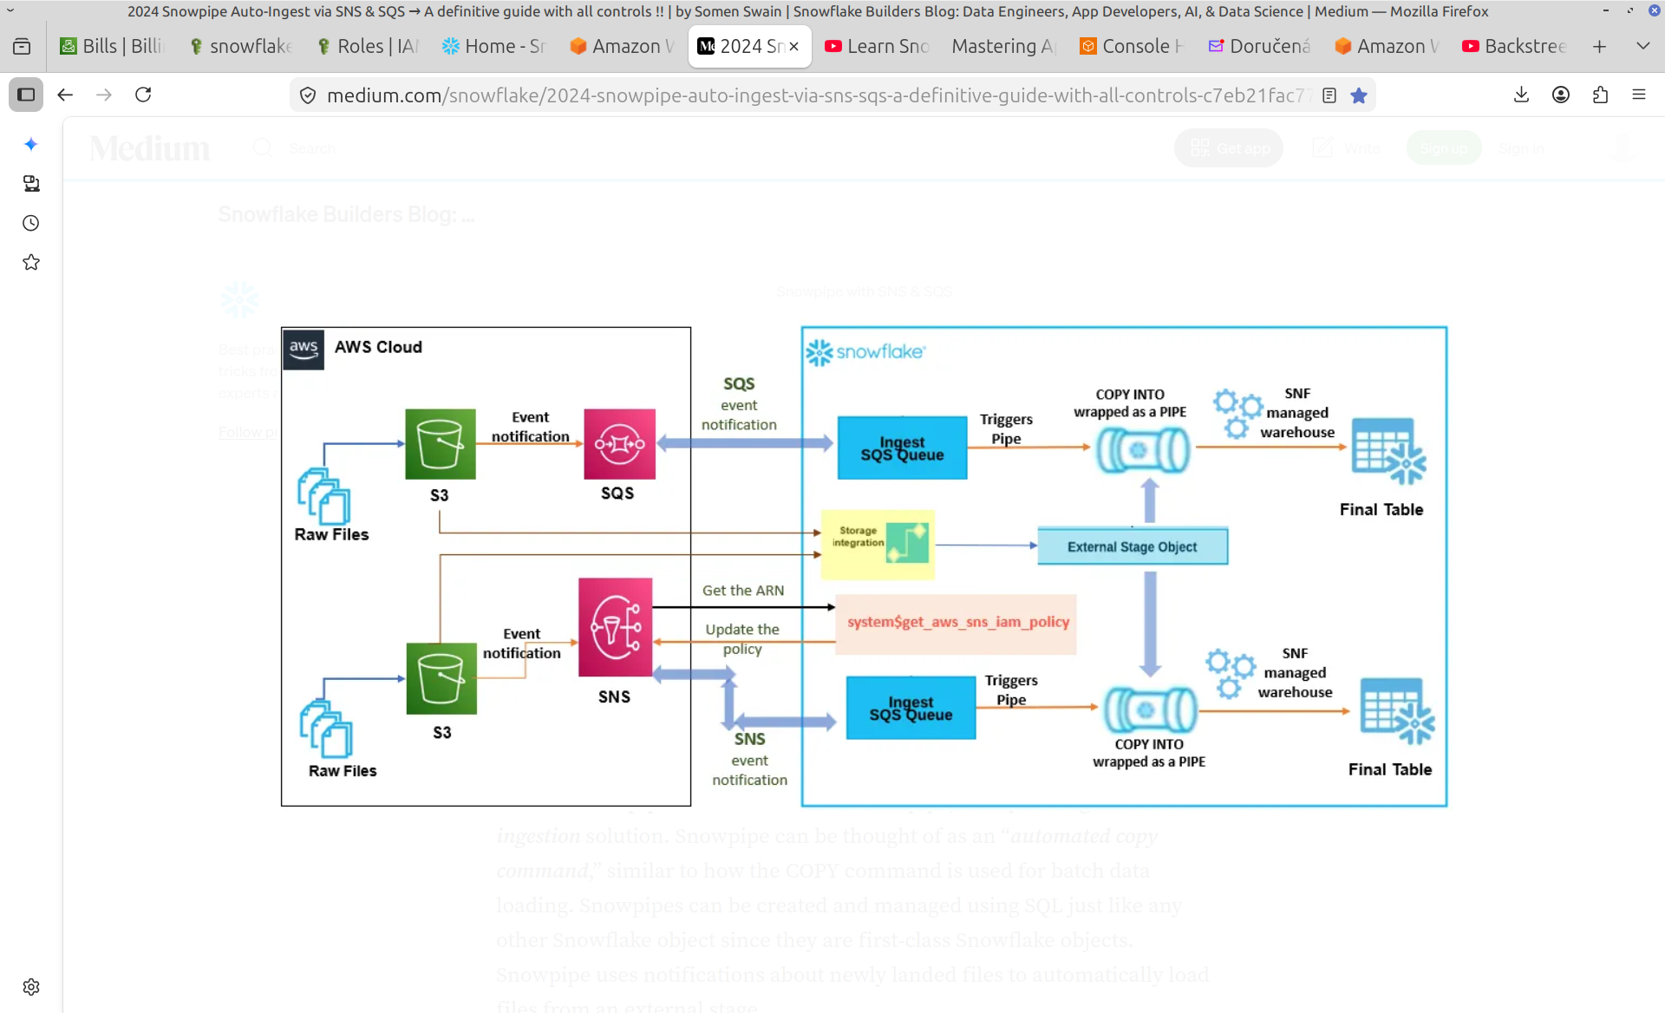

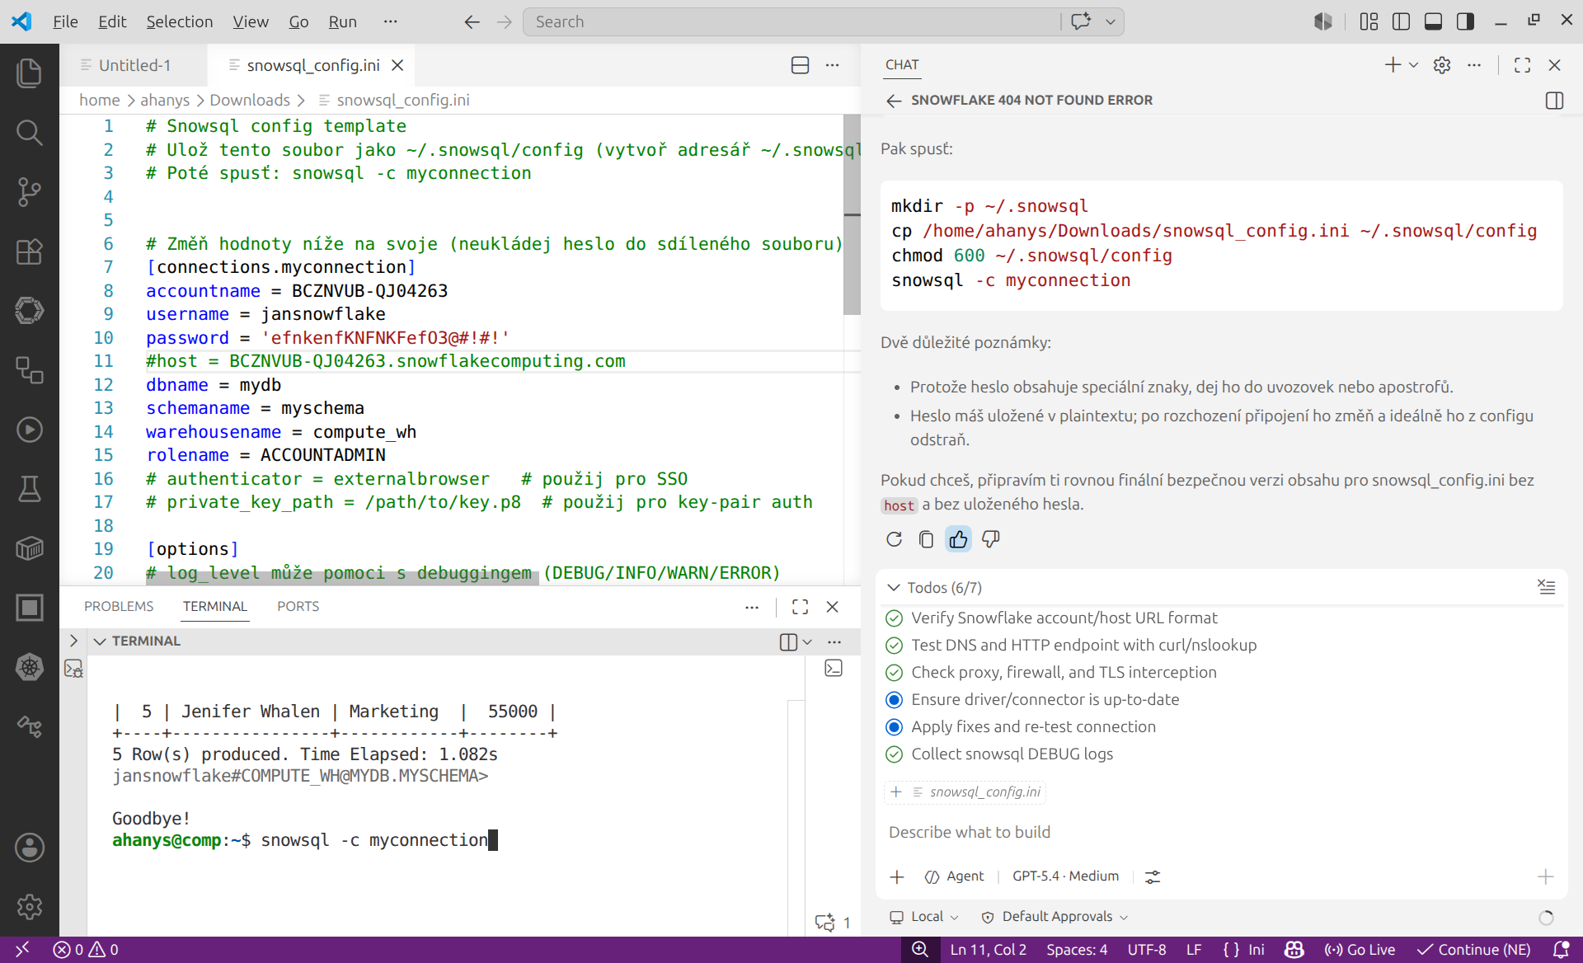

Role trust policy to allow the whole source account (put in the role's Trust relationships in account 839734131943):
{
"Version":"2012-10-17",
"Statement":[
{
"Effect":"Allow",
"Principal":{"AWS":"arn:aws:iam::260289090760:root"},
"Action":"sts:AssumeRole"
}
]
}
- Least-privilege IAM policy to attach to 233p1000-s (in account 260289090760) to allow assuming that role:
{
"Version":"2012-10-17",
"Statement":[
{
"Effect":"Allow",
"Action":"sts:AssumeRole",
"Resource":"arn:aws:iam::839734131943:role/snowflake2"
}
]
}

Welcome to Snowflake!
Your account has been activated.
- Username: JANSNOWFLAKE
- Dedicated Login URL: https://bcznvub-qj04263.snowflakecomputing.com

// Set the Roles, Warehouses and Databases
USE ROLE ACCOUNTADMIN;
USE WAREHOUSE COMPUTE_WH;
USE SCHEMA MYDB.MYSCHEMA;
use database mydb;

GRANT USAGE ON INTEGRATION s3_snowpipe_int TO ROLE ACCOUNTADMIN;
// Create an Employee table
CREATE OR REPLACE TABLE USER (
id INTEGER,
name VARCHAR(50),
location VARCHAR(50),
email VARCHAR(50)
);

CREATE OR REPLACE STORAGE INTEGRATION my_s3_integration
TYPE = EXTERNAL_STAGE
ENABLED = TRUE
STORAGE_PROVIDER = 'S3'
STORAGE_AWS_ROLE_ARN = 'arn:aws:iam::839734131943:role/snowflake2'
STORAGE_ALLOWED_LOCATIONS = ('*');

CREATE OR REPLACE STAGE my_stage
URL = 's3://de-academy-training-bucket11/'
STORAGE_INTEGRATION = my_s3_integration;

S3.sql
DESCRIBE INTEGRATION my_s3_integration;
LIST @my_stage;
// Create an storage integration with s3 and iam role
CREATE OR REPLACE STORAGE INTEGRATION S3_INT
TYPE = EXTERNAL_STAGE
STORAGE_PROVIDER = 'S3'
ENABLED = TRUE
STORAGE_AWS_ROLE_ARN = 'arn:aws:iam::839734131943:role/smowflakerole'
STORAGE_ALLOWED_LOCATIONS = ('s3://de-academy-training-bucket11/');

// Describe the storage integratio
//STORAGE_AWS_aws sts get-caller-identityROLE_ARN = 'arn:aws:iam::260289090760:user/233p1000-s'
DESC INTEGRATION s3_int;

//Create a file format
CREATE OR REPLACE FILE FORMAT my_csv_format
TYPE = 'CSV'
FIELD_DELIMITER = ','
RECORD_DELIMITER = '\n'
SKIP_HEADER = 1;

SHOW ORGANIZATION ACCOUNTS;

//Create a external s3 stage
CREATE OR REPLACE STAGE my_s3_stage
STORAGE_INTEGRATION = S3_INT
URL = 's3://de-academy-training-bucket11/'
FILE_FORMAT = my_csv_format;

//Access the external stage
list @my_s3_stage;

DESCRIBE INTEGRATION s3_int;
DESC STORAGE INTEGRATION s3_snowpipe_int;
describe stage my_s3_stage;

COPY INTO USER
FROM @my_s3_stage/user_table.csv
FILE_FORMAT = (FORMAT_NAME = my_csv_format);

//Select data from the table
SELECT * FROM USER;

//////////////////////////////////////////

S3 EXTERNAL

//Set the Roles, Warehouses and Databases

USE ROLE ACCOUNTADMIN;
USE WAREHOUSE COMPUTE_WH;
use database mydb;
USE SCHEMA MYDB.MYSCHEMA;

//Create an Employee table
CREATE OR REPLACE TABLE EVENT (
EVENT VARIANT
);

//Create an storage integration with s3 and iam role
CREATE OR REPLACE STORAGE INTEGRATION s3_snowpipe_int
TYPE = EXTERNAL_STAGE
STORAGE_PROVIDER = S3
STORAGE_AWS_ROLE_ARN = 'arn:aws:iam::839734131943:role/smowflakerole'
STORAGE_ALLOWED_LOCATIONS = ('s3://de-academy-training-bucket11/event/')
ENABLED = TRUE;

//Describe the storage integration
DESC INTEGRATION s3_snowpipe_int;

//Create a file format
CREATE OR REPLACE FILE FORMAT my_json_format
TYPE = 'JSON';

//Create a external s3 stage
CREATE OR REPLACE STAGE my_s3_snowpipe_stage
STORAGE_INTEGRATION = s3_snowpipe_int
URL = 's3://de-academy-training-bucket11/event/'
FILE_FORMAT = my_json_format;

LIST @my_s3_snowpipe_stage;

DESCRIBE STAGE my_s3_snowpipe_stage;

DESC INTEGRATION s3_snowpipe_int;

DESCRIBE STORAGE INTEGRATION s3_snowpipe_int;

DESC STORAGE INTEGRATION s3_snowpipe_int;
//###################

//Access the external stage
list @my_s3_snowpipe_stage;
SHOW STAGES;
DESC STORAGE INTEGRATION s3_snowpipe_int;
SELECT CURRENT_ROLE();

//Create a snowpipe to load the evenet data from s3
create or replace pipe s3_pipe
auto_ingest = true AS
copy into event
from @my_s3_snowpipe_stage
FILE_FORMAT = (FORMAT_NAME = my_json_format);

//Select the status of the pipe
SELECT SYSTEM$PIPE_STATUS('s3_pipe');

//Get the notification channel
SHOW PIPES;

//Select data from the table
SELECT * FROM event;

FILE_FORMATS
use role accountadmin;
use warehouse compute_wh;
USE SCHEMA MYDB.MYSCHEMA;

// Create an Employee table
CREATE OR REPLACE TABLE STUDENT (
id INTEGER,
name VARCHAR(50),
age INTEGER,
marks INTEGER
);

// Create a named stage
CREATE OR REPLACE STAGE STUDENT_STAGE;

// Access the names internal stage
LIST @STUDENT_STAGE;

// Load data to customer table without file format
COPY INTO STUDENT
FROM @STUDENT_STAGE
FILE_FORMAT = (TYPE = 'CSV' SKIP_HEADER = 1);

// Select data from the table
SELECT * FROM STUDENT;

// Truncate the table
TRUNCATE TABLE STUDENT;

// Create a CSV File format
CREATE OR REPLACE FILE FORMAT CSV_FORMAT
TYPE = 'CSV'
FIELD_DELIMITER = ','
RECORD_DELIMITER = '\n'
SKIP_HEADER = 1;

// Load data to customer table with file format
COPY INTO STUDENT
FROM @STUDENT_STAGE
FILE_FORMAT = (FORMAT_NAME = CSV_FORMAT);

// Select data from the table
SELECT * FROM STUDENT;

// Create a JSON File format
CREATE OR REPLACE FILE FORMAT MY_JSON_FORMAT
TYPE = 'JSON';

show file formats;

STAGES_AND_INTEGRATIONS
USE ROLE ACCOUNTADMIN;
USE WAREHOUSE COMPUTE_WH;
USE SCHEMA MYDB.MYSCHEMA;
use database mydb;

DESC STORAGE INTEGRATION s3_snowpipe_int;

SHOW STORAGE INTEGRATIONS;

CREATE OR REPLACE STORAGE INTEGRATION s3_snowpipe_int
TYPE = EXTERNAL_STAGE
STORAGE_PROVIDER = S3
ENABLED = TRUE
STORAGE_AWS_ROLE_ARN = 'arn:aws:iam::839734131943:role/snowflake_pipe'
STORAGE_ALLOWED_LOCATIONS = ('s3://de-academy-training-bucket123/event/');

RIGHTS
-- Grant to a specific role
GRANT USAGE ON STAGE MYDB.MYSCHEMA.MY_S3_SNOWPIPE_STAGE TO ROLE AmazonS3FullAccess;

-- If they also need to read files from the stage
GRANT READ ON STAGE MYDB.MYSCHEMA.MY_S3_SNOWPIPE_STAGE TO ROLE AmazonS3FullAccess;

-- If they also need to write files to the stage
GRANT WRITE ON STAGE MYDB.MYSCHEMA.MY_S3_SNOWPIPE_STAGE TO ROLE AmazonS3FullAccess;

GRANT USAGE ON DATABASE MYDB TO ROLE AmazonS3FullAccess;
GRANT USAGE ON SCHEMA MYDB.MYSCHEMA TO ROLE AmazonS3FullAccess;
GRANT USAGE ON INTEGRATION S3_SNOWPIPE_INT TO ROLE AmazonS3FullAccess;

DB

//ALTER ACCOUNT QJ04263 SET EDITION = 'ENTERPRISE';

//show accounts;

use role accountadmin;
use warehouse compute_wh;

create or replace database mydb;

create or replace schema MYDB.myschema;

create or replace table PERMANENT_TABLE
(
id int,
name string
);

alter table PERMANENT_TABLE SET DATA_RETENTION_TIME_IN_DAYS = 1;

create or replace transient table TRASIENT_TABLE
(
id int,
name string
);
alter table TRASIENT_TABLE SET DATA_RETENTION_TIME_IN_DAYS = 1;

create or replace temporary table TEMPORARY_TABLE
(
id int,
name string
);
alter table TEMPORARY_TABLE SET DATA_RETENTION_TIME_IN_DAYS = 1;
show tables;

create or replace TABLE employees (
id integer,
name varchar(50),
department varchar(50),
salary integer
);

insert into employees (id, name, department, salary)
values (1, 'Pat Fay', 'HR', 50000),
(2, 'Donald OConnel', 'IT', 75000),
(3, 'Steven King', 'Sales', 60000),
(4, 'Susan Mavris', 'IT', 80000),
(5, 'Jenifer Whalen', 'Marketing', 55000);

select * from employees;

create or replace VIEW it_imployees AS
SELECT id, name, salary
FROM employees
WHERE department = 'IT';

select * from it_imployees;

create or replace secure VIEW hr_imployees AS
SELECT id, name, salary
FROM employees
WHERE department = 'HR';

select * from hr_imployees;

Create or replace VIEW employee_sallaries
AS SELECT
department,
SUM(salary) AS total_salary
FROM employees
GROUP BY department;

select * from employee_sallaries;

create or replace MATERIALIZED VIEW materialized_eployee_salariries
AS SELECT
department,
SUM(salary) AS total_salary
FROM employees
GROUP BY department;

select * from materialized_eployee_salariries;

show views;

create or replace table customer (
id integer,
name varchar(50),
age integer,
state varchar(50)

);

list @%customer;

list @~;

Create or replace STAGE CUSTOMER_STAGE;

list @CUstomer_stage;

Truncate table customer;

copy into customer
FROM @customer_stage
file_format = (TYPE= 'csv', skip_header = 1);

select * from customer;

undrop schema myschema;

