//Set the Roles, Warehouses and Databases

USE ROLE ACCOUNTADMIN;

USE WAREHOUSE COMPUTE_WH;

USE SCHEMA MYDB.MYSCHEMA;

//Create an Employee table

CREATE OR REPLACE TABLE EVENT (
EVENT VARIANT
);

//Create an storage integration with s3 and iam role
CREATE OR REPLACE STORAGE INTEGRATION s3_snowpipe_int
TYPE = EXTERNAL_STAGE
STORAGE_PROVIDER = 'S3'
ENABLED = TRUE
STORAGE_AWS_ROLE_ARN = 'arn:aws:iam::294845879996:role/snowpipe'
STORAGE_ALLOWED_LOCATIONS = ('s3://de-academy-training-bucket/event/');

//Describe the storage integration
DESC INTEGRATION s3_snowpipe_int;

//Create a file format
CREATE OR REPLACE FILE FORMAT my_json_format
TYPE = 'JSON';

//Create a external s3 stage
CREATE OR REPLACE STAGE my_s3_snowpipe_stage
STORAGE_INTEGRATION = s3_snowpipe_int
URL = 's3://de-academy-training-bucket/event/'
FILE_FORMAT = my_json_format;

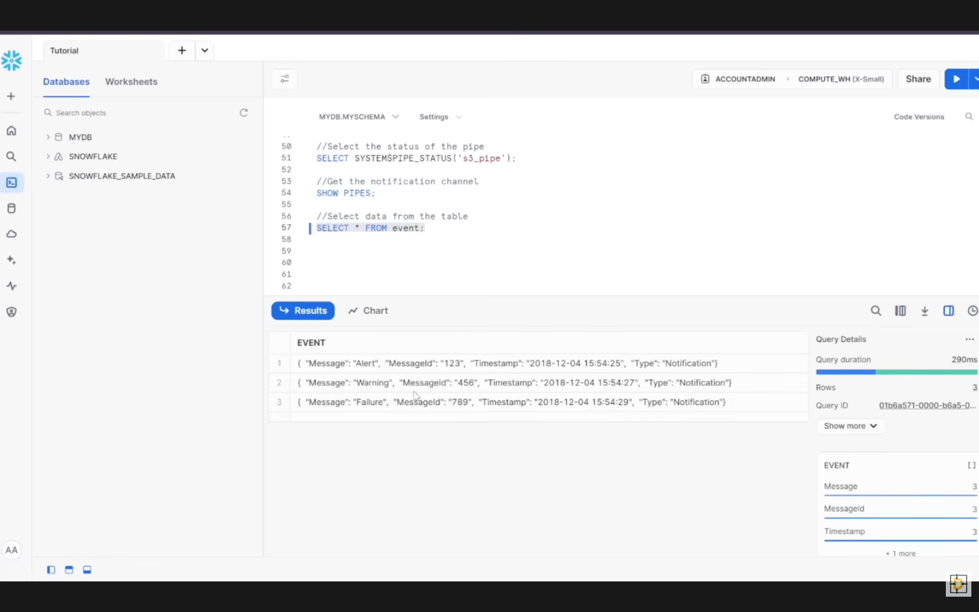

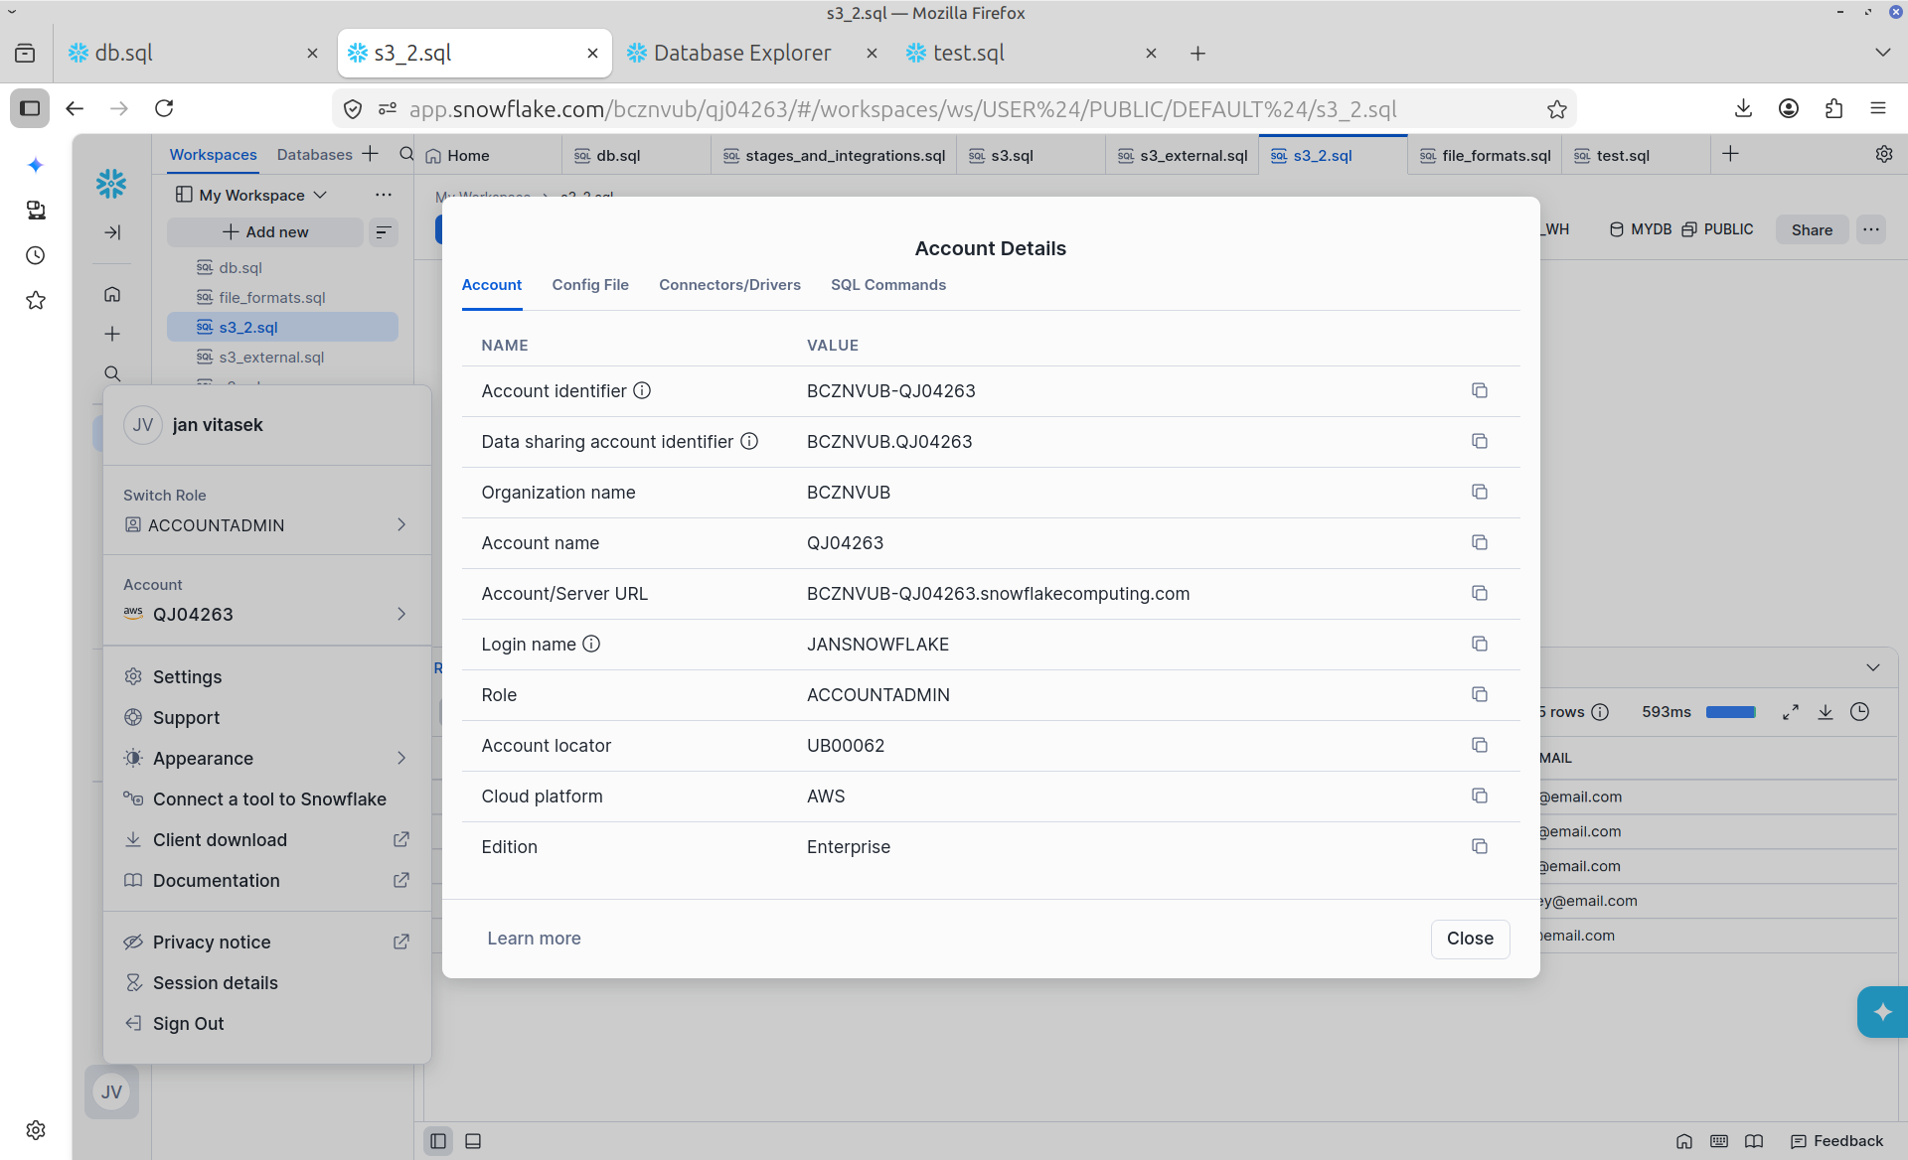

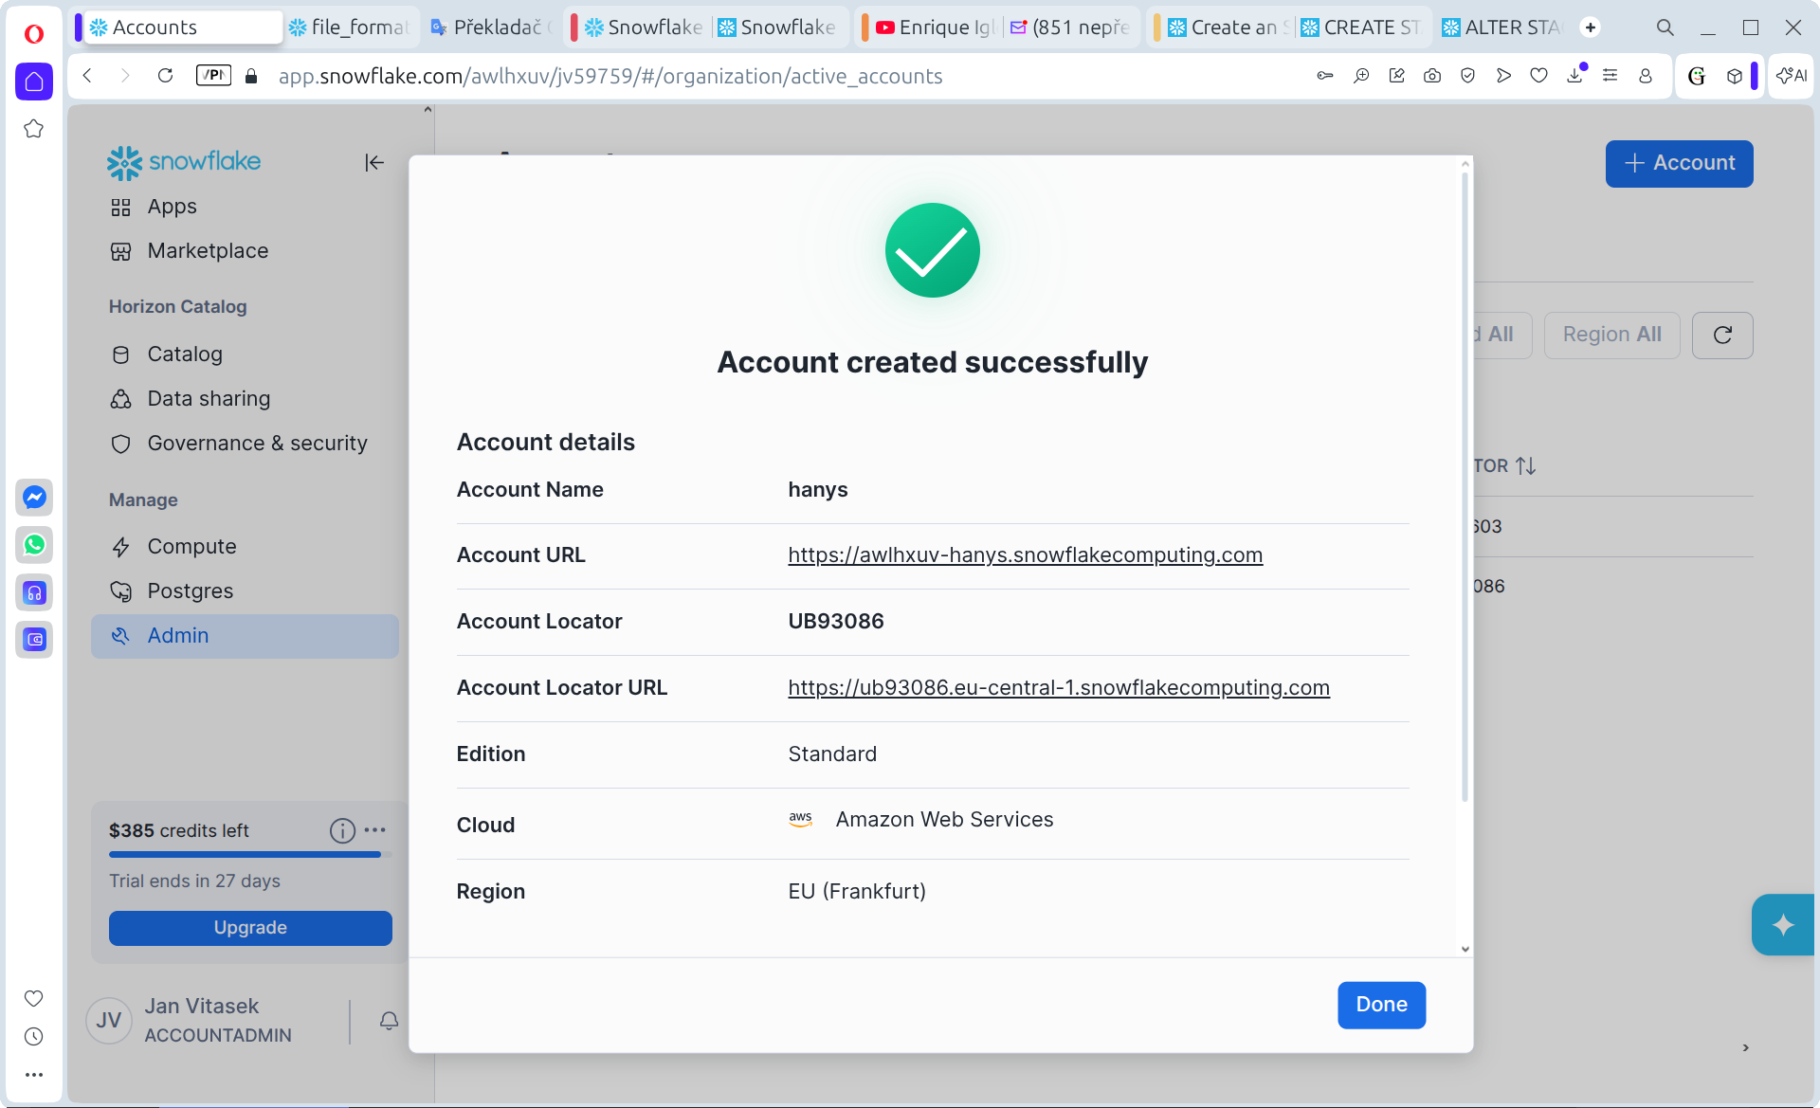
User: I cannot find a user "arn:aws:iam::260289090760:user/y0rp1000-s" in for command list @my_s3_stage;

GitHub Copilot: Optimized tool selectionI’m checking the local SnowSQL config first to see which connection, role, and stage context this command is likely using, then I’ll map why an AWS IAM ARN would appear in a Snowflake stage listing.

I’m reading the active SnowSQL config to identify the account and default connection context that could affect how `LIST @my_s3_stage` resolves storage access.

Read [](file:///home/ahanys/Downloads/snowsql_config.ini)

I’ve confirmed your client is connecting as `ACCOUNTADMIN`; next I’m checking Snowflake’s stage/auth model to distinguish whether this ARN should exist as an AWS IAM user or is expected to come from a storage integration or role assumption path.

Fetched 3 resources

`arn:aws:iam::260289090760:user/y0rp1000-s` is almost certainly not a Snowflake user you should expect to find in your own AWS account. For an S3 external stage that uses a Snowflake storage integration, Snowflake generates an AWS IAM principal on the Snowflake side and your AWS role trust policy must allow that principal to assume the role. So the problem behind `LIST @my_s3_stage` is usually stage/integration or AWS trust-policy configuration, not “missing user” in your IAM console.

Your active SnowSQL profile is using `ACCOUNTADMIN`, so if you connected with that profile, the next checks should be:

```sql
DESC STAGE my_s3_stage;
```

If the stage shows `STORAGE_INTEGRATION`, then run:

```sql
DESC INTEGRATION <integration_name>;
SELECT SYSTEM$VALIDATE_STORAGE_INTEGRATION('<integration_name>');
SHOW GRANTS ON INTEGRATION <integration_name>;
SHOW GRANTS ON STAGE my_s3_stage;
```

What to verify:
1. The role trust policy in AWS allows the exact `STORAGE_AWS_IAM_USER_ARN` from `DESC INTEGRATION`.
2. The trust policy also matches the exact `STORAGE_AWS_EXTERNAL_ID`.
3. The S3 permissions include at least `s3:ListBucket`, `s3:GetBucketLocation`, and `s3:GetObject` for the bucket/prefix behind the stage.
4. Your Snowflake role has `USAGE` on both the stage and the storage integration.

A common failure mode is that the integration was recreated, which changes the external ID and can also change the generated Snowflake-side principal details; then `LIST` starts failing until the AWS trust policy is updated. If you paste the exact `LIST @my_s3_stage` error text plus the output of `DESC STAGE my_s3_stage`, I can tell you which side is broken.

One separate issue: your SnowSQL config currently stores a plaintext password. If that is a real credential, rotate it and switch to `externalbrowser` or another safer auth method.

User: I created another integration and as a STORAGE_AWS_IAM_USER_ARN is "arn:aws:iam::260289090760:user/y0rp1000-s", but this user doesn't exit

GitHub Copilot: That ARN is not supposed to exist in your AWS account.

`STORAGE_AWS_IAM_USER_ARN = arn:aws:iam::260289090760:user/y0rp1000-s` is the Snowflake-managed IAM user in Snowflake’s AWS account. You will not see it under IAM Users in your own AWS console unless you somehow have access to account `260289090760`, which you do not.

What matters is:

1. In your AWS account, create or use an IAM role for S3 access.
2. In that role’s trust policy, set `Principal.AWS` to that Snowflake ARN.
3. Set `sts:ExternalId` to the `STORAGE_AWS_EXTERNAL_ID` from `DESC INTEGRATION`.
4. Attach S3 permissions to the role for the bucket and prefix used by the stage.

Example trust policy shape:

```json
{
"Version": "2012-10-17",
"Statement": [
{
"Effect": "Allow",
"Principal": {
"AWS": "arn:aws:iam::260289090760:user/y0rp1000-s"
},
"Action": "sts:AssumeRole",
"Condition": {
"StringEquals": {
"sts:ExternalId": "<value from DESC INTEGRATION>"
}
}
}
]
}
```

Two important details:

- The Snowflake IAM user is account-wide for your Snowflake account, so multiple storage integrations often show the same `STORAGE_AWS_IAM_USER_ARN`.
- If you recreated the integration, the `STORAGE_AWS_EXTERNAL_ID` may have changed. That is a common reason `LIST @my_s3_stage` fails even when the ARN looks right.

Run these in Snowflake to confirm:

```sql
DESC INTEGRATION <integration_name>;
SELECT SYSTEM$VALIDATE_STORAGE_INTEGRATION('<integration_name>');
DESC STAGE my_s3_stage;
```

If AWS is rejecting that ARN as an invalid principal, paste the exact AWS error and the `DESC INTEGRATION` output fields:
`STORAGE_AWS_IAM_USER_ARN`, `STORAGE_AWS_EXTERNAL_ID`, `STORAGE_AWS_ROLE_ARN`.

Then I can tell you whether the problem is trust policy, stale external ID, or stage wiring.

User: parent_property property property_type property_value property_default
STAGE_FILE_FORMAT FORMAT_NAME String my_csv_format
STAGE_COPY_OPTIONS ON_ERROR String ABORT_STATEMENT ABORT_STATEMENT
STAGE_COPY_OPTIONS SIZE_LIMIT Long
STAGE_COPY_OPTIONS PURGE Boolean false false
STAGE_COPY_OPTIONS RETURN_FAILED_ONLY Boolean false false
STAGE_COPY_OPTIONS ENFORCE_LENGTH Boolean true true
STAGE_COPY_OPTIONS TRUNCATECOLUMNS Boolean false false
STAGE_COPY_OPTIONS FORCE Boolean false false
STAGE_LOCATION URL String ["s3://my-snowflake-bucket111/"]
STAGE_INTEGRATION STORAGE_INTEGRATION String S3_INT
STAGE_CREDENTIALS AWS_ROLE String arn:aws:iam::817137372834:role/snowflakerole
STAGE_CREDENTIALS AWS_EXTERNAL_ID String UB00062_SFCRole=4_X7Jm9B6Ecd2Fg/JXtr9fso+Ta7s=
STAGE_CREDENTIALS SNOWFLAKE_IAM_USER String arn:aws:iam::260289090760:user/y0rp1000-s
DIRECTORY ENABLE Boolean false false
DIRECTORY AUTO_REFRESH Boolean false false
PRIVATELINK USE_PRIVATELINK_ENDPOINT Boolean false false

GitHub Copilot: This output shows the Snowflake side is wired as expected. The key lines are:

- `STORAGE_INTEGRATION = S3_INT`
- `AWS_ROLE = arn:aws:iam::817137372834:role/snowflakerole`
- `AWS_EXTERNAL_ID = UB00062_SFCRole=4_X7Jm9B6Ecd2Fg/JXtr9fso+Ta7s=`
- `SNOWFLAKE_IAM_USER = arn:aws:iam::260289090760:user/y0rp1000-s`

That `SNOWFLAKE_IAM_USER` does not need to exist in your AWS account `817137372834`. It belongs to Snowflake’s AWS account `260289090760`. You are not meant to manage or even see that user in your own IAM console.

What you need in your AWS account is only this:

1. An IAM role: `arn:aws:iam::817137372834:role/snowflakerole`
2. A trust relationship on that role allowing Snowflake’s IAM user to assume it
3. S3 permissions on that role for `s3://my-snowflake-bucket111/`

Your role trust policy should look like this:

```json
{
"Version": "2012-10-17",
"Statement": [
{
"Effect": "Allow",
"Principal": {
"AWS": "arn:aws:iam::260289090760:user/y0rp1000-s"
},
"Action": "sts:AssumeRole",
"Condition": {
"StringEquals": {
"sts:ExternalId": "UB00062_SFCRole=4_X7Jm9B6Ecd2Fg/JXtr9fso+Ta7s="
}
}
}
]
}
```

And the role should have at least these S3 permissions for the bucket and prefix:

```json
{
"Version": "2012-10-17",
"Statement": [
{
"Effect": "Allow",
"Action": [
"s3:GetObject",
"s3:GetObjectVersion"
],
"Resource": "arn:aws:s3:::my-snowflake-bucket111/*"
},
{
"Effect": "Allow",
"Action": [
"s3:ListBucket",
"s3:GetBucketLocation"
],
"Resource": "arn:aws:s3:::my-snowflake-bucket111"
}
]
}
```

So the conclusion is: the ARN is not the problem by itself. The real failure, if `LIST @my_s3_stage` still fails, is almost always one of these:

1. The IAM role trust policy does not use this exact `SNOWFLAKE_IAM_USER`.
2. The trust policy has an old `sts:ExternalId` from a previous integration.
3. The role lacks `s3:ListBucket` or object permissions on the bucket.
4. The stage points to a bucket/prefix not covered by the role policy.
5. Your Snowflake role lacks `USAGE` on the stage or integration.

The fastest next check is:

```sql
DESC INTEGRATION S3_INT;
SELECT SYSTEM$VALIDATE_STORAGE_INTEGRATION('S3_INT');
LIST @my_s3_stage;
```

If you paste the exact error from `SYSTEM$VALIDATE_STORAGE_INTEGRATION('S3_INT')` or from `LIST @my_s3_stage`, I can narrow it to the broken AWS policy line.

User: where can i find user: "arn:aws:iam::260289090760:user/y0rp1000-s"?

GitHub Copilot: You generally cannot find that user yourself.

`arn:aws:iam::260289090760:user/y0rp1000-s` lives in AWS account `260289090760`, which is Snowflake’s AWS side for this integration flow, not your AWS account. So:

- You will not see it in IAM Users in your own AWS account.
- You cannot browse to it unless you have access to AWS account `260289090760`, which customers normally do not.
- You use it only as a principal in the trust policy of your own IAM role.

Where it appears from your side:

1. In Snowflake, via `DESC INTEGRATION S3_INT`
2. In your AWS role trust policy, as `Principal.AWS`
3. In Snowflake docs/examples as the generated Snowflake IAM user for storage integrations

So the practical answer is: you do not “find” or manage that user in your console. You copy the ARN from Snowflake and reference it in the trust relationship for your AWS role.

If AWS says that principal is invalid, the next thing to check is not IAM Users, but whether:
1. The ARN was copied exactly from `DESC INTEGRATION`
2. The integration is enabled
3. The trust policy also uses the exact `STORAGE_AWS_EXTERNAL_ID`
4. There is no stale role policy from an older integration

If you want, I can give you the exact AWS trust policy and S3 policy for your values.

User: yes

GitHub Copilot: Use this trust policy on your AWS role [snowflakerole] if the role is `arn:aws:iam::817137372834:role/snowflakerole`:

```json
{
"Version": "2012-10-17",
"Statement": [
{
"Effect": "Allow",
"Principal": {
"AWS": "arn:aws:iam::260289090760:user/y0rp1000-s"
},
"Action": "sts:AssumeRole",
"Condition": {
"StringEquals": {
"sts:ExternalId": "UB00062_SFCRole=4_X7Jm9B6Ecd2Fg/JXtr9fso+Ta7s="
}
}
}
]
}
```

Use this S3 access policy on that same role for your bucket `s3://my-snowflake-bucket111/`:

```json
{
"Version": "2012-10-17",
"Statement": [
{
"Sid": "AllowReadObjects",
"Effect": "Allow",
"Action": [
"s3:GetObject",
"s3:GetObjectVersion"
],
"Resource": "arn:aws:s3:::my-snowflake-bucket111/*"
},
{
"Sid": "AllowListBucket",
"Effect": "Allow",
"Action": [
"s3:ListBucket",
"s3:GetBucketLocation"
],
"Resource": "arn:aws:s3:::my-snowflake-bucket111"
}
]
}
```

If you also need unloads or `REMOVE`, add these actions to the object-level statement:

```json
"s3:PutObject",
"s3:DeleteObject",
"s3:DeleteObjectVersion"
```

After updating AWS, validate from Snowflake:

```sql
DESC INTEGRATION S3_INT;
SELECT SYSTEM$VALIDATE_STORAGE_INTEGRATION('S3_INT');
LIST @my_s3_stage;
```

If AWS rejects the trust policy with “invalid principal”, paste the exact AWS error. That usually means one of these:
1. The ARN was pasted incorrectly.
2. The role trust policy was edited in the wrong AWS account.
3. There is a partition/region mismatch such as `aws` vs `aws-us-gov` or `aws-cn`.
4. AWS has not accepted the principal format for that account path, in which case we should verify the current Snowflake-generated principal again with `DESC INTEGRATION S3_INT`.

User: where should I put this:
{
"Version": "2012-10-17",
"Statement": [
{
"Sid": "AllowReadObjects",
"Effect": "Allow",
"Action": [
"s3:GetObject",
"s3:GetObjectVersion"
],
"Resource": "arn:aws:s3:::my-snowflake-bucket111/*"
},
{
"Sid": "AllowListBucket",
"Effect": "Allow",
"Action": [
"s3:ListBucket",
"s3:GetBucketLocation"
],
"Resource": "arn:aws:s3:::my-snowflake-bucket111"
}
]
}

GitHub Copilot: Put that JSON in AWS as a permissions policy attached to the IAM role `snowflakerole`.

It does not go into Snowflake, and it does not go into the role’s trust relationship. It belongs in one of these places in AWS account `817137372834`:

1. As an inline policy on the role `snowflakerole`
2. As a customer-managed IAM policy attached to the role `snowflakerole`

In the AWS console:

1. Open `IAM`
2. Open `Roles`
3. Select `snowflakerole`
4. Open `Permissions`
5. Either choose `Add permissions` -> `Create inline policy`
6. Switch to `JSON`
7. Paste that policy
8. Save it

Or create it as a managed policy:

1. Open `IAM`
2. Open `Policies`
3. Click `Create policy`
4. Choose `JSON`
5. Paste the policy
6. Save it
7. Attach it to role `snowflakerole`

Important distinction:

- The S3 policy you pasted goes under `Permissions policies` for the role.
- The Snowflake principal policy with `arn:aws:iam::260289090760:user/y0rp1000-s` goes under the role’s `Trust relationships`.

So your role needs both:
1. A trust policy saying Snowflake can assume the role
2. A permissions policy saying that role can access the S3 bucket

If you want, I can now give you both policies labeled exactly as:
1. `Trust relationship`
2. `Permissions policy`
so you can paste them into the correct two AWS screens.

User: prepis mi text z obrazku do chatu

GitHub Copilot: Jasně, tady je přepis textu z obrázku:

```sql
//Set the Roles, Warehouses and Databases

USE ROLE ACCOUNTADMIN;

USE WAREHOUSE COMPUTE_WH;

USE SCHEMA MYDB.MYSCHEMA;

//Create an Employee table

CREATE OR REPLACE TABLE EVENT (
EVENT VARIANT
);

//Create an storage integration with s3 and iam role
CREATE OR REPLACE STORAGE INTEGRATION s3_snowpipe_int
TYPE = EXTERNAL_STAGE
STORAGE_PROVIDER = 'S3'
ENABLED = TRUE
STORAGE_AWS_ROLE_ARN = 'arn:aws:iam::294845879996:role/snowpipe'
STORAGE_ALLOWED_LOCATIONS = ('s3://de-academy-training-bucket/event/');

//Describe the storage integration
DESC INTEGRATION s3_snowpipe_int;

//Create a file format
CREATE OR REPLACE FILE FORMAT my_json_format
TYPE = 'JSON';

//Create a external s3 stage
CREATE OR REPLACE STAGE my_s3_snowpipe_stage
STORAGE_INTEGRATION = s3_snowpipe_int
URL = 's3://de-academy-training-bucket/event/'
FILE_FORMAT = my_json_format;
```

Jestli chceš, můžu to hned upravit do správné a spustitelné Snowflake SQL verze, protože v tom přepisu z obrázku je nejspíš drobná syntaktická chyba u `CREATE STAGE` a možná chybí čárka nebo závorka podle zamýšleného formátu.

User: kdyz po copy nebo autoingest zustavaji soubory ve stage? proc se nesmazou z bucketu?

GitHub Copilot: I will check Snowflake docs to confirm how COPY and Snowpipe handle file removal and the PURGE option. I'll fetch the relevant Snowflake pages.

Fetched 3 resources

Fetched 2 resources

Krátce: vytvořím rychlý plán kroků, které vysvětlí příčiny a řešení (purge/COPY, Snowpipe, alternativy).

Created 4 todos

Shrnutí a kroky — proč soubory zůstávají ve stage a jak je odstranit

- Proč zůstávají: COPY i Snowpipe standardně NEMAŽOU zdrojové soubory v externím S3 bucketu (výchozí `PURGE = FALSE`). Snowflake pouze přečte data a nechá objekty v bucketu, pokud explicitně nepožádáte o jejich odstranění.

- Jak soubory odstranit po ručním načtení (COPY):
- Do příkazu COPY přidejte `PURGE = TRUE`:
```
COPY INTO mytable
FROM @my_s3_stage
FILE_FORMAT = (FORMAT_NAME = my_csv_format)
PURGE = TRUE;
```
- Nebo nastavit table-level default a pak spouštět COPY bez explicitního přepínače:
```
ALTER TABLE mytable SET STAGE_COPY_OPTIONS = (PURGE = TRUE);
COPY INTO mytable;
```
- POZNÁMKA: Snowflake musí mít oprávnění `s3:DeleteObject` (politika na roli/uživateli) aby mohl soubory smazat.

- Snowpipe (auto-ingest): Snowpipe autoload obvykle NEPROVÁDÍ purge. Doporučené možnosti:
- Použít S3 lifecycle policy k automatickému smazání/přesunu po určité době.
- Nebo nasadit Lambda (S3 event) která:
1) Po nahrání zavolá Snowpipe (nebo notifikaci) — standardní auto-ingest.
2) Počkejte/ověřte, že soubor byl úspěšně nahrán (např. dotazem na COPY_HISTORY nebo Snowpipe load history).
3) Pak smažte objekt (Lambda musí mít práva `s3:DeleteObject`).
- Jiná možnost: nepoužívat Snowpipe, ale pravidelný batch COPY s `PURGE=TRUE`.

- Jak ověřit co se nahrálo / co zůstává:
- Vypsat obsah stage:
```
LIST @my_s3_stage;
```
- Zkontrolovat historii načtení (COPY_HISTORY / SNOWPIPE load history) — použijte výstup COPY nebo sledování přes Snowflake UI / QUERY_HISTORY / COPY_HISTORY funkce pro konkrétní časové okno.
- Spustit `SELECT * FROM TABLE(INFORMATION_SCHEMA.COPY_HISTORY(...))` nebo zkontrolovat výsledky posledního `COPY INTO` (vrací sloupec FILE a STATUS).

- Doporučení:
- Pokud chcete okamžité smazání souborů po načtení a používáte batch, používejte `PURGE = TRUE`.
- Pokud chcete asynchronní (Snowpipe) a bezpečné smazání, použijte S3 lifecycle nebo Lambda + ověření přes COPY_HISTORY.
- Nezapomeňte přidat `s3:DeleteObject` do IAM policy role, kterou Snowflake používá, pokud chcete PURGE od Snowflake.

Chceš, abych pro tebe připravil 1) hotový JSON IAM policy obsahující `s3:DeleteObject` pro tvou roli, nebo 2) příklad AWS Lambda + jednoduchý pseudokód pro ověření v Snowflake a smazání souboru? - Zkontrolovat historii načtení (COPY_HISTORY / SNOWPIPE load history) — použijte výstup COPY nebo sledování přes Snowflake UI / QUERY_HISTORY / COPY_HISTORY funkce pro konkrétní časové okno.
- Spustit `SELECT * FROM TABLE(INFORMATION_SCHEMA.COPY_HISTORY(...))` nebo zkontrolovat výsledky posledního `COPY INTO` (vrací sloupec FILE a STATUS).

- Doporučení:
- Pokud chcete okamžité smazání souborů po načtení a používáte batch, používejte `PURGE = TRUE`.
- Pokud chcete asynchronní (Snowpipe) a bezpečné smazání, použijte S3 lifecycle nebo Lambda + ověření přes COPY_HISTORY.
- Nezapomeňte přidat `s3:DeleteObject` do IAM policy role, kterou Snowflake používá, pokud chcete PURGE od Snowflake.

Chceš, abych pro tebe připravil 1) hotový JSON IAM policy obsahující `s3:DeleteObject` pro tvou roli, nebo 2) příklad AWS Lambda + jednoduchý pseudokód pro ověření v Snowflake a smazání souboru?

User: I cannot find a user "arn:aws:iam::260289090760:user/y0rp1000-s" in for command list @my_s3_stage;

GitHub Copilot: Optimized tool selectionI’m checking the local SnowSQL config first to see which connection, role, and stage context this command is likely using, then I’ll map why an AWS IAM ARN would appear in a Snowflake stage listing.

I’m reading the active SnowSQL config to identify the account and default connection context that could affect how `LIST @my_s3_stage` resolves storage access.

Read [](file:///home/ahanys/Downloads/snowsql_config.ini)

I’ve confirmed your client is connecting as `ACCOUNTADMIN`; next I’m checking Snowflake’s stage/auth model to distinguish whether this ARN should exist as an AWS IAM user or is expected to come from a storage integration or role assumption path.

Fetched 3 resources

`arn:aws:iam::260289090760:user/y0rp1000-s` is almost certainly not a Snowflake user you should expect to find in your own AWS account. For an S3 external stage that uses a Snowflake storage integration, Snowflake generates an AWS IAM principal on the Snowflake side and your AWS role trust policy must allow that principal to assume the role. So the problem behind `LIST @my_s3_stage` is usually stage/integration or AWS trust-policy configuration, not “missing user” in your IAM console.

Your active SnowSQL profile is using `ACCOUNTADMIN`, so if you connected with that profile, the next checks should be:

```sql
DESC STAGE my_s3_stage;
```

If the stage shows `STORAGE_INTEGRATION`, then run:

```sql
DESC INTEGRATION <integration_name>;
SELECT SYSTEM$VALIDATE_STORAGE_INTEGRATION('<integration_name>');
SHOW GRANTS ON INTEGRATION <integration_name>;
SHOW GRANTS ON STAGE my_s3_stage;
```

What to verify:
1. The role trust policy in AWS allows the exact `STORAGE_AWS_IAM_USER_ARN` from `DESC INTEGRATION`.
2. The trust policy also matches the exact `STORAGE_AWS_EXTERNAL_ID`.
3. The S3 permissions include at least `s3:ListBucket`, `s3:GetBucketLocation`, and `s3:GetObject` for the bucket/prefix behind the stage.
4. Your Snowflake role has `USAGE` on both the stage and the storage integration.

A common failure mode is that the integration was recreated, which changes the external ID and can also change the generated Snowflake-side principal details; then `LIST` starts failing until the AWS trust policy is updated. If you paste the exact `LIST @my_s3_stage` error text plus the output of `DESC STAGE my_s3_stage`, I can tell you which side is broken.

One separate issue: your SnowSQL config currently stores a plaintext password. If that is a real credential, rotate it and switch to `externalbrowser` or another safer auth method.

User: I created another integration and as a STORAGE_AWS_IAM_USER_ARN is "arn:aws:iam::260289090760:user/y0rp1000-s", but this user doesn't exit

GitHub Copilot: That ARN is not supposed to exist in your AWS account.

`STORAGE_AWS_IAM_USER_ARN = arn:aws:iam::260289090760:user/y0rp1000-s` is the Snowflake-managed IAM user in Snowflake’s AWS account. You will not see it under IAM Users in your own AWS console unless you somehow have access to account `260289090760`, which you do not.

What matters is:

1. In your AWS account, create or use an IAM role for S3 access.
2. In that role’s trust policy, set `Principal.AWS` to that Snowflake ARN.
3. Set `sts:ExternalId` to the `STORAGE_AWS_EXTERNAL_ID` from `DESC INTEGRATION`.
4. Attach S3 permissions to the role for the bucket and prefix used by the stage.

Example trust policy shape:

```json
{
"Version": "2012-10-17",
"Statement": [
{
"Effect": "Allow",
"Principal": {
"AWS": "arn:aws:iam::260289090760:user/y0rp1000-s"
},
"Action": "sts:AssumeRole",
"Condition": {
"StringEquals": {
"sts:ExternalId": "<value from DESC INTEGRATION>"
}
}
}
]
}
```

Two important details:

- The Snowflake IAM user is account-wide for your Snowflake account, so multiple storage integrations often show the same `STORAGE_AWS_IAM_USER_ARN`.
- If you recreated the integration, the `STORAGE_AWS_EXTERNAL_ID` may have changed. That is a common reason `LIST @my_s3_stage` fails even when the ARN looks right.

Run these in Snowflake to confirm:

```sql
DESC INTEGRATION <integration_name>;
SELECT SYSTEM$VALIDATE_STORAGE_INTEGRATION('<integration_name>');
DESC STAGE my_s3_stage;
```

If AWS is rejecting that ARN as an invalid principal, paste the exact AWS error and the `DESC INTEGRATION` output fields:
`STORAGE_AWS_IAM_USER_ARN`, `STORAGE_AWS_EXTERNAL_ID`, `STORAGE_AWS_ROLE_ARN`.

Then I can tell you whether the problem is trust policy, stale external ID, or stage wiring.

User: parent_property property property_type property_value property_default
STAGE_FILE_FORMAT FORMAT_NAME String my_csv_format
STAGE_COPY_OPTIONS ON_ERROR String ABORT_STATEMENT ABORT_STATEMENT
STAGE_COPY_OPTIONS SIZE_LIMIT Long
STAGE_COPY_OPTIONS PURGE Boolean false false
STAGE_COPY_OPTIONS RETURN_FAILED_ONLY Boolean false false
STAGE_COPY_OPTIONS ENFORCE_LENGTH Boolean true true
STAGE_COPY_OPTIONS TRUNCATECOLUMNS Boolean false false
STAGE_COPY_OPTIONS FORCE Boolean false false
STAGE_LOCATION URL String ["s3://my-snowflake-bucket111/"]
STAGE_INTEGRATION STORAGE_INTEGRATION String S3_INT
STAGE_CREDENTIALS AWS_ROLE String arn:aws:iam::817137372834:role/snowflakerole
STAGE_CREDENTIALS AWS_EXTERNAL_ID String UB00062_SFCRole=4_X7Jm9B6Ecd2Fg/JXtr9fso+Ta7s=
STAGE_CREDENTIALS SNOWFLAKE_IAM_USER String arn:aws:iam::260289090760:user/y0rp1000-s
DIRECTORY ENABLE Boolean false false
DIRECTORY AUTO_REFRESH Boolean false false
PRIVATELINK USE_PRIVATELINK_ENDPOINT Boolean false false

GitHub Copilot: This output shows the Snowflake side is wired as expected. The key lines are:

- `STORAGE_INTEGRATION = S3_INT`
- `AWS_ROLE = arn:aws:iam::817137372834:role/snowflakerole`
- `AWS_EXTERNAL_ID = UB00062_SFCRole=4_X7Jm9B6Ecd2Fg/JXtr9fso+Ta7s=`
- `SNOWFLAKE_IAM_USER = arn:aws:iam::260289090760:user/y0rp1000-s`

That `SNOWFLAKE_IAM_USER` does not need to exist in your AWS account `817137372834`. It belongs to Snowflake’s AWS account `260289090760`. You are not meant to manage or even see that user in your own IAM console.

What you need in your AWS account is only this:

1. An IAM role: `arn:aws:iam::817137372834:role/snowflakerole`
2. A trust relationship on that role allowing Snowflake’s IAM user to assume it
3. S3 permissions on that role for `s3://my-snowflake-bucket111/`

Your role trust policy should look like this:

```json
{
"Version": "2012-10-17",
"Statement": [
{
"Effect": "Allow",
"Principal": {
"AWS": "arn:aws:iam::260289090760:user/y0rp1000-s"
},
"Action": "sts:AssumeRole",
"Condition": {
"StringEquals": {
"sts:ExternalId": "UB00062_SFCRole=4_X7Jm9B6Ecd2Fg/JXtr9fso+Ta7s="
}
}
}
]
}
```

And the role should have at least these S3 permissions for the bucket and prefix:

```json
{
"Version": "2012-10-17",
"Statement": [
{
"Effect": "Allow",
"Action": [
"s3:GetObject",
"s3:GetObjectVersion"
],
"Resource": "arn:aws:s3:::my-snowflake-bucket111/*"
},
{
"Effect": "Allow",
"Action": [
"s3:ListBucket",
"s3:GetBucketLocation"
],
"Resource": "arn:aws:s3:::my-snowflake-bucket111"
}
]
}
```

So the conclusion is: the ARN is not the problem by itself. The real failure, if `LIST @my_s3_stage` still fails, is almost always one of these:

1. The IAM role trust policy does not use this exact `SNOWFLAKE_IAM_USER`.
2. The trust policy has an old `sts:ExternalId` from a previous integration.
3. The role lacks `s3:ListBucket` or object permissions on the bucket.
4. The stage points to a bucket/prefix not covered by the role policy.
5. Your Snowflake role lacks `USAGE` on the stage or integration.

The fastest next check is:

```sql
DESC INTEGRATION S3_INT;
SELECT SYSTEM$VALIDATE_STORAGE_INTEGRATION('S3_INT');
LIST @my_s3_stage;
```

If you paste the exact error from `SYSTEM$VALIDATE_STORAGE_INTEGRATION('S3_INT')` or from `LIST @my_s3_stage`, I can narrow it to the broken AWS policy line.

User: where can i find user: "arn:aws:iam::260289090760:user/y0rp1000-s"?

GitHub Copilot: You generally cannot find that user yourself.

`arn:aws:iam::260289090760:user/y0rp1000-s` lives in AWS account `260289090760`, which is Snowflake’s AWS side for this integration flow, not your AWS account. So:

- You will not see it in IAM Users in your own AWS account.
- You cannot browse to it unless you have access to AWS account `260289090760`, which customers normally do not.
- You use it only as a principal in the trust policy of your own IAM role.

Where it appears from your side:

1. In Snowflake, via `DESC INTEGRATION S3_INT`
2. In your AWS role trust policy, as `Principal.AWS`
3. In Snowflake docs/examples as the generated Snowflake IAM user for storage integrations

So the practical answer is: you do not “find” or manage that user in your console. You copy the ARN from Snowflake and reference it in the trust relationship for your AWS role.

If AWS says that principal is invalid, the next thing to check is not IAM Users, but whether:
1. The ARN was copied exactly from `DESC INTEGRATION`
2. The integration is enabled
3. The trust policy also uses the exact `STORAGE_AWS_EXTERNAL_ID`
4. There is no stale role policy from an older integration

If you want, I can give you the exact AWS trust policy and S3 policy for your values.

User: yes

GitHub Copilot: Use this trust policy on your AWS role [snowflakerole] if the role is `arn:aws:iam::817137372834:role/snowflakerole`:

```json
{
"Version": "2012-10-17",
"Statement": [
{
"Effect": "Allow",
"Principal": {
"AWS": "arn:aws:iam::260289090760:user/y0rp1000-s"
},
"Action": "sts:AssumeRole",
"Condition": {
"StringEquals": {
"sts:ExternalId": "UB00062_SFCRole=4_X7Jm9B6Ecd2Fg/JXtr9fso+Ta7s="
}
}
}
]
}
```

Use this S3 access policy on that same role for your bucket `s3://my-snowflake-bucket111/`:

```json
{
"Version": "2012-10-17",
"Statement": [
{
"Sid": "AllowReadObjects",
"Effect": "Allow",
"Action": [
"s3:GetObject",
"s3:GetObjectVersion"
],
"Resource": "arn:aws:s3:::my-snowflake-bucket111/*"
},
{
"Sid": "AllowListBucket",
"Effect": "Allow",
"Action": [
"s3:ListBucket",
"s3:GetBucketLocation"
],
"Resource": "arn:aws:s3:::my-snowflake-bucket111"
}
]
}
```

If you also need unloads or `REMOVE`, add these actions to the object-level statement:

```json
"s3:PutObject",
"s3:DeleteObject",
"s3:DeleteObjectVersion"
```

After updating AWS, validate from Snowflake:

```sql
DESC INTEGRATION S3_INT;
SELECT SYSTEM$VALIDATE_STORAGE_INTEGRATION('S3_INT');
LIST @my_s3_stage;
```

If AWS rejects the trust policy with “invalid principal”, paste the exact AWS error. That usually means one of these:
1. The ARN was pasted incorrectly.
2. The role trust policy was edited in the wrong AWS account.
3. There is a partition/region mismatch such as `aws` vs `aws-us-gov` or `aws-cn`.
4. AWS has not accepted the principal format for that account path, in which case we should verify the current Snowflake-generated principal again with `DESC INTEGRATION S3_INT`.

User: where should I put this:
{
"Version": "2012-10-17",
"Statement": [
{
"Sid": "AllowReadObjects",
"Effect": "Allow",
"Action": [
"s3:GetObject",
"s3:GetObjectVersion"
],
"Resource": "arn:aws:s3:::my-snowflake-bucket111/*"
},
{
"Sid": "AllowListBucket",
"Effect": "Allow",
"Action": [
"s3:ListBucket",
"s3:GetBucketLocation"
],
"Resource": "arn:aws:s3:::my-snowflake-bucket111"
}
]
}

GitHub Copilot: Put that JSON in AWS as a permissions policy attached to the IAM role `snowflakerole`.

It does not go into Snowflake, and it does not go into the role’s trust relationship. It belongs in one of these places in AWS account `817137372834`:

1. As an inline policy on the role `snowflakerole`
2. As a customer-managed IAM policy attached to the role `snowflakerole`

In the AWS console:

1. Open `IAM`
2. Open `Roles`
3. Select `snowflakerole`
4. Open `Permissions`
5. Either choose `Add permissions` -> `Create inline policy`
6. Switch to `JSON`
7. Paste that policy
8. Save it

Or create it as a managed policy:

1. Open `IAM`
2. Open `Policies`
3. Click `Create policy`
4. Choose `JSON`
5. Paste the policy
6. Save it
7. Attach it to role `snowflakerole`

Important distinction:

- The S3 policy you pasted goes under `Permissions policies` for the role.
- The Snowflake principal policy with `arn:aws:iam::260289090760:user/y0rp1000-s` goes under the role’s `Trust relationships`.

So your role needs both:
1. A trust policy saying Snowflake can assume the role
2. A permissions policy saying that role can access the S3 bucket

If you want, I can now give you both policies labeled exactly as:
1. `Trust relationship`
2. `Permissions policy`
so you can paste them into the correct two AWS screens.

User: prepis mi text z obrazku do chatu

GitHub Copilot: Jasně, tady je přepis textu z obrázku:

```sql
//Set the Roles, Warehouses and Databases

USE ROLE ACCOUNTADMIN;

USE WAREHOUSE COMPUTE_WH;

USE SCHEMA MYDB.MYSCHEMA;

//Create an Employee table

CREATE OR REPLACE TABLE EVENT (
EVENT VARIANT
);

//Create an storage integration with s3 and iam role
CREATE OR REPLACE STORAGE INTEGRATION s3_snowpipe_int
TYPE = EXTERNAL_STAGE
STORAGE_PROVIDER = 'S3'
ENABLED = TRUE
STORAGE_AWS_ROLE_ARN = 'arn:aws:iam::294845879996:role/snowpipe'
STORAGE_ALLOWED_LOCATIONS = ('s3://de-academy-training-bucket/event/');

//Describe the storage integration
DESC INTEGRATION s3_snowpipe_int;

//Create a file format
CREATE OR REPLACE FILE FORMAT my_json_format
TYPE = 'JSON';

//Create a external s3 stage
CREATE OR REPLACE STAGE my_s3_snowpipe_stage
STORAGE_INTEGRATION = s3_snowpipe_int
URL = 's3://de-academy-training-bucket/event/'
FILE_FORMAT = my_json_format;
```

Jestli chceš, můžu to hned upravit do správné a spustitelné Snowflake SQL verze, protože v tom přepisu z obrázku je nejspíš drobná syntaktická chyba u `CREATE STAGE` a možná chybí čárka nebo závorka podle zamýšleného formátu.

User: kdyz po copy nebo autoingest zustavaji soubory ve stage? proc se nesmazou z bucketu?

GitHub Copilot: I will check Snowflake docs to confirm how COPY and Snowpipe handle file removal and the PURGE option. I'll fetch the relevant Snowflake pages.

Fetched 3 resources

Fetched 2 resources

Krátce: vytvořím rychlý plán kroků, které vysvětlí příčiny a řešení (purge/COPY, Snowpipe, alternativy).

Created 4 todos

Shrnutí a kroky — proč soubory zůstávají ve stage a jak je odstranit

- Proč zůstávají: COPY i Snowpipe standardně NEMAŽOU zdrojové soubory v externím S3 bucketu (výchozí `PURGE = FALSE`). Snowflake pouze přečte data a nechá objekty v bucketu, pokud explicitně nepožádáte o jejich odstranění.

- Jak soubory odstranit po ručním načtení (COPY):
- Do příkazu COPY přidejte `PURGE = TRUE`:
```
COPY INTO mytable
FROM @my_s3_stage
FILE_FORMAT = (FORMAT_NAME = my_csv_format)
PURGE = TRUE;
```
- Nebo nastavit table-level default a pak spouštět COPY bez explicitního přepínače:
```
ALTER TABLE mytable SET STAGE_COPY_OPTIONS = (PURGE = TRUE);
COPY INTO mytable;
```
- POZNÁMKA: Snowflake musí mít oprávnění `s3:DeleteObject` (politika na roli/uživateli) aby mohl soubory smazat.

- Snowpipe (auto-ingest): Snowpipe autoload obvykle NEPROVÁDÍ purge. Doporučené možnosti:
- Použít S3 lifecycle policy k automatickému smazání/přesunu po určité době.
- Nebo nasadit Lambda (S3 event) která:
1) Po nahrání zavolá Snowpipe (nebo notifikaci) — standardní auto-ingest.
2) Počkejte/ověřte, že soubor byl úspěšně nahrán (např. dotazem na COPY_HISTORY nebo Snowpipe load history).
3) Pak smažte objekt (Lambda musí mít práva `s3:DeleteObject`).
- Jiná možnost: nepoužívat Snowpipe, ale pravidelný batch COPY s `PURGE=TRUE`.

- Jak ověřit co se nahrálo / co zůstává:
- Vypsat obsah stage:
```
LIST @my_s3_stage;
```
- Zkontrolovat historii načtení (COPY_HISTORY / SNOWPIPE load history) — použijte výstup COPY nebo sledování přes Snowflake UI / QUERY_HISTORY / COPY_HISTORY funkce pro konkrétní časové okno.
- Spustit `SELECT * FROM TABLE(INFORMATION_SCHEMA.COPY_HISTORY(...))` nebo zkontrolovat výsledky posledního `COPY INTO` (vrací sloupec FILE a STATUS).

- Doporučení:
- Pokud chcete okamžité smazání souborů po načtení a používáte batch, používejte `PURGE = TRUE`.
- Pokud chcete asynchronní (Snowpipe) a bezpečné smazání, použijte S3 lifecycle nebo Lambda + ověření přes COPY_HISTORY.
- Nezapomeňte přidat `s3:DeleteObject` do IAM policy role, kterou Snowflake používá, pokud chcete PURGE od Snowflake.

Chceš, abych pro tebe připravil 1) hotový JSON IAM policy obsahující `s3:DeleteObject` pro tvou roli, nebo 2) příklad AWS Lambda + jednoduchý pseudokód pro ověření v Snowflake a smazání souboru? - Zkontrolovat historii načtení (COPY_HISTORY / SNOWPIPE load history) — použijte výstup COPY nebo sledování přes Snowflake UI / QUERY_HISTORY / COPY_HISTORY funkce pro konkrétní časové okno.
- Spustit `SELECT * FROM TABLE(INFORMATION_SCHEMA.COPY_HISTORY(...))` nebo zkontrolovat výsledky posledního `COPY INTO` (vrací sloupec FILE a STATUS).

- Doporučení:
- Pokud chcete okamžité smazání souborů po načtení a používáte batch, používejte `PURGE = TRUE`.
- Pokud chcete asynchronní (Snowpipe) a bezpečné smazání, použijte S3 lifecycle nebo Lambda + ověření přes COPY_HISTORY.
- Nezapomeňte přidat `s3:DeleteObject` do IAM policy role, kterou Snowflake používá, pokud chcete PURGE od Snowflake.

Chceš, abych pro tebe připravil 1) hotový JSON IAM policy obsahující `s3:DeleteObject` pro tvou roli, nebo 2) příklad AWS Lambda + jednoduchý pseudokód pro ověření v Snowflake a smazání souboru?

User: 1

GitHub Copilot: Dávám ti hotovou IAM permissions policy (JSON) – vlož ji jako inline policy nebo jako customer-managed policy a připoj k roli `snowflakerole` (ARN: `arn:aws:iam::817137372834:role/snowflakerole`).

Policy (povoluje čtení/list i mazání objektů v bucketu):
```json
{
"Version": "2012-10-17",
"Statement": [
{
"Sid": "AllowObjectReadWriteDelete",
"Effect": "Allow",
"Action": [
"s3:GetObject",
"s3:GetObjectVersion",
"s3:PutObject",
"s3:DeleteObject",
"s3:DeleteObjectVersion"
],
"Resource": "arn:aws:s3:::my-snowflake-bucket111/*"
},
{
"Sid": "AllowListAndLocation",
"Effect": "Allow",
"Action": [
"s3:ListBucket",
"s3:GetBucketLocation"
],
"Resource": "arn:aws:s3:::my-snowflake-bucket111",
"Condition": {
"StringLike": {
"s3:prefix": [
"*"
]
}
}
}
]
}
```

Krátký postup kam to dát (console):
- IAM → Policies → Create policy → JSON → vlož výše → Review → jméno např. `snowflake-s3-access` → Create.
- IAM → Roles → vyber `snowflakerole` → Attach policies → vyber `snowflake-s3-access` → Attach.

Důležité poznámky:
- Aby Snowflake mohl soubory PURGE (smazat) po `COPY ... PURGE=TRUE` nebo po interním PURGE, musí mít role i tuto `s3:DeleteObject` právo (proto je v policy).
- Trust policy role (Trust relationships) musí obsahovat Snowflake principála (`arn:aws:iam::260289090760:user/...`) a správné `sts:ExternalId` (hodnoty z `DESC INTEGRATION`).
- Pokud používáš Snowpipe (auto-ingest), Snowpipe standardně nesmaže soubory — použij tuto policy jen pokud chceš povolit Snowflakeům (COPY) mazat; pro Snowpipe doporučím S3 lifecycle nebo Lambda workflow s ověřením načtení.

Chceš, abych připravil i hotovou trust policy JSON (pro vložení do Trust relationships) nebo ukázku, jak attachovat tuto policy přes AWS CLI?

