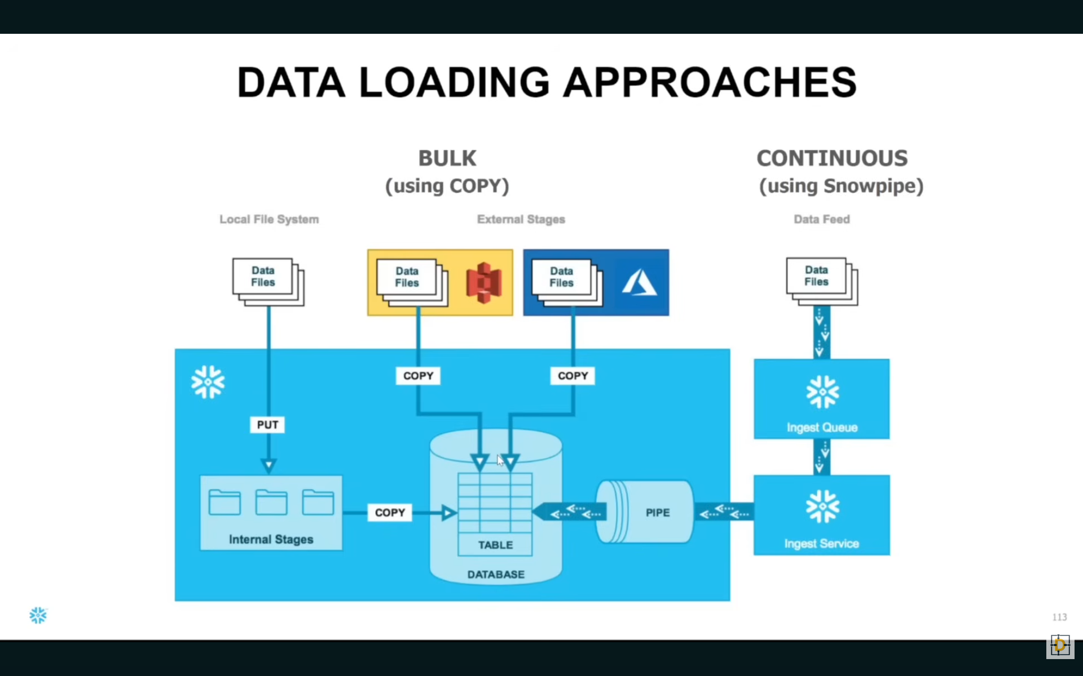

DB
//ALTER ACCOUNT QJ04263 SET EDITION = 'ENTERPRISE';

//show accounts;

use role accountadmin;
use warehouse compute_wh;

create or replace database mydb;

create or replace schema MYDB.myschema;

create or replace table PERMANENT_TABLE
(
id int,
name string
);

alter table PERMANENT_TABLE SET DATA_RETENTION_TIME_IN_DAYS = 1;

create or replace transient table TRASIENT_TABLE
(
id int,
name string
);
alter table TRASIENT_TABLE SET DATA_RETENTION_TIME_IN_DAYS = 1;

create or replace temporary table TEMPORARY_TABLE
(
id int,
name string
);
alter table TEMPORARY_TABLE SET DATA_RETENTION_TIME_IN_DAYS = 1;
show tables;

create or replace TABLE employees (
id integer,
name varchar(50),
department varchar(50),
salary integer
);

insert into employees (id, name, department, salary)
values (1, 'Pat Fay', 'HR', 50000),
(2, 'Donald OConnel', 'IT', 75000),
(3, 'Steven King', 'Sales', 60000),
(4, 'Susan Mavris', 'IT', 80000),
(5, 'Jenifer Whalen', 'Marketing', 55000);

select * from employees;

create or replace VIEW it_imployees AS
SELECT id, name, salary
FROM employees
WHERE department = 'IT';

select * from it_imployees;

create or replace secure VIEW hr_imployees AS
SELECT id, name, salary
FROM employees
WHERE department = 'HR';

select * from hr_imployees;

Create or replace VIEW employee_sallaries
AS SELECT
department,
SUM(salary) AS total_salary
FROM employees
GROUP BY department;

select * from employee_sallaries;

create or replace MATERIALIZED VIEW materialized_eployee_salariries
AS SELECT
department,
SUM(salary) AS total_salary
FROM employees
GROUP BY department;

select * from materialized_eployee_salariries;

show views;

create or replace table customer (
id integer,
name varchar(50),
age integer,
state varchar(50)

);

list @%customer;

list @~;

Create or replace STAGE CUSTOMER_STAGE;

list @Customer_stage;

Truncate table customer;

copy into customer
FROM @customer_stage
file_format = (TYPE= 'csv', skip_header = 1);

select * from customer;

//undrop schema myschema;

MY__STAGES
USE ROLE ACCOUNTADMIN;
USE WAREHOUSE COMPUTE_WH;
USE SCHEMA MYDB.MYSCHEMA;
//use database mydb;

// INTERNAL STAGE

//Create an Employee table
CREATE OR REPLACE TABLE customer (
id INTEGER,
name VARCHAR(50),
age INTEGER,
state VARCHAR(50)
);

//Access the table stage
list @%customer;

//Access the user stage
list @~;

//Create a named stage
CREATE OR REPLACE STAGE CUSTOMER_STAGE;

//Access the names internal stage
list @CUSTOMER_STAGE;

//Truncate the table
TRUNCATE TABLE CUSTOMER;

//undrop schema myschema;

//Load data to customer table
copy into customer
from @CUSTOMER_STAGE
file_format = (TYPE = 'CSV' SKIP_HEADER = 1);

//Select data from the table
SELECT * FROM CUSTOMER;

//undrop schema myschema;

// EXTERNAL STAGE
//Create an Employee table
CREATE OR REPLACE TABLE USER (
id INTEGER,
name VARCHAR(50),
location VARCHAR(50),
email VARCHAR(50)
);

PRI PREGENEROVANI JE NUTNE AKTUALIZOVAT Trusted entities V trust relationships
//Create an storage integration with s3 and iam role
CREATE OR REPLACE STORAGE INTEGRATION s3_int
TYPE = EXTERNAL_STAGE
STORAGE_PROVIDER = 'S3'
ENABLED = TRUE
STORAGE_AWS_ROLE_ARN = 'arn:aws:iam::817137372834:role/snowflakerole'
STORAGE_ALLOWED_LOCATIONS = ('s3://my-snowflake-bucket111/event/');

//Describe the storage integration
DESC INTEGRATION s3_int;

//Create a file format
CREATE OR REPLACE FILE FORMAT my_csv_format
TYPE = 'CSV'
FIELD_DELIMITER = ','
RECORD_DELIMITER = '\n'
SKIP_HEADER = 1;

CREATE OR REPLACE FILE FORMAT my_json_format
TYPE = 'JSON';

CREATE OR REPLACE STAGE my_s3_stage
STORAGE_INTEGRATION = s3_int
URL = 's3://my-snowflake-bucket111/event/'
FILE_FORMAT = my_json_format;

//Access the external stage
list @my_s3_stage;

COPY INTO EVENT
from @my_s3_stage
FILE_FORMAT = (FORMAT_NAME = my_JSON_format);

select * from event;

/////////////////////////////// UP IS WORKIG

// PRIRADIT ROLI UZIVATELI
//Create an storage integration with s3 and iam role
CREATE OR REPLACE STORAGE INTEGRATION s3_int2
TYPE = EXTERNAL_STAGE
STORAGE_PROVIDER = 'S3'
ENABLED = TRUE
STORAGE_AWS_ROLE_ARN = 'arn:aws:iam::817137372834:role/snowflakerole2'
STORAGE_ALLOWED_LOCATIONS = ('s3://my-snowflake-bucket111/users/');

desc integration s3_int2;

CREATE OR REPLACE STAGE my_s3_stage2
STORAGE_INTEGRATION = s3_int2
URL = 's3://my-snowflake-bucket111/users/'
FILE_FORMAT = my_json_format;

list @my_s3_stage2;

COPY INTO user
from @my_s3_stage2
FILE_FORMAT = (FORMAT_NAME = my_csv_format);

select * from user;

// CONTINUOS INGESTION

//Create an Employee table
CREATE OR REPLACE TABLE EVENT2 (
EVENT VARIANT
);

//Create an storage integration with s3 and iam role
CREATE OR REPLACE STORAGE INTEGRATION s3_snowpipe_int
TYPE = EXTERNAL_STAGE
STORAGE_PROVIDER = 'S3'
ENABLED = TRUE
STORAGE_AWS_ROLE_ARN = 'arn:aws:iam::817137372834:role/snowpipe_role'
STORAGE_ALLOWED_LOCATIONS = ('s3://my-snowflake-bucket111/event2/');

//Describe the storage integration
DESC INTEGRATION s3_snowpipe_int;

//Create a file format
CREATE OR REPLACE FILE FORMAT my_json_format
TYPE = 'JSON';

//Create a external s3 stage
CREATE OR REPLACE STAGE my_s3_snowpipe_stage
STORAGE_INTEGRATION = s3_snowpipe_int
URL = 's3://my-snowflake-bucket111/event2/'
FILE_FORMAT = my_json_format;

//Access the external stage
list @my_s3_snowpipe_stage;

//Create a snowpipe to load the event data from s3
create or replace pipe s3_pipe
auto_ingest = true AS
copy into event2
from @my_s3_snowpipe_stage
FILE_FORMAT = (FORMAT_NAME = my_json_format);

//Select the status of the pipe
SELECT SYSTEM$PIPE_STATUS('s3_pipe');

show pipes;

select * from event2;

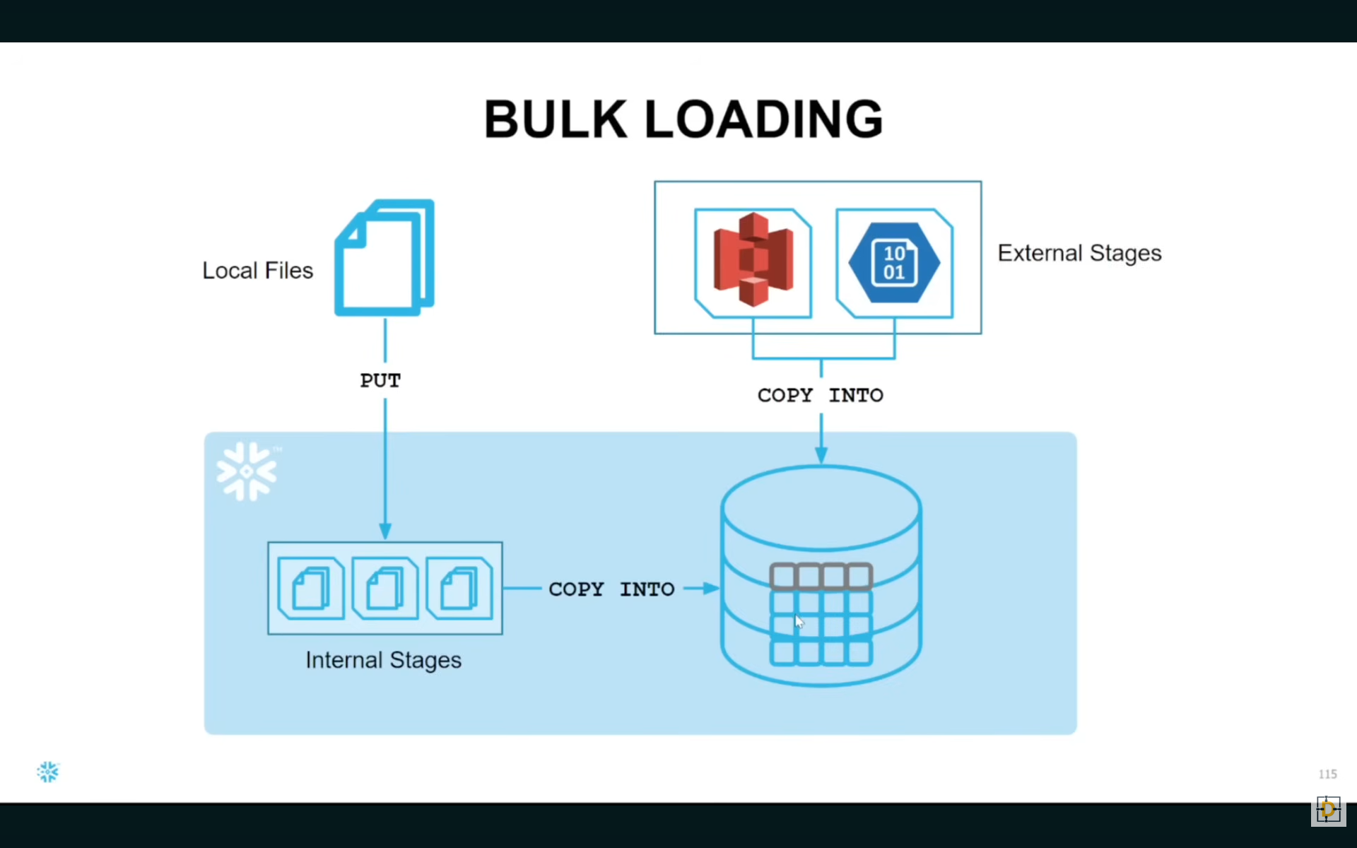
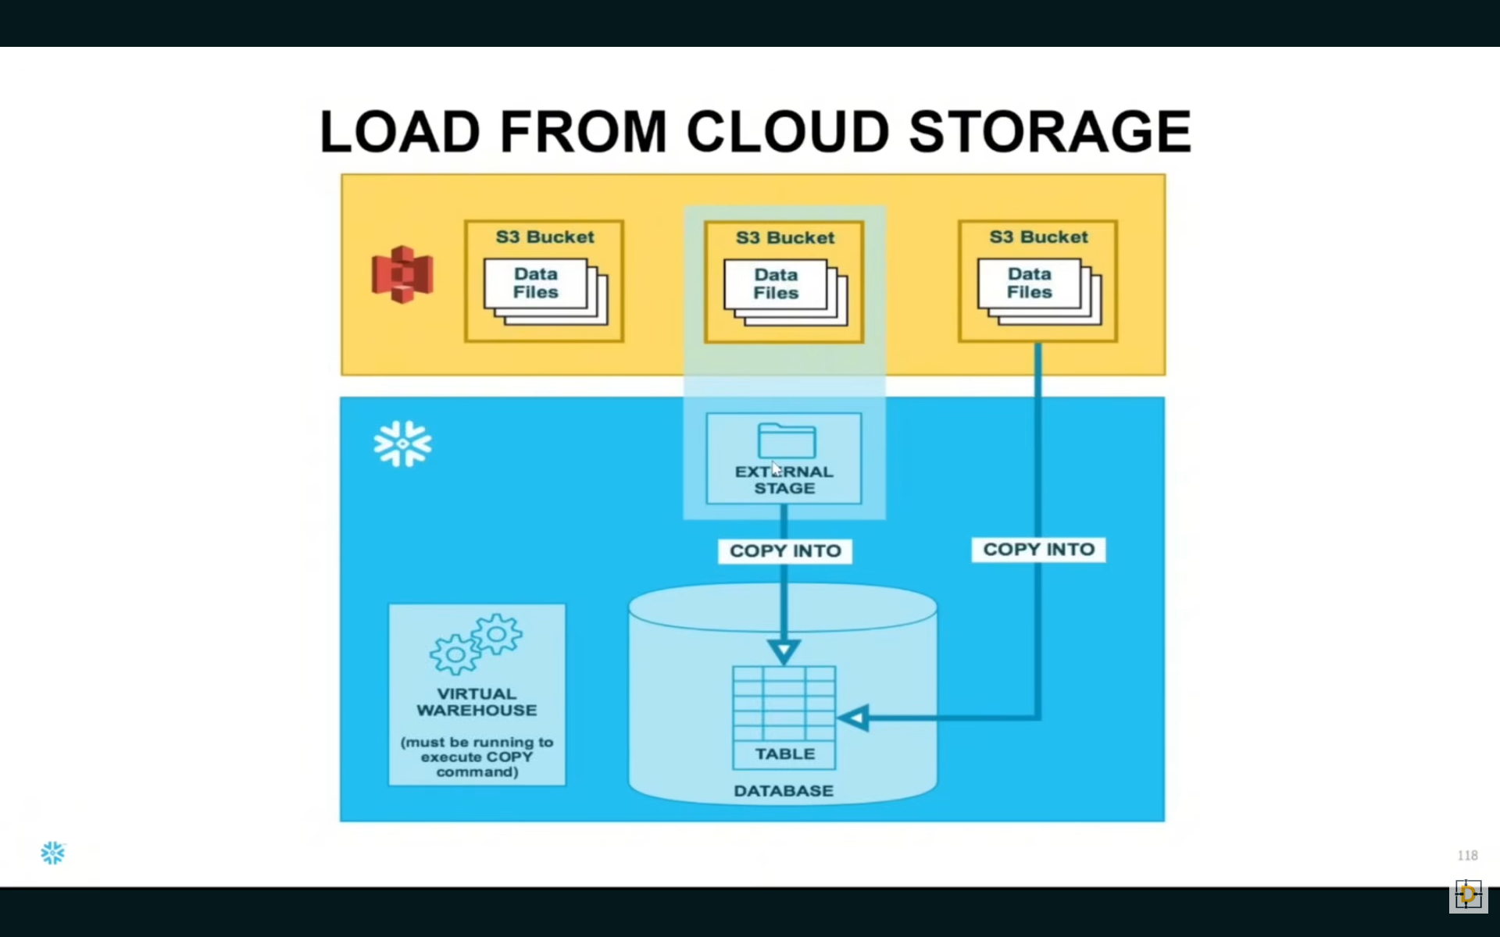
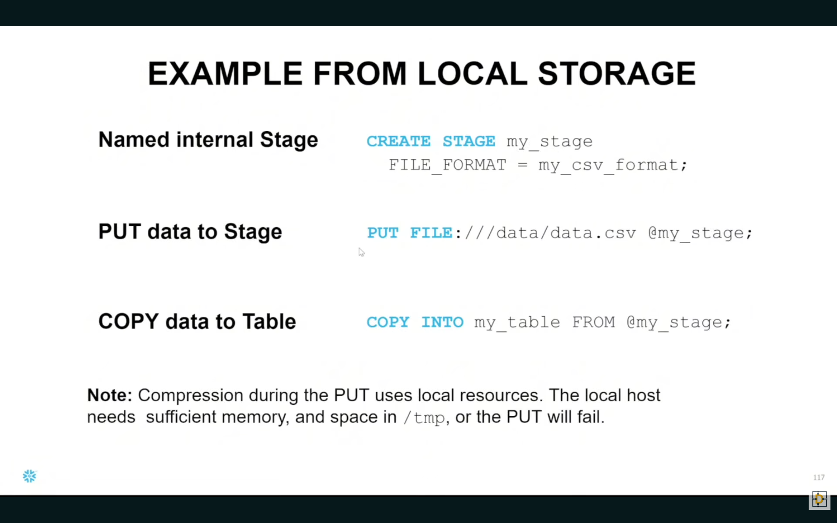
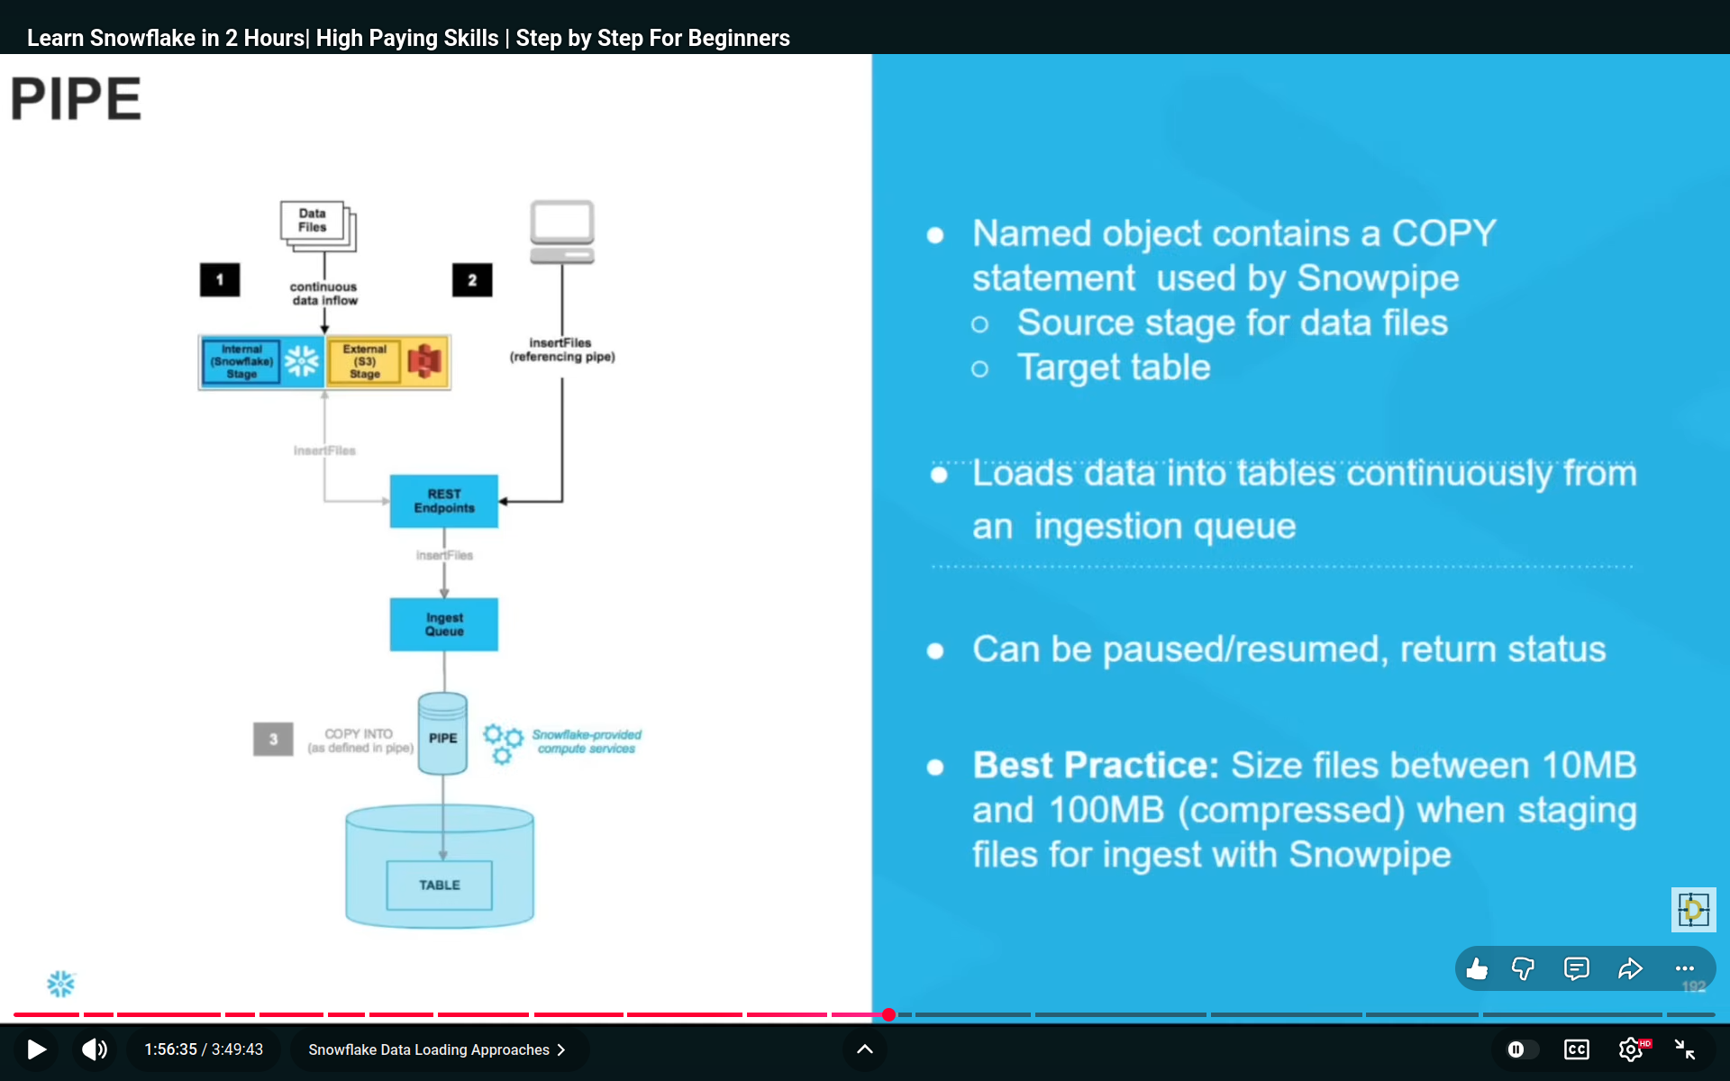
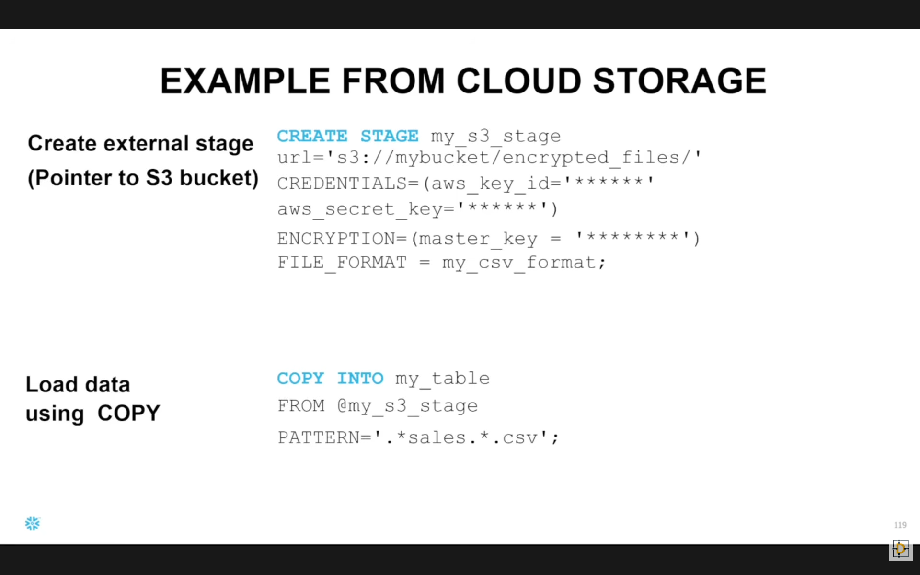
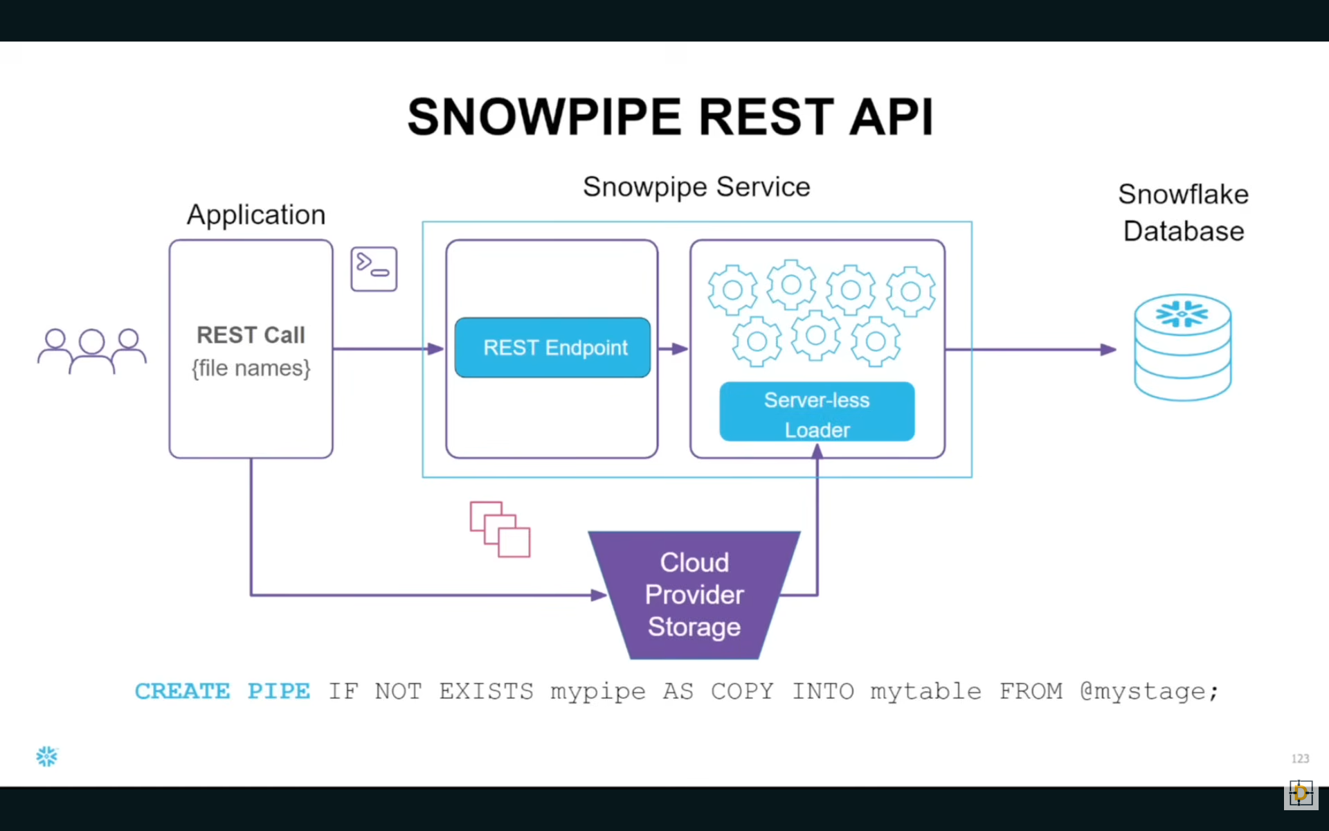
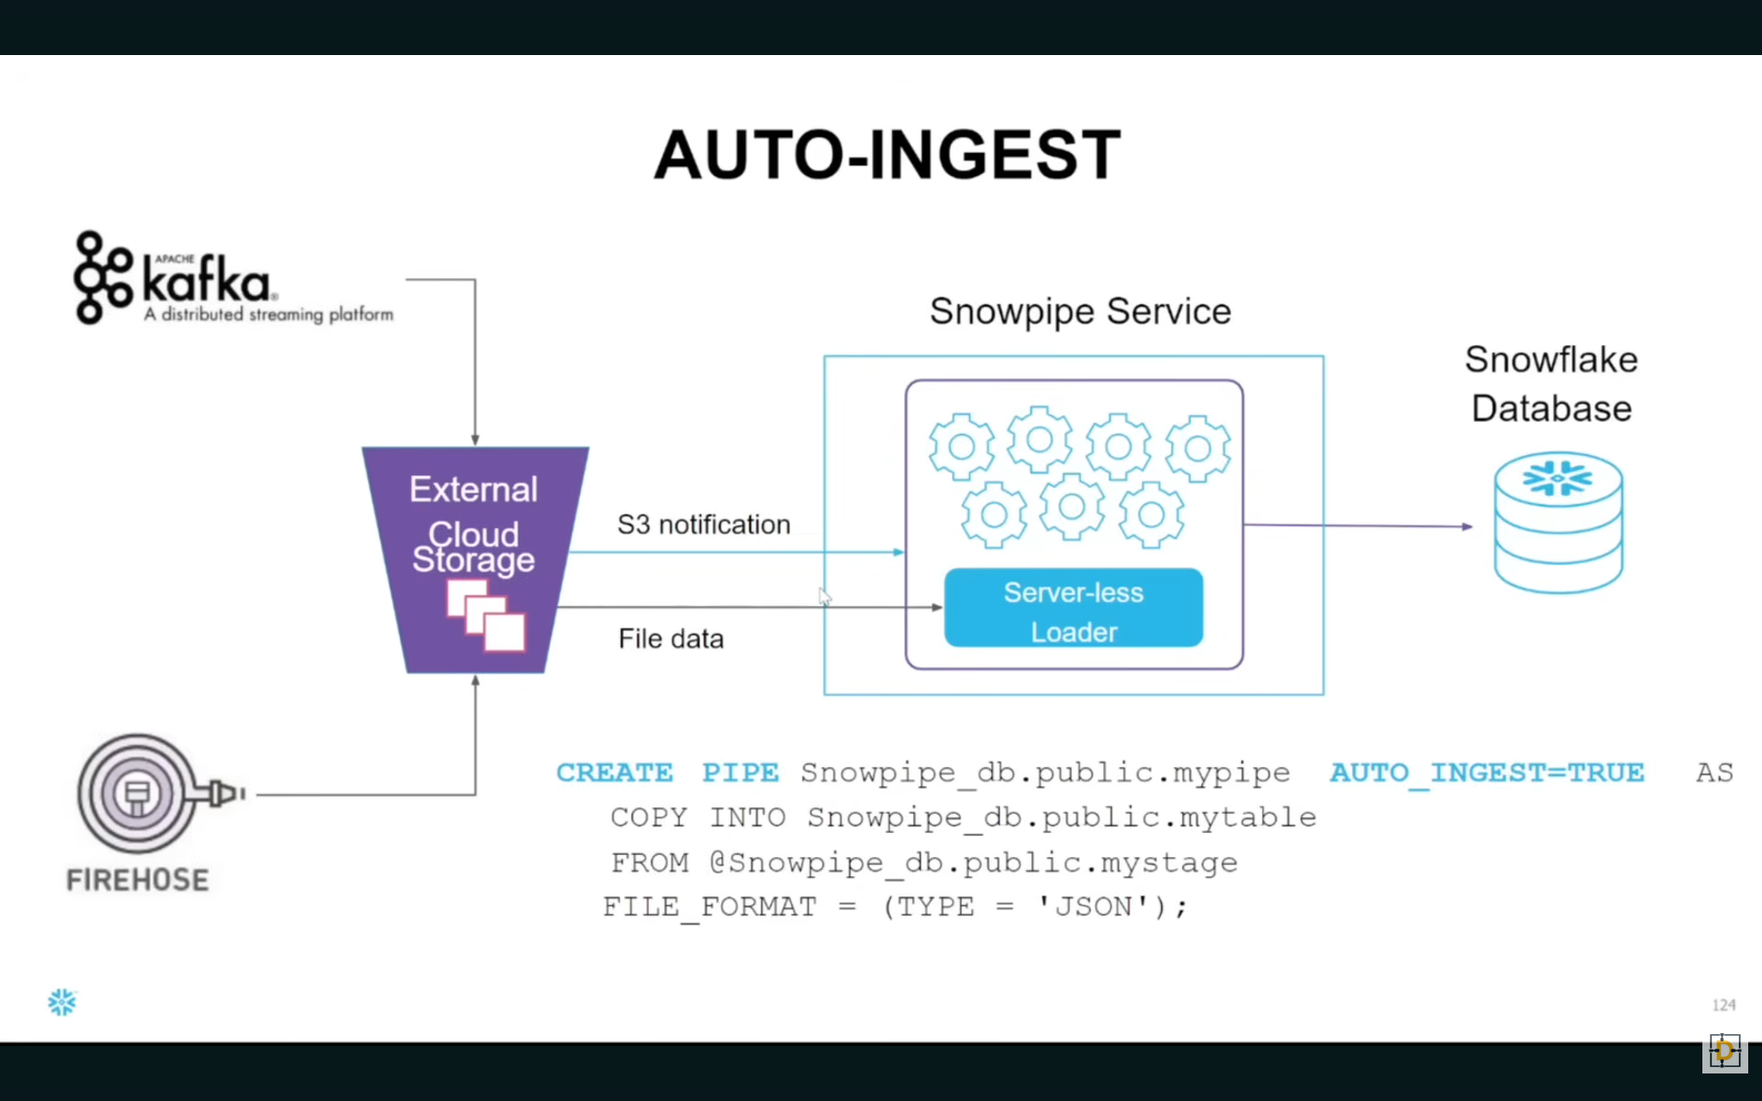
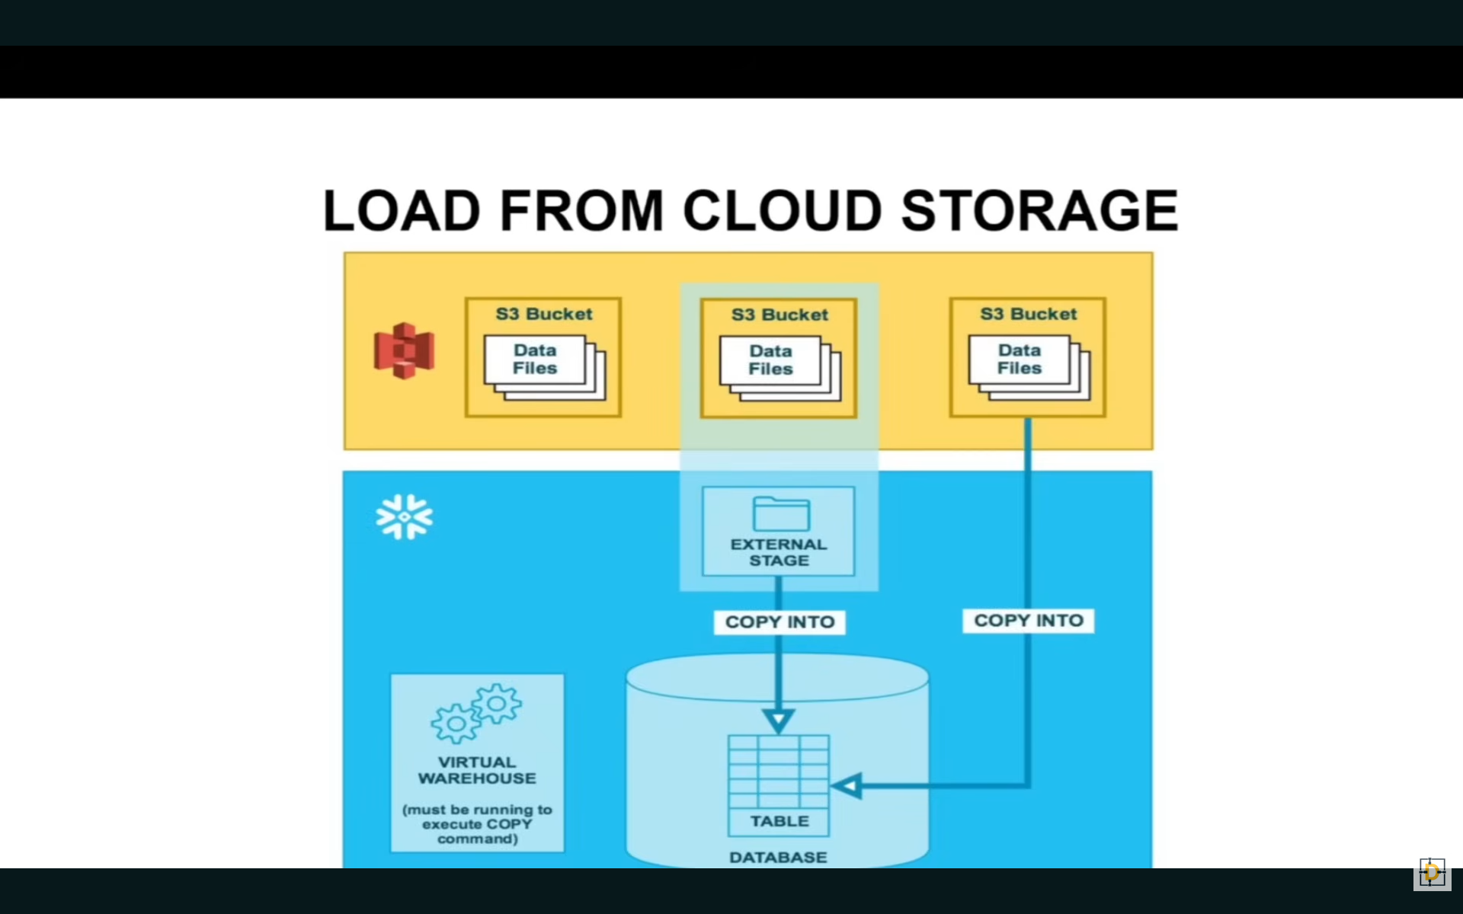
USE ROLE ACCOUNTADMIN;
USE WAREHOUSE COMPUTE_WH;
USE SCHEMA MYDB.MYSCHEMA;
use database mydb;

DESC STORAGE INTEGRATION s3_snowpipe_int;

SHOW STORAGE INTEGRATIONS;

CREATE OR REPLACE STORAGE INTEGRATION s3_snowpipe_int
TYPE = EXTERNAL_STAGE
STORAGE_PROVIDER = S3
ENABLED = TRUE
STORAGE_AWS_ROLE_ARN = 'arn:aws:iam::817137372834:role/snowpipe_role'
STORAGE_ALLOWED_LOCATIONS = ('s3://my-snowflake-bucket111/event/');

//Describe the storage integration
DESC INTEGRATION s3_snowpipe_int;

//Create a file format
CREATE OR REPLACE FILE FORMAT my_json_format
TYPE = 'JSON';

//Create a external s3 stage
CREATE OR REPLACE STAGE my_s3_snowpipe_stage
STORAGE_INTEGRATION = s3_snowpipe_int
URL = 's3://my-snowflake-bucket111/event/'
FILE_FORMAT = my_json_format;

//Access the external stage
LIST @my_s3_snowpipe_stage;

//Create a snowpipe to load the event data from s3
CREATE OR REPLACE PIPE s3_pipe
AUTO_INGEST = TRUE AS
COPY INTO event
FROM @my_s3_snowpipe_stage
FILE_FORMAT = (FORMAT_NAME = my_json_format);

//Select the status of the pipe
SELECT SYSTEM$PIPE_STATUS('s3_pipe');

//Get the notification channel
SHOW PIPES;

//Select data from the table
SELECT * FROM event;

USE SCHEMA MYDB.MYSCHEMA;

//Create an Employee table
CREATE OR REPLACE TABLE customer (
id INTEGER,
name VARCHAR(50),
age INTEGER,
state VARCHAR(50)
);

//Access the table stage
list @%customer;

//Access the user stage
list @~;

//Create a named stage
CREATE OR REPLACE STAGE CUSTOMER_STAGE;

//Access the names internal stage
list @CUSTOMER_STAGE;

//Truncate the table
TRUNCATE TABLE CUSTOMER;

//Load data to customer table
copy into customer
from @CUSTOMER_STAGE
file_format = (TYPE = 'CSV' SKIP_HEADER = 1);

USE ROLE ACCOUNTADMIN;
USE WAREHOUSE COMPUTE_WH;
USE SCHEMA MYDB.MYSCHEMA;
//===== Without Task =======

//Create an source table
CREATE OR REPLACE TABLE SOURCE_TABLE (
id INT,
name VARCHAR,
created_date DATE
);

//Insert some records on the source table
INSERT INTO SOURCE_TABLE VALUES
(1, 'Chaos', '2023-12-11'),
(2, 'Genius', '2024-07-04');

//Select data from source table
select * from SOURCE_TABLE;

//Create an target table
CREATE OR REPLACE TABLE TARGET_TABLE (
id INT,
name VARCHAR,
created_date DATE,
created_day VARCHAR,
created_month VARCHAR,
created_year VARCHAR
);

//Insert data into the target table
INSERT INTO TARGET_TABLE
SELECT
a.id,
a.name,
a.created_date,
DAY(a.created_date) AS created_day,
MONTH(a.created_date) AS created_month,
YEAR(a.created_date) AS created_year
FROM SOURCE_TABLE a
left join target_table b
on a.id = b.id
where b.id is null;

//Select data from target table
select * from TARGET_TABLE;

//Create an target table
CREATE OR REPLACE TABLE TARGET_TABLE (
id INT,
name VARCHAR,
created_date DATE,
created_day VARCHAR,
created_month VARCHAR,
created_year VARCHAR
);

//Insert data into the target table through task

CREATE OR REPLACE TASK my_task
WAREHOUSE = COMPUTE_WH
SCHEDULE = '1 MINUTE'
AS
INSERT INTO TARGET_TABLE
SELECT
a.id,
a.name,
a.created_date,
DAY(a.created_date) AS created_day,
MONTH(a.created_date) AS created_month,
YEAR(a.created_date) AS created_year
FROM SOURCE_TABLE a
left join target_table b
on a.id = b.id
where b.id is null;

//Show tasks
SHOW TASKS;

//Alter the task to execute
ALTER TASK my_task RESUME;

ALTER TASK my_task SUSPEND;

//Check the task status
select * from table(information_schema.TASK_HISTORY(TASK_NAME => 'my_task'));

//Select data from target table
select * from TARGET_TABLE;

//Insert some records on the source table
INSERT INTO SOURCE_TABLE VALUES
(3, 'Elan', '2022-02-24');

