Program Area Focus: Education

Black Spend Event?  Amount: Enter a decimal amount

Date: **9/26/2021** Location: Virtual

On **9/16/2021**, the Brothers of the Eta Chapter of Phi Beta Sigma Fraternity Incorporated hosted a program discussing COVID-19 vaccine health, and answered questions regarding the vaccine or other COVID-19 related questions, as well as other variants. We also had a distinguished speaker, Dr. Craig Fletcher, answering these questions. This was to ultimately beat the negative stigma of the COVID-19 vaccine.

**Goal: To beat the negative stigma of the COVID-19 vaccine.**

|  |  |  |  |
| --- | --- | --- | --- |
| Natl Partner Fundraising Event? | Health Event? | BBB Event? | Education Event? |
|  |  |  |  |

Was there an Outside Speaker/Moderator?

Were funds dispersed?

Disbursement Type: Choose an item.

Funds Recipient: Choose an item.

Amount Dispersed: Enter amount.

The following brothers were involved in the program: *15* brothers participated in this effort. Out of that number, *3* provided materials.

**Total Number of Hours Served: 1 hours**

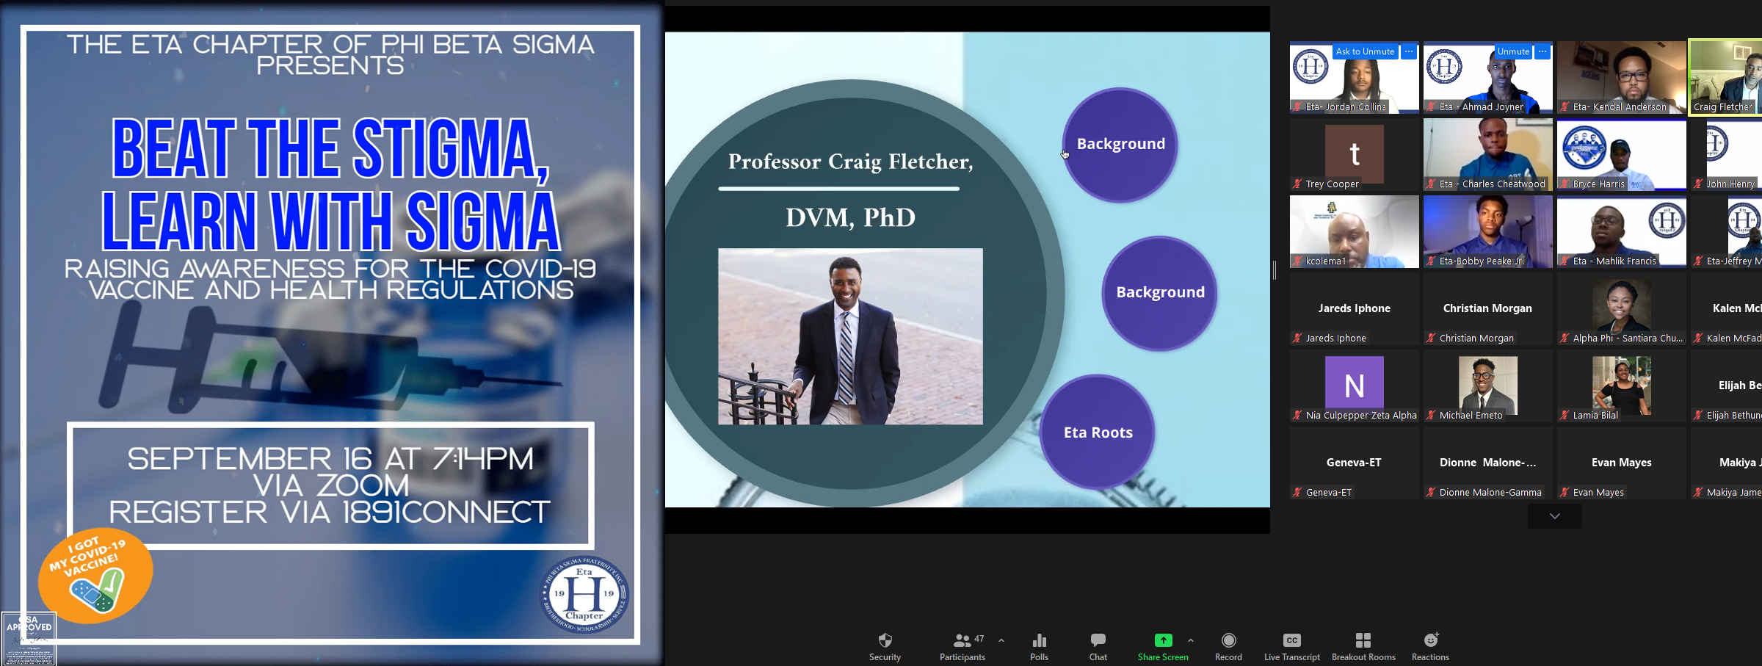

Program Success: **Excellent**

**Recommend this program for the future? Recommend**