Program Area Focus: Education

Black Spend Event?  Amount: Enter a decimal amount

Date: **9/26/2021** Location: Virtual

On **9/16/2021**, the Brothers of the Eta Chapter of Phi Beta Sigma Fraternity Incorporated hosted a program called “Know Your Status”, geared towards educating students on the benefits of sexual health, and why proper sexual hygiene is so important. Also to learn about where on campus you can go for proper protection, check-ups, and more information.

**Goal: To educate students on the benefits of sexual health.**

|  |  |  |  |
| --- | --- | --- | --- |
| Natl Partner Fundraising Event? | Health Event? | BBB Event? | Education Event? |
|  |  |  |  |

Was there an Outside Speaker/Moderator?

Were funds dispersed?

Disbursement Type: Choose an item.

Funds Recipient: Choose an item.

Amount Dispersed: Enter amount.

The following brothers were involved in the program: *15* brothers participated in this effort. Out of that number, *3* provided materials.

**Total Number of Hours Served: 1 hours**

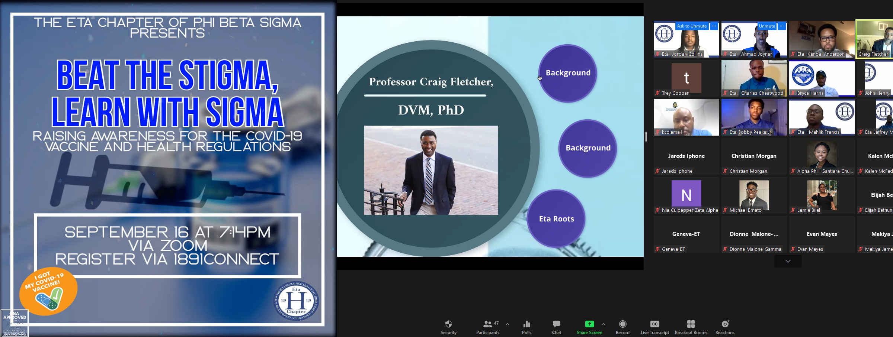

Program Success: **Excellent**

**Recommend this program for the future? Recommend**