Program Area Focus: Education

Black Spend Event?  Amount: Enter a decimal amount

Date: **10/9/2021** Location: Virtual

On **10/8/2021**, the Brothers of the Eta Chapter of Phi Beta Sigma Fraternity Incorporated hosted Man of the year, an annual event that takes place to provide men with an environment to openly discuss what it means to be a man. The target audience is freshman and sophomore male students, but we encourage all men to come. The topics are Financial Literacy, Networking and Branding, Relationships, Maintaining Personal Health, and Redefining Black Manhood.

**Goal:** to provide men with an environment to openly discuss what it means to be a man

|  |  |  |  |
| --- | --- | --- | --- |
| Natl Partner Fundraising Event? | Health Event? | BBB Event? | Education Event? |
|  |  |  |  |

Was there an Outside Speaker/Moderator?

Were funds dispersed?

Disbursement Type: Choose an item.

Funds Recipient: Choose an item.

Amount Dispersed: Enter amount.

The following brothers were involved in the program: *15* brothers participated in this effort. Out of that number, *2* provided materials.

**Total Number of Hours Served: 2 hours**

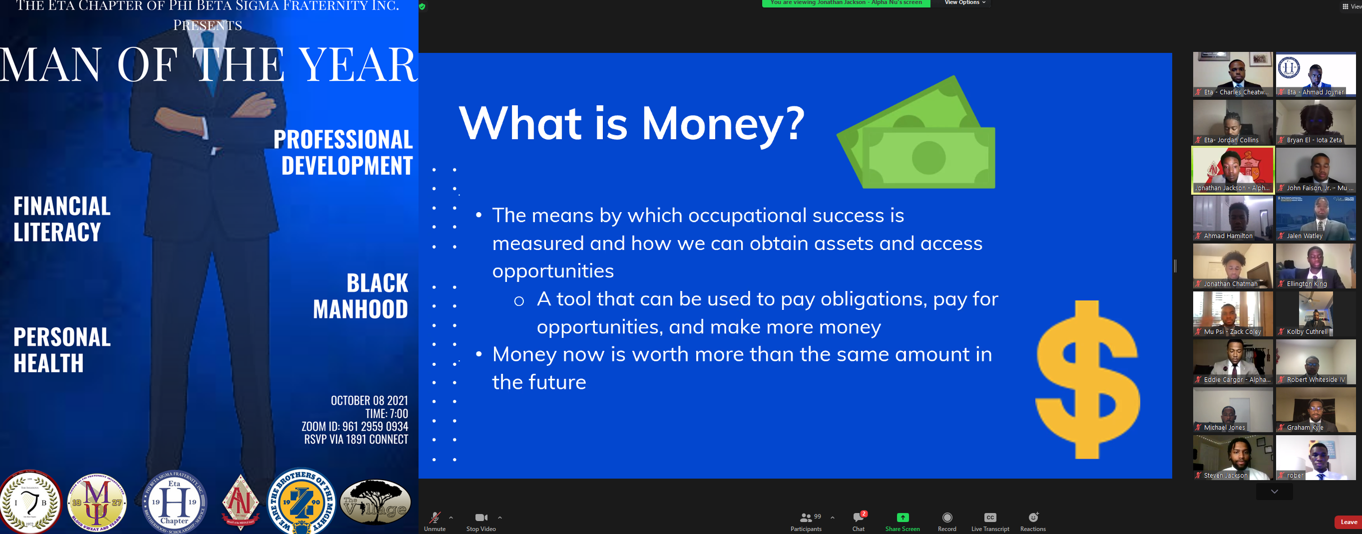

Program Success: **Excellent**

**Recommend this program for the future? Strongly Recommend**