Program Area Focus: Education

Black Spend Event?  Amount: Enter a decimal amount

Date: **8/30/2021** Location: Renaissance Shops, 2521 Phillips Ave

On **8/14/2021**, the Brothers of the Eta Chapter of Phi Beta Sigma Fraternity Incorporated volunteered in the “Back-to-School Resource Fair”. For this service opportunity, the Eta Chapter participated in handing out back-packs with school supplies within them (notebooks, pencils, paper, etc). Children were also educated on why primary school is important.

**Goal: Hand out school supplies to children in need**

|  |  |  |  |
| --- | --- | --- | --- |
| Natl Partner Fundraising Event? | Health Event? | BBB Event? | Education Event? |
|  |  |  |  |

Was there an Outside Speaker/Moderator?

Were funds dispersed?

Disbursement Type: Choose an item.

Funds Recipient: Choose an item.

Amount Dispersed: Enter amount.

The following brothers were involved in the program: *8* brothers participated in this effort. Out of that number, *8* provided materials.

**Total Number of Hours Served: 32 hours**

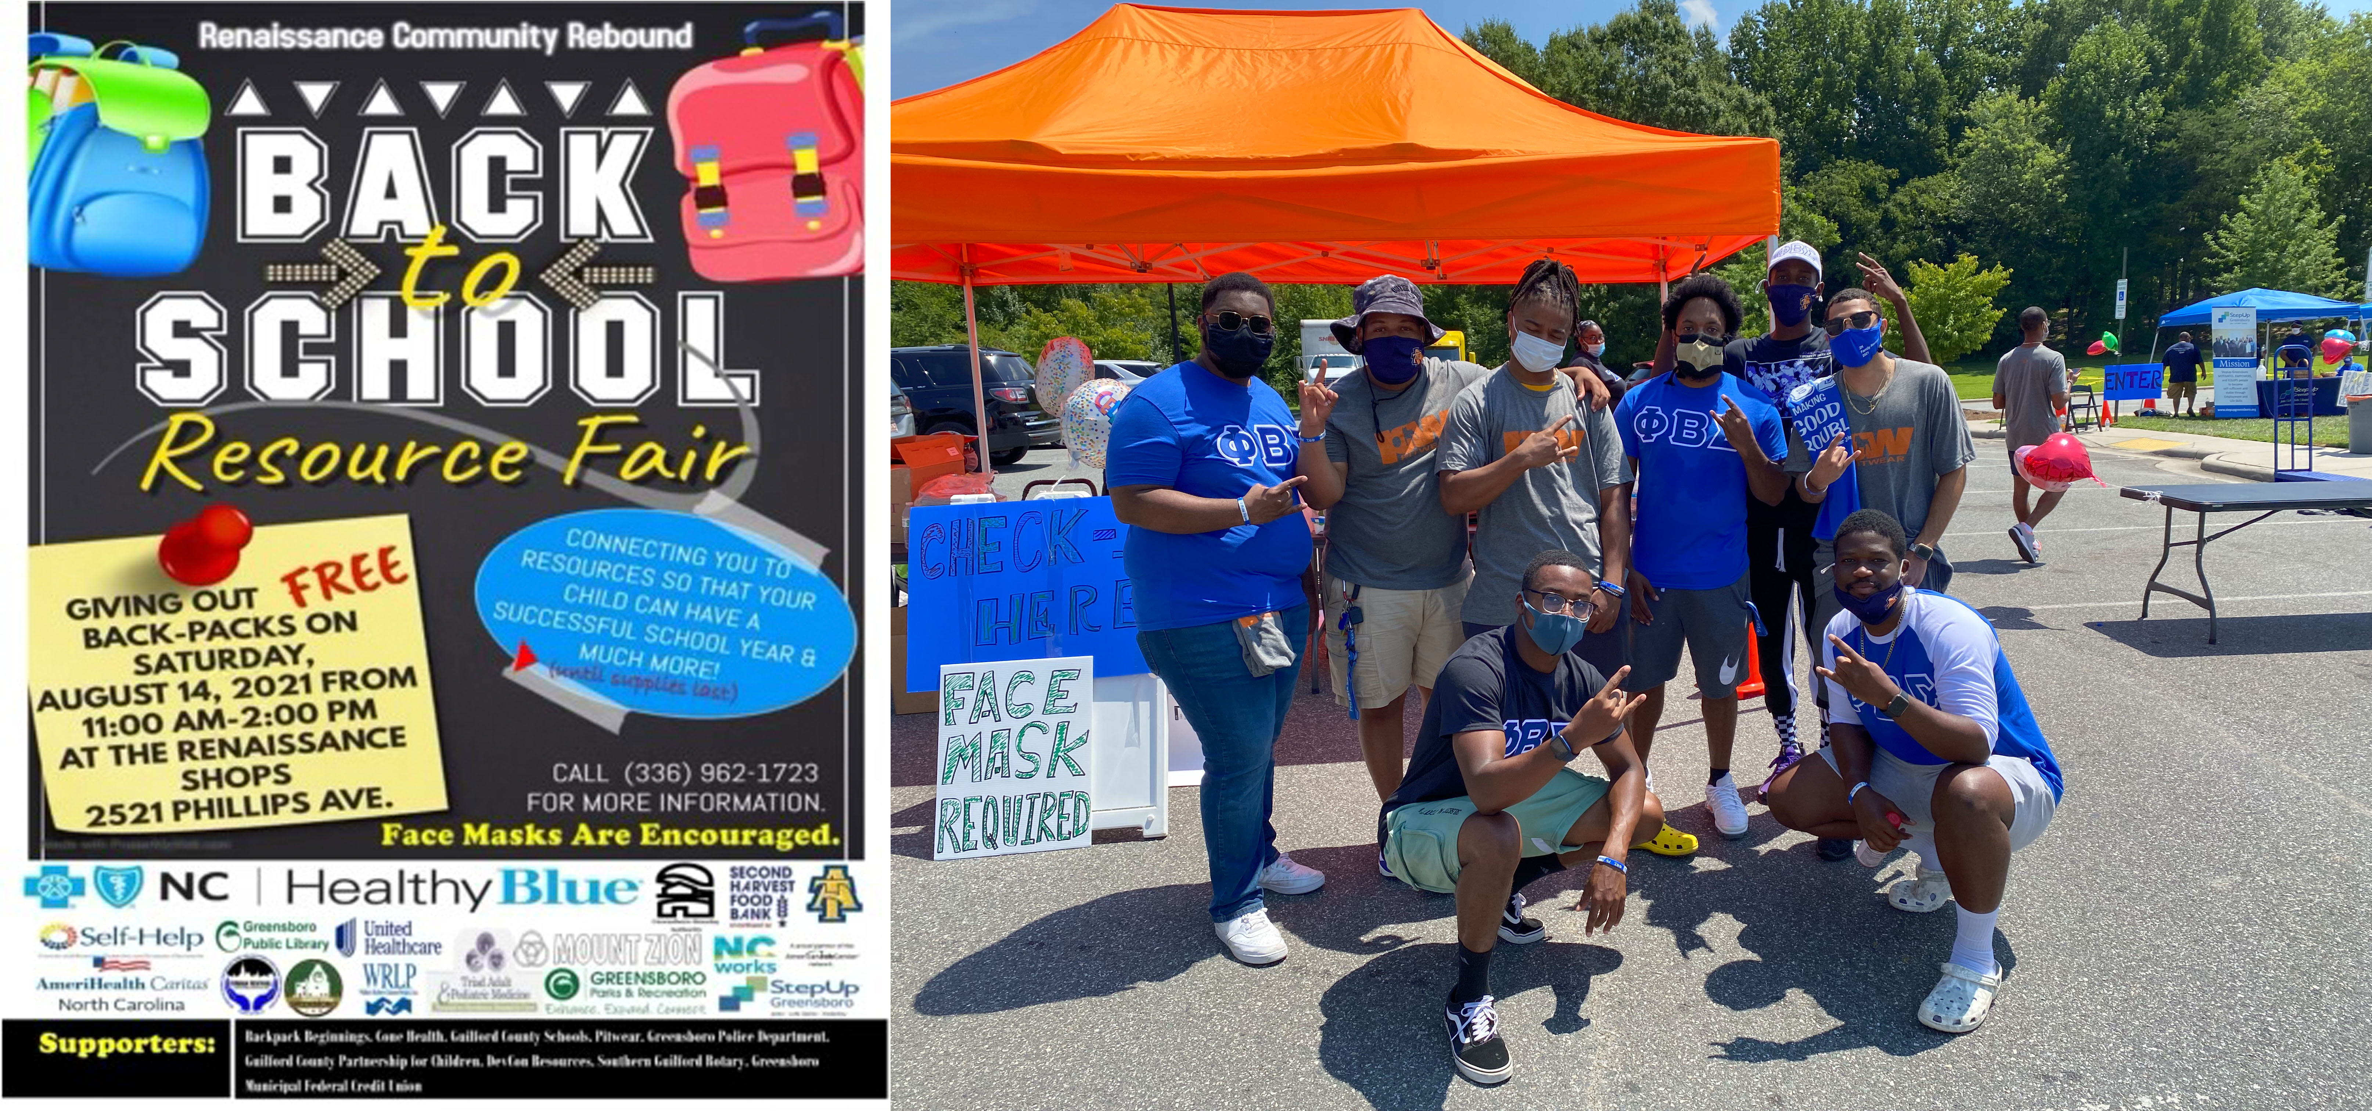

Program Success: **Excellent**

**Recommend this program for the future? Strongly Recommend**