Program Area Focus: Social Action

Black Spend Event?  Amount: Enter a decimal amount

Date: **5/2/2021** Location: Virtual

On **4/30/2021**, the Brothers of the Eta Chapter of Phi Beta Sigma Fraternity Incorporated raised funds and awareness to transform the health of all families! The Eta chapter created a March of Dimes team to help campaign and donate towards the event, with a goal of $600. Through the Phi Beta Sigma – Eta Chapter team we managed to raise $1,222.

**Goal: Raise $600.**

|  |  |  |  |
| --- | --- | --- | --- |
| Natl Partner Fundraising Event? | Health Event? | BBB Event? | Education Event? |
|  |  |  |  |

Was there an Outside Speaker/Moderator?

Were funds dispersed?

Disbursement Type: **Donation to Entity**

Funds Recipient: **March of Dimes**

Amount Dispersed: **$1,222.00**

The following brothers were involved in the program: *19* brothers participated in this effort. Out of that number, *19* provided materials.

**Total Number of Hours Served: 0 hours**

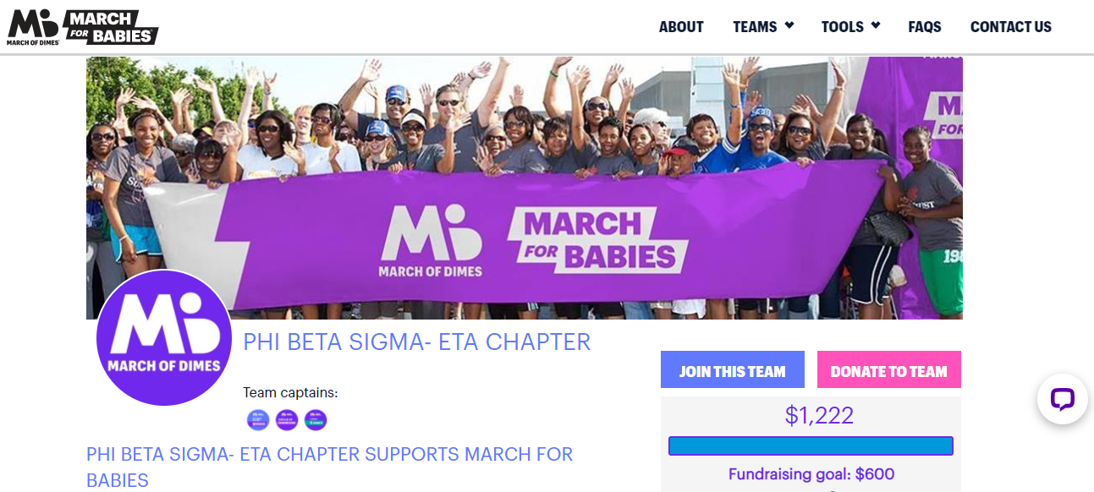

Program Success: **Excellent**

**Recommend this program for the future? Strongly Recommend**