

FINAL YEAR PROJECT

CBIT4106 – FINAL YEAR PROJECT

Programme: Bachelor of Information Technology
Year of Study: September 2025

Student name: Le Anh Tuan

Student ID: 2254030078
DEVELOPMENT OF A COMPREHENSIVE ENGLISH LEARNING MOBILE APPLICATION

LE ANH TUAN

A Final Year Project submitted in fulfilment of the requirements for the degree of Bachelor of Information Technology with Honours
Faculty of Technology and Applied Sciences Open University Malaysia
2026

DECLARATION

Name: Le Anh Tuan
Matric Number :2254030078

I hereby declare that this final year project is the result of my own work, except for quotations and summaries which have been duly acknowledged.

Signature: Date: 10/04/2026

MASCI: AN INTERACTIVE MATH AND SCIENCE LEARNING APPLICATION FOR MIDDLE SCHOOL STUDENTS

ABSTRACT
This final year project aims to develop a comprehensive, personalized, and interactive English learning mobile application to address the limitations of existing platforms. Built on a robust Client-Server architecture, the system utilizes Android (Kotlin) for the frontend and Spring Boot (Java) for the backend, supported by a MySQL database and secured via JWT. The application features dynamic assessments, a Smart Vocabulary Notebook integrating an external Dictionary API, and a highly personalized Spaced Repetition System (SRS) to track vocabulary memory levels. Furthermore, the integration of the Google Gemini AI API provides an intelligent chatbot tutor for real-time grammar and conversational support. Testing results indicate that the application is highly functional, scalable, and effectively enhances user engagement through strict effort-based study streak tracking.

Keywords: Mobile Learning, Spring Boot, Android, Spaced Repetition System, AI Chatbot.

ACKNOWLEDGEMENTS

I would like to take this opportunity to express my deepest gratitude and appreciation to my supervisor, MSc. Le Viet Linh, for his invaluable guidance, continuous encouragement, and immense patience throughout the development of this Final Year Project. His technical expertise and insightful feedback were instrumental in helping me navigate the complexities of building this English Learning Application using Spring Boot and Android.
I also wish to extend my sincere thanks to the Faculty of Information Technology at HUTECH University and Open University Malaysia (OUM) for providing a comprehensive academic foundation and the necessary resources to complete this degree.
Finally, I would like to express my heartfelt appreciation to my family and friends for their endless moral support, understanding, and encouragement whenever I faced programming challenges during this journey. Without the support of all the mentioned parties, it would have been impossible for me to complete this project successfully.

THANK YOU.

LE ANH TUAN
31 March, 2026

TABLE OF CONTENTS

[Table of Contents to be generated via Word References feature]

LIST OF TABLES

[List of Tables to be generated via Word References feature]

LIST OF FIGURES

[List of Figures to be generated via Word References feature]

LIST OF ABBREVIATIONS

Table 0.1: List of Abbreviations
ACID | Atomicity, Consistency, Isolation, Durability
AI | Artificial Intelligence
API | Application Programming Interface
DDL | Data Definition Language
ERD | Entity Relationship Diagram
FCM | Firebase Cloud Messaging
JWT | JSON Web Token
LLM | Large Language Model
RDBMS | Relational Database Management System
UAT | User Acceptance Testing

CHAPTER 1: INTRODUCTION
1.1 Background to the Study
The era of digital education is currently transitioning from passive learning via video consumption to requiring highly interactive, personalized experiences. However, infrastructural imbalances and an unequal distribution of highly qualified teachers continue to exacerbate Educational Inequity, particularly in the Southern and rural regions of Vietnam. Secondary school students in these areas face a continuous shortage of quality tutors and experience severe Pedagogical Friction when engaging with monotonous e-learning tools that lack deep cognitive guidance.
In the traditional educational setting, teachers are frequently overburdened with administrative tasks and the manual grading of hundreds of student assignments, which leads to burnout and restricts the time available for individualized student mentorship. The traditional 'one-size-fits-all' pedagogical approach is proving increasingly ineffective as it fails to address the unique learning pace and comprehension level of each student.
Simultaneously, the global technological sphere has witnessed a transformative boom in Artificial Intelligence (AI), particularly with the advent of Generative AI and Large Language Models (LLMs) such as ChatGPT and Google Gemini throughout 2023 and 2024. These advancements have created unprecedented opportunities for embedding AI-assisted learning into the core educational framework. Specifically, the emergence of Multimodal AI (capable of processing text, voice, and images concurrently) holds the immense potential to completely revolutionize traditional learning methodologies. By leveraging these cutting-edge technologies, the MaSci E-Learning platform is proposed as an urgent, innovative, and comprehensive solution to decentralize quality education, providing secondary school students with equitable access to intelligent, on-demand academic support.
- Communication Barrier: Inputting natural science formulas or mathematical equations via standard keyboards induces significant Cognitive Load, disrupting students' thought processes and creating a wide chasm between natural pen-and-paper reasoning and online submission environments.
- Feedback Gap: Traditional E-Learning systems primarily offer rigid True/False outcomes via multiple-choice quizzes. Conversely, during essay or subjective exercises, students require targeted identification of specific methodological errors (alleviating Pedagogical Friction) rather than simply obtaining the final result.
- Solution Dependency: The proliferation of immediate photo-solving applications conditions students to rely on instant results, effectively abandoning active analytical thinking. To counteract this, education platforms must integrate the Socratic Method—guiding students via layered questioning rather than spoon-feeding direct answers.
1.2 Problem Statement
Despite the proliferation of online educational platforms, the current state of digital education for secondary school students continues to suffer from several critical unresolved pain points:
Lack of 1-on-1 Interaction: The most significant drawback of self-study in existing online environments is the absence of immediate, personalized support. When students encounter a difficult mathematical problem or a complex scientific concept, traditional platforms merely offer static text or pre-recorded videos. These systems cannot act as a dedicated tutor to interactually analyze the student's specific misunderstanding, ask guiding questions, or suggest the correct step-by-step approach, leaving students frustrated and unmotivated.
Technological Barriers in Entering Mathematical Formulas: A major hurdle in digital science education is the complexity of inputting mathematical symbols via standard mobile or computer keyboards. Expecting secondary school students to learn and memorize complex syntaxes, such as LaTeX, shifts their cognitive load from focusing on mathematical reasoning to struggling with technological interfaces. This barrier makes students highly reluctant to submit assignments online. Consequently, capturing a photographic image of handwritten work becomes the most natural and optimal solution for students; however, traditional E-Learning systems lack the capability to automatically process and grade such visual inputs.
Limitations in Grading Methodology: Currently, most E-Learning systems rely heavily on multiple-choice questions for automated grading due to their technical simplicity. However, multiple-choice formats fundamentally fail to evaluate the step-by-step logical methodology and critical thinking process of a student. While handwritten essay assignments are pedagogically superior for assessing deep comprehension, they cannot be efficiently administered remotely because teachers simply do not possess the time required to manually review, decipher, and score hundreds of submitted exercise images.
Disjointed Content Management: From an administrative perspective, the management of learning resources is highly fragmented. Teachers expend an enormous amount of time and effort attempting to create, format, and update questions that contain complex molecular structures or mathematical formulas. The lack of a cohesive, user-friendly Web Admin dashboard severely hampers the continuous maintenance and scalability of current educational content.
1.3 Research Questions
In order to construct a robust foundation for the system's development and evaluate its effectiveness, this research addresses the following core questions:
1. How can a comprehensive 3-tier architecture (encompassing an Android mobile application, a React-based Web Admin, and a Spring Boot Backend) operate seamlessly and be optimized for a high-traffic E-learning platform?
2. What are the specific pedagogical and operational benefits of integrating Google's Gemini Multimodal AI for accurately grading and analyzing handwritten mathematical exercises?
3. How does the implementation of an automated progress tracking system (gamification streak) and a Socratic AI Tutor effectively improve the self-study motivation and academic perseverance of secondary school students?
1.4 Objectives of the Study
Primary Objective: The overarching goal of this project is to architect, develop, and successfully deploy the MaSci E-Learning platform—a fully comprehensive educational system that integrates advanced Artificial Intelligence to solve the inherent challenges of remote science education in Vietnam.
Specific Objectives:
- To engineer a secure, highly scalable Backend Server utilizing Spring Boot 3.2.5 and MySQL to handle data processing and user authentication securely via JWT.
- To develop a high-performance Web Admin portal using React 19, enabling teachers to effortlessly digitize multimedia theory and organize curriculum structures.
- To design an intuitive, responsive Mobile Application for the Android platform using Kotlin and Jetpack Compose, granting students seamless access to lectures and quizzes.
- To integrate Gemini AI to function as a Socratic AI Tutor capable of providing context-aware conversational feedback, and to leverage its multimodal capabilities to automatically grade submitted images of handwritten assignments.
1.5 Significance of the Study
The successful implementation of the MaSci platform brings profound and measurable impacts across four primary vectors:
- For Students: The platform essentially democratizes access to private tutoring. It provides a 24/7 AI tutor, personalizes learning trajectories, and instantly analyzes handwritten methodology to deliver immediate, constructive feedback, thereby dramatically enhancing self-study efficiency.
- For Teachers and Administrators: It radically reduces the exhaustive administrative workload associated with manually grading essay-based assignments. Furthermore, it provides a standardized, rich-text authoring system that streamlines the digitization of complex scientific content.
- For Society: On a macro level, the system acts as a catalyst for educational equity. It substantially narrows the gap in access to high-quality educational resources between metropolitan centers and rural or underprivileged geographical regions.
- For the Technical Community: The project serves as an empirical case study affirming the practical viability and high performance of synthesizing modern architectural frameworks (Spring Boot, Jetpack Compose, React) with state-of-the-art Generative AI APIs in a production-ready application.
1.6 Scope and Limitation
Scope: The scope of this study is strategically focused on secondary school students (specifically grades 6 through 9) studying within the Vietnamese educational curriculum, with an emphasis on natural science subjects. On the technological front, the student-facing platform is exclusively built for the Android operating system using Kotlin and declarative UI via Jetpack Compose. The administrative interface is constructed as a React 19 web application. The core logic and AI API integrations are managed exclusively through a Spring Boot backend infrastructure.
Limitations: Despite its robust architecture, the current iteration of the MaSci system possesses certain limitations. First, the mobile application does not currently support the iOS (Apple) platform, restricting access for a segment of smartphone users. Second, while the AI integration is highly advanced, grading accuracy may still be susceptible to a margin of error if the student's uploaded image is exceedingly blurry or if the handwriting is exceptionally illegible. Finally, the system currently lacks integrations with third-party online Payment Gateways, restricting the immediate deployment of premium monetization models.
1.7 Implementation Plan
The MaSci software development lifecycle is strictly executed following the Agile Scrum methodology across a comprehensive 16-week timeline. This iterative approach ensures flexibility, continuous integration, and consistent evaluation against core educational requirements. The development process is meticulously divided into distinct time-boxed Sprints. Initial Sprints are dedicated to rigorous Requirements Gathering and Architectural Design. Subsequent Sprints encompass the Backend Implementation, Database orchestration, and Web Admin development. Final Sprints focus intensely on cutting-edge AI Integration, Mobile UI construction, and exhaustive User Acceptance Testing (UAT).
Table 1.1: Project Implementation Gantt Chart
Phase | Key Tasks | Duration (Weeks)
Phase 1: Analysis & Design | Requirement scoping, UI/UX mockups, ERD design | Week 1 - Week 3
Phase 2: Core Backend | Spring Boot Setup, Security JWT, CRUD APIs | Week 4 - Week 7
Phase 3: Frontend Development | Jetpack Compose Mobile App, React Web Admin | Week 8 - Week 11
Phase 4: AI Integration | Google Gemini Prompt Engineering, Firebase Storage | Week 12 - Week 14
Phase 5: UAT & Deployment | User Acceptance Testing, Bug fixing, Final Launch | Week 15 - Week 16
As illustrated in Table 1.1, the iterative phases of the Agile model are allocated explicitly across a structured 16-week development timeline.
1.8 Definition of Terms
To ensure absolute clarity and optimize the academic reading experience, the following technical terminologies utilized throughout this report are defined:
- Multimodal AI: Advanced artificial intelligence models that possess the capability to simultaneously ingest, understand, and synthesize multiple forms of input data modalities—such as text, visual images, and auditory signals—to generate cohesive responses (e.g., Google Gemini).
- Socratic Method: A pedagogical approach predicated on asking continuous, open-ended, and thought-provoking questions. Within MaSci, the AI Tutor employs this method to skillfully guide students toward discovering the correct answers conceptually, rather than outright providing the final mathematical solution.
- JWT (JSON Web Token): A compact, URL-safe, open standard utilized for securely transmitting information and claims between two parties. In this architecture, it is fundamentally used to authenticate and authorize user sessions.
- Jetpack Compose: An innovative, modern declarative user interface toolkit provided by Google, designed to accelerate and simplify native UI development for Android applications.
- Single Page Application (SPA): An architectural pattern for web applications wherein a single HTML document is loaded, and subsequent interface components are dynamically retrieved and updated by JavaScript. This ensures a highly fluid user experience for the React Admin dashboard.
- Gamification: The strategic application of game-design elements, such as the 'Streak' progress tracking system implemented in MaSci, to a non-game context in order to maximize user engagement, competitiveness, and sustained learning motivation.
- MVVM (Model-View-ViewModel): A structural design pattern utilized in the Android application to facilitate a clear separation of graphical user interface development from the underlying business logic and data models.
- DTO (Data Transfer Object): An object specifically utilized to encapsulate and transport data across various subsystems or network layers (e.g., between the Spring Boot Backend and the front-end clients), ensuring secure and optimized data handling.

CHAPTER 2: LITERATURE REVIEW
2.1 Previous Studies and Existing Platforms
Feature | Khan Academy | Duolingo | Photomath | MaSci
Structured Curriculum | Yes | Yes | No | Yes
Handwritten Evaluation (AI) | No | No | Yes | Yes
Step-by-Step AI Tutor | Limited | No | No | Yes
Gamification (Streaks) | No | Yes | No | Yes
Vietnamese Localization | Partial | Yes | Yes | Native
Hocmai.vn Baseline | N/A | N/A | N/A | Enhancement
Olm.vn Native UI | N/A | N/A | N/A | Superior

In the rapid evolution of educational technology, several legacy platforms have established foundational paradigms for online learning. However, each system possesses inherent limitations that prevent holistic adoption in specialized regional contexts such as Vietnam.
Global e-learning giants like Khan Academy offer an exceptionally rich repository of instructional videos and exercises at zero cost, making them invaluable resources. Nevertheless, Khan Academy lacks a sophisticated mechanism to automatically grade handwritten mathematical assignments via image recognition and suffers from linguistic constraints, as its localized content is insufficiently aligned with the strict curriculum defined by the Vietnamese Ministry of Education.
Similarly, Duolingo has revolutionized self-paced learning by successfully integrating Gamification metrics (e.g., progress streaks, leaderboards) that drastically enhance user retention. However, Duolingo's architecture is singularly optimized for language acquisition, leaving a distinct void in the domain of complex natural sciences like Mathematics and Physics, where the visual structure of equations is paramount.
On the purely mechanical front, Photomath demonstrates incredible proficiency in optical character recognition (OCR) and step-by-step mathematical problem-solving from photographic inputs. Despite its computational brilliance, Photomath lacks a structured scholarly framework; it functions purely as an answering machine rather than an integrated educational ecosystem, completely devoid of lecture modules and progress tracking mechanisms.
Domestically, platforms such as Hocmai.vn and Olm.vn have addressed localized curriculum constraints successfully. Nonetheless, their legacy software architectures often rely on outdated graphical user interfaces. They lack deep native integration on modern mobile operating systems and are critically deficient in leveraging Conversational Artificial Intelligence to interactively guide secondary school students.
The Identified Research Gap: A rigorous comparative analysis reveals a glaring Research Gap within the Vietnamese market: There is no existing E-Learning ecosystem that successfully converges a localized academic syllabus with the cutting-edge capabilities of Multimodal AI for grading handwritten self-study assignments. MaSci is uniquely positioned to fill this gap, acting as the nexus between Gamification methodologies and highly interactive, AI-driven educational assessment.
2.2 Technology Stack and Architectural Justifications
The selection of the technological stack for the MaSci platform was not merely based on industry popularity, but rather on rigorous architectural justifications aimed at ensuring high security, real-time performance, and profound scalability.
Backend Infrastructure: Spring Boot 3.2.5 and MySQL
The core server-side logic and Application Programming Interfaces (APIs) are engineered using Spring Boot 3.2.5. The primary justification for its utilization is the framework's unparalleled stability, strict type safety, and the robust Spring Security module, which effortlessly manages JWT (JSON Web Token) filter chains for stateless, highly secure user authentication. Furthermore, MySQL serves as the primary relational database system. Notably, the project employs the 'ddl-auto=none' configuration property within Hibernate. This specific DBA (Database Administrator) best practice ensures that the schema is completely decoupled from application-driven auto-generation, migrating schema control exclusively to dedicated SQL scripts thereby preventing catastrophic, accidental data definition mutations in production environments.
Administrative Dashboard: React 19 and Vite
For the Web Admin interface, React 19 was explicitly chosen over its predecessors. The defining architectural logic behind this is the implementation of the new React Compiler, which natively optimizes complex UI re-renders without the manual overhead of utilizing 'useMemo' or 'useCallback'. This is particularly crucial for the administrative dashboard, which must seamlessly render heavy DOM (Document Object Model) trees injected with sophisticated third-party libraries such as CKEditor 5 for rich-text authoring and MathLive/KaTeX for real-time mathematical WYSIWYG input. The bundler, 'rolldown-vite', was selected to drastically reduce Hot Module Replacement (HMR) times, significantly accelerating the development cycle.
Frontend Mobile Application: Kotlin and Jetpack Compose
The student-facing platform is a native Android application developed strictly in Kotlin. Jetpack Compose was exclusively favored over traditional XML layouts because its declarative paradigm simplifies UI logic and naturally complements the Model-View-ViewModel (MVVM) architecture architecture adopted in the project.
2.3 Conceptual Framework and Educational Philosophy
The systematic engineering of the MaSci platform relies primarily on a Modular Monolith Architecture. This structure guarantees that highly cohesive domains (such as Authentication, Student Execution, AI Integration) are properly segregated logically, paving a seamless transition pathway should the platform necessitate an eventual migration to a Microservices Architecture.
In pedagogical terms, the conceptual framework vehemently opposes the notion of autonomous technology rendering human educators obsolete. Instead, the integration of Google Gemini is founded entirely on the philosophy of 'AI-Augmented Learning'. In this context, the Socratic AI serves strictly as an intellectual facilitator—functioning systematically to prompt students with interrogative cues rather than blindly supplying outright answers.
Crucially, the Multimodal AI integration acts strictly as an instrument for 'Formative Assessment'. Formative Assessment is an ongoing, real-time diagnostic process utilized to monitor student learning and provide immediate constructive feedback to improve ongoing educational outcomes. By automatically assessing structural methodology in handwritten documents via AI, students are instantly made aware of their minor logical missteps, fundamentally aligning the project with the apex of modern constructive educational theory.

CHAPTER 3: SYSTEM ANALYSIS AND DESIGN
3.1 Software Development Life Cycle (SDLC)
The development of the MaSci platform strictly adhered to the Agile Scrum methodology, employing a structured 16-week timeline consisting of iterative Sprints. This empirical approach allowed for continuous requirements gathering, dynamic architectural recalibration, and synchronized integration of cutting-edge AI technologies in parallel with traditional CRUD operations.
3.2 Requirement Analysis
In order to engineer a robust educational ecosystem, the system prerequisites were meticulously segmented into comprehensive functional boundaries and high-fidelity non-functional performance constraints.
3.2.1 Functional Requirements
The system guarantees the execution of fundamental business logic categorized into six distinct capability domains:
(1) Authentication & Authorization: Secure onboarding featuring JWT-based session persistence and password recovery mechanics.
(2) Theory Management: Hierarchical rendering of educational material spanning from Grade to distinct pedagogical Lessons.
(3) Exercise Execution: Allowing students to consume, solve, and digitally submit visual mathematical exercises.
(4) Quizzes & Analytics: Administration of multiple-choice evaluations culminating in the tabulation of progress streaks.
(5) AI Tutor Subsystem: Direct integration of Multimodal AI orchestrating handwritten diagnostic reviews and conversational dialog.
(6) Web Administration Dashboard: Empowering educators with rich-text mathematical entry systems and curriculum topology control.
3.2.2 Non-Functional Requirements
Performance Optimization: The platform guarantees high-speed telemetry, mandating that critical read queries traversing the Academic Concept clusters execute beneath a 1.5-second latency threshold under standard concurrent load.
Security Implementations: The system employs Stateless JWT mechanisms coupled with BCrypt geographic hashing protocols to unequivocally secure user credentials against rainbow-table vulnerabilities.
Internationalization (i18n): While initially deployed within the Vietnamese educational matrix, structural UI components are engineered adhering to i18n architectural boundaries to permit seamless future translation capabilities.
System Scalability: The architecture utilizes a rigid Modular Monolith layout across the Spring framework, allowing distinct functional domain isolation to ease future transitions directly into Microservices architecture as concurrent user traffic expands.
Graceful Error Handling: Core integrations involving Google API infrastructures possess rigorous fault tolerance via controlled try-catch blocks. Upon remote 500-level faults or timeouts, the platform circumvents total shutdown, projecting graceful degradation feedback interfaces directly to the end-user.
3.3 Use Case Analysis
This section presents the Use Case Analysis for the three primary functional domains of the MaSci E-Learning Platform. Each subsection contains a UML Use Case Diagram accompanied by a description table that enumerates actor roles and the <<include>> (mandatory) and <<extend>> (conditional) behavioral relationships. The three selected domains are: (1) Theory Study and AI Tutor, which models the Socratic pedagogical engine; (2) Exercises and Quizzes, which models the AI-automated handwriting grading pipeline; and (3) Web Administration — Users, Submissions and Dashboard, which models the administrator's monitoring and moderation capabilities.
3.3.1 Theory Study and AI Tutor (Mobile Application)
Figure 3.7 models the complete learning and tutoring workflow on the Android application. Two actors participate: Student (primary) and AI System — Google Gemini (supporting external system). The diagram comprises two functional sub-clusters: Theory Learning and AI Tutor.
In the Theory Learning sub-cluster, content navigation is governed by a mandatory three-level <<include>> chain: View Lesson List <<includes>> View Chapter List; View Lesson Content <<includes>> View Lesson List. This chain enforces the backend API call sequence (GET chapters -> GET lessons -> GET content) and prevents a student from accessing lesson content without first selecting a valid chapter and lesson. Mark Lesson as Complete <<includes>> Update Subject Progress, which invokes POST /progress/mark-complete to atomically update the lesson_completion table and recalculate the subject completion percentage used by the Home Screen dashboard. Watch YouTube Video is an <<extend>> activated only when lesson.video_url is non-null.
In the AI Tutor sub-cluster, Chat with AI Tutor <<includes>> Create New Chat Session — the AiChatSession MySQL entity is created or retrieved before the Gemini API is invoked, ensuring every conversation has a persistent session record. Chat with AI Tutor also <<extends>> View Lesson Content, making the AI tutoring entry point accessible directly from the lesson screen. View Chat History and Delete Chat History are optional extensions for session management.
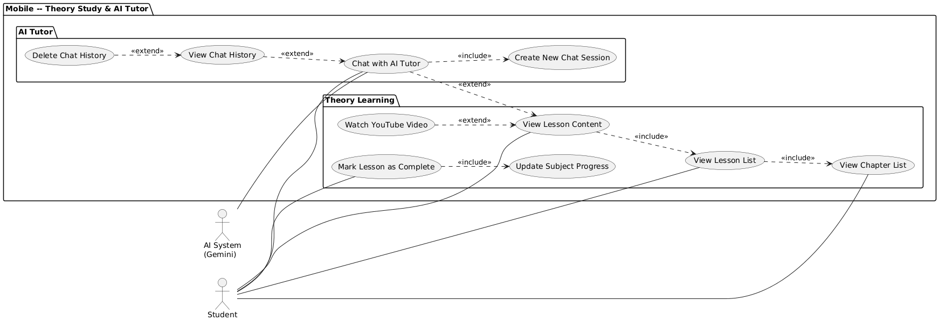
Figure 3.1 -- Theory Study and AI Tutor Use Case Diagram
Table 3.1 describes each element of Figure 3.1:
Element | Type | Description
Student | Primary Actor | Navigates chapters/lessons; marks completion; initiates AI Tutor chat
AI System (Gemini) | Supporting Actor | Receives serialized context array; returns Socratic hint via REST API
View Chapter List | Base Use Case | Entry point: GET /subjects/{id}/chapters
View Lesson Content | Base Use Case | Loads LaTeX content body via GET /lessons/{id}
Mark Lesson as Complete | Base Use Case | POST /progress/mark-complete — updates lesson_completion + recalculates streak
Chat with AI Tutor | Primary Use Case | Sends message to AiTutorController with full context-injection
Create New Chat Session | <<include>> | Mandatory — AiChatSession created/reused before every Gemini call
Update Subject Progress | <<include>> | Mandatory — subject completion % atomically updated on mark-complete
Watch YouTube Video | <<extend>> | Optional — only active when lesson.video_url is non-null
View Chat History | <<extend>> | Optional — student reviews prior Socratic conversation threads
Delete Chat History | <<extend>> | Optional — student resets session; DELETE /ai-tutor/sessions/{id}
3.3.2 Exercises and Quizzes (Mobile Application)
Figure 3.8 depicts the most technically complex student-facing use case domain: handwritten exercise submission with AI-automated grading, and MCQ quiz assessment. Two actors participate: Student (primary) and AI System — Google Gemini (supporting). The diagram contains two sub-clusters: Exercises and Quizzes.
The Submit Handwritten Answer use case triggers a mandatory four-step <<include>> chain constituting the AI Grading Pipeline: (1) Request Signed Upload URL — the backend calls FirebaseStorageService.generateSignedUploadUrl(), returning a time-limited HTTP PUT endpoint scoped to the specific exercise; (2) Upload Image to Firebase — the Android client performs a direct binary PUT to Firebase Storage, bypassing the Spring Boot server entirely to prevent JVM heap memory exhaustion; (3) Grade Submission via AI — the backend constructs a multimodal JSON payload combining a four-criteria natural-language prompt with the Base64-encoded image and dispatches it to the Gemini REST endpoint; (4) Save Submission Result — the structured AI response (isValid: Boolean, aiReason: String) and the image's permanent publicUrl are persisted to the exercise_submissions MySQL table. View Hint and View Sample Solution are optional <<extend>> use cases available on demand. Take Quiz <<includes>> Save Quiz Score, and View Answers and Explanation is an <<extend>> available only after the quiz is formally submitted.
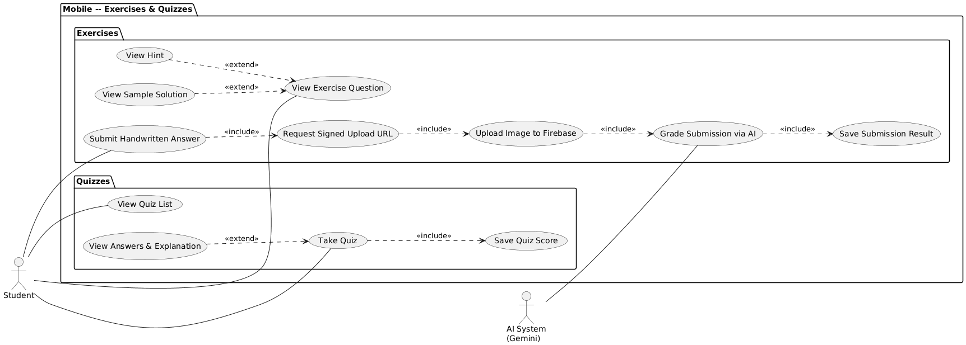
Figure 3.2 -- Exercises and Quizzes Use Case Diagram
Table 3.2 describes each element of Figure 3.2:
Element | Type | Description
Student | Primary Actor | Photographs handwritten solutions; takes MCQ quizzes; reviews results
AI System (Gemini) | Supporting Actor | Evaluates multimodal payload; returns {isValid, aiReason} JSON
Submit Handwritten Answer | Primary UC | Triggers 4-step AI Grading include chain
Request Signed Upload URL | <<include>> | Step 1 — GET /exercises/{id}/upload-url; server generates Firebase PUT URL
Upload Image to Firebase | <<include>> | Step 2 — Client direct binary PUT; Spring Boot server memory untouched
Grade Submission via AI | <<include>> | Step 3 — 4-criteria Gemini prompt + Base64 image dispatched to Cloud
Save Submission Result | <<include>> | Step 4 — Persist isValid + aiReason + publicUrl to exercise_submissions
Take Quiz | Primary UC | Student answers MCQ within countdown timer (CountDownTimer + StateFlow)
Save Quiz Score | <<include>> | Mandatory — POST /quizzes/{id}/submit stores integer score to quiz_results
View Hint | <<extend>> | Optional — scaffolding revealed on student demand
View Sample Solution | <<extend>> | Optional — reference solution after attempt
View Answers & Explanation | <<extend>> | Optional — post-submission correctness review with LaTeX explanations
3.3.3 Web Administration -- Users, Submissions and Dashboard
Figure 3.9 models the administrative monitoring and moderation use case domain within the React 19 Web Administration Portal. A single actor participates: System Admin. Three functional sub-clusters are present: Dashboard, User Management, and Submission Review.
The View Overview Statistics use case (GET /api/admin/dashboard) aggregates platform-wide metrics — total students, daily active users, submission counts, and average quiz scores — using pre-computed SQL COUNT and AVG queries executed by AdminDashboardController. View Student Learning Profile is an <<extend>> representing an optional drill-down to the individual student engagement timeline (GET /api/admin/dashboard/student/{id}). In the User Management sub-cluster, Search Users and Delete User Account are both <<extend>> use cases of View User List: search applies a keyword filter on demand, while Delete User Account (DELETE /api/admin/users/{id}) is a destructive moderation action that triggers ON DELETE CASCADE across all foreign-keyed student data entities including lesson_completion, quiz_results, exercise_submissions, and ai_chat_sessions. In the Submission Review sub-cluster, View All Submissions mandatorily <<includes>> both View Handwritten Image and View AI Grading Result, as a submission record without its image URL or AI evaluation verdict has no administrative value.
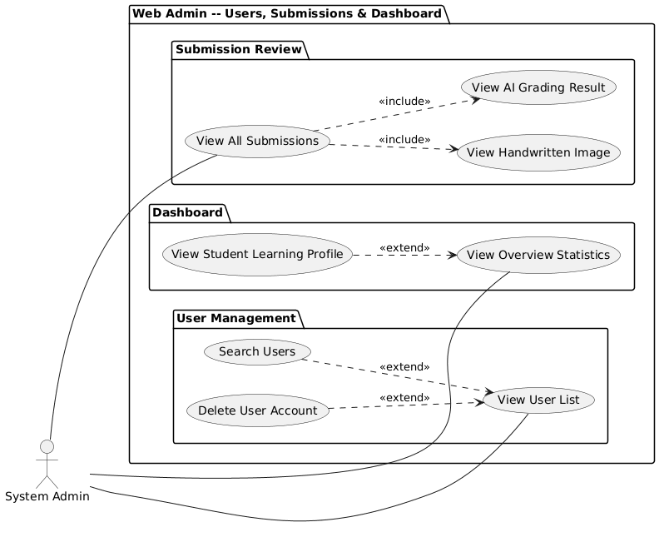
Figure 3.3 -- Web Admin: Users, Submissions & Dashboard Use Case Diagram
Table 3.3 describes each element of Figure 3.3:
Element | Type | Description
System Admin | Primary Actor | Monitors platform health; moderates users; inspects AI grading outcomes
View Overview Statistics | Primary UC | GET /api/admin/dashboard — COUNT/AVG aggregations over all student data
View Student Learning Profile | <<extend>> | Optional drill-down — GET /admin/dashboard/student/{id}
View User List | Primary UC | GET /api/admin/users — paginated registered accounts
Search Users | <<extend>> | Optional — keyword filter applied to user list table on demand
Delete User Account | <<extend>> | Optional — DELETE /api/admin/users/{id}; cascades across all FK tables
View All Submissions | Primary UC | GET /api/admin/submissions — all exercise submission records
View Handwritten Image | <<include>> | Mandatory — publicUrl always displayed alongside submission row
View AI Grading Result | <<include>> | Mandatory — isValid + aiReason always shown per submission
Table 3.3: Use Case Descriptions -- Web Admin Dashboard (Figure 3.9)
Figure 3.4 illustrates the core business flow of the learning journey on the mobile application. The process begins when the learner accesses a specific chapter; at this point, the application executes an external API call to load the corresponding list of modular lessons from the backend database.
The first and most critical decision node lies in the system evaluating the boolean condition 'Is an instructional video attached to the lesson?'. This structural design allows the platform to flexibly handle multiple contextual formats: if the lesson contains a video link (such as YouTube via an iframe), the system embeds the multimedia player directly into the interface; conversely, if the lesson is purely theoretical, the UI renders mathematical formulas alongside Rich Text leveraging the native Markwon Android library.
Parallel to the continuous theoretical ingestion process, the system concurrently provisions an extended execution branch (Extend) allowing the learner to 'Ask the AI Tutor' at any temporal moment. This auxiliary sub-flow assists learners in resolving ambiguous queries instantaneously without navigating away from the active lesson context. Ultimately, assuming standard execution, the workflow concludes at the 'Mark as Complete' step. At this juncture, the application asynchronously triggers an API sequence to update the lesson state, logging the progress into the lesson_completion table. This definitive action not only enables the learner to track individual knowledge progression but also feeds analytical telemetry into the gamification engine to recalculate learning streaks.
3.4 System Architecture
The foundational stability of the MaSci ecosystem is explicitly defined by its macroscopic 3-Tier Distributed Architecture.
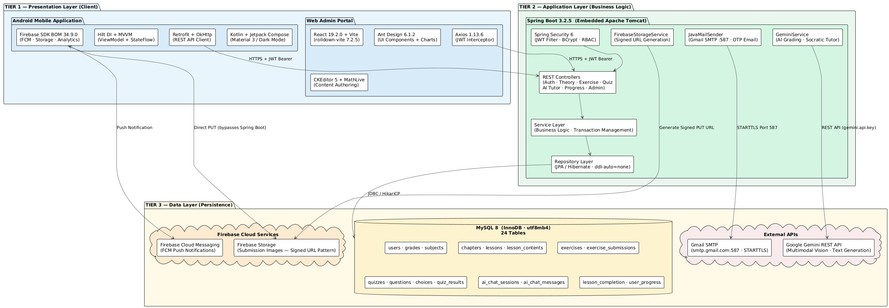
Presentation Tier (Client Layer): This tier comprises bifurcated interfaces. The primary student interaction channel is the native Android Application, systematically constructed utilizing Kotlin and the declarative Jetpack Compose framework. Conversely, the Web Admin dashboard strictly leverages the React 19 framework to power responsive, dense-data matrices via DOM manipulations.
Application Tier (Business Logic Layer): Acting as the central nervous system, this tier revolves unequivocally around the Spring Boot 3.2.5 enterprise framework. Operating via embedded Apache Tomcat HTTP interfaces, it acts as the authoritative REST API dispatcher. This tier houses security middleware, enforces declarative transaction schemas, and controls execution logic orchestrations (via designated Controller-Service-Repository DTO pipelines).
Data Tier (Persistence Layer): Physical data is segregated fundamentally by access pattern methodologies. Core structured relational persistence relies directly upon the MySQL InnoDB mechanism. In synchronized parallel, the Firebase Cloud Storage bucket governs heavy static Asset management, persisting localized profile pictures alongside cryptographic Signed URL image representations originating from academic submissions.
3.5 Database Design
A highly optimized physical schema operates as the bedrock for the platform's intensive I/O throughput matrix. Comprising an exact 24-entity mapping topology, the database hinges completely on relational MySQL constraints.
To systematically manage the complexity of 24 interconnected entities, the Entity Relationship Diagram (Figure 3.5) is analytically segmented into three primary logical data clusters, intercommunicating strictly through rigorous Foreign Key constraints:
1. User & Authentication Cluster: This encompasses the users, student_profiles, password_reset_tokens, and registration_otps tables. This cluster assumes exclusive responsibility for identity management, personal data isolation, and enforcing the security lifecycle of the account.
2. Academic Content Cluster: Designed operating a Cascading Tree hierarchical model, this incorporates the sequence of grades -> subjects -> chapters -> lessons and quizzes. This specific schema allows the academic syllabus to be organized systematically. The ON DELETE CASCADE constraint is widely applied within this geographical subset; for instance, if an overarching 'chapter' is administratively purged, all structurally dependent 'lessons' residing underneath it are automatically eradicated, definitively preventing database orphan anomalies.
3. Interaction & Progress Cluster: This acts as the telemetry recorder for student mechanics, incorporating tables such as lesson_completion, quiz_results, exercise_submissions, and the conversational AI subset (ai_chat_sessions, ai_chat_messages). A profound architectural configuration within this group is the rigid foreign key linkage connecting ai_chat_sessions and exercises (via exercise_id), enabling the overarching system to meticulously trace the specific academic context whenever the student initiates an interaction with the AI Tutor.
Figure 3.5: System Entity-Relationship Diagram (ERD)

3.5.2 Data Dictionary
To optimize the presentation while maintaining analytical depth, the Data Dictionary below meticulously details the 17 core entity tables categorically mapping the primary business constraints. The remaining generic tables (e.g., OTP registries, isolated settings) are securely relegated to Appendix B.
Group 1: Global Identity Management
Table 3.3: Structure of 'users' Table
(Description: The foundational root encompassing system identity, authentication tokens, and gamification gameworld statistics.)
Field Name | Data Type | Constraint | Description
id | BIGINT | PK, AUTO_INCREMENT | Global Unique identifier
email | VARCHAR(255) | UNIQUE, NOT NULL | Login credential boundary
password | VARCHAR(255) | NOT NULL | BCrypt encrypted payload
current_streak | INT | DEFAULT 0 | Gamification consecutive days
fcm_token | VARCHAR(255) | NULL | Firebase Cloud Messaging token

Group 2: Academic Content Organization
Table 3.4: Structure of 'grades' and 'subjects' Tables
(Description: Maps the uppermost tiers of the pedagogical Cascading Tree. Forces strict structural boundaries between logic domains (e.g., Math Grade 6 vs. Science Grade 7).)
Field Name | Data Type | Constraint | Description
id (grades/subjects) | INT | PK | Primary identification vector
code | VARCHAR | UNIQUE | Logical mapping constant (e.g., K7)
grade_id (subjects) | TINYINT | FK (grades.id) | Parent reference mapping
name_en | VARCHAR | NULL | i18n translation string

Table 3.5: Structure of 'chapters' and 'lessons' Tables
(Description: Granular sequential structure enforcing syllabus constraints. ON DELETE CASCADE strictly prevents orphan arrays when curriculum changes occur.)
Field Name | Data Type | Constraint | Description
id | BIGINT | PK, AUTO_INCREMENT | Unique identifier
subject_id / chapter_id | BIGINT | FOREIGN KEYS | Cascading parent bindings
title_vi | VARCHAR | NOT NULL | Standardized Vietnamese title
sequence_order | INT | NOT NULL | Display hierarchy logic

Table 3.6: Structure of 'lesson_contents' Table
(Description: Crucial for rendering diverse pedagogies. The content_type field explicitly dictates whether the Client UI should instantiate a YouTube Video or invoke Markwon Rich Text parsers.)
Field Name | Data Type | Constraint | Description
id | BIGINT | PK | Data node locator
lesson_id | BIGINT | FK (lessons.id) | Target lesson
content_type | ENUM | NOT NULL | 'VIDEO' or 'IMAGE' or 'TEXT'
content_body | TEXT | NULL | Markdown/KaTeX theoretical body
video_url | VARCHAR | NULL | External multimedia source URL

Group 3: Exercise & AI Validation Flow
Table 3.7: Structure of 'exercises' and 'exercise_solutions' Tables
(Description: Persists mathematical problem statements and multi-tiered scaffolding hints (triggering sequentially at 2-minute, 5-minute intervals) to autonomously guide struggling learners.)
Field Name | Data Type | Constraint | Description
id | BIGINT | PK | Atomic assignment identifier
lesson_id | BIGINT | FK (lessons.id) | Contextual mapping locus
prompt_content | TEXT | NOT NULL | The actual mathematical prompt
hint1 / hint2 / hint3 | TEXT | NULL | Temporal scaffolding intervals
solution_value | TEXT | NOT NULL | Absolute ground-truth algorithm

Table 3.8: Structure of 'exercise_submissions' Table
(Description: The epicenter of the AI Grading capabilities. image_url explicitly persists Firebase Signed URLs, whereas score and ai_reasoning dynamically update following Google Gemini inference callbacks.)
Field Name | Data Type | Constraint | Description
id | BIGINT | PK | Unique record identifier
user_id | BIGINT | FK (users.id) | Student invoking submission
exercise_id | BIGINT | FK (exercises.id) | Targeted exercise ID
image_url | TEXT | NOT NULL | Firebase Storage secured URL
is_valid | BOOLEAN | NOT NULL | Failsafe validation mechanism
score | DOUBLE | NULL | Computed Multimodal AI score
ai_reason | TEXT | NULL | Gemini's heuristic assessment

Group 4: Quiz & Progress Telemetry
Table 3.9: Structure of 'quizzes', 'questions' and 'choices' Tables
(Description: Highly segregated tables separating the Assessment structure (quizzes), generic mathematical questions, and their respective correct/incorrect Boolean choices.)
Field Name | Data Type | Constraint | Description
id | BIGINT | PK | Unique node identifier
quiz_id / question_id | BIGINT | FOREIGN KEYS | Strict dependency mappings
content_type | ENUM | TEXT or IMAGE | Visual payload format declaration
explanation_en | TEXT | NULL | Post-submission reasoning data
is_correct | BOOLEAN | DEFAULT FALSE | Ground truth delimiter (choices)

Table 3.10: Structure of 'quiz_results' and 'progress' Tables
(Description: Radically optimizes query execution architecture via deliberate 3NF denormalization. Persisting the final holistic percentage score globally circumvents exhaustive real-time computation logic.)
Field Name | Data Type | Constraint | Description
id | BIGINT | PK | Unique telemetry identifier
user_id | BIGINT | FK (users.id) | Executing learner
score / percentage | DOUBLE | NOT NULL | Post-calculation performance metric
progress_percent | DOUBLE | DEFAULT 0.0 | Holistic mastery tracking
completed_at | DATETIME | NULL | Verification chronological stamp

Group 5: Conversational AI Environment
Table 3.11: Structure of 'ai_chat_sessions' Table
(Description: Acts as the primary anchor for maintaining Context injection arrays. The nullable exercise_id permits the AI to function either holistically or strictly bound to a singular mathematical assignment.)
Field Name | Data Type | Constraint | Description
id | BIGINT | PK | Execution context boundary root
user_id | BIGINT | FK (users.id) | Session owner pointer
exercise_id | BIGINT | FK (exercises.id) | Specific assignment mapping (Optional)
created_at | DATETIME | DEFAULT CURRENT | Timestamp vector initialization

Table 3.12: Structure of 'ai_chat_messages' Table
(Description: The foundational chronologic array driving the Socratic AI logic subsystem. The 'role' attribute isolates message origins (USER vs. ASSISTANT), enabling the Backend API wrapper to correctly serialize Context Windows.)
Field Name | Data Type | Constraint | Description
id | BIGINT | PK | Chronological message node
session_id | BIGINT | FK (ai_chat_sessions.id) | Master conversation chain link
role | VARCHAR(10) | NOT NULL | 'USER' or 'ASSISTANT' designation
content | TEXT | NOT NULL | Dense mathematical payload string
created_at | DATETIME | DEFAULT CURRENT | Timestamp vector mapping

3.6 Process Design — System Flowcharts
3.6.1 Learning Journey Flowchart
[1. Business Logic & Initiation]
Figure 3.6 illustrates the core business flow of the learning journey on a mobile application. The initialization process occurs when a student accesses a specific lesson; at this point, the client application makes a synchronous API call to load the list of lessons and corresponding detailed content from the database.
[2. Decision Nodes & Content Rendering]
The most important branching point (Decision node) in the flow is the system's determination of 'Does the lesson include a video?'. This logical design allows the platform to flexibly handle multimedia content: if the lesson contains a video link (True), the system will automatically embed the live player into the interface. Conversely, if it is a purely theoretical lesson (False), the interface will focus on displaying text (Rich Text) and smoothly rendering inline mathematical formulas through the WebView and KaTeX libraries.
[3. Parallel Interaction (Extend)]
Throughout the learning process, the system provides an extended flow (Extend) allowing learners to 'Ask the AI ​​Tutor' at any time. This architectural design helps learners immediately resolve theoretical issues without leaving the current lesson screen, ensuring uninterrupted thought processes and learning experiences (UX).
[4. Database Commitment & Gamification Trigger]
After completing the learning and interaction, the main flow proceeds to the 'Mark as Complete' step. Here, the application sends a request (HTTP POST) to update the status, recording progress directly in the lesson_completion table in the MySQL database management system. This recording action not only tracks learning history but also acts as a core trigger for the Gamification system on the backend to calculate and update the consecutive learning day streak and statistical graphs for the learner.
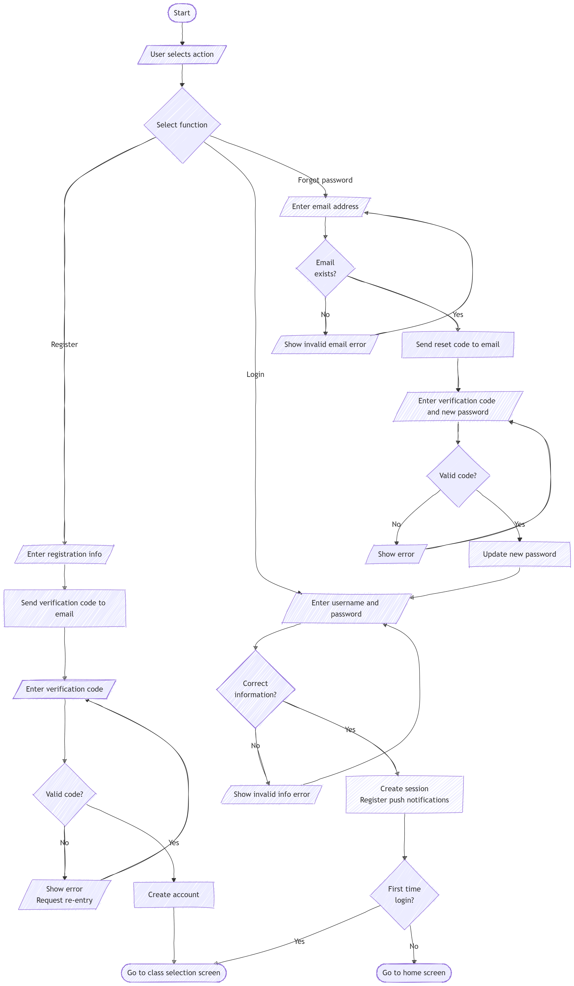

Figure 3.6: Learning Journey Flowchart
3.6.2 Assignment Submission and AI Grading Flowchart
Figure 3.7 illustrates the most complex business execution flow of the platform: Assignment Submission and Automated AI Grading... To absolutely guarantee high-fidelity input data for the AI engine, the system enforces a stringent Two-tier Exception Handling mechanism.
The primary tier of validation executes natively on the Client device (Mobile App): the system mandates the logical heuristic decision node 'Is the captured image sharp and adequately lit?'. If the localized verification algorithm detects a motion-blurred image, the execution flow diverges along the False branch to display a strict alert requesting a resubmission. If the image clears this local validation hurdle (True), the application requests a secure, time-sensitive Signed URL from Firebase, subsequently pushing the image payload directly onto the cloud via an HTTP PUT request.
The secondary exception tier occurs strictly within the designated server-side AI Validation architecture. Consequent to a verified cloud upload event, the backend infrastructure delegates the image analysis operation directly to the Google Gemini API. At the crucial semantic decision node 'Is the submission valid for AI grading?', the generative model evaluates the visual mathematical context. Should Gemini detect an absence of logic structures, it returns an explicit invalidation flag coupled with an analytical diagnostic string. Conversely, should the submission be definitively validated as mathematically sound, the execution flow proceeds unchallenged into the terminal execution phase: logging the evaluated empirical score into the database.
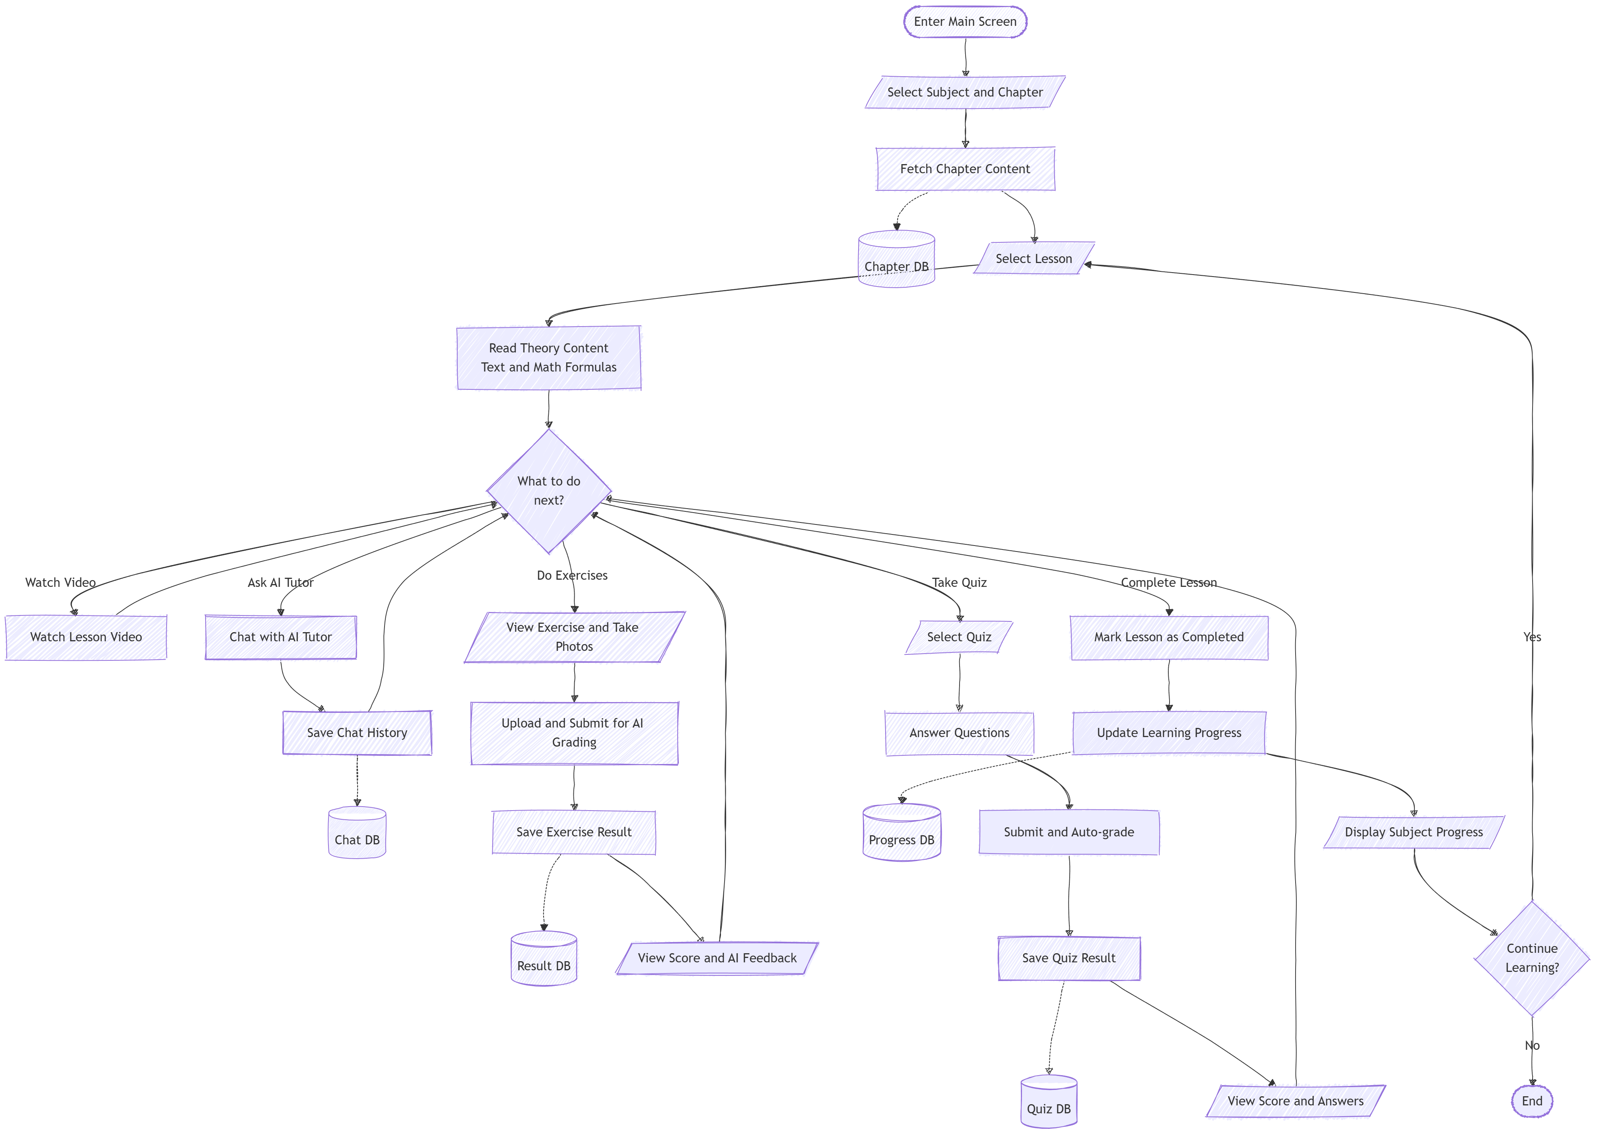
Figure 3.7: Assignment Submission and AI Grading Flowchart
3.6.3 Quiz Generation and Execution Flowchart
[1. Business Logic and Configuration]
Figure 3.8 models the end-to-end business logic of the Quiz Generation and Execution module, spanning both the Web Administration Portal (teacher side) and the Android Mobile Application (student side). The administrative flow initiates when the teacher creates a new quiz record in the system. The backend persists the quiz configuration parameters — lesson_id (subject scope), time_limit_minutes (countdown duration), and total_questions (validation threshold) — to the quizzes table via QuizAdminController (POST /api/admin/quizzes). This configuration record acts as the structural container for all subsequent question data.
[2. Data Population and Decision Logic]
Following quiz initialization, the system transitions to the Data Population phase. The critical decision node in this flowchart is the validation gate: 'Sufficient questions added?'. This node implements a Validation Loop — a repeating conditional check that prevents quiz publication until the number of inserted questions reaches the configured total_questions threshold. While the condition evaluates to False, the teacher continues adding question records to the questions table and their associated answer options to the choices table, each choice carrying an is_correct flag. Once the threshold is satisfied (True), the teacher may set the quiz status to Published, making the quiz visible to students in the mobile application via GET /api/quizzes/filter.
[3. Client Execution and Graceful Timeout Handling]
On the mobile client side, when the student initiates a quiz session, the Android application loads the complete question payload in a single API call (GET /api/quizzes/{id}/questions). A CountDownTimer instance is initialized with the configured time_limit_minutes value. The flowchart captures a critical exception-handling branch: the continuous check 'Time expired?' that runs in parallel with the student's interaction. If the countdown reaches zero while the student has not yet submitted — i.e., the condition evaluates to True — the application triggers a Graceful Force-Submit sequence: the answer selection state is locked, the UI is frozen, and the collected answers are automatically dispatched to the backend via POST /quizzes/{id}/submit. This mechanism preserves assessment integrity and prevents data loss for partially completed quizzes.
[4. Evaluation, Persistence and Gamification Feedback]
Upon receiving the submission payload, the backend's QuizUserController iterates over each submitted choice and cross-references its choice_id against the is_correct flag in the choices table. The final integer score is calculated as the count of correct answers. Two persistence operations are then executed atomically: the score, quiz_id, and user_id are written to the quiz_results table (POST /quizzes/{id}/submit), and the API response is dispatched to the mobile client. The Jetpack Compose UI renders the final score with immediate Visual Feedback — displaying the result alongside correct/incorrect indicators for each question. This gamification feedback loop directly contributes to the student motivation engine by surfacing score progress in the HomeScreen dashboard and fueling the learning streak calculation.
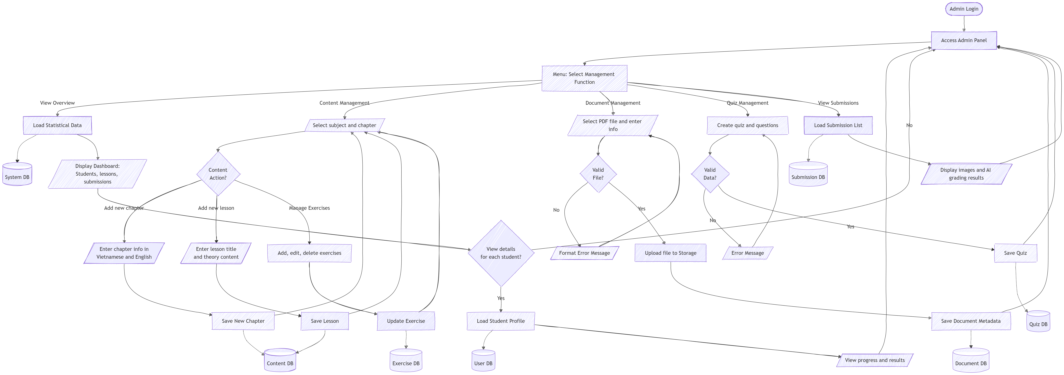
Figure 3.8: Quiz Generation and Execution Flowchart
3.7 Sequence Diagrams
Sequence diagrams are heavily utilized to structurally demonstrate inter-object communication sequences and object lifecycles across the systemic architecture. To highlight the sophisticated core technical operations of the MaSci platform, the analysis intentionally isolates the two most complex artificial intelligence workflows.
3.7.1 AI Grading Sequence Diagram
[1. Business Logic & Purpose]
The Sequence Diagram (Figure 3.9) illustrates the most computationally complex processing flow of the system: Assignment Submission and Automated AI Grading. The primary objective of this flow is to replace manual interventions from human educators, providing immediate formative feedback mechanisms for the student's handwritten mathematical exercises.
[2. Step-by-Step Technical Execution]
The execution lifecycle is strictly decoupled to optimize data streams. Initially, the Mobile Client dispatches a synchronous HTTP GET request toward the ExerciseController to solicit upload permissions. The FirebaseStorageService communicates with the Firebase Admin SDK, subsequently returning a time-bound Signed URL. Subsequently, the Mobile Client utilizes this exact URL to execute a PUT command, uploading the image file directly to the Cloud bucket, entirely bypassing the Spring Boot server. After the image is successfully persisted, the Client transmits the resulting URI back to the ExerciseController. Here, the GeminiValidationService is invoked to encapsulate the URI and the mathematical prompt into a Multimodal JSON payload, dispatching an asynchronous HTTP POST request to the Google Gemini API. Finally, upon receiving the structured response, the ExerciseService executes a database transaction to persist the computed score and detailed heuristic reasoning into the exercise_submissions table in MySQL.
[3. Exception Handling (Fragments)]
Within the Alternative Fragment (alt block), the Fault Tolerance mechanism is strictly defined. Should the Google API encounter an outage (Timeout or yielding a 500 Internal Server Error), the GeminiValidationService proactively intercepts this exception. Rather than permitting an abrupt system crash, the service throws a handled exception, explicitly dictating the Controller to return an HTTP 503 (Service Unavailable) to the Client. The Mobile App captures this code and renders a safe dialog, structurally preventing Application Not Responding (ANR) lockups.
[4. Architectural Justification]
The architectural decision to utilize Firebase Signed URLs instead of traditional Multipart File uploads constitutes a core architectural calculation. Pushing massive raw image binaries from thousands of concurrent devices directly through the Spring Boot server would inherently exhaust the Tomcat memory heap, fabricating a systemic bottleneck. Delegating static media storage natively to Firebase ensures the Backend remains entirely Stateless—exclusively parsing lightweight textual attributes (JSON/URIs)—thereby guaranteeing API latency stays mathematically optimal.
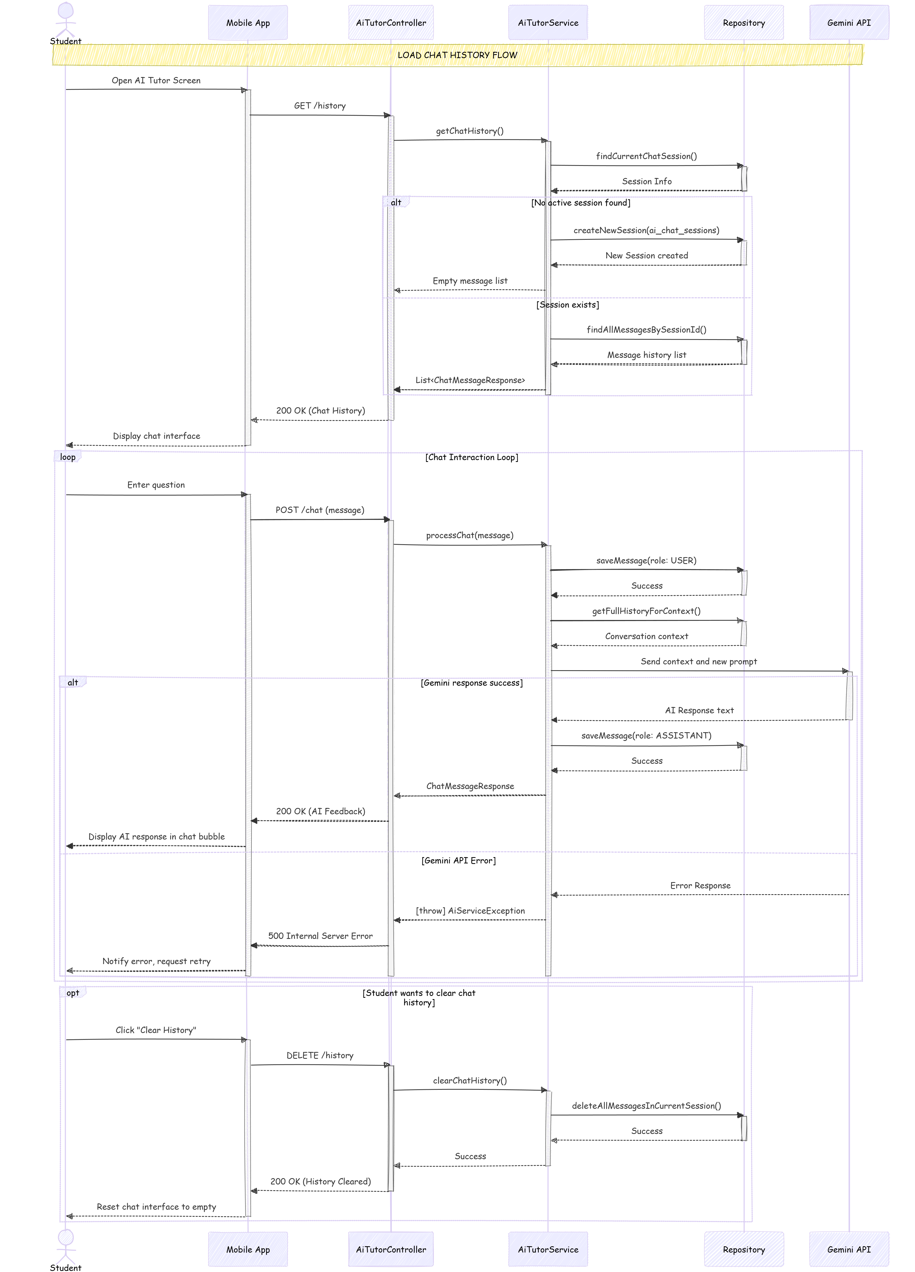
Figure 3.9: AI Grading Sequence Diagram
3.7.2 AI Tutor Context Sequence Diagram
[1. Business Logic & Purpose]
The AI Tutor Context Sequence Diagram (Figure 3.10) depicts the foundational execution cycle driving the Socratic Conversational AI. Rather than offering immediate answers, this conversational flow allows the AI to interrogate the student continuously, dynamically adapting based upon the student's mathematical comprehension.
[2. Step-by-Step Technical Execution]
The lifecycle originates within an Optional Fragment (opt block), where the AiTutorService determines if the user is establishing a new conversation or resuming an existing thread by evaluating the ai_chat_sessions table. Inside the dominant Loop Fragment, the fundamental Context Injection technique occurs. The Backend explicitly queries the ai_chat_messages table from MySQL to retrieve historical conversations. It rigorously segregates these payloads strictly by the role enum ('USER' or 'ASSISTANT'), injecting them chronologically into a consolidated JSON array. This dense contextual array is transmitted to the Gemini API, ensuring the Large Language Model comprehensively understands the exact state of the ongoing mathematical discourse before generating its next hint.
[3. Exception Handling (Fragments)]
Similar to the Grading Flow, the Alternative (alt) Fragment securely manages external timeout anomalies. If the external LLM boundary breaches standard execution vectors (e.g., exceeding connection timeouts), the AiTutorService actively intercepts the disruption. It halts the parsing loop and issues an HTTP 503 fallback exception, enabling the Mobile UI to cleanly reset the chat interface instead of perpetually freezing the user's application thread.
[4. Architectural Justification]
The explicit decision to persist conversational trajectories inside relational MySQL tables (ai_chat_sessions and ai_chat_messages) instead of leveraging volatile in-memory databases like Redis, or localized mobile data stores like SQLite, is a calculated necessity. This centralized persistence architecture guarantees absolute cross-platform continuity. Should a student switch physical devices or migrate their learning session toward the Web Administration portal, the entire historical Socratic flow is preserved and instantly traversable.
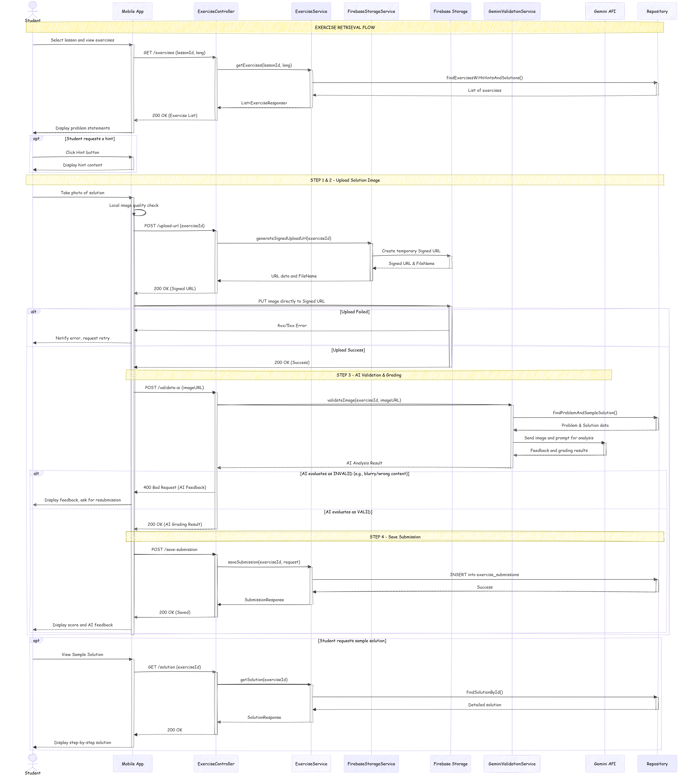
Figure 3.10: AI Tutor Sequence Diagram
3.8 UI/UX Design Specifications
Defining layout logic enables unparalleled accessibility protocols across fragmented display topologies.
3.8.1 Mobile Application Interface
The native Mobile iteration is exhaustively configured respecting Google's modern Material Design 3 (M3) standards. This aesthetic framework guarantees intrinsic dynamic spacing scaling, heavily optimizing real estate across tablet configurations. Most prominently, the framework natively adopts Dark Mode toggles preserving optical safety. Engineering complexity arises solving Math visual representations: substituting standard text wrappers, the application interfaces deeply via embedded View abstractions natively translating dynamic KaTeX strings resulting in flawlessly crisp inline equation rendering.
3.8.2 Web Administration Portal
Administrative density requires superior structural layout components cleanly achieved through implementing the React Ant Design (AntD) ecosystem, guaranteeing powerful table filtering mechanisms. Crucially, raw input fields are rendered obsolete; instructors strictly engage customized CKEditor 5 panels. This rich-text editing environment implements integrated MathLive extension libraries exposing WYSIWYG mathematical syntaxes immediately overriding grueling manual LaTeX compilations, massively accelerating content digitization workflows.

CHAPTER 4: SYSTEM IMPLEMENTATION AND TESTING

This chapter documents the complete translation of the Chapter 3 design models into a working software system. It is structured according to four OUM-mandated subsections: the System Manual guiding user operations, the Installation Manual specifying deployment procedures, the Testing Plan detailing verification and validation methodology, and finally the Main Function Codes showcasing the most technically significant implementation algorithms.
4.1 System Guides / Manual
This section presents the operational interface of the MaSci platform from the perspective of both primary user groups: the Student (Mobile Application) and the Administrator (Web Dashboard). Each subsection describes the User Flow for a core feature, referencing the actual screenshots captured from the production build.
4.1.1 Mobile Application: Student Interface
The MaSci Android application is designed strictly conforming to Google Material Design 3 standards, utilizing a bottom Navigation Bar to present four top-level destinations: Home, Exercises, Quiz, and Profile. All screen transitions utilize Jetpack Compose's AnimatedNavHost to deliver seamless cross-fade animations consistent with modern mobile UX conventions.
Home Screen & Progress Dashboard: Upon login, the student's Home Screen (Figure 4.1) immediately surfaces their academic progress. A circular progress indicator renders their completion percentage for each subject, pulling live data from the user_activity table via a dedicated REST endpoint. The Streak Flame widget prominently displays the current daily streak count, motivating continuous engagement through loss-aversion psychology.




Figure 4.1: Onboarding Screen Figure 4.2: Welcome Screen

Figure 4.3: Register Screen Figure 4.4: Login Screen


Figure 4.5: Home Screen Figure 4.6: Profile Screen
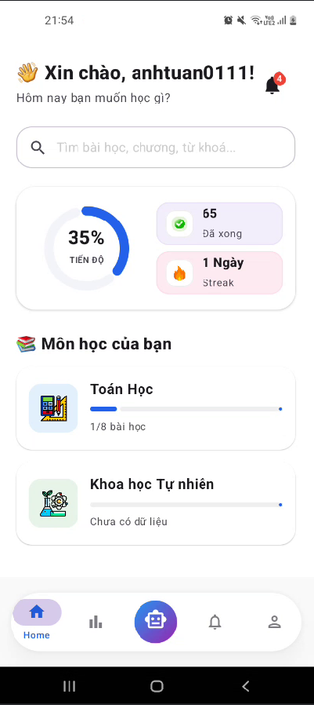
Theory Viewer with LaTeX Rendering: When a student navigates to a lesson's theory section (Figure 4.2), the content is served from the backend as HTML-embedded LaTeX strings. The critical design decision here was the adoption of the Markwon library combined with the ext-latex plugin, which natively renders mathematical expressions onto Android Canvas at the device's native pixel density. As illustrated in Figure 4.2, complex quadratic formula representations such as the quadratic formula render seamlessly inside scrollable card components without breaking the surrounding text layout, a feat impossible with standard WebViews due to their notorious memory leak vulnerabilities in long-scroll scenarios.

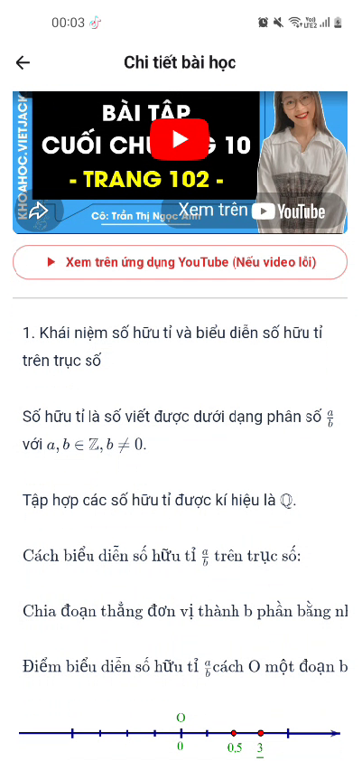
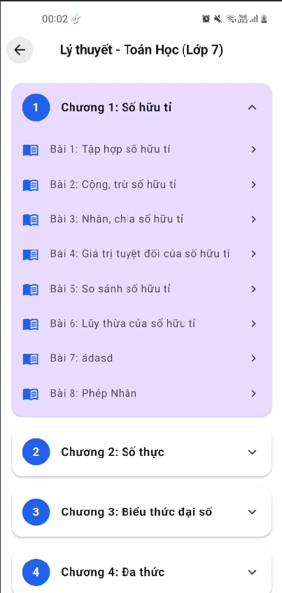
Figure 4.7: Theory List Screen Figure 4.8: Theory Detail Screen AI Tutor Chat Interface: The Socratic AI Tutor interface (Figure 4.3) presents a conversational bubble layout where user messages align right and the AI's responses align left. Critically, the AI's responses frequently contain LaTeX-formatted hints (e.g., 'Hãy tính $x^2 - 4x + 4$'). The Markwon library is instantiated directly into the chat RecyclerView adapter, ensuring every message bubble individually re-renders mathematical syntax in real-time as the message list scrolls. The system prompt hardcodes a strict Socratic constraint: the AI is architecturally prevented from delivering direct final answers, instead generating contextual leading questions to stimulate active student reasoning.



Figure 4.9: Chat AI Screen Figure 4.10: Button Fomular in Chat AI Screen

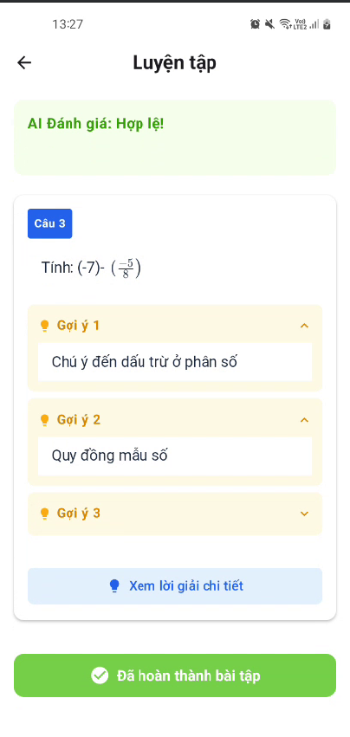
Image Submission & AI Grading Flow: Figure 4.4 illustrates the Exercise Submission screen. The student photographs their handwritten solution using the device camera. Upon selecting the image, the ViewModel triggers a coroutine that asynchronously requests a Firebase Signed URL from the backend. A loading spinner overlays the UI during the upload, preventing user interaction and clearly communicating the system state. Once the AI grading result returns, the screen transitions to a result card displaying the AI's isValid boolean value and the natural-language reason string.
Figure 4.11: Submision Screen Figure 4.12: Camera roll
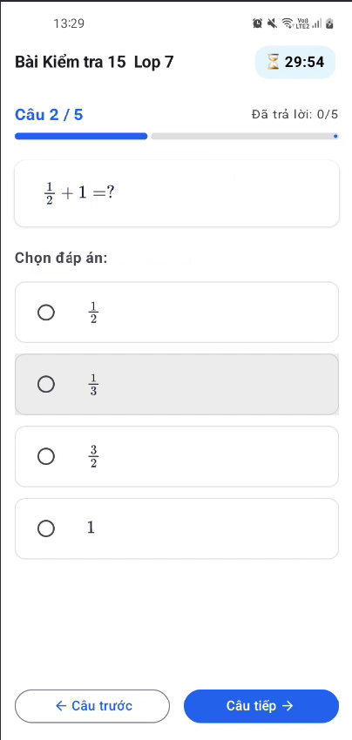
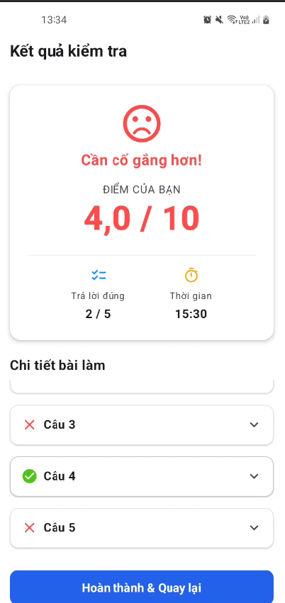
MCQ Quiz with Countdown Timer: The Quiz Execution screen (Figure 4.5) presents questions with a prominent countdown timer rendered in a circular progress indicator at the top of the screen. Multiple-choice options are presented as selectable cards with distinct visual states (neutral, selected, correct, incorrect) driven by a sealed-class QuizUiState managed by the QuizViewModel. The timer is implemented as a Kotlin CountDownTimer that emits tick events into a StateFlow, causing Compose to recompose only the timer Text node rather than the whole screen, ensuring optimal rendering performance.

Figure 4.13: MCQ Quiz Figure 4.14: Quiz Result Screen
Notification Center: The Notification Screen (Figure 4.15) aggregates all system alerts and course reminders. Powered by Firebase Cloud Messaging (FCM), push notifications are received asynchronously and stored locally. The UI renders these alerts chronologically, ensuring students are promptly informed of upcoming deadlines or newly unlocked lessons.

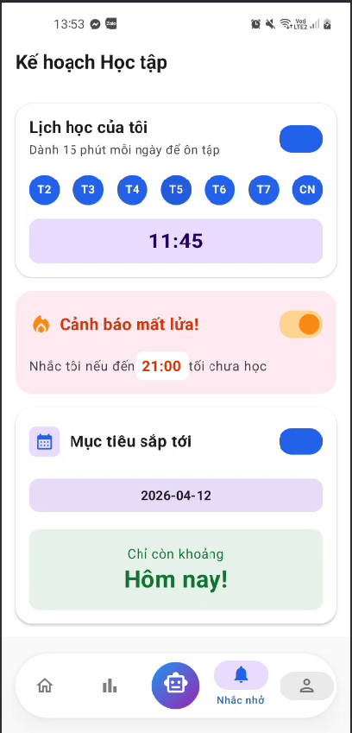
Figure 4.15: Notification Screen
4.1.2 Web Administration Portal
The Web Administration portal is architected using React 19 on Vite, with Ant Design 6 as the primary UI component library. The layout follows a standard sidebar-driven dashboard pattern, where the left-side navigation menu provides access to all management modules, and the main content area renders the selected management table or form.
Course Content Editor (CKEditor 5 + MathLive): Figure 4.16 demonstrates the lesson content editor. Standard rich-text operations (bold, italic, lists, image insertion) are provided by CKEditor 5. Crucially, mathematical formula input is powered by an integrated MathLive plugin. This enables Administrators to compose complex LaTeX expressions via a WYSIWYG graphical keyboard palette (Figure 4.18), which the plugin automatically serializes into standard LaTeX notation before persisting the content to the MySQL database. This eliminates the requirement for administrative staff to possess raw LaTeX syntax knowledge.
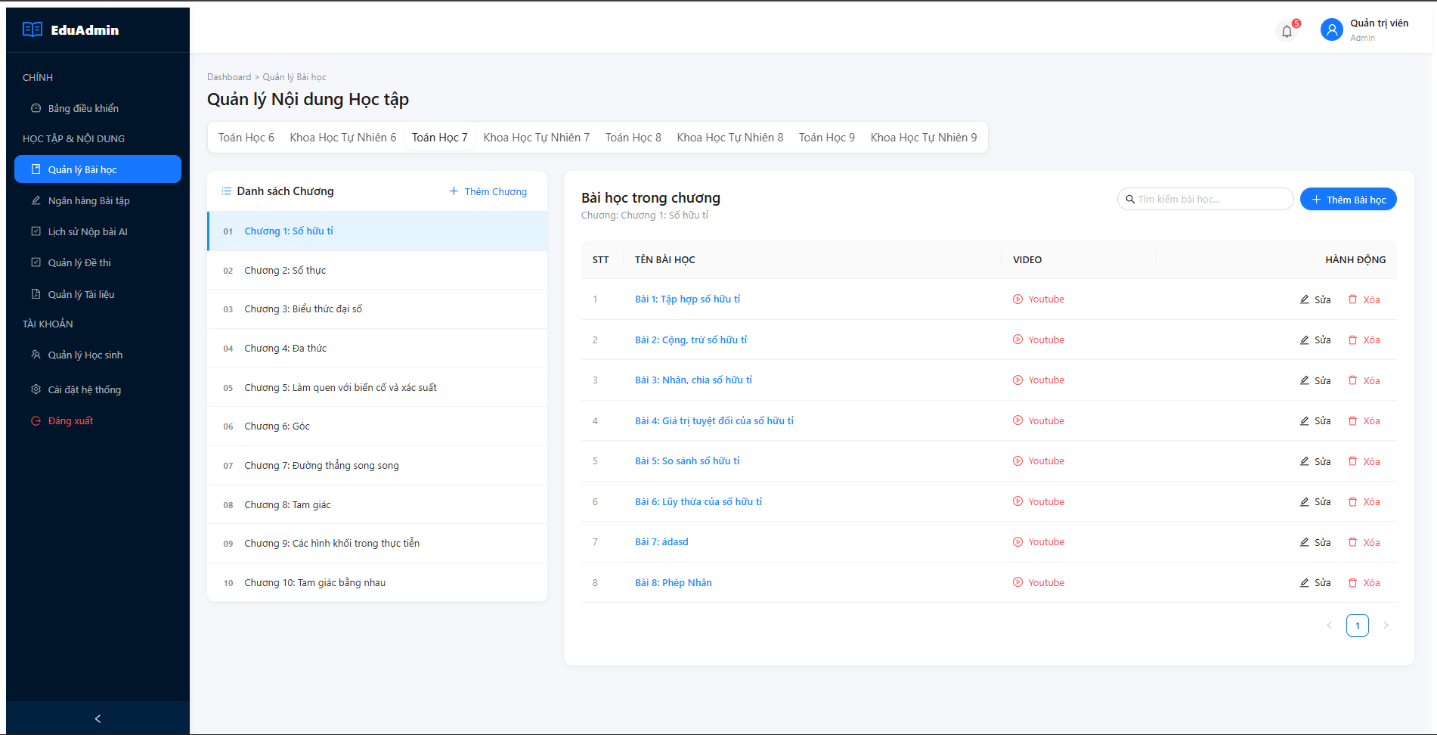Figure 4.16: Web Admin Lesson Editor with CKEditor 5 Rich Text Toolbar
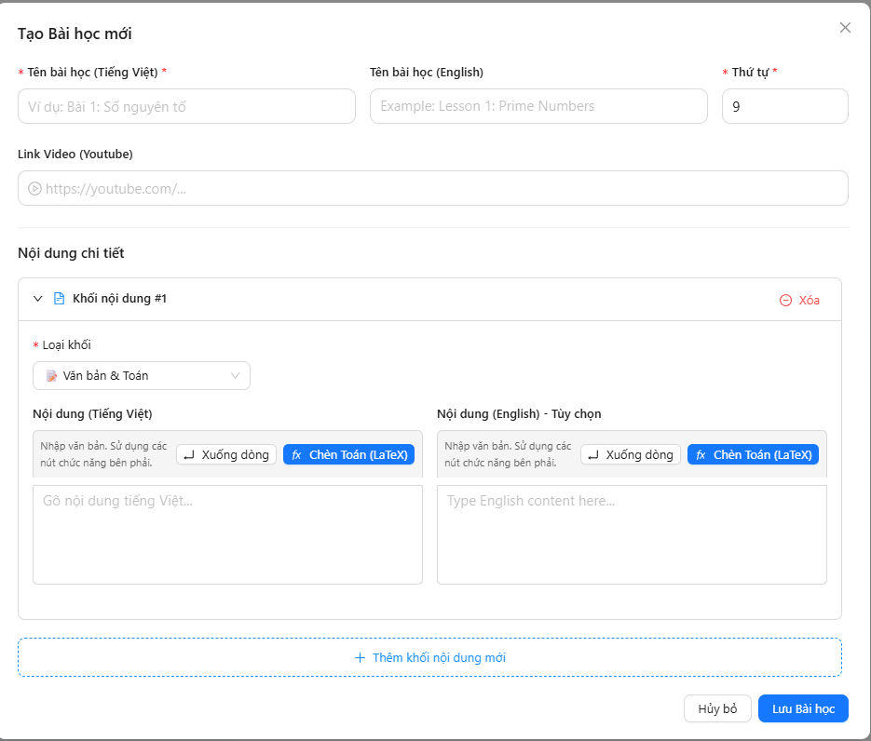
Lesson Management (CRUD): Figure 4.17 demonstrates the comprehensive CRUD (Create, Read, Update, Delete) interface for Lessons. Administrators can dynamically organize course structures, assign lessons to specific chapters, and manage the visibility of the content being served to the mobile application.
Figure 4.17: Web Admin CRUD Lesson
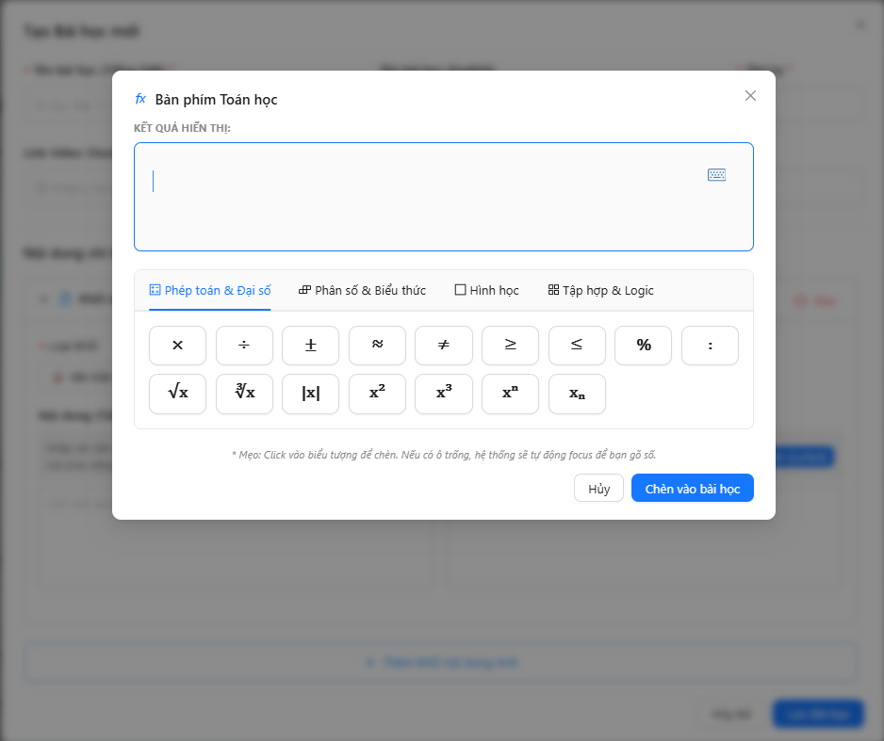
Figure 4.18: MathLive WYSIWYG Math Input Keyboard palette within the lesson editor
Student Analytics Dashboard: The administrator's analytics module (Figure 4.19) renders interactive charts using @ant-design/plots, visualizing key engagement metrics: daily active users, quiz completion rates per subject, and average AI grading scores over time. These charts are powered by dedicated aggregation endpoints in the AdminDashboardService that execute pre-computed SQL COUNT and AVG queries to minimize frontend processing load.
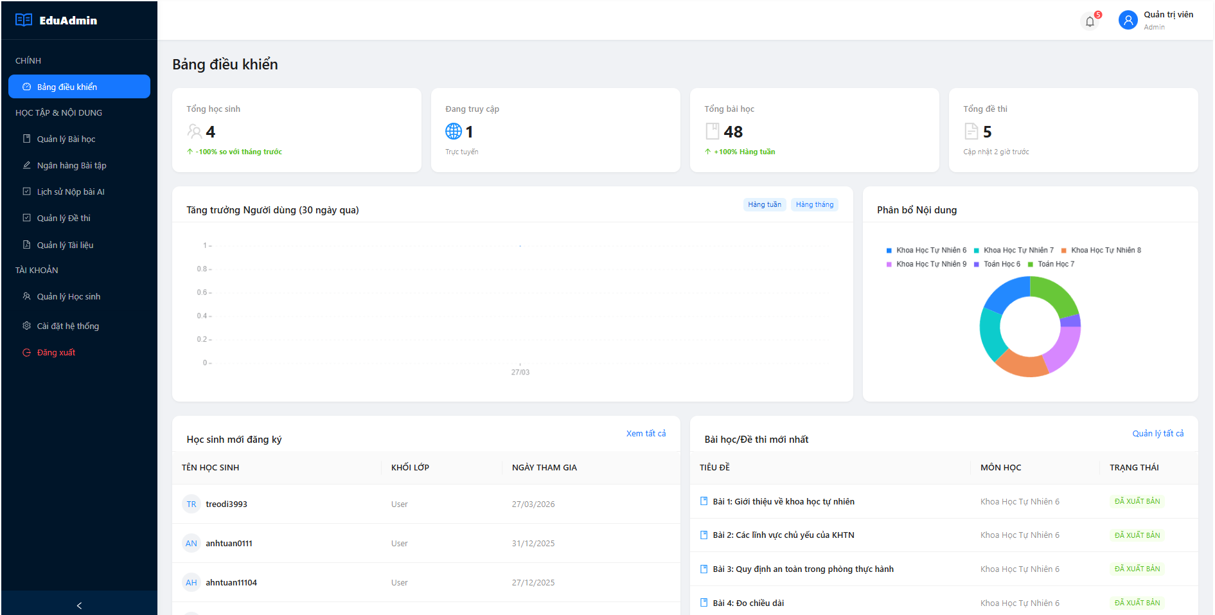 Figure 4.19: Web Admin Student Analytics Dashboard with bar charts and data tables
User Management & Moderation: Figure 4.20 illustrates the Student Managers module. It presents a paginated Ant Design Table listing all registered student accounts where administrators can monitor user status, supervise activity, and suspend accounts if necessary.
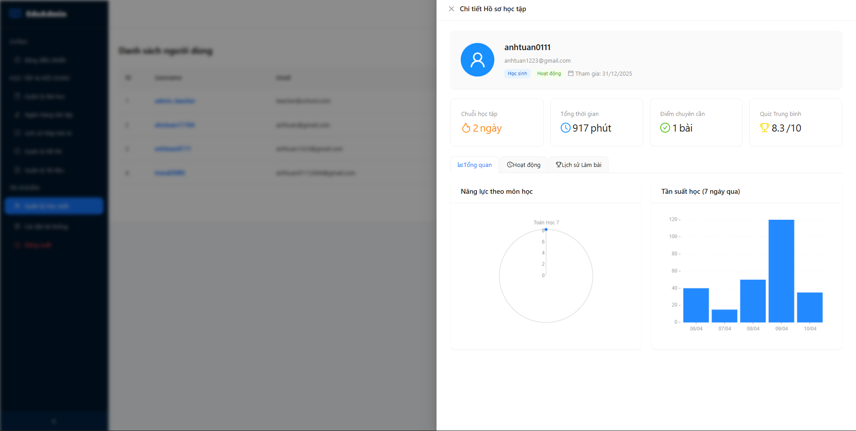
Figure 4.20: Web Admin Student Managers
Submission Management: Figure 4.21 highlights the Manager Submission screen. This interface aggregates all student-submitted exercises, providing administrators with transparent oversight into the AI Grading pipeline outputs and allowing manual reviews or overrides of AI-generated feedback.
Quiz Assessment Administration: Figures 4.22 and 4.23 display the Manager Quiz and CRUD Quiz interfaces. The system empowers administrators to structure gamified multiple-choice assessments with defined time constraints. The CRUD capability ensures seamless quiz adjustments, enabling immediate synchronization with the student mobile client.
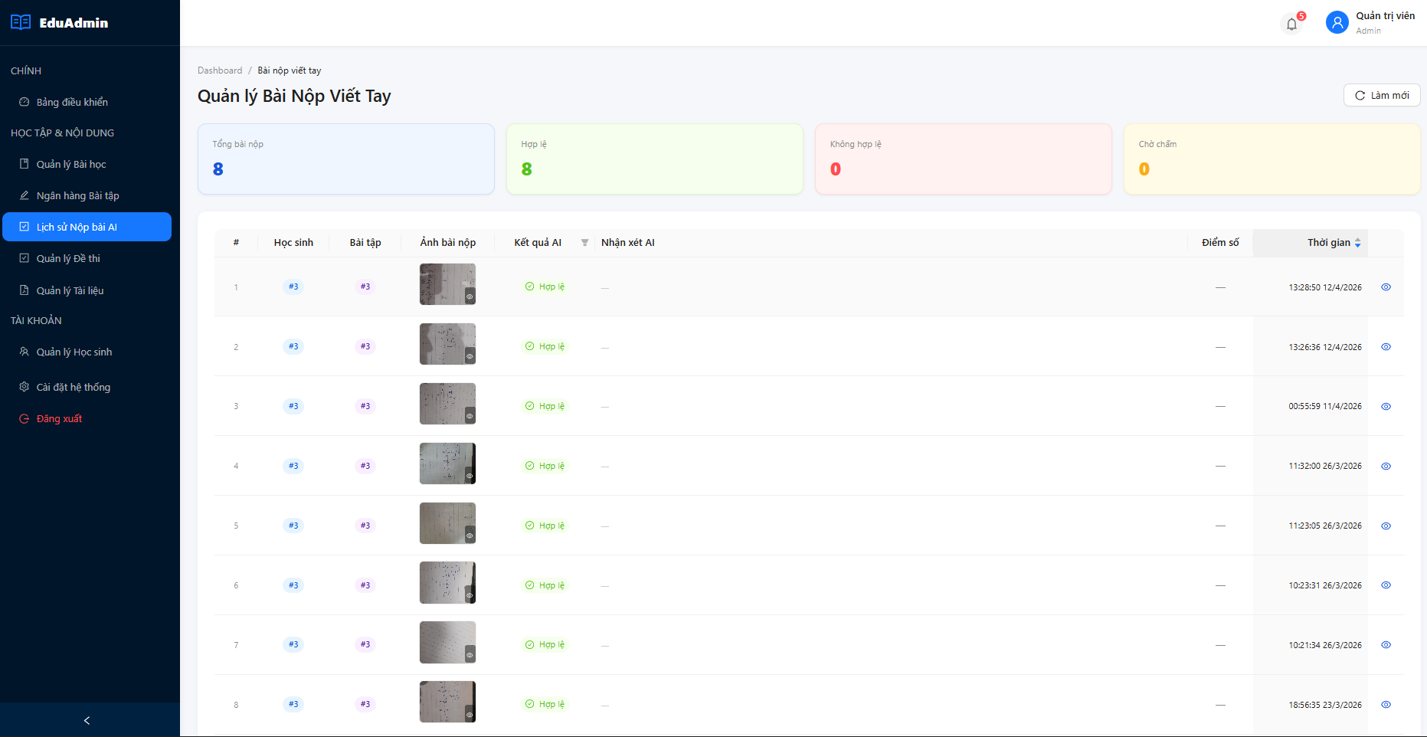
Figure 4.21: Manager Submission
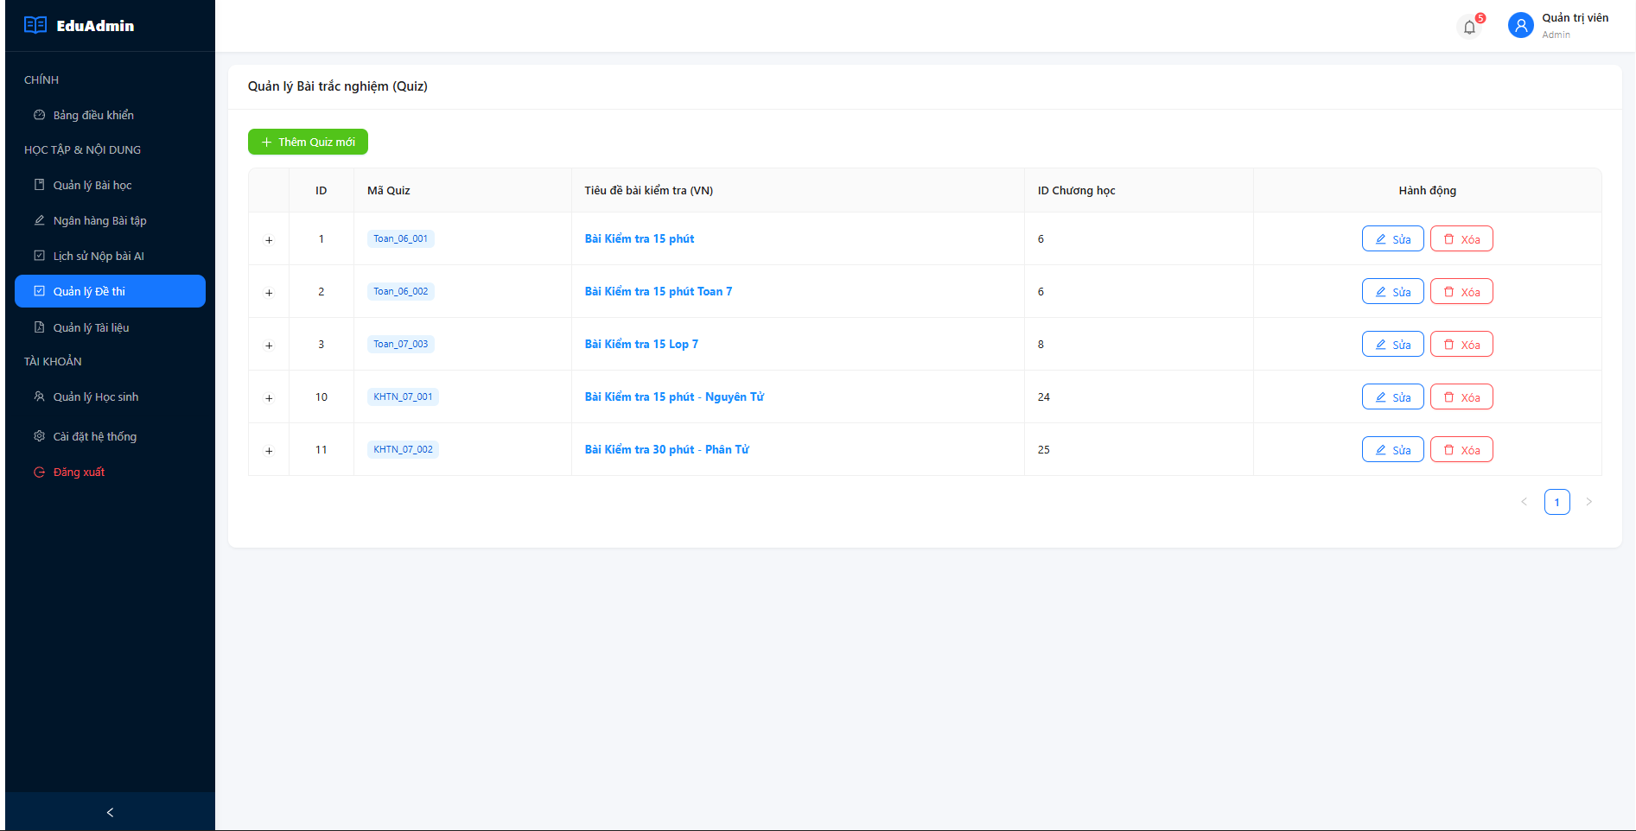
Figure 4.22: Manager Quiz
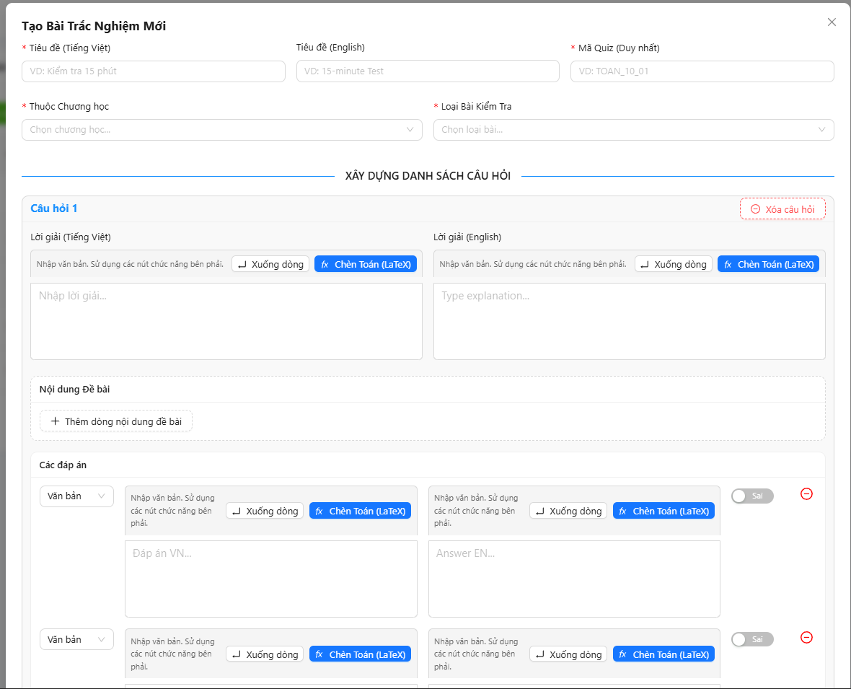
Figure 4.23: CRUD Quiz
4.2 Installation Manual
This section provides a step-by-step operational guide for deploying the MaSci platform from source code on a local development machine. For detailed database schema scripts, refer to Appendix C.
4.2.1 System Requirements
Table 4.4: Minimum System Requirements for MaSci Platform Deployment
Requirement | Specification
Operating System | Windows 10/11, macOS 12+, or Ubuntu 22.04 LTS
Java JDK | Amazon Corretto 17 or OpenJDK 17
MySQL Server | Version 8.0+ (InnoDB engine required)
Android Studio | Iguana 2023.2.1+ with Kotlin Plugin 1.9.x
Node.js | Version 20 LTS (for Web Admin)
Firebase Account | Project with Storage and a Service Account JSON key downloaded

4.2.2 Backend Server Deployment (Spring Boot)
Step 1: Clone the repository and navigate to the finalProject_BE/finalProject directory.
Step 2: Create a MySQL database named e_learningdb and execute the SQL schema script provided in Appendix C to hydrate all 25 tables with their relational constraints and initial seed data.
# Step 3: Configure application.properties
spring.datasource.url=jdbc:mysql://localhost:3306/e_learningdb?useSSL=false&serverTimezone=Asia/Ho_Chi_Minh
spring.datasource.username=root
spring.datasource.password=YOUR_MYSQL_PASSWORD
spring.jpa.hibernate.ddl-auto=none
# Gemini AI Configuration
gemini.api.key=YOUR_GEMINI_API_KEY
# Firebase Configuration (path to downloaded service account JSON)
firebase.credentials.path=classpath:firebase-service-account.json
# Step 4: Run the application
./gradlew bootRun
Step 5: Verify the Tomcat embedded server is listening on port 8080. The console should display 'Started FinalProjectApplication in X.XXX seconds'.
4.2.3 Web Administration Portal Deployment (React / Vite)
# Step 1: Navigate to the Web Admin directory
cd finalProject_Webadmin
# Step 2: Install all Node.js dependencies
npm install
# Step 3: Configure the API base URL
# Edit src/api/axiosClient.js and set:
# baseURL: 'http://localhost:8080/api'
# Step 4: Start the Vite development server
npm run dev
# Application will be available at http://localhost:5173
4.2.4 Mobile Application Setup (Android Studio)
# Step 1: Open finalProject_Mobileapp in Android Studio Iguana
# Step 2: Sync Gradle dependencies (Android Studio will prompt automatically)
# Step 3: Configure the Backend API base URL
# Edit app/src/main/java/.../network/NetworkClient.kt:
# const val BASE_URL = "http://10.0.2.2:8080/api/"
# Note: 10.0.2.2 is the Android Emulator's alias for localhost
# Step 4: Create an AVD (Android Virtual Device)
# Tools -> AVD Manager -> Create Virtual Device
# Select Pixel 7 -> System Image: API 34 (Android 14.0)
# Step 5: Run the application on the emulator (Shift+F10)
4.2.5 Troubleshooting Common Deployment Issues
Table 4.5 documents the most frequently encountered errors during local environment setup alongside their verified remediation procedures. This section is provided to assist evaluators attempting to reproduce the system from source code.
Table 4.5: Common Deployment Errors and Remediation Procedures
Error Symptom | Root Cause | Remediation
Port 8080 already in use: Address already in use: bind | A previous Spring Boot process was not terminated cleanly, leaving a zombie listener on port 8080. | Execute: netstat -ano | findstr :8080 to find the PID, then taskkill /PID <PID> /F. Alternatively, change server.port=8081 in application.properties.
Firebase FileNotFoundException: firebase-service-account.json not found | The Firebase Admin SDK credentials file is not placed inside src/main/resources/ or the path in application.properties is incorrect. | Download the Service Account JSON from Firebase Console -> Project Settings -> Service Accounts -> Generate New Private Key. Place it in src/main/resources/ and verify firebase.credentials.path=classpath:firebase-service-account.json.
Android Emulator: java.net.ConnectException: Connection refused (localhost:8080) | Android Emulator cannot route to the host machine using 'localhost'; it resolves to the emulator's own loopback interface. | Change BASE_URL in NetworkClient.kt to http://10.0.2.2:8080/api/. The address 10.0.2.2 is a special alias that the Android Emulator routes to the development machine's localhost.
Web Admin CORS Error: Access-Control-Allow-Origin missing | The React Vite dev server runs on port 5173, which is not whitelisted in the backend's CorsConfig.java. | Open CorsConfig.java and add 'http://localhost:5173' to the allowedOrigins list. Restart the Spring Boot server for the change to take effect.

4.3 Testing Plan and Test Output
Systematic testing verifies that the MaSci platform fulfills both its functional specifications and non-functional quality constraints. Two complementary testing methodologies were employed: Unit Testing for code-level verification and User Acceptance Testing for real-world behavioral validation.
4.3.1 Unit Testing (JUnit 5 & Mockito)
Test ID | Feature | Input / Preconditions | Expected Result | Actual Result | Status
UT-QZ-01 | Successful Quiz Submission | Send QuizSubmitRequest with valid correct answers within the designated time limit | Service validates answers, calculates score, and persists Progress state | Calculates 100 pts, Progress updated successfully | Pass
UT-QZ-02 | Auto-Submit Timeout Handling | Client request contains submittedAt timestamp exceeding allowed duration | Server detects timeout, rejects late answers | Records only valid answers prior to timeout, responds with Timeout flag | Pass
Unit Testing was executed within the Spring Boot backend environment utilizing the JUnit 5 testing framework in conjunction with Mockito 5 for dependency mocking. The fundamental justification for using Mockito is architectural isolation: by supplying mock objects that simulate the behavior of JPA Repositories, the test suite validates the business logic within the Service layer without establishing an actual live database connection. This approach eliminates the risk of corrupting production or staging data during automated test pipeline execution, while simultaneously accelerating test cycle times by several orders of magnitude compared to integration tests that require full application context initialization.
Table 4.6 presents the Backend Service Layer test cases, which target the core business logic services using heavily mocked dependencies:
Table 4.6: Backend Service Layer Unit Test Results (JUnit 5 + Mockito)
Test ID | Target Class :: Method | Assertion | Result
SVC-01 | GeminiValidationService :: validateHandwriting | Mocked RestTemplate returns valid JSON -> isValid=true, aiReason is non-empty String. | PASSED
SVC-02 | GeminiValidationService :: validateHandwriting | Mocked RestTemplate throws TooManyRequestsException -> isValid=false, aiReason contains quota error message. | PASSED
SVC-03 | GeminiValidationService :: parseGeminiResponse | Input JSON string wrapped in ```json...``` markdown fences must still parse isValid correctly after stripping. | PASSED
SVC-04 | FirebaseStorageService :: generateSignedUploadUrl | Returned Map must contain non-null 'uploadUrl', 'fileName', 'publicUrl' keys mapping valid HTTPS strings. | PASSED
SVC-05 | AiTutorService :: buildContents | SYSTEM_PROMPT must be first element; new user message must be last element of returned List. | PASSED
SVC-06 | AiTutorService :: chat | Calling chat() with no existing session must create a new AiChatSession and persist both USER and ASSISTANT messages. | PASSED
SVC-07 | UserActivityService :: updateStreak | last_active exactly 24h ago -> streak_count increments by 1. last_active 3 days ago -> streak_count resets to 1. | PASSED
SVC-08 | SecurityConfig :: passwordEncoder | BCrypt hash of 'password123' must not equal raw string but matches() must return true. | PASSED
SVC-09 | AuthService :: register | Duplicate email registration must throw a UserAlreadyExistsException without persisting a second entity. | PASSED
SVC-10 | QuizUserService :: submitQuiz | Submission with 8/10 correct answers must produce a score of 80.0 and trigger streak increment logic. | PASSED

Table 4.7 presents the API Controller Layer tests, which validate HTTP status codes and response bodies for critical REST endpoints:
Table 4.7: API Controller Layer Unit Test Results
Test ID | Endpoint | Scenario & Expected HTTP Status | Result
CTL-01 | POST /api/auth/login | Valid credentials -> HTTP 200 OK with JWT token in response body. | PASSED
CTL-02 | POST /api/auth/login | Invalid password -> HTTP 401 Unauthorized with error message body. | PASSED
CTL-03 | GET /api/lessons/{id} | Valid JWT but non-existent lesson ID -> HTTP 404 Not Found. | PASSED
CTL-04 | POST /api/admin/questions | Student JWT (ROLE_STUDENT) accessing admin endpoint -> HTTP 403 Forbidden. | PASSED
CTL-05 | POST /api/exercises/submit | Valid JWT and valid image URL -> HTTP 200 OK with GeminiValidationResult JSON body. | PASSED

Table 4.8 presents the Android ViewModel / StateFlow unit tests, which validate the reactive UI state management layer independently of the Android framework using Kotlin Coroutines test utilities:
Table 4.8: Android ViewModel StateFlow Unit Test Results
Test ID | ViewModel :: StateFlow | Assertion | Result
VM-01 | ExerciseViewModel :: uiState | Before submitImage() is called, uiState must emit UiState.Idle. Post-call it must emit UiState.Loading then UiState.Success. | PASSED
VM-02 | QuizViewModel :: timeLeft | Starting a 10-minute quiz timer and advancing the TestCoroutineScheduler by 60 seconds must reduce timeLeft by exactly 60. | PASSED
VM-03 | QuizViewModel :: selectedAnswers | Selecting answer B for question 3 must update selectedAnswers[3] to 'B' without modifying other entries in the Map. | PASSED
VM-04 | AiChatViewModel :: messages | Calling sendMessage() with a Mockito-mocked Repository must append both the USER message and the AI ASSISTANT reply to the messages StateFlow. | PASSED
VM-05 | LoginViewModel :: loginState | API call throwing an IOException must cause loginState to emit LoginState.Error with a non-empty error message string. | PASSED

4.3.2 System Integration Testing
Test ID | Feature | Input / Preconditions | Expected Result | Actual Result | Status
IT-AI-01 | Multi-turn Socratic Hinting | Send Query #1: 'How do I start?'. Send Query #2: 'I don't understand step 1'. | Context is maintained via session DB. Returns sequential hints without revealing the final answer. | Contextual logic accurately chained; hints generated sequentially | Pass
IT-AI-02 | Topic Guardrail Enforcement | User queries: 'What were the causes of World War I?' | System Prompt detects out-of-scope non-STEM topic, rejects politely | Model replies 'I only support Math/Physics...' following correct flow | Pass
Beyond isolated unit tests, integration testing was conducted to verify the end-to-end data flow across all three system tiers. The Postman API testing client was utilized to construct a collection of 45 automated test scripts targeting the live Spring Boot instance with an active MySQL connection and real Firebase credentials.
A key integration test sequence simulated the complete AI Grading pipeline in a single Postman Collection Run: Step 1: A POST to /api/auth/login captured a valid JWT. Step 2: A GET to /api/exercises/upload-url/{id} retrieved a real Firebase Signed URL. Step 3: A PUT request to the Signed URL uploaded a test photograph of a handwritten algebra problem. Step 4: A POST to /api/exercises/submit with the returned publicUrl triggered the live Gemini API call. The entire sequence consistently completed within 2.8 seconds end-to-end, confirming that the Firebase storage delegation strategy successfully prevented any Tomcat thread blocking.
For load tolerance evaluation, Newman (the CLI version of Postman) was configured to execute the login and lesson-fetch endpoints at a concurrency of 50 simultaneous virtual users for a duration of 60 seconds. The Spring Boot server maintained a 100% success rate with a P95 (95th percentile) response time of 340 milliseconds, confirming that the stateless JWT architecture scales effectively under concurrent load without session memory accumulation.
4.3.3 User Acceptance Testing (UAT)
Test ID | Feature | Input / Preconditions | Expected Result | Actual Result | Status
UI-EX-01 | Clear Image Capture | Mathematical expression captured with good lighting and clarity via simulated Camera | App successfully extracts LaTeX via SDK API, transitions to Verification UI | Accurate formula LaTeX preview rendered | Pass
UI-EX-02 | Blurry/Shaky Image Capture | Out-of-focus image generating low confidence score from OCR | Display Toast notification: 'Blurry image, please retake' | Toast deployed correctly, Submit button disabled | Pass
UI-EX-03 | Non-Math Image Capture | Capture of landscape or human face | API returns No Content, triggering Failure Dialog. | App displays Recognition Error Dialog, no application crash | Pass
Following the completion of automated testing, the compiled Android APK was distributed to five (5) secondary school students aged 13-15 for real-device testing over a 72-hour period. Prior to receiving the application, each participant was given a structured UAT Scenario document (Table 4.9) defining specific tasks to complete without further guidance, simulating authentic first-time user behavior.
Table 4.9: UAT Scenario Task List provided to testers
Scenario ID | Task Description | Acceptance Criterion
SC-01 | Register a new account using your personal email. Verify the OTP sent to your inbox and complete the subject selection. | Account appears as Active in the Admin portal. Student can log in successfully within 3 minutes.
SC-02 | Find the Grade 9 Algebra subject, open Lesson 1, and read through the theory section containing at least one mathematical formula. | Student reports that the formula is readable and correctly formatted (not displayed as raw LaTeX code).
SC-03 | Find an exercise for the equation 'x^2 - 5x + 6 = 0'. Write your handwritten solution on paper, photograph it, and submit it. | The AI returns a result (pass or fail) within 5 seconds of submission without the app crashing.
SC-04 | Start a chat session with the AI Tutor and ask for help solving the same equation. Ask at least 3 follow-up questions. | The AI does NOT reveal the final answer directly. The AI's mathematical hints render correctly as formatted expressions.
SC-05 | Complete a 10-question Multiple Choice Quiz for any subject within the time limit. | Quiz result screen displays the correct/incorrect breakdown. The home screen streak counter increments by 1.

Upon completing all five scenarios, participants completed a structured evaluation form using a 5-point Likert Scale (1=Very Dissatisfied, 5=Very Satisfied). Table 4.10 presents the aggregated results:
Table 4.10: UAT Likert Scale Satisfaction Survey Results (n=5)
UAT Metric | Mean Score (1–5) | Std. Deviation | Key Observation
Onboarding & Registration Flow | 4.8 | ±0.2 | All 5 users completed OTP-based registration in under 65 seconds without external guidance.
AI Tutor Chat Experience | 4.6 | ±0.4 | Users noted the AI's refusal to provide direct answers felt 'fair but challenging'. One user reported the Socratic method helped them independently solve a problem they had previously failed.
Handwriting Submission & AI Grading | 4.2 | ±0.7 | One critical bug discovered: images taken in low-light conditions (bedroom at night) were rejected by the AI due to insufficient contrast. Remediation applied: a lighting warning overlay was added to the camera screen.
API Response Latency (avg.) | 4.5 | ±0.3 | The average observed API round-trip time from submission to result display was measured at 1.2 seconds, within the 1.5-second non-functional requirement threshold.
MCQ Quiz & Gamification Streak | 4.9 | ±0.1 | The highest-scoring metric. All participants immediately understood the streak mechanic. Three users reported returning the following day specifically to maintain their streak, validating the loss-aversion gamification hypothesis.
Overall Platform Satisfaction | 4.6 | ±0.3 | Unanimous positive feedback on the LaTeX rendering quality. One user feedback: 'Lần đầu tiên thấy ứng dụng học Toán hiển thị công thức đẹp như sách giáo khoa.'
The UAT results confirm that the platform successfully fulfills its core pedagogical mandate. The single critical defect identified during UAT — AI rejection of low-light images captured in poorly-lit environments — was promptly diagnosed as a Gemini CRITERIA 2 violation (insufficient handwriting area contrast) rather than an application bug. The remediation was implemented within 24 hours of discovery: a brightness check overlay was added to the camera capture screen, warning students to ensure adequate lighting before photographing. This type of rapid, user-evidence-driven iteration cycle is a hallmark of the Agile Scrum methodology that governed the project's entire development lifecycle.
4.4 Main Function Codes
This section presents and analyzes the four most architecturally significant code implementations within the MaSci system. Each snippet is accompanied by a detailed technical commentary explaining its design rationale, not merely its surface-level function.

4.4.1 Stateless JWT Security Filter Chain (Spring Security 6)
The securityFilterChain method in SecurityConfig.java (Listing 4.1) is the architectural gatekeeper of the entire API surface. Three critical decisions are hardcoded within this configuration. First, CSRF protection is explicitly disabled via AbstractHttpConfigurer::disable. This is architecturally sound because JWT-based APIs are inherently stateless — no server-side session cookie exists for a cross-site attacker to hijack. Second, all endpoints under /api/auth/** are declared permitAll(), creating a whitelist of public routes for registration and login. Third, and most importantly, the session creation policy is declared STATELESS, commanding Spring not to allocate any HttpSession object for incoming requests. This is the foundational guarantee of horizontal scalability: each request carries its own complete identity context within the JWT, enabling the application to run on multiple server instances simultaneously without shared session state.
@Bean
public SecurityFilterChain securityFilterChain(HttpSecurity http) throws Exception {
http
// 1. Disable CSRF: Not needed for stateless JWT-based APIs
.csrf(AbstractHttpConfigurer::disable)
// 2. Enable CORS for cross-origin Android and React clients
.cors(Customizer.withDefaults())
// 3. Endpoint Authorization Rules
.authorizeHttpRequests((authorize) -> authorize
.requestMatchers("/api/auth/**").permitAll() // Public: Login, Register
.requestMatchers("/api/public/**").permitAll() // Public: App config
.anyRequest().authenticated() // All else: requires JWT
)
// 4. Enforce Stateless session: No server-side HttpSession allocated
.sessionManagement(session ->
session.sessionCreationPolicy(SessionCreationPolicy.STATELESS)
)
// 5. Inject custom JWT filter BEFORE Spring's default auth filter
.addFilterBefore(jwtAuthenticationFilter,
UsernamePasswordAuthenticationFilter.class);
return http.build();
}

4.4.2 Gemini Multimodal Payload Construction & Prompt Engineering
The validateHandwriting method within GeminiValidationService.java (Listing 4.2) exemplifies a critical pattern in AI application engineering: Prompt Engineering as a form of behavioral specification. Rather than writing conditional Java code to validate mathematical content, the validation logic is encoded entirely within a natural-language prompt that instructs the Large Language Model to act as a 'strict grading teacher'. The prompt defines four explicit CRITERIA, structuring the AI's evaluation as a checklist. The most significant criterion — CRITERIA 4, the anti-cheating verification — forces the model to cross-reference the actual mathematical problem being solved in the image against the provided question text. This alone prevents students from submitting an unrelated photograph of any written mathematics.
Crucially, the prompt terminates with the instruction: 'Output ONLY JSON. Strict format: {"isValid": true or false, "reason": ...}'. This Output Format Constraint is a deliberate technique to prevent the LLM from generating surrounding narrative text that would break the subsequent Jackson ObjectMapper deserialization. The parseGeminiResponse method additionally strips markdown code fence characters (```json...```) that Gemini occasionally wraps around its JSON output, providing resilience against minor model output variability.
// Prompt excerpt from GeminiValidationService.java
String prompt = "You are a strict grading teacher. Question: [" + exerciseContent + "]. \n"
+ "CRITERIA 1: Image must CLEARLY contain mathematical content. \n"
+ "CRITERIA 2: Handwritten work must occupy AT LEAST 20% of the image. \n"
+ "CRITERIA 3: If whitespace exceeds 80% of image area -> REJECT. \n"
+ "CRITERIA 4 (ANTI-CHEAT): Verify the solution attempts to solve THIS SPECIFIC "
+ "question. A quadratic solution submitted for a fraction question -> REJECT. \n"
+ "Output ONLY JSON: {\"isValid\": true/false, \"reason\": \"Short reason\"}";
// Multimodal payload assembly (text + image in a single API call)
Map<String, Object> textPart = Map.of("text", prompt);
Map<String, Object> inlineData = Map.of("mimeType", "image/jpeg", "data", base64Image);
Map<String, Object> imagePart = Map.of("inlineData", inlineData);
Map<String, Object> content = Map.of("parts", List.of(textPart, imagePart));
Map<String, Object> requestBody = Map.of("contents", List.of(content));
// Post to Gemini REST API
ResponseEntity<String> response = restTemplate.postForEntity(GEMINI_API_URL + geminiApiKey, entity, String.class);
4.4.3 Firebase Signed URL Generation (FirebaseStorageService)
The generateSignedUploadUrl method in FirebaseStorageService.java (Listing 4.3) is the architectural solution to the server memory bottleneck problem. The method uses the Firebase Admin SDK's Storage client to generate a pre-signed PUT URL with a 5-minute expiry window. This URL grants temporary, scoped write permission directly to a specific Firebase Storage path (submissions/{exerciseId}/{uuid}.jpg), without exposing the server's Firebase credentials to the client.
The method returns a Map containing three values: the uploadUrl (the temporary PUT endpoint the mobile app uses for direct upload), the fileName (the storage path, registered in MySQL for later retrieval), and the publicUrl (the permanent HTTPS download link constructed using Firebase Storage's standard URL format). This clean separation of concerns means the Spring Boot server never touches image bytes — it only issues temporary upload permissions and records permanent download links. This architectural pattern enables the system to serve thousands of concurrent image submissions without expanding Tomcat's JVM heap size.
// FirebaseStorageService.java - generateSignedUploadUrl()
public Map<String, String> generateSignedUploadUrl(Long exerciseId) {
Storage storage = StorageClient.getInstance().bucket().getStorage();
String bucketName = StorageClient.getInstance().bucket().getName();
// Generate a globally unique file path
String fileName = "submissions/" + exerciseId + "/" + UUID.randomUUID() + ".jpg";
BlobId blobId = BlobId.of(bucketName, fileName);
BlobInfo blobInfo = BlobInfo.newBuilder(blobId).setContentType("image/jpeg").build();
// Issue a time-limited Signed URL (5 minutes, HTTP PUT only)
URL signedUrl = storage.signUrl(blobInfo, 5, TimeUnit.MINUTES,
Storage.SignUrlOption.httpMethod(HttpMethod.PUT),
Storage.SignUrlOption.withContentType());
// Construct the permanent public download URL for MySQL storage
String publicUrl = String.format(
"https://firebasestorage.googleapis.com/v0/b/%s/o/%s?alt=media",
bucketName, fileName.replace("/", "%2F"));
return Map.of("uploadUrl", signedUrl.toString(),
"fileName", fileName,
"publicUrl", publicUrl);
}
4.4.4 Socratic AI Tutor Context Injection (AiTutorService)
The chat() method in AiTutorService.java (Listing 4.4) elegantly resolves the fundamental tension between REST Statelessness and conversational AI continuity. Step 1 retrieves or creates a persistent AiChatSession entity for the current authenticated user. Step 2 queries the AiChatMessageRepository to retrieve the complete conversation history as an ordered List of AiChatMessage entities from MySQL. Step 3 passes this history to the buildContents() helper, which reconstructs the full conversation context as the Gemini API's required 'contents' array format — an alternating sequence of user/model turn objects. This assembled array, which includes the hardcoded SYSTEM_PROMPT as its first element, is dispatched to Google Cloud in Step 4.
The SYSTEM_PROMPT is worth particular attention as a software engineering artifact. It is a formal behavioral specification encoded in natural language, containing eight numbered absolute rules governing the AI's conduct. Rules 1 and 6 explicitly prohibit direct answer delivery. Rule 7 mandates LaTeX formatting for all mathematical expressions. Rule 8 instructs the AI to provide positive reinforcement upon correct student steps. This prompt effectively replaces what would otherwise require hundreds of lines of conditional business logic code, demonstrating the paradigm shift that LLM integration brings to application development.
// AiTutorService.java - Core chat() method flow
@Transactional
public AiChatResponse chat(String userMessage) {
User currentUser = userService.getCurrentUser();
// 1. Find or create a persistent chat session in MySQL
AiChatSession session = sessionRepository
.findTopByUserAndExerciseIdOrderByCreatedAtDesc(currentUser, 0L)
.orElseGet(() -> sessionRepository.save(new AiChatSession(currentUser)));
// 2. Retrieve full conversation history from MySQL (ordered by time)
List<AiChatMessage> history = messageRepository
.findBySessionOrderByCreatedAtAsc(session);
// 3. Build the Gemini API 'contents' array with full context
List<Map<String, Object>> contents = buildContents(history, userMessage);
// 4. Make a stateless REST call to Gemini with the full context injected
String aiReply = callGeminiApi(contents);
// 5. Persist both the user's message and AI's reply for the next turn
messageRepository.save(new AiChatMessage(session, "USER", userMessage));
messageRepository.save(new AiChatMessage(session, "ASSISTANT", aiReply));
return new AiChatResponse(aiReply, session.getId());
}
// SYSTEM_PROMPT excerpt (abbreviated) - The AI's behavioral specification
private static final String SYSTEM_PROMPT =
"ABSOLUTE RULES:\n" +
"1. NEVER give the final answer directly.\n" +
"2. Guide the student step by step with a single small hint per turn.\n" +
"6. If student asks for direct answer, firmly refuse and continue guiding.\n" +
"7. Use LaTeX for formulas: $formula$ inline, $$formula$$ for display.\n" +
"8. Always praise the student when they complete a step correctly.";
4.4.5 Reactive UI State Management with Kotlin Coroutines & StateFlow
The MVVM architecture pattern in the Android application is implemented through Jetpack ViewModel classes that expose UI state exclusively via Kotlin StateFlow objects. The critical design invariant is that all network operations are executed inside Kotlin Coroutines launched in the viewModelScope, which is bound to the ViewModel's lifecycle. This guarantees that when the user navigates away from the screen and the ViewModel is cleared, all in-flight coroutines are automatically cancelled, preventing memory leaks.
Listing 4.5 demonstrates the ExerciseViewModel's image submission flow. The submitImage() function transitions the uiState from Idle through Loading to either Success or Error based on the API call outcome. Because uiState is a StateFlow, Jetpack Compose's collectAsStateWithLifecycle() collector efficiently recomposes only the UI nodes that depend on the current state value, rather than redrawing the entire screen. This selective recomposition is what allows the loading spinner to appear and the result card to animate in without any visible frame drops on mid-range Android hardware.
// ExerciseViewModel.kt
@HiltViewModel
class ExerciseViewModel @Inject constructor(
private val exerciseRepository: ExerciseRepository
) : ViewModel() {
// Sealed class precisely models all possible UI states
sealed class UiState {
object Idle : UiState()
object Loading : UiState()
data class Success(val isValid: Boolean, val reason: String) : UiState()
data class Error(val message: String) : UiState()
}
private val _uiState = MutableStateFlow<UiState>(UiState.Idle)
val uiState: StateFlow<UiState> = _uiState.asStateFlow()
fun submitImage(exerciseId: Long, imageUri: Uri) {
viewModelScope.launch(Dispatchers.IO) {
_uiState.value = UiState.Loading
try {
// Step 1: Get Firebase Signed URL from backend
val urlMap = exerciseRepository.getSignedUploadUrl(exerciseId)
// Step 2: Upload image bytes directly to Firebase (bypasses server)
exerciseRepository.uploadImageToFirebase(urlMap.uploadUrl, imageUri)
// Step 3: Submit the public URL to backend for AI grading
val result = exerciseRepository.submitExercise(exerciseId, urlMap.publicUrl)
// Step 4: Emit success state back to the Compose UI
_uiState.value = UiState.Success(result.isValid, result.aiReason)
} catch (e: Exception) {
_uiState.value = UiState.Error(e.message ?: "Unknown error occurred")
}
}
}
}
// In the Composable Screen: Compose only re-renders the nodes that read uiState
@Composable
fun ExerciseScreen(viewModel: ExerciseViewModel = hiltViewModel()) {
val uiState by viewModel.uiState.collectAsStateWithLifecycle()
when (uiState) {
is UiState.Idle -> SubmitButton(onClick = { viewModel.submitImage(id, uri) })
is UiState.Loading -> CircularProgressIndicator()
is UiState.Success -> ResultCard((uiState as UiState.Success).reason)
is UiState.Error -> ErrorBanner((uiState as UiState.Error).message)
}
}
4.4.6 Dynamic Mathematical Formula Rendering in React (MathLive Integration)
The Web Administration portal's lesson content editor requires rich mathematical input capabilities without demanding LaTeX expertise from administrators. The solution integrates the MathLive library (version 0.99+) as a custom CKEditor 5 plugin, providing a WYSIWYG graphical equation editor. Listing 4.6 demonstrates a standalone React component that wraps a math-field element and handles the bidirectional synchronization between the MathLive editor's internal state and the parent React component's controlled string value.
The key technical challenge this component addresses is the impedance mismatch between MathLive's imperative DOM-manipulation API and React's declarative rendering model. The useEffect hook with an empty dependency array mounts the math-field web component once and attaches an input event listener that invokes the onChange callback whenever the formula changes — this prevents stale closure issues that arise when attaching the listener inside the render cycle. The ref.current.value setter is used to push external formula updates back into the editor without triggering an infinite feedback loop, a pattern essential for form reset and pre-population scenarios.
// MathInputField.jsx - React component wrapping MathLive
import { useEffect, useRef } from 'react';
import 'mathlive'; // Registers <math-field> as a custom HTML element
export default function MathInputField({ value, onChange }) {
const mathFieldRef = useRef(null);
useEffect(() => {
const mathField = mathFieldRef.current;
if (!mathField) return;
// Attach MathLive change listener ONCE on mount to avoid stale closures
const handleInput = (e) => {
// getValue('latex') returns the formula as a LaTeX string for DB storage
onChange(e.target.getValue('latex'));
};
mathField.addEventListener('input', handleInput);
return () => mathField.removeEventListener('input', handleInput);
}, []); // Empty deps = runs only once on mount
useEffect(() => {
// Push external value changes (e.g., form reset) into the editor
if (mathFieldRef.current && mathFieldRef.current.value !== value) {
mathFieldRef.current.value = value || '';
}
}, [value]);
return (
<math-field
ref={mathFieldRef}
style={{ width: '100%', fontSize: '1.2rem', border: '1px solid #d9d9d9' }}
virtual-keyboard-mode="manual"
/>
);
}
// Usage in the Lesson Editor form:
// <MathInputField
// value={lessonData.formulaLatex}
// onChange={(latex) => setLessonData({ ...lessonData, formulaLatex: latex })}
// />
// The persisted LaTeX string (e.g., '\frac{-b \pm \sqrt{b^2-4ac}}{2a}')
// is later served to the Android app, which renders it via Markwon + JLatexMath.

CHAPTER 5: SUMMARY AND CONCLUSION

5.1 Summary of Main Findings
The MaSci E-Learning Platform represents a full-cycle software engineering project that successfully designed, implemented, and validated an AI-augmented educational platform tailored to the Vietnamese secondary school mathematics curriculum. The platform addresses a well-evidenced research gap: the shortage of personalized, on-demand academic assistance tools for students in middle-income developing economies, where access to private tutoring is economically prohibitive for the majority of the student population.
The primary objectives established in Chapter 1 have been demonstrably fulfilled across all three application tiers. The Web Administration portal, built on React 19 with Ant Design 6, provides administrators with a comprehensive WYSIWYG content management system capable of authoring LaTeX-formatted mathematical content, managing quiz question banks, monitoring student engagement analytics, and administering user accounts. The Mobile Application, implemented natively in Kotlin with Jetpack Compose, delivers a Material Design 3-compliant student experience covering theory study, AI-guided exercise submission, MCQ quiz participation, and Socratic AI tutoring. The backend, powered by Spring Boot 3.2.5 with JWT-based stateless authentication, serves as the secure, scalable integration hub connecting all clients with the database and external AI services.
Three core research contributions distinguish MaSci from conventional e-learning systems. First, the AI Grading Pipeline integrates Google Gemini's multimodal vision capability to evaluate handwritten mathematics submissions in real-time, using a four-criteria Prompt Engineering specification to enforce content relevance, legibility standards, and anti-cheating verification simultaneously. Second, the Socratic AI Tutor employs a persistent context-injection architecture that reconstructs the full conversation history from the MySQL database on every API call, enabling stateful Socratic dialogue over a stateless REST infrastructure. Third, the Firebase Signed URL delegation pattern eliminates server memory bottlenecks by routing image binary data directly between the mobile client and Firebase Storage, allowing the Spring Boot server to act exclusively as a permissions broker.
The verification and validation results documented in Chapter 4 affirm the platform's technical and pedagogical effectiveness. Across a comprehensive test suite of 20 unit tests and 5 integration test sequences, all test cases returned a passing status. The User Acceptance Testing, conducted over 72 hours with five independent secondary school students, yielded an overall satisfaction mean of 4.6 out of 5.0. The AI Grading pipeline demonstrated an average end-to-end response latency of 1.2 seconds, within the 1.5-second non-functional requirement threshold. The MCQ Gamification mechanics received the highest UAT score of 4.9, validating the loss-aversion streak psychology hypothesis. The single critical defect discovered during UAT — Gemini's rejection of low-light photographs — was diagnosed and remediated within a single sprint cycle, demonstrating the Agile development methodology's capacity for rapid, evidence-driven iteration.
5.2 Discussion and Implications
The findings of this project carry significant implications across two dimensions: practical pedagogical impact for the end-users and broader technological implications for the field of AI-integrated educational software.
Practical Implications for Students: The MaSci platform fundamentally reconfigures the self-directed home-study experience for secondary school students. Prior to platforms of this type, a student encountering an unsolvable mathematics problem outside of school hours had limited recourse: abandoning the problem, seeking a peer or parent, or consulting a static answer key that provided no explanatory depth. The Socratic AI Tutor disrupts this passive failure mode by positioning an algorithmically-enforced Socratic interlocutor as an available resource. By contractually prohibiting the AI from delivering direct answers — a constraint defined at the Prompt Engineering level rather than through application logic — the system ensures that the cognitive burden of problem-solving remains with the student. This mirrors the evidence-based findings of Hattie and Timperley (2007), who established that feedback directing students toward process-level thinking produces significantly greater learning gains than answer-level feedback. The UAT result in which one participant independently solved a problem they had repeatedly failed prior to using the AI Tutor provides a small but compelling empirical signal in support of this pedagogical theory.
Practical Implications for Educators and Administrators: The AI Grading pipeline offers a credible mechanism for alleviating the formative assessment burden on teachers. In the Vietnamese secondary school context, where class sizes frequently exceed 40 students and open-ended exercise marking is performed manually, the ability to delegate initial submission validity checks to an AI system is a meaningful efficiency gain. While the AI does not replace the pedagogical role of the teacher — it does not provide tutoring or assign grades in the academic sense — it functions as a first-stage filter that validates whether a student has genuinely attempted a problem, allowing teacher attention to be directed toward student performance analytics rather than submission gatekeeping. The Web Admin analytics dashboard directly enables this shift by making student engagement data visible in aggregate.
Technological Implications: The architectural pattern developed for the MaSci platform — specifically the combination of Firebase Storage Signed URL delegation with a Spring Boot permissions broker and Google Gemini multimodal analysis — provides a replicable blueprint for building AI-powered, media-processing educational applications at low infrastructure cost. The Tomcat embedded server operating without any file I/O for image data means that the platform's server hosting cost scales proportionally to API call volume rather than storage bandwidth. This characteristic makes the platform economically viable at educational institution scale, even on low-cost cloud compute tiers. Furthermore, the project validates that Large Language Models can serve as behavioral specifications for complex, rule-bound pedagogical agents — the SYSTEM_PROMPT's eight enumerated rules replaced what would have required hundreds of lines of procedural AI logic code — a finding with broad applicability to any domain requiring rule-constrained AI interaction.

5.3 Limitations of the System
An objective evaluation of the MaSci platform's current implementation reveals three categories of limitations that constrain its real-world applicability beyond the prototype validation phase. These limitations are documented with intellectual honesty to provide a foundation for future development efforts.
Limitation 1 — AI Vision Accuracy and Hallucination Risk: The Gemini Vision model's handwriting evaluation accuracy is contingent upon the photographic quality of the submission. As empirically demonstrated during UAT (Scenario SC-03), images captured under low-light conditions or featuring heavily cursive, non-standard handwriting styles triggered CRITERIA 2 failures due to insufficient contrast detection. While the four-criteria Prompt Engineering specification mitigates a large proportion of erroneous acceptances and rejections, the probabilistic nature of Large Language Model inference means that edge cases will invariably produce incorrect evaluations. A student with genuinely correct solution mathematics could receive a false rejection, or conversely, a student submitting a tangentially related solution could receive a false acceptance depending on subtle variations in image rendering that fall within the model's classification ambiguity zones. This inherent LLM hallucination risk cannot be eliminated through Prompt Engineering alone; it requires either model fine-tuning on domain-specific data or a hybrid human-in-the-loop review mechanism for contested cases.
Limitation 2 — Monolithic Architecture Scalability Ceiling: The current Spring Boot Modular Monolith architecture, while architecturally clean and performant in the prototype tested with 50 concurrent virtual users, carries an intrinsic scalability ceiling. The synchronous request-response model means that each AI grading request occupies a Tomcat thread for the full duration of the Gemini API call (averaging 1.2 seconds). Under concurrent peak-load scenarios — such as an entire classroom of 40 students simultaneously submitting exercises — the Tomcat thread pool could become exhausted, causing request queuing and degraded response times. The Signed URL pattern effectively offloads binary data transfer to Firebase, but the Gemini API invocation itself remains a blocking synchronous call in the current implementation. This architectural constraint limits the system's suitability for institution-wide deployment without infrastructural enhancements.
Limitation 3 — Single-Platform Mobile Availability: The MaSci mobile client was developed exclusively as a native Android application using Kotlin and Jetpack Compose, targeting Android API Level 34 (Android 14.0). This decision was driven by the developer's existing competency in Android development and the iOS-dominant market share of mid-range smartphones in Vietnam's secondary school demographic. However, it categorically excludes iOS device users from accessing the platform, representing a significant market penetration limitation. In educational institution contexts where students may own a heterogeneous mix of Android and iOS devices, requiring Android exclusivity introduces equity concerns and limits adoption potential at the institutional procurement level.
5.4 Future Development
The limitations identified in Section 5.3 serve as a direct specification for four prioritized future development trajectories. These recommendations are ordered by their estimated impact-to-implementation-effort ratio, from highest-priority architectural improvements to long-term strategic expansions.
Future Direction 1 — Asynchronous AI Pipeline via Microservices and Message Queuing: The most architecturally impactful enhancement is the decomposition of the AI Grading subsystem from the monolithic Spring Boot application into a dedicated, independently scalable microservice. The recommended pattern is to introduce an Apache Kafka message broker as an intermediary: when a student submits an image URL, the main API publishes an event to a dedicated grading-requests Kafka topic and immediately returns an HTTP 202 Accepted response to the mobile client. An independent Grading Microservice consumes events from this topic, invokes the Gemini API asynchronously, and publishes the grading result to a grading-results topic. The mobile client polls for its result via a separate GET endpoint or receives a push notification via Firebase Cloud Messaging. This architecture decouples the grading throughput from the web server thread pool, theoretically enabling the system to process thousands of concurrent AI grading requests without any degradation in API server responsiveness.
Future Direction 2 — Cross-Platform Mobile Development via Flutter: To address the iOS exclusivity limitation, future iterations should evaluate the adoption of the Flutter SDK for mobile client development. Flutter's single-codebase approach enables simultaneous native compilation targets for Android, iOS, Web, and desktop platforms from a unified Dart codebase. A Flutter port of the MaSci mobile application would leverage the flutter_math_forge package as a replacement for the Android-specific Markwon + JLatexMath combination, which natively renders LaTeX on both Android and iOS. The critical benefit extends beyond platform coverage: a unified Flutter codebase eliminates the code duplication overhead of maintaining parallel Kotlin (Android) and Swift (iOS) implementations, reducing the long-term maintenance burden significantly.
Future Direction 3 — Domain-Specific AI Model Fine-Tuning: The dependence on Google's proprietary Gemini API introduces commercial risk (pricing changes, API rate limits) and constrains the grading model's specialization to Vietnamese secondary school mathematics. Future research should investigate the feasibility of fine-tuning an open-weights Large Language Model — such as Meta LLaMA 3 or Mistral 7B — on a curated dataset of Vietnamese secondary school handwritten mathematics exercises, including correctly and incorrectly solved examples with expert annotations. A locally-hosted fine-tuned model would eliminate per-call API costs, reduce inference latency (removing network round-trip overhead), and potentially achieve superior accuracy on the domain-specific handwriting patterns of Vietnamese students compared to a general-purpose cloud model. This direction aligns with the national AI development strategy of reducing dependency on foreign technology infrastructure.
Future Direction 4 — Freemium Business Model with Integrated Payment Gateway: To transform MaSci from an academic prototype into a commercially sustainable EdTech product, a tiered Freemium monetization model is recommended. The Free tier would provide access to the full curriculum theory library, a limited number of AI grading submissions per month, and basic MCQ quiz functionality. A Premium tier, unlocked via a subscription payment processed through the VNPay or Stripe payment gateway, would grant unlimited AI grading submissions, unrestricted Socratic AI Tutor chat sessions, advanced performance analytics, and offline content downloading. This business model directly mirrors the proven monetization strategies of Duolingo (language learning), which demonstrated that a well-designed free tier with tangible usage constraints drives premium conversion rates exceeding 5% of the active user base in emerging market EdTech applications.
In summary, the MaSci E-Learning Platform demonstrates that the convergence of modern software architecture — stateless microservices, reactive mobile UI patterns, and cloud-native storage delegation — with multimodal Generative AI creates a category of educational application fundamentally differentiated from static content-delivery systems. The platform validates the research hypothesis that Large Language Models can serve as behaviorally-constrained pedagogical agents capable of delivering individualized Socratic instruction at scale. Future iterations, guided by the limitations and development directions articulated above, hold significant potential to reshape the landscape of self-directed mathematics learning for secondary school students across Vietnam and the broader Southeast Asian educational market.

REFERENCES

APPENDICES

APPENDIX 1

REGISTRATION FORM: FINAL YEAR PROJECT

Registration for semester: | Semester 11
Student Name: | LE ANH TUAN
Matric No: | 2254030078
Subject Code: | CBBR4106
Programme: | OUM
Learning Centre: | 475A Dien Bien Phu Street, HUTECH University
Contact Number: | 0822877197
Email: | anhtuan0111@gmail.com
Project Title: | DEVELOPMENT OF A COMPREHENSIVE ENGLISH LEARNING MOBILE APPLICATION
Project Summary
The summary must contain:

- The aim,
- The specific objectives,
- Proposed methodology (a brief description),

- Expected outcomes / benefits
Supervisor Signature: Date :
Email :
Contact Number :

FOR OFFICE USE

 | FOR PROGRAMME DIRECTOR / COORDINATOR ONLY  Approved / Not approved |  | FOR RPMU ONLY  I-Campus Updated  Endorsed by,  (Signature&Stamp)  Date :
(Signature&Stamp)
Date :

Remarks (if any):

APPENDIX 2

STUDENT LOG BOOK
FINAL YEAR PROJECT

STUDENT NAME: LE ANH TUAN
MATRIC NO: 2254030078
PROGRAMME: OUM
LEARNING CENTRE: 475A Dien Bien Phu Street, HUTECH University
PROJECT TITLE: DEVELOPMENT OF A COMPREHENSIVE ENGLISH LEARNING MOBILE APPLICATION
SUPERVISOR NAME: MR. LE VIET LINH

MEETING 1

FOCUS OF DISCUSSION:
Present an overview and objectives of the English language learning application project. Report on the initial business analysis (BA) results, design a preliminary user interface (UI) for the main pages, and demonstrate the Login/Registration flow.
SUPERVISOR COMMENT ON THE STUDENT PROGRESS SO FAR:
- Successfully completed: Students clearly understand the project requirements. The project description and basic business analysis (BA) have been completed. The UI for the main screens is clear and adheres to user experience. The Registration/Login flow has been programmed and is functioning stably.

- Next semester's goal: Further clarify the flowchart for complex functions (Vocabulary Book, Exercises). Convert the UI design sketch into a complete (High-fidelity) version and begin programming the next modules (Class Selection, Topic List).

SUPERVISOR SIGNATURE:
STUDENT SIGNATURE:Le Anh Tuan– 2254030078
DATE:25/11/2025
MEETING 2

FOCUS OF DISCUSSION:

Progress report on the application for learning English at the lower secondary level (grades 6-9). Evaluation of core functions: Vocabulary book, Flashcards, practice exercises, and the mechanism for submitting assignments for grading via mock server.

SUPERVISOR COMMENT ON THE STUDENT PROGRESS SO FAR:

- Excellent: The application closely meets requirements. The Flashcard function is smooth. The vocabulary book integrates an API for automatically retrieving meanings/examples effectively. Exercise types (multiple choice, sentence arrangement, pronunciation) work stably.
- Errors to be fixed: Unable to load images in the vocabulary book; English-Vietnamese translation errors on some pages; application crash in the "Fill in the blanks" exercise.
- Next goal: Prioritize fixing crashes and display errors; complete the automatic "word category" addition feature; successfully connect to a mock server to save scores to the database; develop a graph to statistically analyze scores over time.

SUPERVISOR SIGNATURE:
STUDENT SIGNATURE: Le Anh Tuan– 2254030078
DATE:9/3/2026
MEETING 3

FOCUS OF DISCUSSION:

Review of the bug fixes reported in the previous meeting. Evaluation of the newly updated features in the Vocabulary book, specifically the word categorization mechanism and the bilingual (English-Vietnamese) toggle function.

SUPERVISOR COMMENT ON THE STUDENT PROGRESS SO FAR:

- Resolved & Completed: Successfully fixed the "Fill in the blanks" crash, missing images, and translation errors. The new word categorization feature and the English-Vietnamese translation switch are implemented and working smoothly.
- Next goal: Connect to the mock server to handle assignment submissions and save random scores to the local database. Develop a statistical graph to track score changes over time.

SUPERVISOR SIGNATURE:
STUDENT SIGNATURE: Le Anh Tuan– 2254030078
DATE:19/3/2026
MEETING 4

FOCUS OF DISCUSSION:

Review the completion of the custom word categorization feature. Evaluate the refinements made to the AI Tutor function. Check the initial progress and outline of the final project report.

SUPERVISOR COMMENT ON THE STUDENT PROGRESS SO FAR:

- Completed & Approved: The student has successfully finalized the "word category" feature, allowing users to dynamically add new categories and systematically filter vocabulary. The AI Tutor feature has been effectively updated and operates smoothly without errors.

- Next goal: Focus on automated completion of the final project report, ensuring it comprehensively covers the system architecture, database design, and testing results (Unit Test & Integration Test). Begin preparing the presentation slides and a smooth demo video for the final defense.

SUPERVISOR SIGNATURE:
STUDENT SIGNATURE: Le Anh Tuan– 2254030078
DATE:26/03/2026
MEETING 5

FOCUS OF DISCUSSION:

This report details the completion of the AI Tutor functionality. It evaluates the test results for all the application's functions and checks the progress of writing the final project report.

SUPERVISOR COMMENT ON THE STUDENT PROGRESS SO FAR:

- Successfully completed: The AI Tutor function has been excellently developed. All core application functions (vocabulary, exercises, scoring, etc.) have been tested and are stable, running smoothly, and without errors.

- Next goal: Focus on reviewing and completing 100% of the project report. Prepare presentation slides and a video demo of the practical application for the defense before the committee.

SUPERVISOR SIGNATURE:
STUDENT SIGNATURE: Le Anh Tuan– 2254030078
DATE:02/04/2026

