INP Data Analysis Bootcamp

Imaging Section: Mouse Data

Welcome! Your TAs for this session are:

Clayton Barnes, Graduate Student, Cardin Lab

Katie Ferguson, Postdoc, Cardin Lab

Antonio Oliveira Fonseca, Graduate Student, Van Dijk Lab

Data for this task are traces of the change in Ca2+ fluorescence from layer 2/3 somatostatin-positive (SOM+) GABAergic interneurons in V1 cortex of an awake mouse. These cells are cool because they are very visually responsive, even when the visual stimulus is large (this is not true for all cells). They inhibit the distal dendrites of neighboring pyramidal cells as well as other interneuron populations.

You will be given two data files. They contain the change in fluorescence of individual cells during the presentation of drifting grating visual stimuli, along with other information like the timing of the visual stimuli. The files are called:

'sampleCRFdata.mat' – here we have varied the contrast of the stimuli.

'sampleRFdata.mat’ – here we have varied the size of the stimuli.

Each .mat file will load the following variables:

cellData: a matrix; the change in Ca2+ fluorescence (time points x neurons)

stimValue: a vector; the values of the various stimuli

time: a vector; time for the fluorescence trace

visOn: a vector; the indices of the visual stimuli onset

visOff: a vector; the indices of the visual stimuli offset

as well as the optional wheel variables (the mice are positioned on a wheel while they look at the visual stimuli):

wheelOn: a vector; the indices of the onset of running

wheelOff: a vector; the indices of the offset of running (i.e., onset of sitting)

**In each section of ‘intracellular_analysis_intermediate.m’, use the suggestions given to fill in the rest of the necessary code.**

We will start by looking at the contrast data ('sampleCRFdata.mat ‘). You will pick your favorite cell and plot its change in fluorescence across time. Then add asterisks to tell you when the visual stim is turning on, and when it is turning off. Your first plot should look something like this (it will vary slightly depending on which neuron you choose):

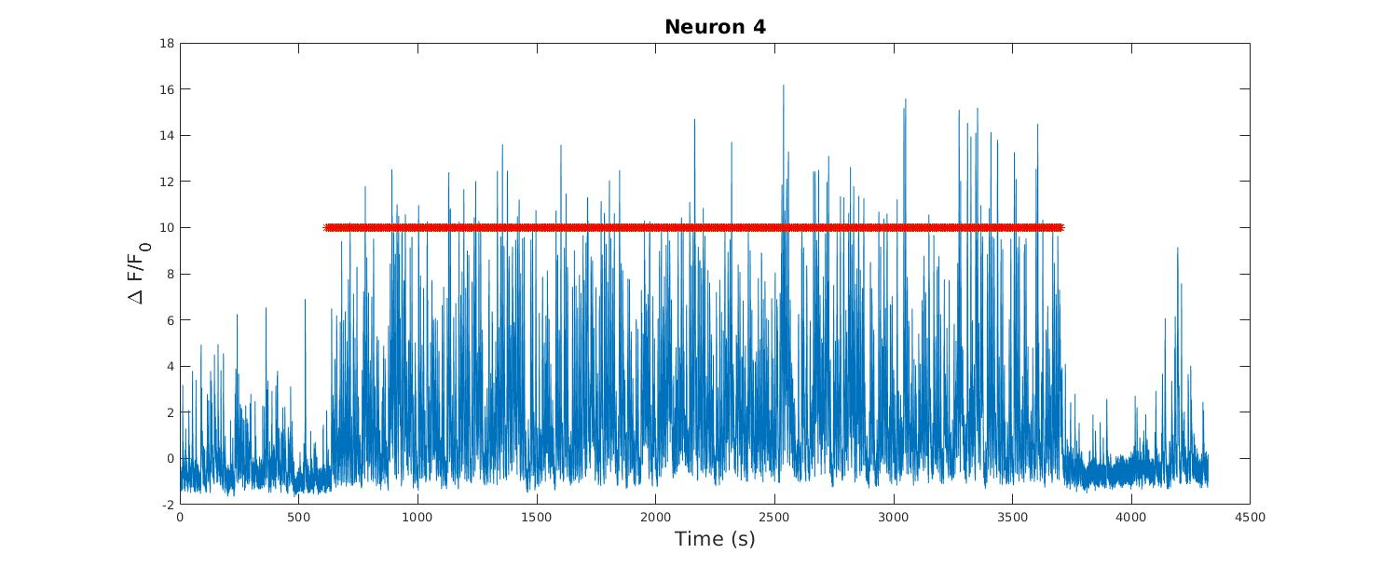

If you zoom into your Ca2+ traces, you should see something like this:

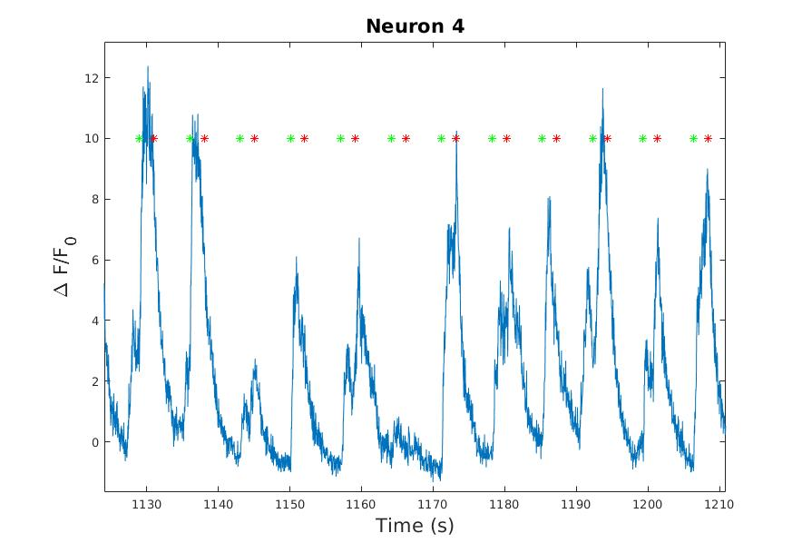

You can see how robustly these cells respond to the visual stimuli!

Now using your favorite cell, plot a heatmap to visualize the responses to visual stimuli. Your x-axis will be the time from visual stimuli onset, and the y-axis will be the trial number. Let’s also plot the average response across all trials underneath the heatmap (using subplot).

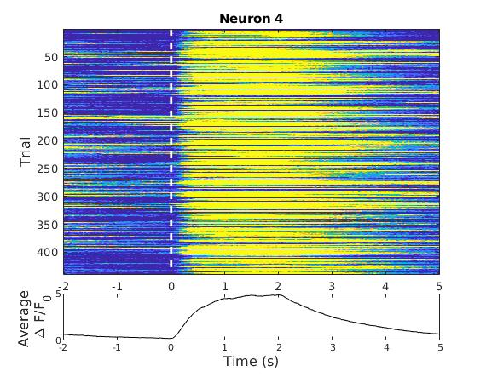

You can see that this cell responds really robustly to the visual stimuli. What do you notice about its response? How long after visual stimulus onset does the average activity peak?

There is quite a bit of variability in the strength of response to each stimuli (you can see this easily in the zoomed in Ca2+ trace). This is because all the stimuli are not the same – we are varying the contrasts (or sizes in the sampleRFdata.mat file)! Let’s find the mean and SEM of the responses for each stimulus, and create and error bar plot to visualize.

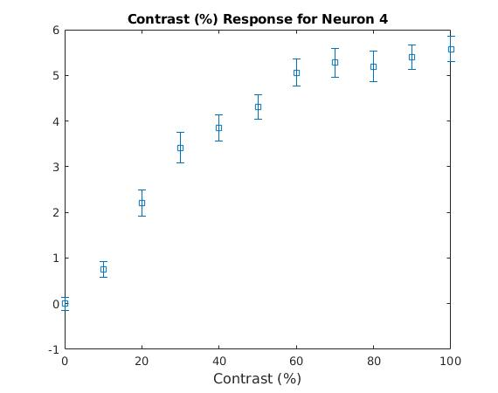

The cell responds to stimuli with high contrast as compared to those with lower contrast.

There are some exercises at the end. Don't do the 'bonus challenges' until you finish the exercises. You can choose the exercises that are most interesting to you. For example, what stimulus sizes do these SOM+ cells fire most strongly for? If you’re interested in learning more about the wheel data, just ask!