1.
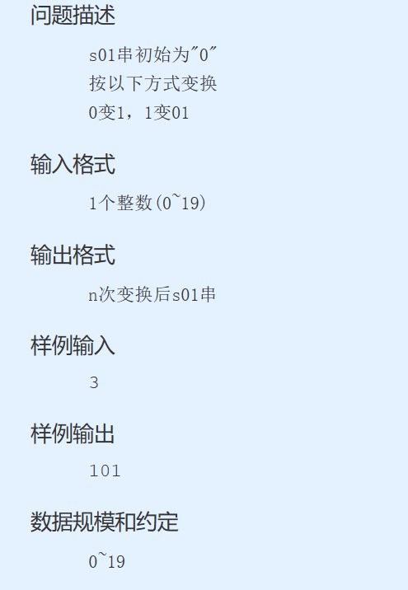
递归方式代码：
#define _CRT_SECURE_NO_WARNINGS
#include<stdio.h>
#include<windows.h>
void digui(int n)
{
if (n == 0)
printf("0");
else if (n == 1)
printf("1");
else if (n == 2)
printf("01");
else
{
digui(n - 2);
digui(n - 3);
digui(n - 2);
}

}
void main()
{
printf("输入一个数");
int n;
scanf("%d", &n);
digui(n);
system("pause");
}
动态规划代码：
#define _CRT_SECURE_NO_WARNINGS
#include<stdio.h>
#include<Windows.h>
#include<string.h>
void main()
{
char a[150]= "0";
char b[150] = "1";
char c[150] = "01";
char d[150];
int n;
scanf("%d", &n);
int i;
for (i = 3; i <= n; i++)
{
strcpy(d, b);
strcat(d, a);
strcat(d, b);
strcpy(a, b);
strcpy(b, c);
strcpy(c, d);

}
printf("%s", d);
system("pause");

}

2.

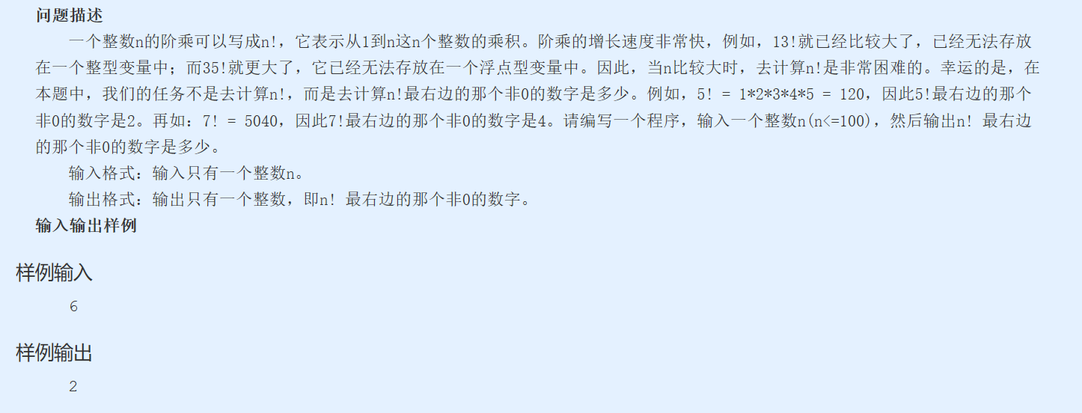
代码
#define _CRT_SECURE_NO_WARNINGS
#include<stdio.h>
#include<windows.h>
void main()
{
int n;
printf("输入一个数");
scanf("%d", &n);
int i;
int sum = 1;
for (i = 2; i <= n; i++)
{
sum *= i;
while (sum % 10 == 0)
{
sum /= 10;
}
sum = sum % 10;
}
printf("%d", sum);
system("pause");
}

3.
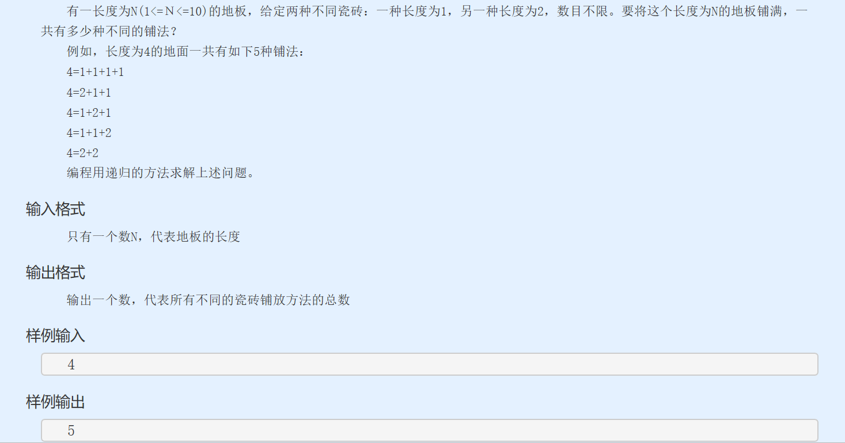
递归代码：
#define _CRT_SECURE_NO_WARNINGS
#include<stdio.h>
#include<windows.h>
int digui(int n)
{
if (n == 1)
return 1;
else if (n == 2)
return 2;
else
return digui(n - 1) + digui(n - 2);
}
void main()
{
int n;
printf("输入一个数");
scanf("%d", &n);
printf("%d", digui(n));

system("pause");
}
动态规划代码：
#define _CRT_SECURE_NO_WARNINGS
#include<stdio.h>
#include<Windows.h>
void main()
{
int a = 1, b = 2, sum;
int n;
scanf("%d", &n);
if (n == 1 || n == 2)
sum = n;
else
{
for (int i = 3; i <= n; i++)
{
sum = a + b;
a = b;
b = sum;
}
}
printf("%d", sum);
system("pause");

}

