Lappeenrannan teknillinen yliopisto

School of Business and Management

Sofware Development Skills

Viivi Aholainen, 000391764

LEARNING DIARY, FRONT-END MODULE

LEARNING DIARY

30.08.2022
Created git repository for course work. Got myself familiar with the course.

31.08.2022
Today I watched the first video and set up my VSCode environment and workflow. Right away I learnt a lot. My previous knowledge about front-end development was the basics of HTML, CSS and JavaScript which were helpful as the tutorial dove right into using Sass. Yesterday as I created the git repository, I thought I would do a different for each video but right away as I started watching the first video, I decided to work on the same project for the whole course. First I’ll work on it based on the tutorial videos and then I’ll refine it into more personalized final project.
After the first tutorial the website looks quite empty. We have a body and a header with their colors defined in Sass. I’m very excited to learn Sass because just the possibility to define colors at one place and use them as variables seems very useful and fun to work with.

02.09.2022
I watched the second video and my website isn’t empty anymore. Now it has the basic html for the home page and the menu and styling for the home page. The homepage has a background image, opaque grey overlay on top of that and on top of everything there’s headings and icons. I learnt to make icon links, make a nice looking background with image and overlay and how functions and nesting work in scss.

Here’s the website after the second video:
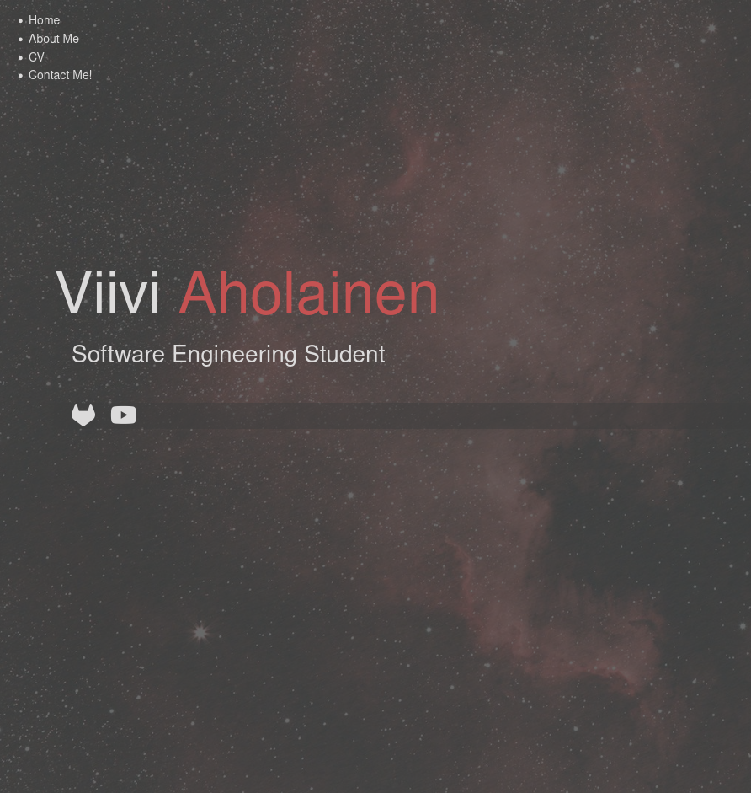

02.09.2022
After the third video the visible changes to the website are the menu button how it reacts to a click: by transforming from three lines to an X. The whole button is made with pure CSS which I think is really cool and I wonder what kind of things I could make in the future.



Main things I learnt from this was toggling DOM elements’ classes and the transform function of CSS.

03.09.2022
After the fourth video, the website now has a working menu and responsiveness. The page adapts to narrower displays. Today I learnt one way to create a menu page and how to make a website more responsive. I also learnt more about transitions.
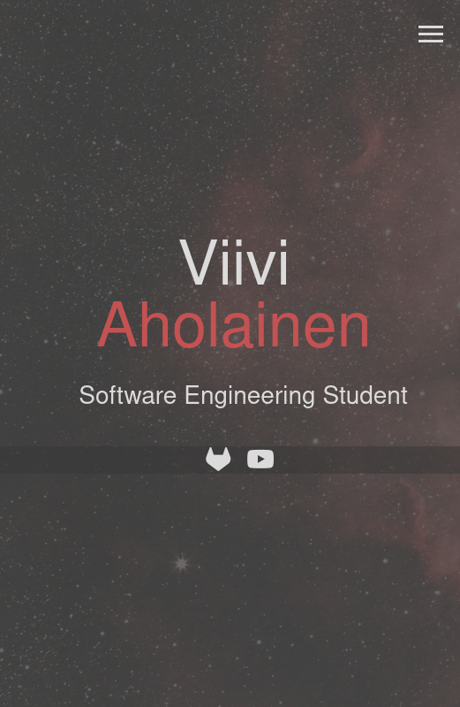

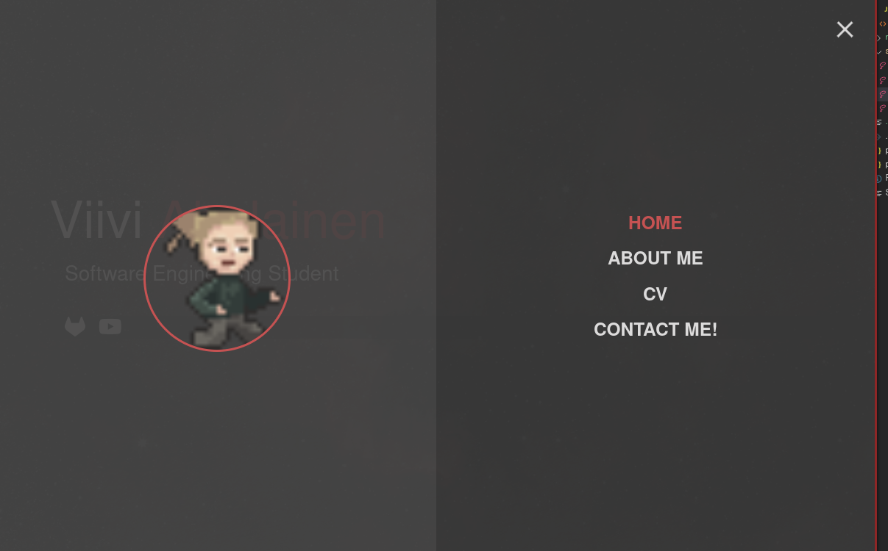
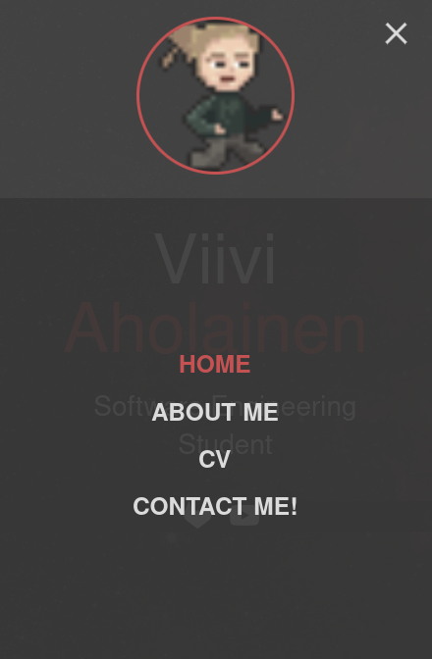

18.09.2022
The fifth tutorial was about using CSS grid and with it we made a new page to the website. Now there is an about page with grid layout and a sticky footer. I was somewhat familiar with grid layouts beforehand but I had no idea about the use of grid-template-areas. That is a function I’m very glad to have learnt about because it made everything so simple. I also learnt how to make a sticky footer by adjusting the main elements height. I also found the command lorem<number of words> to generate filler text neat and useful.
This is what the about page looks like now on wide and narrow displays:
