Estimating the number of COVID-19 cases from population isolation level
Adriano J. Holanda^{,2}
¹Department of Computing and Mathematics - Faculty of Philosophy, Science and Letters at Ribeirão Preto - University of São Paulo, 3900 Bandeirantes Ave.,Ribeirão Preto, São Paulo, 14040-901, Brazil
²Faculty “Dr. Francisco Maeda”, Ituverava, São Paulo, Brazil

Abstract
We use the logistic function to estimate the number of individuals infected by a virus in a period of time as a function of social isolation level in the previous period of the infection occurrences. Each period is composed by a fixed date range in days which the social isolation is supposed to take effect over the virus spread in the next date range. The sample is the COVID-19 cases and social isolation level data from São Paulo State, Brazil. The proposed method is divided into two stages: 1) The logistic function is fitted against COVID-19 empirical data to obtain the function parameters; 2) the function parameters, except for the overall growth rate, and the mean of social isolation level for all periods of time are used to calculate a constant called λ. The logistic growth rate for each period of time is calculated using λ and the isolation level for that period. The number of cases in a period is estimated using the logistic function and the growth rate from previous period of time to obtain the effect of social isolation during the elapsed time. The period of time that produces a better correlation between empirical and estimated data was 5 days. We conclude the method performs a data estimation with high correlation with the empirical data.

Keywords:
SARS-CoV-2, COVID-19, logistic function, isolation

Introduction
SARS-CoV-2 is the virus that causes the infection called coronavirus disease (COVID-19).
COVID-19 pandemic control will depend on the coverage of population immunity obtained
through infection or vaccination¹. The mutants of SARS-CoV-2 impose a predictability challenge in the long-term efficacy of the current vaccines. It’s of utmost importance the preparation of updated vaccines tailored to emerging variants that are cross-reactive against all circulating variants². Indeed, the minority of the population in some countries is immunized against SARS-CoV-2, e.g., only 44.8% of the population is fully vaccinated in Brazil³. The SARS-CoV-2 variants and its low rate of immunization impose the continuation of non-pharmacological approaches: handwashing, use of facial masks and social distancing⁴. Among these approaches, only social distancing can be assessed effectively using communication traces⁵. Isolating cases, quarantining contacts and implementing large-scale social distancing approaches have been proved to be effective in the control of virus spread⁶.
In this study, we use the logistic function to calculate the expected number of COVID-19 cases as a function of time based on the isolation level of the population and observed number of cases. We've chosen the São Paulo State, Brazil data as sample, but the method is simple and generic to apply to any population data. São Paulo is one and the most populous of the 26 states of the Federative Republic of Brazil with more than 40-million inhabitants, 21.9% of Brazilian population and is responsible for 33.9% of Brazil's GPD (Gross Domestic Product) (www.ibge.gov.br/cidades-e-estados/sp.html).

Methods

Data preparation
We gathered the number of cases of COVID-19 in São Paulo State, Brazil, from Github repository of “São Paulo Plan” (github.com/seade-R/dados-covid-sp) that is a initiative from the state government to organize and process data related to COVID-19 from all cities of the state. The plan aims to help in the decision-making along the application of public procedures to control the SARS-CoV-2 spread. We also fetched the social isolation level data for all state cities from “São Paulo Plan”, but from another web address (www.saopaulo.sp.gov.br/coronavirus/isolamento).
In order to avoid large discrepancies in the number of cases due delayed notification,
each data point is composed by a group of days which each group is labeled by the most recent date in the group and all groups have the same number of days. All data points contain the sum of the COVID-19 cases and the mean of the population isolation levels in the group for all cities located in the São Paulo State.

Fitting
We choose the logistic function to model the SARS-CoV-2 spread behavior. We use the
solution for

N/dt = rN(1 – N/K) (1)

that is

N(t) = K/(1-(K-Nm)/Nm) e^{-rt}) (2)

where K is the maximum value reachable by N, N_{m} is the curve midpoint, r is the growth rate and t is the time.
Equation 1 shows a hypothetical logistic function plotted using Equation 1 where before the midpoint the number of cases between two consecutive time steps increases, and after the midpoint decreases. The curve reaches a plateau in the maximum value for n(t). The number of cases n and time t are normalized. In an empirical scenario, the plateau could be achieved if the process that is feeding the curve growth is controlled with the maximum value for n(t) not being reached.

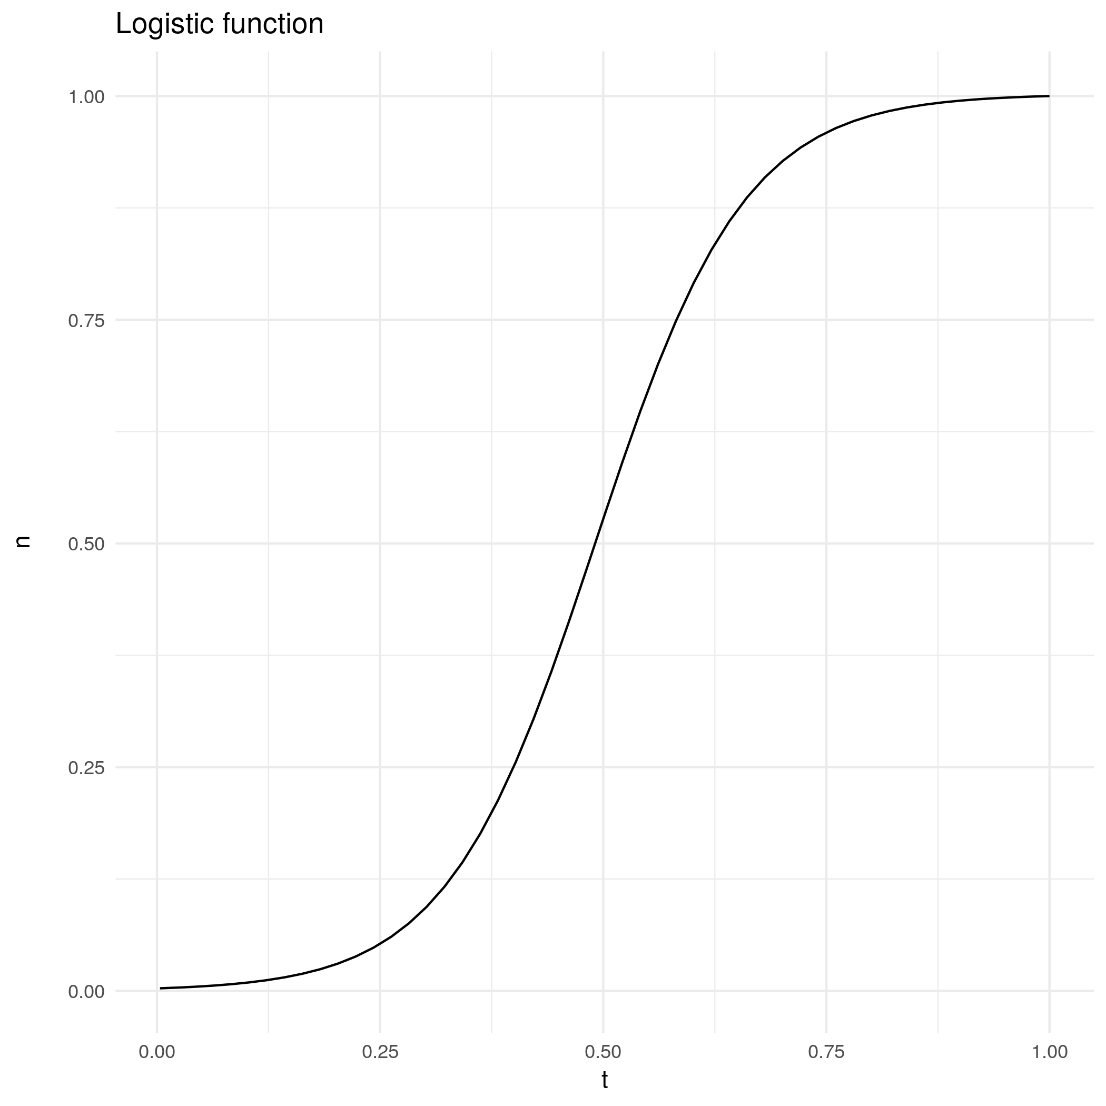
Figure 1. Hypothetical normalized logistic function – curve of Equation 1 with K=1.0 and an arbitrary growth rate r=0.04; the midpoint coordinates are (0.5, 0.5). The K represents a normalized measure where the maximum value is the divisor factor.
We considered N to be the number of infected individuals and choose the logistic function because of its behavior, with an exponential increase at the beginning but slowing down after a midpoint and reaching a plateau. The same behavior occurs with a virus dissemination when at the beginning it spreads exponentially, and it starts to decrease the contamination after some control protocol is implemented, like vaccination or lock-down, or in the worst case scenario when the majority of the population is infected.
The graph of the cumulative number of empirical cases of COVID-19 at each time step was plotted, and the Equation 2 was fitted against the empirical data.

Estimation
We postulate that the growth rate r in the logistic function is inversely proportional to the population isolation level i modulated by a constant λ:

r_{fit} = λ i → λ = r_{fit} i . (3)

We calculate the constant by multiplying the mean isolation level i of all time steps by
r_{fit} obtained with the fitting of logistic function and the empirical data.

The constant calculated using Equation 3 and isolation level of each time interval i(t)
are used to estimate the growth rate r(t) using the formula:

r(t) = λ/i(t). (4)

A time step is a period of time in days used to group the COVID-19 cases where the social isolation level from the last period takes effect over the SARS-CoV-2 spread. The estimated number of cases N(t) is calculated using Equation 2 plugging r(t-1) instead of r(t) because we take the previous growth rate r(t-1) to predict the effect in the number of cases after a period of time N(t):

N(t) = K / (1- ((K-N_{m}) / Nm) e^{-r(t-1) t} . (5)

We compare these results with the empirical data using Pearson correlation. We use a time step t equals to 5 days because it was the value with a better correlation between empirical and estimated data. Furthermore, we only use integers as time intervals for days because the variation in the correlation values was not significant to justify handling fractional values that increases the complexity of code and analysis.

Results
Figure 2 shows the accumulated number of COVID-19 cases per time step in São Paulo State and the fitting performed using logistic function (Equation 5) that proved to be a good approximation to the cumulative growth of number of cases.
We notice the consistent increase in the number of cases with the plateau to be achieved when the number of cases reaches 5,482,799 according to the parameters extracted from fitting.

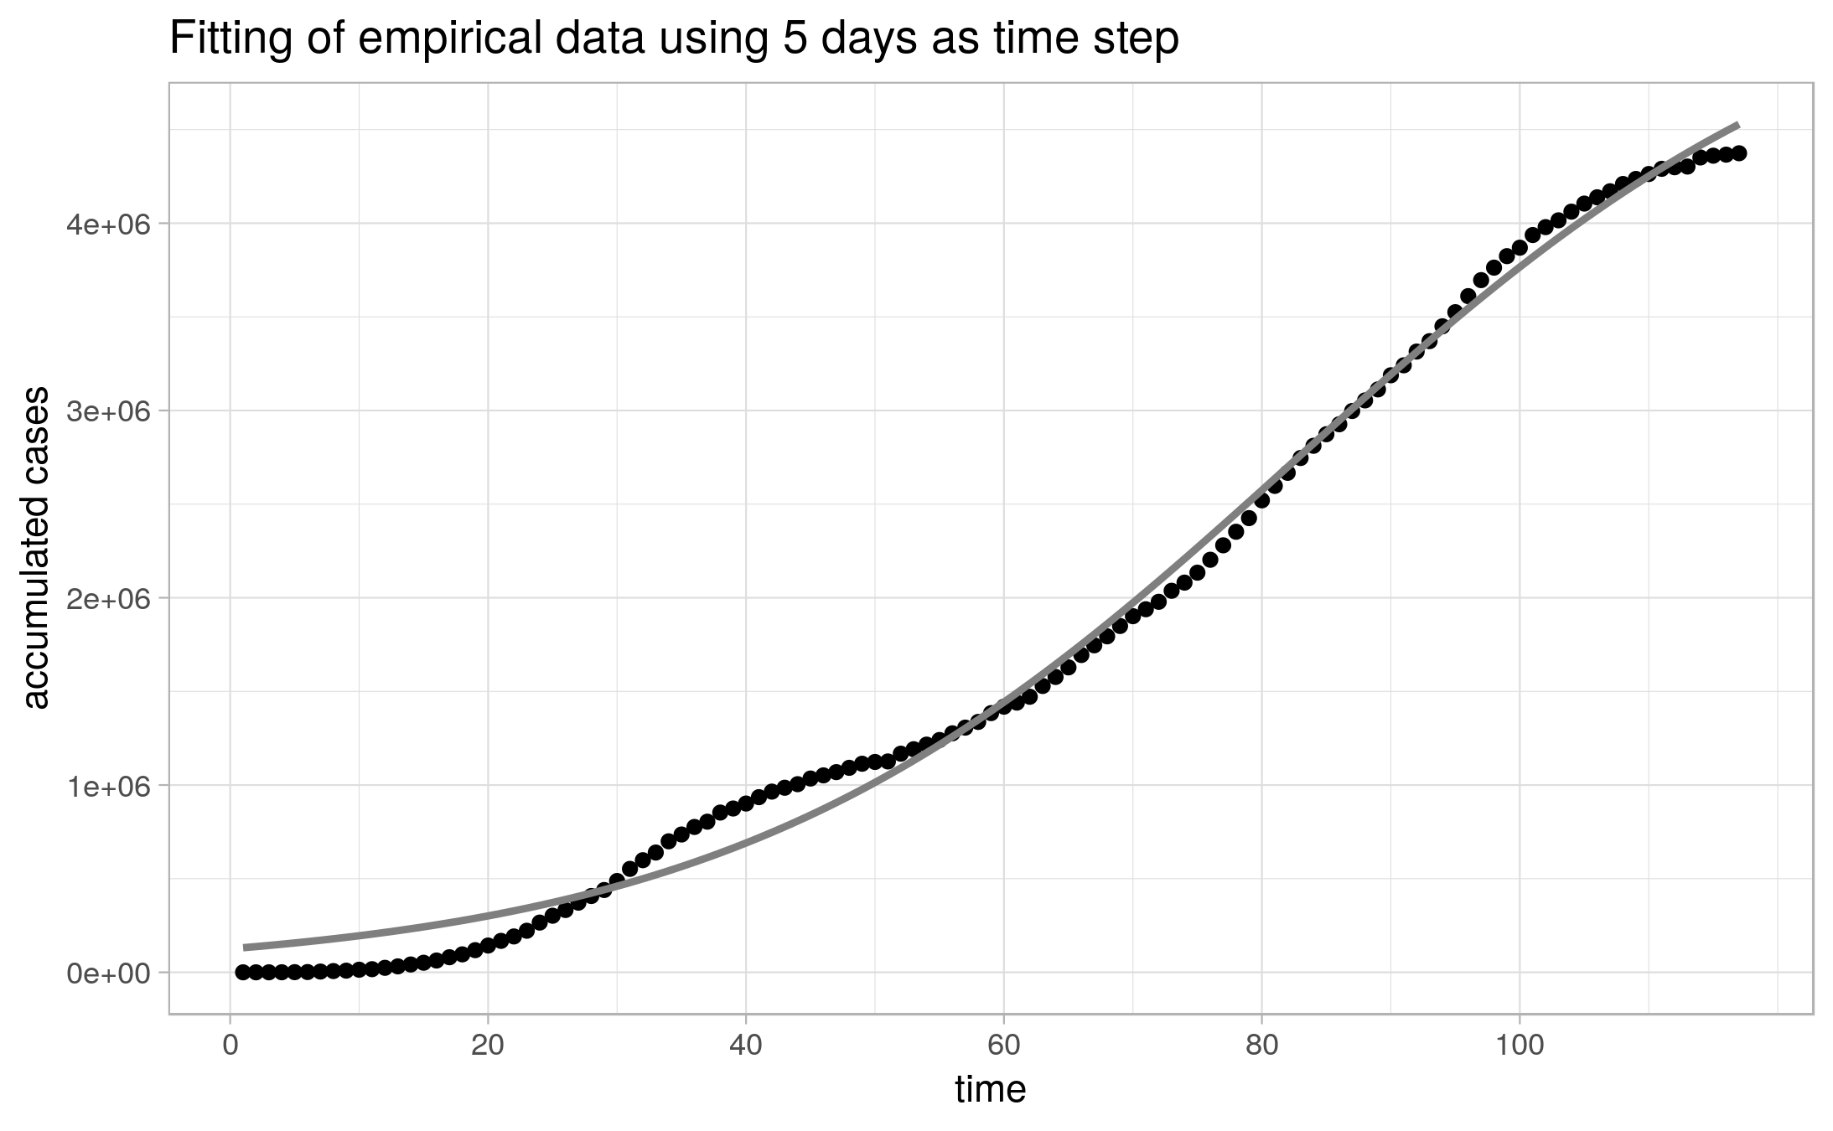
Figure 2: Curve of accumulated number of cases at each time step t and its fitting curve
using the logistic function (Equation 2) where the parameters obtained from fitting are: r=0.045, N_{m}=125,673, K=5,482,799 . The Pearson correlation between the empirical and fitted data is 0.997 and p-value < 2.2 x 10⁻¹⁶. The number of time steps is 117 and the initial and final dates are “2020-03-01” and “2021-10-05”, respectively.

Figure 3 shows the empirical curve again and the estimated number of cases using the fitting parameters K and N_{m} and the calculation of growth rate r(t) using Equation 4, where the isolation level i(t) is used, to plug into logistic function (Equation 5) and calculate the estimated number of cases N(t+1).
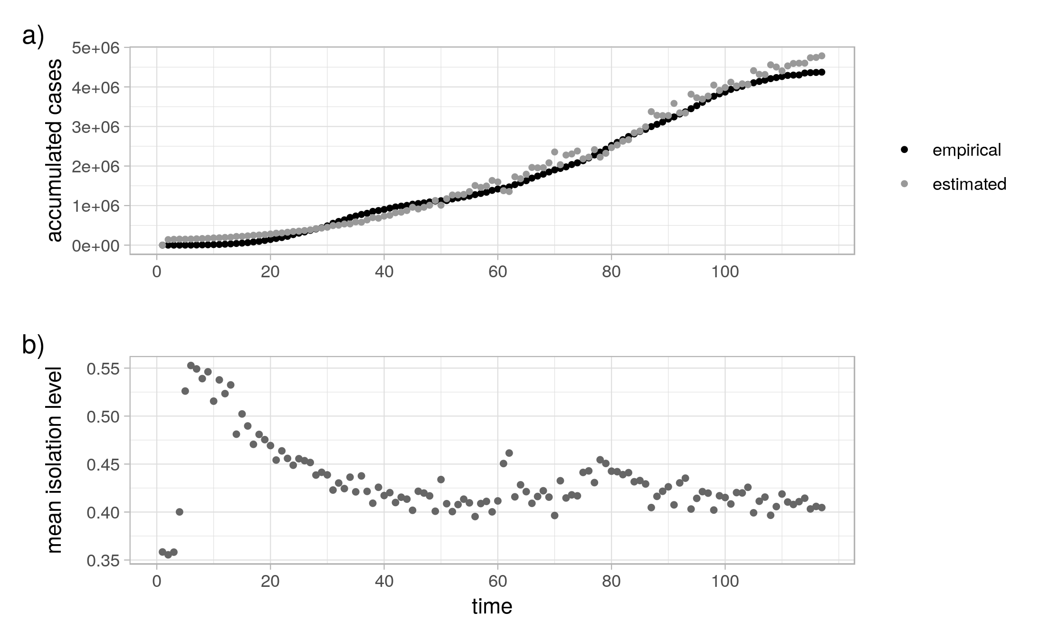
Figure 3: a) Curve of accumulated number of cases and the estimation using the logistic function (Equation 5) with the growth rate r(t) obtained from Equation 4. The constant λ was calculated using Equation 3 with r=0.045 and i =0.433 ± 0.038. The Pearson correlation coefficient between empirical and estimated data is 0.996 and p-value < 2.2 x 10⁻¹⁶. b) Mean isolation level at each time step t. The number of steps, initial and final dates are the same as Figure 2.

We noticed at the beginning of the curve in Figure 3b, high values of isolation levels. At that moment, the São Paulo State government adopted more strict rules to avoid circulation of people. It was issued from March 16th and March 22nd a decree to encourage home-based working whenever possible, closure of schools and non-emergencies commerce⁷.

Discussion
The proposed method to predict the number of infected individuals using the current empirical data and the logistic function proved to be an effective approximation for the infection spread.
It's a simple method and the fact it doesn't take into account other barriers to the infection spread, like the use of a facial mask, is a good property since it's very difficult to obtain the correlation about the application of these fundamental procedures and the number of cases.
The main reason to develop a simple but accurate method to estimate the number of infected individuals using the isolation level is to help in the decision-making process related to the control of infection spread. The isolation level is a reliable measure and may be used to predict the desired behavior of the population in time steps and check if the infection is really being controlled, reaching a remission in an expected time ahead.
We adopted a simpler method instead of more detailed compartmental models^{8,9,10}, e.g. SIR (Susceptible, Infectious, or Recovered), SEIR (Susceptible, Exposed, Infectious, or Recovered) or SEIS (Susceptible, Exposed, Infectious, then Susceptible again), due to the following reasons: a) The number of infected individuals is very small when compared with population if there is an application of approaches to control the virus spread; b) It's difficult to assess the influence of non-pharmacological approaches and the approximation used somewhat seems to embed this influence due to the high correlation the empirical and estimated data; c) Births, deaths, deaths due to the disease, immigration and emigration rates are also difficult to assess effectively in most countries, even deaths due to the disease may be contaminated by errors related to death certificate misjudgment; d) It's challenging to assess, in some of these models, the number of individuals with repeated infections and the gradual loss of acquired immunity because some aspects of the immunization process is yet to be unraveled, at least for COVID-19.
Another advantage of our method over the compartmental models is the reduction of dimensionality to one manageable and reliable dimension, this process is also called feature engineering¹¹. This property also facilitates the source code understanding, maintenance and efficiency. The data is easily updated and the number of days in each time step may be changed in the source code.
For future developments, we visualize the use of Control Theory in the estimation phase¹². The isolation level and number of cases may be used as process variable and set point, respectively, in a controller like PI (Proportional-Integral) or PID (PI-Derivative), optimizing the system according to some properties. The properties may be the vaccination rate and the vaccines’ stock, number of ICU (Intensive Care Unit) beds in a hospital, and even immunization loss growth rate.

Source code and data availability
R code and data required to reproduce the analyses and Figures are available from
https://github.com/aholanda/pandiso.

Declaration of conflict of interest
We have no known conflict of financial interests or personal relationships that could have
appeared to influence the work reported in this paper.

References
1. World Health Organization, COVID-19 vaccines,
https://www.who.int/emergencies/diseases/novel-coronavirus-2019/covid-19-vaccines,
accessed: 2021-08-05 (2021).

2. Harvey WT, Carabelli AM, Jackson B, Gupta RK, Thomson EC, Harrison EM, Ludden C, Reeve R, Rambaut R, Peacock SJ, Robertson DL. SARS-CoV-2 variants, spike mutations and immune escape. Nature Reviews Microbiology. 2021;19 (17):409-424. doi:10.1038/s41579-021-00573-0.

3. Brazilian Ministry of Health, Vacinação, www.gov.br/saude/pt-br/vacinacao, accessed: 2021/10/07 (2021).

4. World Health Organization, Infection prevention and control during health care when coronavirus disease (COVID-19) is suspected or confirmed. Interim guidance, COVID-19: Infection prevention and control WASH,
www.who.int/publications/i/item/WHO-2019-nCoV-IPC-2021.1,
accessed: 2021/08/05 (2021).

5. Farrahi K, Emonet R, Cebrian M. Epidemic contact tracing via communication traces. PLoS ONE. 2014;9 (5):e95133. doi:10.1371/journal.pone.0095133

6. Aquino EML, Silveira IH, Pescarini JM, Aquino R, Souza-Filho JA, Rocha AS, Ferreira A, Victor A, Teixeira C, Machado DB, Paixão E, Alves FJO, Pilecco F, Menezes G, Gabrielli L, Leite L, Almeida MCC, Ortelan N, Fernandes QHRF, Ortiz RJF, Palmeira RN, Junior EPP, Aragão E, Souza LEPF, Netto MB, Teixeira MG, Barreto ML, Ichihara MY, Lima RTRS. Social distancing measures to control the COVID-19 pandemic: Potential impacts and challenges in Brazil, Ciência e Saúde Coletiva. 2020; 24(1):2423-2446. doi:10.1590/1413-81232020256.1.10502020.

7. Cruz CHB. Social distancing in São Paulo State: demonstrating the reduction in cases using time series analysis of deaths due to COVID-19, Revista. Brasileira de Epidemiologia. 2020;23:E200056. doi:10.1590/1980-549720200056.
8. Ross R. An application of the theory of probabilities to the study of a priori pathometry - Part I. Proceedings of the Royal Society of London. Series A, Containing Papers of a Mathematical and Physical Character. 1916;92 (638):204-230. doi:10.1098/rspa.1916.0007.

9. Ross R, Hudson HP. An application of the theory of probabilities to the study of a priori pathometry - Part II, Proceedings of the Royal Society of London. Series A, Containing Papers of a Mathematical and Physical Character. 1917;93 (650):212-215.
doi:10.1098/rspa.1917.0014.

10. Ross R, Hudson HP. An application of the theory of probabilities to the study of a priori pathometry - Part III, Proceedings of the Royal Society of London. Series A, Containing Papers of a Mathematical and Physical Character. 1917;93 (650):225-240.
doi:10.1098/rspa.1917.0015.

11. Spiegelhalter D. The Art of Statistics: How to Learn from Data. Basic Books Publishing, 2019.

12. Stewart G, Heusden KV, Dumont GA. How control theory can help us control COVID-19, IEEE Spectrum. 2020;6 (57):22–29.

Contact information: aholanda@usp.br

