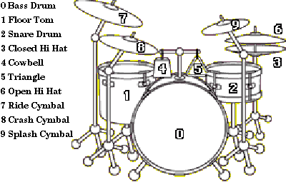
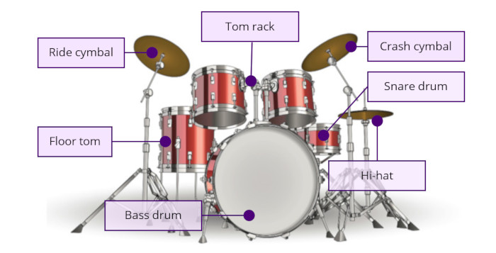
Mid Tom
High Tom

Example 1:
CC|x---------------|--------x-------|
HH|--x-x-x-x-x-x-x-|----------------|
SD|----o-------o---|oooo------------|
HT|----------------|----oo----------|
MT|----------------|------oo--------|
BD|o-------o-------|o-------o-------|
Here the following symbols mean:
- CC: crash cymbal
- HH: Hi-hat
- SD: Snare drum
- HT: High Tom (right tom rack)
- MT: Mid Tom (left tom rack)
- BD: Bass Drum
- o: strike or normal hit / if it is on a hi-hat it means open hit
- x: strike / on a hi-hat it means closed hit “
- O: accent or hit harder than normal

Example 2:
C |-----------------|-----------------|-----------------|---------------x-|
H |-x-x-x-x-x-x-x-x-|-x-x-x-x-x-x-x-x-|-x-x-x-x-x-x-x-x-|-x-x-x-x-x-x-x---|
t |-----------------|-----------------|-------------o---|-------o---------|
S |-----o-------o---|-----o-------o---|-----o-----o-----|-o-o---------o---|
B |---------o-------|-o-------o-----o-|-o-------o-----o-|-----o---o-o---o-|
Here the following symbols mean:
- C: crash cymbal
- H: Hi-hat
- t: Mid Tom
- S: Snare drum
- BD: Bass Drum
- o = strike or normal hit / if it is on a hi-hat it means open hit
- x = strike / on a hi-hat it means closed hit “

Example 3:
t -----o-------o---|
T ---------------o-| repeat
F -o-o-o-o-o-o-o-o-| 2x
B -o---o---o---o---|

Here the following symbols mean:

- t: Mid Tom
- T: High Tom
- F: Floor Tom
- B: Bass Drum
- o = strike or normal hit / if it is on a hi-hat it means open hit

Special Cases

Example 4:

|----repeat-3x----| |----repeat-1x----|
C -x---------------|-----------------|-----------------|-----------------|
H -----x---x---x---|-----------------|-----------------|-----------------|
S -----------------|-----------------|-----------------|---------------f-|
B -----------------|-o---------------|-----------------|-----------------|

Here the following symbol mean:

- f: flam or two strokes hit by alternating hands with the first hit being a grace note followed by a stronger first hit with the other hand. The two notes are meant to be played in extremely close succession, so it almost sounds like one hit.

Example 5:
C -x-------x-------|
H ---X-x-X---X-x-X-|
S -----o-------o---|
B -o-------o-------|
Here the following symbol mean:
- x: strike / on a hi-hat it means closed hit
- X: hard cymbal

Example 6:
|----repeat-5x----|
C -----------------|-----------------| -------x-------------|
S -oo--o-------o-g-|-oo--o-------o-g-| 5 -oo--o-o-oooooooooooo|
F -oo--o-----------|-oo--o-----------|--- -oo--o---------------|
B ---------o--o---o|----o----o--o---o| 4 ----o----------------|
Hf-------x---------|-------x---------| ---------------------|

- g: ghost or hit softer than normal

Example 7:

C |x--------x--------|---------x--x-----|x--------x--------|---------x--x-----|
R |------x-----x--x--|x--x-xx-----------|---x-xx-----x-xx--|x--x-xx-----------|
SD|---------o--------|---------o--o-----|---------o--------|---------o--o-----|
FT|------------------|--------------o-o-|------------------|--------------oo--|
B |o----------------o|o----------o------|o-----------------|o----------oo-----|
(1tl2tl3tl4tl5tl6tl|1tl2tl3tl4tl5tl6tl|1tl2tl3tl4tl5tl6tl|1tl2tl3tl4tl5tl6tl)

- R: Ride cymbal
- 1t12t13t…: Timing/Beats/Position

Example 8:
C |x---x-----------|x---------------------|x---x-x-------------|
T |----------------|----------------dddo--|--------x-----oooo--|
SD|----o---oooo----|----dddo--dddo--------|----o---oooooo------|
FT|------------ooo-|----------------------|--------------------|
B |o--o------------|o--o-----o-----o-----o|o--o----------------|
(1 + 2 + 3 + 4 + |1 + 2tl+tl3tl+tl4tl+tl|1 + 2 + 3tl+tl4tl+tl)

- d: double stroke or a roll

Example 9:
|------------REPEAT-3X------------|
C |x---x-----------|#---------------|----------------|x--x--x---------|
SD|----o---oooo----|----------------|----------------|o--o--o--oooooo-|
FT|-------------oo-|----------------|----------------|---------oooooo-|
B |o--o------------|o-x-x-x-x-x-x-x-|x-x-x-x-x-x-x-x-|o--o--o---------|
(1 + 2 + 3 + 4 + |1 + 2 + 3 + 4 + |1 + 2 + 3 + 4 + |1 + 2 + 3 + 4 + )

- #: choke or hit the cymbal, then grab it so the sound stops abruptly

