**Name: Khaled Elbardawell**

**Student Number: 20173784**

**Brief description of my Wi-Fi**





|  |  |
| --- | --- |
| **Internet speed** | **8mbps** |
| **Bandwidth** | **2.4** |
| **Vendor** | **Hadara** |
| **Router type** | **TP-link** |
| **Channel** | **10** |
| **WPS state** | **Configured** |
| **WPS mode** | **PBC** |
| **Encryption** | **AES** |
| **WDS** | **off** |
| **ISP** | **Bridge Mode** |
| **IP Version** | **IPv4** |

**My Wi-Fi Heatmap images:** (use NetSpot app free edition)

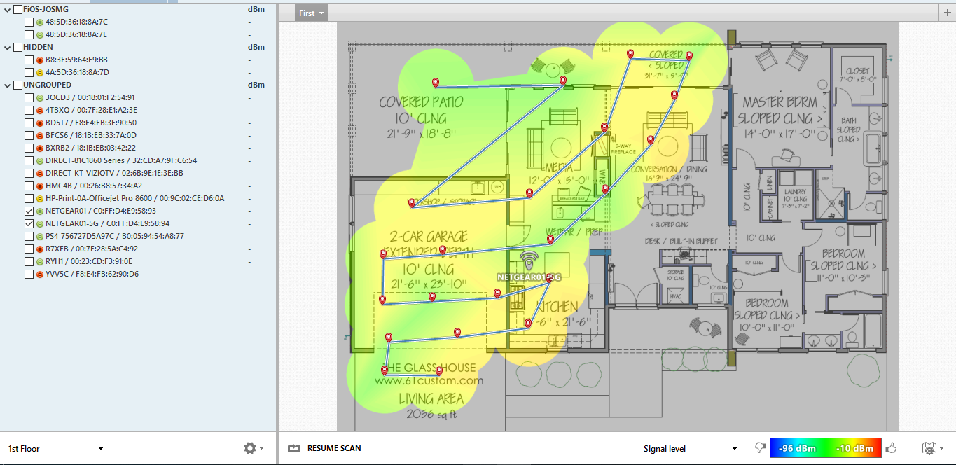

**We note through the heatmap of my Wi-Fi network that the strongest points that the Internet reaches are the red points (-10 DBM), and the weakest areas are the ones in blue (-96 DBM).**

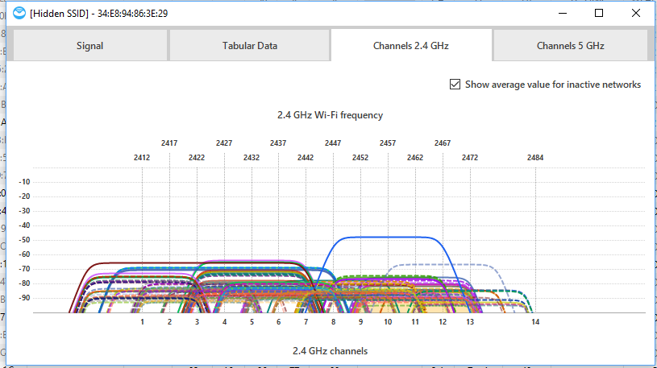

**Based on the above figure, note that wave interference occurs most widely in networks with a frequency of 2.4 GHz. There are several reasons for this because the frequencies range from 1 to 14 and this leads to the sharing of more than one network on the same channel (frequency) because of the large number of networks that exist relative to the range of frequencies.**

**Description of any measures taken to improve your Wi-Fi coverage and throughput:**

1. **Select a Good Place for Your Router**
2. **Use the latest and latest Wi-Fi technology**
3. **Switch to a Different Wi-Fi Channel**
4. **Increase your internet speed according to the number of devices you use**
5. **Measure Wired Internet Performance**
6. **Communicate with the Internet service provider in order to find out if there are problems that need to be resolved or not.**
7. **Switch to 5 GHz**