COMP9322 Assignment1 Document

Author: Tianpeng Chen z5176343 (tianpeng.chen@student.unsw.edu.au)

# Project structure

## Backend

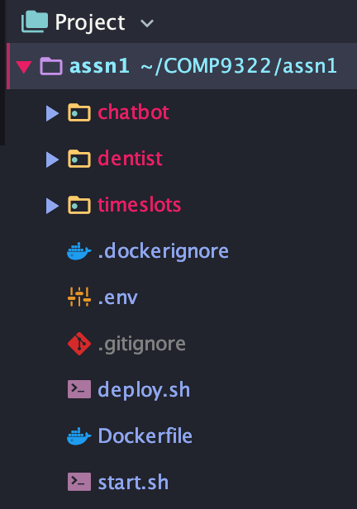

* chatbot

contains the source code and docker file for the Chatfuel chatbot webhook server

* dentist

contains the source code and docker file for the **dentist** microservice

* timeslots

contains the source code and docker file for the **timeslot** microservice

Under each sub-folder, I also wrote a deploy script to help me deploying my app.

In addition, as I have all my services deployed on *Heroku*, a docker image containers *Heroku-cli* is also provided. You can run *start.sh* to build and run the image, which will automatically deploy all the three services to *Heroku*.

## Frontend

I used Chatfuel to build a chatbot which is accessible on Facebook Messenger. You can search “Tim 9322 Dentist Reservation” to start chatting with the bot.

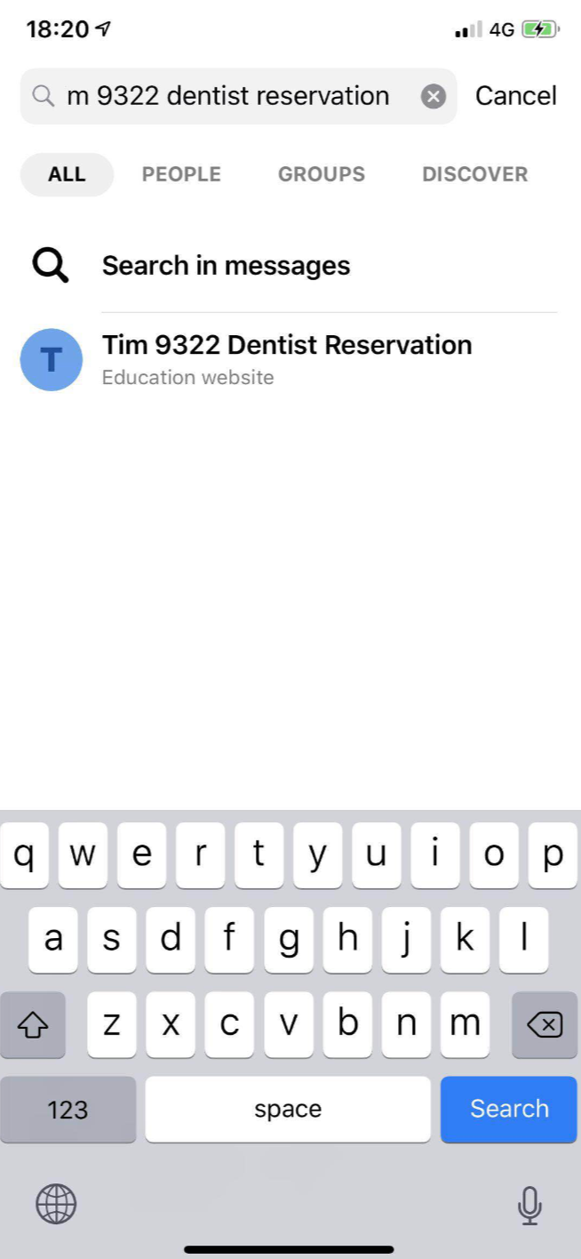

# API Documentation

API documentation and tests are available with *swagger.* You can test these APIs through:

* timeslot microservice

<https://tim-9322-timeslot.herokuapp.com/v1/help>

* dentist

<https://tim-9322-dentist.herokuapp.com/v1/help>

# Deployment

All the services are deployed to *Heroku.* A start script *“start.sh”* is provided to build and run a *Heroku-cli* enabled docker image (which also contains an API key to access my Heroku apps), to deploy all the three apps to *Heroku.* If you want to deploy the services, just run “$ ./start.sh” in the project root.

# Bonus

As considering how to identify users, I found that Chatfuel provides a *“chatfuel user id”* which can help me identify each user. After that, I added a jwt-encryption to my webhook server, which encrypts the current user_id into a JWT, and send it to the **timeslot** microservice.

These two endpoints requires a JWT authorization in **timeslot**:

/timeslots/{id}/reserve

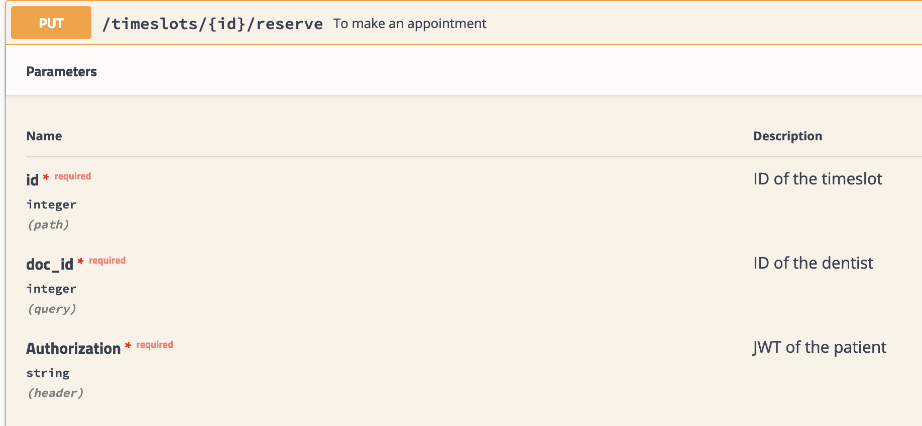

After a successful API call, the user JWT will be stored in the database.



/timeslots/{id}/cancel

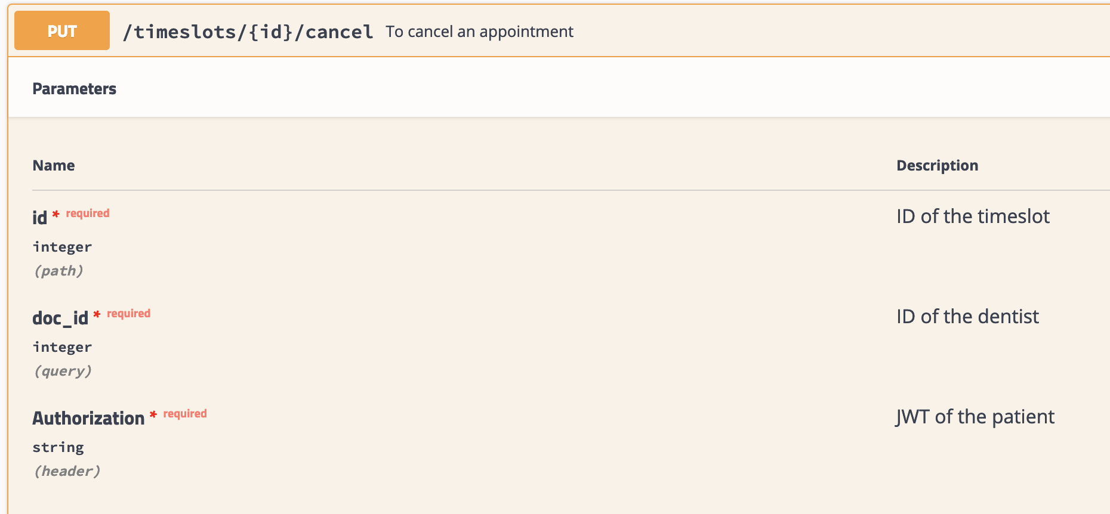

If someone called this API to cancel a reservation, it will require a user JWT and check against the one stored in the database, to ensure only the creator of the booking has the right to cancel it.

## Thank you!