Honeypot Project: Monitoring Attacks on an Open Virtual Machine in Azure

Objective
To demonstrate the risks of insecure networks exposed to the internet by deploying a honeypot VM in Azure. It involves passive monitoring of unauthorized login attempts, mapping attacker geolocations, and analyzing the speed at which open systems are exploited, highlighting the importance of proactive detection and threat intelligence.

Part I: Azure Setup
- Create Free Azure Account: https://azure.microsoft.com/en-us/pricing/purchase-options/azure-account
- Create the Honey Pot (Azure VM):
  - Create a new Windows 10 VM and note down the username and password:
    - OS: Windows 10
    - Username/Password: Corporate sounding but simple to remember
- Opening Network Configuration:
  - Go to Network Security Group (NSG) attached to VM
  - Add a new inbound rule to allow all traffic from all IPs (insecure but intentional)
  - Disable Windows Firewall from inside the VM:
    - Start wf.msc Properties Turn OFF all profiles
Part II: Simulating & Capturing Attacks
- Attempt to login 3 or more times using a wrong username or password (e.g., employee)
- Login Successfully afterwards to check Event Viewer:
  - Open Event Viewer Windows Logs Security
    - Filter for Event ID 4625 (failed login attempts)
Part III: Log Centralization & SIEM Integration
- In Azure, Setup Log Analytics Workspace (LAW)
- Deploy Microsoft Sentinel:
  - Create a Sentinel instance and connect it the LAW
- Connect VM Logs to LAW:
  - Configure “Windows Security Events via AMA” connector
  - Create the required Data Collection Rule (DCR)
- Query Logs via the following:
  - SecurityEvent
| where EventID == 4625

Part IV: IP Geolocation
- Upload GeoIP Watchlist:
  - Download the geoip-summerized.csv

  - In Sentinel, upload as a Watchlist:
    - Name: geoip
    - Search Key: network
- Enrich Logs with Location Data:
  - Run the following query to now include city, country, and ISP data:
    - let GeoIPDB_FULL = _GetWatchlist("geoip");
let WindowsEvents = SecurityEvent
| where EventID == 4625
| evaluate ipv4_lookup(GeoIPDB_FULL, IpAddress, network);
WindowsEvents
Part V: Create Attack Maps via Sentinel Workbook
- Build Attack Map Workbook:
  - Create a new Workbook in Sentinel
  - Remove difficult visuals
  - Add a new Query Element
  - Open the Advance Editor and replace the existing Query with the following:

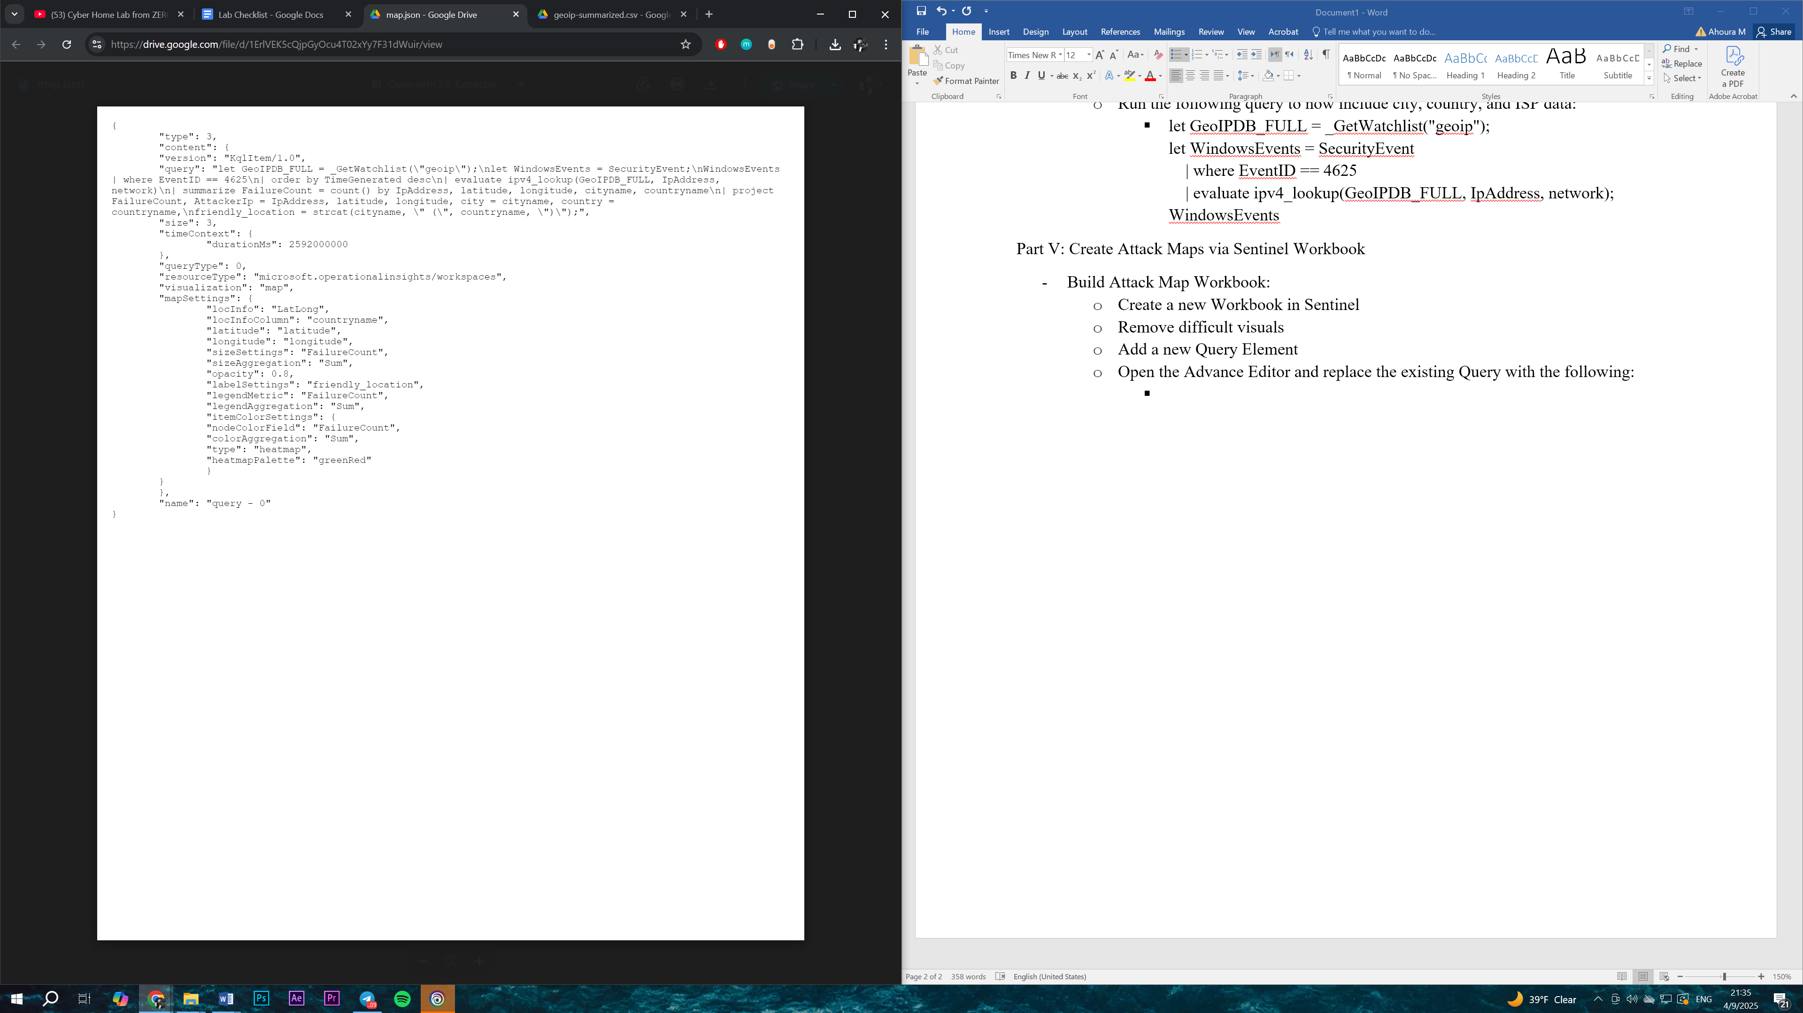
  - View and analyze the newly created and modified map:
    - The map will display attacked locations based on IP
    - Watch real-time updates (refresh) as attacked continue probing the honeypot
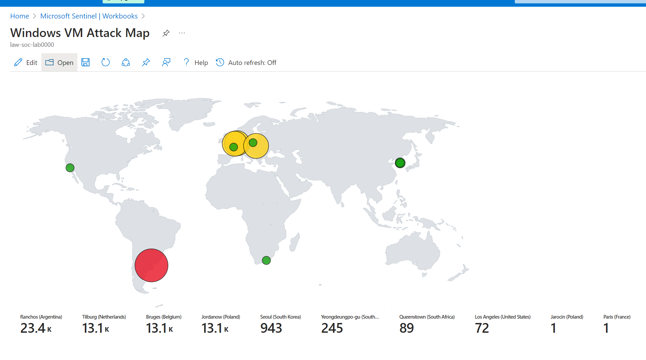
- Windows VM Attack Map Demonstrating IP-based Locations of Attackers Trying to Exploit the Honeypot

- Sample the log data:
  - Included below is an export of log data from Azure Monitor Log Analytics which show top locations of Failed Login Attempts:
    - Ranchos, Argentina: 23.4k
    - Tilburg, Netherlands: 13.1k
    - Bruges, Belgium: 13.1k
    - Jordanow, Poland: 13.1k
    - Seoul, South Korea: 943
    - Yeongdeungpo-gu, South Korea: 245
    - Queenstown, South Africa: 89
    - Los Angeles, United States: 72
    - Jarocin, Poland: 1
    - Paris, France: 1
  - Log Data File:

Cleanup & Ethics
- After data collection and attacker mapping, delete the VM and resource group
- Do not interact or respond to attackers as the honeypot is strictly passive and observational
Project Outcome
Within minutes of VM exposure with an open RDP and a disabled Firewall, the system experienced thousands of brute-force login attempts. Attack traffic generated from a globally distributed set of IPs indicating use of botnets and automated attack frameworks. This illustrates how open and unprotected services are quickly and repeatedly targeted, even with no advertisement. The IPs were geolocated using a watchlist-backed enrichment pipeline, leverage KQL and ipv4_lookup functions. Logs were then visualized using Azure Workbooks; effectively demonstrating hot zones for the global threat actors. This rapid attack behavior reinforces the necessity of zero-trust principles, least privilege access, and proper Network Security Group (NSG) configurations such as Endpoint Hardening and Network Segmentation.
Final Thoughts
This project presents a controlled yet realistic simulation of what can happen when infrastructure is left exposed to the internet. Implementation of Endpoint Hardening and Network Segmentation by cybersecurity professionals are of critical importance in real world scenarios where attackers leverage and utilize automated scanning tools and credential stuffing techniques in order to identify and exploit targets. This project also highlights the practical application of SIEM tools, particularly Microsoft Sentinel, for aggregating logs, enriching them with threat intelligence, and visualizing insights. The use of KQL enables powerful queries to identify patterns in login failures, lateral movement, and reconnaissance behavior. Ultimately, the project underscores that even unadvertised and freshly deployed VMs are quickly targeted, validating the pervasive and automated nature of modern cyber threats. By simulating this real-world scenario, security professionals and learners alike gain firsthand experience with adversary tactics, cloud telemetry, and operational security best practices.

