ProDuctive: A Productivity Assistant
By Andrew Houts and Joe Dion

Proposal
- The application we are building is for productivity and time management. We want to create an application that allows a user to create reminders and notes from one application. There is not a product on the market currently that has great note taking and reminder creating capabilities; it can be difficult to switch between multiple applications for notetaking and reminders. I call the application ProDuctive.
- I would like to use this solution personally and I believe other students would find the ability to create reminders within a notes application intuitive.
- Even if this application does bring any financial earnings, I would like to reap the benefits of having a more productive and well organized life.
- The application will allow for users to create accounts. From those accounts users will be able to take plain text notes and create reminders from within the notetaking input. Users will also be able to view past notes. Users will also be able to see all of their reminders in a separate view as well. This data will be stored remotely in SQL databases.

Functionality
Transactions:
- User
  - Create a user by supplying email & password.
  - Update email or password.
- Note
  - Create a note (note title does not have to be unique)
  - Update a notes content or title.
  - Share a note with another user.
- Reminder
  - Create a reminder. Reminders have body and a datetime to remind the user.
  - Delete the association between a user and a reminder.
Constraints:
- User email, password can not be null.
- Note title can not be null or empty.
- Reminder must have a reminder_datetime.
- Reminder title must not be null or empty.
- When a note is modified update its updated_at field.
Part C:
- Yes I would like to include menus to navigate around the application.
- There will be two menus
  - The first menu, will be displayed on startup. The menu will display a login and create user option.
    - This menu will lead to a sub menu that will display fields that will allow one to create a user with an email and password.
  - The second menu will contain options to
    - Force update
      - This will force check for an update
    - New note
      - This will lead to text entry box where the user can specify a title, body of the notes, share it with another user, and submit it
    - View notes
      - This will lead to a table containing all of the titles and dates of the notes. When a user clicks on a cell they will be taken to a text view of the notes where they can view/edit it.
      - The user will also be able to share this information
      - This will also have a search feature
    - New reminder
      - The user will be presented with a view that will allow them to create the title of the reminder and date and time they would like to be reminded
    - View reminders
      - The user will be able to view all reminders sorted by date.
      - Reminders can be checked off and then removed from the database.

ER Diagram
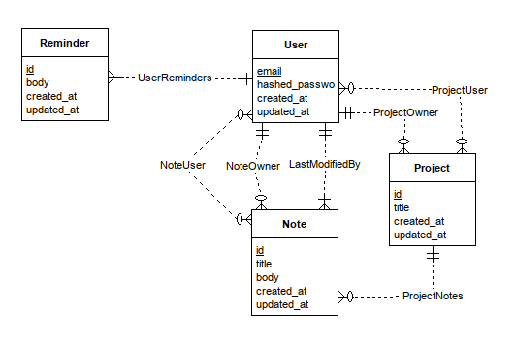

FDs
user_id → user_email, user_password, reminder_ids, project_ids, note_ids
reminder_id → user_id, reminder_content
note_id → user_id, note_title, note_content, project_id
project_id → note_ids, user_id, project_title

Code
Code can be found at:
https://github.com/ahouts/ProDuctive-server
https://github.com/ahouts/ProDuctive-client
DDL can be found in the migrations folder, DML used inline in the data folder of productive-server.

Assumptions
- The user is patient
  - Every action takes a second to load the results from the server. I couldn’t figure out how to install OracleDB on the server, so I am using a SSH tunnel to the school database and using that. As a result, every query to the database must go through the internet which takes much longer than a typical DB query.
  - This could be fixed by cashing client side, but that is out of the scope of this project.
- They have java installed on their computer and the antivirus doesn’t block the application.

